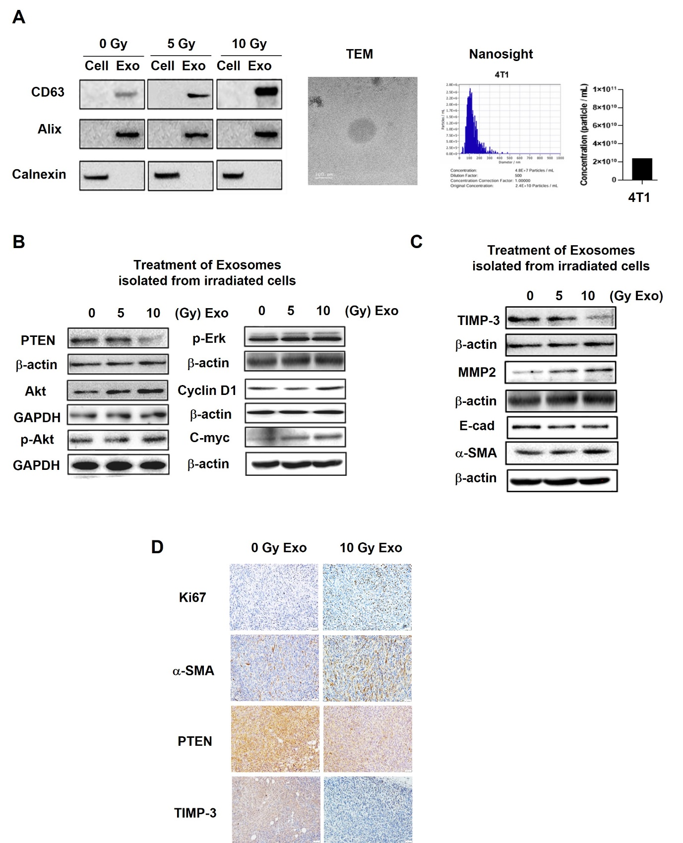

Supplementary Fig. 1 Exosomal miR-21 downregulates tumor suppressor genes, activating downstream signaling pathway A Exosome characterization by western blot for exosome marker (CD63 and Alix) and cell marker (Calnexin), along with TEM imaging and Nanosight analysis. B Western blot of the PTEN as a target of miR-21, and PTEN-related proteins in 4T1 breast cancer cells with exosomes (0/5/10 Gy). C Western blot of the TIMP-3 as a target of miR-21, and TIMP-3 related proteins in 4T1 with exosomes (0/5/10 Gy). D Immunohistochemistry of Ki67, a-SMA, PTEN and TIMP-3 in xenograft tumor tissues treated with 0, 10 Gy exosomes.
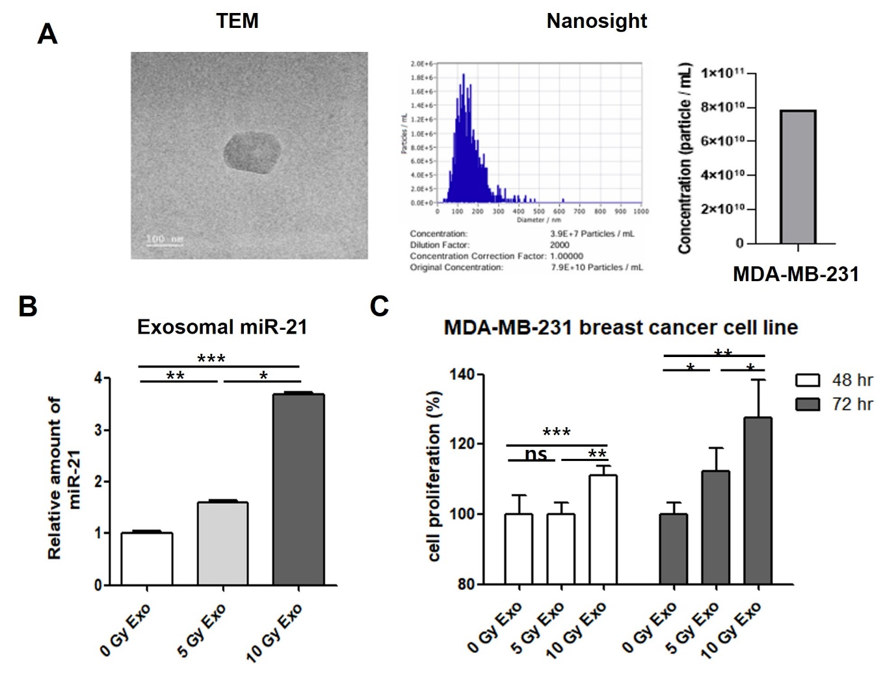
Supplementary Fig. 2 Exosomal miR-21 levels are enhanced by high-dose irradiation in human breast cancer cell line. A TEM image and Nanosight analysis of exosomes derived from MDA-MB-231. B Quantification of exosomal miR-21 levels isolated from irradiated MDA-MB-231 (0/5/10 Gy). C Cell proliferation of MDA-MB-231 with exosomes (0/5/10 Gy).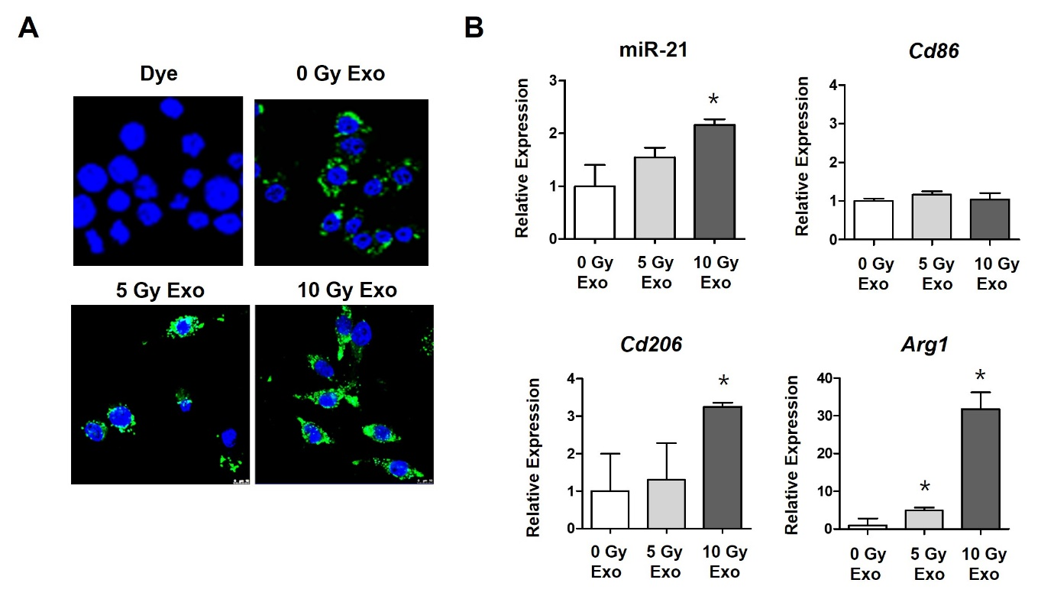
Supplementary Fig. 3 Relevance of radiation induced exosomes and M1/M2 polarization. A Confocal microscopy of RAW264.7 after Dye labeled Exo treatment. B qRT-PCR of miR-21, M1 marker (Cd86) and M2 marker (Cd206 and Arginase 1) after exosomes treatment (0/5/10 Gy).

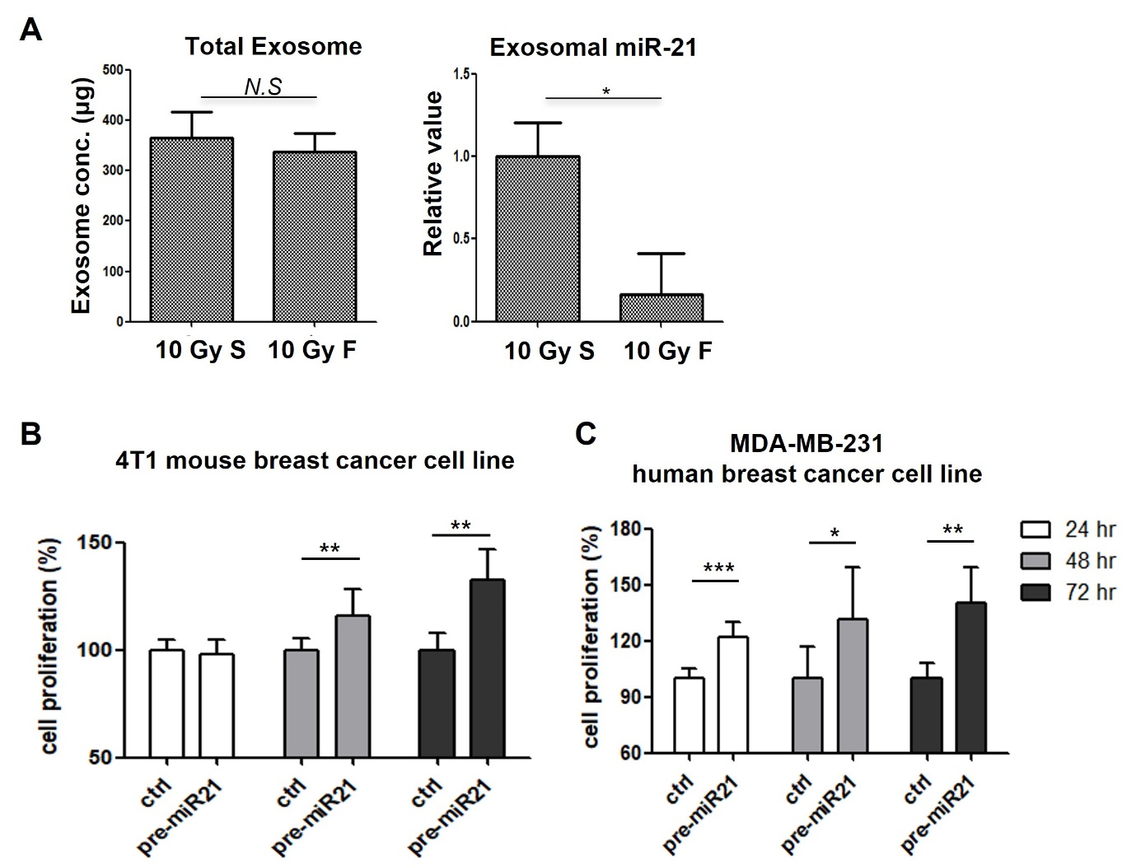
Supplementary Fig. 4 Exosomal miR-21 was different on fractionated radiation A Comparison of the total exosome amount and exosomal miR-21 levels between single-dose (10 Gy) and fractionated irradiation (2 Gy, 5 times). B, C Cell proliferation of 4T1 (B) and MDA-MB-231 (C) transfected with pre-miR-21.

