Tumor-priming CD8⁺ natural killer T-like cells as an efficient novel cell therapy for relapsed/refractory multiple myeloma

Supplementary Materials and Methods
Live cell imaging
Single cancer cell arrays were fabricated using IM-9 cells, as previously described (1), and were used to quantitatively analyze TPNC-cancer- and CIK-cancer cell interactions. A modified Olympus IX 83 epi-fluorescence microscope with a 40 × (UPlanFLN, NA = 1.30) objective lens and an ANDOR Zyla 4.2 sCOMS camera were used for the imaging experiments. The microscope was automatically controlled using Micro-manager. The microscope stage was equipped with a Chamlide TC incubator system (Live Cell Instrument) maintaining cell culture conditions (37°C, CO₂ 5%). The acquired images were processed using the ImageJ software. CIK cells and TPNC were stained with 1 μg/mL of LysoTracker Deep Red (Invitrogen, Carlsbad, CA, USA) by incubating at 37℃ for 1 h. IM-9 cells were labeled with 10 μg/mL CellTrace CFSE (Invitrogen) by incubating at 37℃ for 15 min prior to the fabrication of the single cell arrays. LysoTracker-labeled effector cells in complete RPMI-1640 medium containing 10 μg/mL propidium iodide (PI) were seeded onto a single-cell array of IM-9 cells loaded in a magnetic chamber. The effector cell-seeded chamber was mounted on a microscope stage equipped with an incubator system, and time-lapse imaging was performed at 3-min intervals for 3 h.

NK cell culture and anti-CD19 CAR-NK cell generation
Cord blood-derived mononuclear cells were isolated by density gradient centrifugation and cultured in CTS™ NK-Xpander™ medium (Gibco, USA) supplemented with IL-2, IL-18, and IL-21 on day 0. On days 3 and 5, only IL-2 was replenished to support NK cell expansion. For CAR-NK cell generation, cells were seeded into 24-well plates on day 7 and transduced the following day with a lentiviral vector encoding an anti-CD19 CAR construct containing 4-1BB and CD3ζ signaling domains. Transduction was performed using spinoculation in the presence of polybrene and the TBK1 inhibitor BX795. CAR-NK cells were then expanded for 7–10 days before use in functional assays. For non-transduced NK cell culture, IL-2 and IL-21 were supplemented every 2–3 days after day 7 to maintain NK cell viability and activity.

Magnetic isolation of CD3⁺ cells
CD3⁺ T cells were isolated from 1 × 10⁸ cord blood mononuclear cells (CBMC) using anti-CD3 MicroBeads (Miltenyi Biotec, Cat# 130-050-101) and LS columns (Miltenyi Biotec, Cat# 130-042-401), according to the manufacturer’s instructions.

Reference

1. Kim SE, Kim H, Doh J. Single cell arrays of hematological cancer cells for assessment of lymphocyte cytotoxicity dynamics, serial killing, and extracellular molecules. Lab Chip. 2019;19(11):2009-18.

Supplementary Figures

Figure S1
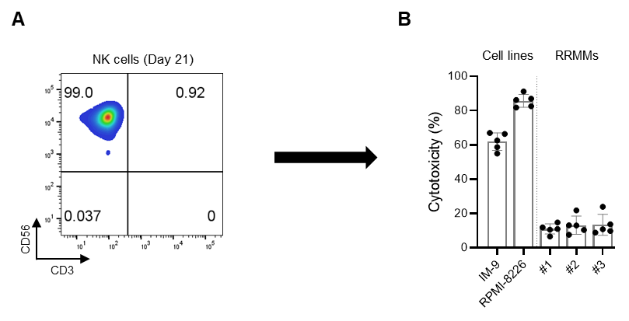
Supplementary Figure S1. Cytotoxicity of cord blood derived-NK cells against MM cell lines and RRMM samples
(A) NK cells were cultured for 21 days and analyzed by FACS to confirm CD3⁻CD56⁺ identity. (B) NK cells were co-cultured with MM cell lines (IM-9, RPMI-8226) and RRMM patient-derived samples (#1–3) at an effector-to-target ratio of 5:1 for 4 hours. Cytotoxicity was quantified based on CFSE⁺FVD⁺ target cell death. Data are presented as mean ± SD of five independent experiments.

Figure S2

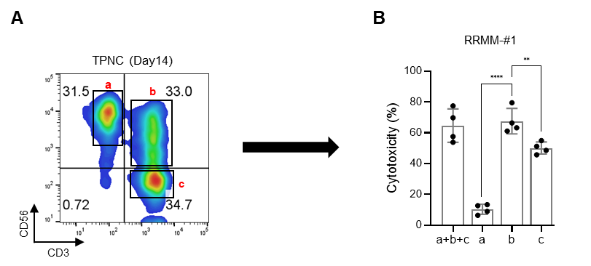
Supplementary Figure S2. Subset analysis of TPNC cytotoxicity
(A) TPNC were analyzed at day 14 for population distribution using flow cytometry. (B) Each subset (a: CD3⁻CD56⁺, b: CD3⁺CD56⁺, c: CD3⁺CD56⁻) was sorted and tested for cytotoxicity against RRMM cells. Cytotoxicity was measured at a 5:1 effector-to-target (E:T) ratio using CFSE⁺FVD⁺ markers after a 4 hour co-culture. Data are presented as mean ± SD of four independent experiments. ** P <0.01; **** P < 0.0001 based on Student’s t-test.

Figure S3

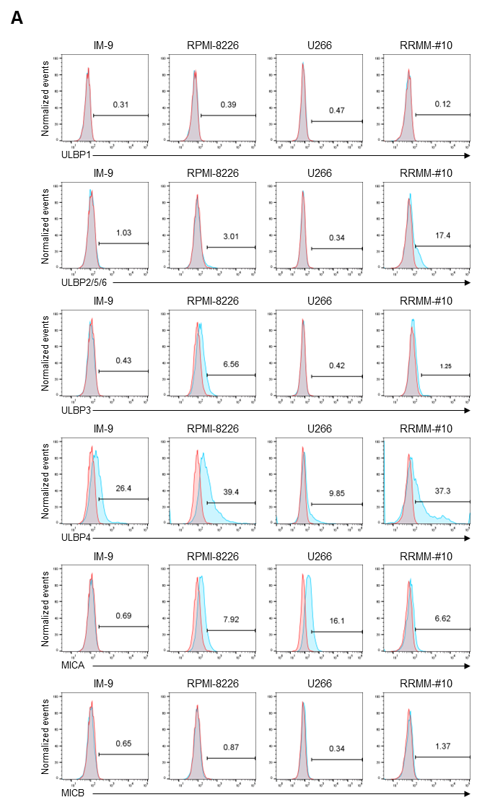

Supplementary Figure S3. Expression of NKG2D ligands on MM cell lines and RRMM cells
Expression of NKG2D ligands was assessed by flow cytometry in multiple myeloma (MM) cell lines (IM-9, RPMI-8226, U266) and a primary RRMM sample (RRMM-#10). Surface levels of ULBP1, ULBP2/5/6, ULBP3, ULBP4, MICA, and MICB were evaluated. Histograms represent normalized fluorescence intensity; red lines indicate isotype controls and blue lines represent ligand-stained samples.

Figure S4

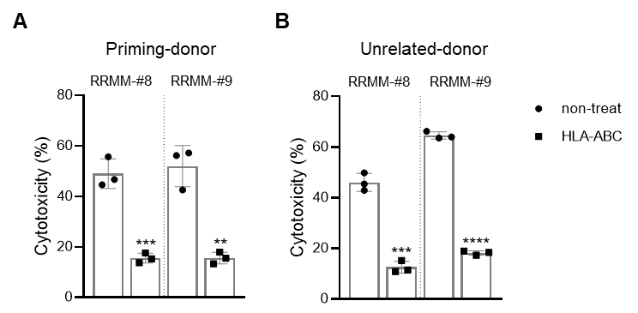

Supplementary Figure S4. HLA class I blockade reduces TPNC-mediated cytotoxicity against both autologous and unrelated RRMM samples
TPNC were co-cultured with RRMM target cells in the presence or absence of HLA-ABC blocking antibody. (A) Cytotoxicity against autologous (priming donor) targets: TPNC were generated from RRMM-#8 or RRMM-#9 and tested against their respective autologous targets. (B) Cytotoxicity against unrelated targets: TPNC generated from RRMM-#10 were tested against unrelated RRMM-#8 and RRMM-#9 target cells. Cytotoxicity was measured at a 5:1 effector-to-target (E:T) ratio using CFSE⁺FVD⁺ markers after a 4-hour co-culture. Data are presented as mean ± SD of three independent experiments. ** P < 0.01, *** P < 0.001, **** P < 0.0001 based on Student’s t-test.

Figure S5

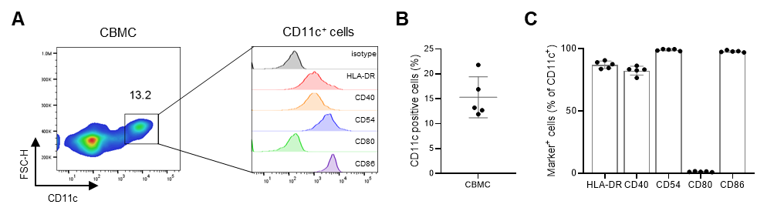

Supplementary Figure S5. Phenotypic characterization of CD11c⁺ APCs in CBMC
(A) Representative flow cytometry plots showing the presence of CD11c⁺ cells (~13.2%) within CBMC. Histograms depict surface expression of APC-associated markers (HLA-DR, CD40, CD54, CD80, CD86) within the CD11c⁺ population. (B) Frequency of CD11c⁺ cells as a percentage of total CBMC (n = 5). (C) Expression levels of APC-associated markers among CD11c⁺ cells. Data are presented as mean ± SD of five independent experiments.

Figure S6

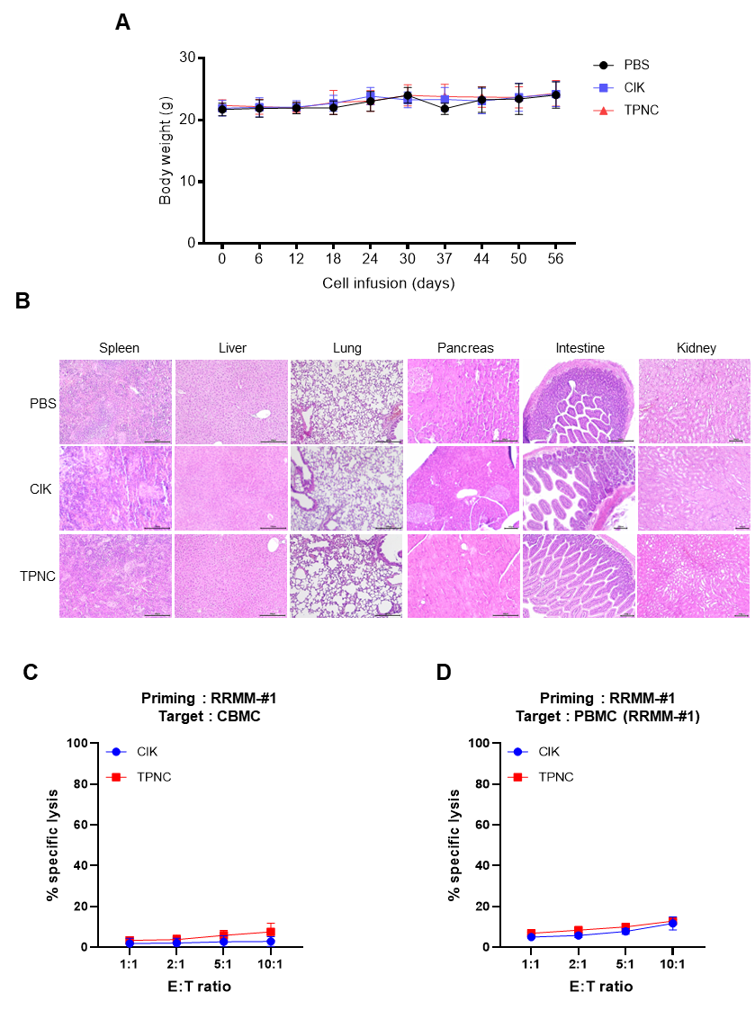

Supplementary Figure S6. Safety evaluation of TPNC therapy
TPNC and CIK cells were administered intravenously for 3 weeks at a dose of 1 × 10⁸ cells once a week, and the mice were sacrificed after 8 weeks. (A) Body weight changes of mice receiving different treatment. (B) Representative image of H&E staining for mice organs. (C) Cytotoxicity of TPNC and CIK against allogeneic CBMC (D) Cytotoxicity of TPNC and CIK against PBMC from RRMM-#1. Data are presented as mean ± SD of three independent experiments (C, D).

Figure S7

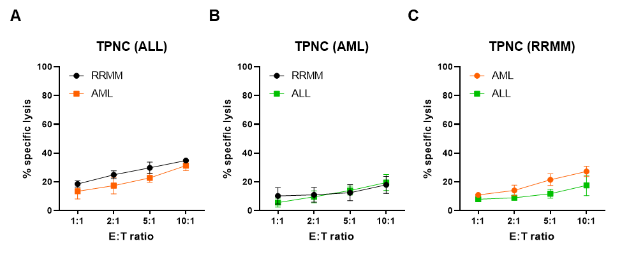

Supplementary Figure S7. Tumor-specific cytotoxicity of TPNC against other hematologic malignancies
Generate TPNC with various patient-derived cells (ALL, AML, RRMM) as feeder cells and analyze their cytotoxicity against different hematologic malignancies. Cells were co-cultured for 4 hours. Quantitative assessment of killed cells was performed in the CFSE⁺FVD⁺ region. (A) Cytotoxicity of TPNC (ALL) against RRMM and AML, (B) Cytotoxicity of TPNC (AML) against RRMM and ALL (C) Cytotoxicity of TPNC (RRMM) against AML and ALL. Data are presented as mean ± SD of three independent experiments (A, B, C).

Table S1
UPN | Age, years | Sex | MM type | R-ISS | BM clonal plasma cells at the time of sample collection | Precvious treatments
#1 | 73 | M | IgG, kappa | II | 100.00% | VAD - Auto - Vd - Rd - Pd - Daratumumab
#2 | 74 | M | LCD, kappa | III | 44.80% | VMP -Rd - Kd- Pd - Daratumumab - CTd - selinexor
#3 | 62 | M | IgG, kappa | II | 24.20% | VTd - Auto - KRd
#4 | 83 | M | IgA, lambda | III | 19.20% | Rd
#5 | 62 | M | IgG, kappa | II | 8.20% | VTd - Auto - KRd
#6 | 73 | F | LCD, lambda | III | 3.55% | Cd-Vd-Auto-Rd-CTd-Kd-Daratumumab-PCd
#7 | 63 | F | LCD, kappa | III | 34% | VTd
#8 | 68 | M | IgG, lambda | II | 3.52% | VTd-Auto-IRd
#9 | 66 | F | IgG, lambda | I | 5.47% | Td-Auto-Rd-Kd
#10 | 62 | F | LCD, lambda | II | 54.60% | VRd-Auto-Vd-Pd-Kd-Daratumumab

Supplementary Table S1. Clinical characteristics of the analyzed relapsed and refractory multiple myeloma (RRMM) patients. Samples from RRMM patients were used for tumor-priming CD8⁺ natural killer T-like cells experiments. Abbreviations, UPN, unique patient number; M, male; F, female; R-ISS, revised international staging system; BM, bone marrow; LCD, light chain disease, IgG, immunoglobulin G, IgA, immunoglobulin A; VMP, bortezomib-melphalan-prednisolone; Rd, lenalidomide-dexamethasone; Kd, carfilzomib-dexamethasone; Pd, pomalidomide-dexamethasone; CTd, cyclophosphamide-thalidomide-dexamethasone; VAD, vincristine-doxorubicin-dexamethasone; Auto, autologous stem cell transplantation; Vd, bortezomib-dexamethasone; VTd, bortezomib-thalidomide-dexamethasone; KRd, carfilzomib-lenalidomide-dexamethasone; Cd, cyclophosphamide-dexamethasone; PCd, pomalidomide-cyclophosphamide-dexamethasone; IRd, ixazomib-lenalidomide-dexamethasone; Td, thalidomide-dexamethasone; DVTd, daratumumab-bortezomib-thalidomide-dexamethasone; VRd, bortezomib-lenalidomide-dexamethasone.

Table S2
UPN | Age, years | Sex | Diagnosis | Cytogenetic and molecular risk groups (specific alterations) | Immunophenotyping | WBC at the time of sample collection (/μL)
#1 | 68 | M | AML | Intermediate  (Trisomy21, FLT3, DNMT3A, EZH2, NRAS, ZRSR2 ) | CD13, CD33, CD117, HLA-DR, CD71, Cytoplasmic MPO | 122,650
#2 | 53 | F | AML | Intermediate | CD11c, CD33, CD64, CD117, CD56, Cytoplasmic MPO, CD71 | 163,410
#1 | 54 | M | ALL | Poor (BCR-ABL1) | CD13, CD33, HLA-DR, TDT, CD19, CD34, Cytoplasmic CD79a | 461,400
#2 | 60 | M | ALL | Poor (BCR-ABL1, p16) | CD13, CD10, CD19, CD20, HLA-DR, CD71, Cytoplasmic CD79a | 295,140

Supplementary Table S2. Clinical characteristics of the analyzed newly diagnosed acute lymphoblastic leukemia (ALL) and acute myeloid leukemia (AML) patients. Samples from ALL and AML patients were used for tumor-priming CD8⁺ natural killer T-like cells experiments. Abbreviations, UPN, unique patient number; M, male; F, female; FLT3, FMS‐like tyrosine kinase 3; DNMT3A, DNA (cytosine-5)-methyltransferase 3; EZH2, Enhancer of zeste homolog 2; NRAS, NRAS proto-oncogene; ZRSR2, zinc finger CCCH-type, RNA binding motif and serine/arginine rich 2; BCR-ABL1, breakpoint cluster region protein-ABL Proto-Oncogene 1, Non-Receptor Tyrosine Kinase; HLA-DR, major histocompatibility complex, class II, DR alpha; MPO, Myeloperoxidase; TDT, Terminal deoxynucleotidyl transferase; WBC, white blood cell.

Table S3
Antibody Name | Catalog Number | Manufacturer
anti-CD3-FITC | 561807 | BD Biosciences
anti-CD3-PE | 561803 | BD Biosciences
anti-CD56-PE-cy7 | 335791 | BD Biosciences
anti-CD4-PE | 555347 | BD Biosciences
anti-CD8-PE | 555367 | BD Biosciences
anti-CD16-PE | 556619 | BD Biosciences
anti-CD62L-PE | 555544 | BD Biosciences
anti-CD45RA-FITC | 347723 | BD Biosciences
anti-CD45RO-PE | 12-0457-42 | eBioscience™
anti-CD57-PE | 560844 | BD Biosciences
anti-NKp30-PE | 558407 | BD Biosciences
anti-NKp44-PE | 558563 | BD Biosciences
anti-NKp46-PE | 557991 | BD Biosciences
anti-NKp80-PE | 566329 | BD Biosciences
anti-NKG2C-PE | FAB138P | R&D Systems
anti-NKG2D-PE | 557940 | BD Biosciences
anti-CD69-PE | 555531 | BD Biosciences
anti-NKG2A-PE | FAB1059P | R&D Systems
anti-CD158b-PE | 559785 | BD Biosciences
anti-TIGIT-PE | 372704 | BioLegend
anti-GITR-PE | 311604 | BioLegend
anti-BTLA-PE | 558485 | BD Biosciences
anti-LAG3-PE | 565616 | BD Biosciences
anti-CXCR3-PE | 353706 | BioLegend
anti-CXCR4-PE | 306506 | BioLegend
anti-CXCR6-PE | 356004 | BioLegend
anti-Perforin-FITC | 308103 | BioLegend
anti-Granzyme B-FITC | 515403 | BioLegend
anti-CD45-FITC | 368507 | BioLegend
anti-FMC63 antibody | FM3-Y45-25tests | ACRObiosystems
anti-mouse IgG1-PE-cy7 | 406613 | BioLegend
anti-ULBP1-PerCP | FAB1380C | R&D Systems
anti-ULBP2/5/6-PE | FAB1298P | R&D Systems
anti-ULBP3-PE | FAB1517P | R&D Systems
anti-ULBP4-PE | FAB6285P | R&D Systems
anti-MICA-PE | FAB1300P | R&D Systems
anti-MICB-PE | FAB1599P | R&D Systems
anti-CD11c-PC5 | IM3707 | Beckman Coulter
anti-HLA-DR-PE | IM1639 | Beckman Coulter
anti-CD40-PE | IM1936U | Beckman Coulter
anti-CD54-PE | IM1239U | Beckman Coulter
anti-CD80-PE | PN IM1976U | Beckman Coulter
anti-CD86-PE | IM2729U | Beckman Coulter
anti-LFA-1-PE | 363405 | BioLegend
anti-DNAM-1-PE | 337106 | BioLegend
anti-CD112-PE | 337409 | BioLegend
anti-CD155-FITC | 337628 | BioLegend
anti-ICAM-1-PE | 353105 | BioLegend
anti-ICAM-2-PE | 328505 | BioLegend
anti-ICAM-3-PE | 3330005 | BioLegend
LFA-1 blocker | 301202 | BioLegend
DNAM-1 blocker | 338302 | BioLegend
HLA-ABC blocker | 311402 | BioLegend

Supplementary Table S3. Antibodies used in flow cytometry studies
FITC, fluorescein isothiocyanate; PE, phycoerythrin; PE-Cy7, phycoerythrin-cyanine7; PerCP, peridinin-chlorophyll protein complex; PC5, phycoerythrin-cyanine5

Supplementary Movie S1 Legend
Live imaging of interaction between human TPNC/CIK cells (yellow border line), IM-9 cells (Green) and PI (Blue) using fluorescence microscopy.

