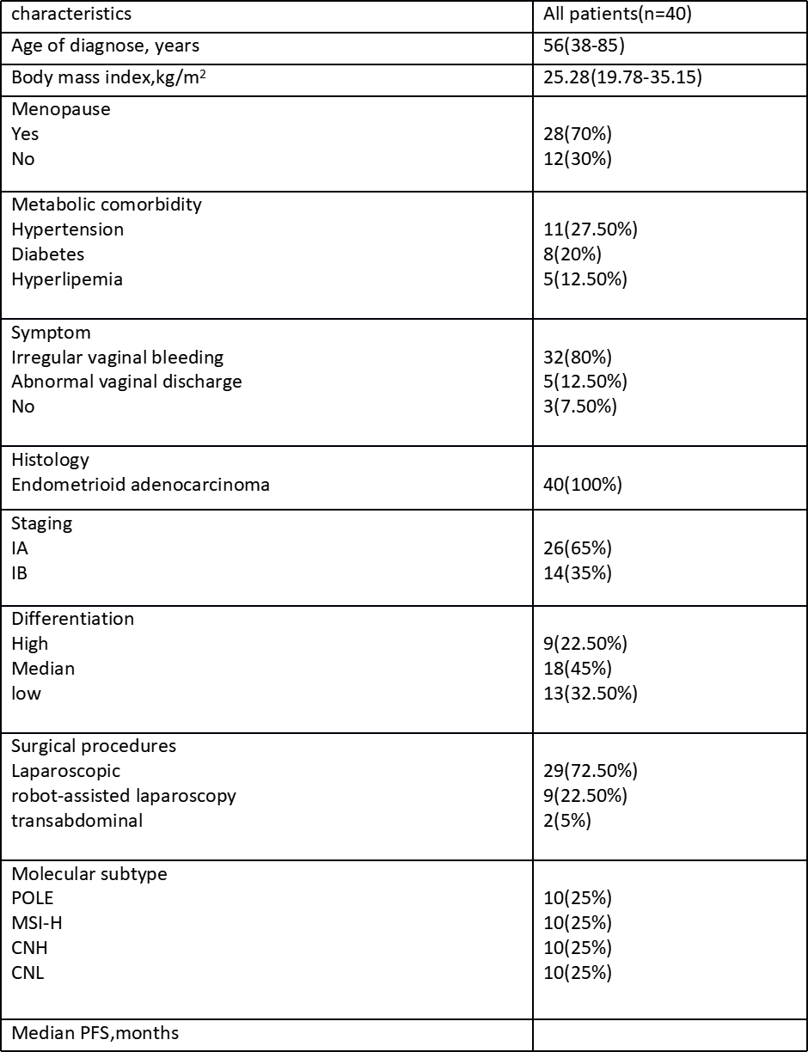
Supplementary Table
clinical and pathological characteristics in the enrolled patient

