Supplementary Figures
Supplementary Figure S1

Supplementary Figure S2

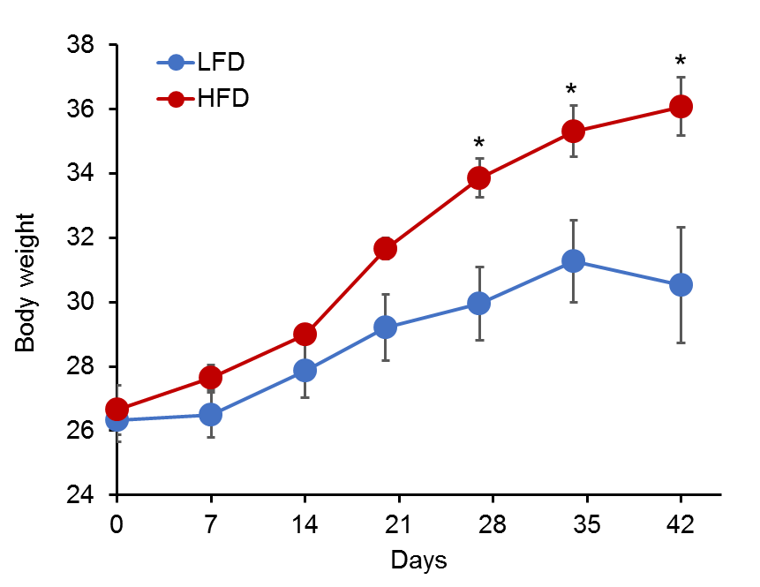
Supplementary Figure S3

Supplementary Figure S4

