Supplemental
Table S1. Relative abundances of bacterial phyla in which plant-beneficial strains are currently recognized in Avatar, Sherpa and Traviata oilseed rape cultivars
Phylum | Avatar¹⁾ | Sherpa¹⁾ | Traviata¹⁾
Cyanobacteria | 0.107±0.025ª | 0.124±0.067ª | 0.087±0.041ª
Firmicutes | 0.070±0.017ª | 0.083±0.011ª | 0.075±0.010ª
Acidobacteria | 0.032±0.003ª ↓ | 0.061±0.005^{b} | 0.060±0.005^{b}
Actinobacteria | 0.041±0.004ª | 0.049±0.004^{ab} | 0.055±0.006^{b}
Chloroflexi | 0.024±0.005ª ↓ | 0.044±0.003^{b} | 0.043±0.008^{b}
Bacteroidetes | 0.041±0.007ª | 0.036±0.004ª | 0.034±0.002ª
Planctomycetes | 0.013±0.002ª ↓ | 0.027±0.003^{b} | 0.022±0.001^{b}
Verrucomicrobia | 0.008±0.002ª | 0.016±0.002^{b} | 0.012±0.003^{ab}
Gemmatimonadetes | 0.008±0.001ª | 0.013±0.002^{ab} | 0.014±0.003^{b}
Nitrospirae | 0.003±0.001ª | 0.005±0.001^{b} | 0.004±0.000^{ab}
Armatimonadetes | 0.001±0.000ª ↓ | 0.003±0.001^{b} | 0.003±0.001^{b}
¹⁾ Mean values and standard deviations (mean ± SD) are provided in oilseed rape seeds samples. Values designated with the same letters were not significantly different (P<0.05) according to a Tukey-HSD T-test.

Table S2 Relative proportions of PICRUSt predicted functions of 16S rRNA marker gene with over 1% abundance in all samples
Predicted function* | Avatar | Sherpa | Traviata
Transporters | 5.92±0.12 ª | 5.60±0.15 ª | 5.75±0.18 ª
ABC transporters | 3.68±0.08 ª | 3.45±0.09 ª | 3.54±0.10 ª
DNA repair and recombination proteins | 2.17±0.03 ª | 2.28±0.05 ª | 2.24±0.02 ª
Two-component system | 2.13±0.04 ª | 2.10±0.03 ª | 2.09±0.02 ª
Purine metabolism | 1.79±0.02 ª | 1.89±0.02 ª | 1.87±0.02 ª
Bacterial motility proteins | 1.84±0.01 ª | 1.81±0.05 ª | 1.72±0.06 ª
Ribosome | 1.59±0.05 ª | 1.74±0.07 ª | 1.70±0.05 ª
Oxidative phosphorylation | 1.41±0.02 ª | 1.49±0.02 ª | 1.45±0.04 ª
Peptidases | 1.39±0.02 ª | 1.48±0.02 ª | 1.46±0.02 ª
Transcription factors | 1.40±0.04 ª | 1.35±0.05 ª | 1.40±0.06 ª
Pyrimidine metabolism | 1.20±0.02 ª | 1.29±0.03 ª | 1.27±0.02 ª
Arginine and proline metabolism | 1.20±0.01 ª | 1.23±0.02 ª | 1.24±0.01 ª
Amino acid related enzymes | 1.16±0.02 ª | 1.22±0.01 ª | 1.21±0.02 ª
Butanoate metabolism | 1.19±0.02 ^{b}↑ | 1.08±0.03 ª | 1.11±0.01 ^{ab}
Pyruvate metabolism | 1.13±0.01 ª | 1.12±0.01 ª | 1.12±0.01 ª
Carbon fixation pathways in prokaryotes | 1.03±0.02 ª | 1.09±0.01 ª | 1.07±0.02 ª
Propanoate metabolism | 1.09±0.02 ª↑ | 0.98±0.02 ª | 1.01±0.01 ^{ab}
Ribosome Biogenesis | 0.99±0.02 ª | 1.05±0.03 ª | 1.02±0.01 ª
Glycolysis / Gluconeogenesis | 0.99±0.01 ª | 1.02±0.00 ª | 1.03±0.01 ª
* rows where a predicted function was found in a significantly higher abundance in Avatar seeds compared to at least one of the other cultivar were highlighted in bold. Mean values and standard deviations (mean ± SD) are provided in oilseed rape seeds samples. Values designated with the same letters were not significantly different (P<0.05) according to a Tukey-HSD T-test.

Table S3 Relative proportions of PICRUSt predicted functions of 16S rRNA marker gene with significant difference between the samples and over 0.3% abundance
Predicted function* | Avatar | Sherpa | Traviata
Butanoate metabolism | 1.19±0.02 ^{b}↑ | 1.08±0.03 ª | 1.11±0.01 ^{ab}
Propanoate metabolism | 1.09±0.02 ^{b}↑ | 0.98±0.02 ª | 1.01±0.01 ^{ab}
Valine, leucine and isoleucine degradation | 1.03±0.02 ^{b}↑ | 0.92±0.04 ª | 0.94±0.02 ^{ab}
Fatty acid metabolism | 0.91±0.02 ^{b}↑ | 0.78±0.02 ª | 0.80±0.01 ^{ab}
Glyoxylate and dicarboxylate metabolism | 0.86±0.01 ^{b}↑ | 0.78±0.03 ª | 0.80±0.01 ^{ab}
Benzoate degradation | 0.78±0.03 ^{b}↑ | 0.61±0.02 ª | 0.64±0.03 ^{ab}
Tryptophan metabolism | 0.72±0.02 ^{b}↑ | 0.63±0.02 ª | 0.66±0.01 ^{ab}
Lysine biosynthesis | 0.58±0.01 ^{b} | 0.61±0.01 ª↑ | 0.60±0.01 ^{ab}
beta-Alanine metabolism | 0.59±0.01 ^{b}↑ | 0.50±0.01 ª | 0.51±0.01 ^{ab}
Aminobenzoate degradation | 0.57±0.02 ^{b}↑ | 0.47±0.02 ª | 0.49±0.01 ^{ab}
Tyrosine metabolism | 0.51±0.01 ^{b}↑ | 0.47±0.01 ª | 0.48±0.00 ^{ab}
Glutathione metabolism | 0.50±0.01 ^{b}↑ | 0.47±0.01 ª | 0.47±0.01 ^{ab}
Limonene and pinene degradation | 0.50±0.02 ^{b}↑ | 0.41±0.01 ª | 0.42±0.01 ^{ab}
Phenylalanine metabolism | 0.44±0.01 ^{b}↑ | 0.40±0.03 ª | 0.42±0.01 ^{ab}
Geraniol degradation | 0.47±0.02 ^{b}↑ | 0.37±0.01 ª | 0.39±0.01 ^{ab}
Chloroalkane and chloroalkene degradation | 0.34±0.01 ^{b}↑ | 0.30±0.01 ª | 0.31±0.01 ^{ab}
* the highest abundances among the seed samples for a predicted function were highlighted in bold. Mean values and standard deviations (mean ± SD) are provided in oilseed rape seeds samples. Values designated with the same letters were not significantly different (P<0.05) according to a Tukey-HSD T-test.

Table S4 Alpha rarification analysis of predicted microbial functions*
 | Chao1 | Observed OTUs | Shannon
Avatar | 284.4±1.4 ª | 282.8±1.8 ª | 6.9±01 ª
Sherpa | 286.94±3.2 ª | 282.0±0.7 ^{ab} | 6.9±0.0 ª
Traviata | 326.8±58.9 ª | 288.0±4.1 ^{b} | 6.9±0.0 ª
The richness was calculated using the Chao1, observed OTUs and Shannon estimators. Mean values and standard deviations (mean ± SD) are provided for seed samples. Values designated with the same letters were not significantly different (P<0.05) according to a Tukey-HSD T-test.

Fig. S1 Production sites of the Avatar and Sherpa seeds
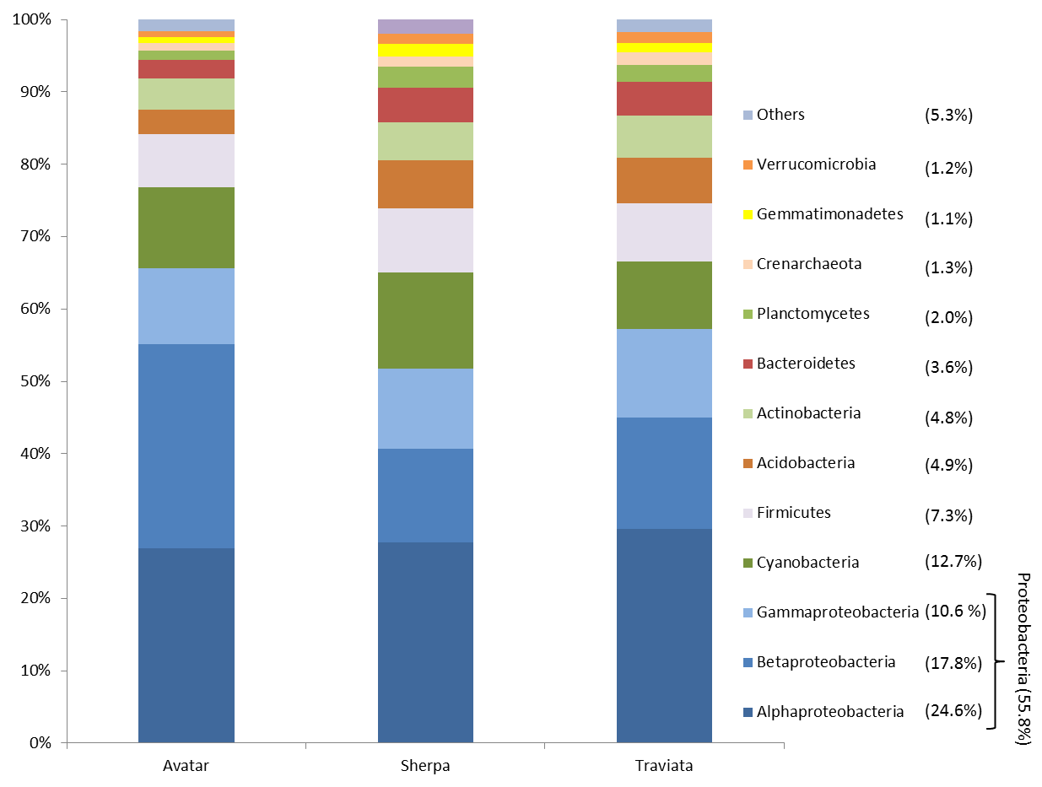

Fig. S2. Overlap of the different bacterial communities from oilseed rape seeds based on total OTU count (97% similarity). The OTU was regarded as present in a given cultivar if it was observed in at least one of the four replicates; the data was not normalized in order to include all observed OTUs.

