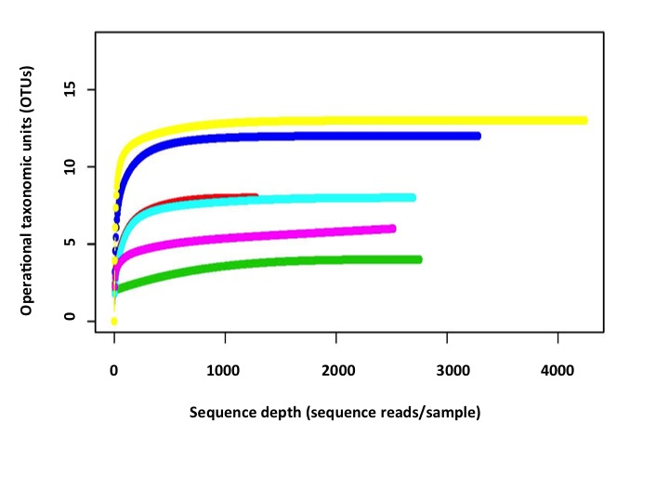
Additional File 3: Representative rarefaction curves of D. andersoni ticks in 2012 – 2014 Lake Como populations. The species diversity of the midgut (MG) and salivary glands (SG) of adult male F1 Lake Como (LC) ticks collected from 2012 – 2014 were plotted as a function of read depth. Samples that were plotted include: 2014 SG (yellow), 2014 MG (dark blue), 2012 MG (red), 2012 SG (pale blue), 2013 SG (fuchsia) and 2013 MG (green).

