Additional File 10. Unweighted UniFrac beta diversity PCoA plot per skin site colored by temporality. In blue, dogs born from January to May that had spent at least 5.5 months in the kennel (T1 group) and in red, dogs born from June to September that had spent 2.5 months in the kennel (T2 group).
(A) Inner pinna (B) Chin
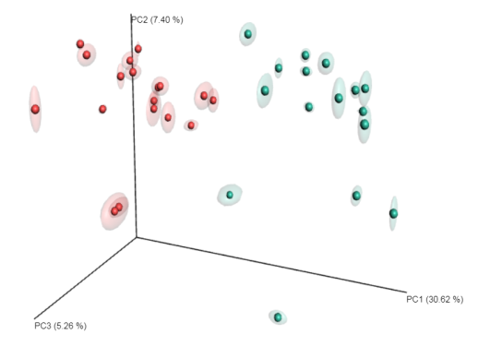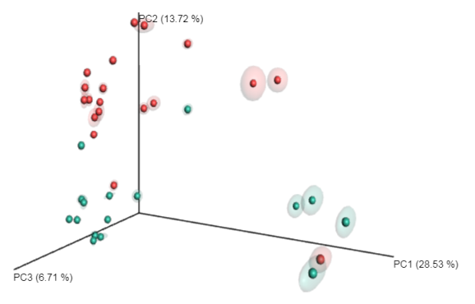
(C) Nasal skin (D) Dorsal back
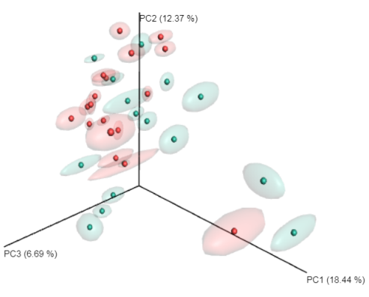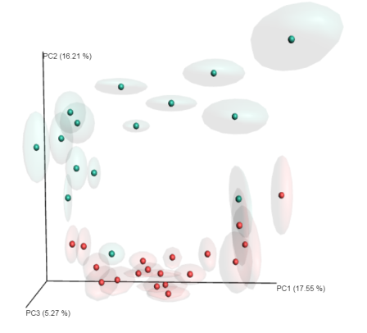
(E) Axilla (F) Abdomen
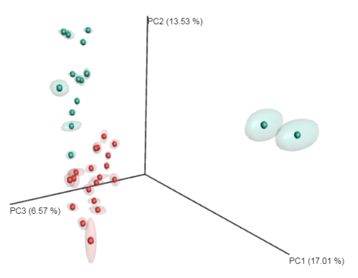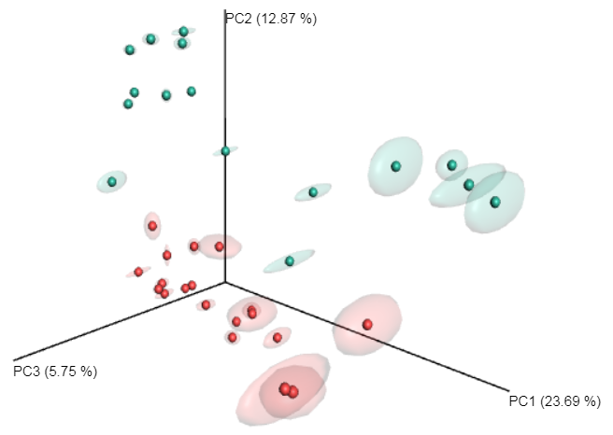
(G) Interdigital region (H) Perianal area
