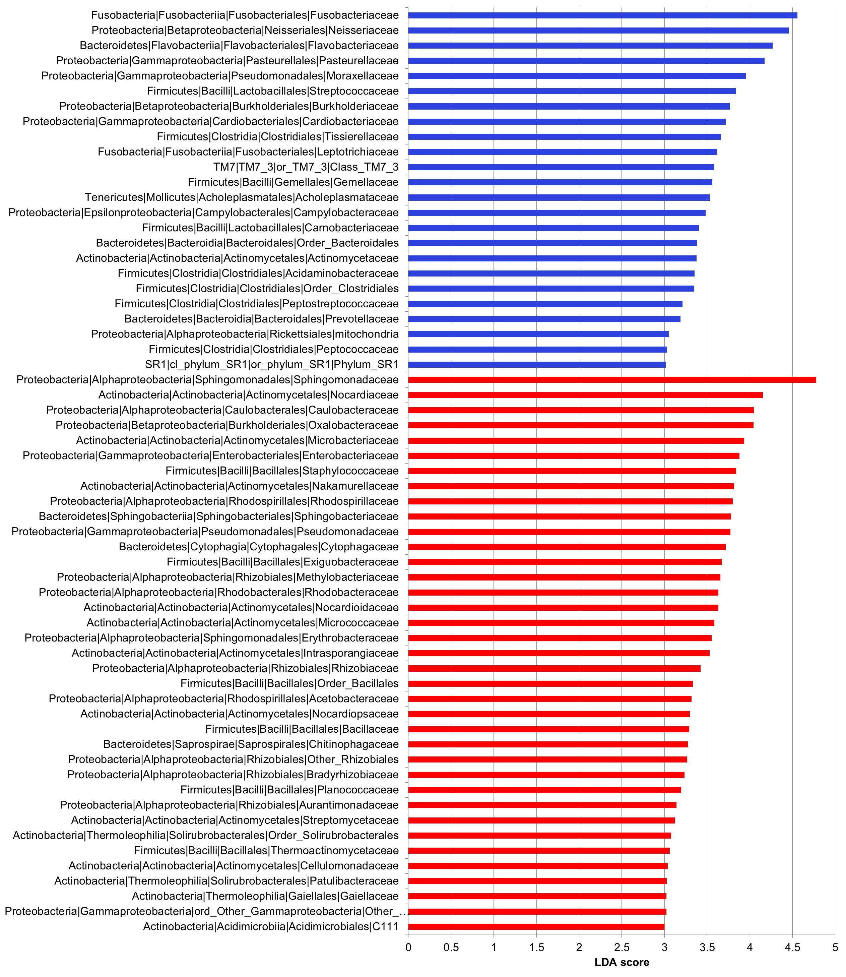
Additional File 11. Differentially distributed families based on Temporality. Histogram of linear discriminant analysis (LDA) effect size (LEfSe) for differentially abundance distribution (α = 0.05, LDA score >3).

