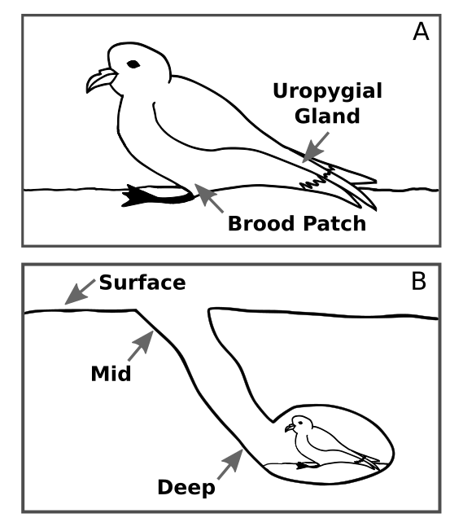
Figure S2- Diagrams depicting bird body site sampling locations and burrow soil sampling depths. A) Swab samples were obtained from each Leach’s storm-petrel at the uropygial gland, found on the dorsal side of the bird near the tail, and the brood patch, found on the ventral side. B) Soil samples were collected deep within the burrow, from the entrance of the burrow, and 30 cm away from the burrow entrance, referred to as deep, mid, and surface burrow soil, respectively.

