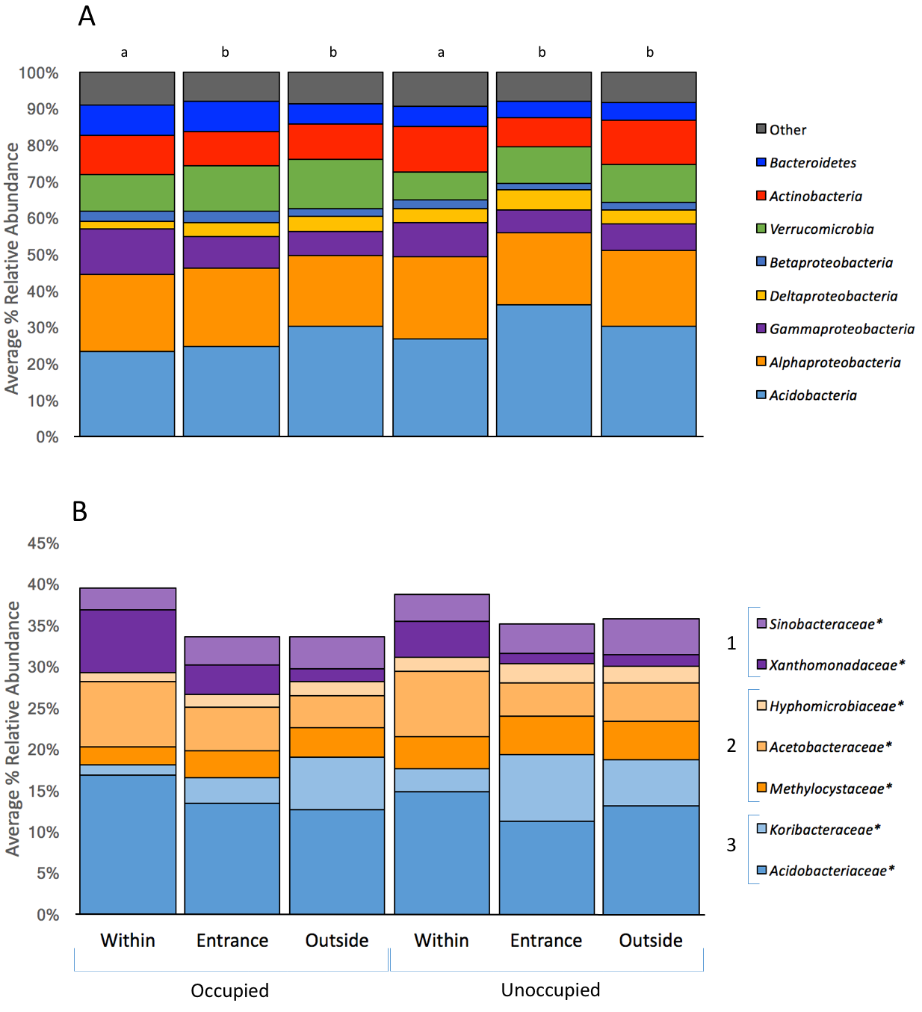

Figure S4- Relative abundance of top 25 bacterial species ranked by phylum (A) and family (B) among occupied and unoccupied deep, mid, and surface burrow soil categories. Burrow occupancy had no effect on bacterial community composition or structure, but burrow communities were significantly different based on depth (pseudo-F:2.796, p < 0.001, n = 78). Families that differed significantly among deep, mid, and surface burrow soil are marked with an asterisk (*). Phyla or class levels in (B) are represented as 1) Gammaproteobacteria, 2) Alphaproteobacteria, and 3) Acidobacteria.

