Additional file for “A reservoir of ‘historical’ antibiotic resistance genes in remote pristine Antarctic soils”

Marc W. Van Goethem, Rian Pierneef, Oliver K. I. Bezuidt, Yves Van De Peer, Don A. Cowan and Thulani P. Makhalanyane

Table S1. Environmental factors of the 17 sampled sites.
Table S2. The selected ARGs chosen from noradab, including the names, gene and ARG description, and ARG families.
Figure S1. The number of unique ARGs and number of unique AR hosts per site. Linear model indicated in red and lowess in blue (Pearson’s correlation r = 0.89, P = 1.62e-06).
Figure S2. ARG host frequencies across sampled sites. The number of different ARG hosts is indicated in green with the number of unique ARG hosts displayed in red, axis on the left. The black line represents the relative abundance, axis on the right.
Figure S3. ARG redundancy analysis. The only environmental factor to display a significant impact was percentage N (P = 0.024).
Table S1. Environmental factors of the 17 sampled sites.
Site | pH | P (ppm) | Na (cmol(+)/kg) | K (mg/kg) | Ca (cmol(+)/kg) | Mg (cmol(+)/kg) | % C | % N | Altitude (m.a.s.)
BG12-3 | 8.20 | 11 | 0.6 | 61 | 2.16 | 0.89 | 0.1 | 0.02 | 1109
MS2-2 | 7.79 | 12 | 1.4 | 26 | 6.33 | 1.41 | 0.12 | 0.016 | 497
MS4-1 | 7.74 | 20 | 0.37 | 299 | 6.43 | 1.02 | 0.12 | 0.021 | 527
MS3-5 | 7.81 | 9 | 0.7 | 35 | 6.04 | 1.33 | 0.1 | 0.017 | 547
TG1-5 | 8.14 | 18 | 0.07 | 83 | 2.8 | 1.62 | 0.12 | 0.028 | 1017
MGM-3 | 7.65 | 25 | 0.34 | 32 | 1.0 | 0.47 | 0.12 | 0.032 | 157
MS6-5 | 8.70 | 22 | 0.94 | 116 | 4.95 | 0.91 | 0.12 | 0.017 | 488
MS1-1 | 7.58 | 24 | 1.92 | 78 | 12.78 | 2.1 | 0.15 | 0.032 | 556
MG3-2 | 7.53 | 14 | 0.13 | 58 | 1.29 | 0.78 | 0.1 | 0.02 | 189
MtG22-5 | 7.94 | 17 | 0.32 | 56 | 4.48 | 1.37 | 0.1 | 0.028 | 963
MS7-5 | 7.94 | 60 | 0.53 | 54 | 7.97 | 2.15 | 0.13 | 0.026 | 440
PT-2 | 8.21 | 15 | 0.07 | 44 | 1.09 | 0.53 | 0.12 | 0.008 | 811
MS5-1 | 7.77 | 23 | 0.49 | 87 | 4.02 | 0.98 | 0.1 | 0.01 | 576
TG5-1 | 8.08 | 15 | 0.28 | 22 | 2.97 | 1.57 | 0.12 | 0.019 | 729
CN-4 | 7.95 | 19 | 0.07 | 75 | 0.48 | 0.32 | 0.14 | 0.016 | 220
MtG-4 | 8.17 | 4 | 0.13 | 15 | 3.7 | 0.44 | 0.1 | 0.024 | 652
MG6-4 | 7.86 | 12 | 0.33 | 29 | 1.49 | 0.63 | 0.12 | 0.016 | 763

Table S2. The selected ARGs chosen from noradab, including the names, gene and ARG description, and ARG families.

ARGs | Gene Description | ARG Description | ARG Family
noradab.113 | Dihydrofolate reductase | dfrE is a chromosome-encoded dihydrofolate reductase found in Enterococcus faecalis | dfrE is a chromosome-encoded dihydrofolate reductase found in Enterococcus faecalis.
noradab.1928 | Macrolide transporter ATP-binding/permease protein | Resistance-nodulation-cell division transporter system. | ABC efflux/transporter system.
noradab.4221 | Fosmidomycin resistance protein | Efflux pump/potassium antiporter system | Efflux pump/potassium antiporter system. RosA: Major facilitator superfamily transporter.

Figure S1. The number of unique ARGs and number of unique AR hosts per site. Linear model indicated in red and lowess in blue (Pearson’s correlation r = 0.89, P = 1.62e-06).
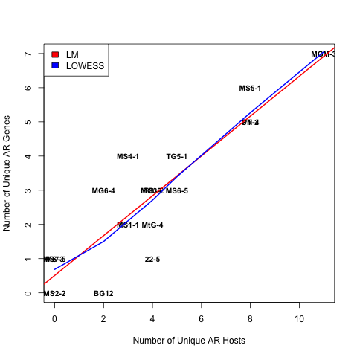
Figure S2. ARG host frequencies across sampled sites. The number of different ARG hosts is indicated in green with the number of unique ARG hosts displayed in red, axis on the left. The black line represents the relative abundance, axis on the right.
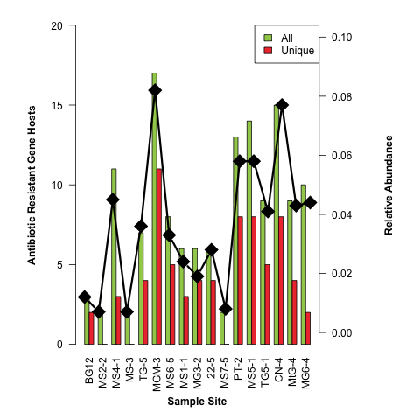
Figure S3. ARG redundancy analysis. The only environmental factor to display a significant impact was percentage N (P = 0.024).
