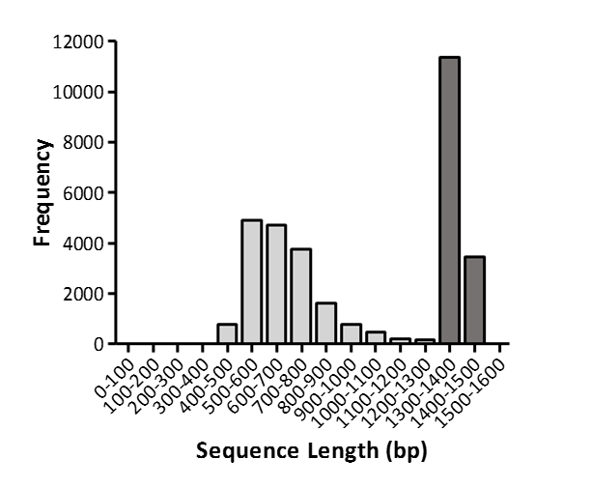
Additional file 10 Length distributions of assembled sequences, which includes all scaffolds. Shaded in dark grey are the sequence lengths analyzed in this study.

