Additional File 2.

Tables
Table S2. SourceTracker prediction proportion variation (indicated by mean, SD and RSD) between runs in leave-one-out cross-validation by 656 samples (refer to Fig. 1d).
Table S3. SourceTracker prediction proportion variation (indicated by mean, SD and RSD) between runs of eight artificial configurations (refer to Fig. 2).
Table S4. Location of 12 HK sediment samples, 9 PRE and SCS sediments.
Table S7. Sequence information of ARGs of relative high correlation (R² ≥ 0.5) with overall abundance profiles.

Table S2. SourceTracker prediction proportion variation (indicated by mean, SD and RSD) between runs in leave-one-out cross validation by 656 samples (refer to Fig. 1D).
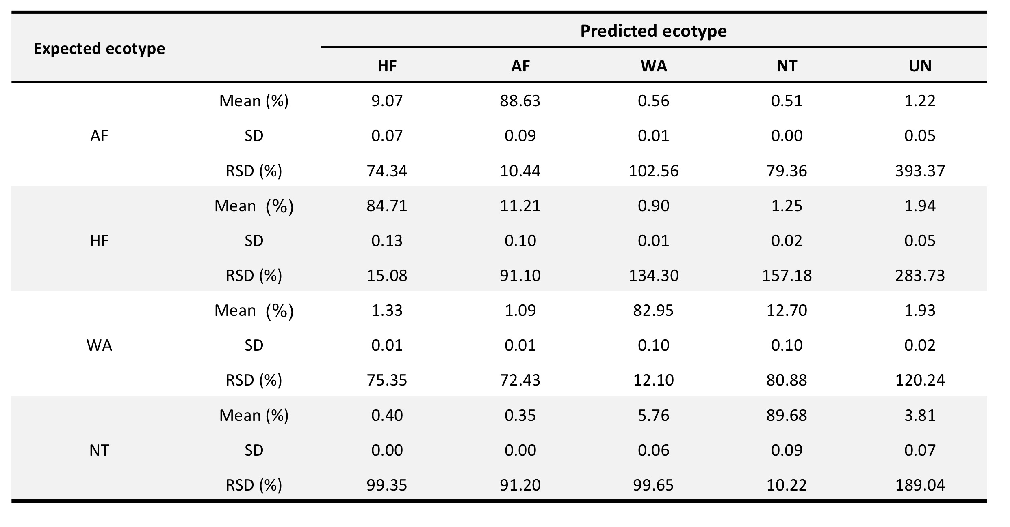

Table S3. SourceTracker prediction proportion variation (indicated by mean, SD and RSD) between runs of eight artificial configurations (refer to Fig. 2).
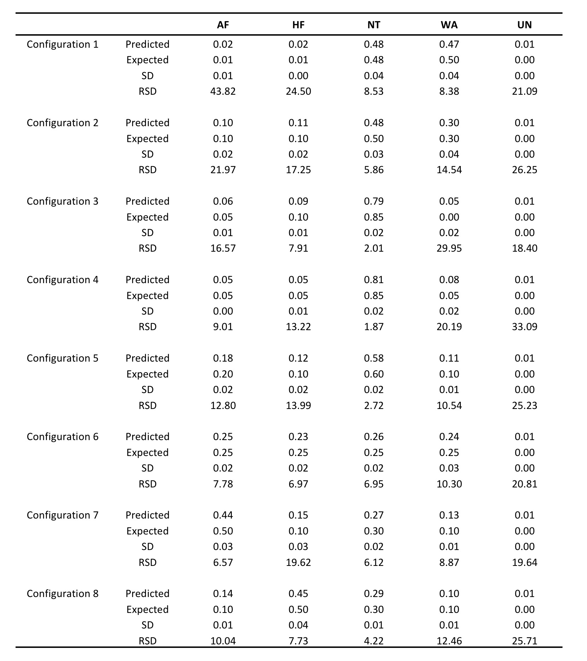

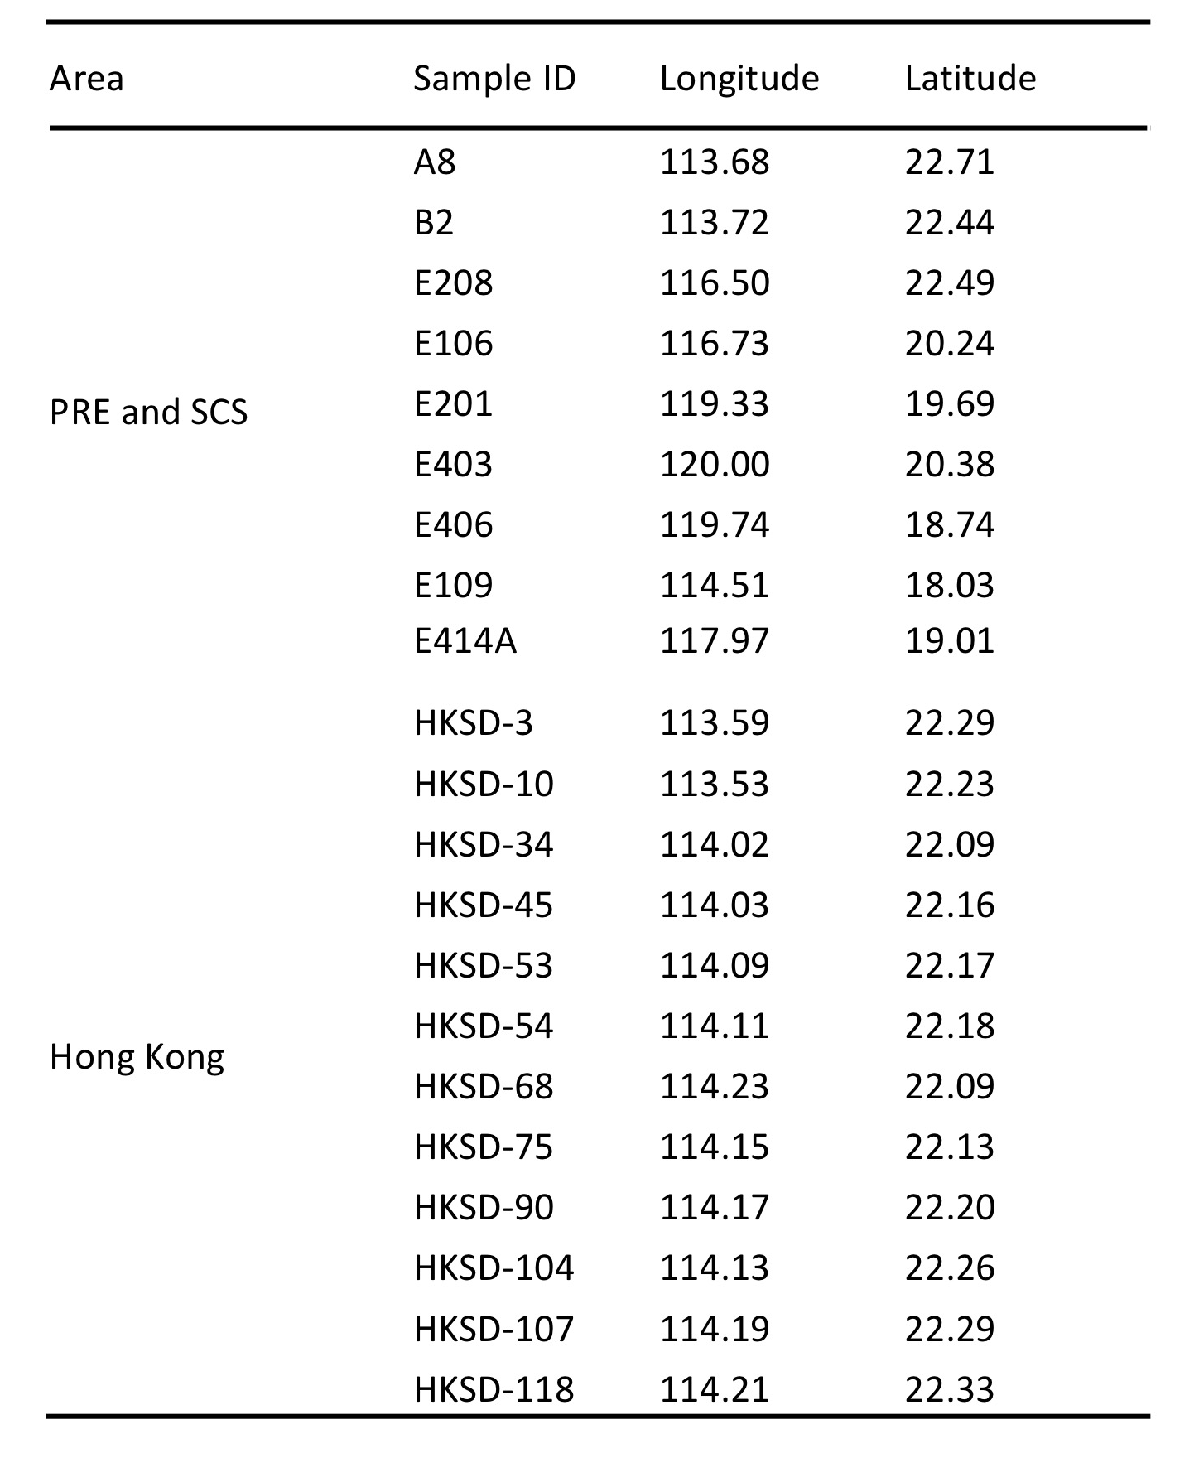
Table S4. Location of 12 HK sediment samples, 9 PRE and SCS sediments.

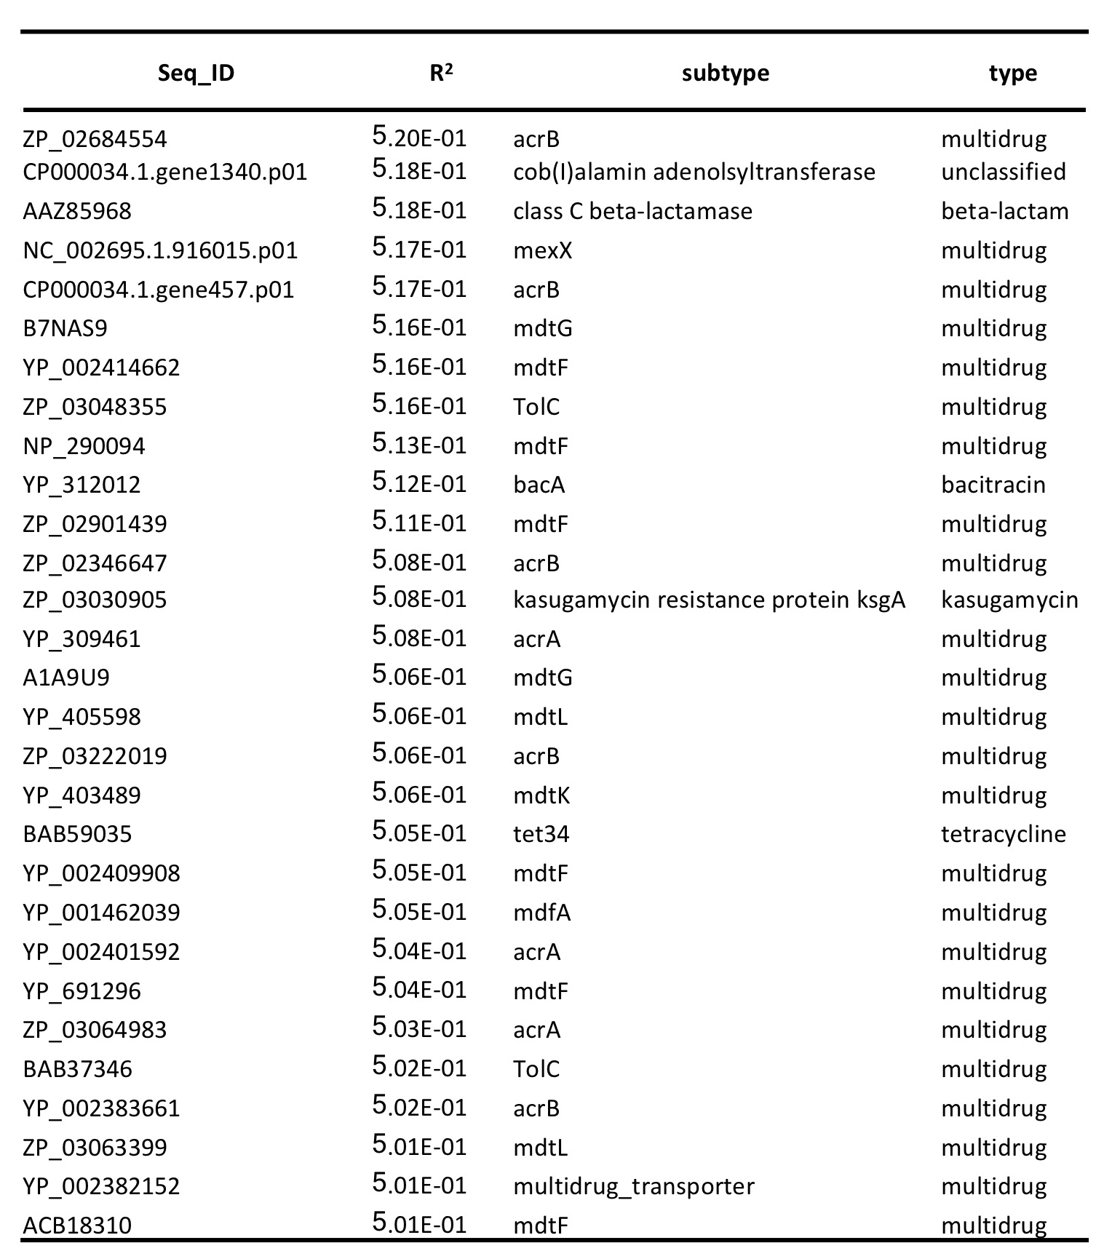
Table S7. Sequence information of ARGs of relative high correlation (R² ≥ 0.5) with overall abundance profiles.

