Table S1. Correlation coefficients (Pearson’s ρ) between the relative abundances of dominant bacterial phyla/classes and soil total Hg and methylmercury (MeHg) contents. P values below 0.05 are in bold.

 | Paddy soil (n = 72) |  |  | Upland soil (n = 69)
 | Total Hg | MeHg |  | Total Hg | MeHg
Alphaproteobacteria | 0.07 | -0.03 |  | 0.01 | 0.35
Betaproteobacteria | -0.24 | -0.08 |  | 0.19 | -0.01
Deltaproteobacteria | -0.25 | -0.27 |  | -0.06 | -0.06
Gammaproteobacteria | -0.03 | .006 |  | 0.15 | 0.24
Actinobacteria | 0.39 | 0.31 |  | 0.00 | 0.10
Acidobacteria | -0.25 | -0.17 |  | -0.13 | -0.35
Chloroflexi | -0.12 | -0.19 |  | -0.28 | -0.27
Bacteroidetes | 0.30 | 0.45 |  | 0.21 | 0.15
Gemmatimonadetes | 0.15 | 0.20 |  | -0.31 | -0.08
Nitrospirae | -0.28 | -0.45 |  | -0.06 | -0.39
Firmicutes | 0.55 | 0.47 |  | 0.26 | -0.07
Verrucomicrobia | 0.10 | 0.12 |  | -0.02 | -0.16

Table S2. Correlation coefficients (Spearman’s ρ) between bacterial abundance, richness and modules (Mod) and soil properties. TC and TN, total carbon and total nitrogen, respectively; SOC, soil organic carbon; DOC, dissolved organic carbon; P values below 0.05 are in bold.

 | Abundance | Richness | Mod#0 | Mod#1 | Mod#2 | Mod#3 | Mod#4
 | Paddy soil
Longitude | -0.67 | 0.05 | 0.06 | 0.49 | -0.32 | -0.22 | -0.15
Latitude | -0.43 | -0.09 | -0.05 | 0.44 | -0.34 | -0.30 | -0.13
pH | -0.11 | 0.29 | 0.51 | -0.07 | -0.35 | 0.2 | -0.04
TC | -0.43 | 0.01 | -0.13 | 0.21 | -0.15 | -0.14 | 0.06
TN | -0.44 | 0.06 | -0.15 | 0.2 | -0.11 | -0.17 | 0.04
C:N | -0.49 | 0.06 | -0.13 | 0.34 | -0.2 | -0.12 | 0.09
SOC | 0.64 | -0.249 | 0.380 | -0.28 | -0.30 | -0.05 | -0.24
NH₄⁺ | 0.22 | -0.08 | -0.13 | -0.35 | 0.31 | 0.1 | 0.03
NO₃⁻ | -0.33 | -0.21 | 0.25 | 0.25 | -0.46 | 0 | -0.24
DOC | 0.04 | -0.069 | 0.317 | -0.41 | -0.136 | 0.29 | -0.125
Ni | 0.38 | -0.35 | 0.13 | -0.28 | 0.01 | -0.03 | -0.12
Cu | 0.26 | -0.35 | 0.26 | -0.12 | -0.08 | -0.02 | -0.29
Cd | -0.33 | -0.01 | 0.28 | 0.23 | -0.28 | -0.03 | -0.26
Pb | 0.29 | -0.16 | 0.04 | -0.03 | -0.01 | -0.07 | -0.02
As | 0.35 | -0.32 | 0.02 | -0.2 | -0.01 | -0.07 | -0.03
Zn | 0.04 | 0 | -0.04 | 0.2 | -0.12 | -0.13 | 0.13
 | Upland soil
Longitude | 0.205 | 0.42 | 0.55 | 0.34 | 0.04 | 0.53 | -0.45
Latitude | 0.38 | 0.31 | 0.50 | 0.26 | 0 | 0.38 | -0.30
pH | 0.1 | -0.07 | 0.12 | 0.16 | -0.75 | -0.03 | 0.51
TC | -0.22 | -0.08 | -0.22 | -0.02 | -0.29 | -0.33 | 0.21
TN | -0.14 | -0.1 | -0.28 | -0.07 | 0.27 | -0.44 | -0.02
CN | -0.15 | -0.06 | -0.1 | 0.07 | -0.38 | -0.26 | 0.25
SOC | -0.08 | 0.07 | 0.27 | 0.50 | -0.12 | -0.47 | 0
NH₄⁺ | 0.11 | 0.36 | 0.41 | 0.28 | 0.04 | 0.47 | -0.38
NO₃⁻ | -0.06 | -0.38 | -0.40 | -0.16 | -0.15 | -0.59 | 0.47
DOC | 0.41 | -0.34 | -0.42 | -0.40 | -0.06 | -0.16 | 0.34
Ni | 0.01 | -0.13 | 0.02 | 0.04 | -0.09 | -0.14 | 0.19
Cu | -0.12 | 0 | 0.054 | 0.03 | -0.16 | 0.06 | 0.12
Cd | -0.04 | 0.16 | 0.21 | 0.28 | -0.22 | 0.19 | 0.02
Pb | -0.13 | -0.05 | 0.01 | 0.09 | -0.19 | -0.09 | 0.2
As | 0.031 | -0.11 | -0.26 | -0.33 | 0.2 | -0.17 | 0.19
Zn | 0.034 | -0.25 | -0.29 | -0.05 | -0.35 | -0.11 | 0.44

Table S3. Correlation coefficients (Spearman’s ρ) between three major components extracted from Principal Component Analysis (PCA) and soil properties. TC and TN, total carbon and total nitrogen, respectively; SOC, soil organic carbon; DOC, dissolved organic carbon; P values below 0.05 are in bold.

Paddy soil |  |  |  |  | Upland soil
 | PC1 | PC 2 | PC 3 |  | PC1 | PC 2 | PC 3
pH | 0.02 | -0.21 | -0.33 |  | -0.12 | 0.12 | 0.11
TC | 0.16 | -0.27 | 0.17 |  | 0.00 | 0.13 | 0.04
TS | 0.18 | -0.24 | 0.22 |  | 0.11 | 0.13 | -0.03
CN | 0.07 | -0.39 | 0.15 |  | -0.10 | 0.20 | 0.03
SOC | -0.06 | 0.39 | 0.16 |  | -0.04 | 0.02 | -0.08
NH₄⁺ | -0.15 | 0.25 | -0.46 |  | -0.05 | -0.19 | 0.18
NO₃⁻ | -0.12 | -0.24 | -0.20 |  | -0.16 | 0.34 | -0.17
DOC | -.041 | 0.12 | -0.93 |  | -0.19 | 0.99 | -0.07
Ni | -0.48 | 0.82 | 0.16 |  | -0.48 | 0.22 | -0.65
Cu | -0.52 | 0.75 | 0.14 |  | -0.61 | 0.012 | -0.67
Cd | -0.58 | 0.05 | 0.18 |  | -0.63 | -0.13 | -0.33
Pb_ | -0.80 | 0.55 | 0.26 |  | -0.79 | -0.02 | -0.45
As | -0.38 | 0.53 | 0.10 |  | -0.34 | -0.05 | -0.03
Zn | -0.99 | 0.02 | 0.12 |  | -0.96 | 0.15 | 0.24

Table S4. Standardized direct effects (P < 0.05) from the Structural Equation Modeling in Figure 4. PC means major components extracted from Principal Component Analysis (PCA) of soil properties (Table S3).

Response variables |  | Predictors | Standardized effect | P-value
Paddy soil
PC2 | ← | Longitude | -0.796 | 0.01
PC3 | ← | Latitude | 1.088 | <0.001
PC3 | ← | Longitude | -0.794 | 0.013
Mod#0 | ← | Latitude | -1.449 | <0.001
Mod#3 | ← | Latitude | -0.758 | 0.027
Mod#0 | ← | Longitude | 1.442 | <0.001
Abundance | ← | Longitude | -0.743 | 0.002
Mod#4 | ← | Longitude | -0.714 | 0.047
Abundance | ← | PC1 | -0.219 | 0.007
Diversity | ← | PC2 | -0.42 | <0.001
Mod#4 | ← | PC2 | -0.293 | 0.029
Upland soil
Diversity | ← | Longitude | 0.67 | 0.02
Mod#0 | ← | PC1 | 0.296 | 0.021
Mod#4 | ← | PC1 | -0.509 | <0.001
Mod#2 | ← | PC1 | 0.401 | 0.006
Diversity | ← | PC2 | -0.518 | <0.001
Mod#4 | ← | PC2 | 0.257 | 0.015
Abundance | ← | PC3 | 0.308 | 0.002
Mod#4 | ← | PC3 | 0.224 | 0.011

Table S5. The ID and definition of the predicted functional genes (see Figure 5) were annotated according to Kyoto Encyclopedia of Genes and Genomes (KEGG) using metagenomic data derived from a subset of our soil samples.

KEGG ID | KEGG gene
K02527 | 3-deoxy-D-manno-octulosonic-acid transferase
K07058 | membrane protein
K03527 | 4-hydroxy-3-methylbut-2-en-1-yl diphosphate reductase
K02301 | protoheme IX farnesyltransferase
K00943 | dTMP kinase
K03294 | basic amino acid/polyamine antiporter, APA family
K11381 | 2-oxoisovalerate dehydrogenase E1 component
K00930 | acetylglutamate/acetylaminoadipate kinase
K03307 | solute: Na+ symporter, SSS family
K08676 | tricorn protease
K07486 | transposase
K00548 | 5-methyltetrahydrofolate--homocysteine methyltransferase
K01426 | amidase
K00368 | nitrite reductase (NO-forming)
K00130 | betaine-aldehyde dehydrogenase
K03570 | rod shape-determining protein MreC
K00507 | stearoyl-CoA desaturase (delta-9 desaturase)
K01907 | acetoacetyl-CoA synthetase
K01251 | adenosylhomocysteinase
K02259 | cytochrome c oxidase subunit XV assembly protein
K06915 | uncharacterized protein
K03177 | tRNA pseudouridine synthase B

Table S6. Correlation coefficients (Pearson’s ρ) between bacterial modules (Mod) within co-occurrence network and soil Hg contents. P values below 0.05 are in bold.

 |  | Mod#0 | Mod#1 | Mod#2 | Mod#3 | Mod#4
Paddy soil | Total Hg | -0.21 | 0.071 | 0.04 | 0.08 | 0.25
 | MeHg | -0.27 | -0.29 | 0.14 | 0.18 | 0.31
Upland soil | Total Hg | -0.18 | -0.05 | -0.26 | 0.26 | 0.13
 | MeHg | -0.29 | -0.14 | -0.12 | 0.18 | 0.22

Figure S1. Bacterial abundance (a) and diversity (b) in paddy (n = 72) and upland (n = 69) soils from Hg-impacted areas in China.
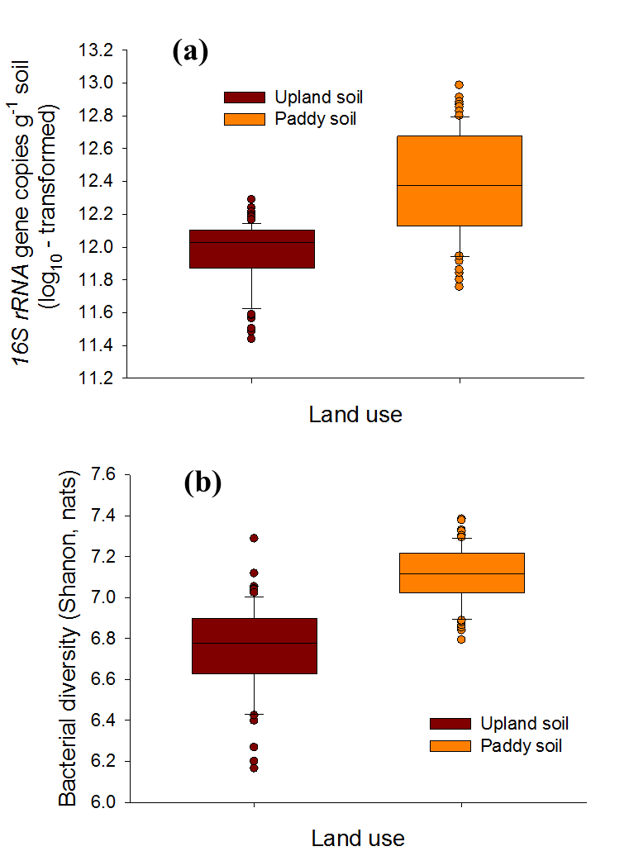
Figure S2. Relative mean abundances of the dominant phyla (classes) based on MiSeq sequencing of 16S rRNA gene in paddy and upland soils.

Figure S3. Predictor importance of significant (P < 0.05) genera in Firmicutes (F) and Bacteroidetes (B) responding to soil total Hg based on Fandom Forest (RF) analyses (a). Linear relationships between the predicted main genera and soil total Hg (b). RF Importance = Increase in % mean square error.

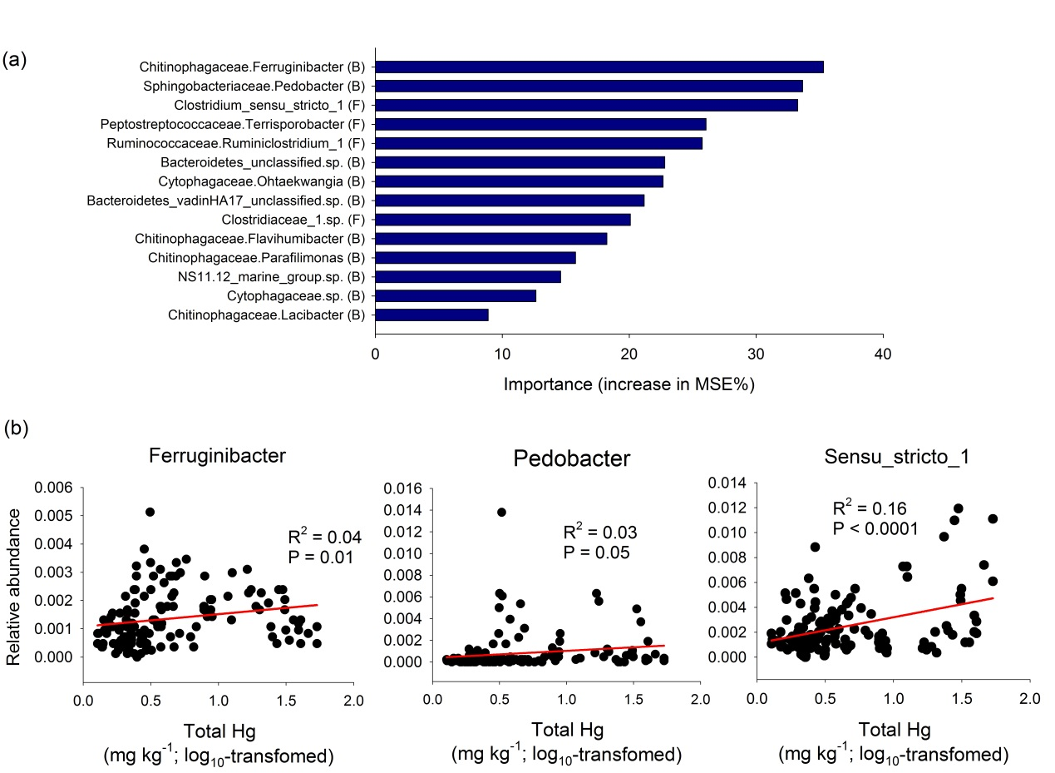
Figure S4. Linear relationship between the most important genus in Nitrospirare and soil methylmercury (MeHg) contents.

Figure S5. Random Forest (RF) analysis identifying the significant environmental predictors of bacterial abundance and diversity in paddy (a) and upland soils (b). RF Importance = Increase in % mean square error. Color, black and white columns represents P < 0.05, P < 0.10 and P > 0.10, respectively.

Figure S6. Random Forest (RF) analysis identifying the significant environmental predictors of the relative abundance of ecological clusters (modules #0-4) of bacterial occurrence network in paddy soils (a) and upland (b) soils. RF Importance = Increase in % mean square error. Color, black and white columns represent P < 0.05, P < 0.10 and P > 0.10, respectively.

Figure S7. Random Forest (RF) analysis identifying the significant gene predictors of soil MeHg. RF Importance = Increase in % mean square error. Only predictors from the RF with a P < 0.05 are selected to show in the figure.

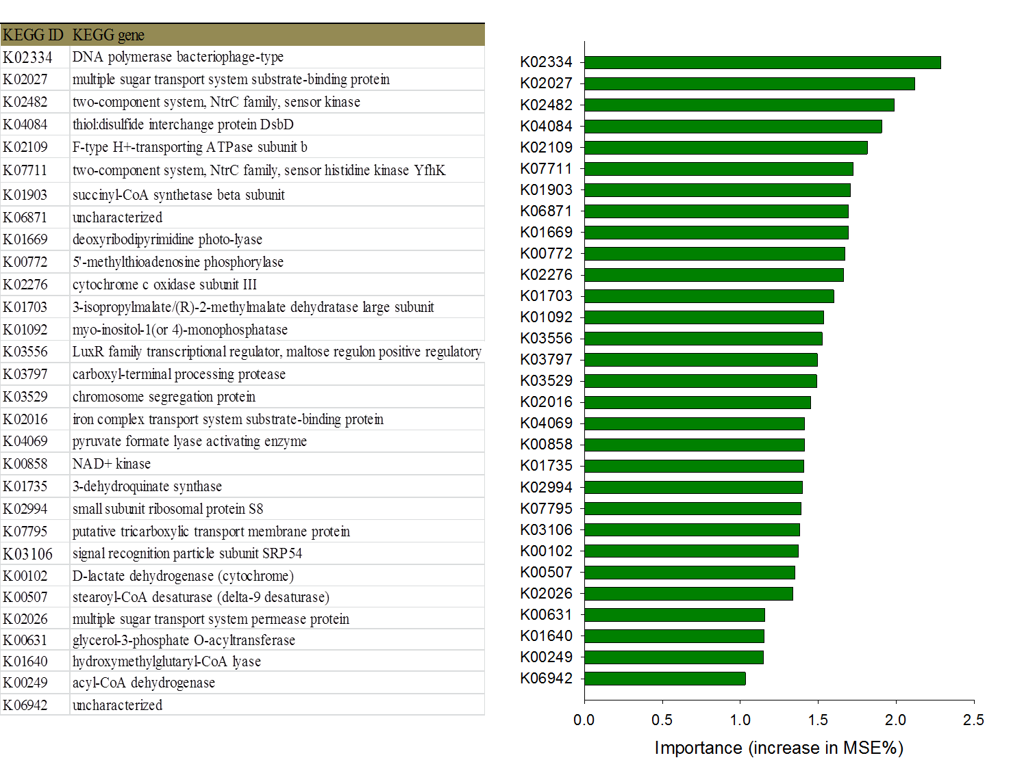

Figure S8. Map of the study area and 24 sampling locations around the Fenghuang (FH) and Wanshan (WS) Hg mining area across China. One paddy site and one and upland site were chosen for sampling from each of these locations. One upland site in location No. 6 was omitted because no representative upland field is adjacent to the paddy field at this location. 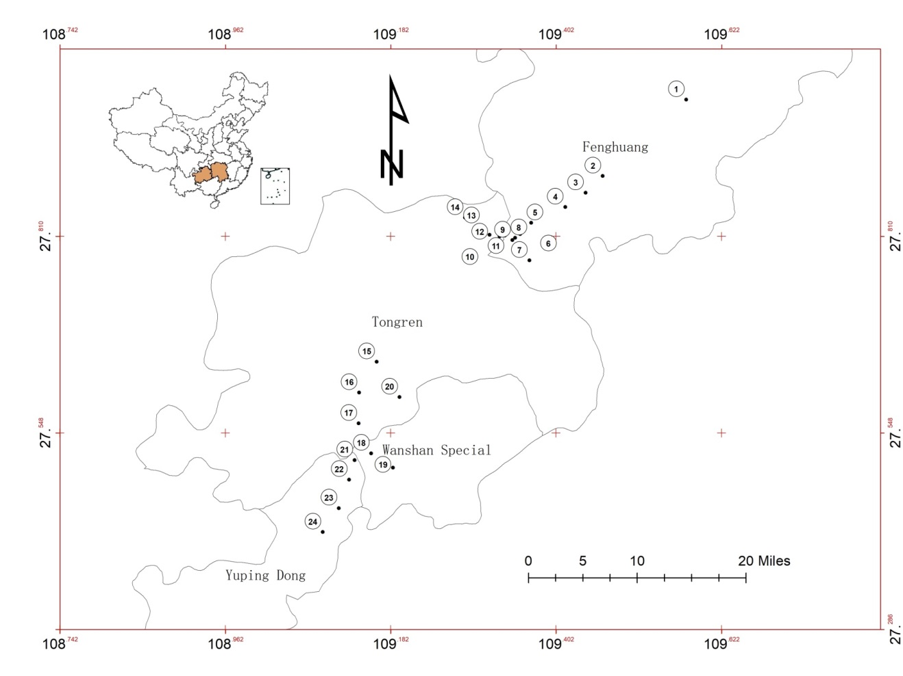

Figure S9. Rarefaction and Shannon curves of 16S rRNA gene sequencing of paddy (green lines) and upland soils (red lines). The x-axis represents the number of sequences while the y-axis represents the number of detected OTU's (a) and Shannon diversity index (b), respectively.

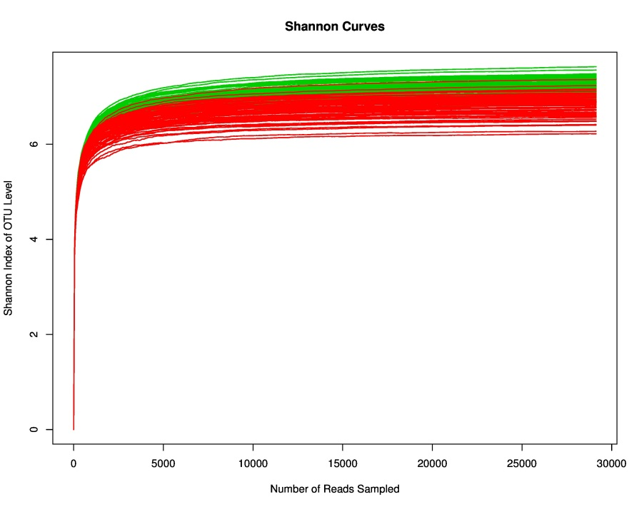
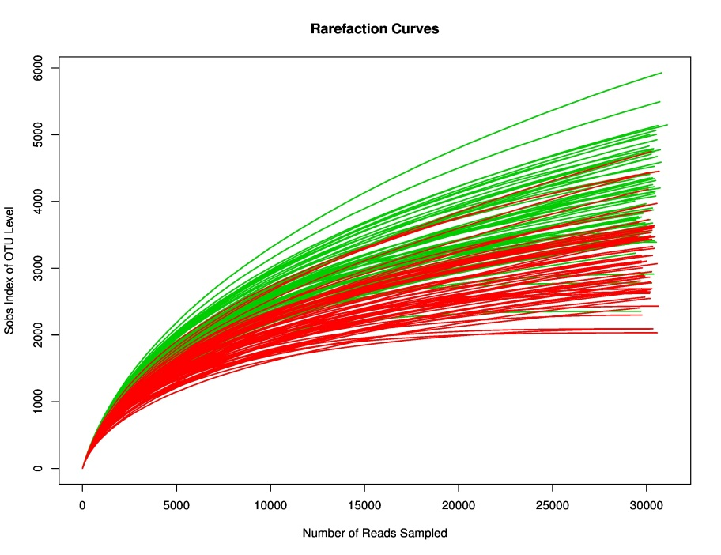
(a)
(b)

Figure 10. An a priori model identifying effects of Hg on soil abundance, diversity and the major five ecological clusters (modules, Mod) within co-occurrence network of bacterial communities. Mod#X stand for modules. The Hg box includes total Hg and methylmercury, and the spatial box includes longitude and latitude. The soil box includes soil properties that were represented by the three major components by performing principal component analysis of soil variables including pH, soil organic carbon (SOC), C: N and others (Table S3).

