Supplementary material

Enterobacteriaceae dominate the core microbiome and contribute to the resistome of arugula (Eruca sativa Mill.)
Tomislav Cernava^{1*}, Armin Erlacher^{1,3*}, Jung Soh², Christoph W. Sensen^{2,4}, Martin Grube³, Gabriele Berg¹
¹ Institute of Environmental Biotechnology, Graz University of Technology, Petersgasse 12, 8010 Graz, Austria
² Institute of Computational Biotechnology, Graz University of Technology, Petersgasse 14, 8010 Graz, Austria
³ Institute of Plant Sciences, University of Graz, Holteigasse 6, 8010 Graz, Austria
⁴ BioTechMed Graz, Mozartgasse 12/II, 8010 Graz, Austria
* These authors contributed equally.

Email addresses: tomislav.cernava@tugraz.at; armin.erlacher@tugraz.at; jung.soh@tugraz.at; csensen@tugraz.at; martin.grube@uni-graz.at; gabriele.berg@uni-graz.at

Author for correspondence:
Gabriele Berg, Graz University of Technology, Institute of Environmental Biotechnology, Petersgasse 12, A-8010 Graz, email: gabriele.berg@tugraz.at, telephone: +43 316 873 8310

Submitted to Microbiome
Running title: Antibiotic resistances in the E. sativa microbiome
Key words: antibiotic resistances; microbiome; Enterobacteriaceae; raw-eaten vegetables; microbial communities

Table S1. Sample and processing details. Composite samples were obtained from multiple plants that were homogenized prior to DNA extractions and isolation of bacteria.
Sample type | Sampling period | Plant growth stage | Samples processed for tcDNA extraction | NGS method | Isolation media
Eruca phyllosphere (all aboveground plant parts) | July | Leaves fully developed | 3 composite samples | Roche 454 pyrosequencing | -
Eruca phyllosphere (all aboveground plant parts) | November | Flowering stage | 1 composite sample | Illumina HiSeq2000 | PDA, MacConkey, KingsB, R2A, MIS, NAII
Eruca rhizosphere | July | Leaves fully developed | 3 composite samples | Roche 454 pyrosequencing | -
Eruca rhizosphere | November | Flowering stage | 1 composite sample | Illumina HiSeq2000 | PDA, MacConkey, KingsB, R2A, MIS, NAII
Bulk soil | November | - | 1 composite sample | Illumina HiSeq2000 | PDA, MacConkey, KingsB, R2A, MIS, NAII

Table S2. Alignment of quality-filtered reads to genomes of the Brassicacea plant family.
Sample | Quality-filtered reads | Aligned to  Brassica oleracea  genome | Aligned to  Brassica rapa  genome | Aligned to  Raphanus sativus  genome | Aligned to  at least one  genome | Not aligned to  any genome
Phyllosphere | 41,867,724 | 10,138,094  (24.21%) | 8,734,400  (20.86%) | 8,873,451  (21.19%) | 12,040,211  (28.76%) | 29,827,513  (71.24%)
Rhizosphere | 35,463,395 | 480,897  (1.36%) | 411,291  (1.16%) | 414,820  (1.17%) | 584,141  (1.65%) | 34,879,254  (98.35%)
Soil | 27,085,866 | 29,385  (0.11%) | 25,714  (0.09%) | 24,779  (0.09%) | 42,586  (0.16%) | 27,043,280  (99.84%)

Table S3. Assembly statistics for the Velvet-based de novo assembly. For the median coverage, N50, and Maximum contig length columns two values are shown. The first value for median coverage represents the number of k-mers, while the second value represents the number of utilized bases.
Sample | k-mer | Median coverage |  | Number of contigs | N50 |  | Maximum contig length |  | Total assembly length | Number of reads used
Phyllosphere | 79 | 2.793893 | 5.863240 | 1,387,116 | 403 | 481 | 152,920 | 152,998 | 306,637,366 | 23,643,355
Rhizosphere | 79 | 1.791781 | 3.760216 | 387,201 | 225 | 303 | 16,916 | 16,994 | 91,405,824 | 3,056,914
Soil | 75 | 1.451613 | 2.883871 | 273,109 | 192 | 266 | 3,562 | 3,636 | 53,493,324 | 1,242,904

Table S4. Multi-resistant isolates identified in antibiotic susceptibility experiments. Colors indicate the isolation source of the isolates. Soil (grey); Rhizosphere (blue); Phyllosphere (green)
Isolate | NCBI 16S rRNA database BLAST | NCBI nt collection BLAST
35 EAS-0 MacK | Serratia marcescens | Serratia marcescens
47 EAR-1 MacK | Pseudomonas kilonensis/corrugata | Pseudomonas brassicacearum
49 EAR-2 MacK | Pseudomonas brassicacearum | Pseudomonas brassicacearum
51 EAR-2 MacK | Pseudomonas mendelii | Pseudomonas mandelii/syringae
60 EAP-2 MacK | Erwinia persicina | Erwinia rhapontici
71 EAS-2 R2A | Erwinia persicina | Erwinia rhapontici
77 EAR-2 R2A | Chryseobacterium lactis | Chryseobacterium joostei
135 EAS-2 NA | Pseudomonas migulae/arsenicoxydans | Pseudomonas migulae/brassicacearum
136 EAR-3 NA | Bacillus toyonensis/thurigensis | Bacillus oryzaecorticis/thuringensis
150 EAP-3 NA | Sphingobacterium faecium | Sphingobacterium kitahiroshimense
154 EAP-2 NA | Pseudomonas helmaticensis | Pseudomonas baetica

Figure S1. Metadata profile starting 14 days before sampling of plants for the metagenome sequencing.

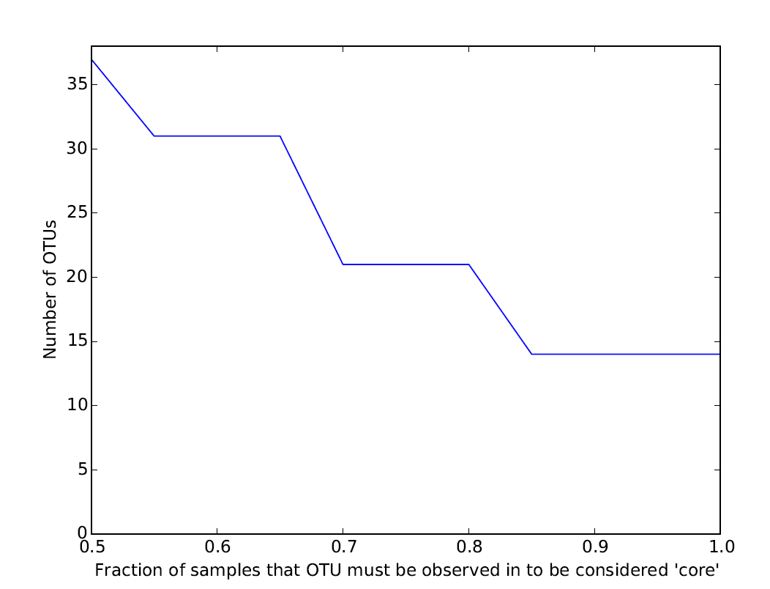
Figure S2. Core OTUs assigned to enterobacteria across 50% - 100% of the samples.

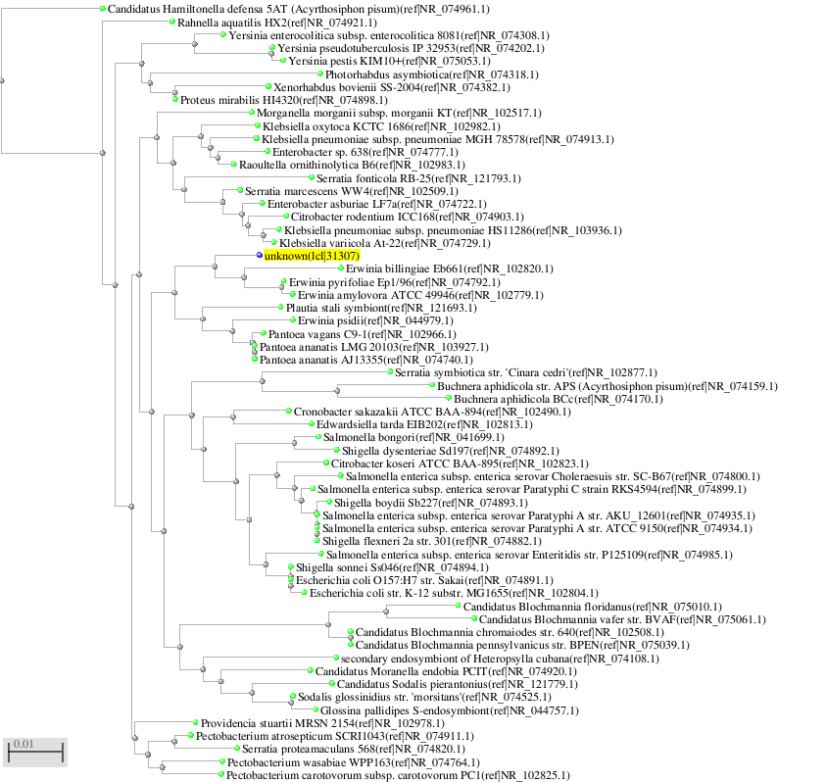
Figure S3. Neighbor joining tree with max. sequence identity 0.1 (90% similarity) and RefSeq BLAST assignments. OTU 52 is highlighted in yellow.

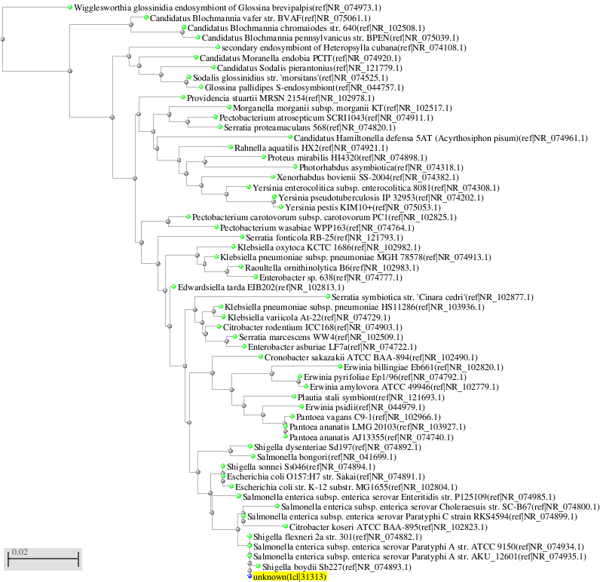
Figure S4. Neighbor joining tree with max. sequence identity 0.1 (90% similarity) and RefSeq BLAST assignments. OTU 58 is highlighted in yellow.

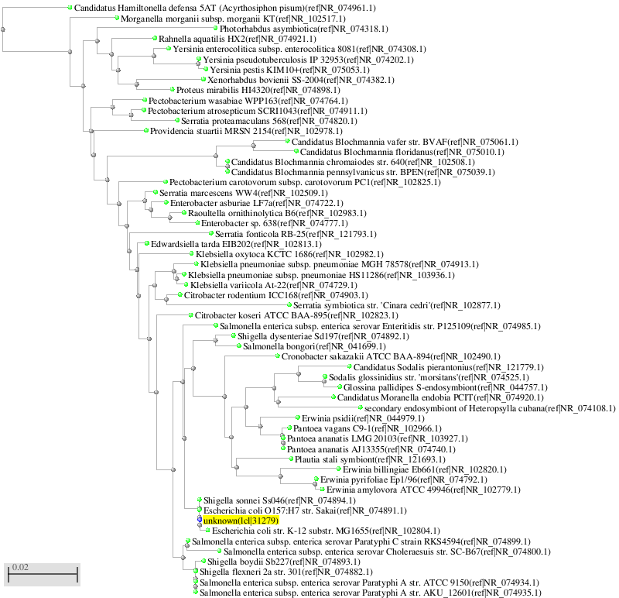
Figure S5. Neighbor joining tree with max. sequence identity 0.1 (90% similarity) and RefSeq BLAST assignments. OTU27 is highlighted in yellow.

