Additional file 1
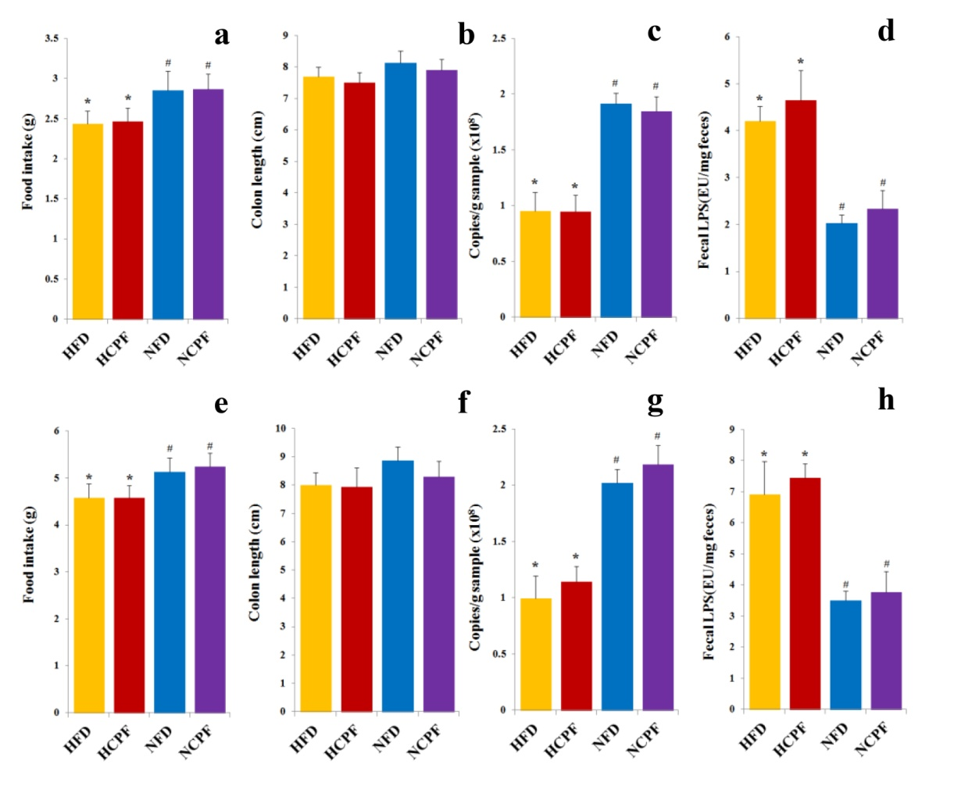
Figure S1 Effects of chlorpyrifos administration on food intake (a and e), colon length (b and f), fecal bacteria amount (c and g) and fecal LPS levels (d and h) in C57Bl/6 (a-d) and CD-1 (ICR) mice (e-h). Data are expressed as the mean ± SEM. *P < 0.05 versus NFD group; # P < 0.05 versus HFD group. NFD, normal fat diet; NCPF, normal fat diet + chlorpyrifos; HFD, high fat diet; HCPF, high fat diet + chlorpyrifos.

