Additional file 2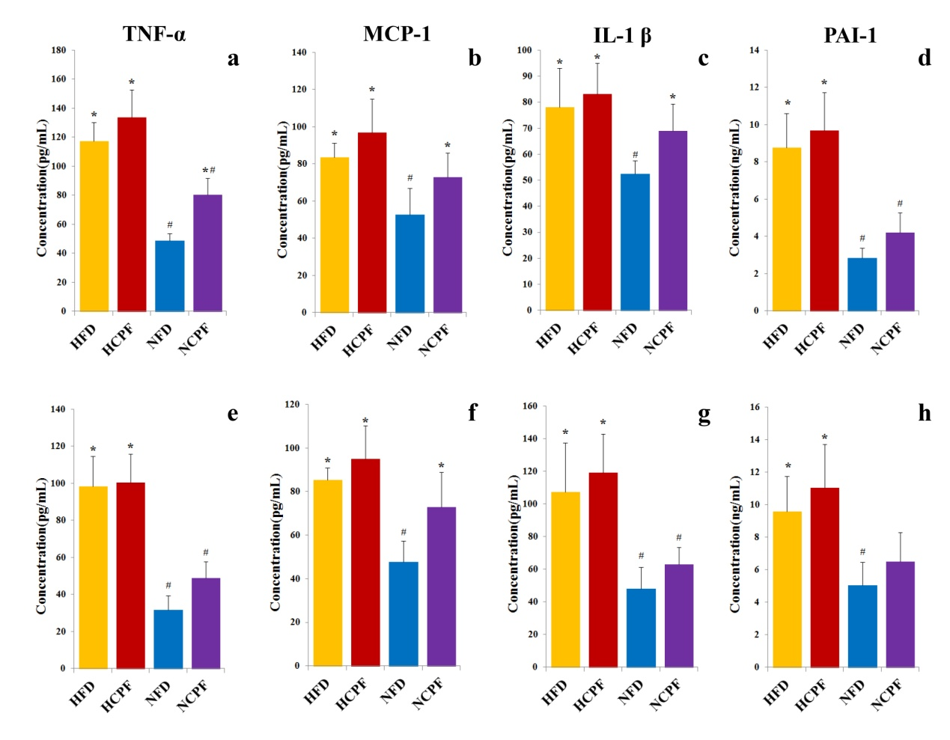
Figure S2 Effects of chlorpyrifos treatment on the the concentration of proinflammatory cytokines in plasma in C57Bl/6 (a-d) and CD-1 (ICR) mice (e-h). Data are expressed as the mean ± SEM. *P < 0.05 versus NFD group; # P < 0.05 versus HFD group. NFD, normal fat diet; NCPF, normal fat diet + chlorpyrifos; HFD, high fat diet; HCPF, high fat diet + chlorpyrifos.

