Additional file 3
Phylum Level
b
b
a
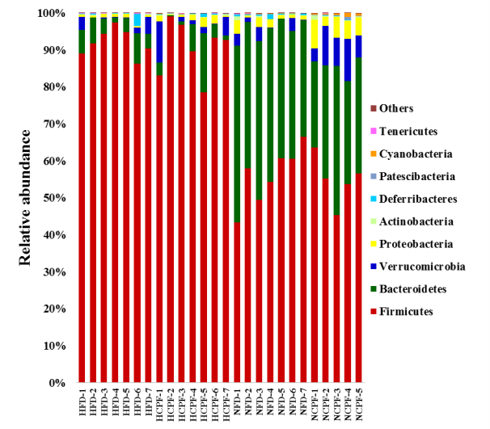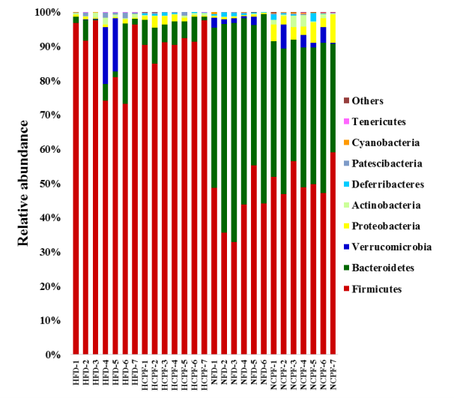
d
c

Family Level
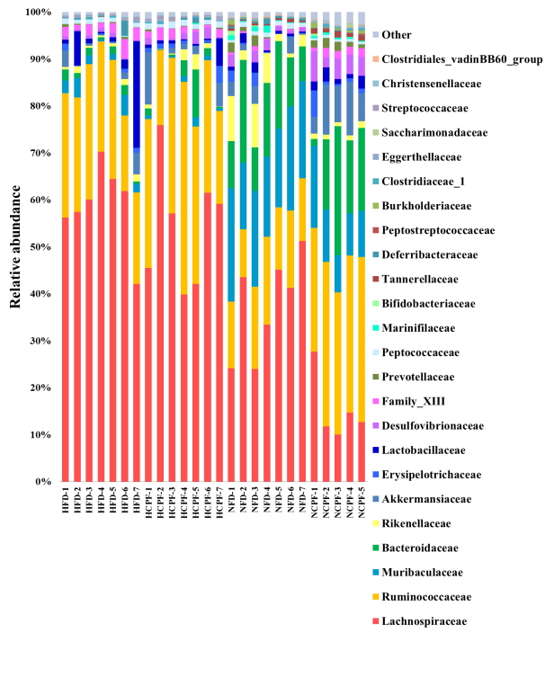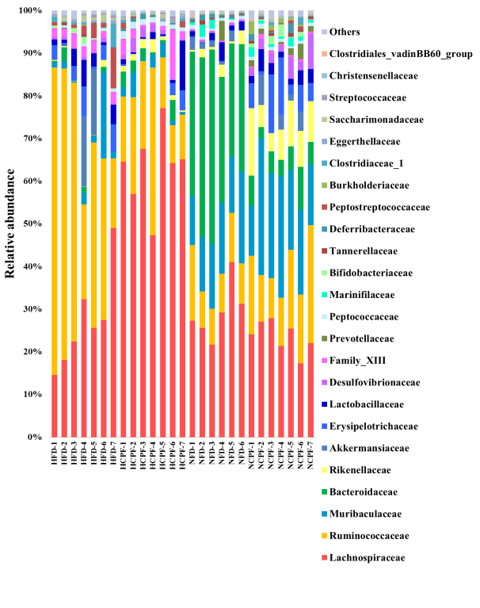

Genus Level
f
e
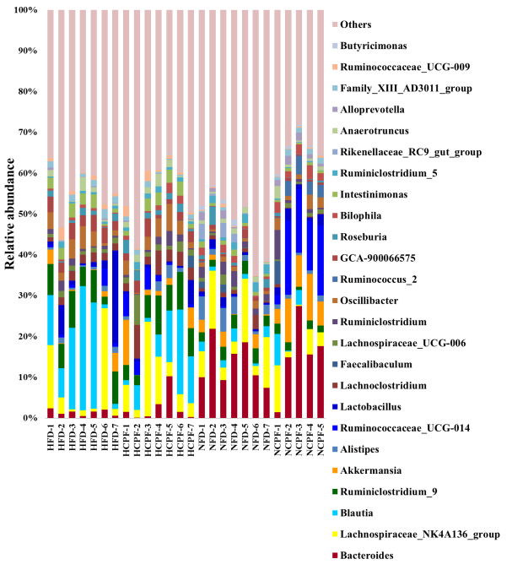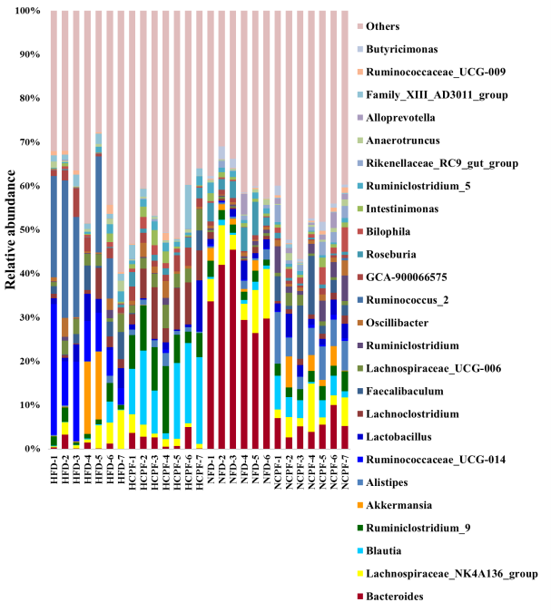

Figure S3 Microbiota membership for cecal samples of C57Bl/6 (a, c and e) and CD-1(ICR) (b, d and f) mice. Box plots depicting the taxonomic distribution within NFD, NCPF, HFD and HCPF cecal samples at the Phylum, Family and Genus levels. NFD, normal fat diet; NCPF, normal fat diet + chlorpyrifos; HFD, high fat diet; HCPF, high fat diet + chlorpyrifos.

