Additional file 5
Phylum Level
b
a
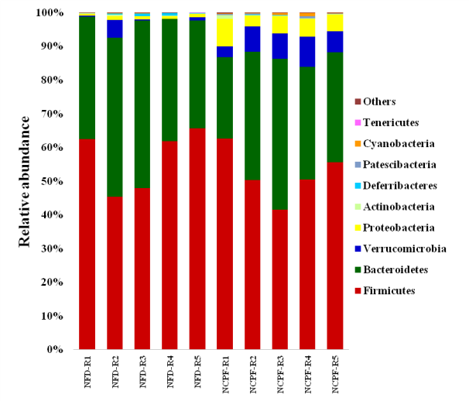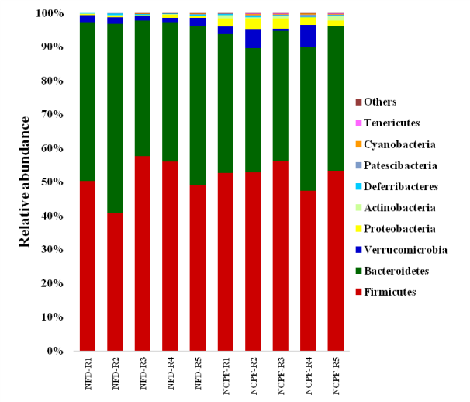

Family Level
d
c
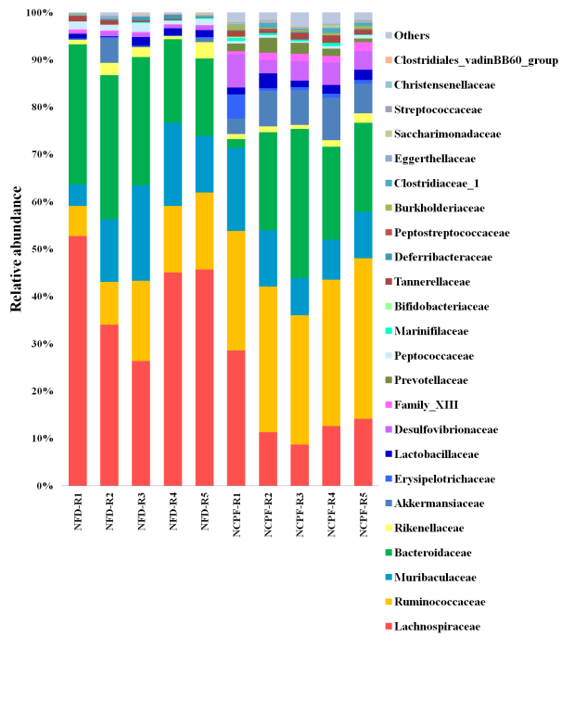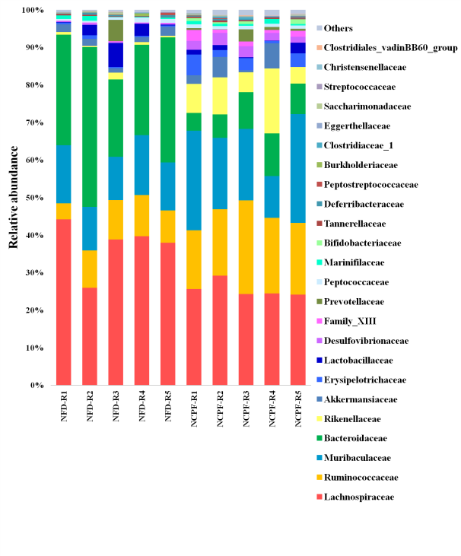

Genus Level
e
f
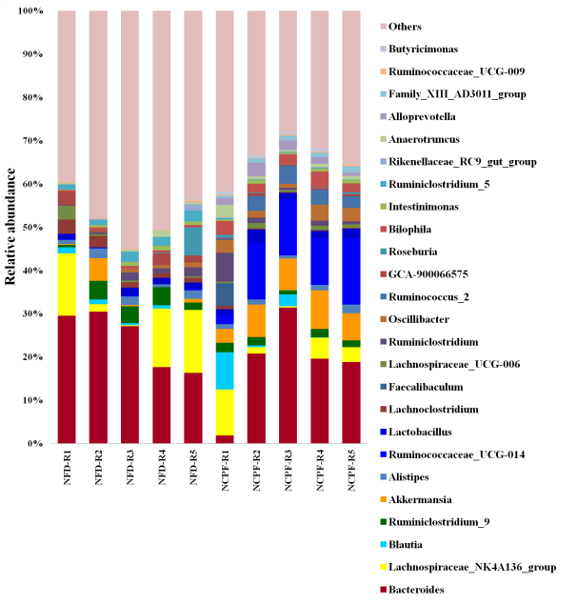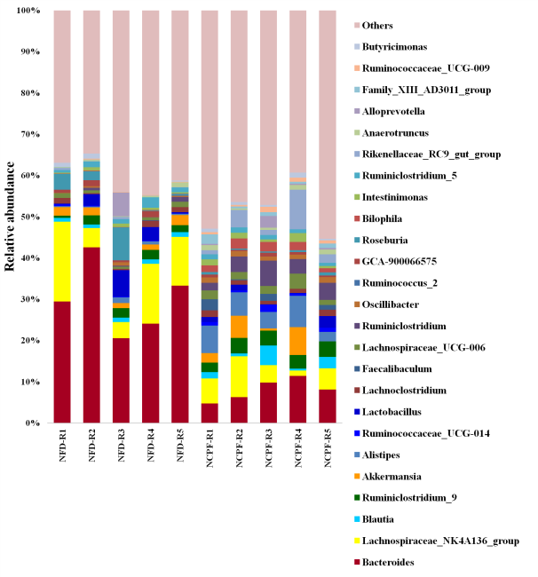
Figure S5 Microbiota membership for cecal samples of C57Bl/6 (a, c and e) and CD-1(ICR) (b, d and f) mice. Box plots depicting the taxonomic distribution within NFD-R and NCPF-R cecal samples at the Phylum, Family and Genus levels. NFD-R, re-colonized with NFD group’s microbiota; NCPF-R, re-colonized with NCPF group’s microbiota.

