Supplementary Materials
Table S1 Selected 10 Sphingobium and 10 Sphingomonas genomes
Class | Strain | abbreviation | BioProject ID
Sphingobium | Sphingobium baderi strain DE-13 | SBBA | 300354
Sphingobium | Sphingobium chlorophenolicum L-1 | SBCH | 50015
Sphingobium | Sphingobium cloacae JCM 10874 | SBCL | 345589
Sphingobium | Sphingobium herbicidovorans strain MH | SBHE | 380772
Sphingobium | Sphingobium hydrophobicum strain C1 | SBHY | 397800
Sphingobium | Sphingobium indicum B90A | SBIN | 50313
Sphingobium | Sphingobium japonicum UT26S | SBJA | 19949
Sphingobium | Sphingobium sp. RAC03 | SBRA | 319832
Sphingobium | Sphingobium yanoikuyae strain SHJ | SBYA | 239177
Sphingobium | Sphingobium sp. YG1 | SBYG | 436102
Sphingomonas | Sphingomonas sp. Cra20 | SMCR | 418884
Sphingomonas | Sphingomonas sp. FARSPH | SMFA | 474545
Sphingomonas | Sphingomonas hengshuiensis strain WHSC-8 | SMHE | 274606
Sphingomonas | Sphingomonas koreensis strain ABOJV | SMKO | 445389
Sphingomonas | Sphingomonas sp. LM7 | SMLM | 363095
Sphingomonas | Sphingomonas melonis TY | SMME | 345324
Sphingomonas | Sphingomonas panacis strain DCY99 | SMPA | 308882
Sphingomonas | Sphingomonas sanxanigenens NX02 | SMSA | 213647
Sphingomonas | Sphingomonas taxi strain ATCC 55669 | SMTA | 261987
Sphingomonas | Sphingomonas wittichii RW1 | SMWI | 17343

Table S2 Selected 10 alphaproteobacterial and 10 betaproteobacterial genomes
Class | Strain | abbreviation | BioProject ID
Alphaproteobacteria | Acidiphilium multivorum AIU301 | AAM | 60101
Alphaproteobacteria | Ketogulonigenium vulgarum WSH 001 | AKV | 161161
Alphaproteobacteria | Mesorhizobium australicum WSM2073 | AMAU | 47287
Alphaproteobacteria | Methylocapsa acidiphila B2 | AMAC | 72841
Alphaproteobacteria | Methyloferula stellata AR4 | AMS | 165575
Alphaproteobacteria | Rhodovibrio salinarum DSM 9154 | ARS | 84315
Alphaproteobacteria | Roseobacter litoralis Och 149 | ARL | 19357
Alphaproteobacteria | Sphingobium japonicum UT26S 1 | ASJ | 19949
Alphaproteobacteria | Starkeya novella DSM 506 | ASN | 37659
Alphaproteobacteria | Tistrella mobilis KA081020 065 | ATM | 76349
Betaproteobacteria | Alicycliphilus denitrificans K601 | BAD | 50751
Betaproteobacteria | Dechlorosoma suillum PS | BDS | 37693
Betaproteobacteria | Gallionella capsiferriformans ES 2 | BGC | 32827
Betaproteobacteria | Herbaspirillum seropedicae SmR1 | BHS | 47945
Betaproteobacteria | Nitrosospira multiformis ATCC 25196 | BNM | 13912
Betaproteobacteria | Ramlibacter tataouinensis TTB310 | BRT | 16294
Betaproteobacteria | Sideroxydans lithotrophicus ES 1 | BSL | 33161
Betaproteobacteria | Snodgrassella alvi wkB2 | BSA | 167602
Betaproteobacteria | Sulfuricella denitrificans skB26 | BSD | 170011
Betaproteobacteria | Tetrathiobacter kashmirensis WT001 | BTK | 67337

Table S3 Relative abundance of the selected 10 alphaproteobacterial and 10 betaproteobacterial genomes for metagenomic data simulation
Genome | Relative abundance
Genome | Replicate 1 | Replicate 2 | Replicate 3
AAM | 226 | 640 | 134
AKV | 669 | 315 | 16
AMAC | 731 | 8 | 261
AMAU | 507 | 292 | 201
AMS | 555 | 332 | 113
ARL | 184 | 554 | 262
ARS | 380 | 290 | 330
ASJ | 399 | 221 | 380
ASN | 246 | 324 | 430
ATM | 338 | 465 | 197
BAD | 468 | 336 | 196
BDS | 651 | 69 | 280
BGC | 456 | 173 | 371
BHS | 652 | 339 | 9
BNM | 938 | 44 | 18
BRT | 97 | 363 | 540
BSA | 478 | 400 | 122
BSD | 332 | 116 | 552
BSL | 497 | 375 | 128
BTK | 345 | 549 | 106

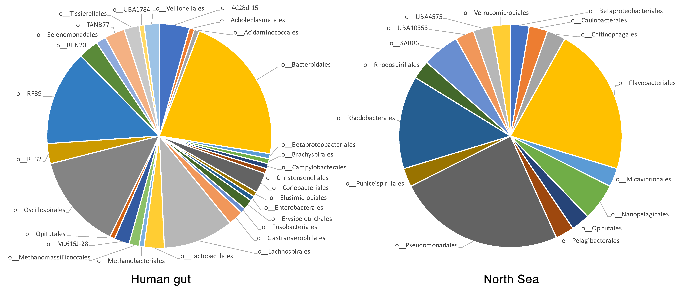

Figure S1. Taxonomic classification of the human gut and North Sea genome bins at order level.

