Supplementary Information
Supplementary Information I: Summary of Datasets and Databases
Table S1.1 identifies the various body sites classified as dry, moist and sebaceous respectively, along with the number of samples from each site (56). Table S1.2 shows the number of taxa in our world database, and in our lists of abundant and all skin bacteria for the entire Bacterial kingdom, as well as for the four dominant phyla found on human skin.
Table S1.1 Dry, moist and sebaceous skin sites
used in this study.
dry | no. samples
hypothenar palm | 16
volar forearm | 13
moist | no. samples
antecubital fossa | 15
axilla | 2
inguinal crease | 15
interdigital web space | 11
nares | 11
popliteal crease | 15
plantar heel | 17
toe web | 16
sebaceous | no. samples
alar crease | 17
back | 13
cheek | 16
external auditory canal | 15
glabella | 14
manubrium | 14
occiput | 15
retroauricular crease | 16
.
Table S1.2 Numbers of bacterial taxa overall and in each of the dominant four phyla in our world database, and amongst abundant (0.1% of reads in at least one sample) and all (0.001% of reads in at least one sample) bacteria on human skin.
Category | Bacteria | Actinobacteria | Firmicutes | Proteobacteria | Bacteroidetes
world | 4702 | 915 | 699 | 1485 | 621
skin (abundant) | 971 | 139 | 211 | 406 | 64
skin (all) | 180 | 37 | 53 | 73 | 12

Figure S1.1 Species diversity within each genus for (A) abundant skin taxa, (B) all skin taxa and (C) the world database

Figure S1.2 Species diversity within each family for (A) abundant skin taxa, (B) all skin taxa and (C) the world database

Figure S1.3 Species diversity within each order for (A) abundant skin taxa, (B) all skin taxa and (C) the world database

Table S1.3 List of abundant skin taxa (present at >0.1% of reads in at least one sample)
Phylum | Class | Order | Family | Genus/Species
Actinobacteria | Actinobacteria | Actinomycetales | Actinomycetaceae | Mobiluncus curtisii
Actinobacteria | Actinobacteria | Actinomycetales | Corynebacteriaceae | Corynebacterium argentoratense
Actinobacteria | Actinobacteria | Actinomycetales | Corynebacteriaceae | Corynebacterium aurimucosum
Actinobacteria | Actinobacteria | Actinomycetales | Corynebacteriaceae | Corynebacterium callunae
Actinobacteria | Actinobacteria | Actinomycetales | Corynebacteriaceae | Corynebacterium diphtheriae
Actinobacteria | Actinobacteria | Actinomycetales | Corynebacteriaceae | Corynebacterium efficiens
Actinobacteria | Actinobacteria | Actinomycetales | Corynebacteriaceae | Corynebacterium glutamicum
Actinobacteria | Actinobacteria | Actinomycetales | Corynebacteriaceae | Corynebacterium halotolerans
Actinobacteria | Actinobacteria | Actinomycetales | Corynebacteriaceae | Corynebacterium jeikeium
Actinobacteria | Actinobacteria | Actinomycetales | Corynebacteriaceae | Corynebacterium kroppenstedtii
Actinobacteria | Actinobacteria | Actinomycetales | Corynebacteriaceae | Corynebacterium maris
Actinobacteria | Actinobacteria | Actinomycetales | Corynebacteriaceae | Corynebacterium resistens
Actinobacteria | Actinobacteria | Actinomycetales | Corynebacteriaceae | Corynebacterium terpenotabidum
Actinobacteria | Actinobacteria | Actinomycetales | Corynebacteriaceae | Corynebacterium urealyticum
Actinobacteria | Actinobacteria | Actinomycetales | Corynebacteriaceae | Corynebacterium variabile
Actinobacteria | Actinobacteria | Actinomycetales | Gordoniaceae | Gordonia bronchialis
Actinobacteria | Actinobacteria | Actinomycetales | Gordoniaceae | Gordonia polyisoprenivorans
Actinobacteria | Actinobacteria | Actinomycetales | Nocardiaceae | Rhodococcus erythropolis
Actinobacteria | Actinobacteria | Actinomycetales | Geodermatophilaceae | Modestobacter marinus
Actinobacteria | Actinobacteria | Actinomycetales | Dermabacteraceae | Brachybacterium faecium
Actinobacteria | Actinobacteria | Actinomycetales | Dermacoccaceae | Kytococcus sedentarius
Actinobacteria | Actinobacteria | Actinomycetales | Microbacteriaceae | Clavibacter michiganensis
Actinobacteria | Actinobacteria | Actinomycetales | Microbacteriaceae | Microbacterium testaceum
Actinobacteria | Actinobacteria | Actinomycetales | Micrococcaceae | Arthrobacter arilaitensis
Actinobacteria | Actinobacteria | Actinomycetales | Micrococcaceae | Arthrobacter chlorophenolicus
Actinobacteria | Actinobacteria | Actinomycetales | Micrococcaceae | Arthrobacter phenanthrenivorans
Actinobacteria | Actinobacteria | Actinomycetales | Micrococcaceae | Kocuria rhizophila
Actinobacteria | Actinobacteria | Actinomycetales | Micrococcaceae | Micrococcus luteus
Actinobacteria | Actinobacteria | Actinomycetales | Micrococcaceae | Rothia dentocariosa
Actinobacteria | Actinobacteria | Actinomycetales | Micrococcaceae | Rothia mucilaginosa
Actinobacteria | Actinobacteria | Actinomycetales | Propionibacteriaceae | Propionibacterium acidipropionici
Actinobacteria | Actinobacteria | Actinomycetales | Propionibacteriaceae | Propionibacterium acnes
Actinobacteria | Actinobacteria | Actinomycetales | Propionibacteriaceae | Propionibacterium avidum
Actinobacteria | Actinobacteria | Actinomycetales | Propionibacteriaceae | Propionibacterium propionicum
Actinobacteria | Actinobacteria | Bifidobacteriales | Bifidobacteriaceae | Bifidobacterium adolescentis
Actinobacteria | Actinobacteria | Bifidobacteriales | Bifidobacteriaceae | Bifidobacterium longum
Actinobacteria | Actinobacteria | Bifidobacteriales | Bifidobacteriaceae | Gardnerella vaginalis
Bacteroidetes | Bacteroidia | Bacteroidales | Bacteroidaceae | Bacteroides fragilis
Bacteroidetes | Bacteroidia | Bacteroidales | Bacteroidaceae | Bacteroides vulgatus
Bacteroidetes | Bacteroidia | Bacteroidales | Bacteroidaceae | Bacteroides xylanisolvens
Bacteroidetes | Bacteroidia | Bacteroidales | Porphyromonadaceae | Parabacteroides distasonis
Bacteroidetes | Bacteroidia | Bacteroidales | Porphyromonadaceae | Porphyromonas asaccharolytica
Bacteroidetes | Bacteroidia | Bacteroidales | Porphyromonadaceae | Porphyromonas gingivalis
Bacteroidetes | Bacteroidia | Bacteroidales | Prevotellaceae | Prevotella dentalis
Bacteroidetes | Bacteroidia | Bacteroidales | Prevotellaceae | Prevotella denticola
Bacteroidetes | Bacteroidia | Bacteroidales | Prevotellaceae | Prevotella intermedia
Bacteroidetes | Bacteroidia | Bacteroidales | Prevotellaceae | Prevotella melaninogenica
Bacteroidetes | Flavobacteriia | Flavobacteriales | Flavobacteriaceae | Capnocytophaga ochracea
Bacteroidetes | Flavobacteriia | Flavobacteriales | Flavobacteriaceae | Weeksella virosa
Deinococcus-Thermus | Deinococci | Deinococcales | Deinococcaceae | Deinococcus geothermalis
Deinococcus-Thermus | Deinococci | Deinococcales | Deinococcaceae | Deinococcus proteolyticus
Deinococcus-Thermus | Deinococci | Thermales | Thermaceae | Thermus scotoductus
Firmicutes | Bacilli | Bacillales | Bacillaceae | Bacillus cereus
Firmicutes | Bacilli | Bacillales | Bacillaceae | Bacillus licheniformis
Firmicutes | Bacilli | Bacillales | Bacillaceae | Bacillus subtilis
Firmicutes | Bacilli | Bacillales | Staphylococcaceae | Staphylococcus aureus
Firmicutes | Bacilli | Bacillales | Staphylococcaceae | Staphylococcus carnosus
Firmicutes | Bacilli | Bacillales | Staphylococcaceae | Staphylococcus epidermidis
Firmicutes | Bacilli | Bacillales | Staphylococcaceae | Staphylococcus haemolyticus
Firmicutes | Bacilli | Bacillales | Staphylococcaceae | Staphylococcus lugdunensis
Firmicutes | Bacilli | Bacillales | Staphylococcaceae | Staphylococcus pasteuri
Firmicutes | Bacilli | Bacillales | Staphylococcaceae | Staphylococcus pseudintermedius
Firmicutes | Bacilli | Bacillales | Staphylococcaceae | Staphylococcus saprophyticus
Firmicutes | Bacilli | Bacillales | Staphylococcaceae | Staphylococcus warneri
Firmicutes | Bacilli | Lactobacillales | Carnobacteriaceae | Carnobacterium maltaromaticum
Firmicutes | Bacilli | Lactobacillales | Enterococcaceae | Enterococcus faecalis
Firmicutes | Bacilli | Lactobacillales | Enterococcaceae | Tetragenococcus halophilus
Firmicutes | Bacilli | Lactobacillales | Lactobacillaceae | Lactobacillus acidophilus
Firmicutes | Bacilli | Lactobacillales | Lactobacillaceae | Lactobacillus amylovorus
Firmicutes | Bacilli | Lactobacillales | Lactobacillaceae | Lactobacillus buchneri
Firmicutes | Bacilli | Lactobacillales | Lactobacillaceae | Lactobacillus crispatus
Firmicutes | Bacilli | Lactobacillales | Lactobacillaceae | Lactobacillus gasseri
Firmicutes | Bacilli | Lactobacillales | Lactobacillaceae | Lactobacillus helveticus
Firmicutes | Bacilli | Lactobacillales | Lactobacillaceae | Lactobacillus johnsonii
Firmicutes | Bacilli | Lactobacillales | Lactobacillaceae | Lactobacillus kefiranofaciens
Firmicutes | Bacilli | Lactobacillales | Lactobacillaceae | Lactobacillus reuteri
Firmicutes | Bacilli | Lactobacillales | Lactobacillaceae | Lactobacillus salivarius
Firmicutes | Bacilli | Lactobacillales | Leuconostocaceae | Leuconostoc mesenteroides
Firmicutes | Bacilli | Lactobacillales | Streptococcaceae | Lactococcus lactis
Firmicutes | Bacilli | Lactobacillales | Streptococcaceae | Streptococcus agalactiae
Firmicutes | Bacilli | Lactobacillales | Streptococcaceae | Streptococcus anginosus
Firmicutes | Bacilli | Lactobacillales | Streptococcaceae | Streptococcus intermedius
Firmicutes | Bacilli | Lactobacillales | Streptococcaceae | Streptococcus dysgalactiae
Firmicutes | Bacilli | Lactobacillales | Streptococcaceae | Streptococcus gordonii
Firmicutes | Bacilli | Lactobacillales | Streptococcaceae | Streptococcus mitis
Firmicutes | Bacilli | Lactobacillales | Streptococcaceae | Streptococcus mutans
Firmicutes | Bacilli | Lactobacillales | Streptococcaceae | Streptococcus oligofermentans
Firmicutes | Bacilli | Lactobacillales | Streptococcaceae | Streptococcus oralis
Firmicutes | Bacilli | Lactobacillales | Streptococcaceae | Streptococcus parasanguinis
Firmicutes | Bacilli | Lactobacillales | Streptococcaceae | Streptococcus pneumoniae
Firmicutes | Bacilli | Lactobacillales | Streptococcaceae | Streptococcus pseudopneumoniae
Firmicutes | Bacilli | Lactobacillales | Streptococcaceae | Streptococcus pyogenes
Firmicutes | Bacilli | Lactobacillales | Streptococcaceae | Streptococcus salivarius
Firmicutes | Bacilli | Lactobacillales | Streptococcaceae | Streptococcus sanguinis
Firmicutes | Bacilli | Lactobacillales | Streptococcaceae | Streptococcus thermophilus
Firmicutes | Clostridia | Clostridiales | Clostridiaceae | Clostridium beijerinckii
Firmicutes | Clostridia | Clostridiales | Eubacteriaceae | Eubacterium rectale
Firmicutes | Clostridia | Clostridiales | Lachnospiraceae | Ruminococcus obeum
Firmicutes | Clostridia | Clostridiales | Lachnospiraceae | Ruminococcus torques
Firmicutes | Clostridia | Clostridiales | Peptoniphilaceae | Anaerococcus prevotii
Firmicutes | Clostridia | Clostridiales | Peptoniphilaceae | Finegoldia magna
Firmicutes | Clostridia | Clostridiales | Peptostreptococcaceae | Filifactor alocis
Firmicutes | Clostridia | Clostridiales | Ruminococcaceae | Faecalibacterium prausnitzii
Firmicutes | Clostridia | Clostridiales | Ruminococcaceae | Ruminococcus bromii
Firmicutes | Negativicutes | Selenomonadales | Veillonellaceae | Veillonella parvula
Fusobacteria | Fusobacteriia | Fusobacteriales | Fusobacteriaceae | Fusobacterium nucleatum
Fusobacteria | Fusobacteriia | Fusobacteriales | Leptotrichiaceae | Leptotrichia buccalis
Proteobacteria | Alphaproteobacteria | Caulobacterales | Caulobacteraceae | Brevundimonas subvibrioides
Proteobacteria | Alphaproteobacteria | Caulobacterales | Caulobacteraceae | Caulobacter segnis
Proteobacteria | Alphaproteobacteria | Caulobacterales | Caulobacteraceae | Caulobacter vibrioides
Proteobacteria | Alphaproteobacteria | Caulobacterales | Caulobacteraceae | Phenylobacterium zucineum
Proteobacteria | Alphaproteobacteria | Rhizobiales | Brucellaceae | Ochrobactrum anthropi
Proteobacteria | Alphaproteobacteria | Rhizobiales | Methylobacteriaceae | Methylobacterium populi
Proteobacteria | Alphaproteobacteria | Rhizobiales | Methylobacteriaceae | Methylobacterium radiotolerans
Proteobacteria | Alphaproteobacteria | Rhodobacterales | Rhodobacteraceae | Dinoroseobacter shibae
Proteobacteria | Alphaproteobacteria | Rhodobacterales | Rhodobacteraceae | Paracoccus aminophilus
Proteobacteria | Alphaproteobacteria | Rhodobacterales | Rhodobacteraceae | Paracoccus denitrificans
Proteobacteria | Alphaproteobacteria | Rhodobacterales | Rhodobacteraceae | Rhodobacter capsulatus
Proteobacteria | Alphaproteobacteria | Rhodobacterales | Rhodobacteraceae | Rhodobacter sphaeroides
Proteobacteria | Alphaproteobacteria | Rhodobacterales | Rhodobacteraceae | Ruegeria pomeroyi
Proteobacteria | Alphaproteobacteria | Sphingomonadales | Sphingomonadaceae | Novosphingobium aromaticivorans
Proteobacteria | Alphaproteobacteria | Sphingomonadales | Sphingomonadaceae | Sphingobium japonicum
Proteobacteria | Alphaproteobacteria | Sphingomonadales | Sphingomonadaceae | Sphingomonas wittichii
Proteobacteria | Alphaproteobacteria | Sphingomonadales | Sphingomonadaceae | Sphingopyxis alaskensis
Proteobacteria | Betaproteobacteria | Burkholderiales | Alcaligenaceae | Achromobacter xylosoxidans
Proteobacteria | Betaproteobacteria | Burkholderiales | Comamonadaceae | Alicycliphilus denitrificans
Proteobacteria | Betaproteobacteria | Burkholderiales | Comamonadaceae | Comamonas testosteroni
Proteobacteria | Betaproteobacteria | Burkholderiales | Comamonadaceae | Delftia acidovorans
Proteobacteria | Betaproteobacteria | Burkholderiales | Comamonadaceae | Variovorax paradoxus
Proteobacteria | Betaproteobacteria | Burkholderiales | Oxalobacteraceae | Herbaspirillum seropedicae
Proteobacteria | Betaproteobacteria | Burkholderiales |  | Methylibium petroleiphilum
Proteobacteria | Betaproteobacteria | Neisseriales | Neisseriaceae | Neisseria gonorrhoeae
Proteobacteria | Betaproteobacteria | Neisseriales | Neisseriaceae | Neisseria lactamica
Proteobacteria | Betaproteobacteria | Neisseriales | Neisseriaceae | Neisseria meningitidis
Proteobacteria | Betaproteobacteria | Rhodocyclales | Rhodocyclaceae | Azospira oryzae
Proteobacteria | Epsilonproteobacteria | Campylobacterales | Campylobacteraceae | Campylobacter concisus
Proteobacteria | Epsilonproteobacteria | Campylobacterales | Campylobacteraceae | Campylobacter hominis
Proteobacteria | Epsilonproteobacteria | Campylobacterales | Helicobacteraceae | Helicobacter pylori
Proteobacteria | Gammaproteobacteria | Aeromonadales | Aeromonadaceae | Aeromonas hydrophila
Proteobacteria | Gammaproteobacteria | Aeromonadales | Aeromonadaceae | Aeromonas salmonicida
Proteobacteria | Gammaproteobacteria | Aeromonadales | Aeromonadaceae | Aeromonas veronii
Proteobacteria | Gammaproteobacteria | Alteromonadales | Shewanellaceae | Shewanella baltica
Proteobacteria | Gammaproteobacteria | Alteromonadales | Shewanellaceae | Shewanella oneidensis
Proteobacteria | Gammaproteobacteria | Enterobacteriales | Enterobacteriaceae | Citrobacter koseri
Proteobacteria | Gammaproteobacteria | Enterobacteriales | Enterobacteriaceae | Cronobacter sakazakii
Proteobacteria | Gammaproteobacteria | Enterobacteriales | Enterobacteriaceae | Enterobacter asburiae
Proteobacteria | Gammaproteobacteria | Enterobacteriales | Enterobacteriaceae | Enterobacter cloacae
Proteobacteria | Gammaproteobacteria | Enterobacteriales | Enterobacteriaceae | Escherichia coli
Proteobacteria | Gammaproteobacteria | Enterobacteriales | Enterobacteriaceae | Klebsiella oxytoca
Proteobacteria | Gammaproteobacteria | Enterobacteriales | Enterobacteriaceae | Klebsiella pneumoniae
Proteobacteria | Gammaproteobacteria | Enterobacteriales | Enterobacteriaceae | Klebsiella variicola
Proteobacteria | Gammaproteobacteria | Enterobacteriales | Enterobacteriaceae | Pantoea ananatis
Proteobacteria | Gammaproteobacteria | Enterobacteriales | Enterobacteriaceae | Pantoea vagans
Proteobacteria | Gammaproteobacteria | Enterobacteriales | Enterobacteriaceae | Raoultella ornithinolytica
Proteobacteria | Gammaproteobacteria | Enterobacteriales | Enterobacteriaceae | Salmonella enterica
Proteobacteria | Gammaproteobacteria | Enterobacteriales | Enterobacteriaceae | Serratia liquefaciens
Proteobacteria | Gammaproteobacteria | Enterobacteriales | Enterobacteriaceae | Serratia marcescens
Proteobacteria | Gammaproteobacteria | Pasteurellales | Pasteurellaceae | Aggregatibacter aphrophilus
Proteobacteria | Gammaproteobacteria | Pasteurellales | Pasteurellaceae | Haemophilus influenzae
Proteobacteria | Gammaproteobacteria | Pasteurellales | Pasteurellaceae | Haemophilus parainfluenzae
Proteobacteria | Gammaproteobacteria | Pseudomonadales | Moraxellaceae | Acinetobacter baumannii
Proteobacteria | Gammaproteobacteria | Pseudomonadales | Moraxellaceae | Acinetobacter calcoaceticus
Proteobacteria | Gammaproteobacteria | Pseudomonadales | Moraxellaceae | Acinetobacter oleivorans
Proteobacteria | Gammaproteobacteria | Pseudomonadales | Pseudomonadaceae | Pseudomonas aeruginosa
Proteobacteria | Gammaproteobacteria | Pseudomonadales | Pseudomonadaceae | Pseudomonas mendocina
Proteobacteria | Gammaproteobacteria | Pseudomonadales | Pseudomonadaceae | Pseudomonas resinovorans
Proteobacteria | Gammaproteobacteria | Pseudomonadales | Pseudomonadaceae | Pseudomonas brassicacearum
Proteobacteria | Gammaproteobacteria | Pseudomonadales | Pseudomonadaceae | Pseudomonas entomophila
Proteobacteria | Gammaproteobacteria | Pseudomonadales | Pseudomonadaceae | Pseudomonas fluorescens
Proteobacteria | Gammaproteobacteria | Pseudomonadales | Pseudomonadaceae | Pseudomonas poae
Proteobacteria | Gammaproteobacteria | Pseudomonadales | Pseudomonadaceae | Pseudomonas protegens
Proteobacteria | Gammaproteobacteria | Pseudomonadales | Pseudomonadaceae | Pseudomonas fulva
Proteobacteria | Gammaproteobacteria | Pseudomonadales | Pseudomonadaceae | Pseudomonas putida
Proteobacteria | Gammaproteobacteria | Pseudomonadales | Pseudomonadaceae | Pseudomonas stutzeri
Proteobacteria | Gammaproteobacteria | Pseudomonadales | Pseudomonadaceae | Pseudomonas syringae
Proteobacteria | Gammaproteobacteria | Pseudomonadales | Pseudomonadaceae | Pseudomonas savastanoi
Proteobacteria | Gammaproteobacteria | Xanthomonadales | Xanthomonadaceae | Pseudoxanthomonas spadix
Proteobacteria | Gammaproteobacteria | Xanthomonadales | Xanthomonadaceae | Pseudoxanthomonas suwonensis
Proteobacteria | Gammaproteobacteria | Xanthomonadales | Xanthomonadaceae | Stenotrophomonas maltophilia
Proteobacteria | Gammaproteobacteria | Xanthomonadales | Xanthomonadaceae | Xanthomonas campestris

Table S1.4 List of all skin taxa (present at >0.001% of reads in at least one sample)
Phylum | Class | Order | Family | Genus/Species
Actinobacteria | Actinobacteria | Acidimicrobiales | Acidimicrobiaceae | Acidimicrobium ferrooxidans
Actinobacteria | Actinobacteria | Acidimicrobiales | Acidimicrobiaceae | Ilumatobacter coccineus
Actinobacteria | Actinobacteria | Actinomycetales | Actinomycetaceae | Arcanobacterium haemolyticum
Actinobacteria | Actinobacteria | Actinomycetales | Actinomycetaceae | Mobiluncus curtisii
Actinobacteria | Actinobacteria | Actinomycetales | Catenulisporaceae | Catenulispora acidiphila
Actinobacteria | Actinobacteria | Actinomycetales | Corynebacteriaceae | Corynebacterium argentoratense
Actinobacteria | Actinobacteria | Actinomycetales | Corynebacteriaceae | Corynebacterium aurimucosum
Actinobacteria | Actinobacteria | Actinomycetales | Corynebacteriaceae | Corynebacterium callunae
Actinobacteria | Actinobacteria | Actinomycetales | Corynebacteriaceae | Corynebacterium diphtheriae
Actinobacteria | Actinobacteria | Actinomycetales | Corynebacteriaceae | Corynebacterium efficiens
Actinobacteria | Actinobacteria | Actinomycetales | Corynebacteriaceae | Corynebacterium glutamicum
Actinobacteria | Actinobacteria | Actinomycetales | Corynebacteriaceae | Corynebacterium halotolerans
Actinobacteria | Actinobacteria | Actinomycetales | Corynebacteriaceae | Corynebacterium jeikeium
Actinobacteria | Actinobacteria | Actinomycetales | Corynebacteriaceae | Corynebacterium kroppenstedtii
Actinobacteria | Actinobacteria | Actinomycetales | Corynebacteriaceae | Corynebacterium maris
Actinobacteria | Actinobacteria | Actinomycetales | Corynebacteriaceae | Corynebacterium pseudotuberculosis
Actinobacteria | Actinobacteria | Actinomycetales | Corynebacteriaceae | Corynebacterium resistens
Actinobacteria | Actinobacteria | Actinomycetales | Corynebacteriaceae | Corynebacterium terpenotabidum
Actinobacteria | Actinobacteria | Actinomycetales | Corynebacteriaceae | Corynebacterium ulcerans
Actinobacteria | Actinobacteria | Actinomycetales | Corynebacteriaceae | Corynebacterium urealyticum
Actinobacteria | Actinobacteria | Actinomycetales | Corynebacteriaceae | Corynebacterium variabile
Actinobacteria | Actinobacteria | Actinomycetales | Gordoniaceae | Gordonia bronchialis
Actinobacteria | Actinobacteria | Actinomycetales | Gordoniaceae | Gordonia polyisoprenivorans
Actinobacteria | Actinobacteria | Actinomycetales | Mycobacteriaceae | Amycolicicoccus subflavus
Actinobacteria | Actinobacteria | Actinomycetales | Mycobacteriaceae | Mycobacterium avium
Actinobacteria | Actinobacteria | Actinomycetales | Mycobacteriaceae | Mycobacterium indicus pranii
Actinobacteria | Actinobacteria | Actinomycetales | Mycobacteriaceae | Mycobacterium intracellulare
Actinobacteria | Actinobacteria | Actinomycetales | Mycobacteriaceae | Mycobacterium yongonense
Actinobacteria | Actinobacteria | Actinomycetales | Mycobacteriaceae | Mycobacterium abscessus
Actinobacteria | Actinobacteria | Actinomycetales | Mycobacteriaceae | Mycobacterium chubuense
Actinobacteria | Actinobacteria | Actinomycetales | Mycobacteriaceae | Mycobacterium gilvum
Actinobacteria | Actinobacteria | Actinomycetales | Mycobacteriaceae | Mycobacterium kansasii
Actinobacteria | Actinobacteria | Actinomycetales | Mycobacteriaceae | Mycobacterium leprae
Actinobacteria | Actinobacteria | Actinomycetales | Mycobacteriaceae | Mycobacterium marinum
Actinobacteria | Actinobacteria | Actinomycetales | Mycobacteriaceae | Mycobacterium neoaurum
Actinobacteria | Actinobacteria | Actinomycetales | Mycobacteriaceae | Mycobacterium rhodesiae
Actinobacteria | Actinobacteria | Actinomycetales | Mycobacteriaceae | Mycobacterium smegmatis
Actinobacteria | Actinobacteria | Actinomycetales | Mycobacteriaceae | Mycobacterium tuberculosis
Actinobacteria | Actinobacteria | Actinomycetales | Mycobacteriaceae | Mycobacterium vanbaalenii
Actinobacteria | Actinobacteria | Actinomycetales | Nocardiaceae | Nocardia brasiliensis
Actinobacteria | Actinobacteria | Actinomycetales | Nocardiaceae | Nocardia cyriacigeorgica
Actinobacteria | Actinobacteria | Actinomycetales | Nocardiaceae | Nocardia farcinica
Actinobacteria | Actinobacteria | Actinomycetales | Nocardiaceae | Rhodococcus equi
Actinobacteria | Actinobacteria | Actinomycetales | Nocardiaceae | Rhodococcus erythropolis
Actinobacteria | Actinobacteria | Actinomycetales | Nocardiaceae | Rhodococcus jostii
Actinobacteria | Actinobacteria | Actinomycetales | Nocardiaceae | Rhodococcus opacus
Actinobacteria | Actinobacteria | Actinomycetales | Nocardiaceae | Rhodococcus pyridinivorans
Actinobacteria | Actinobacteria | Actinomycetales | Segniliparaceae | Segniliparus rotundus
Actinobacteria | Actinobacteria | Actinomycetales | Tsukamurellaceae | Tsukamurella paurometabola
Actinobacteria | Actinobacteria | Actinomycetales | Acidothermaceae | Acidothermus cellulolyticus
Actinobacteria | Actinobacteria | Actinomycetales | Frankiaceae | Frankia alni
Actinobacteria | Actinobacteria | Actinomycetales | Geodermatophilaceae | Blastococcus saxobsidens
Actinobacteria | Actinobacteria | Actinomycetales | Geodermatophilaceae | Geodermatophilus obscurus
Actinobacteria | Actinobacteria | Actinomycetales | Geodermatophilaceae | Modestobacter marinus
Actinobacteria | Actinobacteria | Actinomycetales | Nakamurellaceae | Nakamurella multipartita
Actinobacteria | Actinobacteria | Actinomycetales | Glycomycetaceae | Stackebrandtia nassauensis
Actinobacteria | Actinobacteria | Actinomycetales | Kineosporiaceae | Kineococcus radiotolerans
Actinobacteria | Actinobacteria | Actinomycetales | Beutenbergiaceae | Beutenbergia cavernae
Actinobacteria | Actinobacteria | Actinomycetales | Cellulomonadaceae | Cellulomonas fimi
Actinobacteria | Actinobacteria | Actinomycetales | Cellulomonadaceae | Cellulomonas flavigena
Actinobacteria | Actinobacteria | Actinomycetales | Cellulomonadaceae | Cellvibrio gilvus
Actinobacteria | Actinobacteria | Actinomycetales | Dermabacteraceae | Brachybacterium faecium
Actinobacteria | Actinobacteria | Actinomycetales | Dermacoccaceae | Kytococcus sedentarius
Actinobacteria | Actinobacteria | Actinomycetales | Intrasporangiaceae | Intrasporangium calvum
Actinobacteria | Actinobacteria | Actinomycetales | Jonesiaceae | Jonesia denitrificans
Actinobacteria | Actinobacteria | Actinomycetales | Microbacteriaceae | Clavibacter michiganensis
Actinobacteria | Actinobacteria | Actinomycetales | Microbacteriaceae | Leifsonia xyli
Actinobacteria | Actinobacteria | Actinomycetales | Microbacteriaceae | Microbacterium testaceum
Actinobacteria | Actinobacteria | Actinomycetales | Micrococcaceae | Arthrobacter arilaitensis
Actinobacteria | Actinobacteria | Actinomycetales | Micrococcaceae | Arthrobacter aurescens
Actinobacteria | Actinobacteria | Actinomycetales | Micrococcaceae | Arthrobacter chlorophenolicus
Actinobacteria | Actinobacteria | Actinomycetales | Micrococcaceae | Arthrobacter phenanthrenivorans
Actinobacteria | Actinobacteria | Actinomycetales | Micrococcaceae | Kocuria rhizophila
Actinobacteria | Actinobacteria | Actinomycetales | Micrococcaceae | Micrococcus luteus
Actinobacteria | Actinobacteria | Actinomycetales | Micrococcaceae | Renibacterium salmoninarum
Actinobacteria | Actinobacteria | Actinomycetales | Micrococcaceae | Rothia dentocariosa
Actinobacteria | Actinobacteria | Actinomycetales | Micrococcaceae | Rothia mucilaginosa
Actinobacteria | Actinobacteria | Actinomycetales | Promicromonosporaceae | Isoptericola variabilis
Actinobacteria | Actinobacteria | Actinomycetales | Promicromonosporaceae | Xylanimonas cellulosilytica
Actinobacteria | Actinobacteria | Actinomycetales | Sanguibacteraceae | Sanguibacter keddieii
Actinobacteria | Actinobacteria | Actinomycetales |  | Tropheryma whipplei
Actinobacteria | Actinobacteria | Actinomycetales | Micromonosporaceae | Actinoplanes friuliensis
Actinobacteria | Actinobacteria | Actinomycetales | Micromonosporaceae | Actinoplanes missouriensis
Actinobacteria | Actinobacteria | Actinomycetales | Micromonosporaceae | Micromonospora aurantiaca
Actinobacteria | Actinobacteria | Actinomycetales | Micromonosporaceae | Salinispora arenicola
Actinobacteria | Actinobacteria | Actinomycetales | Micromonosporaceae | Salinispora tropica
Actinobacteria | Actinobacteria | Actinomycetales | Micromonosporaceae | Verrucosispora maris
Actinobacteria | Actinobacteria | Actinomycetales | Nocardioidaceae | Kribbella flavida
Actinobacteria | Actinobacteria | Actinomycetales | Propionibacteriaceae | Microlunatus phosphovorus
Actinobacteria | Actinobacteria | Actinomycetales | Propionibacteriaceae | Propionibacterium acidipropionici
Actinobacteria | Actinobacteria | Actinomycetales | Propionibacteriaceae | Propionibacterium acnes
Actinobacteria | Actinobacteria | Actinomycetales | Propionibacteriaceae | Propionibacterium avidum
Actinobacteria | Actinobacteria | Actinomycetales | Propionibacteriaceae | Propionibacterium freudenreichii
Actinobacteria | Actinobacteria | Actinomycetales | Propionibacteriaceae | Propionibacterium propionicum
Actinobacteria | Actinobacteria | Actinomycetales | Pseudonocardiaceae | Actinosynnema mirum
Actinobacteria | Actinobacteria | Actinomycetales | Pseudonocardiaceae | Amycolatopsis mediterranei
Actinobacteria | Actinobacteria | Actinomycetales | Pseudonocardiaceae | Amycolatopsis orientalis
Actinobacteria | Actinobacteria | Actinomycetales | Pseudonocardiaceae | Pseudonocardia dioxanivorans
Actinobacteria | Actinobacteria | Actinomycetales | Pseudonocardiaceae | Saccharomonospora viridis
Actinobacteria | Actinobacteria | Actinomycetales | Pseudonocardiaceae | Saccharopolyspora erythraea
Actinobacteria | Actinobacteria | Actinomycetales | Pseudonocardiaceae | Saccharothrix espanaensis
Actinobacteria | Actinobacteria | Actinomycetales | Pseudonocardiaceae | Thermobispora bispora
Actinobacteria | Actinobacteria | Actinomycetales | Streptomycetaceae | Kitasatospora setae
Actinobacteria | Actinobacteria | Actinomycetales | Streptomycetaceae | Streptomyces coelicolor
Actinobacteria | Actinobacteria | Actinomycetales | Streptomycetaceae | Streptomyces albus
Actinobacteria | Actinobacteria | Actinomycetales | Streptomycetaceae | Streptomyces avermitilis
Actinobacteria | Actinobacteria | Actinomycetales | Streptomycetaceae | Streptomyces collinus
Actinobacteria | Actinobacteria | Actinomycetales | Streptomycetaceae | Streptomyces fulvissimus
Actinobacteria | Actinobacteria | Actinomycetales | Streptomycetaceae | Streptomyces griseus
Actinobacteria | Actinobacteria | Actinomycetales | Streptomycetaceae | Streptomyces hygroscopicus
Actinobacteria | Actinobacteria | Actinomycetales | Streptomycetaceae | Streptomyces pratensis
Actinobacteria | Actinobacteria | Actinomycetales | Streptomycetaceae | Streptomyces rapamycinicus
Actinobacteria | Actinobacteria | Actinomycetales | Streptomycetaceae | Streptomyces scabiei
Actinobacteria | Actinobacteria | Actinomycetales | Streptomycetaceae | Streptomyces venezuelae
Actinobacteria | Actinobacteria | Actinomycetales | Streptomycetaceae | Streptomyces violaceusniger
Actinobacteria | Actinobacteria | Actinomycetales | Nocardiopsaceae | Nocardiopsis alba
Actinobacteria | Actinobacteria | Actinomycetales | Nocardiopsaceae | Nocardiopsis dassonvillei
Actinobacteria | Actinobacteria | Actinomycetales | Nocardiopsaceae | Thermobifida fusca
Actinobacteria | Actinobacteria | Actinomycetales | Streptosporangiaceae | Streptosporangium roseum
Actinobacteria | Actinobacteria | Actinomycetales | Thermomonosporaceae | Thermomonospora curvata
Actinobacteria | Actinobacteria | Bifidobacteriales | Bifidobacteriaceae | Bifidobacterium adolescentis
Actinobacteria | Actinobacteria | Bifidobacteriales | Bifidobacteriaceae | Bifidobacterium animalis
Actinobacteria | Actinobacteria | Bifidobacteriales | Bifidobacteriaceae | Bifidobacterium asteroides
Actinobacteria | Actinobacteria | Bifidobacteriales | Bifidobacteriaceae | Bifidobacterium bifidum
Actinobacteria | Actinobacteria | Bifidobacteriales | Bifidobacteriaceae | Bifidobacterium breve
Actinobacteria | Actinobacteria | Bifidobacteriales | Bifidobacteriaceae | Bifidobacterium dentium
Actinobacteria | Actinobacteria | Bifidobacteriales | Bifidobacteriaceae | Bifidobacterium longum
Actinobacteria | Actinobacteria | Bifidobacteriales | Bifidobacteriaceae | Bifidobacterium thermophilum
Actinobacteria | Actinobacteria | Bifidobacteriales | Bifidobacteriaceae | Gardnerella vaginalis
Actinobacteria | Actinobacteria | Coriobacteriales | Coriobacteriaceae | Adlercreutzia equolifaciens
Actinobacteria | Actinobacteria | Coriobacteriales | Coriobacteriaceae | Atopobium parvulum
Actinobacteria | Actinobacteria | Coriobacteriales | Coriobacteriaceae | Coriobacterium glomerans
Actinobacteria | Actinobacteria | Coriobacteriales | Coriobacteriaceae | Cryptobacterium curtum
Actinobacteria | Actinobacteria | Coriobacteriales | Coriobacteriaceae | Eggerthella lenta
Actinobacteria | Actinobacteria | Coriobacteriales | Coriobacteriaceae | Gordonibacter pamelaeae
Actinobacteria | Actinobacteria | Coriobacteriales | Coriobacteriaceae | Olsenella uli
Actinobacteria | Actinobacteria | Coriobacteriales | Coriobacteriaceae | Slackia heliotrinireducens
Actinobacteria | Actinobacteria | Rubrobacterales | Rubrobacteraceae | Rubrobacter xylanophilus
Actinobacteria | Actinobacteria | Solirubrobacterales | Conexibacteraceae | Conexibacter woesei
Aquificae | Aquificae | Aquificales | Aquificaceae | Thermocrinis albus
Aquificae | Aquificae | Aquificales | Hydrogenothermaceae | Sulfurihydrogenibium azorense
Aquificae | Aquificae | Desulfurobacteriales | Desulfurobacteriaceae | Desulfurobacterium thermolithotrophum
Armatimonadetes | Chthonomonadetes | Chthonomonadales | Chthonomonadaceae | Chthonomonas calidirosea
Bacteroidetes |  | Bacteroidetes Order II. Incertae sedis | Rhodothermaceae | Rhodothermus marinus
Bacteroidetes |  | Bacteroidetes Order II. Incertae sedis | Rhodothermaceae | Salinibacter ruber
Bacteroidetes | Bacteroidia | Bacteroidales | Bacteroidaceae | Bacteroides fragilis
Bacteroidetes | Bacteroidia | Bacteroidales | Bacteroidaceae | Bacteroides helcogenes
Bacteroidetes | Bacteroidia | Bacteroidales | Bacteroidaceae | Bacteroides salanitronis
Bacteroidetes | Bacteroidia | Bacteroidales | Bacteroidaceae | Bacteroides thetaiotaomicron
Bacteroidetes | Bacteroidia | Bacteroidales | Bacteroidaceae | Bacteroides vulgatus
Bacteroidetes | Bacteroidia | Bacteroidales | Bacteroidaceae | Bacteroides xylanisolvens
Bacteroidetes | Bacteroidia | Bacteroidales | Porphyromonadaceae | Odoribacter splanchnicus
Bacteroidetes | Bacteroidia | Bacteroidales | Porphyromonadaceae | Paludibacter propionicigenes
Bacteroidetes | Bacteroidia | Bacteroidales | Porphyromonadaceae | Parabacteroides distasonis
Bacteroidetes | Bacteroidia | Bacteroidales | Porphyromonadaceae | Porphyromonas asaccharolytica
Bacteroidetes | Bacteroidia | Bacteroidales | Porphyromonadaceae | Porphyromonas gingivalis
Bacteroidetes | Bacteroidia | Bacteroidales | Porphyromonadaceae | Tannerella forsythia
Bacteroidetes | Bacteroidia | Bacteroidales | Prevotellaceae | Prevotella dentalis
Bacteroidetes | Bacteroidia | Bacteroidales | Prevotellaceae | Prevotella denticola
Bacteroidetes | Bacteroidia | Bacteroidales | Prevotellaceae | Prevotella intermedia
Bacteroidetes | Bacteroidia | Bacteroidales | Prevotellaceae | Prevotella melaninogenica
Bacteroidetes | Bacteroidia | Bacteroidales | Prevotellaceae | Prevotella ruminicola
Bacteroidetes | Bacteroidia | Bacteroidales | Rikenellaceae | Alistipes finegoldii
Bacteroidetes | Bacteroidia | Bacteroidales | Rikenellaceae | Alistipes shahii
Bacteroidetes | Cytophagia | Cytophagales | Cyclobacteriaceae | Belliella baltica
Bacteroidetes | Cytophagia | Cytophagales | Cyclobacteriaceae | Cyclobacterium marinum
Bacteroidetes | Cytophagia | Cytophagales | Cyclobacteriaceae | Echinicola vietnamensis
Bacteroidetes | Cytophagia | Cytophagales | Cytophagaceae | Cytophaga hutchinsonii
Bacteroidetes | Cytophagia | Cytophagales | Cytophagaceae | Dyadobacter fermentans
Bacteroidetes | Cytophagia | Cytophagales | Cytophagaceae | Emticicia oligotrophica
Bacteroidetes | Cytophagia | Cytophagales | Cytophagaceae | Fibrella aestuarina
Bacteroidetes | Cytophagia | Cytophagales | Cytophagaceae | Flexibacter litoralis
Bacteroidetes | Cytophagia | Cytophagales | Cytophagaceae | Leadbetterella byssophila
Bacteroidetes | Cytophagia | Cytophagales | Cytophagaceae | Runella slithyformis
Bacteroidetes | Cytophagia | Cytophagales | Cytophagaceae | Spirosoma linguale
Bacteroidetes | Cytophagia | Cytophagales | Flammeovirgaceae | Marivirga tractuosa
Bacteroidetes | Flavobacteriia | Flavobacteriales | Blattabacteriaceae | Blattabacterium punctulatus
Bacteroidetes | Flavobacteriia | Flavobacteriales | Cryomorphaceae | Fluviicola taffensis
Bacteroidetes | Flavobacteriia | Flavobacteriales | Cryomorphaceae | Owenweeksia hongkongensis
Bacteroidetes | Flavobacteriia | Flavobacteriales | Flavobacteriaceae | Aequorivita sublithincola
Bacteroidetes | Flavobacteriia | Flavobacteriales | Flavobacteriaceae | Capnocytophaga canimorsus
Bacteroidetes | Flavobacteriia | Flavobacteriales | Flavobacteriaceae | Capnocytophaga ochracea
Bacteroidetes | Flavobacteriia | Flavobacteriales | Flavobacteriaceae | Cellulophaga algicola
Bacteroidetes | Flavobacteriia | Flavobacteriales | Flavobacteriaceae | Cellulophaga lytica
Bacteroidetes | Flavobacteriia | Flavobacteriales | Flavobacteriaceae | Croceibacter atlanticus
Bacteroidetes | Flavobacteriia | Flavobacteriales | Flavobacteriaceae | Flavobacterium branchiophilum
Bacteroidetes | Flavobacteriia | Flavobacteriales | Flavobacteriaceae | Flavobacterium columnare
Bacteroidetes | Flavobacteriia | Flavobacteriales | Flavobacteriaceae | Flavobacterium indicum
Bacteroidetes | Flavobacteriia | Flavobacteriales | Flavobacteriaceae | Flavobacterium johnsoniae
Bacteroidetes | Flavobacteriia | Flavobacteriales | Flavobacteriaceae | Flavobacterium psychrophilum
Bacteroidetes | Flavobacteriia | Flavobacteriales | Flavobacteriaceae | Gramella forsetii
Bacteroidetes | Flavobacteriia | Flavobacteriales | Flavobacteriaceae | Muricauda ruestringensis
Bacteroidetes | Flavobacteriia | Flavobacteriales | Flavobacteriaceae | Nonlabens dokdonensis
Bacteroidetes | Flavobacteriia | Flavobacteriales | Flavobacteriaceae | Ornithobacterium rhinotracheale
Bacteroidetes | Flavobacteriia | Flavobacteriales | Flavobacteriaceae | Psychroflexus torquis
Bacteroidetes | Flavobacteriia | Flavobacteriales | Flavobacteriaceae | Riemerella anatipestifer
Bacteroidetes | Flavobacteriia | Flavobacteriales | Flavobacteriaceae | Robiginitalea biformata
Bacteroidetes | Flavobacteriia | Flavobacteriales | Flavobacteriaceae | Weeksella virosa
Bacteroidetes | Flavobacteriia | Flavobacteriales | Flavobacteriaceae | Zobellia galactanivorans
Bacteroidetes | Flavobacteriia | Flavobacteriales | Flavobacteriaceae | Zunongwangia profunda
Bacteroidetes | Sphingobacteriia | Sphingobacteriales | Chitinophagaceae | Chitinophaga pinensis
Bacteroidetes | Sphingobacteriia | Sphingobacteriales | Chitinophagaceae | Niastella koreensis
Bacteroidetes | Sphingobacteriia | Sphingobacteriales | Saprospiraceae | Haliscomenobacter hydrossis
Bacteroidetes | Sphingobacteriia | Sphingobacteriales | Saprospiraceae | Saprospira grandis
Bacteroidetes | Sphingobacteriia | Sphingobacteriales | Sphingobacteriaceae | Pedobacter heparinus
Bacteroidetes | Sphingobacteriia | Sphingobacteriales | Sphingobacteriaceae | Pedobacter saltans
Bacteroidetes | Sphingobacteriia | Sphingobacteriales | Sphingobacteriaceae | Solitalea canadensis
Chlorobi | Chlorobia | Chlorobiales | Chlorobiaceae | Chlorobaculum parvum
Chlorobi | Chlorobia | Chlorobiales | Chlorobiaceae | Chlorobaculum tepidum
Chlorobi | Chlorobia | Chlorobiales | Chlorobiaceae | Chlorobium limicola
Chlorobi | Chlorobia | Chlorobiales | Chlorobiaceae | Chlorobium phaeobacteroides
Chlorobi | Chlorobia | Chlorobiales | Chlorobiaceae | Pelodictyon luteolum
Chlorobi | Chlorobia | Chlorobiales | Chlorobiaceae | Pelodictyon phaeoclathratiforme
Chlorobi | Chlorobia | Chlorobiales | Chlorobiaceae | Chloroherpeton thalassium
Chlorobi | Chlorobia | Chlorobiales | Chlorobiaceae | Prosthecochloris aestuarii
Ignavibacteriae | Ignavibacteria | Ignavibacteriales | Ignavibacteriaceae | Ignavibacterium album
Chlamydiae | Chlamydiia | Chlamydiales | Chlamydiaceae | Chlamydia pneumoniae
Chlamydiae | Chlamydiia | Chlamydiales | Chlamydiaceae | Chlamydia psittaci
Chlamydiae | Chlamydiia | Chlamydiales | Chlamydiaceae | Chlamydophila caviae
Chlamydiae | Chlamydiia | Chlamydiales | Parachlamydiaceae | Parachlamydia acanthamoebae
Verrucomicrobia | Opitutae | Opitutales | Opitutaceae | Opitutus terrae
Verrucomicrobia | Opitutae | Puniceicoccales | Puniceicoccaceae | Coraliomargarita akajimensis
Verrucomicrobia |  | Methylacidiphilales | Methylacidiphilaceae | Methylacidiphilum infernorum
Verrucomicrobia | Verrucomicrobiae | Verrucomicrobiales | Verrucomicrobiaceae | Akkermansia muciniphila
Chloroflexi | Anaerolineae | Anaerolineales | Anaerolineaceae | Anaerolinea thermophila
Chloroflexi | Caldilineae | Caldilineales | Caldilineaceae | Caldilinea aerophila
Chloroflexi | Chloroflexia | Chloroflexales | Chloroflexaceae | Chloroflexus aggregans
Chloroflexi | Chloroflexia | Chloroflexales | Roseiflexaceae | Roseiflexus castenholzii
Chloroflexi | Chloroflexia | Herpetosiphonales | Herpetosiphonaceae | Herpetosiphon aurantiacus
Chloroflexi | Dehalococcoidia | Dehalococcoidales | Dehalococcoidaceae | Dehalococcoides mccartyi
Chloroflexi | Thermomicrobia | Sphaerobacterales | Sphaerobacteraceae | Sphaerobacter thermophilus
Chloroflexi | Thermomicrobia | Thermomicrobiales | Thermomicrobiaceae | Thermomicrobium roseum
Chrysiogenetes | Chrysiogenetes | Chrysiogenales | Chrysiogenaceae | Desulfurispirillum indicum
Cyanobacteria | Gloeobacteria | Gloeobacterales |  | Gloeobacter kilaueensis
Cyanobacteria | Gloeobacteria | Gloeobacterales |  | Gloeobacter violaceus
Cyanobacteria |  | Nostocales | Nostocaceae | Anabaena cylindrica
Cyanobacteria |  | Nostocales | Nostocaceae | Anabaena variabilis
Cyanobacteria |  | Nostocales | Nostocaceae | Cylindrospermum stagnale
Cyanobacteria |  | Nostocales | Nostocaceae | Nostoc punctiforme
Cyanobacteria |  | Nostocales | Rivulariaceae | Calothrix parietina
Cyanobacteria | Oscillatoriophycideae(subclass) | Chroococcales |  | Acaryochloris marina
Cyanobacteria | Oscillatoriophycideae(subclass) | Chroococcales |  | Chamaesiphon minutus
Cyanobacteria | Oscillatoriophycideae(subclass) | Chroococcales |  | Cyanobacterium aponinum
Cyanobacteria | Oscillatoriophycideae(subclass) | Chroococcales |  | Cyanobacterium stanieri
Cyanobacteria | Oscillatoriophycideae(subclass) | Chroococcales |  | Cyanobium gracile
Cyanobacteria | Oscillatoriophycideae(subclass) | Chroococcales |  | Dactylococcopsis salina
Cyanobacteria | Oscillatoriophycideae(subclass) | Chroococcales |  | Microcystis aeruginosa
Cyanobacteria | Oscillatoriophycideae(subclass) | Chroococcales |  | Synechococcus elongatus
Cyanobacteria | Oscillatoriophycideae(subclass) | Oscillatoriales |  | Arthrospira platensis
Cyanobacteria | Oscillatoriophycideae(subclass) | Oscillatoriales |  | Crinalium epipsammum
Cyanobacteria | Oscillatoriophycideae(subclass) | Oscillatoriales |  | Oscillatoria acuminata
Cyanobacteria | Oscillatoriophycideae(subclass) | Oscillatoriales |  | Oscillatoria nigro-viridis
Cyanobacteria | Oscillatoriophycideae(subclass) | Oscillatoriales |  | Trichodesmium erythraeum
Cyanobacteria |  | Pleurocapsales |  | Chroococcidiopsis thermalis
Cyanobacteria |  | Pleurocapsales |  | Stanieria cyanosphaera
Deferribacteres | Deferribacteres | Deferribacterales | Deferribacteraceae | Calditerrivibrio nitroreducens
Deferribacteres | Deferribacteres | Deferribacterales | Deferribacteraceae | Deferribacter desulfuricans
Deferribacteres | Deferribacteres | Deferribacterales | Deferribacteraceae | Denitrovibrio acetiphilus
Deferribacteres | Deferribacteres | Deferribacterales | Deferribacteraceae | Flexistipes sinusarabici
Deinococcus-Thermus | Deinococci | Deinococcales | Deinococcaceae | Deinococcus deserti
Deinococcus-Thermus | Deinococci | Deinococcales | Deinococcaceae | Deinococcus geothermalis
Deinococcus-Thermus | Deinococci | Deinococcales | Deinococcaceae | Deinococcus gobiensis
Deinococcus-Thermus | Deinococci | Deinococcales | Deinococcaceae | Deinococcus maricopensis
Deinococcus-Thermus | Deinococci | Deinococcales | Deinococcaceae | Deinococcus peraridilitoris
Deinococcus-Thermus | Deinococci | Deinococcales | Deinococcaceae | Deinococcus proteolyticus
Deinococcus-Thermus | Deinococci | Deinococcales | Deinococcaceae | Deinococcus radiodurans
Deinococcus-Thermus | Deinococci | Deinococcales | Trueperaceae | Truepera radiovictrix
Deinococcus-Thermus | Deinococci | Thermales | Thermaceae | Marinithermus hydrothermalis
Deinococcus-Thermus | Deinococci | Thermales | Thermaceae | Meiothermus ruber
Deinococcus-Thermus | Deinococci | Thermales | Thermaceae | Meiothermus silvanus
Deinococcus-Thermus | Deinococci | Thermales | Thermaceae | Oceanithermus profundus
Deinococcus-Thermus | Deinococci | Thermales | Thermaceae | Thermus oshimai
Deinococcus-Thermus | Deinococci | Thermales | Thermaceae | Thermus scotoductus
Deinococcus-Thermus | Deinococci | Thermales | Thermaceae | Thermus thermophilus
Dictyoglomi | Dictyoglomia | Dictyoglomales | Dictyoglomaceae | Dictyoglomus thermophilum
Elusimicrobia | Elusimicrobia | Elusimicrobiales | Elusimicrobiaceae | Elusimicrobium minutum
Acidobacteria | Acidobacteriia | Acidobacteriales | Acidobacteriaceae | Acidobacterium capsulatum
Acidobacteria | Acidobacteriia | Acidobacteriales | Acidobacteriaceae | Granulicella mallensis
Acidobacteria | Acidobacteriia | Acidobacteriales | Acidobacteriaceae | Granulicella tundricola
Acidobacteria | Acidobacteriia | Acidobacteriales | Acidobacteriaceae | Terriglobus roseus
Acidobacteria | Acidobacteriia | Acidobacteriales | Acidobacteriaceae | Terriglobus saanensis
Fibrobacteres | Fibrobacteria | Fibrobacterales | Fibrobacteraceae | Fibrobacter succinogenes
Firmicutes | Bacilli | Bacillales | Alicyclobacillaceae | Alicyclobacillus acidocaldarius
Firmicutes | Bacilli | Bacillales | Alicyclobacillaceae | Kyrpidia tusciae
Firmicutes | Bacilli | Bacillales | Bacillaceae | Amphibacillus xylanus
Firmicutes | Bacilli | Bacillales | Bacillaceae | Anoxybacillus flavithermus
Firmicutes | Bacilli | Bacillales | Bacillaceae | Bacillus cellulosilyticus
Firmicutes | Bacilli | Bacillales | Bacillaceae | Bacillus anthracis
Firmicutes | Bacilli | Bacillales | Bacillaceae | Bacillus cereus
Firmicutes | Bacilli | Bacillales | Bacillaceae | Bacillus cytotoxicus
Firmicutes | Bacilli | Bacillales | Bacillaceae | Bacillus thuringiensis
Firmicutes | Bacilli | Bacillales | Bacillaceae | Bacillus toyonensis
Firmicutes | Bacilli | Bacillales | Bacillaceae | Bacillus weihenstephanensis
Firmicutes | Bacilli | Bacillales | Bacillaceae | Bacillus clausii
Firmicutes | Bacilli | Bacillales | Bacillaceae | Bacillus coagulans
Firmicutes | Bacilli | Bacillales | Bacillaceae | Bacillus halodurans
Firmicutes | Bacilli | Bacillales | Bacillaceae | Bacillus infantis
Firmicutes | Bacilli | Bacillales | Bacillaceae | Bacillus megaterium
Firmicutes | Bacilli | Bacillales | Bacillaceae | Bacillus pseudofirmus
Firmicutes | Bacilli | Bacillales | Bacillaceae | Bacillus pumilus
Firmicutes | Bacilli | Bacillales | Bacillaceae | Bacillus amyloliquefaciens
Firmicutes | Bacilli | Bacillales | Bacillaceae | Bacillus atrophaeus
Firmicutes | Bacilli | Bacillales | Bacillaceae | Bacillus licheniformis
Firmicutes | Bacilli | Bacillales | Bacillaceae | Bacillus subtilis
Firmicutes | Bacilli | Bacillales | Bacillaceae | Geobacillus thermodenitrificans
Firmicutes | Bacilli | Bacillales | Bacillaceae | Halobacillus halophilus
Firmicutes | Bacilli | Bacillales | Bacillaceae | Lysinibacillus sphaericus
Firmicutes | Bacilli | Bacillales | Bacillaceae | Oceanobacillus iheyensis
Firmicutes | Bacilli | Bacillales |  | Exiguobacterium antarcticum
Firmicutes | Bacilli | Bacillales |  | Exiguobacterium sibiricum
Firmicutes | Bacilli | Bacillales | Listeriaceae | Listeria innocua
Firmicutes | Bacilli | Bacillales | Listeriaceae | Listeria ivanovii
Firmicutes | Bacilli | Bacillales | Listeriaceae | Listeria monocytogenes
Firmicutes | Bacilli | Bacillales | Listeriaceae | Listeria seeligeri
Firmicutes | Bacilli | Bacillales | Listeriaceae | Listeria welshimeri
Firmicutes | Bacilli | Bacillales | Paenibacillaceae | Brevibacillus brevis
Firmicutes | Bacilli | Bacillales | Paenibacillaceae | Paenibacillus larvae
Firmicutes | Bacilli | Bacillales | Paenibacillaceae | Paenibacillus mucilaginosus
Firmicutes | Bacilli | Bacillales | Paenibacillaceae | Paenibacillus terrae
Firmicutes | Bacilli | Bacillales | Paenibacillaceae | Thermobacillus composti
Firmicutes | Bacilli | Bacillales | Planococcaceae | Solibacillus silvestris
Firmicutes | Bacilli | Bacillales | Sporolactobacillaceae | Bacillus selenitireducens
Firmicutes | Bacilli | Bacillales | Staphylococcaceae | Macrococcus caseolyticus
Firmicutes | Bacilli | Bacillales | Staphylococcaceae | Staphylococcus aureus
Firmicutes | Bacilli | Bacillales | Staphylococcaceae | Staphylococcus carnosus
Firmicutes | Bacilli | Bacillales | Staphylococcaceae | Staphylococcus epidermidis
Firmicutes | Bacilli | Bacillales | Staphylococcaceae | Staphylococcus haemolyticus
Firmicutes | Bacilli | Bacillales | Staphylococcaceae | Staphylococcus lugdunensis
Firmicutes | Bacilli | Bacillales | Staphylococcaceae | Staphylococcus pasteuri
Firmicutes | Bacilli | Bacillales | Staphylococcaceae | Staphylococcus pseudintermedius
Firmicutes | Bacilli | Bacillales | Staphylococcaceae | Staphylococcus saprophyticus
Firmicutes | Bacilli | Bacillales | Staphylococcaceae | Staphylococcus warneri
Firmicutes | Bacilli | Lactobacillales | Aerococcaceae | Aerococcus urinae
Firmicutes | Bacilli | Lactobacillales | Carnobacteriaceae | Carnobacterium maltaromaticum
Firmicutes | Bacilli | Lactobacillales | Enterococcaceae | Enterococcus casseliflavus
Firmicutes | Bacilli | Lactobacillales | Enterococcaceae | Enterococcus faecalis
Firmicutes | Bacilli | Lactobacillales | Enterococcaceae | Enterococcus faecium
Firmicutes | Bacilli | Lactobacillales | Enterococcaceae | Enterococcus hirae
Firmicutes | Bacilli | Lactobacillales | Enterococcaceae | Enterococcus mundtii
Firmicutes | Bacilli | Lactobacillales | Enterococcaceae | Melissococcus plutonius
Firmicutes | Bacilli | Lactobacillales | Enterococcaceae | Tetragenococcus halophilus
Firmicutes | Bacilli | Lactobacillales | Lactobacillaceae | Lactobacillus acidophilus
Firmicutes | Bacilli | Lactobacillales | Lactobacillaceae | Lactobacillus amylovorus
Firmicutes | Bacilli | Lactobacillales | Lactobacillaceae | Lactobacillus brevis
Firmicutes | Bacilli | Lactobacillales | Lactobacillaceae | Lactobacillus buchneri
Firmicutes | Bacilli | Lactobacillales | Lactobacillaceae | Lactobacillus casei
Firmicutes | Bacilli | Lactobacillales | Lactobacillaceae | Lactobacillus crispatus
Firmicutes | Bacilli | Lactobacillales | Lactobacillaceae | Lactobacillus delbrueckii
Firmicutes | Bacilli | Lactobacillales | Lactobacillaceae | Lactobacillus fermentum
Firmicutes | Bacilli | Lactobacillales | Lactobacillaceae | Lactobacillus gasseri
Firmicutes | Bacilli | Lactobacillales | Lactobacillaceae | Lactobacillus helveticus
Firmicutes | Bacilli | Lactobacillales | Lactobacillaceae | Lactobacillus johnsonii
Firmicutes | Bacilli | Lactobacillales | Lactobacillaceae | Lactobacillus kefiranofaciens
Firmicutes | Bacilli | Lactobacillales | Lactobacillaceae | Lactobacillus plantarum
Firmicutes | Bacilli | Lactobacillales | Lactobacillaceae | Lactobacillus reuteri
Firmicutes | Bacilli | Lactobacillales | Lactobacillaceae | Lactobacillus rhamnosus
Firmicutes | Bacilli | Lactobacillales | Lactobacillaceae | Lactobacillus ruminis
Firmicutes | Bacilli | Lactobacillales | Lactobacillaceae | Lactobacillus sakei
Firmicutes | Bacilli | Lactobacillales | Lactobacillaceae | Lactobacillus salivarius
Firmicutes | Bacilli | Lactobacillales | Lactobacillaceae | Lactobacillus sanfranciscensis
Firmicutes | Bacilli | Lactobacillales | Lactobacillaceae | Pediococcus claussenii
Firmicutes | Bacilli | Lactobacillales | Lactobacillaceae | Pediococcus pentosaceus
Firmicutes | Bacilli | Lactobacillales | Leuconostocaceae | Leuconostoc carnosum
Firmicutes | Bacilli | Lactobacillales | Leuconostocaceae | Leuconostoc citreum
Firmicutes | Bacilli | Lactobacillales | Leuconostocaceae | Leuconostoc gelidum
Firmicutes | Bacilli | Lactobacillales | Leuconostocaceae | Leuconostoc kimchii
Firmicutes | Bacilli | Lactobacillales | Leuconostocaceae | Leuconostoc mesenteroides
Firmicutes | Bacilli | Lactobacillales | Leuconostocaceae | Oenococcus oeni
Firmicutes | Bacilli | Lactobacillales | Leuconostocaceae | Weissella koreensis
Firmicutes | Bacilli | Lactobacillales | Streptococcaceae | Lactococcus garvieae
Firmicutes | Bacilli | Lactobacillales | Streptococcaceae | Lactococcus lactis
Firmicutes | Bacilli | Lactobacillales | Streptococcaceae | Streptococcus agalactiae
Firmicutes | Bacilli | Lactobacillales | Streptococcaceae | Streptococcus anginosus
Firmicutes | Bacilli | Lactobacillales | Streptococcaceae | Streptococcus constellatus
Firmicutes | Bacilli | Lactobacillales | Streptococcaceae | Streptococcus intermedius
Firmicutes | Bacilli | Lactobacillales | Streptococcaceae | Streptococcus dysgalactiae
Firmicutes | Bacilli | Lactobacillales | Streptococcaceae | Streptococcus equi
Firmicutes | Bacilli | Lactobacillales | Streptococcaceae | Streptococcus gallolyticus
Firmicutes | Bacilli | Lactobacillales | Streptococcaceae | Streptococcus gordonii
Firmicutes | Bacilli | Lactobacillales | Streptococcaceae | Streptococcus infantarius
Firmicutes | Bacilli | Lactobacillales | Streptococcaceae | Streptococcus iniae
Firmicutes | Bacilli | Lactobacillales | Streptococcaceae | Streptococcus lutetiensis
Firmicutes | Bacilli | Lactobacillales | Streptococcaceae | Streptococcus mitis
Firmicutes | Bacilli | Lactobacillales | Streptococcaceae | Streptococcus mutans
Firmicutes | Bacilli | Lactobacillales | Streptococcaceae | Streptococcus oligofermentans
Firmicutes | Bacilli | Lactobacillales | Streptococcaceae | Streptococcus oralis
Firmicutes | Bacilli | Lactobacillales | Streptococcaceae | Streptococcus parasanguinis
Firmicutes | Bacilli | Lactobacillales | Streptococcaceae | Streptococcus parauberis
Firmicutes | Bacilli | Lactobacillales | Streptococcaceae | Streptococcus pasteurianus
Firmicutes | Bacilli | Lactobacillales | Streptococcaceae | Streptococcus pneumoniae
Firmicutes | Bacilli | Lactobacillales | Streptococcaceae | Streptococcus pseudopneumoniae
Firmicutes | Bacilli | Lactobacillales | Streptococcaceae | Streptococcus pyogenes
Firmicutes | Bacilli | Lactobacillales | Streptococcaceae | Streptococcus salivarius
Firmicutes | Bacilli | Lactobacillales | Streptococcaceae | Streptococcus sanguinis
Firmicutes | Bacilli | Lactobacillales | Streptococcaceae | Streptococcus suis
Firmicutes | Bacilli | Lactobacillales | Streptococcaceae | Streptococcus thermophilus
Firmicutes | Bacilli | Lactobacillales | Streptococcaceae | Streptococcus uberis
Firmicutes | Clostridia | Clostridiales | Clostridiaceae | Alkaliphilus metalliredigens
Firmicutes | Clostridia | Clostridiales | Clostridiaceae | Alkaliphilus oremlandii
Firmicutes | Clostridia | Clostridiales | Clostridiaceae | Clostridium acetobutylicum
Firmicutes | Clostridia | Clostridiales | Clostridiaceae | Clostridium beijerinckii
Firmicutes | Clostridia | Clostridiales | Clostridiaceae | Clostridium botulinum
Firmicutes | Clostridia | Clostridiales | Clostridiaceae | Clostridium cellulolyticum
Firmicutes | Clostridia | Clostridiales | Clostridiaceae | Clostridium cellulovorans
Firmicutes | Clostridia | Clostridiales | Clostridiaceae | Clostridium kluyveri
Firmicutes | Clostridia | Clostridiales | Clostridiaceae | Clostridium ljungdahlii
Firmicutes | Clostridia | Clostridiales | Clostridiaceae | Clostridium novyi
Firmicutes | Clostridia | Clostridiales | Clostridiaceae | Clostridium pasteurianum
Firmicutes | Clostridia | Clostridiales | Clostridiaceae | Clostridium perfringens
Firmicutes | Clostridia | Clostridiales | Clostridiaceae | Clostridium saccharobutylicum
Firmicutes | Clostridia | Clostridiales | Clostridiaceae | Clostridium saccharoperbutylacetonicum
Firmicutes | Clostridia | Clostridiales | Clostridiaceae | Clostridium tetani
Firmicutes | Clostridia | Clostridiales | Clostridiales Family XVII. Incertae Sedis | Sulfobacillus acidophilus
Firmicutes | Clostridia | Clostridiales | Clostridiales Family XVII. Incertae Sedis | Thermaerobacter marianensis
Firmicutes | Clostridia | Clostridiales | Eubacteriaceae | Acetobacterium woodii
Firmicutes | Clostridia | Clostridiales | Eubacteriaceae | Eubacterium eligens
Firmicutes | Clostridia | Clostridiales | Eubacteriaceae | Eubacterium limosum
Firmicutes | Clostridia | Clostridiales | Eubacteriaceae | Eubacterium rectale
Firmicutes | Clostridia | Clostridiales | Heliobacteriaceae | Heliobacterium modesticaldum
Firmicutes | Clostridia | Clostridiales | Lachnospiraceae | Ruminococcus obeum
Firmicutes | Clostridia | Clostridiales | Lachnospiraceae | Ruminococcus torques
Firmicutes | Clostridia | Clostridiales | Lachnospiraceae | Butyrivibrio fibrisolvens
Firmicutes | Clostridia | Clostridiales | Lachnospiraceae | Butyrivibrio proteoclasticus
Firmicutes | Clostridia | Clostridiales | Lachnospiraceae | Cellulosilyticum lentocellum
Firmicutes | Clostridia | Clostridiales | Lachnospiraceae | Coprococcus catus
Firmicutes | Clostridia | Clostridiales | Lachnospiraceae | Clostridium saccharolyticum
Firmicutes | Clostridia | Clostridiales | Lachnospiraceae | Lachnoclostridium phytofermentans
Firmicutes | Clostridia | Clostridiales | Lachnospiraceae | Roseburia hominis
Firmicutes | Clostridia | Clostridiales | Lachnospiraceae | Roseburia intestinalis
Firmicutes | Clostridia | Clostridiales | Oscillospiraceae | Oscillibacter valericigenes
Firmicutes | Clostridia | Clostridiales | Peptococcaceae | Desulfitobacterium dehalogenans
Firmicutes | Clostridia | Clostridiales | Peptococcaceae | Desulfitobacterium dichloroeliminans
Firmicutes | Clostridia | Clostridiales | Peptococcaceae | Desulfitobacterium hafniense
Firmicutes | Clostridia | Clostridiales | Peptococcaceae | Desulfosporosinus acidiphilus
Firmicutes | Clostridia | Clostridiales | Peptococcaceae | Desulfosporosinus meridiei
Firmicutes | Clostridia | Clostridiales | Peptococcaceae | Desulfosporosinus orientis
Firmicutes | Clostridia | Clostridiales | Peptococcaceae | Desulfotomaculum acetoxidans
Firmicutes | Clostridia | Clostridiales | Peptococcaceae | Desulfotomaculum carboxydivorans
Firmicutes | Clostridia | Clostridiales | Peptococcaceae | Desulfotomaculum gibsoniae
Firmicutes | Clostridia | Clostridiales | Peptococcaceae | Desulfotomaculum kuznetsovii
Firmicutes | Clostridia | Clostridiales | Peptococcaceae | Desulfotomaculum reducens
Firmicutes | Clostridia | Clostridiales | Peptococcaceae | Desulfotomaculum ruminis
Firmicutes | Clostridia | Clostridiales | Peptococcaceae | Pelotomaculum thermopropionicum
Firmicutes | Clostridia | Clostridiales | Peptococcaceae | Syntrophobotulus glycolicus
Firmicutes | Clostridia | Clostridiales | Peptococcaceae | Thermincola potens
Firmicutes | Clostridia | Clostridiales | Peptoniphilaceae | Anaerococcus prevotii
Firmicutes | Clostridia | Clostridiales | Peptoniphilaceae | Finegoldia magna
Firmicutes | Clostridia | Clostridiales | Peptostreptococcaceae | Filifactor alocis
Firmicutes | Clostridia | Clostridiales | Peptostreptococcaceae | Clostridium sticklandii
Firmicutes | Clostridia | Clostridiales | Peptostreptococcaceae | Peptoclostridium difficile
Firmicutes | Clostridia | Clostridiales | Ruminococcaceae | Ethanoligenens harbinense
Firmicutes | Clostridia | Clostridiales | Ruminococcaceae | Faecalibacterium prausnitzii
Firmicutes | Clostridia | Clostridiales | Ruminococcaceae | Clostridium clariflavum
Firmicutes | Clostridia | Clostridiales | Ruminococcaceae | Clostridium stercorarium
Firmicutes | Clostridia | Clostridiales | Ruminococcaceae | Eubacterium siraeum
Firmicutes | Clostridia | Clostridiales | Ruminococcaceae | Ruminococcus albus
Firmicutes | Clostridia | Clostridiales | Ruminococcaceae | Ruminococcus bromii
Firmicutes | Clostridia | Clostridiales | Ruminococcaceae | Ruminococcus champanellensis
Firmicutes | Clostridia | Clostridiales | Symbiobacteriaceae | Symbiobacterium thermophilum
Firmicutes | Clostridia | Clostridiales | Syntrophomonadaceae | Syntrophomonas wolfei
Firmicutes | Clostridia | Clostridiales |  | Gottschalkia acidurici
Firmicutes | Clostridia | Halanaerobiales | Halanaerobiaceae | Halanaerobium hydrogeniformans
Firmicutes | Clostridia | Halanaerobiales | Halanaerobiaceae | Halanaerobium praevalens
Firmicutes | Clostridia | Halanaerobiales | Halanaerobiaceae | Halothermothrix orenii
Firmicutes | Clostridia | Halanaerobiales | Halobacteroidaceae | Acetohalobium arabaticum
Firmicutes | Clostridia | Halanaerobiales | Halobacteroidaceae | Halobacteroides halobius
Firmicutes | Clostridia | Natranaerobiales | Natranaerobiaceae | Natranaerobius thermophilus
Firmicutes | Clostridia | Thermoanaerobacterales | Thermoanaerobacteraceae | Caldanaerobacter subterraneus
Firmicutes | Clostridia | Thermoanaerobacterales | Thermoanaerobacteraceae | Ammonifex degensii
Firmicutes | Clostridia | Thermoanaerobacterales | Thermoanaerobacteraceae | Moorella thermoacetica
Firmicutes | Clostridia | Thermoanaerobacterales | Thermoanaerobacteraceae | Tepidanaerobacter acetatoxydans
Firmicutes | Clostridia | Thermoanaerobacterales | Thermoanaerobacteraceae | Thermacetogenium phaeum
Firmicutes | Clostridia | Thermoanaerobacterales | Thermoanaerobacteraceae | Thermoanaerobacter italicus
Firmicutes | Clostridia | Thermoanaerobacterales | Thermoanaerobacteraceae | Thermoanaerobacter wiegelii
Firmicutes | Clostridia | Thermoanaerobacterales | Thermoanaerobacterales Family III. Incertae Sedis | Caldicellulosiruptor kristjanssonii
Firmicutes | Clostridia | Thermoanaerobacterales | Thermoanaerobacterales Family III. Incertae Sedis | Caldicellulosiruptor owensensis
Firmicutes | Clostridia | Thermoanaerobacterales | Thermoanaerobacterales Family III. Incertae Sedis | Caldicellulosiruptor saccharolyticus
Firmicutes | Clostridia | Thermoanaerobacterales | Thermoanaerobacterales Family III. Incertae Sedis | Thermoanaerobacterium saccharolyticum
Firmicutes | Clostridia | Thermoanaerobacterales | Thermoanaerobacterales Family III. Incertae Sedis | Thermoanaerobacterium thermosaccharolyticum
Firmicutes | Clostridia | Thermoanaerobacterales | Thermoanaerobacterales Family III. Incertae Sedis | Thermoanaerobacterium xylanolyticum
Firmicutes | Clostridia | Thermoanaerobacterales | Thermoanaerobacterales Family III. Incertae Sedis | Thermosediminibacter oceani
Firmicutes | Clostridia | Thermoanaerobacterales | Thermoanaerobacterales Family IV. Incertae Sedis | Mahella australiensis
Firmicutes | Clostridia | Thermoanaerobacterales | Thermodesulfobiaceae | Coprothermobacter proteolyticus
Firmicutes | Clostridia | Thermoanaerobacterales | Thermodesulfobiaceae | Thermodesulfobium narugense
Firmicutes | Erysipelotrichia | Erysipelotrichales | Erysipelotrichaceae | Erysipelothrix rhusiopathiae
Firmicutes | Negativicutes | Selenomonadales | Acidaminococcaceae | Acidaminococcus fermentans
Firmicutes | Negativicutes | Selenomonadales | Acidaminococcaceae | Acidaminococcus intestini
Firmicutes | Negativicutes | Selenomonadales | Veillonellaceae | Megamonas hypermegale
Firmicutes | Negativicutes | Selenomonadales | Veillonellaceae | Megasphaera elsdenii
Firmicutes | Negativicutes | Selenomonadales | Veillonellaceae | Selenomonas ruminantium
Firmicutes | Negativicutes | Selenomonadales | Veillonellaceae | Selenomonas sputigena
Firmicutes | Negativicutes | Selenomonadales | Veillonellaceae | Veillonella parvula
Fusobacteria | Fusobacteriia | Fusobacteriales | Fusobacteriaceae | Fusobacterium nucleatum
Fusobacteria | Fusobacteriia | Fusobacteriales | Fusobacteriaceae | Ilyobacter polytropus
Fusobacteria | Fusobacteriia | Fusobacteriales | Leptotrichiaceae | Leptotrichia buccalis
Fusobacteria | Fusobacteriia | Fusobacteriales | Leptotrichiaceae | Sebaldella termitidis
Fusobacteria | Fusobacteriia | Fusobacteriales | Leptotrichiaceae | Streptobacillus moniliformis
Gemmatimonadetes | Gemmatimonadetes | Gemmatimonadales | Gemmatimonadaceae | Gemmatimonas aurantiaca
Nitrospirae | Nitrospira | Nitrospirales | Nitrospiraceae | Leptospirillum ferrooxidans
Planctomycetes | Phycisphaerae | Phycisphaerales | Phycisphaeraceae | Phycisphaera mikurensis
Planctomycetes | Planctomycetia | Planctomycetales | Planctomycetaceae | Isosphaera pallida
Planctomycetes | Planctomycetia | Planctomycetales | Planctomycetaceae | Pirellula staleyi
Planctomycetes | Planctomycetia | Planctomycetales | Planctomycetaceae | Planctomyces brasiliensis
Planctomycetes | Planctomycetia | Planctomycetales | Planctomycetaceae | Planctomyces limnophilus
Planctomycetes | Planctomycetia | Planctomycetales | Planctomycetaceae | Rhodopirellula baltica
Planctomycetes | Planctomycetia | Planctomycetales | Planctomycetaceae | Singulisphaera acidiphila
Proteobacteria | Alphaproteobacteria | Caulobacterales | Caulobacteraceae | Asticcacaulis excentricus
Proteobacteria | Alphaproteobacteria | Caulobacterales | Caulobacteraceae | Brevundimonas subvibrioides
Proteobacteria | Alphaproteobacteria | Caulobacterales | Caulobacteraceae | Caulobacter segnis
Proteobacteria | Alphaproteobacteria | Caulobacterales | Caulobacteraceae | Caulobacter vibrioides
Proteobacteria | Alphaproteobacteria | Caulobacterales | Caulobacteraceae | Phenylobacterium zucineum
Proteobacteria | Alphaproteobacteria | Magnetococcales | Magnetococcaceae | Magnetococcus marinus
Proteobacteria | Alphaproteobacteria | Parvularculales | Parvularculaceae | Parvularcula bermudensis
Proteobacteria | Alphaproteobacteria | Rhizobiales | Bartonellaceae | Bartonella australis
Proteobacteria | Alphaproteobacteria | Rhizobiales | Bartonellaceae | Bartonella clarridgeiae
Proteobacteria | Alphaproteobacteria | Rhizobiales | Bartonellaceae | Bartonella grahamii
Proteobacteria | Alphaproteobacteria | Rhizobiales | Bartonellaceae | Bartonella henselae
Proteobacteria | Alphaproteobacteria | Rhizobiales | Bartonellaceae | Bartonella quintana
Proteobacteria | Alphaproteobacteria | Rhizobiales | Bartonellaceae | Bartonella tribocorum
Proteobacteria | Alphaproteobacteria | Rhizobiales | Bartonellaceae | Bartonella vinsonii
Proteobacteria | Alphaproteobacteria | Rhizobiales | Beijerinckiaceae | Beijerinckia indica
Proteobacteria | Alphaproteobacteria | Rhizobiales | Beijerinckiaceae | Methylocella silvestris
Proteobacteria | Alphaproteobacteria | Rhizobiales | Bradyrhizobiaceae | Bradyrhizobium diazoefficiens
Proteobacteria | Alphaproteobacteria | Rhizobiales | Bradyrhizobiaceae | Bradyrhizobium japonicum
Proteobacteria | Alphaproteobacteria | Rhizobiales | Bradyrhizobiaceae | Bradyrhizobium oligotrophicum
Proteobacteria | Alphaproteobacteria | Rhizobiales | Bradyrhizobiaceae | Nitrobacter hamburgensis
Proteobacteria | Alphaproteobacteria | Rhizobiales | Bradyrhizobiaceae | Nitrobacter winogradskyi
Proteobacteria | Alphaproteobacteria | Rhizobiales | Bradyrhizobiaceae | Oligotropha carboxidovorans
Proteobacteria | Alphaproteobacteria | Rhizobiales | Bradyrhizobiaceae | Rhodopseudomonas palustris
Proteobacteria | Alphaproteobacteria | Rhizobiales | Brucellaceae | Ochrobactrum anthropi
Proteobacteria | Alphaproteobacteria | Rhizobiales | Hyphomicrobiaceae | Hyphomicrobium denitrificans
Proteobacteria | Alphaproteobacteria | Rhizobiales | Hyphomicrobiaceae | Hyphomicrobium nitrativorans
Proteobacteria | Alphaproteobacteria | Rhizobiales | Hyphomicrobiaceae | Pelagibacterium halotolerans
Proteobacteria | Alphaproteobacteria | Rhizobiales | Hyphomicrobiaceae | Rhodomicrobium vannielii
Proteobacteria | Alphaproteobacteria | Rhizobiales | Methylobacteriaceae | Methylobacterium extorquens
Proteobacteria | Alphaproteobacteria | Rhizobiales | Methylobacteriaceae | Methylobacterium nodulans
Proteobacteria | Alphaproteobacteria | Rhizobiales | Methylobacteriaceae | Methylobacterium populi
Proteobacteria | Alphaproteobacteria | Rhizobiales | Methylobacteriaceae | Methylobacterium radiotolerans
Proteobacteria | Alphaproteobacteria | Rhizobiales | Phyllobacteriaceae | Mesorhizobium australicum
Proteobacteria | Alphaproteobacteria | Rhizobiales | Phyllobacteriaceae | Mesorhizobium ciceri
Proteobacteria | Alphaproteobacteria | Rhizobiales | Phyllobacteriaceae | Mesorhizobium loti
Proteobacteria | Alphaproteobacteria | Rhizobiales | Phyllobacteriaceae | Mesorhizobium opportunistum
Proteobacteria | Alphaproteobacteria | Rhizobiales | Rhizobiaceae | Liberibacter crescens
Proteobacteria | Alphaproteobacteria | Rhizobiales | Rhizobiaceae | Agrobacterium fabrum
Proteobacteria | Alphaproteobacteria | Rhizobiales | Rhizobiaceae | Agrobacterium tumefaciens
Proteobacteria | Alphaproteobacteria | Rhizobiales | Rhizobiaceae | Agrobacterium vitis
Proteobacteria | Alphaproteobacteria | Rhizobiales | Rhizobiaceae | Rhizobium etli
Proteobacteria | Alphaproteobacteria | Rhizobiales | Rhizobiaceae | Rhizobium leguminosarum
Proteobacteria | Alphaproteobacteria | Rhizobiales | Rhizobiaceae | Rhizobium tropici
Proteobacteria | Alphaproteobacteria | Rhizobiales | Rhizobiaceae | Sinorhizobium fredii
Proteobacteria | Alphaproteobacteria | Rhizobiales | Rhizobiaceae | Sinorhizobium medicae
Proteobacteria | Alphaproteobacteria | Rhizobiales | Rhizobiaceae | Sinorhizobium meliloti
Proteobacteria | Alphaproteobacteria | Rhizobiales | Rhodobiaceae | Parvibaculum lavamentivorans
Proteobacteria | Alphaproteobacteria | Rhizobiales | Xanthobacteraceae | Azorhizobium caulinodans
Proteobacteria | Alphaproteobacteria | Rhizobiales | Xanthobacteraceae | Starkeya novella
Proteobacteria | Alphaproteobacteria | Rhizobiales | Xanthobacteraceae | Xanthobacter autotrophicus
Proteobacteria | Alphaproteobacteria | Rhodobacterales | Hyphomonadaceae | Hirschia baltica
Proteobacteria | Alphaproteobacteria | Rhodobacterales | Hyphomonadaceae | Hyphomonas neptunium
Proteobacteria | Alphaproteobacteria | Rhodobacterales | Hyphomonadaceae | Maricaulis maris
Proteobacteria | Alphaproteobacteria | Rhodobacterales | Rhodobacteraceae | Dinoroseobacter shibae
Proteobacteria | Alphaproteobacteria | Rhodobacterales | Rhodobacteraceae | Ketogulonicigenium vulgare
Proteobacteria | Alphaproteobacteria | Rhodobacterales | Rhodobacteraceae | Leisingera methylohalidivorans
Proteobacteria | Alphaproteobacteria | Rhodobacterales | Rhodobacteraceae | Octadecabacter antarcticus
Proteobacteria | Alphaproteobacteria | Rhodobacterales | Rhodobacteraceae | Octadecabacter arcticus
Proteobacteria | Alphaproteobacteria | Rhodobacterales | Rhodobacteraceae | Paracoccus aminophilus
Proteobacteria | Alphaproteobacteria | Rhodobacterales | Rhodobacteraceae | Paracoccus denitrificans
Proteobacteria | Alphaproteobacteria | Rhodobacterales | Rhodobacteraceae | Phaeobacter gallaeciensis
Proteobacteria | Alphaproteobacteria | Rhodobacterales | Rhodobacteraceae | Phaeobacter inhibens
Proteobacteria | Alphaproteobacteria | Rhodobacterales | Rhodobacteraceae | Rhodobacter capsulatus
Proteobacteria | Alphaproteobacteria | Rhodobacterales | Rhodobacteraceae | Rhodobacter sphaeroides
Proteobacteria | Alphaproteobacteria | Rhodobacterales | Rhodobacteraceae | Roseobacter denitrificans
Proteobacteria | Alphaproteobacteria | Rhodobacterales | Rhodobacteraceae | Roseobacter litoralis
Proteobacteria | Alphaproteobacteria | Rhodobacterales | Rhodobacteraceae | Ruegeria pomeroyi
Proteobacteria | Alphaproteobacteria | Rhodospirillales | Acetobacteraceae | Acetobacter pasteurianus
Proteobacteria | Alphaproteobacteria | Rhodospirillales | Acetobacteraceae | Acidiphilium cryptum
Proteobacteria | Alphaproteobacteria | Rhodospirillales | Acetobacteraceae | Acidiphilium multivorum
Proteobacteria | Alphaproteobacteria | Rhodospirillales | Acetobacteraceae | Gluconacetobacter diazotrophicus
Proteobacteria | Alphaproteobacteria | Rhodospirillales | Acetobacteraceae | Gluconobacter oxydans
Proteobacteria | Alphaproteobacteria | Rhodospirillales | Acetobacteraceae | Granulibacter bethesdensis
Proteobacteria | Alphaproteobacteria | Rhodospirillales | Acetobacteraceae | Komagataeibacter medellinensis
Proteobacteria | Alphaproteobacteria | Rhodospirillales | Rhodospirillaceae | Azospirillum brasilense
Proteobacteria | Alphaproteobacteria | Rhodospirillales | Rhodospirillaceae | Azospirillum lipoferum
Proteobacteria | Alphaproteobacteria | Rhodospirillales | Rhodospirillaceae | Magnetospirillum gryphiswaldense
Proteobacteria | Alphaproteobacteria | Rhodospirillales | Rhodospirillaceae | Magnetospirillum magneticum
Proteobacteria | Alphaproteobacteria | Rhodospirillales | Rhodospirillaceae | Rhodospirillum photometricum
Proteobacteria | Alphaproteobacteria | Rhodospirillales | Rhodospirillaceae | Rhodospirillum rubrum
Proteobacteria | Alphaproteobacteria | Rhodospirillales | Rhodospirillaceae | Tistrella mobilis
Proteobacteria | Alphaproteobacteria | Rickettsiales | Anaplasmataceae | Anaplasma phagocytophilum
Proteobacteria | Alphaproteobacteria | Rickettsiales | Anaplasmataceae | Ehrlichia chaffeensis
Proteobacteria | Alphaproteobacteria | Rickettsiales | Anaplasmataceae | Neorickettsia risticii
Proteobacteria | Alphaproteobacteria | Rickettsiales | Rickettsiaceae | Orientia tsutsugamushi
Proteobacteria | Alphaproteobacteria | Rickettsiales | Rickettsiaceae | Rickettsia canadensis
Proteobacteria | Alphaproteobacteria | Rickettsiales | Rickettsiaceae | Rickettsia akari
Proteobacteria | Alphaproteobacteria | Rickettsiales | Rickettsiaceae | Rickettsia felis
Proteobacteria | Alphaproteobacteria | Rickettsiales | Rickettsiaceae | Rickettsia rickettsii
Proteobacteria | Alphaproteobacteria | Rickettsiales | Rickettsiaceae | Rickettsia prowazekii
Proteobacteria | Alphaproteobacteria | Rickettsiales | Rickettsiaceae | Rickettsia typhi
Proteobacteria | Alphaproteobacteria | Sphingomonadales | Erythrobacteraceae | Erythrobacter litoralis
Proteobacteria | Alphaproteobacteria | Sphingomonadales | Sphingomonadaceae | Novosphingobium aromaticivorans
Proteobacteria | Alphaproteobacteria | Sphingomonadales | Sphingomonadaceae | Sphingobium japonicum
Proteobacteria | Alphaproteobacteria | Sphingomonadales | Sphingomonadaceae | Sphingomonas wittichii
Proteobacteria | Alphaproteobacteria | Sphingomonadales | Sphingomonadaceae | Sphingopyxis alaskensis
Proteobacteria | Alphaproteobacteria | Sphingomonadales | Sphingomonadaceae | Zymomonas mobilis
Proteobacteria | Alphaproteobacteria |  | Micavibrio aeruginosavorus
Proteobacteria | Alphaproteobacteria |  | Polymorphum gilvum
Proteobacteria | Betaproteobacteria | Burkholderiales | Alcaligenaceae | Achromobacter xylosoxidans
Proteobacteria | Betaproteobacteria | Burkholderiales | Alcaligenaceae | Advenella kashmirensis
Proteobacteria | Betaproteobacteria | Burkholderiales | Alcaligenaceae | Bordetella avium
Proteobacteria | Betaproteobacteria | Burkholderiales | Alcaligenaceae | Bordetella bronchiseptica
Proteobacteria | Betaproteobacteria | Burkholderiales | Alcaligenaceae | Bordetella parapertussis
Proteobacteria | Betaproteobacteria | Burkholderiales | Alcaligenaceae | Bordetella petrii
Proteobacteria | Betaproteobacteria | Burkholderiales | Alcaligenaceae | Taylorella asinigenitalis
Proteobacteria | Betaproteobacteria | Burkholderiales | Alcaligenaceae | Taylorella equigenitalis
Proteobacteria | Betaproteobacteria | Burkholderiales | Burkholderiaceae | Burkholderia ambifaria
Proteobacteria | Betaproteobacteria | Burkholderiales | Burkholderiaceae | Burkholderia cenocepacia
Proteobacteria | Betaproteobacteria | Burkholderiales | Burkholderiaceae | Burkholderia cepacia
Proteobacteria | Betaproteobacteria | Burkholderiales | Burkholderiaceae | Burkholderia lata
Proteobacteria | Betaproteobacteria | Burkholderiales | Burkholderiaceae | Burkholderia multivorans
Proteobacteria | Betaproteobacteria | Burkholderiales | Burkholderiaceae | Burkholderia vietnamiensis
Proteobacteria | Betaproteobacteria | Burkholderiales | Burkholderiaceae | Burkholderia gladioli
Proteobacteria | Betaproteobacteria | Burkholderiales | Burkholderiaceae | Burkholderia glumae
Proteobacteria | Betaproteobacteria | Burkholderiales | Burkholderiaceae | Burkholderia phenoliruptrix
Proteobacteria | Betaproteobacteria | Burkholderiales | Burkholderiaceae | Burkholderia phymatum
Proteobacteria | Betaproteobacteria | Burkholderiales | Burkholderiaceae | Burkholderia phytofirmans
Proteobacteria | Betaproteobacteria | Burkholderiales | Burkholderiaceae | Burkholderia rhizoxinica
Proteobacteria | Betaproteobacteria | Burkholderiales | Burkholderiaceae | Burkholderia xenovorans
Proteobacteria | Betaproteobacteria | Burkholderiales | Burkholderiaceae | Burkholderia pseudomallei
Proteobacteria | Betaproteobacteria | Burkholderiales | Burkholderiaceae | Burkholderia thailandensis
Proteobacteria | Betaproteobacteria | Burkholderiales | Burkholderiaceae | Cupriavidus metallidurans
Proteobacteria | Betaproteobacteria | Burkholderiales | Burkholderiaceae | Cupriavidus necator
Proteobacteria | Betaproteobacteria | Burkholderiales | Burkholderiaceae | Cupriavidus pinatubonensis
Proteobacteria | Betaproteobacteria | Burkholderiales | Burkholderiaceae | Cupriavidus taiwanensis
Proteobacteria | Betaproteobacteria | Burkholderiales | Burkholderiaceae | Pandoraea pnomenusa
Proteobacteria | Betaproteobacteria | Burkholderiales | Burkholderiaceae | Polynucleobacter necessarius
Proteobacteria | Betaproteobacteria | Burkholderiales | Burkholderiaceae | Ralstonia pickettii
Proteobacteria | Betaproteobacteria | Burkholderiales | Burkholderiaceae | Ralstonia solanacearum
Proteobacteria | Betaproteobacteria | Burkholderiales | Comamonadaceae | Acidovorax avenae
Proteobacteria | Betaproteobacteria | Burkholderiales | Comamonadaceae | Acidovorax citrulli
Proteobacteria | Betaproteobacteria | Burkholderiales | Comamonadaceae | Acidovorax ebreus
Proteobacteria | Betaproteobacteria | Burkholderiales | Comamonadaceae | Alicycliphilus denitrificans
Proteobacteria | Betaproteobacteria | Burkholderiales | Comamonadaceae | Comamonas testosteroni
Proteobacteria | Betaproteobacteria | Burkholderiales | Comamonadaceae | Delftia acidovorans
Proteobacteria | Betaproteobacteria | Burkholderiales | Comamonadaceae | Polaromonas naphthalenivorans
Proteobacteria | Betaproteobacteria | Burkholderiales | Comamonadaceae | Ramlibacter tataouinensis
Proteobacteria | Betaproteobacteria | Burkholderiales | Comamonadaceae | Rhodoferax ferrireducens
Proteobacteria | Betaproteobacteria | Burkholderiales | Comamonadaceae | Variovorax paradoxus
Proteobacteria | Betaproteobacteria | Burkholderiales | Comamonadaceae | Verminephrobacter eiseniae
Proteobacteria | Betaproteobacteria | Burkholderiales | Oxalobacteraceae | Collimonas fungivorans
Proteobacteria | Betaproteobacteria | Burkholderiales | Oxalobacteraceae | Herbaspirillum seropedicae
Proteobacteria | Betaproteobacteria | Burkholderiales | Oxalobacteraceae | Herminiimonas arsenicoxydans
Proteobacteria | Betaproteobacteria | Burkholderiales |  | Leptothrix cholodnii
Proteobacteria | Betaproteobacteria | Burkholderiales |  | Methylibium petroleiphilum
Proteobacteria | Betaproteobacteria | Burkholderiales |  | Rubrivivax gelatinosus
Proteobacteria | Betaproteobacteria | Burkholderiales |  | Thiomonas arsenitoxydans
Proteobacteria | Betaproteobacteria | Burkholderiales |  | Thiomonas intermedia
Proteobacteria | Betaproteobacteria | Hydrogenophilales | Hydrogenophilaceae | Thiobacillus denitrificans
Proteobacteria | Betaproteobacteria | Methylophilales | Methylophilaceae | Methylobacillus flagellatus
Proteobacteria | Betaproteobacteria | Methylophilales | Methylophilaceae | Methylotenera mobilis
Proteobacteria | Betaproteobacteria | Methylophilales | Methylophilaceae | Methylotenera versatilis
Proteobacteria | Betaproteobacteria | Methylophilales | Methylophilaceae | Methylovorus glucosotrophus
Proteobacteria | Betaproteobacteria | Neisseriales | Chromobacteriaceae | Chromobacterium violaceum
Proteobacteria | Betaproteobacteria | Neisseriales | Chromobacteriaceae | Laribacter hongkongensis
Proteobacteria | Betaproteobacteria | Neisseriales | Neisseriaceae | Neisseria gonorrhoeae
Proteobacteria | Betaproteobacteria | Neisseriales | Neisseriaceae | Neisseria lactamica
Proteobacteria | Betaproteobacteria | Neisseriales | Neisseriaceae | Neisseria meningitidis
Proteobacteria | Betaproteobacteria | Nitrosomonadales | Nitrosomonadaceae | Nitrosomonas europaea
Proteobacteria | Betaproteobacteria | Nitrosomonadales | Nitrosomonadaceae | Nitrosomonas eutropha
Proteobacteria | Betaproteobacteria | Nitrosomonadales | Nitrosomonadaceae | Nitrosospira multiformis
Proteobacteria | Betaproteobacteria | Rhodocyclales | Rhodocyclaceae | Azospira oryzae
Proteobacteria | Betaproteobacteria | Sulfuricellales | Sulfuricellaceae | Sulfuricella denitrificans
Proteobacteria | Betaproteobacteria |  | Kinetoplastibacterium blastocrithidii
Proteobacteria | Deltaproteobacteria | Bdellovibrionales | Bacteriovoracaceae | Bacteriovorax marinus
Proteobacteria | Deltaproteobacteria | Bdellovibrionales | Bdellovibrionaceae | Bdellovibrio bacteriovorus
Proteobacteria | Deltaproteobacteria | Bdellovibrionales | Bdellovibrionaceae | Bdellovibrio exovorus
Proteobacteria | Deltaproteobacteria | Desulfarculales | Desulfarculaceae | Desulfarculus baarsii
Proteobacteria | Deltaproteobacteria | Desulfobacterales | Desulfobacteraceae | Desulfatibacillum alkenivorans
Proteobacteria | Deltaproteobacteria | Desulfobacterales | Desulfobacteraceae | Desulfobacterium autotrophicum
Proteobacteria | Deltaproteobacteria | Desulfobacterales | Desulfobacteraceae | Desulfobacula toluolica
Proteobacteria | Deltaproteobacteria | Desulfobacterales | Desulfobulbaceae | Desulfobulbus propionicus
Proteobacteria | Deltaproteobacteria | Desulfobacterales | Desulfobulbaceae | Desulfocapsa sulfexigens
Proteobacteria | Deltaproteobacteria | Desulfobacterales | Desulfobulbaceae | Desulfurivibrio alkaliphilus
Proteobacteria | Deltaproteobacteria | Desulfovibrionales | Desulfohalobiaceae | Desulfohalobium retbaense
Proteobacteria | Deltaproteobacteria | Desulfovibrionales | Desulfomicrobiaceae | Desulfomicrobium baculatum
Proteobacteria | Deltaproteobacteria | Desulfovibrionales | Desulfovibrionaceae | Desulfovibrio aespoeensis
Proteobacteria | Deltaproteobacteria | Desulfovibrionales | Desulfovibrionaceae | Desulfovibrio africanus
Proteobacteria | Deltaproteobacteria | Desulfovibrionales | Desulfovibrionaceae | Desulfovibrio alaskensis
Proteobacteria | Deltaproteobacteria | Desulfovibrionales | Desulfovibrionaceae | Desulfovibrio desulfuricans
Proteobacteria | Deltaproteobacteria | Desulfovibrionales | Desulfovibrionaceae | Desulfovibrio gigas
Proteobacteria | Deltaproteobacteria | Desulfovibrionales | Desulfovibrionaceae | Desulfovibrio hydrothermalis
Proteobacteria | Deltaproteobacteria | Desulfovibrionales | Desulfovibrionaceae | Desulfovibrio magneticus
Proteobacteria | Deltaproteobacteria | Desulfovibrionales | Desulfovibrionaceae | Desulfovibrio salexigens
Proteobacteria | Deltaproteobacteria | Desulfovibrionales | Desulfovibrionaceae | Desulfovibrio vulgaris
Proteobacteria | Deltaproteobacteria | Desulfovibrionales | Desulfovibrionaceae | Lawsonia intracellularis
Proteobacteria | Deltaproteobacteria | Desulfurellales | Desulfurellaceae | Hippea maritima
Proteobacteria | Deltaproteobacteria | Desulfuromonadales | Geobacteraceae | Geobacter bemidjiensis
Proteobacteria | Deltaproteobacteria | Desulfuromonadales | Geobacteraceae | Geobacter daltonii
Proteobacteria | Deltaproteobacteria | Desulfuromonadales | Geobacteraceae | Geobacter lovleyi
Proteobacteria | Deltaproteobacteria | Desulfuromonadales | Geobacteraceae | Geobacter metallireducens
Proteobacteria | Deltaproteobacteria | Desulfuromonadales | Geobacteraceae | Geobacter sulfurreducens
Proteobacteria | Deltaproteobacteria | Desulfuromonadales | Geobacteraceae | Geobacter uraniireducens
Proteobacteria | Deltaproteobacteria | Desulfuromonadales | Pelobacteraceae | Pelobacter carbinolicus
Proteobacteria | Deltaproteobacteria | Desulfuromonadales | Pelobacteraceae | Pelobacter propionicus
Proteobacteria | Deltaproteobacteria | Myxococcales | Anaeromyxobacteraceae | Anaeromyxobacter dehalogenans
Proteobacteria | Deltaproteobacteria | Myxococcales | Cystobacteraceae | Stigmatella aurantiaca
Proteobacteria | Deltaproteobacteria | Myxococcales | Myxococcaceae | Corallococcus coralloides
Proteobacteria | Deltaproteobacteria | Myxococcales | Myxococcaceae | Myxococcus fulvus
Proteobacteria | Deltaproteobacteria | Myxococcales | Myxococcaceae | Myxococcus stipitatus
Proteobacteria | Deltaproteobacteria | Myxococcales | Myxococcaceae | Myxococcus xanthus
Proteobacteria | Deltaproteobacteria | Myxococcales | Kofleriaceae | Haliangium ochraceum
Proteobacteria | Deltaproteobacteria | Myxococcales | Polyangiaceae | Sorangium cellulosum
Proteobacteria | Deltaproteobacteria | Syntrophobacterales | Syntrophaceae | Desulfobacca acetoxidans
Proteobacteria | Deltaproteobacteria | Syntrophobacterales | Syntrophaceae | Syntrophus aciditrophicus
Proteobacteria | Deltaproteobacteria | Syntrophobacterales | Syntrophobacteraceae | Syntrophobacter fumaroxidans
Proteobacteria | Epsilonproteobacteria | Campylobacterales | Campylobacteraceae | Arcobacter butzleri
Proteobacteria | Epsilonproteobacteria | Campylobacterales | Campylobacteraceae | Arcobacter nitrofigilis
Proteobacteria | Epsilonproteobacteria | Campylobacterales | Campylobacteraceae | Campylobacter coli
Proteobacteria | Epsilonproteobacteria | Campylobacterales | Campylobacteraceae | Campylobacter concisus
Proteobacteria | Epsilonproteobacteria | Campylobacterales | Campylobacteraceae | Campylobacter curvus
Proteobacteria | Epsilonproteobacteria | Campylobacterales | Campylobacteraceae | Campylobacter fetus
Proteobacteria | Epsilonproteobacteria | Campylobacterales | Campylobacteraceae | Campylobacter hominis
Proteobacteria | Epsilonproteobacteria | Campylobacterales | Campylobacteraceae | Campylobacter jejuni
Proteobacteria | Epsilonproteobacteria | Campylobacterales | Campylobacteraceae | Campylobacter lari
Proteobacteria | Epsilonproteobacteria | Campylobacterales | Campylobacteraceae | Sulfurospirillum barnesii
Proteobacteria | Epsilonproteobacteria | Campylobacterales | Campylobacteraceae | Sulfurospirillum deleyianum
Proteobacteria | Epsilonproteobacteria | Campylobacterales | Helicobacteraceae | Helicobacter cetorum
Proteobacteria | Epsilonproteobacteria | Campylobacterales | Helicobacteraceae | Helicobacter hepaticus
Proteobacteria | Epsilonproteobacteria | Campylobacterales | Helicobacteraceae | Helicobacter mustelae
Proteobacteria | Epsilonproteobacteria | Campylobacterales | Helicobacteraceae | Helicobacter pylori
Proteobacteria | Epsilonproteobacteria | Campylobacterales | Helicobacteraceae | Sulfuricurvum kujiense
Proteobacteria | Epsilonproteobacteria | Campylobacterales | Helicobacteraceae | Sulfurimonas autotrophica
Proteobacteria | Epsilonproteobacteria | Campylobacterales | Helicobacteraceae | Sulfurimonas denitrificans
Proteobacteria | Epsilonproteobacteria | Campylobacterales | Nitratifractor salsuginis
Proteobacteria | Epsilonproteobacteria | Nautiliales | Nautiliaceae | Nautilia profundicola
Proteobacteria | Gammaproteobacteria | Acidithiobacillales | Acidithiobacillaceae | Acidithiobacillus caldus
Proteobacteria | Gammaproteobacteria | Acidithiobacillales | Acidithiobacillaceae | Acidithiobacillus ferrivorans
Proteobacteria | Gammaproteobacteria | Acidithiobacillales | Acidithiobacillaceae | Acidithiobacillus ferrooxidans
Proteobacteria | Gammaproteobacteria | Aeromonadales | Aeromonadaceae | Aeromonas hydrophila
Proteobacteria | Gammaproteobacteria | Aeromonadales | Aeromonadaceae | Aeromonas salmonicida
Proteobacteria | Gammaproteobacteria | Aeromonadales | Aeromonadaceae | Aeromonas veronii
Proteobacteria | Gammaproteobacteria | Aeromonadales | Aeromonadaceae | Tolumonas auensis
Proteobacteria | Gammaproteobacteria | Alteromonadales | Alteromonadaceae | Alteromonas macleodii
Proteobacteria | Gammaproteobacteria | Alteromonadales | Alteromonadaceae | Glaciecola nitratireducens
Proteobacteria | Gammaproteobacteria | Alteromonadales | Alteromonadaceae | Glaciecola psychrophila
Proteobacteria | Gammaproteobacteria | Alteromonadales | Alteromonadaceae | Marinobacter adhaerens
Proteobacteria | Gammaproteobacteria | Alteromonadales | Alteromonadaceae | Marinobacter hydrocarbonoclasticus
Proteobacteria | Gammaproteobacteria | Alteromonadales | Alteromonadaceae | Saccharophagus degradans
Proteobacteria | Gammaproteobacteria | Alteromonadales |  | Teredinibacter turnerae
Proteobacteria | Gammaproteobacteria | Alteromonadales | Colwelliaceae | Colwellia psychrerythraea
Proteobacteria | Gammaproteobacteria | Alteromonadales | Ferrimonadaceae | Ferrimonas balearica
Proteobacteria | Gammaproteobacteria | Alteromonadales | Idiomarinaceae | Idiomarina loihiensis
Proteobacteria | Gammaproteobacteria | Alteromonadales | Pseudoalteromonadaceae | Pseudoalteromonas atlantica
Proteobacteria | Gammaproteobacteria | Alteromonadales | Pseudoalteromonadaceae | Pseudoalteromonas haloplanktis
Proteobacteria | Gammaproteobacteria | Alteromonadales | Psychromonadaceae | Psychromonas ingrahamii
Proteobacteria | Gammaproteobacteria | Alteromonadales | Shewanellaceae | Shewanella amazonensis
Proteobacteria | Gammaproteobacteria | Alteromonadales | Shewanellaceae | Shewanella baltica
Proteobacteria | Gammaproteobacteria | Alteromonadales | Shewanellaceae | Shewanella denitrificans
Proteobacteria | Gammaproteobacteria | Alteromonadales | Shewanellaceae | Shewanella frigidimarina
Proteobacteria | Gammaproteobacteria | Alteromonadales | Shewanellaceae | Shewanella halifaxensis
Proteobacteria | Gammaproteobacteria | Alteromonadales | Shewanellaceae | Shewanella loihica
Proteobacteria | Gammaproteobacteria | Alteromonadales | Shewanellaceae | Shewanella oneidensis
Proteobacteria | Gammaproteobacteria | Alteromonadales | Shewanellaceae | Shewanella pealeana
Proteobacteria | Gammaproteobacteria | Alteromonadales | Shewanellaceae | Shewanella piezotolerans
Proteobacteria | Gammaproteobacteria | Alteromonadales | Shewanellaceae | Shewanella putrefaciens
Proteobacteria | Gammaproteobacteria | Alteromonadales | Shewanellaceae | Shewanella sediminis
Proteobacteria | Gammaproteobacteria | Alteromonadales | Shewanellaceae | Shewanella violacea
Proteobacteria | Gammaproteobacteria | Alteromonadales | Shewanellaceae | Shewanella woodyi
Proteobacteria | Gammaproteobacteria | Cardiobacteriales | Cardiobacteriaceae | Dichelobacter nodosus
Proteobacteria | Gammaproteobacteria | Chromatiales | Chromatiaceae | Allochromatium vinosum
Proteobacteria | Gammaproteobacteria | Chromatiales | Chromatiaceae | Nitrosococcus halophilus
Proteobacteria | Gammaproteobacteria | Chromatiales | Chromatiaceae | Nitrosococcus oceani
Proteobacteria | Gammaproteobacteria | Chromatiales | Chromatiaceae | Thiocystis violascens
Proteobacteria | Gammaproteobacteria | Chromatiales | Chromatiaceae | Thioflavicoccus mobilis
Proteobacteria | Gammaproteobacteria | Chromatiales | Ectothiorhodospiraceae | Alkalilimnicola ehrlichii
Proteobacteria | Gammaproteobacteria | Chromatiales | Ectothiorhodospiraceae | Halorhodospira halophila
Proteobacteria | Gammaproteobacteria | Chromatiales | Ectothiorhodospiraceae | Spiribacter salinus
Proteobacteria | Gammaproteobacteria | Chromatiales | Ectothiorhodospiraceae | Thioalkalivibrio nitratireducens
Proteobacteria | Gammaproteobacteria | Chromatiales | Ectothiorhodospiraceae | Thioalkalivibrio sulfidiphilus
Proteobacteria | Gammaproteobacteria | Chromatiales | Halothiobacillaceae | Halothiobacillus neapolitanus
Proteobacteria | Gammaproteobacteria | Enterobacteriales | Enterobacteriaceae | Buchnera aphidicola
Proteobacteria | Gammaproteobacteria | Enterobacteriales | Enterobacteriaceae | Citrobacter koseri
Proteobacteria | Gammaproteobacteria | Enterobacteriales | Enterobacteriaceae | Citrobacter rodentium
Proteobacteria | Gammaproteobacteria | Enterobacteriales | Enterobacteriaceae | Cronobacter sakazakii
Proteobacteria | Gammaproteobacteria | Enterobacteriales | Enterobacteriaceae | Cronobacter turicensis
Proteobacteria | Gammaproteobacteria | Enterobacteriales | Enterobacteriaceae | Dickeya dadantii
Proteobacteria | Gammaproteobacteria | Enterobacteriales | Enterobacteriaceae | Dickeya zeae
Proteobacteria | Gammaproteobacteria | Enterobacteriales | Enterobacteriaceae | Edwardsiella ictaluri
Proteobacteria | Gammaproteobacteria | Enterobacteriales | Enterobacteriaceae | Edwardsiella piscicida
Proteobacteria | Gammaproteobacteria | Enterobacteriales | Enterobacteriaceae | Edwardsiella tarda
Proteobacteria | Gammaproteobacteria | Enterobacteriales | Enterobacteriaceae | Enterobacter aerogenes
Proteobacteria | Gammaproteobacteria | Enterobacteriales | Enterobacteriaceae | Enterobacter asburiae
Proteobacteria | Gammaproteobacteria | Enterobacteriales | Enterobacteriaceae | Enterobacter cloacae
Proteobacteria | Gammaproteobacteria | Enterobacteriales | Enterobacteriaceae | Enterobacter lignolyticus
Proteobacteria | Gammaproteobacteria | Enterobacteriales | Enterobacteriaceae | Erwinia amylovora
Proteobacteria | Gammaproteobacteria | Enterobacteriales | Enterobacteriaceae | Erwinia billingiae
Proteobacteria | Gammaproteobacteria | Enterobacteriales | Enterobacteriaceae | Erwinia pyrifoliae
Proteobacteria | Gammaproteobacteria | Enterobacteriales | Enterobacteriaceae | Erwinia tasmaniensis
Proteobacteria | Gammaproteobacteria | Enterobacteriales | Enterobacteriaceae | Escherichia coli
Proteobacteria | Gammaproteobacteria | Enterobacteriales | Enterobacteriaceae | Escherichia fergusonii
Proteobacteria | Gammaproteobacteria | Enterobacteriales | Enterobacteriaceae | Klebsiella oxytoca
Proteobacteria | Gammaproteobacteria | Enterobacteriales | Enterobacteriaceae | Klebsiella pneumoniae
Proteobacteria | Gammaproteobacteria | Enterobacteriales | Enterobacteriaceae | Klebsiella variicola
Proteobacteria | Gammaproteobacteria | Enterobacteriales | Enterobacteriaceae | Morganella morganii
Proteobacteria | Gammaproteobacteria | Enterobacteriales | Enterobacteriaceae | Pantoea ananatis
Proteobacteria | Gammaproteobacteria | Enterobacteriales | Enterobacteriaceae | Pantoea vagans
Proteobacteria | Gammaproteobacteria | Enterobacteriales | Enterobacteriaceae | Pectobacterium atrosepticum
Proteobacteria | Gammaproteobacteria | Enterobacteriales | Enterobacteriaceae | Pectobacterium carotovorum
Proteobacteria | Gammaproteobacteria | Enterobacteriales | Enterobacteriaceae | Pectobacterium wasabiae
Proteobacteria | Gammaproteobacteria | Enterobacteriales | Enterobacteriaceae | Photorhabdus asymbiotica
Proteobacteria | Gammaproteobacteria | Enterobacteriales | Enterobacteriaceae | Photorhabdus luminescens
Proteobacteria | Gammaproteobacteria | Enterobacteriales | Enterobacteriaceae | Proteus mirabilis
Proteobacteria | Gammaproteobacteria | Enterobacteriales | Enterobacteriaceae | Providencia stuartii
Proteobacteria | Gammaproteobacteria | Enterobacteriales | Enterobacteriaceae | Rahnella aquatilis
Proteobacteria | Gammaproteobacteria | Enterobacteriales | Enterobacteriaceae | Raoultella ornithinolytica
Proteobacteria | Gammaproteobacteria | Enterobacteriales | Enterobacteriaceae | Salmonella bongori
Proteobacteria | Gammaproteobacteria | Enterobacteriales | Enterobacteriaceae | Salmonella enterica
Proteobacteria | Gammaproteobacteria | Enterobacteriales | Enterobacteriaceae | Serratia liquefaciens
Proteobacteria | Gammaproteobacteria | Enterobacteriales | Enterobacteriaceae | Serratia marcescens
Proteobacteria | Gammaproteobacteria | Enterobacteriales | Enterobacteriaceae | Serratia plymuthica
Proteobacteria | Gammaproteobacteria | Enterobacteriales | Enterobacteriaceae | Serratia proteamaculans
Proteobacteria | Gammaproteobacteria | Enterobacteriales | Enterobacteriaceae | Serratia symbiotica
Proteobacteria | Gammaproteobacteria | Enterobacteriales | Enterobacteriaceae | Shigella boydii
Proteobacteria | Gammaproteobacteria | Enterobacteriales | Enterobacteriaceae | Shigella dysenteriae
Proteobacteria | Gammaproteobacteria | Enterobacteriales | Enterobacteriaceae | Shigella flexneri
Proteobacteria | Gammaproteobacteria | Enterobacteriales | Enterobacteriaceae | Shigella sonnei
Proteobacteria | Gammaproteobacteria | Enterobacteriales | Enterobacteriaceae | Shimwellia blattae
Proteobacteria | Gammaproteobacteria | Enterobacteriales | Enterobacteriaceae | Sodalis glossinidius
Proteobacteria | Gammaproteobacteria | Enterobacteriales | Enterobacteriaceae | Wigglesworthia glossinidia
Proteobacteria | Gammaproteobacteria | Enterobacteriales | Enterobacteriaceae | Xenorhabdus bovienii
Proteobacteria | Gammaproteobacteria | Enterobacteriales | Enterobacteriaceae | Xenorhabdus nematophila
Proteobacteria | Gammaproteobacteria | Enterobacteriales | Enterobacteriaceae | Yersinia enterocolitica
Proteobacteria | Gammaproteobacteria | Enterobacteriales | Enterobacteriaceae | Yersinia pestis
Proteobacteria | Gammaproteobacteria | Legionellales | Coxiellaceae | Coxiella burnetii
Proteobacteria | Gammaproteobacteria | Legionellales | Legionellaceae | Legionella longbeachae
Proteobacteria | Gammaproteobacteria | Legionellales | Legionellaceae | Legionella pneumophila
Proteobacteria | Gammaproteobacteria | Methylococcales | Methylococcaceae | Methylococcus capsulatus
Proteobacteria | Gammaproteobacteria | Methylococcales | Methylococcaceae | Methylomicrobium alcaliphilum
Proteobacteria | Gammaproteobacteria | Methylococcales | Methylococcaceae | Methylomonas methanica
Proteobacteria | Gammaproteobacteria | Oceanospirillales | Alcanivoracaceae | Alcanivorax borkumensis
Proteobacteria | Gammaproteobacteria | Oceanospirillales | Alcanivoracaceae | Alcanivorax dieselolei
Proteobacteria | Gammaproteobacteria | Oceanospirillales | Alcanivoracaceae | Kangiella koreensis
Proteobacteria | Gammaproteobacteria | Oceanospirillales | Hahellaceae | Hahella chejuensis
Proteobacteria | Gammaproteobacteria | Oceanospirillales | Halomonadaceae | Chromohalobacter salexigens
Proteobacteria | Gammaproteobacteria | Oceanospirillales | Halomonadaceae | Halomonas elongata
Proteobacteria | Gammaproteobacteria | Oceanospirillales | Oceanospirillaceae | Marinomonas mediterranea
Proteobacteria | Gammaproteobacteria | Oceanospirillales | Oceanospirillaceae | Marinomonas posidonica
Proteobacteria | Gammaproteobacteria | Oceanospirillales | Oceanospirillaceae | Thalassolituus oleivorans
Proteobacteria | Gammaproteobacteria | Pasteurellales | Pasteurellaceae | Actinobacillus pleuropneumoniae
Proteobacteria | Gammaproteobacteria | Pasteurellales | Pasteurellaceae | Actinobacillus succinogenes
Proteobacteria | Gammaproteobacteria | Pasteurellales | Pasteurellaceae | Actinobacillus suis
Proteobacteria | Gammaproteobacteria | Pasteurellales | Pasteurellaceae | Aggregatibacter actinomycetemcomitans
Proteobacteria | Gammaproteobacteria | Pasteurellales | Pasteurellaceae | Aggregatibacter aphrophilus
Proteobacteria | Gammaproteobacteria | Pasteurellales | Pasteurellaceae | Bibersteinia trehalosi
Proteobacteria | Gammaproteobacteria | Pasteurellales | Pasteurellaceae | Gallibacterium anatis
Proteobacteria | Gammaproteobacteria | Pasteurellales | Pasteurellaceae | Haemophilus ducreyi
Proteobacteria | Gammaproteobacteria | Pasteurellales | Pasteurellaceae | Haemophilus influenzae
Proteobacteria | Gammaproteobacteria | Pasteurellales | Pasteurellaceae | Haemophilus parainfluenzae
Proteobacteria | Gammaproteobacteria | Pasteurellales | Pasteurellaceae | Haemophilus parasuis
Proteobacteria | Gammaproteobacteria | Pasteurellales | Pasteurellaceae | Histophilus somni
Proteobacteria | Gammaproteobacteria | Pasteurellales | Pasteurellaceae | Mannheimia haemolytica
Proteobacteria | Gammaproteobacteria | Pasteurellales | Pasteurellaceae | Pasteurella multocida
Proteobacteria | Gammaproteobacteria | Pseudomonadales | Moraxellaceae | Acinetobacter baumannii
Proteobacteria | Gammaproteobacteria | Pseudomonadales | Moraxellaceae | Acinetobacter calcoaceticus
Proteobacteria | Gammaproteobacteria | Pseudomonadales | Moraxellaceae | Acinetobacter oleivorans
Proteobacteria | Gammaproteobacteria | Pseudomonadales | Moraxellaceae | Moraxella catarrhalis
Proteobacteria | Gammaproteobacteria | Pseudomonadales | Moraxellaceae | Psychrobacter arcticus
Proteobacteria | Gammaproteobacteria | Pseudomonadales | Moraxellaceae | Psychrobacter cryohalolentis
Proteobacteria | Gammaproteobacteria | Pseudomonadales | Pseudomonadaceae | Azotobacter vinelandii
Proteobacteria | Gammaproteobacteria | Pseudomonadales | Pseudomonadaceae | Cellvibrio japonicus
Proteobacteria | Gammaproteobacteria | Pseudomonadales | Pseudomonadaceae | Pseudomonas aeruginosa
Proteobacteria | Gammaproteobacteria | Pseudomonadales | Pseudomonadaceae | Pseudomonas mendocina
Proteobacteria | Gammaproteobacteria | Pseudomonadales | Pseudomonadaceae | Pseudomonas resinovorans
Proteobacteria | Gammaproteobacteria | Pseudomonadales | Pseudomonadaceae | Pseudomonas brassicacearum
Proteobacteria | Gammaproteobacteria | Pseudomonadales | Pseudomonadaceae | Pseudomonas entomophila
Proteobacteria | Gammaproteobacteria | Pseudomonadales | Pseudomonadaceae | Pseudomonas fluorescens
Proteobacteria | Gammaproteobacteria | Pseudomonadales | Pseudomonadaceae | Pseudomonas poae
Proteobacteria | Gammaproteobacteria | Pseudomonadales | Pseudomonadaceae | Pseudomonas protegens
Proteobacteria | Gammaproteobacteria | Pseudomonadales | Pseudomonadaceae | Pseudomonas denitrificans
Proteobacteria | Gammaproteobacteria | Pseudomonadales | Pseudomonadaceae | Pseudomonas fulva
Proteobacteria | Gammaproteobacteria | Pseudomonadales | Pseudomonadaceae | Pseudomonas monteilii
Proteobacteria | Gammaproteobacteria | Pseudomonadales | Pseudomonadaceae | Pseudomonas putida
Proteobacteria | Gammaproteobacteria | Pseudomonadales | Pseudomonadaceae | Pseudomonas stutzeri
Proteobacteria | Gammaproteobacteria | Pseudomonadales | Pseudomonadaceae | Pseudomonas syringae
Proteobacteria | Gammaproteobacteria | Pseudomonadales | Pseudomonadaceae | Pseudomonas savastanoi
Proteobacteria | Gammaproteobacteria | Thiotrichales | Francisellaceae | Francisella tularensis
Proteobacteria | Gammaproteobacteria | Thiotrichales | Piscirickettsiaceae | Methylophaga frappieri
Proteobacteria | Gammaproteobacteria | Thiotrichales | Piscirickettsiaceae | Methylophaga nitratireducenticrescens
Proteobacteria | Gammaproteobacteria | Thiotrichales | Piscirickettsiaceae | Thioalkalimicrobium cyclicum
Proteobacteria | Gammaproteobacteria | Thiotrichales | Piscirickettsiaceae | Thiomicrospira crunogena
Proteobacteria | Gammaproteobacteria |  | Simiduia agarivorans
Proteobacteria | Gammaproteobacteria | Vibrionales | Vibrionaceae | Aliivibrio fischeri
Proteobacteria | Gammaproteobacteria | Vibrionales | Vibrionaceae | Aliivibrio salmonicida
Proteobacteria | Gammaproteobacteria | Vibrionales | Vibrionaceae | Photobacterium profundum
Proteobacteria | Gammaproteobacteria | Vibrionales | Vibrionaceae | Vibrio anguillarum
Proteobacteria | Gammaproteobacteria | Vibrionales | Vibrionaceae | Vibrio cholerae
Proteobacteria | Gammaproteobacteria | Vibrionales | Vibrionaceae | Vibrio furnissii
Proteobacteria | Gammaproteobacteria | Vibrionales | Vibrionaceae | Vibrio alginolyticus
Proteobacteria | Gammaproteobacteria | Vibrionales | Vibrionaceae | Vibrio campbellii
Proteobacteria | Gammaproteobacteria | Vibrionales | Vibrionaceae | Vibrio parahaemolyticus
Proteobacteria | Gammaproteobacteria | Vibrionales | Vibrionaceae | Vibrio nigripulchritudo
Proteobacteria | Gammaproteobacteria | Vibrionales | Vibrionaceae | Vibrio splendidus
Proteobacteria | Gammaproteobacteria | Vibrionales | Vibrionaceae | Vibrio vulnificus
Proteobacteria | Gammaproteobacteria | Xanthomonadales | Xanthomonadaceae | Frateuria aurantia
Proteobacteria | Gammaproteobacteria | Xanthomonadales | Xanthomonadaceae | Pseudoxanthomonas spadix
Proteobacteria | Gammaproteobacteria | Xanthomonadales | Xanthomonadaceae | Pseudoxanthomonas suwonensis
Proteobacteria | Gammaproteobacteria | Xanthomonadales | Xanthomonadaceae | Rhodanobacter denitrificans
Proteobacteria | Gammaproteobacteria | Xanthomonadales | Xanthomonadaceae | Stenotrophomonas maltophilia
Proteobacteria | Gammaproteobacteria | Xanthomonadales | Xanthomonadaceae | Xanthomonas albilineans
Proteobacteria | Gammaproteobacteria | Xanthomonadales | Xanthomonadaceae | Xanthomonas alfalfae
Proteobacteria | Gammaproteobacteria | Xanthomonadales | Xanthomonadaceae | Xanthomonas campestris
Proteobacteria | Gammaproteobacteria | Xanthomonadales | Xanthomonadaceae | Xanthomonas citri
Proteobacteria | Gammaproteobacteria | Xanthomonadales | Xanthomonadaceae | Xanthomonas fuscans
Proteobacteria | Gammaproteobacteria | Xanthomonadales | Xanthomonadaceae | Xanthomonas euvesicatoria
Proteobacteria | Gammaproteobacteria | Xanthomonadales | Xanthomonadaceae | Xanthomonas oryzae
Proteobacteria | Gammaproteobacteria | Xanthomonadales | Xanthomonadaceae | Xylella fastidiosa
Spirochaetes | Spirochaetia | Spirochaetales | Brachyspiraceae | Brachyspira hyodysenteriae
Spirochaetes | Spirochaetia | Spirochaetales | Brachyspiraceae | Brachyspira intermedia
Spirochaetes | Spirochaetia | Spirochaetales | Brachyspiraceae | Brachyspira murdochii
Spirochaetes | Spirochaetia | Spirochaetales | Brachyspiraceae | Brachyspira pilosicoli
Spirochaetes | Spirochaetia | Spirochaetales | Leptospiraceae | Leptospira borgpetersenii
Spirochaetes | Spirochaetia | Spirochaetales | Leptospiraceae | Leptospira interrogans
Spirochaetes | Spirochaetia | Spirochaetales | Spirochaetaceae | Sphaerochaeta globosa
Spirochaetes | Spirochaetia | Spirochaetales | Spirochaetaceae | Sphaerochaeta pleomorpha
Spirochaetes | Spirochaetia | Spirochaetales | Spirochaetaceae | Spirochaeta africana
Spirochaetes | Spirochaetia | Spirochaetales | Spirochaetaceae | Spirochaeta smaragdinae
Spirochaetes | Spirochaetia | Spirochaetales | Spirochaetaceae | Spirochaeta thermophila
Spirochaetes | Spirochaetia | Spirochaetales | Spirochaetaceae | Treponema azotonutricium
Spirochaetes | Spirochaetia | Spirochaetales | Spirochaetaceae | Treponema brennaborense
Spirochaetes | Spirochaetia | Spirochaetales | Spirochaetaceae | Treponema denticola
Spirochaetes | Spirochaetia | Spirochaetales | Spirochaetaceae | Treponema pedis
Spirochaetes | Spirochaetia | Spirochaetales | Spirochaetaceae | Treponema primitia
Spirochaetes | Spirochaetia | Spirochaetales | Spirochaetaceae | Treponema succinifaciens
Synergistetes | Synergistia | Synergistales | Synergistaceae | Aminobacterium colombiense
Synergistetes | Synergistia | Synergistales | Synergistaceae | Anaerobaculum mobile
Synergistetes | Synergistia | Synergistales | Synergistaceae | Fretibacterium fastidiosum
Synergistetes | Synergistia | Synergistales | Synergistaceae | Thermanaerovibrio acidaminovorans
Tenericutes | Mollicutes | Acholeplasmatales | Acholeplasmataceae | Acholeplasma brassicae
Tenericutes | Mollicutes | Acholeplasmatales | Acholeplasmataceae | Acholeplasma laidlawii
Tenericutes | Mollicutes | Acholeplasmatales | Acholeplasmataceae | Acholeplasma palmae
Tenericutes | Mollicutes | Entomoplasmatales | Entomoplasmataceae | Mesoplasma florum
Tenericutes | Mollicutes | Entomoplasmatales | Spiroplasmataceae | Spiroplasma apis
Tenericutes | Mollicutes | Entomoplasmatales | Spiroplasmataceae | Spiroplasma chrysopicola
Tenericutes | Mollicutes | Entomoplasmatales | Spiroplasmataceae | Spiroplasma diminutum
Tenericutes | Mollicutes | Entomoplasmatales | Spiroplasmataceae | Spiroplasma syrphidicola
Tenericutes | Mollicutes | Entomoplasmatales | Spiroplasmataceae | Spiroplasma taiwanense
Tenericutes | Mollicutes | Mycoplasmatales | Mycoplasmataceae | Mycoplasma agalactiae
Tenericutes | Mollicutes | Mycoplasmatales | Mycoplasmataceae | Mycoplasma bovis
Tenericutes | Mollicutes | Mycoplasmatales | Mycoplasmataceae | Mycoplasma conjunctivae
Tenericutes | Mollicutes | Mycoplasmatales | Mycoplasmataceae | Mycoplasma crocodyli
Tenericutes | Mollicutes | Mycoplasmatales | Mycoplasmataceae | Mycoplasma cynos
Tenericutes | Mollicutes | Mycoplasmatales | Mycoplasmataceae | Mycoplasma fermentans
Tenericutes | Mollicutes | Mycoplasmatales | Mycoplasmataceae | Mycoplasma gallisepticum
Tenericutes | Mollicutes | Mycoplasmatales | Mycoplasmataceae | Mycoplasma genitalium
Tenericutes | Mollicutes | Mycoplasmatales | Mycoplasmataceae | Mycoplasma hyopneumoniae
Tenericutes | Mollicutes | Mycoplasmatales | Mycoplasmataceae | Mycoplasma mobile
Tenericutes | Mollicutes | Mycoplasmatales | Mycoplasmataceae | Mycoplasma leachii
Tenericutes | Mollicutes | Mycoplasmatales | Mycoplasmataceae | Mycoplasma mycoides
Tenericutes | Mollicutes | Mycoplasmatales | Mycoplasmataceae | Mycoplasma penetrans
Tenericutes | Mollicutes | Mycoplasmatales | Mycoplasmataceae | Mycoplasma putrefaciens
Tenericutes | Mollicutes | Mycoplasmatales | Mycoplasmataceae | Mycoplasma synoviae
Tenericutes | Mollicutes | Mycoplasmatales | Mycoplasmataceae | Mycoplasma wenyonii
Tenericutes | Mollicutes | Mycoplasmatales | Mycoplasmataceae | Ureaplasma parvum
Tenericutes | Mollicutes | Mycoplasmatales | Mycoplasmataceae | Ureaplasma urealyticum
Thermodesulfobacteria | Thermodesulfobacteria | Thermodesulfobacteriales | Thermodesulfobacteriaceae | Thermodesulfobacterium geofontis
Thermotogae | Thermotogae | Thermotogales | Thermotogaceae | Fervidobacterium pennivorans
Thermotogae | Thermotogae | Thermotogales | Thermotogaceae | Kosmotoga olearia
Thermotogae | Thermotogae | Thermotogales | Thermotogaceae | Marinitoga piezophila
Thermotogae | Thermotogae | Thermotogales | Thermotogaceae | Petrotoga mobilis
Thermotogae | Thermotogae | Thermotogales | Thermotogaceae | Thermosipho africanus
Thermotogae | Thermotogae | Thermotogales | Thermotogaceae | Thermosipho melanesiensis
Thermotogae | Thermotogae | Thermotogales | Thermotogaceae | Thermotoga thermarum
 |  |  |  | Thermobaculum terrenum

Figure S1.1 – S1.3 show how species diversity is distributed among genra (S1.1), families (S1.2) and orders (S1.3) for abundant skin taxa, all skin taxa, and within our world database. Tables S1.3 and S1.4 provide further taxonomic detail, listing each species within our set of abundant skin microbes (185 species) and within our full database (971 species).

Supplementary Information II: Phylogenetically Corrected Abundant vs. Rare Analysis
Table S2.1 p-values for our phylogenetically corrected and naïve regression models for each binary trait. Traits shown in purple are significantly different between abundant and rare taxa, regardless of whether phylogeny is accounted for. Traits shown in red are only significantly different when phylogeny is accounted for. Traits shown in black are never significantly different.
Property | p-value  (phylogenetic correction) | p-value  (naive)
spore | 0.0018971 | 0.0000066
urease | 0.0096407 | 0.0198115
catalase | 0.0234165 | 0.0010955
H2S.production | 0.0250826 | 0.0312478
aesculin.hydrolysis | 0.0394342 | 0.003431
nitrate.reduction | 0.0468589 | 0.1476493
tellurite.reductase | 0.0996023 | 0.4986451
acid.phosphatase | 0.11107 | 0.3427225
indole.production | 0.1226892 | 0.3551695
gelatinase | 0.1565554 | 0.0402519
pyrazinamidase | 0.1603656 | 0.0062074
pigment | 0.1662447 | 0.1081922
alkaline.phosphatase | 0.2801919 | 0.0041473
oxidase | 0.3169469 | 0.9043971
alpha.galactosidase | 0.3705846 | 0.3880936
arylsulfatase | 0.6665642 | 0.4942192
methane.production | 0.9902427 | 0.7404402

Table S2.2 p-values for our phylogenetically corrected and naïve regression models for each qualitative trait. Traits shown in purple are significantly different between abundant and rare taxa, regardless of whether phylogeny is accounted for. Traits shown in blue are only significantly different when phylogeny is not accounted for. Traits shown in black are never significantly different.
Property | p-value  (phylogenetic correction) | p-value  (naive)
oxygen | 0 | 0.0000038
gram | 0.0000081 | 0.0000071
motility | 0.0000206 | 0.0002365
shape | 0.112307 | 0.0003253
aggregation | 0.3888261 | 0.8166577

Table S2.3 p-values for our phylogenetically corrected and naïve regression models for carbon substrate use. Uses shown in purple are significantly different between abundant and rare taxa, regardless of whether phylogeny is accounted for. Uses shown in blue are only significantly different when phylogeny is not accounted for. Uses shown in red are only significantly different between abundant and rare taxa when phylogeny is accounted for. All remaining carbon substrates showed no difference between abundant and rare taxa, regardless of whether or not phylogenetic correction was performed.
Property | p-value  (phylogenetic correction) | p-value  (naive)
succinate | 0.0023402 | 0.0002057
xylose | 0.0625046 | 0.0002321
acetate | 0.0071451 | 0.0015359
malate | 0.0473865 | 0.0026159
serine | 0.0124822 | 0.0064257
proline | 0.0408959 | 0.0084473
glutamate | 0.0231213 | 0.0097892
gluconate | 0.0236054 | 0.0268427
cellobiose | 0.2114483 | 0.0004844
glucose | 0.0704883 | 0.0035059
alanine | 0.1006266 | 0.0048108
citrate | 0.1013365 | 0.0051717
formate | 0.0830485 | 0.0138382
malonate | 0.0808464 | 0.0149082
valerate | 0.128235 | 0.0263087
leucine | 0.5292001 | 0.0305671
putrescine | 0.4977342 | 0.0309385
aspartate | 0.3482498 | 0.0332374
glycine | 0.9973798 | 0.0396153
asparagine | 0.0929159 | 0.047413
pyruvate | 0.2785002 | 0.0490681
2-ketogluconate | 0.0461109 | 0.1537924

Supplementary Information III: Skin Bacteria vs. the World (All Taxa)
In the main text, we considered comparisons between abundant skin taxa and the bacteria in the world in general. Here, we extend our analysis to consider comparisons between all skin taxa and the bacteria in the world.
Figure S3.1 Qualitative trait comparison for all taxa (>0.001% of reads in at least one sample; see also Supplementary Information I). (A) Proportion of taxa with a specific, qualitative trait in skin microbial communities (x-axis) versus the world as a whole (y-axis). Filled symbols represent traits that are significantly different in skin environments; open circles represent traits that are not; marker size reflects significance. (B) Plots of trait proportions among skin bacteria (pink) and world bacteria (green). Open red circles denote traits that are overrepresented on skin; filled green circles denote traits that are overrepresented in the world (underrepresented on skin).

Figure S3.1 shows results for qualitative traits. In keeping with trends observed across abundant skin taxa (see main text, Figure 3A), we find that spore formation, acid and alkaline phosphatase, oxidase, pigment production and catalase activity are underrepresented among skin bacteria. In addition, however, analysis of the full skin microbiome shows that aesculin hydrolysis and α-galactosidase are also underrepresented on skin, while hydrogen sulfide and indole are slightly, but significantly overrepresented. For categorical traits, we again see broad similarity between results for abundant taxa and the skin community at large (see main text, Figure 3B). Skin species are less likely to be aerobic and more likely to be facultative as compared to bacteria from the entire world. In addition, however, when rarer skin species are included in the analysis, we find that skin species are also more likely to be anaerobic or microaerophilic. For the full community, skin bacteria are more likely to exhibit type iv pilli and flagella and, correspondingly, more likely to be motile (note that this is slightly different from results for abundant bactera) than world bacteria. As with abundant species, all skin taxa are more likely to be coccobacilli or cocci and less likely to be rods as compared to world bacteria. However, in contrast to abundant skin taxa, which were less likely to be spirilla, species from the broader skin community are more likely to be spirilla. Skin bacteria are more likely to be Gram-negative as compared to bacteria from other environments. Finally, skin bacteria are less likely to grow in chains, preferring to aggregate as clumps or grow singly, instead.
Figure S3.2 compares quantitative traits among world and all skin bacteria. Skin bacteria from the full community have more difficulty at high pH, a lower pH optimum and a smaller range of pH values over which growth can occur. They prefer warmer temperatures, can tolerate warmer temperatures, and have more difficulty at cold temperatures. Additionally, they have a smaller pH range. Finally, they are less resilient to hypotonic conditions and have a lower GC content (see Figure S3.3).

Figure S3.2 Boxplots comparing quantitative traits among skin bacteria (pink) and bacteria from the world in general (green) for all skin microbes (>0.001% of reads in at least one sample; see also Supplemental Information I). Red stars are used to denote significant differences between a trait value in the world versus on skin. Box width indicates the relative number of microbes used for the comparison.

Figure S3.3 Boxplots comparing GC percent among skin bacteria (pink) and bacteria from the world in general (green). Blue stars are used to denote significant differences between a trait value in the world versus on skin. Box width indicates the relative number of microbes used for the comparison. Analyses are shown for (A) all skin bacteria (>0.001% of reads in at least one sample) and (B) abundant skin taxa (>0.1% of reads in at least one sample).

Supplementary Information IV: Skin Bacteria vs. the World (Accounting for Phylogeny)
Figure S4.1 Proportion of taxa with a specific, qualitative trait amongst abundant skin microbes (x-axis, >0.1% of reads in at least one sample) versus the world as a whole (y-axis) for (A) Actinobacteria, (B) Firmicutes. (C) Proteobacteria and (D) Bacteroidetes. Filled symbols represent traits that are significantly different in skin environments; open circles represent traits that are not; marker size reflects significance.
Figure S4.2 Proportion of taxa with a specific, qualitative trait amongst all skin microbes (x-axis, >0.001% of reads in at least one sample) versus the world as a whole (y-axis) for (A) Actinobacteria, (B) Firmicutes. (C) Proteobacteria and (D) Bacteroidetes. Filled symbols represent traits that are significantly different in skin environments; open circles represent traits that are not; marker size reflects significance.

Figures S4.1 and S4.2 show a comparison of binary traits amongst skin and world Actinobacteria, Firmicutes, Proteobacteria, and Bacteroidetes for abundant skin taxa (>0.1% of reads in at least one sample) and all skin taxa (>0.001% of reads in at least one sample) respectively. Tables S4.1, S4.2 and S4.3 summarize these results, along with the results in Figure S3.1 and in Figure 3 and Table 2 from the main text.
Table S4.1 Significant differences between skin microbes and microbes from the world for binary traits. ‘W’ indicates that a trait that is signficantly overrepresented among world microbes; ‘S’ indicates that it is significantly overrepresented among skin microbes; ‘n/a’ indicates that a trait was not reported from a particular environment. Outcomes for abundant skin taxa (>0.1% of reads in at least one sample) are stated first (black); outcomes for the full skin community (>0.001% of reads in at least one sample) are stated second (grey). One star indicates that $0.67<{ρ_{w}}/{ρ_{s}} or {ρ_{w}}/{ρ_{s}}>1.5$ and $ρ_{w}>0.05$, where $ρ_{w}$ and $ρ_{s}$ are the proportions of taxa exhibiting a particular trait in the world and on skin respectively. Two stars indicate that $0.5<{ρ_{w}}/{ρ_{s}} or {ρ_{w}}/{ρ_{s}}>2$ and $ρ_{w}>0.05$.

 | Bacteria |  | Actinobacteria |  | Firmicutes |  | Proteobacteria |  | Bacteroidetes
general
spore | W** | W | W** | W* | W** | W* | W
pigment | W | W |  |  |  | W** | W | W* |  | W
nitrate reduction
enzyme activity
acid phosphatase | W** | W** |  |  |  | W** | W** | W** | W** | W*
alkaline phosphatase | W* | W** |  |  |  |  | W** | W**
aesulin hydrolysis |  | W |  |  |  |  |  | W*
α-galactosidase |  | W* |  |  |  |  | W | W
arylsulfatase |  |  | W |  |  |  |  |  | n/a
catalase | W | W* | S |  | W** | W** |  | W |  | W
oxidase | W* | W* |  |  | W** | W** |  | W* | W** | W*
urease |  |  |  |  |  |  |  |  | W**
gelatinase
pyrazinamidase |  |  | S** | S** |  |  |  |  | n/a
tellurite reductase |  |  |  |  |  |  | n/a |  | n/a
gas production
H₂S production |  | S* |  |  |  |  |  | S** | W
indole production |  |  | W | W | W |  |  | S
methane production |  |  | n/a |  |  |  |  |  | n/a

Table S4.2 The proportion of taxa exhibiting a particular binary trait in the world ($ρ_{w}$), among abundant (>0.1% reads) skin organisms ($ρ_{s}$), and the ratio of the two (${ρ_{w}}/{ρ_{s}}$).

 | Bacteria |  |  | Actinobacteria |  |  | Firmicutes |  |  | Proteobacteria |  |  | Bacteroides
 | ρ_{s} | ρ_{w} | ρ_{w}/ρ_{s} | ρ_{s} | ρ_{w} | ρ_{w}/ρ_{s} | ρ_{s} | ρ_{w} | ρ_{w}/ρ_{s} | ρ_{s} | ρ_{w} | ρ_{w}/ρ_{s} | ρ_{s} | ρ_{w} | ρ_{w}/ρ_{s}
general
spore | 0.039 | 0.289 | 7.445 | 0.000 | 0.486 | --- | 0.119 | 0.632 | 5.305 | 0.000 | 0.018 | --- | 0.000 | 0.005 | ---
pigment | 0.646 | 0.797 | 1.234 | 0.750 | 0.781 | 1.041 | 0.571 | 0.798 | 1.396 | 0.615 | 0.803 | 1.305 | 0.625 | 0.923 | 1.476
nitrate.reduction | 0.306 | 0.290 | 0.948 | 0.378 | 0.341 | 0.901 | 0.208 | 0.222 | 1.068 | 0.370 | 0.339 | 0.918 | 0.083 | 0.163 | 1.952
enzymes
acid.phosphatase | 0.050 | 0.231 | 4.615 | 0.081 | 0.183 | 2.251 | 0.075 | 0.103 | 1.365 | 0.014 | 0.232 | 16.910 | 0.083 | 0.417 | 5.005
alkaline.phosphatase | 0.178 | 0.276 | 1.550 | 0.162 | 0.184 | 1.132 | 0.226 | 0.106 | 0.468 | 0.096 | 0.295 | 3.076 | 0.500 | 0.549 | 1.098
aesculin.hydrolysis | 0.294 | 0.308 | 1.044 | 0.270 | 0.328 | 1.213 | 0.396 | 0.333 | 0.841 | 0.205 | 0.233 | 1.134 | 0.583 | 0.462 | 0.792
alpha.galactosidase | 0.067 | 0.081 | 1.209 | 0.054 | 0.074 | 1.375 | 0.094 | 0.060 | 0.637 | 0.000 | 0.042 | --- | 0.417 | 0.196 | 0.471
arylsulfatase | 0.006 | 0.004 | 0.727 | 0.000 | 0.017 | --- | 0.000 | 0.001 | --- | 0.014 | 0.000 | 0.000 | --- | --- | ---
catalase | 0.511 | 0.622 | 1.217 | 0.757 | 0.577 | 0.763 | 0.226 | 0.468 | 2.066 | 0.603 | 0.692 | 1.147 | 0.417 | 0.733 | 1.758
oxidase | 0.244 | 0.460 | 1.882 | 0.054 | 0.133 | 2.467 | 0.019 | 0.295 | 15.619 | 0.521 | 0.653 | 1.255 | 0.083 | 0.689 | 8.271
urease | 0.189 | 0.147 | 0.778 | 0.324 | 0.195 | 0.600 | 0.170 | 0.069 | 0.404 | 0.178 | 0.182 | 1.025 | 0.000 | 0.095 | ---
gelatinase | 0.228 | 0.197 | 0.866 | 0.297 | 0.221 | 0.743 | 0.151 | 0.157 | 1.043 | 0.233 | 0.142 | 0.610 | 0.417 | 0.361 | 0.866
pyrazinamidase | 0.050 | 0.016 | 0.323 | 0.243 | 0.055 | 0.225 | 0.000 | 0.003 | --- | 0.000 | 0.001 | --- | --- | --- | ---
tellurite.reductase | 0.011 | 0.003 | 0.249 | 0.027 | 0.008 | 0.283 | 0.019 | 0.001 | 0.076 | --- | --- | --- | --- | --- | ---
gas production
H2S.production | 0.056 | 0.055 | 0.984 | 0.054 | 0.062 | 1.152 | 0.038 | 0.063 | 1.668 | 0.082 | 0.053 | 0.639 | 0.000 | 0.037 | ---
indole.production | 0.072 | 0.038 | 0.527 | 0.000 | 0.010 | --- | 0.000 | 0.044 | --- | 0.123 | 0.038 | 0.306 | 0.333 | 0.071 | 0.213
methane.production | 0.006 | 0.001 | 0.230 | --- | --- | --- | 0.000 | 0.001 | --- | 0.014 | 0.003 | 0.246 | --- | --- | ---

Table S4.3 The proportion of taxa exhibiting a particular binary trait in the world ($ρ_{w}$), among all (>0.001% reads) skin organisms ($ρ_{s}$), and the ratio of the two (${ρ_{w}}/{ρ_{s}}$).

 | Bacteria |  |  | Actinobacteria |  |  | Firmicutes |  |  | Proteobacteria |  |  | Bacteroides
 | ρ_{s} | ρ_{w} | ρ_{w}/ρ_{s} | ρ_{s} | ρ_{w} | ρ_{w}/ρ_{s} | ρ_{s} | ρ_{w} | ρ_{w}/ρ_{s} | ρ_{s} | ρ_{w} | ρ_{w}/ρ_{s} | ρ_{s} | ρ_{w} | ρ_{w}/ρ_{s}
general
spore | 0.204 | 0.289 | 1.416 | 0.302 | 0.486 | 1.610 | 0.420 | 0.632 | 1.504 | 0.039 | 0.018 | 0.453 | 0.000 | 0.005 | ---
pigment | 0.565 | 0.797 | 1.410 | 0.740 | 0.781 | 1.056 | 0.339 | 0.798 | 2.354 | 0.500 | 0.803 | 1.606 | 0.684 | 0.923 | 1.348
nitrate.reduction | 0.263 | 0.290 | 1.103 | 0.338 | 0.341 | 1.008 | 0.171 | 0.222 | 1.300 | 0.365 | 0.339 | 0.931 | 0.109 | 0.163 | 1.487
enzymes
acid.phosphatase | 0.066 | 0.231 | 3.501 | 0.115 | 0.183 | 1.586 | 0.043 | 0.103 | 2.415 | 0.042 | 0.232 | 5.532 | 0.219 | 0.417 | 1.907
alkaline.phosphatase | 0.115 | 0.276 | 2.390 | 0.122 | 0.184 | 1.501 | 0.095 | 0.106 | 1.117 | 0.101 | 0.295 | 2.921 | 0.422 | 0.549 | 1.302
aesculin.hydrolysis | 0.213 | 0.308 | 1.443 | 0.295 | 0.328 | 1.112 | 0.360 | 0.333 | 0.925 | 0.126 | 0.233 | 1.855 | 0.422 | 0.462 | 1.095
alpha.galactosidase | 0.054 | 0.081 | 1.505 | 0.079 | 0.074 | 0.939 | 0.071 | 0.060 | 0.845 | 0.010 | 0.042 | 4.306 | 0.219 | 0.196 | 0.898
arylsulfatase | 0.010 | 0.004 | 0.392 | 0.065 | 0.017 | 0.270 | 0.000 | 0.001 | --- | 0.002 | 0.000 | 0.000 | --- | --- | ---
catalase | 0.403 | 0.622 | 1.545 | 0.626 | 0.577 | 0.922 | 0.218 | 0.468 | 2.146 | 0.480 | 0.692 | 1.440 | 0.516 | 0.733 | 1.421
oxidase | 0.241 | 0.460 | 1.909 | 0.072 | 0.133 | 1.853 | 0.062 | 0.295 | 4.783 | 0.409 | 0.653 | 1.598 | 0.422 | 0.689 | 1.634
urease | 0.135 | 0.147 | 1.089 | 0.273 | 0.195 | 0.712 | 0.066 | 0.069 | 1.035 | 0.160 | 0.182 | 1.140 | 0.109 | 0.095 | 0.869
gelatinase | 0.175 | 0.197 | 1.126 | 0.259 | 0.221 | 0.852 | 0.147 | 0.157 | 1.071 | 0.165 | 0.142 | 0.861 | 0.438 | 0.361 | 0.824
pyrazinamidase | 0.022 | 0.016 | 0.747 | 0.151 | 0.055 | 0.362 | 0.000 | 0.003 | --- | 0.000 | 0.001 | --- | --- | --- | ---
tellurite.reductase | 0.007 | 0.003 | 0.384 | 0.036 | 0.008 | 0.213 | 0.009 | 0.001 | 0.151 | --- | --- | --- | --- | --- | ---
gas production
H2S.production | 0.100 | 0.055 | 0.547 | 0.065 | 0.062 | 0.962 | 0.081 | 0.063 | 0.781 | 0.138 | 0.053 | 0.381 | 0.063 | 0.037 | 0.593
indole.production | 0.058 | 0.038 | 0.660 | 0.000 | 0.010 | --- | 0.033 | 0.044 | 1.337 | 0.081 | 0.038 | 0.464 | 0.188 | 0.071 | 0.378
methane.production | 0.004 | 0.001 | 0.310 | --- | --- | --- | 0.005 | 0.001 | 0.302 | 0.007 | 0.003 | 0.456 | --- | --- | ---

As in the main text, we again see that, even within phyla, many traits are differentially observed amongst skin microbes. Some of these traits are unique to a particular phylum. For example, Actinobacteria appear to have an over-abundance of representatives that are positive for pyrazinamidase; however this is not observed amongst Firmicutes, Proteobacteria or Bacteroidetes. Other traits appear to exhibit more consistent differential representation across phyla. Spore formation, for example, is under-represented in skin microbiomes for Actinobacteria, Firmicutes and abundant Proteobacteria. Meanwhile, acid phosphatase is under-represented for all phyla except Actinobacteria and abundant Firmicutes. Very few trends exhibit changes across phyla (but see H₂S and indole production and catalase), hinting that differential trait representation depends more on environmental selection than on niche partitioning amongst microbes.
Figure S4.3 Plots of trait proportions among skin bacteria (pink) and world bacteria (green) for abundant skin taxa (>0.1% of reads in at least one sample). Open red circles denote traits that are overrepresented on skin; filled green circles denote traits that are overrepresented in the world (underrepresented on skin).

Figure S4.4 Plots of trait proportions among skin bacteria (pink) and world bacteria (green) for abundant skin taxa (>0.001% of reads in at least one sample). Open red circles denote traits that are overrepresented on skin; filled green circles denote traits that are overrepresented in the world (underrepresented on skin).

In Figures S4.3 and S4.4, we show a comparison of categorical traits amongst skin and world Actinobacteria, Firmicutes, Proteobacteria, and Bacteroidetes for abundant skin taxa (>0.1% of reads in at least one sample) and all skin taxa (>0.001% of reads in at least one sample) respectively. Tables S4.4, S4.5 and S4.6 summarize these results, along with the results in Figure S3.2 and Figure 3 and Table 3 from the main text.
Table S4.4 Significant differences between skin microbes and microbes from the world for categorical traits. ‘W’ indicates that a trait that is signficantly overrepresented among world microbes; ‘S’ indicates that it is significantly overrepresented among skin microbes; ‘n/a’ indicates that a trait was not reported from a particular environment. Outcomes for abundant skin taxa (>0.1% of reads in at least one sample) are stated first (black); outcomes for the full skin community (>0.001% of reads in at least one sample) are stated second (grey). One star indicates that $0.67<{ρ_{w}}/{ρ_{s}}<1.5$ and $ρ_{w}>0.05$, where $ρ_{w}$ and $ρ_{s}$ are the proportions of taxa exhibiting a particular trait in the world and on skin respectively. Two stars indicate that $0.5<{ρ_{w}}/{ρ_{s}}<2$ and $ρ_{w}>0.05$.

 | Bacteria |  | Actinobacteria |  | Firmicutes |  | Proteobacteria |  | Bacteroidetes
oxygen use
aerobic | W* | W** | W* | W* | W** | W** | W | W* | W** | W*
anaerobic |  | S** |  | S |  | S* |  |  | S** | S**
facultative | S** | S** | S** | S** | S** | S* | S* | S*
microaerophilic |  | S |  | S | W |  |  | S
motility
non-motile |  | W |  |  | S* |  | W* | W*
axial filament | W |  |  |  | n/a |  |  |  | n/a
flagella |  | S |  |  | W** |  | S | S
gliding | W |  |  |  |  |  | W
type IV pili |  | S | n/a |  | n/a |  | S |  | n/a
shape
cocci | S** | S* |  |  | S** |  |  |  | W | W
ovoid/coccobacillus | S** | S |  |  | S | S
rod | W | W |  |  | W** | W
spirillum | W | S | W |  | n/a |  | W
gram
Gram negative |  | S |  |  |  | S** | S |  | S | S
Gram positive |  | W |  | W | S |  | W |  | W | W
Gram variable |  |  |  |  | W** W** |  |  |  | n/a
aggregation
chain | W* | W** | W** | W* |  | W* | W** | W** | W | W**
clump | S* | S* | S** | S** |  | S** | S* | S*
single |  | S* |  |  |  |  |  | S** |  | S

Table S4.5 The proportion of taxa exhibiting a particular qualitative trait in the world ($ρ_{w}$), among abundant (>0.1% reads) skin organisms ($ρ_{s}$), and the ratio of the two (${ρ_{w}}/{ρ_{s}}$).

 | Bacteria |  |  | Actinobacteria |  |  | Firmicutes |  |  | Proteobacteria |  |  | Bacteroides
 | ρ_{s} | ρ_{w} | ρ_{w}/ρ_{s} | ρ_{s} | ρ_{w} | ρ_{w}/ρ_{s} | ρ_{s} | ρ_{w} | ρ_{w}/ρ_{s} | ρ_{s} | ρ_{w} | ρ_{w}/ρ_{s} | ρ_{s} | ρ_{w} | ρ_{w}/ρ_{s}
oxygen use
aerobic | 0.360 | 0.710 | 1.971 | 0.559 | 0.904 | 1.618 | 0.019 | 0.420 | 21.862 | 0.549 | 0.718 | 1.307 | 0.083 | 0.826 | 9.914
anaerobic | 0.151 | 0.122 | 0.808 | 0.088 | 0.032 | 0.363 | 0.192 | 0.278 | 1.444 | 0.042 | 0.087 | 2.059 | 0.833 | 0.103 | 0.124
facultative | 0.453 | 0.157 | 0.346 | 0.294 | 0.055 | 0.187 | 0.788 | 0.293 | 0.371 | 0.352 | 0.182 | 0.516 | 0.083 | 0.071 | 0.847
microaerophilic | 0.035 | 0.011 | 0.307 | 0.059 | 0.009 | 0.152 | 0.000 | 0.009 | --- | 0.056 | 0.014 | 0.242 | --- | --- | ---
motility
non-motile | 0.648 | 0.642 | 0.989 | 0.943 | 0.952 | 1.010 | 0.894 | 0.579 | 0.648 | 0.235 | 0.431 | 1.830 | 0.917 | 0.762 | 0.831
axial filament | 0.000 | 0.002 | --- | 0.000 | 0.003 | --- | --- | --- | --- | 0.000 | 0.001 | --- | --- | --- | ---
flagella | 0.333 | 0.308 | 0.925 | 0.057 | 0.040 | 0.699 | 0.106 | 0.419 | 3.936 | 0.735 | 0.564 | 0.767 | 0.000 | 0.005 | ---
gliding | 0.006 | 0.048 | 7.955 | 0.000 | 0.005 | --- | 0.000 | 0.002 | --- | 0.000 | 0.005 | --- | 0.083 | 0.233 | 2.798
type IV pili | 0.012 | 0.000 | 0.000 | --- | --- | --- | --- | --- | --- | 0.029 | 0.000 | 0.000 | --- | --- | ---
shape
cocci | 0.200 | 0.085 | 0.424 | 0.226 | 0.150 | 0.665 | 0.423 | 0.159 | 0.375 | 0.048 | 0.040 | 0.831 | 0.000 | 0.013 | ---
ovoid/coccobacillus | 0.144 | 0.066 | 0.462 | 0.032 | 0.098 | 3.040 | 0.231 | 0.037 | 0.161 | 0.095 | 0.072 | 0.758 | 0.167 | 0.020 | 0.119
rod | 0.656 | 0.837 | 1.276 | 0.742 | 0.740 | 0.997 | 0.346 | 0.804 | 2.323 | 0.857 | 0.873 | 1.018 | 0.833 | 0.964 | 1.156
spirillum | 0.000 | 0.012 | --- | 0.000 | 0.012 | --- | --- | --- | --- | 0.000 | 0.015 | --- | 0.000 | 0.003 | ---
gram
Gram negative | 0.533 | 0.611 | 1.145 | 0.000 | 0.004 | --- | 0.068 | 0.114 | 1.679 | 1.000 | 0.996 | 0.996 | 1.000 | 0.994 | 0.994
Gram positive | 0.461 | 0.374 | 0.812 | 0.971 | 0.992 | 1.022 | 0.932 | 0.813 | 0.873 | 0.000 | 0.003 | --- | 0.000 | 0.006 | ---
Gram variable | 0.006 | 0.015 | 2.524 | 0.029 | 0.005 | 0.162 | 0.000 | 0.072 | --- | 0.000 | 0.001 | --- | --- | --- | ---
aggregation
chain | 0.300 | 0.571 | 1.904 | 0.077 | 0.672 | 8.739 | 0.652 | 0.618 | 0.947 | 0.111 | 0.548 | 4.936 | 0.000 | 0.526 | ---
clump | 0.550 | 0.330 | 0.600 | 0.769 | 0.258 | 0.336 | 0.304 | 0.261 | 0.859 | 0.667 | 0.365 | 0.548 | 0.500 | 0.427 | 0.854
single | 0.150 | 0.098 | 0.657 | 0.154 | 0.069 | 0.451 | 0.043 | 0.121 | 2.776 | 0.222 | 0.087 | 0.389 | 0.500 | 0.047 | 0.095

Table S4.6 The proportion of taxa exhibiting a particular qualitative trait in the world ($ρ_{w}$), among all (>0.001% reads) skin organisms ($ρ_{s}$), and the ratio of the two (${ρ_{w}}/{ρ_{s}}$).

 | Bacteria |  |  | Actinobacteria |  |  | Firmicutes |  |  | Proteobacteria |  |  | Bacteroides
 | ρ_{s} | ρ_{w} | ρ_{w}/ρ_{s} | ρ_{s} | ρ_{w} | ρ_{w}/ρ_{s} | ρ_{s} | ρ_{w} | ρ_{w}/ρ_{s} | ρ_{s} | ρ_{w} | ρ_{w}/ρ_{s} | ρ_{s} | ρ_{w} | ρ_{w}/ρ_{s}
oxygen use
aerobic | 0.350 | 0.710 | 2.031 | 0.567 | 0.904 | 1.595 | 0.090 | 0.420 | 4.671 | 0.425 | 0.718 | 1.688 | 0.472 | 0.826 | 1.751
anaerobic | 0.251 | 0.122 | 0.486 | 0.126 | 0.032 | 0.254 | 0.440 | 0.278 | 0.631 | 0.115 | 0.087 | 0.753 | 0.377 | 0.103 | 0.274
facultative | 0.319 | 0.157 | 0.492 | 0.220 | 0.055 | 0.250 | 0.455 | 0.293 | 0.644 | 0.335 | 0.182 | 0.542 | 0.094 | 0.071 | 0.748
microaerophilic | 0.081 | 0.011 | 0.133 | 0.087 | 0.009 | 0.103 | 0.015 | 0.009 | 0.601 | 0.124 | 0.014 | 0.110 | 0.057 | 0.000 | 0.000
motility
non-motile | 0.518 | 0.642 | 1.239 | 0.924 | 0.952 | 1.031 | 0.598 | 0.579 | 0.969 | 0.250 | 0.431 | 1.722 | 0.623 | 0.762 | 1.223
axial filament | 0.001 | 0.002 | 1.606 | 0.000 | 0.003 | --- | --- | --- | --- | 0.003 | 0.001 | 0.307 | --- | --- | ---
flagella | 0.431 | 0.308 | 0.715 | 0.076 | 0.040 | 0.524 | 0.402 | 0.419 | 1.041 | 0.726 | 0.564 | 0.777 | 0.016 | 0.005 | 0.316
gliding | 0.042 | 0.048 | 1.147 | 0.000 | 0.005 | --- | 0.000 | 0.002 | --- | 0.009 | 0.005 | 0.512 | 0.361 | 0.233 | 0.646
type IV pili | 0.007 | 0.000 | 0.000 | --- | --- | --- | --- | --- | --- | 0.012 | 0.000 | 0.000 | --- | --- | ---
shape
cocci | 0.137 | 0.085 | 0.619 | 0.180 | 0.150 | 0.833 | 0.220 | 0.159 | 0.722 | 0.042 | 0.040 | 0.950 | 0.000 | 0.013 | ---
ovoid/coccobacillus | 0.095 | 0.066 | 0.696 | 0.045 | 0.098 | 2.177 | 0.120 | 0.037 | 0.309 | 0.089 | 0.072 | 0.809 | 0.049 | 0.020 | 0.407
rod | 0.741 | 0.837 | 1.129 | 0.766 | 0.740 | 0.966 | 0.660 | 0.804 | 1.218 | 0.854 | 0.873 | 1.022 | 0.902 | 0.964 | 1.068
spirillum | 0.026 | 0.012 | 0.438 | 0.009 | 0.012 | 1.319 | --- | --- | --- | 0.015 | 0.015 | 1.027 | 0.049 | 0.003 | 0.068
gram
Gram negative | 0.687 | 0.611 | 0.889 | 0.016 | 0.004 | 0.220 | 0.254 | 0.114 | 0.450 | 0.995 | 0.996 | 1.001 | 1.000 | 0.994 | 0.994
Gram positive | 0.301 | 0.374 | 1.242 | 0.951 | 0.992 | 1.043 | 0.734 | 0.813 | 1.108 | 0.003 | 0.003 | 1.320 | 0.000 | 0.006 | ---
Gram variable | 0.012 | 0.015 | 1.285 | 0.033 | 0.005 | 0.146 | 0.012 | 0.072 | 6.268 | 0.003 | 0.001 | 0.264 | --- | --- | ---
aggregation
chain | 0.267 | 0.571 | 2.139 | 0.341 | 0.672 | 1.969 | 0.379 | 0.618 | 1.630 | 0.190 | 0.548 | 2.879 | 0.190 | 0.526 | 2.759
clump | 0.577 | 0.330 | 0.573 | 0.585 | 0.258 | 0.441 | 0.526 | 0.261 | 0.497 | 0.629 | 0.365 | 0.581 | 0.476 | 0.427 | 0.897
single | 0.156 | 0.098 | 0.630 | 0.073 | 0.069 | 0.949 | 0.095 | 0.121 | 1.274 | 0.181 | 0.087 | 0.478 | 0.333 | 0.047 | 0.142

Again, we find that traits are over-/under-represented even within phyla, suggesting that trait selection is not occurring primarily via broad preference for specific bacterial linneages. Some traits, for example oxygen use and aggregation, show striking patterns of conservation across phyla. Other traits, for example shape, show more variability. The latter might indicate niche partitioning, whereas the former hints at forces in the environment governing which microbes can/cannot colonize the skin surface.
Table S4.7 Significant differences between skin microbes and microbes from the world. ‘L’ indicates that a trait is signficantly lower among skin taxa; ‘H’ indicates that it is significantly higher. Outcomes for abundant skin taxa (>0.1% of reads in at least one sample) are stated first (black); outcomes for the full skin community (>0.001% of reads in at least one sample) are stated second (grey). One star indicates that $\left|\frac{v_{w}-v_{s}}{v_{w}}\right|>0.25$, where $v_{w}$ and $v_{s}$ are the mean values of the trait in the world and on skin respectively. Two stars indicate that $\left|\frac{v_{w}-v_{s}}{v_{w}}\right|>1$.

 | Bacteria |  | Actinobacteria |  | Firmicutes |  | Proteobacteria |  | Bacteroidetes
GC content | L | L | L | L | L | L |  | L
pH
pH optimum |  | L |  | L
pH lower bound
pH upper bound | L | L | L |  | L | L |  | L
pH range | L* | L | L* | L |  | L* | L | L
temperature
temp. optimum | H | H | H | H | H |  | H | H
temp. lower bound | H* | H* |  | H |  | H |  | H | H** | H*
temp. upper bound | H | H | H | H |  | H |  |  | H
temp. range |  | L |  |  |  |  |  | L | L
NaCl
NaCl optimum |  |  | H** | H**
NaCl lower bound | H** | H** |  |  | H** H**
NaCl upper bound |  |  | H*
NaCl range |  |  |  |  |  |  |  |  | L**

Table S4.8 Mean values of quantitative traits across world organisms ($v_{w}$), abundant (>0.1% reads) skin organisms ($v_{s}$), and the relative difference between the two $∆v=\left|\frac{v_{w}-v_{s}}{v_{w}}\right|$.

 | Bacteria |  |  | Actinobacteria |  |  | Firmicutes |  |  | Proteobacteria |  |  | Bacteroides
 | v_{s} | v_{w} | Δv | v_{s} | v_{w} | Δv | v_{s} | v_{w} | Δv | v_{s} | v_{w} | Δv | v_{s} | v_{w} | Δv
GC content | 51.74 | 54.79 | 0.06 | 62.28 | 69.35 | 0.10 | 37.42 | 43.22 | 0.13 | 57.82 | 58.74 | 0.02 | 44.48 | 41.02 | -0.08
pH
pH optimum | 7.06 | 7.22 | 0.02 | 6.93 | 7.23 | 0.04 | 6.76 | 7.30 | 0.07 | 7.11 | 7.22 | 0.01 | 7.93 | 7.22 | -0.10
pH lower bound | 5.72 | 5.65 | -0.01 | 6.00 | 5.56 | -0.08 | 5.19 | 5.78 | 0.10 | 5.94 | 5.65 | -0.05 | 6.50 | 5.72 | -0.14
pH upper bound | 7.97 | 9.03 | 0.12 | 8.43 | 9.39 | 0.10 | 6.95 | 9.02 | 0.23 | 8.32 | 8.94 | 0.07 | --- | --- | ---
pH range | 2.41 | 3.38 | 0.29 | 2.10 | 3.95 | 0.47 | 2.28 | 3.16 | 0.28 | 2.59 | 3.32 | 0.22 | --- | --- | ---
temperature
temp. optimum | 33.23 | 30.82 | -0.08 | 32.30 | 29.41 | -0.10 | 35.60 | 36.44 | 0.02 | 31.25 | 29.42 | -0.06 | 34.80 | 28.02 | -0.24
temp. lower bound | 18.84 | 15.07 | -0.25 | 17.12 | 16.09 | -0.06 | 18.20 | 19.86 | 0.08 | 17.42 | 13.52 | -0.29 | 25.83 | 10.44 | -1.47
temp. upper bound | 42.29 | 39.49 | -0.07 | 39.85 | 37.84 | -0.05 | 46.26 | 46.40 | 0.00 | 39.50 | 37.98 | -0.04 | 44.00 | 35.90 | -0.23
temp. range | 25.26 | 24.72 | -0.02 | 22.76 | 21.98 | -0.04 | 28.94 | 26.75 | -0.08 | 24.95 | 24.81 | -0.01 | 20.20 | 25.87 | 0.22
NaCl
NaCl optimum | 1.23 | 0.77 | -0.59 | 2.07 | 0.84 | -1.45 | 1.71 | 1.10 | -0.56 | 0.29 | 0.72 | 0.59 | --- | --- | ---
NaCl lower bound | 1.09 | 0.02 | -64.36 | 0.62 | 0.68 | 0.10 | 1.94 | 0.44 | -3.45 | -0.25 | -0.16 | -0.59 | -0.80 | -0.16 | -3.97
NaCl upper bound | 1.68 | 1.55 | -0.09 | 2.27 | 1.61 | -0.42 | 2.25 | 1.91 | -0.18 | 1.21 | 1.51 | 0.20 | 0.37 | 1.26 | 0.70
NaCl range | 1.14 | 1.49 | 0.23 | 2.53 | 1.54 | -0.64 | 1.70 | 1.81 | 0.06 | 0.74 | 1.45 | 0.49 | -1.41 | 1.21 | 2.17

Table S4.9 Mean values of quantitative traits across world organisms ($v_{w}$), abundant (>0.1% reads) skin organisms ($v_{s}$), and the relative difference between the two $∆v=\left|\frac{v_{w}-v_{s}}{v_{w}}\right|$.

 | Bacteria |  |  | Actinobacteria |  |  | Firmicutes |  |  | Proteobacteria |  |  | Bacteroides
 | v_{s} | v_{w} | Δv | v_{s} | v_{w} | Δv | v_{s} | v_{w} | Δv | v_{s} | v_{w} | Δv | v_{s} | v_{w} | Δv
GC content | 50.58 | 54.79 | 0.08 | 65.00 | 69.35 | 0.06 | 40.35 | 43.22 | 0.07 | 54.52 | 58.74 | 0.07 | 42.33 | 41.02 | -0.03
pH
pH optimum | 7.04 | 7.22 | 0.03 | 6.85 | 7.23 | 0.05 | 7.15 | 7.30 | 0.02 | 7.09 | 7.22 | 0.02 | 7.37 | 7.22 | -0.02
pH lower bound | 5.60 | 5.65 | 0.01 | 5.84 | 5.56 | -0.05 | 5.61 | 5.78 | 0.03 | 5.52 | 5.65 | 0.02 | 5.57 | 5.72 | 0.03
pH upper bound | 8.30 | 9.03 | 0.08 | 9.04 | 9.39 | 0.04 | 7.98 | 9.02 | 0.12 | 8.55 | 8.94 | 0.04 | 8.31 | 8.96 | 0.07
pH range | 2.74 | 3.38 | 0.19 | 3.22 | 3.95 | 0.18 | 2.34 | 3.16 | 0.26 | 3.03 | 3.32 | 0.09 | 3.24 | 3.12 | -0.04
temperature
temp. optimum | 34.96 | 30.82 | -0.13 | 33.14 | 29.41 | -0.13 | 40.57 | 36.44 | -0.11 | 30.66 | 29.42 | -0.04 | 28.63 | 28.02 | -0.02
temp. lower bound | 20.27 | 15.07 | -0.34 | 19.45 | 16.09 | -0.21 | 22.95 | 19.86 | -0.16 | 16.55 | 13.52 | -0.22 | 15.66 | 10.44 | -0.50
temp. upper bound | 42.70 | 39.49 | -0.08 | 40.95 | 37.84 | -0.08 | 49.81 | 46.40 | -0.07 | 37.57 | 37.98 | 0.01 | 38.51 | 35.90 | -0.07
temp. range | 23.53 | 24.72 | 0.05 | 21.82 | 21.98 | 0.01 | 27.46 | 26.75 | -0.03 | 22.51 | 24.81 | 0.09 | 24.83 | 25.87 | 0.04
NaCl
NaCl optimum | 0.89 | 0.77 | -0.15 | 2.04 | 0.84 | -1.43 | 1.08 | 1.10 | 0.02 | 0.83 | 0.72 | -0.16 | 1.09 | 0.52 | -1.12
NaCl lower bound | 0.35 | 0.02 | -19.87 | 0.50 | 0.68 | 0.26 | 1.09 | 0.44 | -1.51 | 0.13 | -0.16 | 1.80 | -0.08 | -0.16 | 0.48
NaCl upper bound | 1.52 | 1.55 | 0.02 | 1.74 | 1.61 | -0.09 | 1.70 | 1.91 | 0.11 | 1.54 | 1.51 | -0.02 | 1.08 | 1.26 | 0.14
NaCl range | 1.40 | 1.49 | 0.06 | 1.47 | 1.54 | 0.04 | 1.47 | 1.81 | 0.19 | 1.55 | 1.45 | -0.07 | 0.97 | 1.21 | 0.20

Tables S4.7, S4.8 and S4.9 summarize results for quantitative traits across phyla (see also Figure 4 and Table 4 in the main text). Again, we see conservation across phyla for GC content, pH upper bound and range, and temperature optimum, lower and upper bound and, to some extent, range. By contrast, NaCl requirements are more specific to individual phyla, with overall trends driven by Firmicutes.
Table S4.10 p-values for our phylogenetically corrected and naïve regression models for each binary trait. Traits shown in purple are significantly different between skin and world taxa, regardless of whether phylogeny is accounted for. Traits shown in red are only significantly different when phylogeny is accounted for. Traits shown in black are never significantly different.
Property | p-value  (phylogenetic correction) | p-value  (naive)
pigment | 0 | 0
acid.phosphatase | 0 | 0
alkaline.phosphatase | 0 | 0
aesculin.hydrolysis | 0 | 0
catalase | 0 | 0
oxidase | 0 | 0
H2S.production | 0 | 0.0000001
gram | 0 | 0.0000664
alpha.galactosidase | 0 | 0.0034644
indole.production | 0.0000001 | 0.0046263
arylsulfatase | 0.0223193 | 0.015741
tellurite.reductase | 0.0224166 | 0.0354029
gelatinase | 0.0000079 | 0.0831803
nitrate.reduction | 0.0000002 | 0.0853473
pyrazinamidase | 0.000415 | 0.2793105
urease | 0.0000259 | 0.2929794
methane.production | 0.1911093 | 0.079127

Table S4.11 p-values for our phylogenetically corrected and naïve regression models for each qualitative trait. Traits shown in purple are significantly different between skin and world taxa, regardless of whether phylogeny is accounted for.
Property | p-value  (phylogenetic correction) | p-value  (naive)
oxygen | 0 | 0
specific_motility | 0 | 0
shape | 0 | 0
aggregation | 0 | 0
spore | 0.0000002 | 0.0000095

Supplementary Information V: Trait Comparison Across Skin Environments

Below, we show figures comparing qualitative and quantitative traits among the three different skin environments. Almost no trends are significant (see main text).
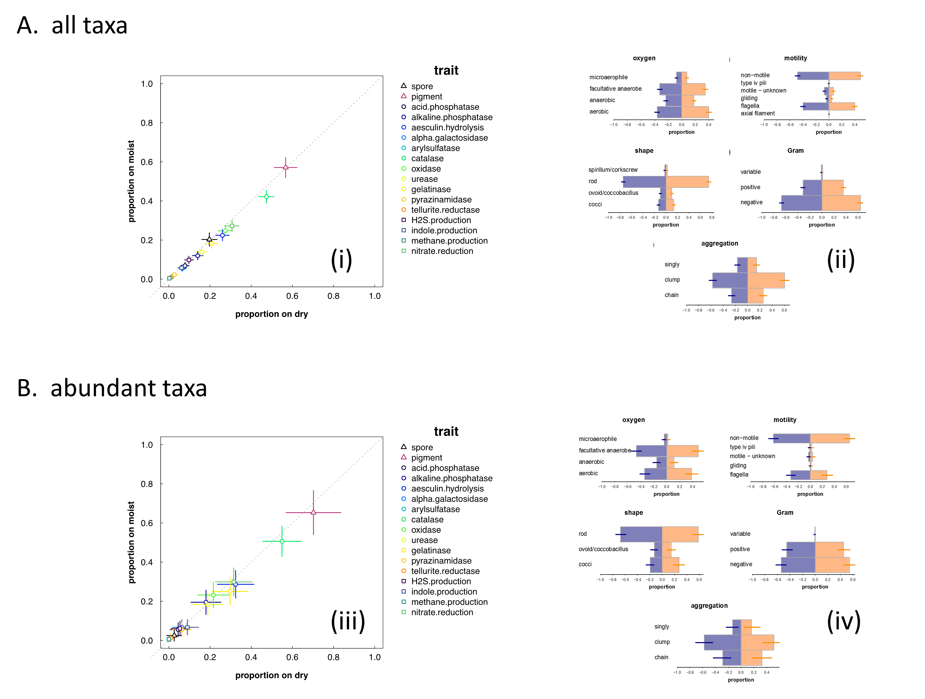

Figure S5.1 Trait comparisons for (A) all skin taxa (>0.001% of reads in at least one sample) and (B) abundant skin taxa (>0.1% of reads in at least one sample). Panels (i,iii), illustrate the proportion of taxa with a specific, qualitative trait at dry sites (x-axis) versus at moist sites (y-axis). Filled symbols represent traits that are significantly different between the two sites; open circles represent traits that are not. Panels (ii,iv), show plots of trait proportions among moist skin bacteria (blue) and dry skin bacteria (peach). No differences are significant.

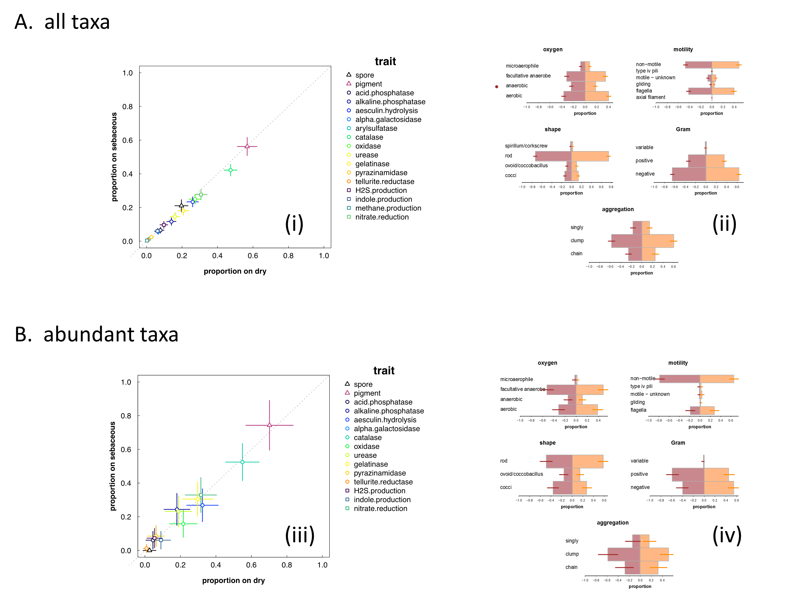

Figure S5.2 Trait comparisons for (A) all skin taxa (>0.001% of reads in at least one sample) and (B) abundant skin taxa (>0.1% of reads in at least one sample). Panels (i,iii), illustrate the proportion of taxa with a specific, qualitative trait at dry sites (x-axis) versus at sebaceous sites (y-axis). Filled symbols represent traits that are significantly different between the two sites; open circles represent traits that are not; symbol size reflects significance. Panels (ii,iv), show plots of trait proportions among dry skin bacteria (peach) and sebaceous skin bacteria (red). The filled red circle denotes the one trait that is overrepresented on sebaceous skin.

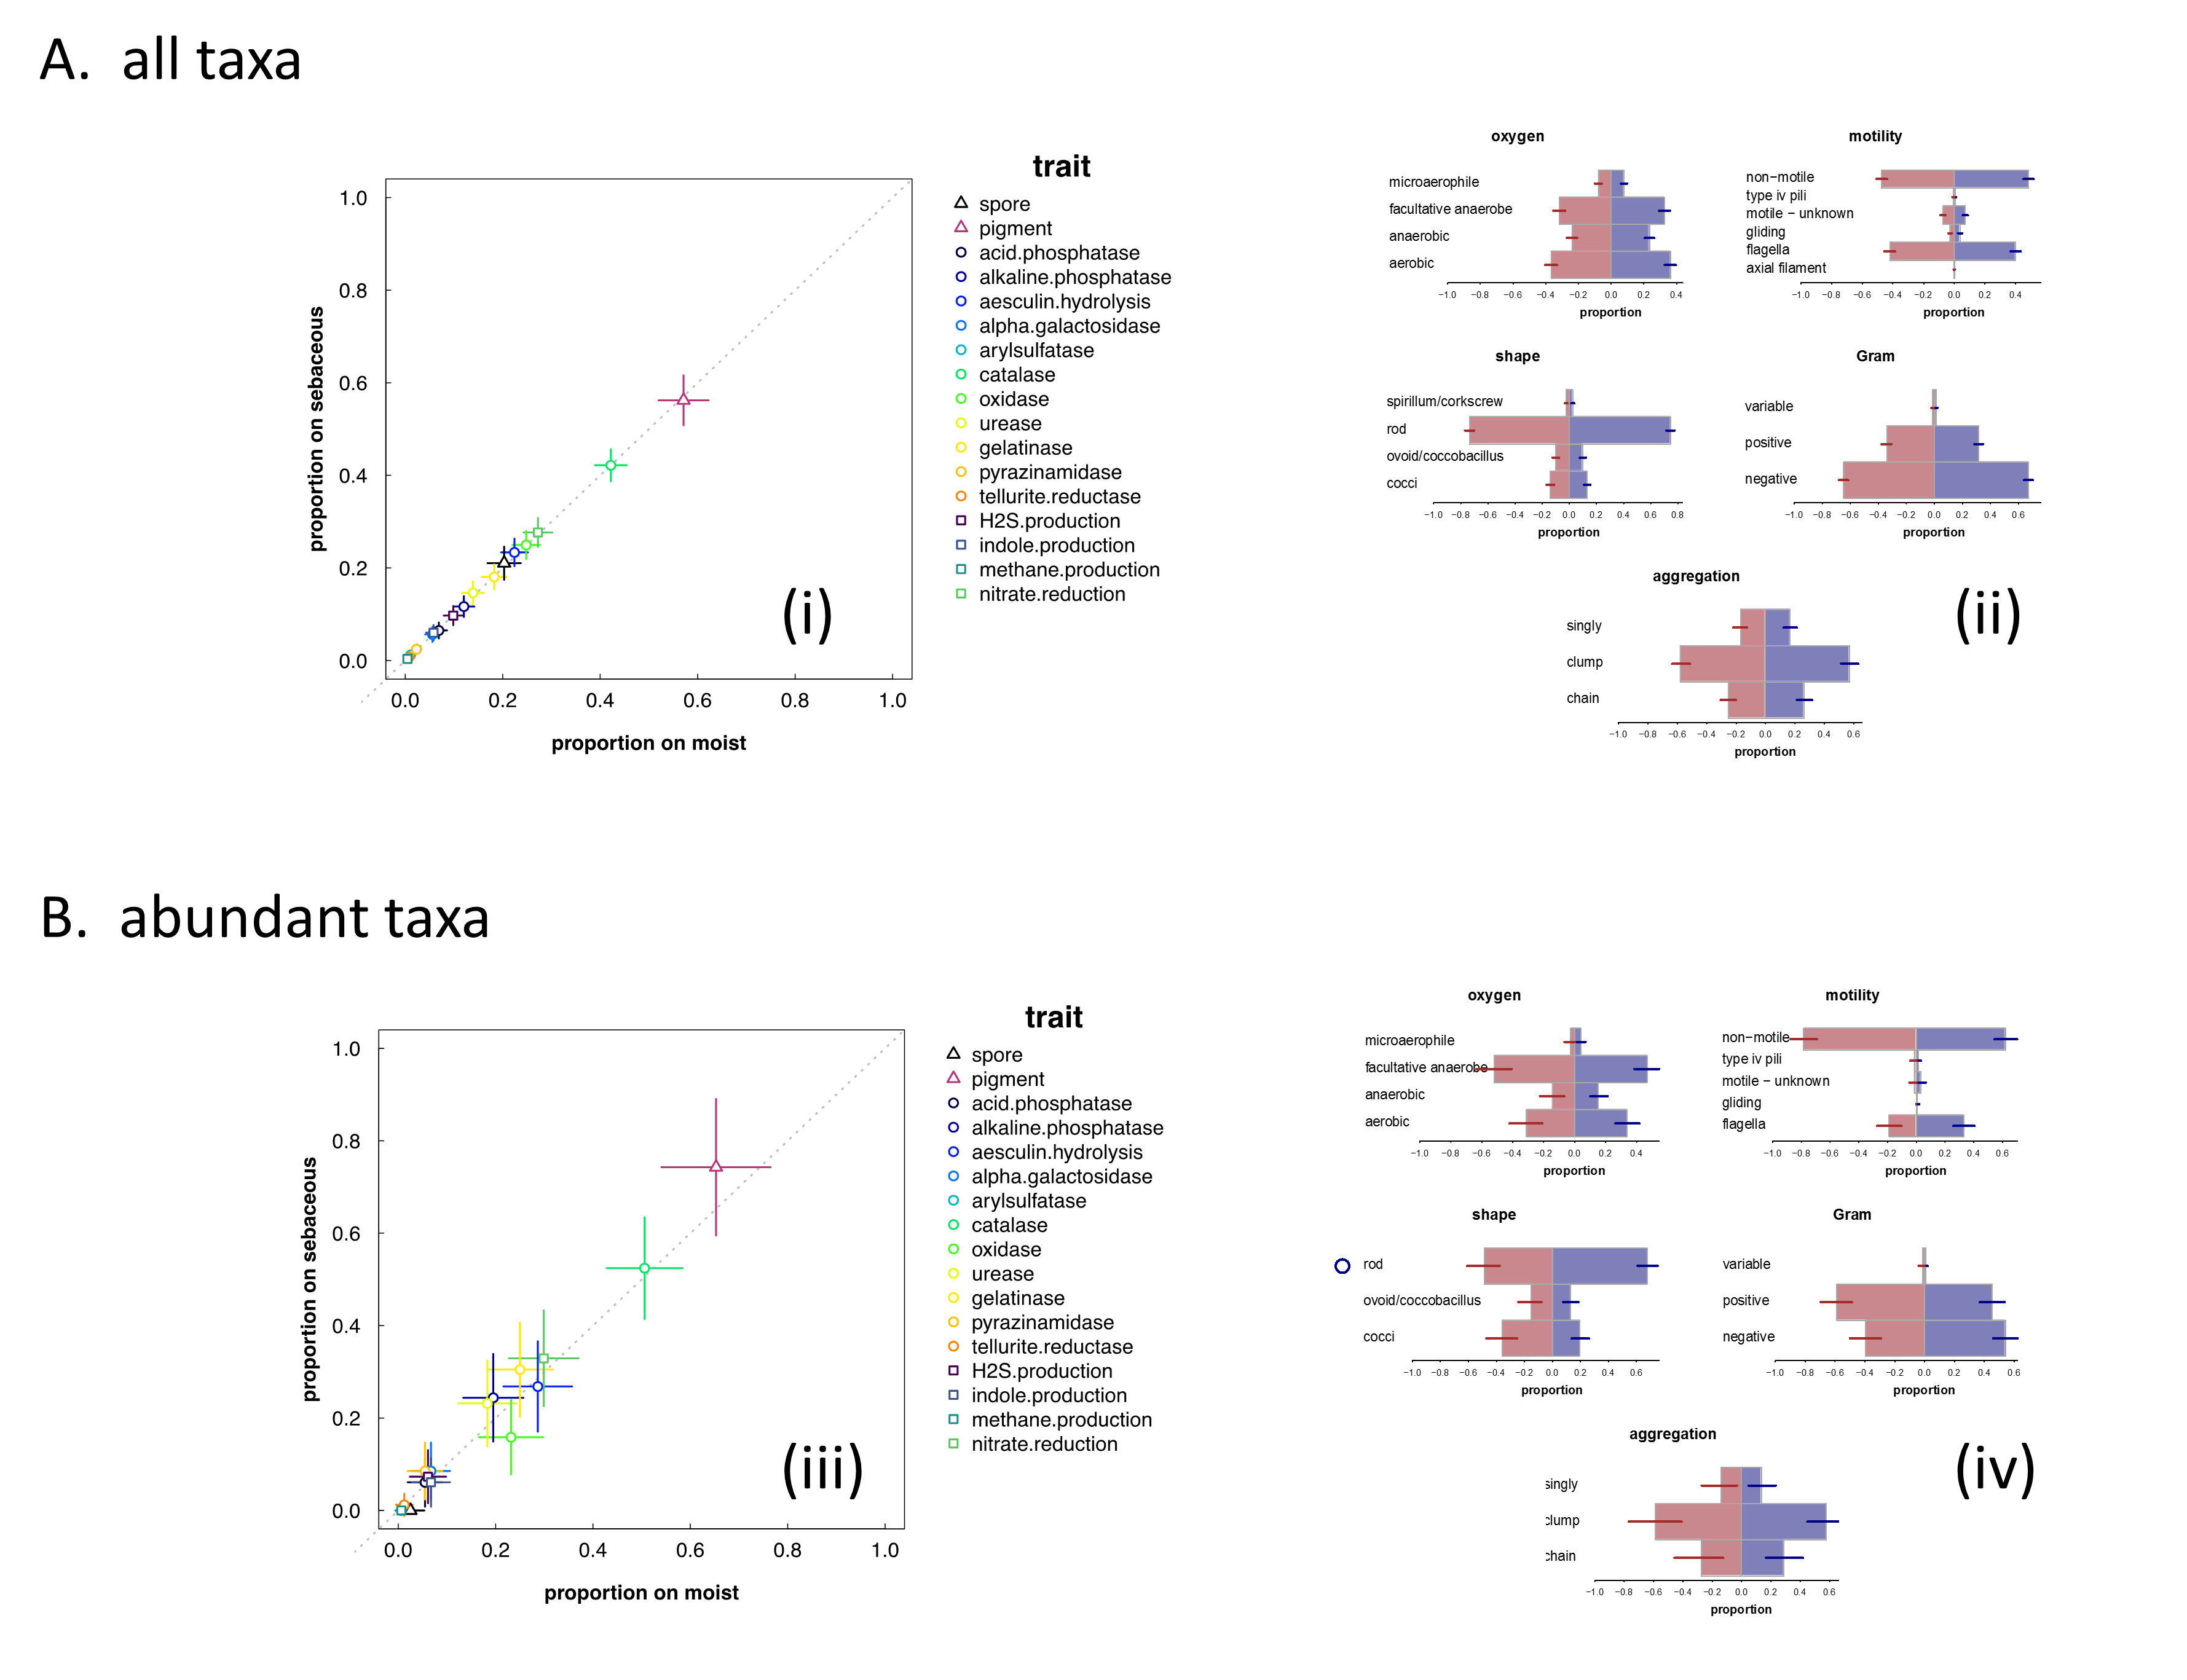

Figure S5.3 Trait comparisons for (A) all skin taxa (>0.001% of reads in at least one sample) and (B) abundant skin taxa (>0.1% of reads in at least one sample). Panels (i,iii), illustrate the proportion of taxa with a specific, qualitative trait at moist sites (x-axis) versus at sebaceous sites (y-axis). Filled symbols represent traits that are significantly different between the two sites; open circles represent traits that are not; symbol size reflects significance. Panels (ii,iv), show plots of trait proportions among moist skin bacteria (blue) and sebaceous skin bacteria (red). The open blue circle denotes the one trait that was overrepresented on moist skin.

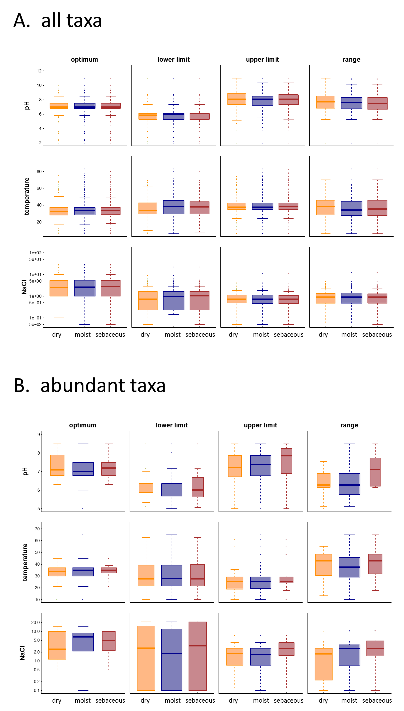

Figure S5.4 Boxplots comparing quantitative traits among skin bacteria from dry (peach), moist (blue) and sebaceous (red) sites for (A) all skin bacteria (>0.001% of reads in at least one sample) and (B) abundant skin bacteria (>0.1% of reads in at least one sample). No differences are signficant.

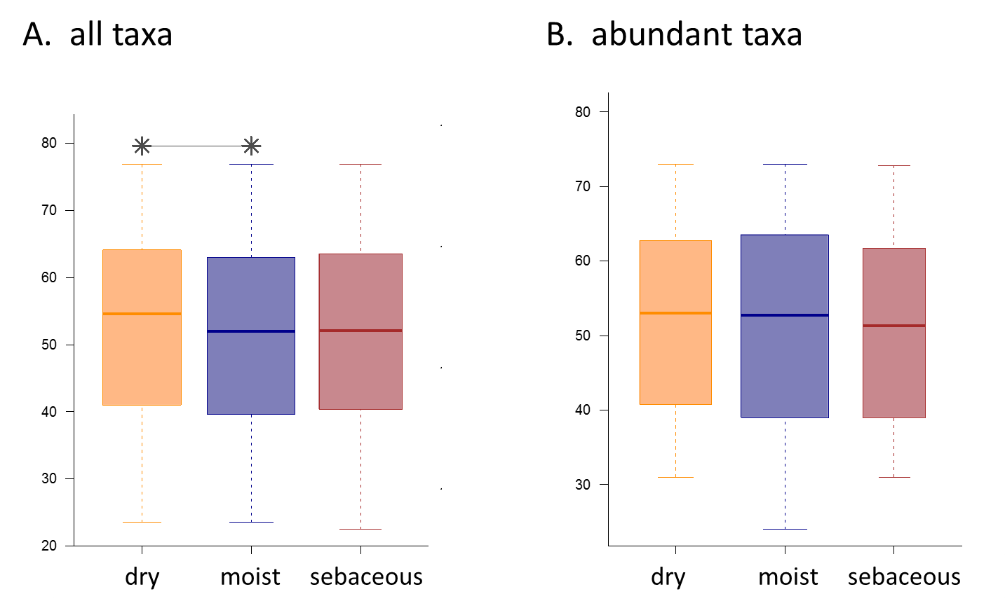

Figure S5.5 Boxplots comparing GC percent among skin bacteria from dry (peach), moist (blue), and sebaceous (red) skin environments. Stars are used to denote significant differences between a trait value in the world versus on skin. Box width indicates the relative number of microbes used for the comparison. Analyses are shown for (A) all skin bacteria (>0.001% of reads in at least one sample) and (B) abundant skin taxa (>0.1% of reads in at least one sample).

In Figures S4.6 – S4.11, we show comparisons for substrate use across the three different skin environments. Again, there is little difference, although there are a few differences between moist and sebaceous sites. Specifically, bacterial use of three organic acids – quinate, malonate, and caprate – as well as glucosamine (a monosaccharide) is overrepresented at sebaceous sites. By contrast, bacterial use of three saccharides –rhamnose, xylose, and cellobiose – as well as glycine (an amino acid) and urea are overrepresented at moist sites.

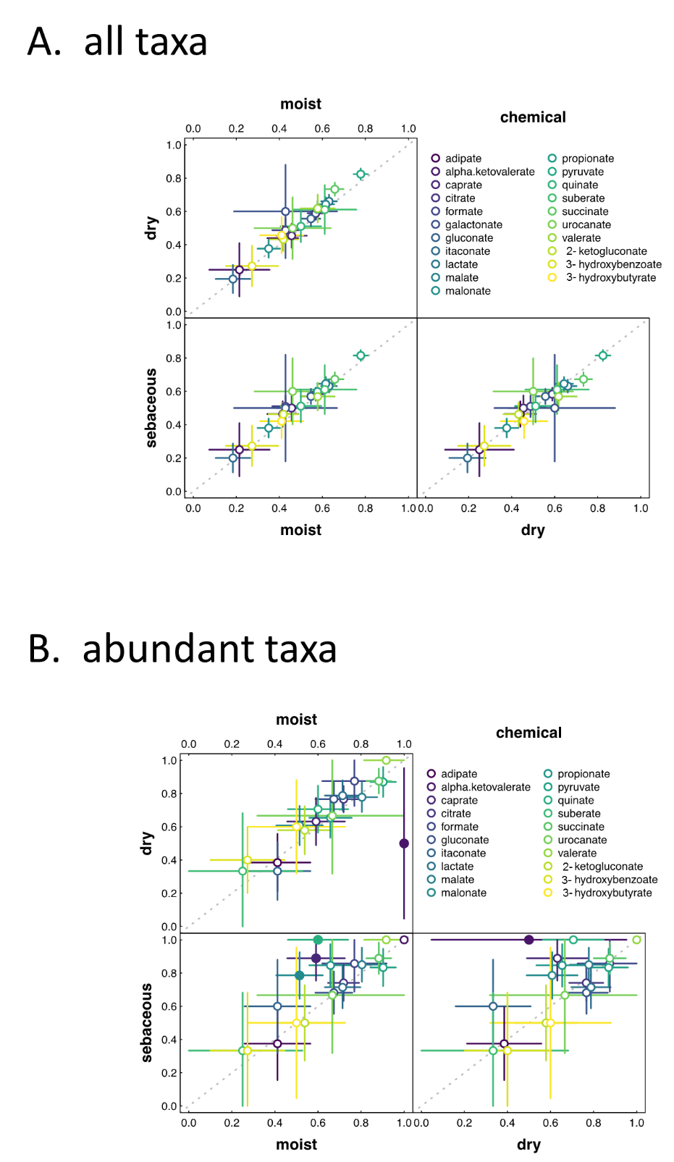

Figure S5.6 Pairwise comparison (dry vs. moist, dry vs. sebaceous, moist vs. sebaceous) of organic acid use. Analyses are shown for (A) all skin bacteria (>0.001% of reads in at least one sample) and (B) abundant skin taxa (>0.1% of reads in at least one sample). Filled circles indicate a significant difference between sites; open circles indicate the opposite. Note that in the main text, we do not assume that results for α-ketovalerate are signficant, because there were too few taxa for which this trait was reported.

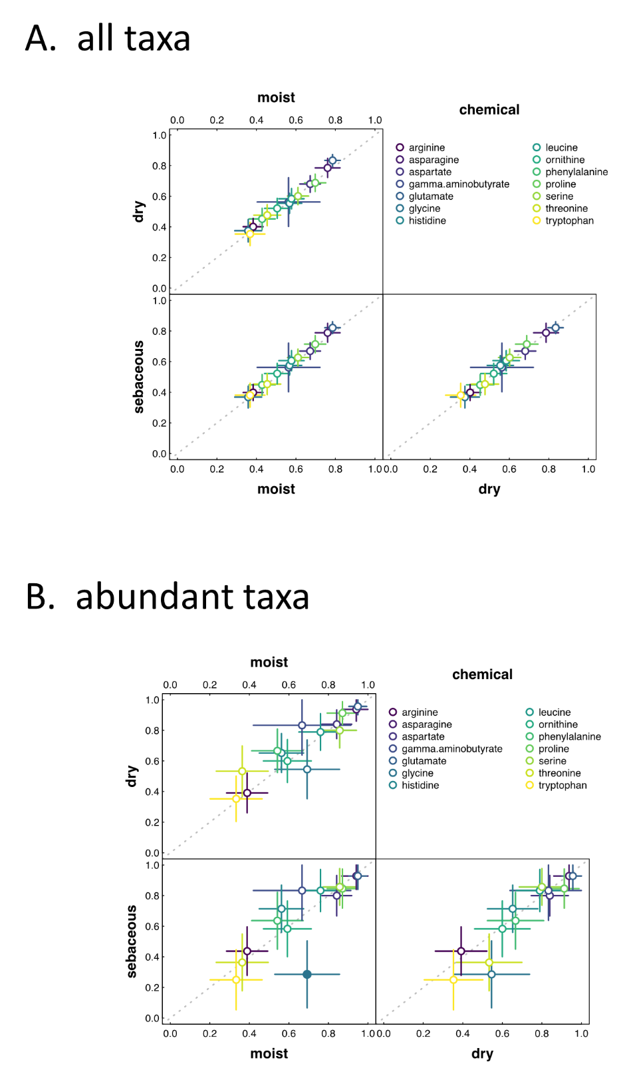

Figure S5.7 Pairwise comparison (dry vs. moist, dry vs. sebaceous, moist vs. sebaceous) of amino acid use. Analyses are shown for (A) all skin bacteria (>0.001% of reads in at least one sample) and (B) abundant skin taxa (>0.1% of reads in at least one sample). Filled circles indicate a significant difference between sites; open circles indicate the opposite.
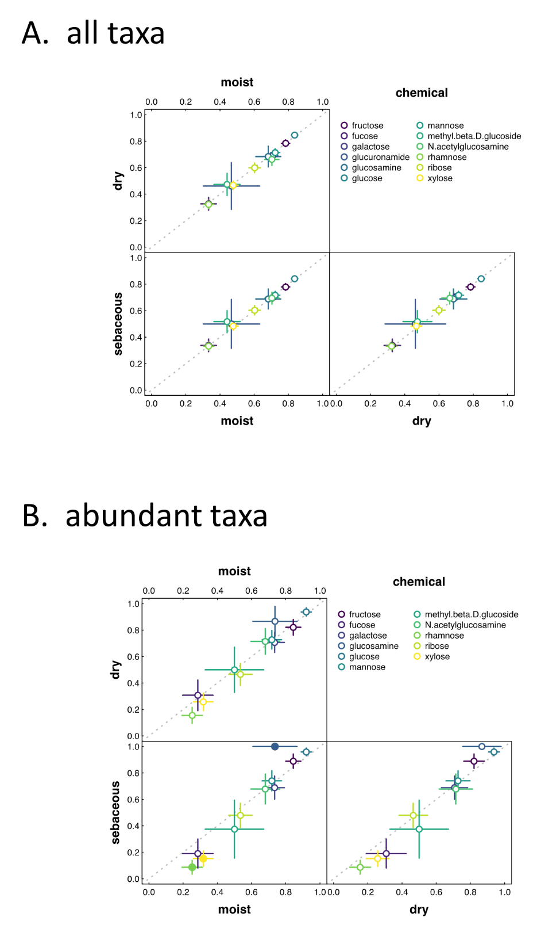

Figure S5.8 Pairwise comparison (dry vs. moist, dry vs. sebaceous, moist vs. sebaceous) of monosaccharide use. Analyses are shown for (A) all skin bacteria (>0.001% of reads in at least one sample) and (B) abundant skin taxa (>0.1% of reads in at least one sample). Filled circles indicate a significant difference between sites; open circles indicate the opposite.

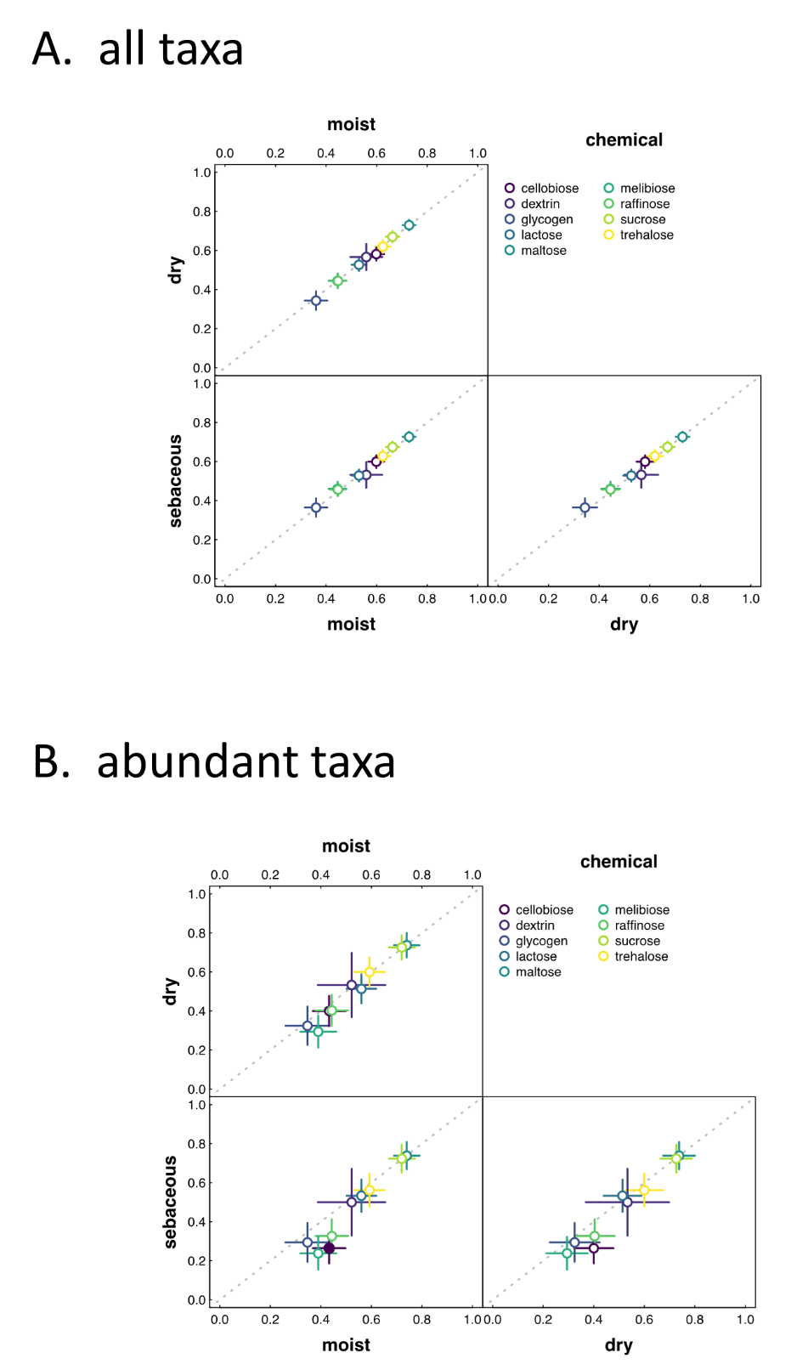

Figure S5.9 Pairwise comparison (dry vs. moist, dry vs. sebaceous, moist vs. sebaceous) of oligo/polysaccharide use. Analyses are shown for (A) all skin bacteria (>0.001% of reads in at least one sample) and (B) abundant skin taxa (>0.1% of reads in at least one sample). Filled circles indicate a significant difference between sites; open circles indicate the opposite.

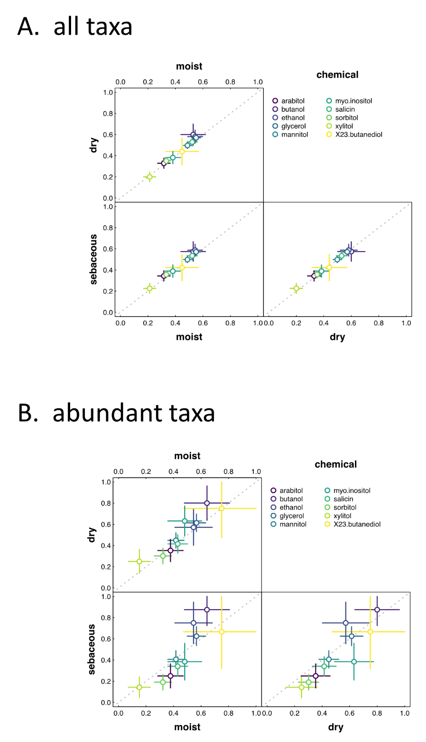
Figure S5.10 Pairwise comparison (dry vs. moist, dry vs. sebaceous, moist vs. sebaceous) of alcohol use. Analyses are shown for (A) all skin bacteria (>0.001% of reads in at least one sample) and (B) abundant skin taxa (>0.1% of reads in at least one sample). Open circles indicate no significant difference between sites.

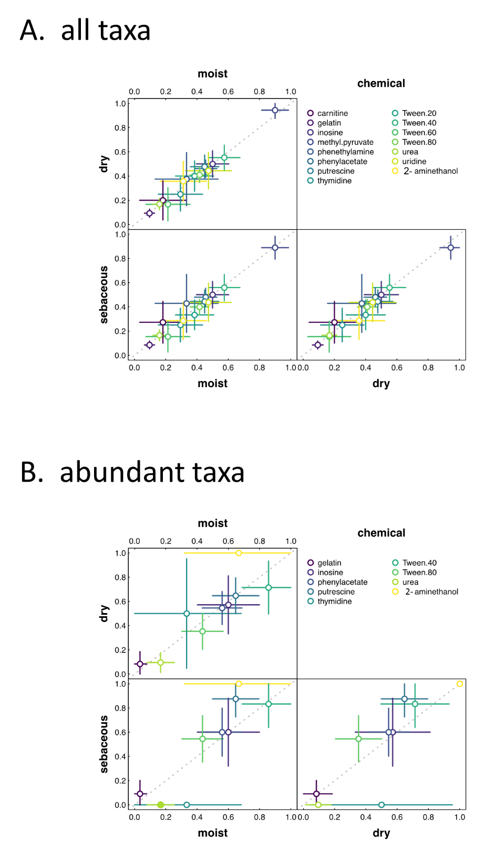

Figure S5.11 Pairwise comparison (dry vs. moist, dry vs. sebaceous, moist vs. sebaceous) of use of specialized chemicals. Analyses are shown for (A) all skin bacteria (>0.001% of reads in at least one sample) and (B) abundant skin taxa (>0.1% of reads in at least one sample). Open circles indicate no significant difference between sites.

Supplementary Information VI: Example Comparisons Between Our Database and the ProTrait Database
In what follows, we compare our database to the ProTrait database using bacterial oxygen use and glucose use as examples. For the ProTrait database, we assume binarized predictions at a precision of ≥ 0.9.
Oxygen Use
Information about oxygen use was simultaneously missing from both databases for 86 taxa (8.8%). Oxygen use was missing from our database, but not from the ProTrait database for 51 taxa (5.2%). Oxygen use was missing from the ProTrait database but not from our database for 347 taxa (35.7%). Finally, oxygen use was simultaneously reported in both databases for 462 taxa (47.6%) . Of the 462 taxa that contained information on oxygen use in both databases, 27 taxa (5.8%) exhibited discrepancies. By far the largest type of discrepancy was facultative anaerobes being recorded as strict aerobes or anaerobes or strict aerobes or anaerobes being recorded as facultative anaerobes in one versus the other database. Indeed, there were only 5 blatant discrepancies (an aerobe being classified as an anaerobe or vice versa). Our database classified two organisms as anaerobic that were actually aerobes and one organism as aerobic that was actually an anaerobe. Meanwhile, the ProTrait database classified two organisms as anaerobic that were actually microaerophilic. Thus, while accuracy seems comparable between the two databases, at least for oxygen use, our database has much greater coverage.

Glucose Use
Information about the ability to use glucose as a substrate was simultaneously missing from both databases for 308 taxa (31.7%). Information on glucose use was missing from our database, but not from the ProTrait database for 20 taxa (2.0%). Information on glucose use was missing from the ProTrait database, but not from our database for 496 taxa (51.1%). Finally, information about glucose use was simultaneously reported in both databases for 122 taxa (12.5%). Of the 122 taxa that contained information on glucose use in both databases, 4 taxa (3.3%) exhibited discrepancies. One species was Arthrobacter phenanthrenivorans, which we reported as negative for glucose use. Although the only reference to glucose in our literature reported that acid was not produced from this substrate, we cannot rule out other findings in more recent papers. The other three species with discrepancies were all within the genus Acinetobacter. For all three of these, we reported positive glucose use, whereas ProTrait reported negative use. In our literature sources, we found evidence that all three strains can oxidize glucose, which we classify as positive use. Despite these minor differences, again we find good agreement between our database and the ProTrait database, suggesting that trait coverage, rather than accuracy, is the main benefit of manual curation.

