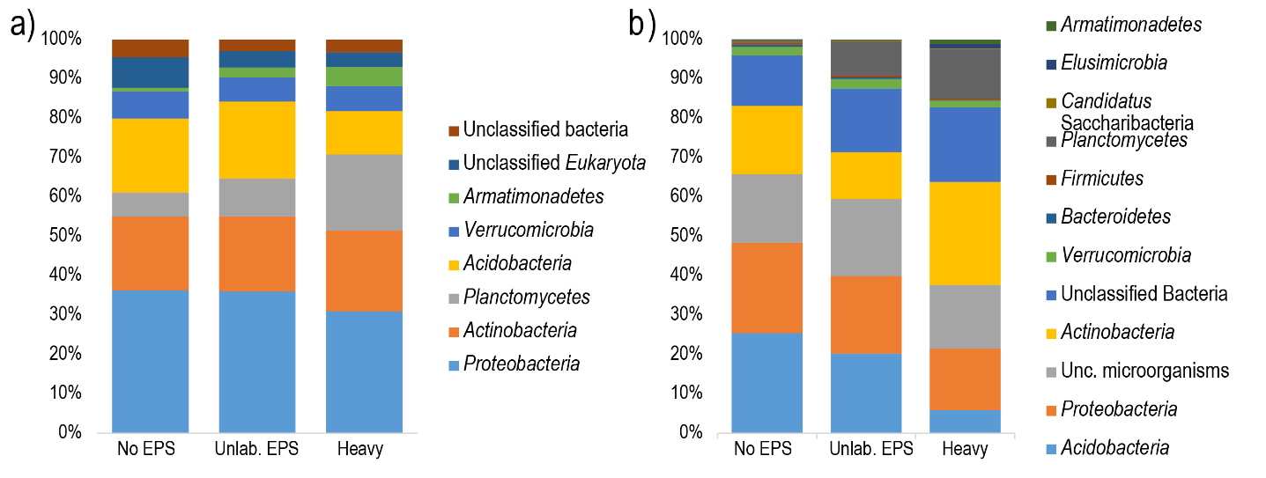
Supplementary material
Supplementary Figure S1: Taxonomic composition and relative abundance of microbial groups at phylym level in SIP metagenome treatments based on a) SSU rRNA gene sequence classification (>2.2 % abundance) b) ORF taxonomic classification (>0.1% abundance). Average abundances of 4 replicates. Unc: unclassified. No EPS – incubation without WH15EPS. Unlab EPS-incubation containing ¹²C-WH15EPS. Heavy – ‘heavy fraction’ of incubations containing ¹³C-WH15EPS

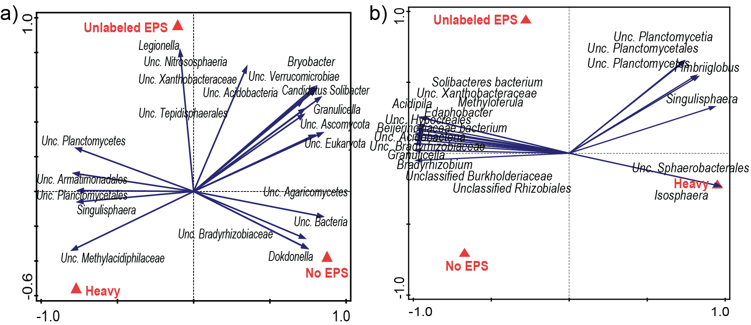
Supplementary Figure S2: Biplot of the Redundancy analysis (RDA) based on normalized and Hellinger-transformed abundances of a) SSU rRNA gene taxonomy classification and b) ORF taxonomic classification. Only the best 20 fitting groups are displayed. Unc: unclassified. No EPS – incubation without WH15EPS. Unlab EPS-incubation containing ¹²C-WH15EPS. Heavy – ‘heavy fraction’ of incubations containing ¹³C-WH15EPS

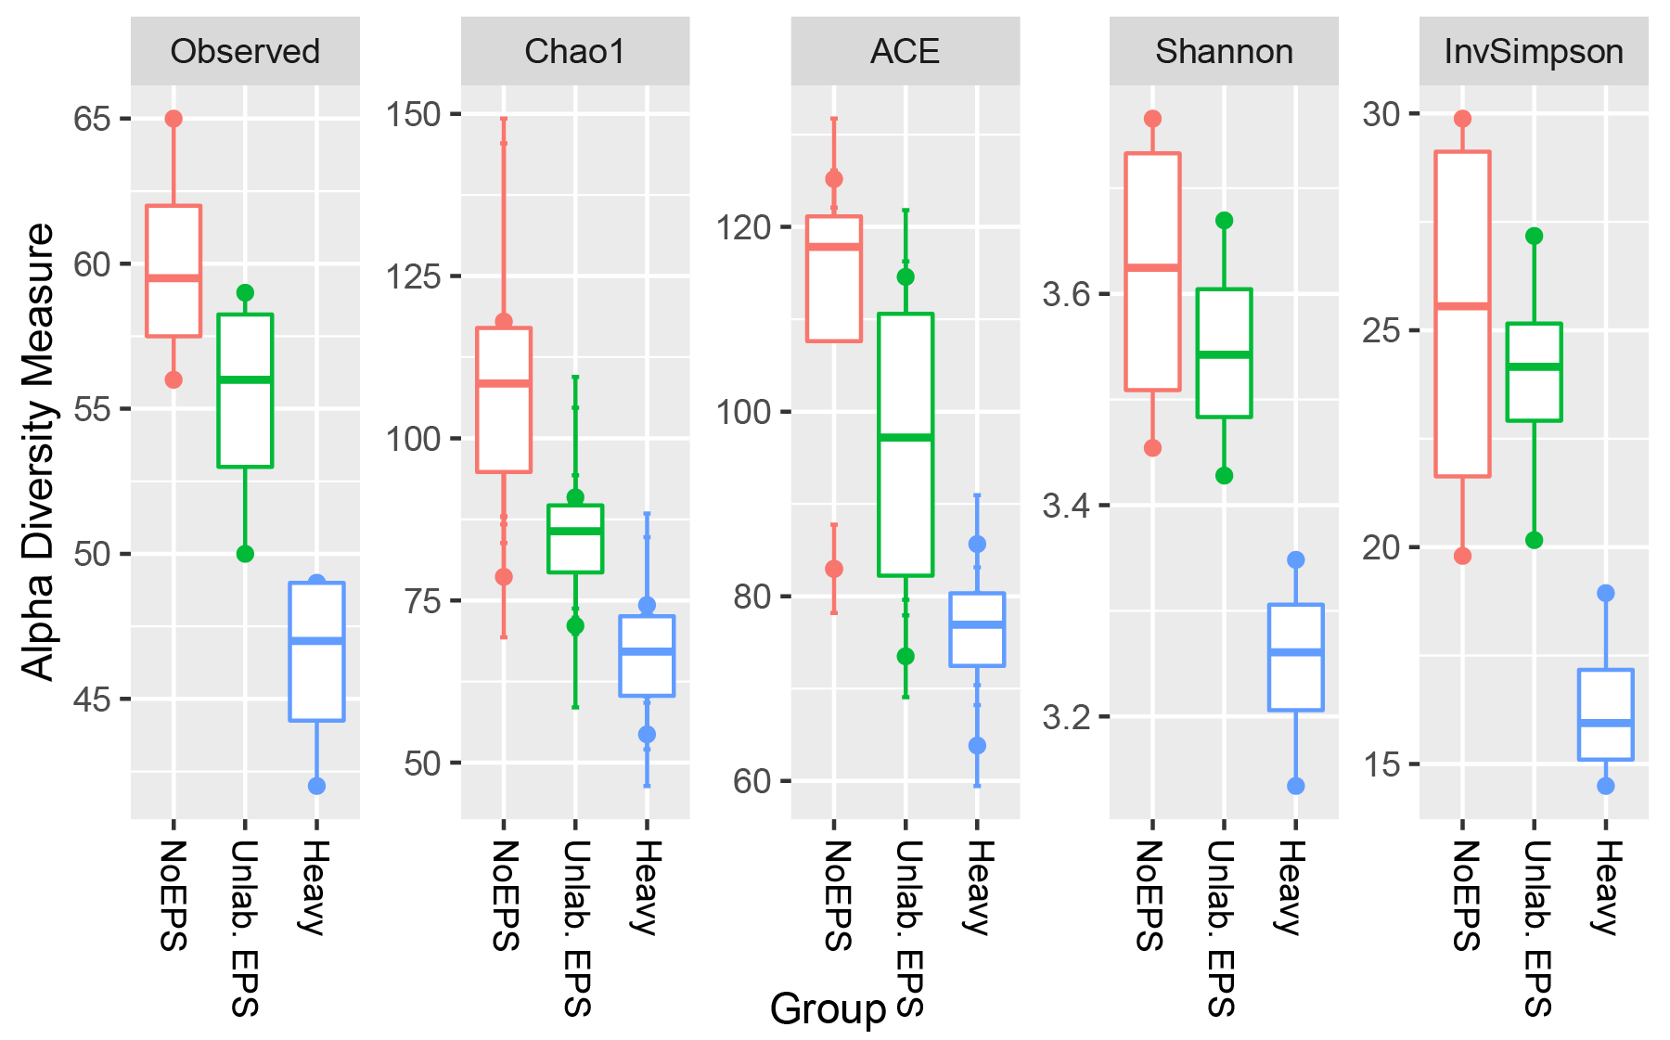
Supplementary Figure S3: Box-plot comparisons of alpha-diversity assessment by richness estimators (number of observed OTUs, Chao1, ACE) and diversity indices (Shannon, Inverse Simpson) for SIP 16S rRNA gene samples. ‘Heavy fraction’ values are significantly lower in comparison with both controls for all comparisons (p-value < 0.05). Comparisons performed across treatments using ANOVA test and Tukey`s HSD post-hoc test. Data rarefied to the minimum sampling depth. Unlab. EPS-incubation containing ¹²C-WH15EPS. Heavy – ‘heavy fraction’ of incubations containing ¹³C-WH15EPS.

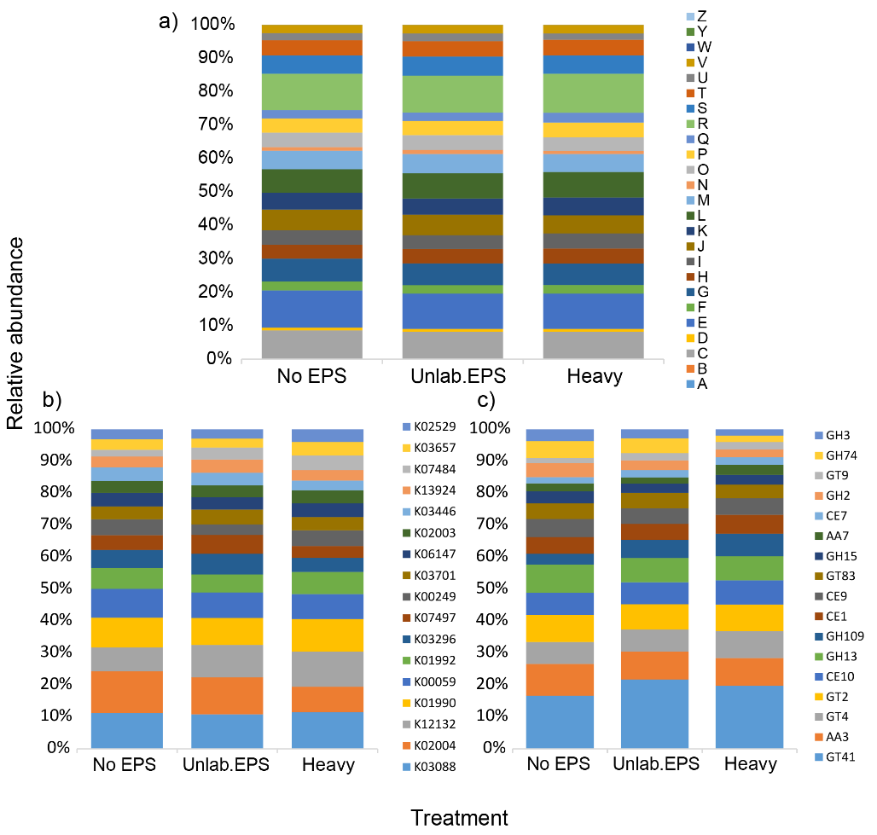
Supplementary Figure S4: Relative abundance distribution of the most abundant functional categories in TPM-normalized metagenome sequencing data from the SIP metagenome. a) COG annotation (all categories); b) KEGG annotation (above 0.1 % abundance); c) dbCAN annotation (above 1% abundance). E-Amino acid transport and metabolism; G- Carbohydrate transport and metabolism; H-Coenzyme transport and metabolism; C-Energy production and conversion; I-Lipid transport and metabolism; F-Nucleotide transport and metabolism; Q- Secondary metabolites; D-Cell cycle; N-Cell motility; M-Cell wall/membrane/envelope biogenesis; V-Defence mechanisms; P-Inorganic ion transport and metabolism; U-Intracellular trafficking; O-Post translational modification; T-Signal transduction mechanisms; L-Replication, recombination and repair; K-Transcription; J-Translation; S-Function unknown; R-General function and prediction; X-Mobilome.

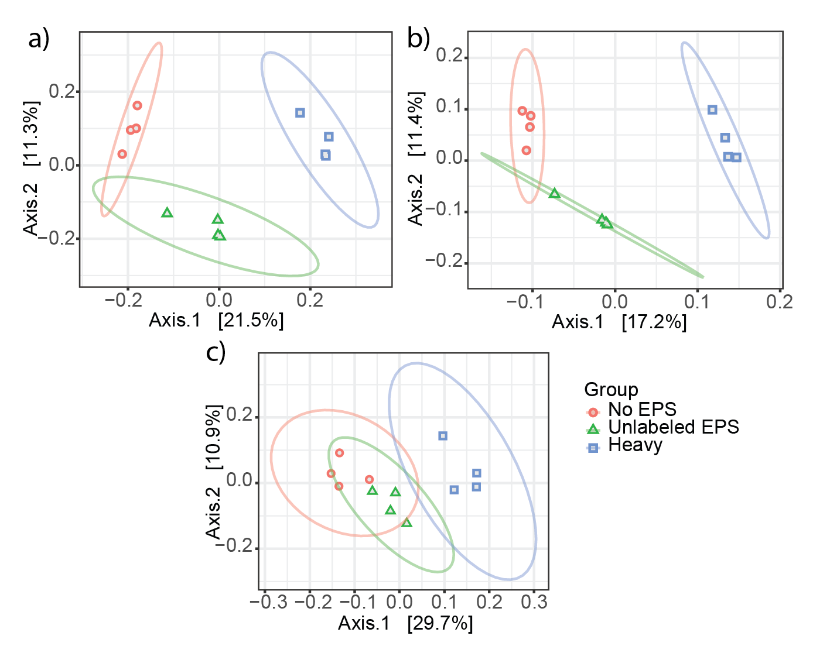
Supplementary Figure S5: Principal Coordinate Analysis (PCoA) clustering of normalized and Hellinger-transformed SIP metagenome sequencing data based on Bray-Curtis distances of a) COG annotation, b) KEGG annotation and c) dbCAN annotation. No EPS – incubation without WH15EPS. Unlabeled EPS-incubation containing ¹²C-WH15EPS. Heavy – ‘heavy fraction’ of incubations containing ¹³C-WH15EPS.

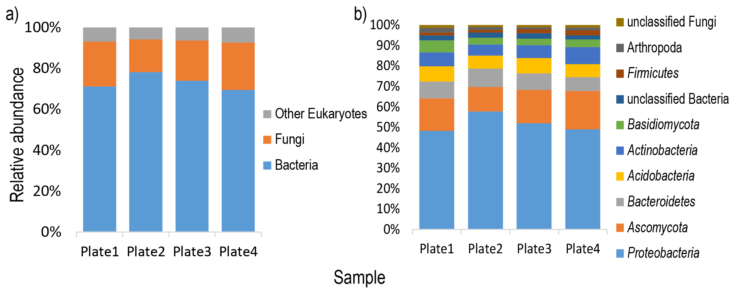
Supplementary Figure S6: Taxonomic composition and relative abundance of microbial groups at a) kingdom and b) phylum level in samples from the metagenome shotgun of cultivated microorganism based SSU rRNA gene taxonomic classification. Average from 2 replicates per plate of culture medium.

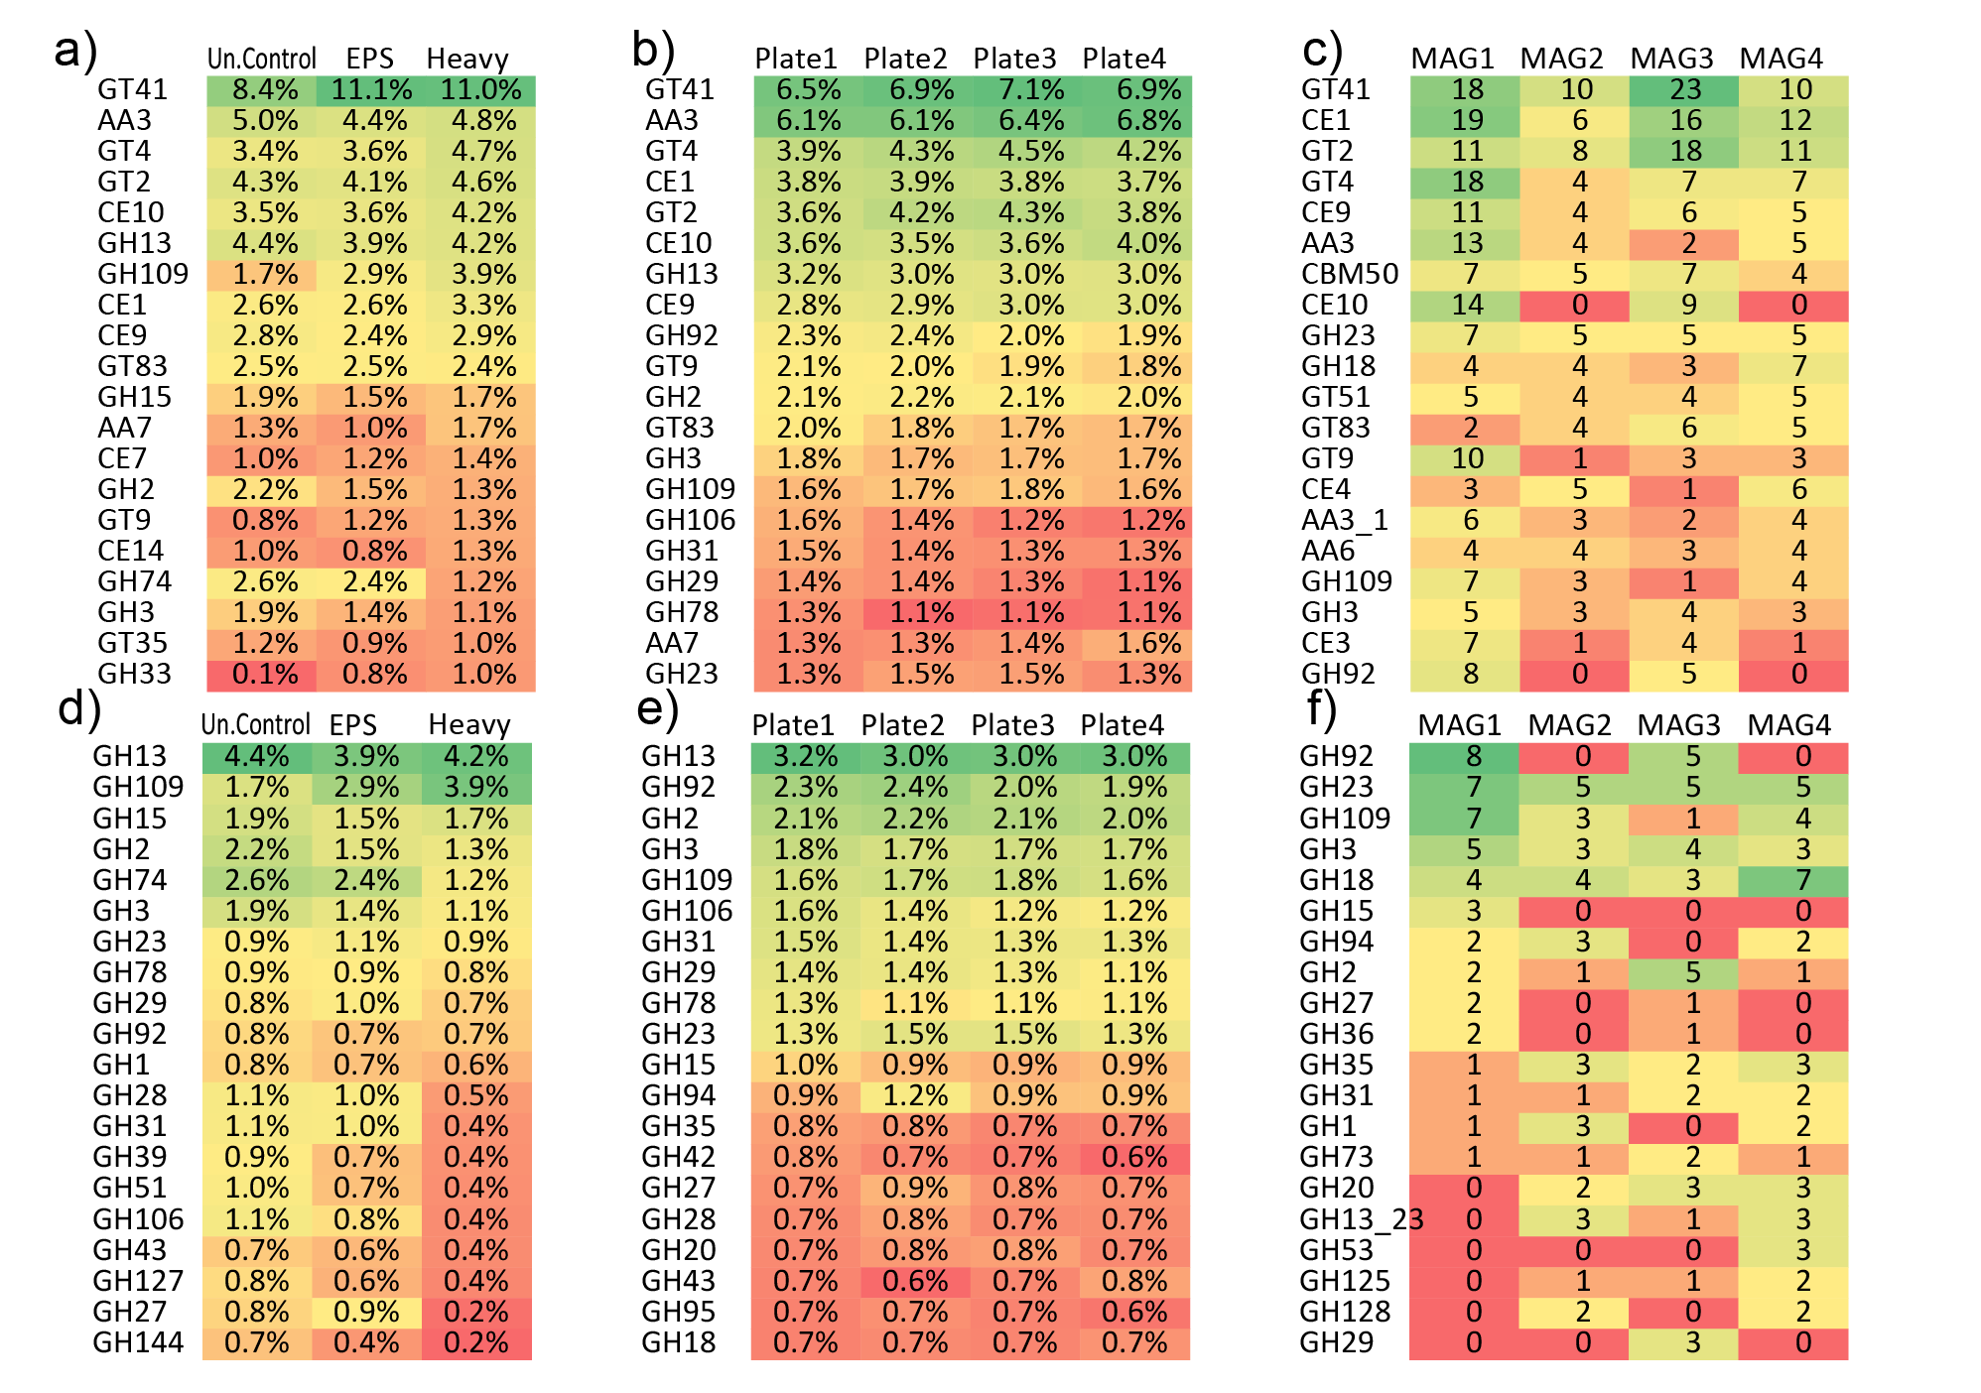
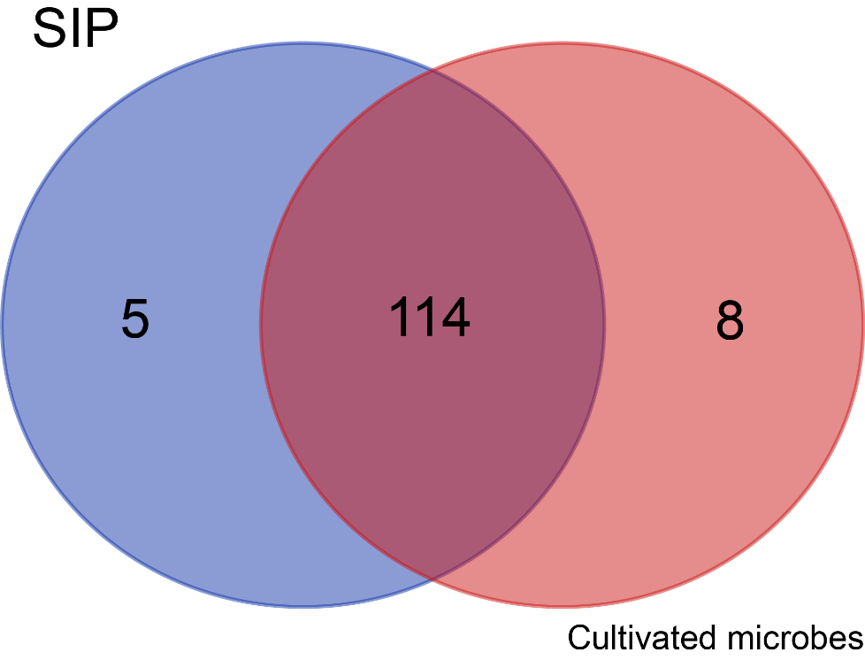
Supplementary Figure S8: Distribution of the 20 most abundant CAZyme families in a) SIP metagenome samples (relative abundance, average of 4 replicates); b) metagenome of cultivated microorganisms (relative abundance, average of 2 replicates); c) Metagenome-Assembled Genomes (MAGs) (number of genes), and most abundant glycosyl hydrolases (GH) in d) SIP metagenome samples (relative abundance, average of 4 replicates), e) metagenome of cultivated microorganisms (relative abundance, average of 2 replicates) and f) Metagenome-Assembled Genomes (MAGs) (number of genes).
Supplementary Figure S7: Venn diagram depicting the number of common and unique glycoside hydrolase (GH) families observed in SIP metagenome and metagenome of cultivate microorganisms` datasets.
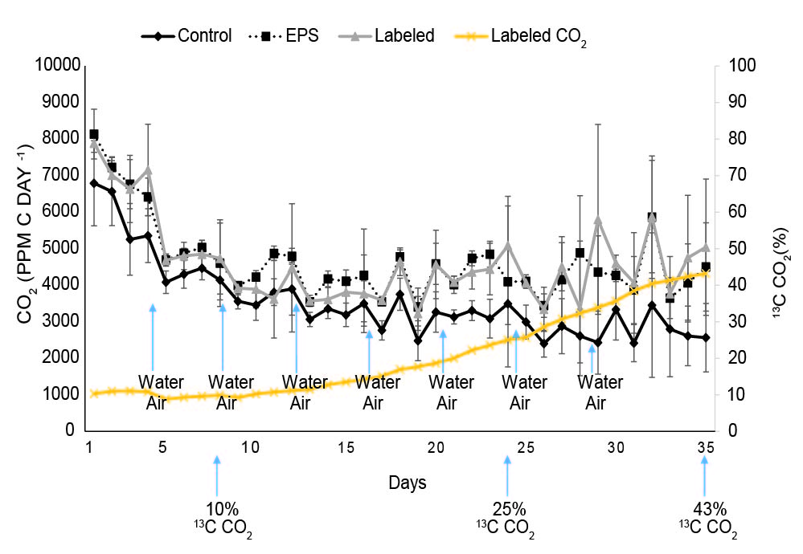
Supplementary Figure S9: CO₂ emission. CO₂ production during total incubation period. Control: control without EPS; EPS: control containing ¹²C-EPS; Labeled: incubation with ¹³C-EPS; Labeled CO₂ percentage: ¹³CO₂ emitted during ¹³C-EPS sample incubation; water: days when samples were hydrated; air: days when samples were aired.

Supplementary Table S1: COG functions that significantly segregated across treatments selected by Boruta random forests algorithm based on 1000 permutations in the SIP metagenome treatment comparisons.
COG | Function |  | Category
COG0043* | 3-polyprenyl-4-hydroxybenzoate decarboxylase | H | Coenzyme transport and metabolism
COG2985* | transport protein/Uncharacterized membrane protein YbjL | P | Inorganic ion transport and metabolism
COG3492* | Deoxycytidine triphosphate deaminase | S | Function unknown
COG3534 | Alpha-N-arabinofuranosidase (EC 3.2.1.55 | G | G Carbohydrate transport and metabolism
COG3547* | Transposase | L | Replication, recombination and repair
ENOG410XNWR | ABC transporter substrate-binding protein | E | Amino acid transport and metabolism
ENOG410XQPR* | Sulfite exporter TauE/SafE | S | Function unknown
ENOG410XQRG | Transcriptional regulator | K | Transcription
ENOG410XRW3* | secreted protein | S | Function unknown
ENOG410Y9A5* | Cna B-type protein | S | Function unknown
ENOG410YCZ9* | NA | S | Function unknown
ENOG410ZNCC* | NA | S | Function unknown
ENOG4111SDB* | NA | S | Function unknown
COG0665 | Glycine/D-amino acid oxidase | E | Amino acid transport and metabolism
COG0745 | OmpR -regulatoR | T | Signal transduction mechanisms
COG1309 | Transcriptional regulator | K | Transcription
COG2243 | Precorrin-2 methylase | H | Coenzyme transport and metabolism
ENOG410XPHN* | NA | S | Function unknown
ENOG410XQ2Q* | sialic acid-specific 9-O-acetylesterase | S | Function unknown
ENOG410XQ46 | Protein of unknown function (DUF1549) (Planctomycetes) | S | Function unknown
ENOG410XQWX* | NA | S | Function unknown
ENOG410XQXZ | NA | S | Function unknown
ENOG410XRSU | NA (Acidobacteria) | S | Function unknown
ENOG410XZSR | NA (Acidobacteria) | S | Function unknown
ENOG410Y0YH | reductase | I | Lipid transport and metabolism
ENOG410ZWC6 | kelch repeat-containing protein | S | Function unknown
ENOG4111HEH | (ABC) transporter | S | Function unknown
ENOG4111HR8 | Tetr family transcriptional regulator | K | Transcription
ENOG4111R18 | integral membrane transport protein | P | Inorganic ion transport and metabolism
ENOG4111TA9 | NA | S | Function unknown
ENOG41120VN | NA (Planctomycetes) | S | Function unknown
ENOG41126W5 | NA | S | Function unknown
*Higher abundance in ¹²C-EPS-amended control samples. Blue – more abundant in unamended control samples. Orange: more abundant in Labeled samples

Supplementary Table S2: KEGG orthologs that significantly segregated across treatments selected by Boruta random forests algorithm based on 1000 permutations in the SIP metagenome treatment comparisons.
KEGG |  | Annotation | KEGG Metabolic Pathway
K00467 |  | Lactate 2-monooxygenase | Metabolic pathways/Pyruvate
K01811* |  | Alpha-D-xyloside xylohydrolase | -
K01999* |  | Branched-chain amino acid transport system substrate-binding protein | ABC transporters/quorum sensing
K02083 |  | Allantoate deiminase | Metabolic pathways/Microbial metabolism/Purines
K02274* |  | Cytochrome c oxidase subunit I | Metabolic pathways/Oxidative phosphorilation
K03074 |  | Preprotein translocase subunit secf | Protein export/Bacterial secretion
K03307* |  | Solute:Na+ symporter, SSS family | -
K03832* |  | Periplasmic protein tonb | -
K07263* |  | Zinc protease | -
K07795 |  | Putative tricarboxylic transport membrane protein | Two-component system
K08964 |  | Methylthioribulose-1-phosphate dehydratase | Metabolic pathways/Amino-acids
K09758* |  | Aspartate 4-decarboxylase | Metabolic pathways/Amino-acids
K10826 |  | Putative ABC transporter transmembrane protein | -
K18900 |  | Lysr family transcriptional regulator, regulator for bpeef and oprc | -
K00200* |  | Formylmethanofuran dehydrogenase subunit A | Metabolic pathways/microbial metabolism/carbon metabolism/methane metabolism
K00249 |  | Acyl-coa dehydrogenase | Antibiotics/fatty acids/secondary metabolites
K00477 |  | Phytanoyl-coa hydroxylase | Peroxysome
K01087 |  | Trehalose 6-phosphate phosphatase | Metabolic pathways/starch sucrose met
K01133 |  | Choline-sulfatase | -
K01258 |  | Tripeptide aminopeptidase | -
K01515 |  | ADP-ribose pyrophosphatase | Metabolic pathways/Purine metabolism
K01992 |  | ABC-2 type transport system permease protein | -
K02551 |  | 2-succinyl-5-enolpyruvyl-6-hydroxy-3-cyclohexene-1-carboxylate synthase | Metabolic pathways/Ubiquinone biosynthesis
K02657 |  | Twitching motility two-component system response regulator pilg | Two component system/Biofilm
K03075 |  | Preprotein translocase subunit secg | Bacterial secretion/Protein export
K03167* |  | DNA topoisomerase VI subunit B | -
K03620 |  | Ni/Fe-hydrogenase 1 B-type cytochrome subunit | Two componente system
K05786 |  | Chloramphenicol-sensitive protein rard | -
K05970* |  | Sialate O-acetylesterase | -
K06606* |  | 2-keto-myo-inositol isomerase | Metabolic pathways/microbial metabolism/inositol metabolism
K08282 |  | Non-specific serine/threonine protein kinase | -
K08602* |  | Oligoendopeptidase F | -
K09684 |  | Pucr family transcriptional regulator, purine catabolism regulatory protein | -
K10301* |  | F-box protein 21 | -
K10714* |  | Methylene-tetrahydromethanopterin dehydrogenase | Metabolic pathways/ Microbial metabolism/ Carbon metabolism/ Methane metabolism
K11708* |  | Manganese/zinc/iron transport system permease protein | ABC transporters
K15342 |  | CRISP-associated protein Cas1 | -
K17329 |  | N,N'-diacetylchitobiose transport system substrate-binding protein | ABC transporters
K19169* |  | DNA sulfur modification protein dndb | -
K19542 |  | MFS transporter, DHA2 family, tetracycline/oxytetracycline resistance protein | -
*Higher abundance in EPS amended samples. Blue – more abundant in unamended control samples. Orange: more abundant in Labeled samples
Supplementary Table S3: CAZyme families that significantly segregated across treatments selected by Boruta random forests algorithm based on 1000 permutations in the SIP metagenome treatment comparisons.
CAZY family | Function
AA1* | Multicopper oxidases
CE8* | Pectin methylesterase
GH18* | Chitinase
GH2 | β-galactosidase
GH27* | α-galactosidase
GH28* | Pectin polygalacturonase
GH3 | β-glucosidase/xylosidase
GH31* | α-glucosidases
GH36 | α-galactosidase/N-acetylgalactosaminidase
GH42* | β-galactosidases
GH51 | Hemicellulases
GH79 | Proteoglycanases
GH115* | Xylan α-glucuronidase
CBM66 | Fructan-binding modules
CBM9* | Xylan-binding modules
CE6 | Acetyl xylan esterase
GH109 | α-N-acetylgalactosaminidase
GH117 | α-1,3-L-neoagarooligosaccharide hydrolase
GH17 | 1,3;1,4-β-D-glucan endohydrolases
GH32 | Invertases
GH33* | Sialidases
GH50 | β-agarase
GH71 | α-1,3-glucanase
GT12* | [N-acetylneuraminyl]-galactosylglucosylceramide N-acetylgalactosaminyltransferase
GT4 | Mannosyltransferases/N-acetylglucosaminyltransferases
GT87 | Polyprenol-P-Man: α-1,2-mannosyltransferase
PL10* | Pectate lyase
AA-auxiliary activity; CE-carbohydrate esterase; GH-glycoside hydrolase; GT-glycoside transferase; PL-polysaccharide lyases. *Higher abundance in EPS-amendedsamples. Blue – more abundant in unamended control samples. Orange: more abundant in Labeled samples

Supplementary Table S4: Most abundant CAZyme families (above 1% abundance) and most abundant KEGG orthologs (above 0.2% abundance) in the shotgun metagenome of cultivated microorganisms.
Category | Ave abundance (%) |  |  |  |  | Associated functions
CAZy family
GT41 | 6.83% |  |  | UDP-GlcNAc: peptide β-N-acetylglucosaminyltransferase; UDP-Glc: peptide N-β-glucosyltransferase
AA3 | 6.35% |  |  | Glucose-methanol-choline (GMC) family of oxidoreductases,
GT4 | 4.24% |  |  | Mannosyltransferases/ N-acetylglucosaminyltransferases
CE1 | 3.78% |  |  | Large variety of substrates
GT2 | 3.96% |  |  | Cellulose synthase, chitin synthase, mannosyltransferase, glucosyltransferase, galactosyltransferase, rhamnosyltransferase
CE10 | 3.67% |  |  | Esterases acting on non-carbohydrate substrates
GH13 | 3.05% |  |  | α-glucosidase
CE9 | 2.93% |  |  | Deacetylation of N-acetylglucosamine-6-phosphate to glucosamine-6-phosphate
GH92 | 2.15% |  |  | α-mannosidase
GT9 | 1.97% |  |  | Lipopolysaccharide N-acetylglucosaminyltransferase/Heptosyltransferase
GH2 | 2.07% |  |  | β-galactosidase
GT83 | 1.80% |  |  | Undecaprenyl phospho-α-L-4-amino-4-deoxy-L-arabinose; dodecaprenyl phospho-β-galacturonic acid:lipopolysaccharide core α-galacturonosyl transferase
GH3 | 1.71% |  |  | β-glucosidases/galactosidases/xylosidases
GH109 | 1.69% |  |  | α-N-acetylgalactosaminidase
GH106 | 1.34% |  |  | α-L-rhamnosidase/rhamnogalacturonan α-L-rhamnohydrolase
GH31 | 1.40% |  |  | α-xylosidase/glucosidase/mannosidase
GH29 | 1.29% |  |  | α-fucosidase
GH78 | 1.16% |  |  | α-L-rhamnosidase/rhamnogalacturonan α-L-rhamnohydrolase
AA7 | 1.40% |  |  | Gluco/chito-oligosaccharide oxidase
GH23 | 1.39% |  |  | Peptidoglycan lyase
CBM50 | 1.02% |  |  | Bind to the N-acetylglucosamine residues in bacterial peptidoglycans and in chitin
GT51 | 1.08% |  |  | Murein polymerase
CE4 | 1.08% |  |  | De-acylation of polysaccharides
KEGG ortholog
K03296 |  |  | 0,50% | Hydrophobic/amphiphilic exporter-1 (mainly G- bacteria), HAE1 family
K02014 |  |  | 0,50% | Iron complex outermembrane recepter protein
K02004 |  |  | 0,46% | Putative ABC transport system permease protein
K00059 |  |  | 0,41% | 3-oxoacyl-[acyl-carrier protein] reductase
K03406 |  |  | 0,32% | Methyl-accepting chemotaxis protein
K01995 |  |  | 0,29% | Branched-chain amino acid transport system ATP-binding protein
K00128 |  |  | 0,28% | Aldehyde dehydrogenase (NAD+)
K18139 |  |  | 0,27% | Outer membrane protein, multidrug efflux system
K01996 |  |  | 0,27% | Branched-chain amino acid transport system ATP-binding protein
K18138 |  |  | 0,26% | Multidrug resistance, efflux pump MexAB-OprM
K08191 |  |  | 0,26% | MFS transporter, ACS family, hexuronate transporter
K02030 |  |  | 0,25% | Polar amino acid transport system substrate-binding protein
K02056 |  |  | 0,25% | Simple sugar transport system ATP-binding protein
K00249 |  |  | 0,25% | Acyl-CoA dehydrogenase
K03088 |  |  | 0,24% | RNA polymerase sigma-70 factor, ECF subfamily
K03762 |  |  | 0,24% | MFS transporter, MHS family, proline/betaine transporter
K01897 |  | 0,24% |  | Long-chain acyl-CoA synthetase
K02483 |  |  | 0,23% | Two-component system, OmpR family, response regulator
K01990 |  |  | 0,22% | ABC-2 type transport system ATP-binding protein
K08369 |  |  | 0,21% | MFS transporter, putative metabolite:H+ symporter
K03296 |  |  | 0,50% | Hydrophobic/amphiphilic exporter-1 (mainly G- bacteria), HAE1 family
AA-auxiliary activity; CE-carbohydrate esterase; GH-glycoside hydrolase; GT-glycoside transferase; PL-polysaccharide lyases

Supplementary Table S5: MAGs coverage in all samples
Sample | MAG1 | MAG2 | MAG3 | MAG4
OCP1 | 160.7 | 18.9 | 1805.1 | 13.2
OCP2 | 126.8 | 29.4 | 1285.5 | 20.6
OCP3 | 252.2 | 81.7 | 1826.3 | 51.1
OCP4 | 119.9 | 58.3 | 1348.9 | 45.5
OCP5 | 191.6 | 0.0 | 1715.5 | 0.0
OCP6 | 127.2 | 48.0 | 1443.8 | 40.0
OCP7 | 150.3 | 0.0 | 1376.4 | 0.0
OCP8 | 178.4 | 90.3 | 1149.0 | 54.5

Supplementary Table S6: Most abundant KEGG orthologs in MAGs and their associated functions. A selection of the top 10 most abundant KEGG orthologs in each genome is displayed. Annotation performed using eggNOG database.
KEGG | Associated function | Category
K18139 | Outer membrane protein, multidrug efflux system | Transporters
K02029 | Polar amino acid transport system permease protein | Transporters
K03762 | MFS transporter, MHS family, proline/betaine transporter | Transporters
K08369 | MFS transporter, putative metabolite:H+ symporter | Transporters
K10441 | Ribose transport system ATP-binding protein | Transporters
K00059 | 3-oxoacyl-[acyl-carrier protein] reductase | Lipid metabolism
K03088 | rpoE | Transcription machinery
K02014 | Iron complex outermembrane recepter protein | Transporters
K03296 | Hydrophobic/amphiphilic exporter-1 (mainly G- bacteria), HAE1 family | Transporters
K01990 | ABC-2 type transport system ATP-binding protein | Transporters
K03286 | OmpA-OmpF porin, OOP family | Transporters
K02004 | Putative ABC transport system permease protein | Transporters
K16089 | Outer membrane receptor for ferrienterochelin and colicins | Transporters
K03406 | Methyl-accepting chemotaxis protein | Signal transduction
K00799 | Glutathione S-transferase | Metabolism of amino acids
K02660 | Twitching motility protein PilJ | Secretion system
K02030 | Polar amino acid transport system substrate-binding protein | Transporters
K02027 | Multiple sugar transport system substrate-binding protein | Transporters
K10440 | Ribose transport system permease protein | Transporters
K02483 | Two-component system, OmpR family, response regulator | Two-component system
K01996 | Branched-chain amino acid transport system ATP-binding protein | Transporters
K02056 | Simple sugar transport system ATP-binding protein | Transporters
K01995 | Branched-chain amino acid transport system ATP-binding protein | Transporters

Supplementary Table S7: Sugar transporters in MAG1 annotated with eggNOG database.
KEGG | Gene | Type of transporter
K10111 | malK | Multiple sugar transport
K10112 | msmX | Multiple sugar transport
K10227 | smoE | Sorbitol/mannitol transport system
K10228 | smoF | Sorbitol/mannitol transport system
K10229 | smoG | Sorbitol/mannitol transport system
K10439 | rbsB | Ribose transport system
K10440 | rbsC | Ribose transport system
K10441 | rbsA | Ribose transport system
K10537 | araF | L-arabinose transport system
K10538 | araH | L-arabinose transport system
K10539 | araG | L-arabinose transport system
K10543 | xylF | D-xylose transport system
K10544 | xylH | D-xylose transport system
K10545 | xylG | D-xylose transport system
K10552 | frcB | Fructose transport system
K10553 | frcC | Fructose transport system
K10554 | frcA | Fructose transport system
K10559 | rhaS | Rhamnose transport system
K10560 | rhaP | Rhamnose transport system
K10561 | rhaQ | Rhamnose transport system
K10562 | rhaT | Rhamnose transport system
K17315 | gtsA | Glucose/mannose transport system
K17316 | gtsB | Glucose/mannose transport system
K17317 | gtsC | Glucose/mannose transport system

Supplementary Table S8: Sugar transporters in MAG2 annotated with eggNOG database.
KEGG | Gene | Type of transporter
K06726 | rbsD | D-ribose pyranase
K10108 | malE | Maltose/maltodextrin transport system
K10109 | malF | Maltose/maltodextrin transport system
K10110 | malG | Maltose/maltodextrin transport system
K10111 | malK | Multiple sugar transport
K10112 | msmX | Multiple sugar transport
K10117 | msmE | Raffinose/stachyose/melibiose transport system
K10118 | msmF | Raffinose/stachyose/melibiose transport system
K10119 | msmG | Raffinose/stachyose/melibiose transport system
K10191 | lacK | Lactose/L-arabinose transport system
K10193 | togM | Oligogalacturonide transport system
K10228 | smoF | Sorbitol/mannitol transport system
K10229 | smoG | Sorbitol/mannitol transport system
K10234 | aglG | Alpha-glucoside transport system
K10235 | aglK | Alpha-glucoside transport system
K10236 | thuE | Trehalose/maltose transport system
K10237 | thuF | Trehalose/maltose transport system
K10238 | thuG | Trehalose/maltose transport system
K10240 | cebE | Cellobiose transport system
K10241 | cebF | Cellobiose transport system
K10242 | cebG | Cellobiose transport system
K10439 | rbsB | Ribose transport system
K10440 | rbsC | Ribose transport system
K10441 | rbsA | Ribose transport system
K10537 | araF | L-arabinose transport system
K10538 | araH | L-arabinose transport system
K10539 | araG | L-arabinose transport system
K10540 | mglB | Methyl-galactoside transport system
K10541 | mglC | Methyl-galactoside transport system
K10542 | mglA | Methyl-galactoside transport system
K10543 | xylF | D-xylose transport system
K10544 | xylH | D-xylose transport system
K10545 | xylG | D-xylose transport system
K10548 | - | Putative multiple sugar transport
K10550 | alsC | D-allose transport system
K10552 | frcB | Fructose transport system
K10553 | frcC | Fructose transport system
K10554 | frcA | Fructose transport system
K10558 | lsrA | AI-2 transport system
K10559 | rhaS | Rhamnose transport system
K10560 | rhaP | Rhamnose transport system
K10561 | rhaQ | Rhamnose transport system
K10562 | rhaT | Rhamnose transport system
K15770 | cycB | Arabinogalactan oligomer /
K15771 | ganP | Arabinogalactan oligomer /
K15772 | ganQ | Arabinogalactan oligomer /
K17204 | eryE | Erythritol transport system
K17207 | xltA | Putative xylitol transport
K17208 | ibpA | Inositol transport system
K17209 | iatP | Inositol transport system
K17210 | iatA | Inositol transport system
K17213 | inositol | Inositol transport system substrate-binding
K17214 | inositol | Inositol transport system permease
K17215 | inositol | Inositol transport system ATP-binding
K17241 | aguE | Alpha-1 4-digalacturonate transport
K17242 | aguF | Alpha-1 4-digalacturonate transport
K17244 | chiE | Putative chitobiose transport
K17245 | chiF | Putative chitobiose transport
K17246 | chiG | Putative chitobiose transport
K17315 | gtsA | Glucose/mannose transport system
K17316 | gtsB | Glucose/mannose transport system
K17317 | gtsC | Glucose/mannose transport system

Supplementary Table S9: General type transporters in MAG3 annotated with eggNOG database.
KEGG | Type of transporter
K06147 | ATP-binding cassette subfamily B bacterial
K02004 | Putative ABC transport system permease
K02003 | Putative ABC transport system ATP-binding
K01992 | ABC-2 type transport system permease
K01990 | ABC-2 type transport system ATP-binding
K03286 | OmpA-OmpF porin OOP family
K11085 | ATP-binding cassette subfamily B bacterial
K16013 | ATP-binding cassette subfamily C bacterial

Supplementary Table S10: Sugar transporters in MAG4 annotated with eggNOG database.
KEGG | Gene | Type of transporter
K06726 | rbsD | D-ribose pyranase
K10108 | malE | Maltose/maltodextrin transport system substrate-binding protein
K10109 | malF | Maltose/maltodextrin transport system permease protein
K10110 | malG | Maltose/maltodextrin transport system permease protein
K10111 | malK | Multiple sugar transport system ATP-binding
K10112 | msmX | Multiple sugar transport system ATP-binding
K10117 | msmE | Raffinose/stachyose/melibiose transport system substrate-binding protein
K10118 | msmF | Raffinose/stachyose/melibiose transport system permease protein
K10119 | msmG | Raffinose/stachyose/melibiose transport system permease protein
K10191 | lacK | Lactose/L-arabinose transport system ATP-binding protein
K10193 | togM | Oligogalacturonide transport system permease protein
K10227 | smoE | Sorbitol/mannitol transport system substrate-binding protein
K10228 | smoF | Sorbitol/mannitol transport system permease protein
K10229 | smoG | Sorbitol/mannitol transport system permease protein
K10234 | aglG | Alpha-glucoside transport system permease protein
K10235 | aglK | Alpha-glucoside transport system ATP-binding protein
K10236 | thuE | Trehalose/maltose transport system substrate-binding protein
K10237 | thuF | Trehalose/maltose transport system permease protein
K10238 | thuG | Trehalose/maltose transport system permease protein
K10240 | cebE | Cellobiose transport system substrate-binding protein
K10241 | cebF | Cellobiose transport system permease protein
K10242 | cebG | Cellobiose transport system permease protein
K10439 | rbsB | Ribose transport system substrate-binding protein
K10440 | rbsC | Ribose transport system permease protein
K10441 | rbsA | Ribose transport system ATP-binding protein
K10537 | araF | L-arabinose transport system substrate-binding protein
K10538 | araH | L-arabinose transport system permease protein
K10539 | araG | L-arabinose transport system ATP-binding protein
K10540 | mglB | Methyl-galactoside transport system substrate-binding protein
K10541 | mglC | Methyl-galactoside transport system permease protein
K10542 | mglA | Methyl-galactoside transport system ATP-binding protein
K10543 | xylF | D-xylose transport system substrate-binding protein
K10544 | xylH | D-xylose transport system permease protein
K10545 | xylG | D-xylose transport system ATP-binding protein
K10548 | - | Putative multiple sugar transport system
K10550 | alsC | D-allose transport system permease protein
K10552 | frcB | Fructose transport system substrate-binding protein
K10553 | frcC | Fructose transport system permease protein
K10554 | frcA | Fructose transport system ATP-binding protein
K10559 | rhaS | Rhamnose transport system substrate-binding protein
K10560 | rhaP | Rhamnose transport system permease protein
K10561 | rhaQ | Rhamnose transport system permease protein
K10562 | rhaT | Rhamnose transport system ATP-binding protein
K15770 | cycB | Arabinogalactan oligomer / maltooligosaccharide transport
K15771 | ganP | Arabinogalactan oligomer / maltooligosaccharide transport
K15772 | ganQ | Arabinogalactan oligomer / maltooligosaccharide transport
K17208 | ibpA | Inositol transport system substrate-binding protein
K17213 | inositol | Inositol transport system substrate-binding protein
K17214 | inositol | Inositol transport system permease protein
K17215 | inositol | Inositol transport system ATP-binding protein
K17241 | aguE | Alpha-1 4-digalacturonate transport system substrate-binding
K17242 | aguF | Alpha-1 4-digalacturonate transport system permease
K17244 | chiE | Putative chitobiose transport system substrate-binding
K17245 | chiF | Putative chitobiose transport system permease
K17246 | chiG | Putative chitobiose transport system permease
K17313 | treU | Trehalose transport system permease protein
K17315 | gtsA | Glucose/mannose transport system substrate-binding protein
K17316 | gtsB | Glucose/mannose transport system permease protein
K17317 | gtsC | Glucose/mannose transport system permease protein
K17324 | glpS | Glycerol transport system ATP-binding protein
K17325 | glpT | Glycerol transport system ATP-binding protein

Supplementary Table S11: Families of CAZymes observed in the MAGs, number of ORFs in each genome and associated enzymatic functions.
dbcan | MAG1 | MAG2 | MAG3 | MAG4
GH1 | 1 | 3 | 0 | 2 | β-glucosidases and β-galactosidases:
GH10 | 0 | 1 | 0 | 1 | Endo-beta-1,3-xylanase, endo-beta-1,4-xylanases
GH102 | 1 | 1 | 0 | 1 | Lytic transglycosidease
GH103 | 1 | 1 | 1 | 1 | Lytic transglycosideases
GH104 | 0 | 0 | 1 | 0 | Lytic transglyosylases
GH105 | 0 | 0 | 1 | 0 | Rhamnogalacturonidases
GH109 | 7 | 3 | 1 | 4 | α-N-acetylgalactosaminidase
GH12 | 1 | 0 | 0 | 0 | Endo-β-1,4-glucanase, endo-β-1,3-1,4-glucanase
GH123 | 0 | 0 | 1 | 0 | N-acetyl-β-galactosaminidases
GH125 | 0 | 1 | 1 | 2 | α-mannosidases
GH127 | 0 | 0 | 0 | 1 | Arabinofuranosidase
GH128 | 0 | 2 | 0 | 2 | β-1,3-glucanases
GH13_10 | 1 | 0 | 0 | 0 | α-hydrolases, transglycosidases and isomerases
GH13_11 | 1 | 1 | 1 | 1 | α-hydrolases, transglycosidases and isomerases
GH13_15 | 0 | 1 | 0 | 1 | α-hydrolases, transglycosidases and isomerases
GH13_16 | 1 | 0 | 0 | 0 | α-hydrolases, transglycosidases and isomerases
GH13_23 | 0 | 3 | 1 | 3 | α-hydrolases, transglycosidases and isomerases
GH13_26 | 1 | 0 | 0 | 0 | α-hydrolases, transglycosidases and isomerases
GH13_3 | 1 | 0 | 0 | 0 | α-hydrolases, transglycosidases and isomerases
GH13_36 | 0 | 1 | 1 | 1 | α-hydrolases, transglycosidases and isomerases
GH13_9 | 1 | 1 | 0 | 1 | α-hydrolases, transglycosidases and isomerases
GH130 | 0 | 0 | 1 | 0 | β-mannoside phosporilases
GH133 | 1 | 0 | 0 | 0 | Amylo-α-1,6-glucosidase
GH135 | 1 | 0 | 0 | 0 | Galactosaminogalactan hydrolase
GH141 | 1 | 0 | 0 | 0 | α-L-fucosidase/xylanase
GH144 | 0 | 1 | 0 | 1 | Endo-β-1,2-glucanase
GH15 | 3 | 0 | 0 | 0 | Glucoamylase
GH16 | 1 | 0 | 0 | 0 | β-1,4 or β-1,3 glycosidic bonds in various glucans and Galactans
GH17 | 0 | 0 | 2 | 0 | 1,3-β-D-glucan endohydrolases and 1,3;1,4-β-D-glucan Endohydrolases
GH18 | 4 | 4 | 3 | 7 | Chitinases (EC 3.2.1.14) and endo-β-N-acetylglucosaminidase
GH19 | 0 | 0 | 1 | 0 | Chitinases
GH2 | 2 | 1 | 5 | 1 | β-galactosidases, β-glucuronidases, β-mannosidases, exo-β-glucosaminidases
GH20 | 0 | 2 | 3 | 3 | Exo-acting β-N-acetylglucosaminidases, β-N-acetylgalactosamindase and β-6-SO3-N-Acetylglucosaminidases
GH23 | 7 | 5 | 5 | 5 | Lytic transglycosideases
GH24 | 0 | 0 | 2 | 0 | Lysozyme
GH27 | 2 | 0 | 1 | 0 | α-Galactosidase
GH28 | 1 | 1 | 0 | 2 | Polygalacturonases.
GH29 | 0 | 0 | 3 | 0 | α-fucosidases
GH3 | 5 | 3 | 4 | 3 | Exo-acting β-D-glucosidases, α-L-arabinofuranosidases, β-D-xylopyranosidases
GH30 | 0 | 0 | 1 | 0 | β-glucosylceramidase, β-1,6-glucanase, and β-xylosidase
GH31 | 1 | 1 | 2 | 2 | α-glucosidases
GH33 | 0 | 1 | 1 | 1 | Sialidases and trans-sialidases
GH35 | 1 | 3 | 2 | 3 | β-galactosidases
GH36 | 2 | 0 | 1 | 0 | α-N-acetylgalactosaminidase
GH37 | 1 | 0 | 1 | 0 | Trehalase
GH42 | 1 | 0 | 1 | 1 | β-galactosidases, α-L-arabinosidase, β-D-fucosidase
GH49 | 1 | 0 | 0 | 0 | dextranase, isopullulanase
GH5 | 1 | 0 | 0 | 0 | Endo- and exoglucanases, endo- and exomannanases
GH5_13 | 1 | 0 | 0 | 0 | Endo- and exoglucanases, endo- and exomannanases
GH5_19 | 0 | 1 | 0 | 1 | Endo- and exoglucanases, endo- and exomannanases
GH5_43 | 1 | 0 | 0 | 0 | Endo- and exoglucanases, endo- and exomannanases
GH5_48 | 0 | 1 | 0 | 1 | Endo- and exoglucanases, endo- and exomannanases
GH50 | 0 | 0 | 1 | 0 | β-agarase
GH51 | 0 | 0 | 0 | 1 | L-arabinfuranosidases
GH53 | 0 | 0 | 0 | 3 | β-1,4-galactanase
GH54 | 2 | 0 | 0 | 0 | α-L-arabinofuranosidase and β-xylosidase
GH55 | 1 | 1 | 1 | 1 | β-1,3-glucanases, including both exo- and endo
GH63 | 1 | 1 | 1 | 1 | Exo-acting α-glucosidases
GH64 | 1 | 1 | 0 | 2 | β-1,3-glucanase
GH65 | 0 | 0 | 2 | 0 | Maltose phosphorylase, trehalose phosphorylase, kojibiose phosphorylase
GH73 | 1 | 1 | 2 | 1 | β-N-acetylglucosaminidases.
GH76 | 0 | 1 | 1 | 0 | Endo-acting α-mannanases
GH77 | 1 | 0 | 0 | 0 | 4-α-glucanotransferase
GH78 | 1 | 0 | 1 | 0 | α-L-rhamnosidases
GH79 | 1 | 0 | 1 | 0 | β-glucuronidase , β-4-O-methyl-glucuronidase , baicalin β-glucuronidase , heparanase and hyaluronidase
GH87 | 1 | 0 | 0 | 0 | α-1,3-glucanase
GH9 | 0 | 0 | 1 | 1 | Cellulases
GH92 | 8 | 0 | 5 | 0 | Exo-acting α-mannosidases,
GH94 | 2 | 3 | 0 | 2 | phosphorylase, cellodextrin phosphorylase, chitobiose phosphorylase
GH95 | 1 | 0 | 0 | 0 | 1,2-α-L-fucosidases, 1,2-α-L-galactosidases

Supplementary Table S12: Coordinates of the sampling sites
Site number | Latitude | Longitude
1 | 51°59'14.5“N | 5°47'32.7"E
2 | 51°59'15.9"N | 5°47'29.5"E
3 | 51°59'15.7"N | 5°47'27.7"E
4 | 51°59'14.8"N | 5°47'23.2"E

Supplementary Table S13: Physicochemical properties of topsoil-litter samples.
Component | Unit | Average(Sd) | Component | Unit | Average(Sd)
total N | mg N/kg | 16535±3217 | CEC | % | 81±0.0
C/N ratio |  | 20±6 | CEC | mmol+/kg | 214±42
Available N | kg N/ha | 252±187 | B | μg B/kg | 488±4.2
pH |  | 3.05±0.1 | Cu | μg Cu/kg | 48±9.9
OM | % | 55.8±3.5 | Fe | μg Fe/kg | 3070±466.7
Na | mg Na/kg | 34.5±4.9 | Mn | μg Mn/kg | 101920±9362.1
P | mg P/kg | 42.65±6.4 | Zn | μg Zn/kg | 8860±693.0
K | mg K/k | 218±11.3 | Clay | % | 5.5±0.7
Ca | kg Ca/ha | 13±0 | Silt | % | 10±14.1
Mg | mg Mg/kg | 175±7.1 | Sand | % | 27.5±12.0
Sd: Standard deviation

