Additional File 1

Diversity of isoprene-degrading bacteria in phyllosphere and soil communities from a high isoprene-emitting environment: a Malaysian oil palm plantation

Ornella Carrión^{1ǂ*}, Lisa Gibson^{1ǂ}, Dafydd M.O. Elias², Niall P. McNamara², Theo A. van Alen³, Huub J.M. Op den Camp³, Christina Vimala Supramaniam⁴, Terry J. McGenity⁵, J. Colin Murrell^{1*}
¹School of Environmental Sciences, University of East Anglia, Norwich Research Park, Norwich, NR4 7TJ, UK
²Centre of Ecology and Hydrology, Lancaster University, Bailrigg, Lancaster, LA1 4AP, UK
³Department of Microbiology, Faculty of Science, IWWR, Radboud University Nijmegen, Heyendaalseweg 135, NL-6525 AJ Nijmegen, The Netherlands
⁴School of Biosciences, Nottingham Centre of Sustainable Palm Oil, University of Nottingham-Malaysia, Jalan Broga, 43500 Semenyih, Selangor Darul Ehsan, Malaysia
⁵School of Life Sciences, University of Essex, Colchester, UK
^{ǂ}These authors contributed equally to this work

*Corresponding authors:
J Colin Murrell, School of Environmental Sciences, University of East Anglia
Norwich Research Park, NR4 7TJ, UK
E-mail: j.c.murrell@uea.ac.uk
Tel: (+44) 01603 592959

Ornella Carrión, School of Environmental Sciences, University of East Anglia
Norwich Research Park, NR4 7TJ, UK
E-mail: o.carrion-fonseca@uea.ac.uk
Tel: (+44) 01603 592239
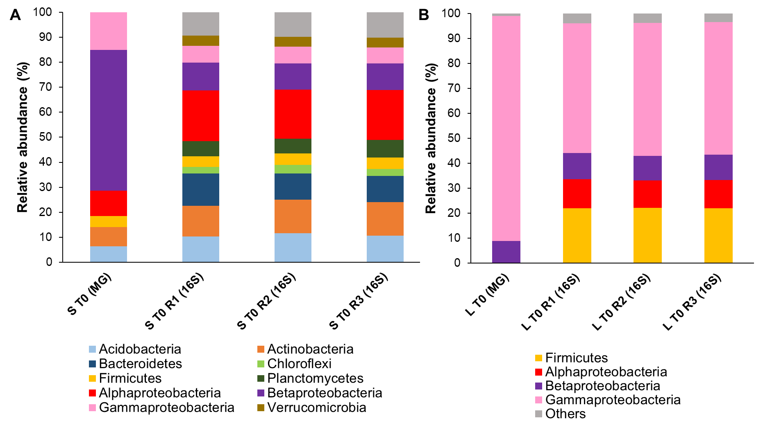

Fig S1. Bacterial diversity profile of the oil palm unenriched (T0) community at the phyla level. Bacterial community composition was analysed by 16S rRNA gene amplicon (16S) and metagenomics (MG) sequencing. A: soil T0 samples; B: phyllosphere T0 samples. Only phyla with >2% relative abundance in at least one of the samples are represented. The Proteobacteria phylum is subdivided into Alpha-, Beta- and Gammaproteobacteria classes. Bacterial phyla with <2% relative abundance are recorded as “Others”.

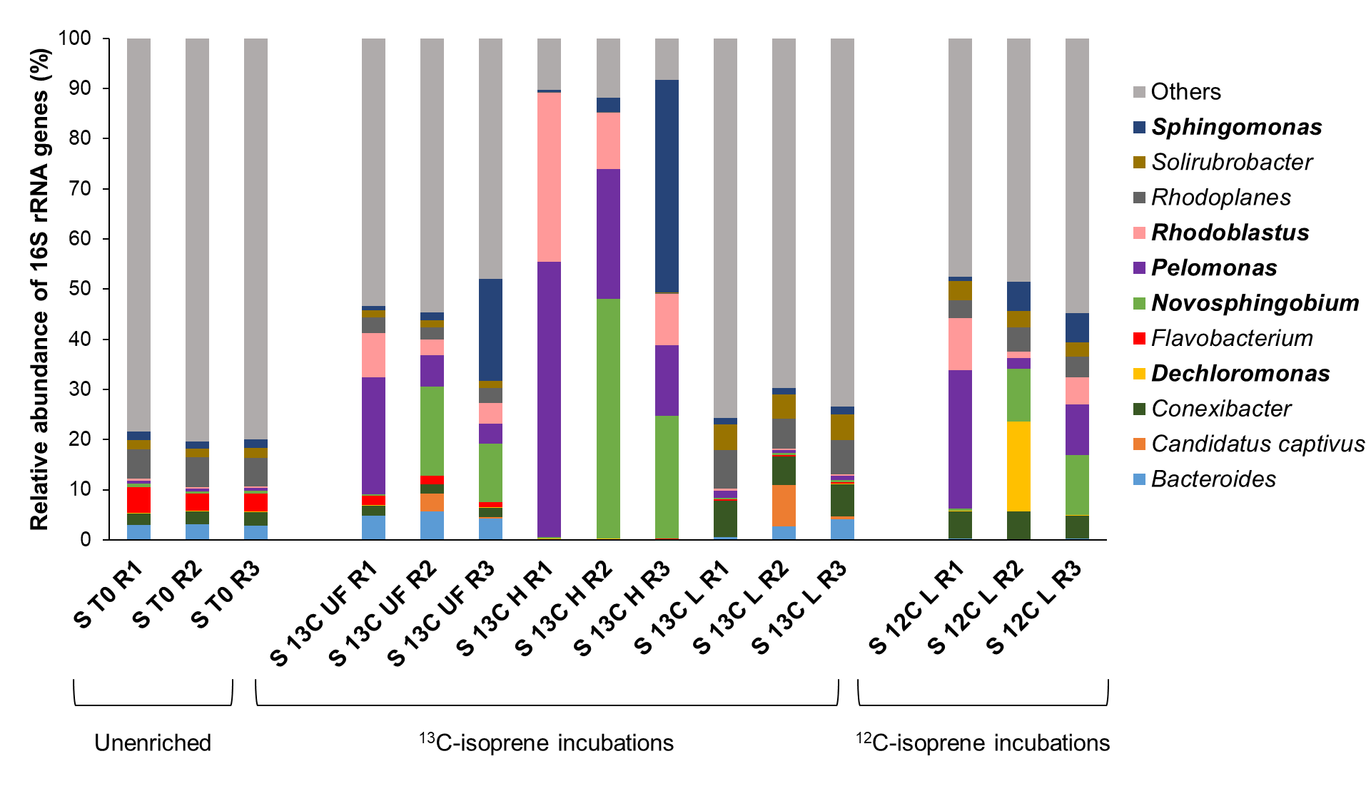
Fig S2. Bacterial community profiles of oil palm soil samples analysed by 16S rRNA gene amplicon sequencing. T0: unenriched samples; 13C UF: unfractionated DNA from ¹³C-isoprene enrichments; 13C H: heavy DNA from ¹³C-isoprene incubations; 13C L: light DNA from ¹³C-isoprene samples; 12C L: light DNA from ¹²C-isoprene control samples. Only OTUs with >5% relative abundance in at least one of the replicates are represented. Genera present at >10% in any sample are shown in bold. OTUs with <5% relative abundance are shown as “Others”.

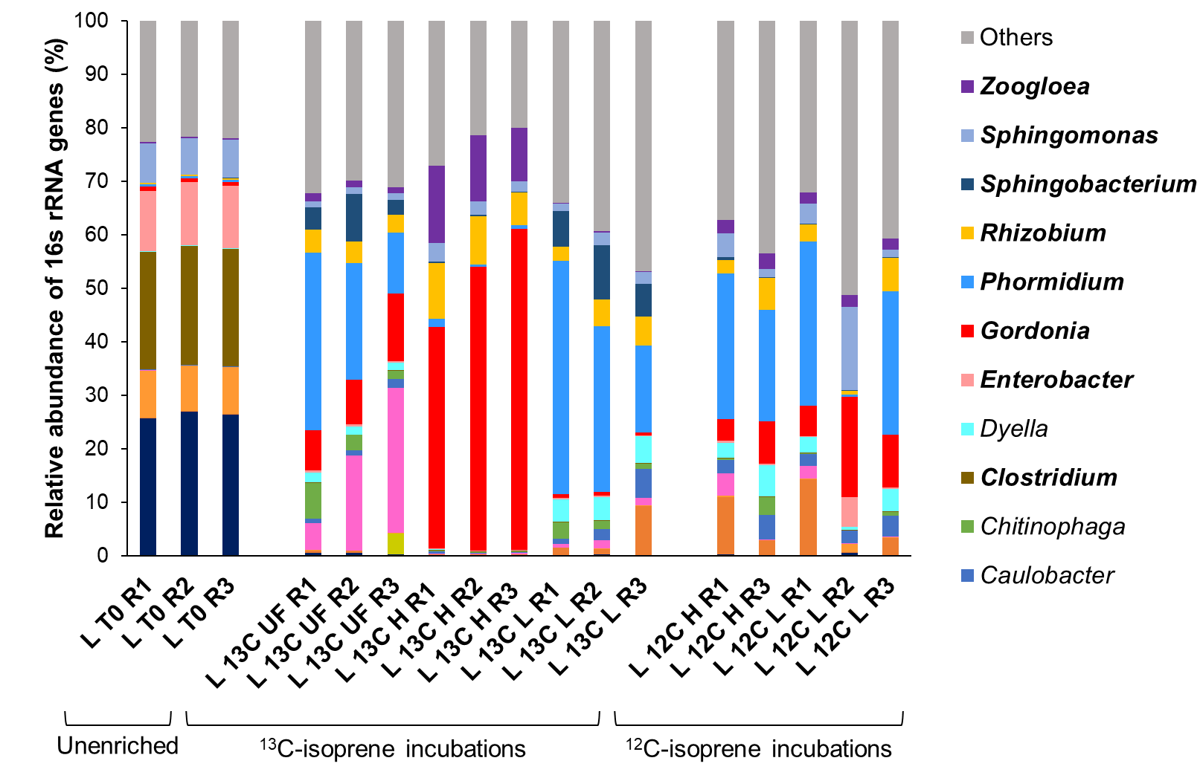

Fig S3. Bacterial community composition of oil palm leaf samples analysed by 16S rRNA gene amplicon sequencing. T0: unenriched samples; 13C UF: unfractionated DNA from ¹³C-isoprene enrichments; 13C H: heavy DNA from ¹³C-isoprene incubations; 13C L: light DNA from ¹³C-isoprene samples; 12C H: heavy DNA from ¹²C-isoprene control incubations; 12C L: light DNA from ¹²C-isoprene control samples. Only OTUs with >5% relative abundance in at least one of the replicates are represented. Genera present at >10% in any sample are shown in bold. OTUs with <5% relative abundance are recorded as “Others”.

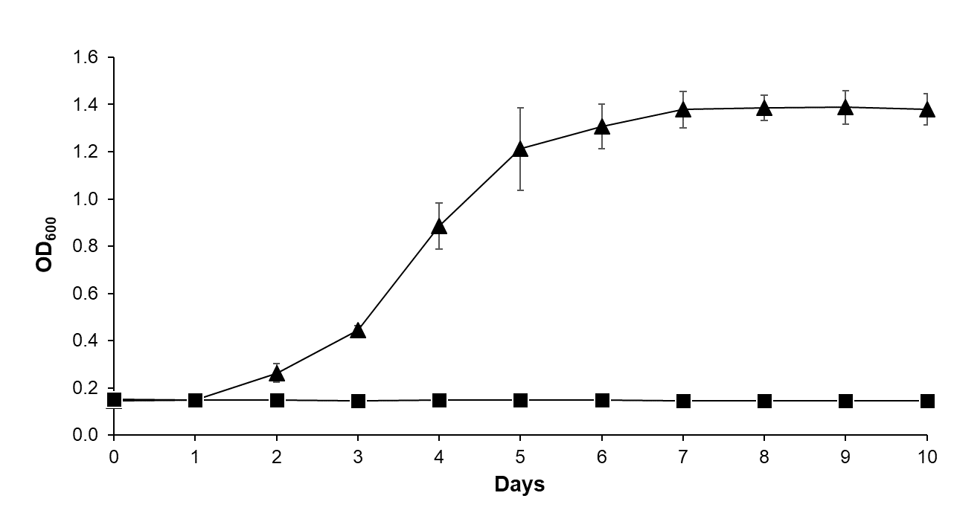

Fig S4. Growth curve of Variovorax sp. OPL2.2 on isoprene as sole carbon and energy source. Triangles: Variovorax sp. OPL2.2 cultures amended with isoprene (5%; v/v). Data points represent the average of three biological replicates with their respective standard deviations. Squares: Variovorax sp. OPL2.2 culture with no carbon source added (control; one replicate).

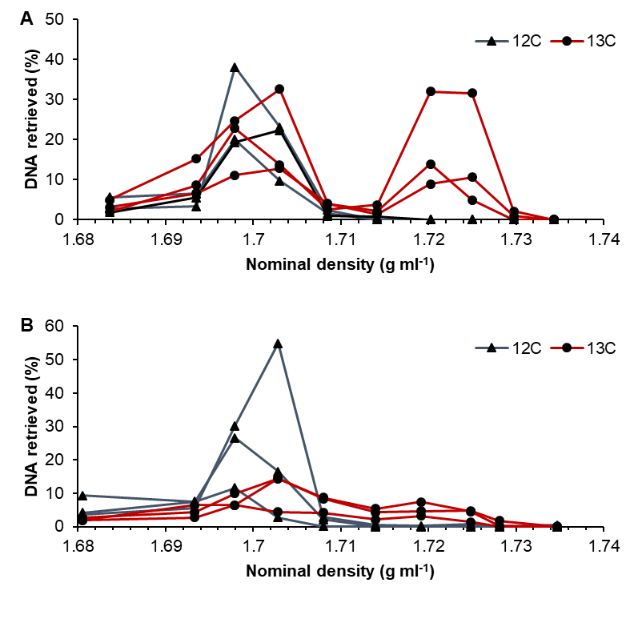
Fig S5. DNA retrieved as function of density of each fraction recovered after isopycnic ultracentrifugation. A: soil samples incubated with ¹²C (blue line) or ¹³C-isoprene (red line); B: leaf incubations with ¹²C (blue line) or ¹³C-isoprene (red line).
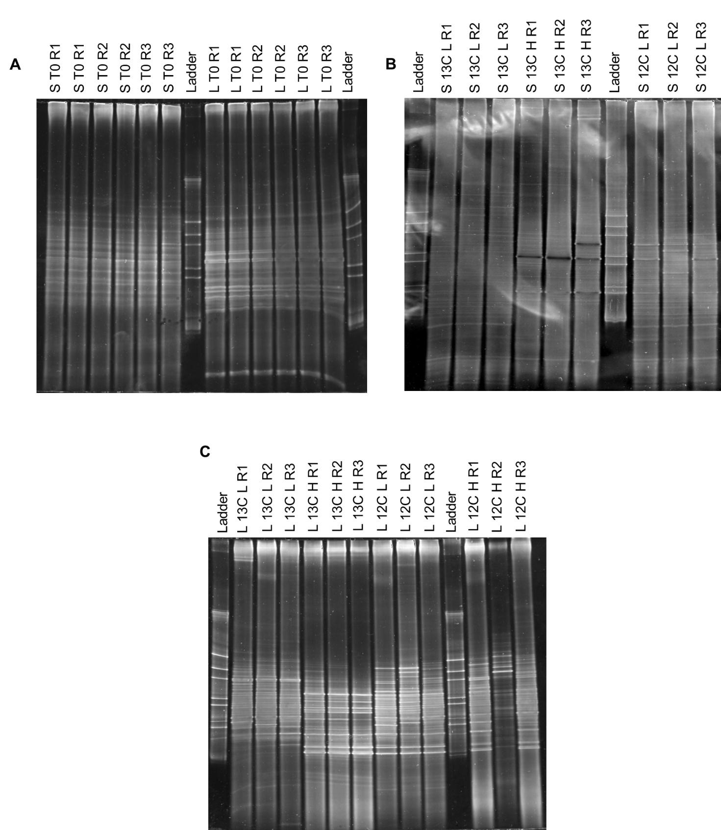
Fig S6. 16S rRNA gene profiles of oil palm soil and phyllosphere samples analysed by DGGE. A: biological replicates from unenriched soil (S T0) and phyllosphere (L T0) samples, each of which was run in duplicate. B: biological replicates from heavy (H) and light (L) soil incubations with ¹³C or ¹²C-isoprene (control). C: biological replicates from heavy (H) and light (L) leaf samples enriched ¹³C or ¹²C-isoprene.
Table S1. Relative abundance of key isoprene-degrading bacterial genera in oil palm soil and leaf samples.
Genus | S T0 | L T0 | S 13C H | L 13C H
Gordonia | 0.7 ± 0.2% | 0.8 ± 0.1% | 0.9 ± 0.1% | 51.4 ± 9.3%
Novosphingobium | 0.6 ± 0.1% | 2.8 ± 0.1% | 24.2 ± 23.8% | 0.3 ± 0.1%
Pelomonas | 0.5 ± <0.1% | 0.4 ± 0.1% | 31.7 ± 21.0% | 0.4 ± 0.1%
Rhodoblastus | 0.4 ± 0.1% | 0.2 ± <0.1% | 18.4 ± 13.3% | 0.3 ± 0.1%
Sphingomonas | 1.5 ± 0.1% | 7.1 ± 0.3% | 15.2 ± 23.6% | 2.6 ± 0.7%
Zoogloea | 0.2 ± <0.1% | 0.3 ± 0.1% | 0.3 ± 0.1% | 12.3 ± 2.2%

Relative abundance of bacterial genera in oil palm incubations was analysed by 16S rRNA gene amplicon sequencing. Values shown represent the average of three biological replicates with their respective standard deviations. S T0: unenriched soil samples; L T0: unenriched leaf samples; S 13C H: heavy DNA from soil samples enriched with ¹³C-isoprene; L 13C H: heavy DNA from leaf samples enriched with ¹³C-isoprene.

Table S2. Statistics for metagenome assemblies.
 | S T0 | S 13C H R1-2 | S 13C H R3 | L T0 | L 13C H R1-3
Contigs | 138,886 | 36,166 | 22,852 | 76,131 | 114,878
Largest contig (bp) | 75,971 | 703,868 | 1,215,493 | 732,750 | 621,426
Total length (bp) | 101,440,201 | 64,831,442 | 49,671,873 | 152,876,094 | 150,393,192
GC (%) | 63.9 | 64.9 | 64.6 | 56.5 | 66
N50 | 684 | 2,852 | 5,677 | 5,018 | 1,565
N75 | 568 | 1,078 | 1,322 | 1,171 | 798
L50 | 50,076 | 3,502 | 959 | 3,953 | 18,953
L75 | 91,069 | 13,317 | 6,174 | 21,847 | 54,079
Bins | 4 | 9 | 7 | 28 | 24

Metagenomes from unenriched soil (S T0) and leaf (L T0) samples and ¹³C-heavy fractions from soil (S 13C H R1-2 and S 13C H R3) and leaf (L 13C H R1-3) incubations were assembled with metaSPAdes using kmers 21, 33 and 55. Quality of the assemblies was analysed by MetaQUAST and bins obtained using MaxBin2.

Table S3. Metagenome assembled-genomes (MAGs) that contain genes encoding proteins homologous to IsoABCDEF (E<1e-40).
MAG | Metagenome  of origin | Size (Mbp) | N50 | Completeness  (%) | Contamination  (%) | Strain heterogeneity (%)
Novosphingobium | S 13C H R3 | 3.7 | 441,005 | 99.5 | <0.1 | 0
Rhizobiales | S 13C H R3 | 4.1 | 59,990 | 97.6 | 2.5 | 79
Gordonia polyisoprenivorans | L 13C H R1-3 | 6.1 | 194,257 | 99.8 | 0.9 | 40
Zoogloeaceae | L 13C H R1-3 | 5.2 | 49,423 | 98.7 | 2.1 | 10
Ralstonia | L 13C H R1-3 | 4.5 | 5,039 | 79 | 6.4 | 0

MAGs were reconstructed from metagenomic sequencing of ¹³C-heavy DNA from soil (S 13C H) and leaf (L 13C H) incubations with ¹³C-isoprene. MAGs completeness and contamination was assessed and taxonomically assigned using CheckM (see Methods). N50 is calculated for contigs.
Table S4. MAGs genes encoding polypeptides homologous to proteins involved in isoprene metabolism from ratified isoprene-degrading strains.

Novosphingobium MAG
Gene | Description | Closest protein from ratified isoprene degrader | Amino acid identity (%) | Coverage (%)
isoA | Hydroxylase α-subunit | IsoA from Sphingopyxis sp. OPL5 | 95.2 | 100
isoB | Hydroxylase γ-subunit | IsoB from Sphingopyxis sp. OPL5 | 100 | 85.1
isoC | Rieske-type ferredoxin | IsoC from Sphingopyxis sp. OPL5 | 100 | 78.6
isoD | Coupling protein | IsoD from Sphingopyxis sp. OPL5 | 100 | 90.6
isoE | Hydroxylase β-subunit | IsoE from Sphingopyxis sp. OPL5 | 83.7 | 100
isoF | Flavoprotein NADH reductase | IsoF from Sphingopyxis sp. OPL5 | 76.2 | 100
isoG | Racemase | IsoG from Sphingopyxis sp. OPL5 | 91.1 | 100
isoH | Dehydrogenase | IsoH from Sphingopyxis sp. OPL5 | 89.4 | 100
isoI | Glutathione-S-transferase | IsoI from Sphingopyxis sp. OPL5 | 89.8 | 100
isoJ | Glutathione-S-transferase | IsoJ from Sphingopyxis sp. OPL5 | 90.6 | 98
aldH1 | Aldehyde dehydrogenase | AldH1 from Sphingopyxis sp. OPL5 | 85.3 | 100

Rhizobiales MAG

Gene | Description | Closest protein from ratified isoprene degrader | Amino acid identity (%) | Coverage (%)
isoA | Hydroxylase α-subunit | IsoA from Sphingopyxis sp. OPL5 | 84.9 | 100
isoB | Hydroxylase γ-subunit | IsoB from Sphingopyxis sp. OPL5 | 67.4 | 97
isoC | Rieske-type ferredoxin | IsoC from Sphingopyxis sp. OPL5 | 61.2 | 92
isoD | Coupling protein | IsoD from Ramlibacter sp. WS9 | 60 | 92
isoE | Hydroxylase β-subunit | IsoE from Sphingopyxis sp. OPL5 | 54.8 | 98
isoF | Flavoprotein NADH reductase | IsoF from Sphingopyxis sp. OPL5 | 54.9 | 99
isoG | Racemase | IsoG from Sphingopyxis sp. OPL5 | 72.9 | 96
isoH | Dehydrogenase | IsoH from Sphingopyxis sp. OPL5 | 74.3 | 100
isoI | Glutathione-S-transferase | IsoI from Sphingopyxis sp. OPL5 | 72.9 | 95
isoJ | Glutathione-S-transferase | IsoJ from Sphingopyxis sp. OPL5 | 69.9 | 100
aldH1 | Aldehyde dehydrogenase | AldH1 from Sphingopyxis sp. OPL5 | 64.7 | 99

Gordonia polyisoprenovorans MAG

Gene | Description | Closest protein from ratified isoprene degrader | Amino acid identity (%) | Coverage (%)
isoA | Hydroxylase α-subunit | IsoA from Gordonia polyisoprenovorans i37 | 98.8 | 100
isoB | Hydroxylase γ-subunit | IsoB from Gordonia polyisoprenovorans i37 | 82.1 | 100
isoC | Rieske-type ferredoxin | IsoC from Gordonia polyisoprenovorans i37 | 99.1 | 100
isoD | Coupling protein | IsoD from Ramlibacter sp. WS9 | 99 | 95
isoE | Hydroxylase β-subunit | IsoE from Gordonia polyisoprenovorans i37 | 98.8 | 100
isoF | Flavoprotein NADH reductase | IsoF from Gordonia polyisoprenovorans i37 | 99.4 | 100
isoG | Racemase | IsoG from Gordonia polyisoprenovorans i37 | 98.3 | 100
isoH | Dehydrogenase | IsoH from Gordonia polyisoprenovorans i37 | 99.1 | 100
isoI | Glutathione-S-transferase | IsoI from Gordonia polyisoprenovorans i37 | 100 | 100
isoJ | Glutathione-S-transferase | IsoJ from Gordonia polyisoprenovorans i37 | 94.7 | 100
aldH1 | Aldehyde dehydrogenase | AldH1 from Gordonia polyisoprenovorans i37 | 83 | 100
aldH2 | Aldehyde dehydrogenase | AldH2 from Gordonia polyisoprenovorans i37 | 94.8 | 100
gshB | Glutathione synthetase | GshB from Gordonia polyisoprenovorans i37 | 99.1 | 98
coADR | CoA disulfide reductase | CoADR from Gordonia polyisoprenovorans i37 | 94 | 100

Zoogloeaceae MAG
Gene | Description | Closest protein from ratified isoprene degrader | Amino acid identity (%) | Coverage (%)
isoA | Hydroxylase α-subunit | IsoA from Variovorax sp. WS11 | 51.1 | 100
isoB | Hydroxylase γ-subunit | IsoB from Ramlibacter sp. WS9 | 51.7 | 97
isoC | Rieske-type ferredoxin | IsoC from Ramlibacter sp. WS9 | 51 | 93
isoD | Coupling protein | IsoD from Gordonia sp. OPL2 | 44.9 | 85
isoE | Hydroxylase β-subunit | IsoE from Ramlibacter sp. WS9 | 43 | 85
isoF | Flavoprotein NADH reductase | IsoF from Ramlibacter sp. WS9 | 39 | 97

Ralstonia MAG
Gene | Description | Closest protein from ratified isoprene degrader | Amino acid identity (%) | Coverage (%)
isoA | Hydroxylase α-subunit | IsoA from Variovorax sp. WS11 | 48.3 | 100
isoB | Hydroxylase γ-subunit | IsoB from Ramlibacter sp. WS9 | 52.5 | 83
isoC | Rieske-type ferredoxin | IsoC from Ramlibacter sp. WS9 | 47.6 | 92
isoD | Coupling protein | IsoD from Rhodococcus opacus PD630 | 44.2 | 81
isoE | Hydroxylase β-subunit | IsoE from Nocardioides sp. WS12 | 45.1 | 94
isoF | Flavoprotein NADH reductase | IsoF from Rhodococcus opacus PD630 | 39.1 | 100

Homology of the polypeptides encoded by genes recovered from MAGs to proteins from ratified isoprene degraders was analysed by BLASTx (see Methods) and is expressed as amino acid identity.

Table S5. ASVs retrieved from isoA amplicon sequencing analysis of ¹³C-heavy DNA from soil and leaf incubations.
 | Closest IsoA sequence | Source | Amino acid  Identity (%) | Cover (%) | Soil Samples  RA (%) | Leaf Samples  RA (%)
ASV_1 | Gordonia i37 | Isolate | 100 | 99 | 5.3±4.6 | 91.9±7.3
ASV_2 | Rhizobiales | Metagenome | 100 | 99 | 35.5±6.1 | ND
ASV_4 | Rhizobiales | Metagenome | 92.5 | 99 | 6.1±5.3 | ND
ASV_5 | Rhizobiales | Metagenome | 100 | 99 | 8.9±8.7 | ND
ASV_7 | Rhizobiales | Metagenome | 100 | 99 | 4.2±3.7 | ND
ASV_8 | Rhizobiales | Metagenome | 71 | 99 | 2.2±3.8 | ND
ASV_9 | Rhizobiales | Metagenome | 98.7 | 99 | 1.8±3.1 | ND
ASV_11 | Novosphingobium | Metagenome | 100 | 99 | 3.7±3.4 | ND
ASV_12 | Rhizobiales | Metagenome | 98.9 | 99 | 1.4±1.3 | ND
ASV_13 | Rhodococcus AD45 | Isolate | 100 | 99 | 3.9±3.4 | 0.9±1.3
ASV_14 | Rhizobiales | Metagenome | 98.1 | 99 | 1.8±0.4 | ND
ASV_15 | Rhizobiales | Metagenome | 96.2 | 99 | 2.5±2.4 | ND
ASV_16 | Rhodococcus AD45 | Isolate | 84.91 | 99 | 2.9±2.1 | ND
ASV_17 | Rhizobiales | Metagenome | 92.45 | 99 | 0.6±1 | ND
ASV_18 | Rhizobiales | Metagenome | 98.9 | 99 | 2.6±4.5 | ND
ASV_19 | Rhizobiales | Metagenome | 100 | 99 | 1.8±3.1 | ND
ASV_21 | Rhizobiales | Metagenome | 98.7 | 99 | 0.3±0.6 | ND
ASV_23 | Rhodococcus AD45 | Isolate | 99.37 | 99 | 1.2±1 | ND
ASV_24 | Rhizobiales | Metagenome | 100 | 99 | 0.2±0.3 | ND
ASV_26 | Rhizobiales | Metagenome | 98.1 | 99 | 0.2±0.4 | ND
ASV_29 | Rhizobiales | Metagenome | 100 | 99 | 1.8±3.2 | ND
ASV_30 | Rhizobiales | Metagenome | 98.7 | 99 | 0.1±0.3 | ND
ASV_34 | Gordonia i37 | Isolate | 98.1 | 99 | ND | 3.4±5.6
ASV_37 | Rhizobiales | Metagenome | 96.2 | 99 | 0.1±0.2 | ND
ASV_44 | Novosphingobium | Metagenome | 99.4 | 99 | 2.6±4.6 | ND
ASV_53 | Rhizobiales | Isolate | 99.4 | 95 | 0.5±0.8 | ND
ASV_59 | Gordonia i37 | Isolate | 99.4 | 96 | ND | 1.8±3
ASV_85 | Gordonia i37 | Isolate | 99.4 | 96 | ND | 2.7±3.8
ASV_110 | Rhizobiales | Metagenome | 99.4 | 100 | 0.1±0.2 | ND
ASV_114 | Gordonia i37 | Isolate | 100 | 99 | ND | 0.9±1.3
ASV_122 | Rhizobiales | Metagenome | 95.6 | 100 | 0.1±0.2 | ND
ASV_160 | Novosphingobium | Metagenome | 100 | 99 | 0.2±0.4 | ND
ASV_168 | Gordonia i37 | Isolate | 93.1 | 100 | ND | 1.7±3.0

Amino acid identity of ASVs retrieved from soil (S 13C H) and phyllosphere (L 13C H) samples to IsoA from ratified isoprene-degrading strains or MAGs reconstructed from metagenomes analysed in this study was determined by BLASTx (see Methods). Relative abundance (RA) of each ASV in heavy fractions from ¹³C-isoprene soil and leaf incubations represent the average of three biological replicates with their respective standard deviations. ND: not detected.
Table S6. Location of oil palm trees used to set up soil and leaf DNA-SIP incubations.
Sample | Latitude (N) | Longitude (E) | Elevation (m)
Palong A | 2° 54' 03'' | 102° 39' 54'' | 55
Palong B | 2° 54' 06'' | 102° 39' 33'' | 63
Palong C | 2° 54' 03'' | 102° 38' 56'' | 33

Soil and leaf samples were collected from the same trees to allow comparison of the diversity of isoprene degraders from both environments.

