Additional file 2: Figure S5: Analysis, showing the distance to centroid and beta-dispersion, based on Bray–Curtis dissimilarity between All AMs in a) all children and four AMs separately; and in b) boys and c) girls separately. Permutational analysis of variance (PERMANOVA) test adjusted for gender (not in gender specific analysis), age and language.
a)

AMs for all children | Distance centroid | Beta dispersion (Low, Medium, High)
Amoxicillin-clavulanate | 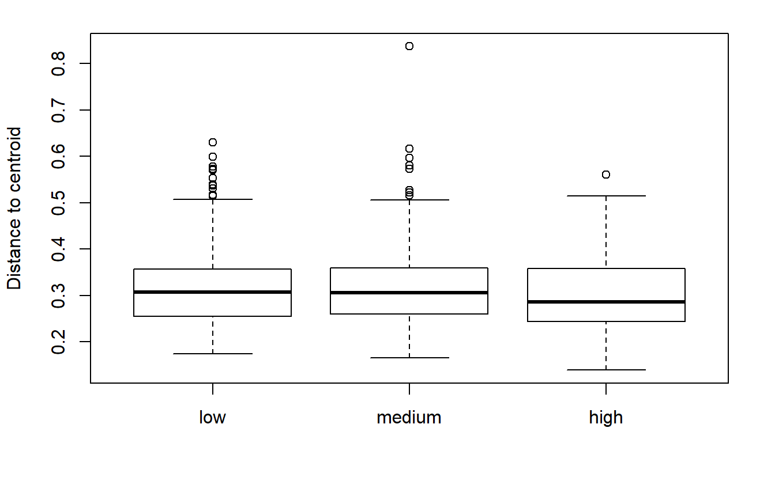 | 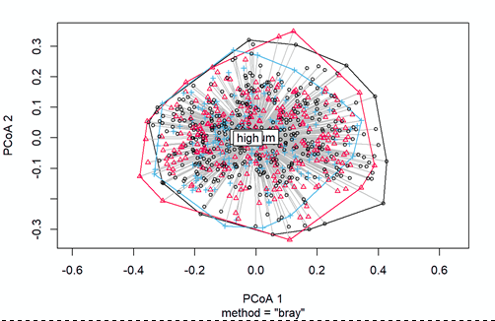
Phenoxymethylpenicillin | 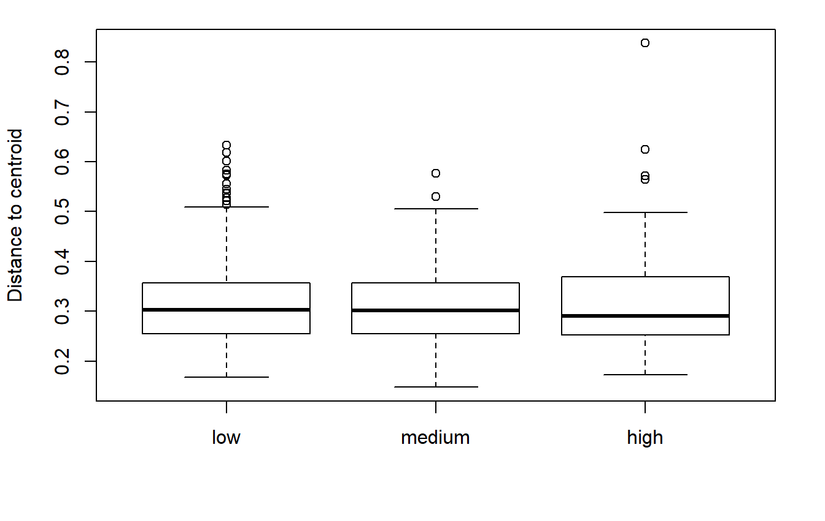 | 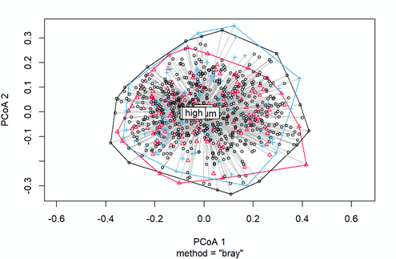

b)

AMs in boys | Distance to centroids | Beta dispersion (Low, Medium, High)
Amoxicillin-clavulanate | 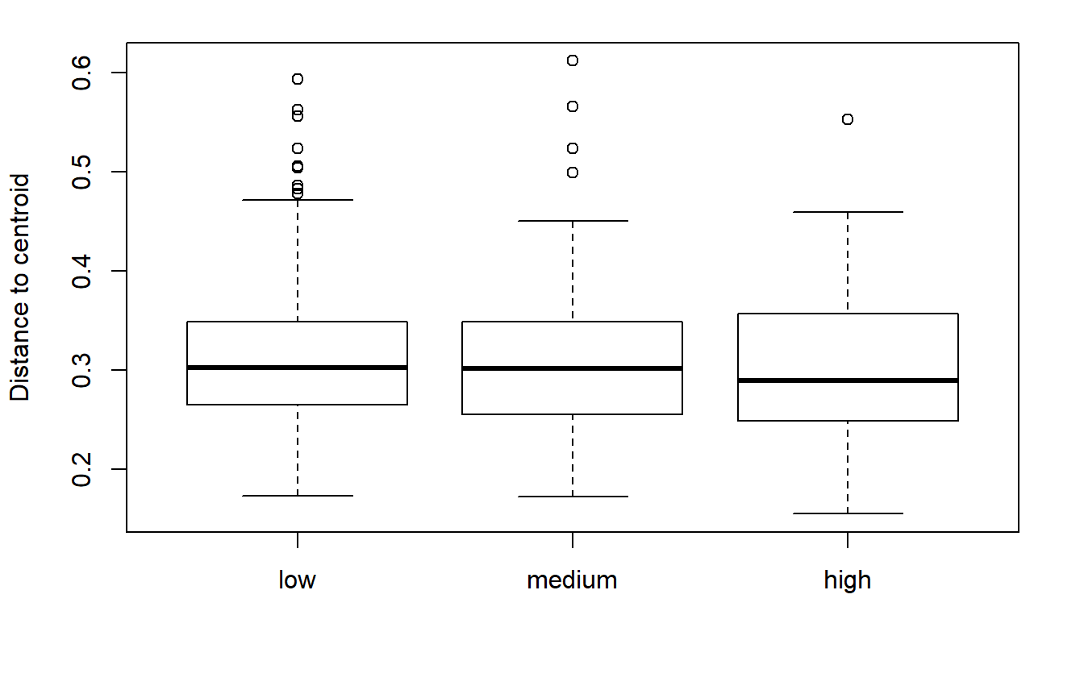 | 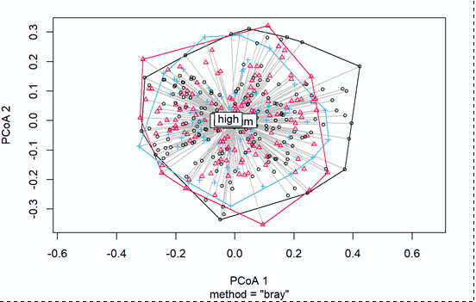l̥
Phenoxymethylpenicillin | 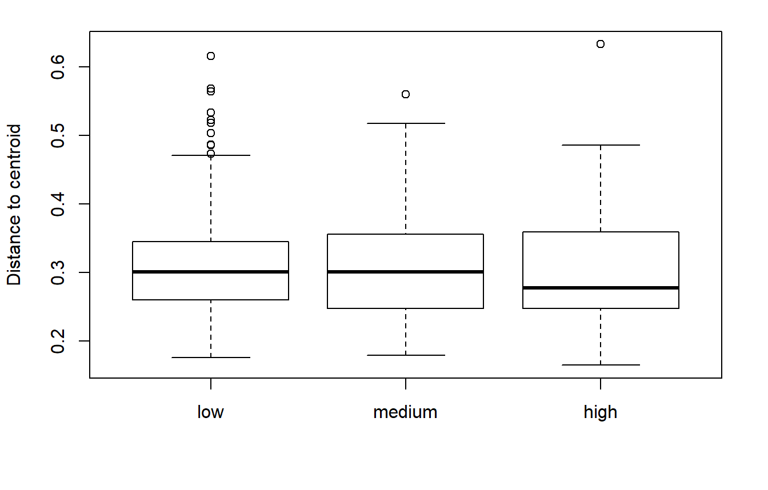 | 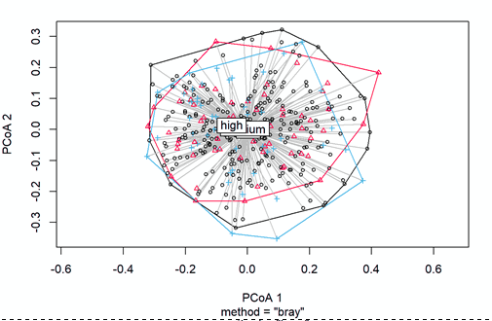

c)

AMs in girls | Distance to centroids | Beta dispersion (Low, Medium, High)
All AMs | 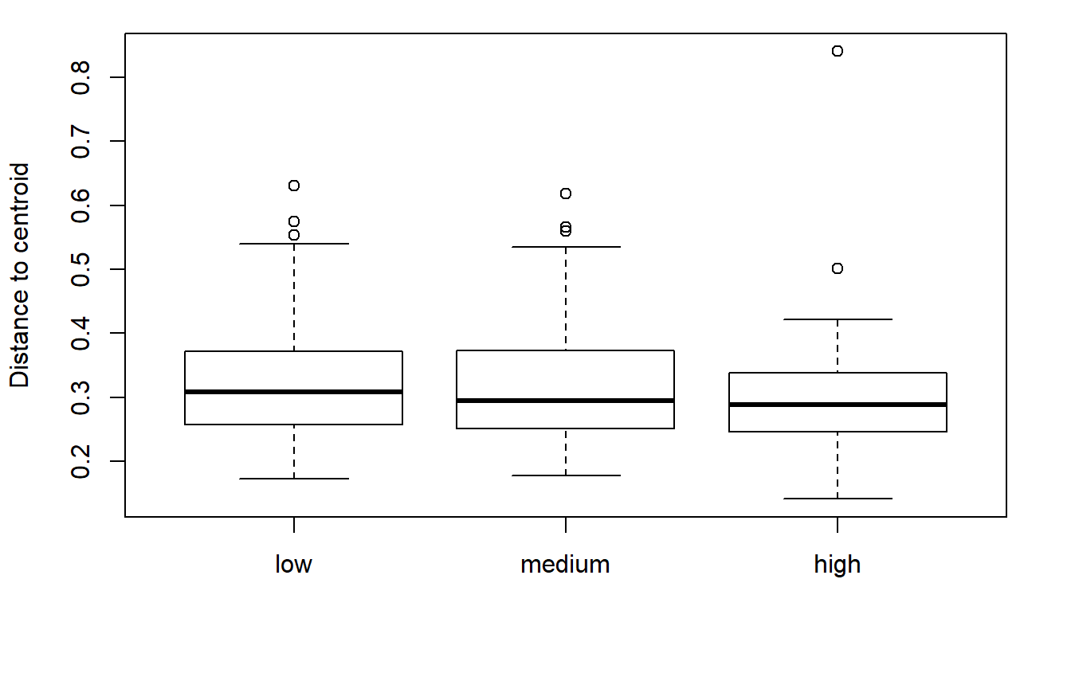 | 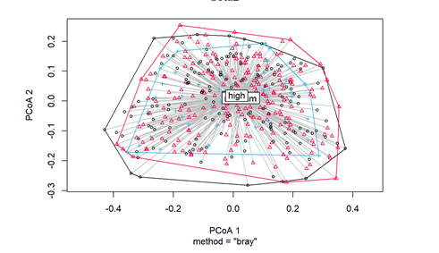
Amoxicillin | 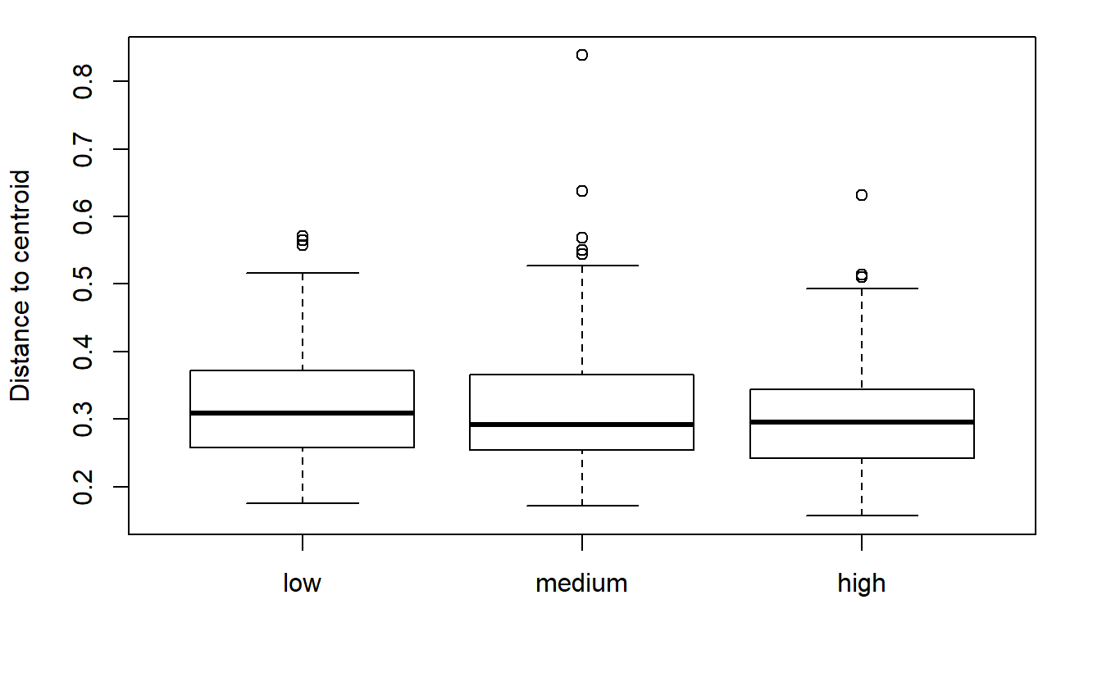 | 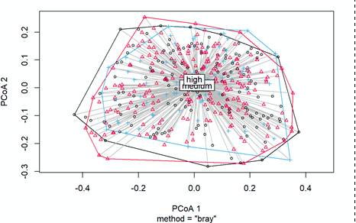
Azithromycin | 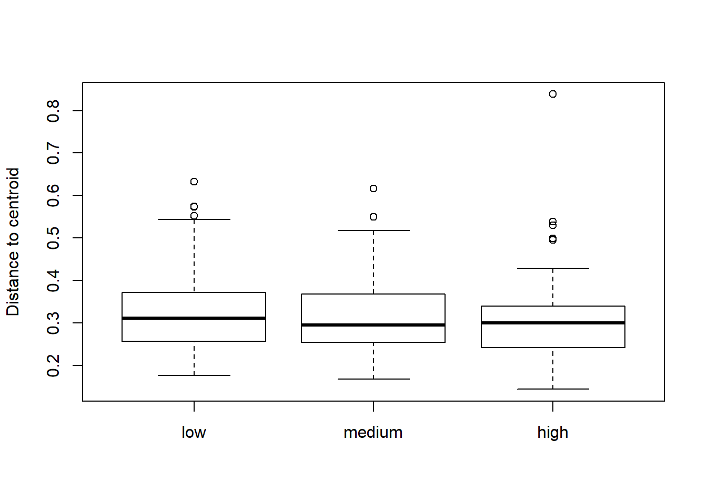 | 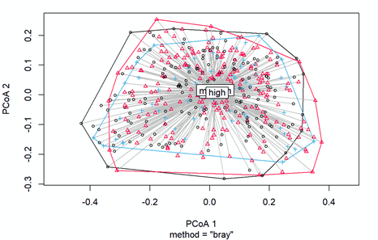
Amoxicillin-clavulanate | 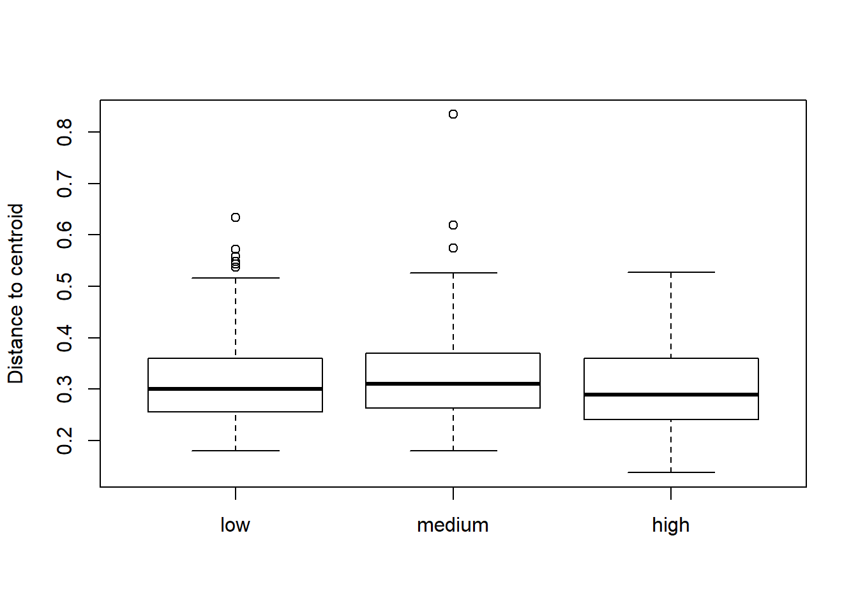 | 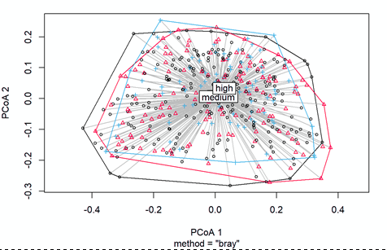
Phenoxymethylpenicillin | 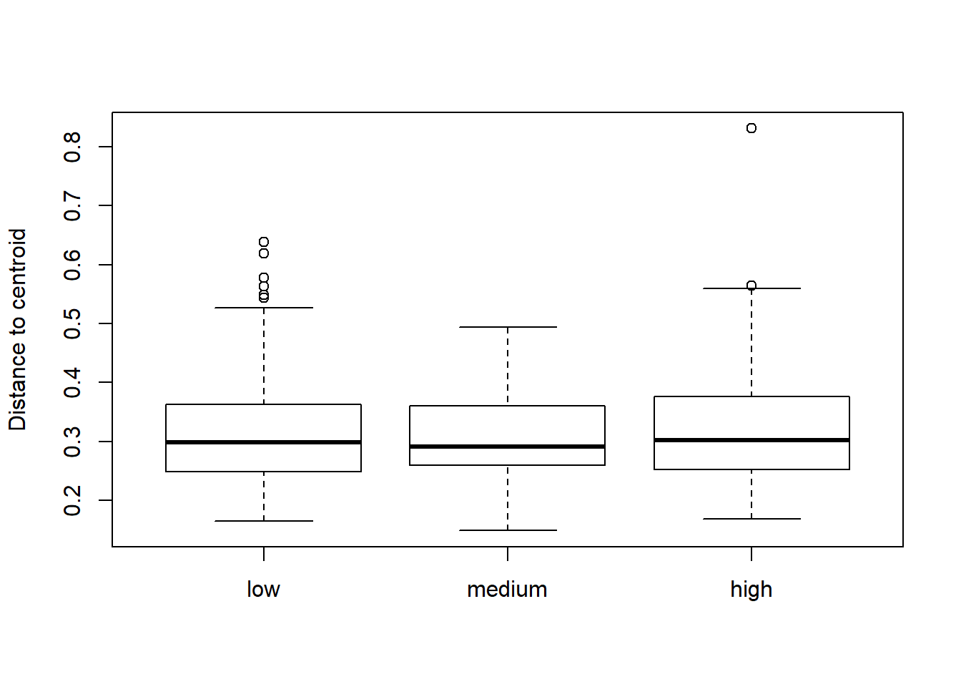 | 