SUPPLEMENTARY TABLES

Suppl. Table 1. Single-nucleotide polymorphisms (SNP) associated with the OTU variables.
Trait | Chr | SNP | bp | A1 | A2 | Freq | b | se | p | log10(p)
OTU1 | 5 | ctg7180001925291_748_SCT | 27518103 | C | T | 0.10 | -0.51 | 0.12 | 2.49E-05 | -4.6
 | 5 | ctg7180001311517_3981_SAG | 29290387 | G | A | 0.10 | -0.46 | 0.11 | 2.51E-05 | -4.6
 | 5 | ctg7180001833723_2640_SAG | 56739234 | A | G | 0.01 | -1.44 | 0.28 | 4.53E-07 | -6.3
 | 14 | ctg7180001903206_2590_SCT | 5592915 | C | T | 0.15 | -0.45 | 0.10 | 1.81E-06 | -5.7
 | 19 | ctg7180001841090_969_SAG | 42066887 | G | A | 0.02 | -1.03 | 0.23 | 8.21E-06 | -5.1
 | 19 | ctg7180001800309_4785_SCT | 67320228 | C | T | 0.09 | -0.55 | 0.13 | 1.70E-05 | -4.8
 | 19 | ctg7180001645427_1176_SAG | 75579801 | A | G | 0.02 | -1.16 | 0.27 | 1.57E-05 | -4.8
OTU2 | 1 | ctg7180001908955_3685_SAG | 4697317 | G | A | 0.06 | -0.46 | 0.11 | 2.11E-05 | -4.7
 | 5 | ctg7180001722113_3376_SGT | 25219965 | G | T | 0.01 | -1.05 | 0.21 | 7.26E-07 | -6.1
 | 5 | ctg7180001672687_10612_SAG | 28647949 | A | G | 0.01 | -1.05 | 0.21 | 7.26E-07 | -6.1
 | 6 | ctg7180001847439_3403_SAC | 32454164 | A | C | 0.03 | -0.59 | 0.14 | 2.32E-05 | -4.6
 | 6 | ctg7180001828921_349_SAG | 64415855 | G | A | 0.01 | -0.96 | 0.20 | 1.30E-06 | -5.9
 | 11 | ctg7180001900871_1769_SCT | 85379984 | T | C | 0.08 | -0.39 | 0.09 | 1.13E-05 | -4.9
 | 12 | ctg7180001666651_1965_SAC | 12523402 | A | C | 0.03 | -0.70 | 0.16 | 1.56E-05 | -4.8
 | 12 | ctg7180001840586_4279_SCT | 43076320 | C | T | 0.07 | -0.47 | 0.10 | 1.92E-06 | -5.7
 | 12 | ctg7180001839373_5142_SAC | 54225053 | C | A | 0.01 | -1.14 | 0.21 | 8.12E-08 | -7.1
 | 12 | ctg7180001484203_1236_SAC | 68394895 | C | A | 0.02 | -1.09 | 0.20 | 9.88E-08 | -7.0
 | 15 | ctg7180001298386_4207_SGT | 20950022 | T | G | 0.02 | -0.95 | 0.21 | 3.77E-06 | -5.4
 | 15 | ctg7180001878210_7094_SAG | 36237432 | A | G | 0.02 | -0.78 | 0.18 | 1.97E-05 | -4.7
 | 22 | ctg7180001807745_17982_SAC | 34245759 | C | A | 0.02 | -1.08 | 0.21 | 1.40E-07 | -6.9
 | 24 | ctg7180001301776_10058_SAG | 26185685 | A | G | 0.10 | -0.39 | 0.09 | 8.01E-06 | -5.1
 | 29 | ctg7180001835668_5175_SAC | 35464325 | A | C | 0.04 | -0.76 | 0.13 | 6.34E-09 | -8.2
 | 29 | ctg7180001540342_979_SAC | 37759078 | C | A | 0.13 | -0.32 | 0.07 | 1.51E-05 | -4.8
OTU5 | 7 | ctg7180001798708_11367_SCT | 14075405 | C | T | 0.51 | 0.27 | 0.06 | 2.56E-05 | -4.6
 | 7 | ctg7180001798708_5931_SAG | 14080841 | G | A | 0.40 | -0.28 | 0.07 | 3.62E-05 | -4.4
 | 15 | ctg7180001298386_4207_SGT | 20950022 | T | G | 0.02 | -1.15 | 0.26 | 1.41E-05 | -4.9
OTU6 | 3 | ctg7180001338507_1900_SCT | 12338431 | C | T | 0.36 | 0.17 | 0.04 | 1.47E-05 | -4.8
 | 3 | ctg7180001916975_10480_SGT | 26091556 | T | G | 0.43 | 0.18 | 0.04 | 8.24E-06 | -5.1
OTU7 | 5 | ctg7180001841488_1545_SCT | 8907693 | C | T | 0.15 | 0.38 | 0.08 | 5.82E-06 | -5.2

Suppl. Table 2. Regression estimates, standard errors, F- and p-values when regressing OTUs on growth, metabolism, and feed efficiency variables. The model also contained regression on day and random effects of animal (utilizing genomic relationships), and tank for which variance components are included.
Dependent variable | Variables | Estimate | Stderr | F-value | p-value | Variance component
WG | Day | 3.338 | 0.177 | 355.73 | <0.005
 | OTU1 | -0.324 | 0.376 | 0.15 | NS
 | OTU2 | 2.191 | 1.199 | 0.04 | NS
 | OTU3 | -1.352 | 0.624 | 4.66 | <0.05
 | OTU5 | -0.743 | 0.535 | 1.78 | NS
 | OTU6 | -0.440 | 0.866 | 0.26 | NS
 | OTU7 | 0.179 | 0.492 | 0.30 | NS
 | Tank |  |  |  |  | 13.84 ± 3.25
 | Animal |  |  |  |  | 5.54 ± 0.69
RG | Day | 9.969 | 0.522 | 365.90 | <0.005
 | OTU1 | 0.983 | 0.854 | 3.64 | NS
 | OTU2 | -3.500 | 2.715 | 0.01 | NS
 | OTU3 | 1.118 | 1.410 | 2.04 | NS
 | OTU5 | -0.149 | 1.214 | 0.06 | NS
 | OTU6 | 1.094 | 1.963 | 0.31 | NS
 | OTU7 | 2.121 | 1.117 | 3.29 | NS
 | Tank |  |  |  |  | 122.00 ± 26.75
 | Animal |  |  |  |  | 14.56 ± 2.56
AMC | Day | 0.270 | 0.027 | 101.92 | <0.005
 | OTU1 | 0.004 | 0.006 | 0.01 | NS
 | OTU2 | -0.020 | 0.020 | 0.00 | NS
 | OTU3 | 0.006 | 0.010 | 0.42 | NS
 | OTU5 | 0.001 | 0.009 | 0.08 | NS
 | OTU6 | 0.010 | 0.014 | 0.49 | NS
 | OTU7 | 0.007 | 0.008 | 0.55 | NS
 | Tank |  |  |  |  | 0.48 ± 0.11
 | Animal |  |  |  |  | 0.41x10⁻³ ± 1.03x10⁻⁴
AMN | Day | 0.288 | 0.019 | 230.96 | <0.005
 | OTU1 | 0.002 | 0.014 | 0.66 | NS
 | OTU2 | -0.048 | 0.045 | 0.59 | NS
 | OTU3 | 0.018 | 0.023 | 0.99 | NS
 | OTU5 | 0.015 | 0.020 | 0.85 | NS
 | OTU6 | 0.020 | 0.032 | 0.37 | NS
 | OTU7 | 0.017 | 0.018 | 0.57 | NS
 | Tank |  |  |  |  | 0.17 ± 0.04
 | Animal |  |  |  |  | 0.41x10⁻² ± 7.08x10⁻⁴
ALC | Day | 0.088 | 0.028 | 9.78 | <0.005
 | OTU1 | 0.004 | 0.004 | 0.29 | NS
 | OTU2 | -0.014 | 0.013 | 0.08 | NS
 | OTU3 | -0.004 | 0.007 | 0.34 | NS
 | OTU5 | 0.005 | 0.006 | 1.22 | NS
 | OTU6 | 0.009 | 0.010 | 0.89 | NS
 | OTU7 | 0.007 | 0.005 | 1.21 | NS
 | Tank |  |  |  |  | 1.83 ± 0.41
 | Animal |  |  |  |  | 0.18x10⁻³ ± 4.52x⁻⁴

Suppl. Table 2. Continued

Dependent variable | Variables | Estimate | Stderr | F-value | p-value | Variance component
ALN | Day | 0.445 | 0.032 | 191.05 | <0.005
 | OTU1 | 0.013 | 0.015 | 0.05 | NS
 | OTU2 | -0.061 | 0.047 | 0.00 | NS
 | OTU3 | 0.007 | 0.024 | 0.52 | NS
 | OTU5 | 0.012 | 0.021 | 0.88 | NS
 | OTU6 | 0.024 | 0.034 | 0.49 | NS
 | OTU7 | 0.034 | 0.019 | 2.58 | NS
 | Tank |  |  |  |  | 0.51 ± 0.11
 | Animal |  |  |  |  | 0.37x10⁻² ± 7.42x10⁻⁴
AAC | Day | 0.082 | 0.019 | 17.95 | <0.005
 | OTU1 | 0.007 | 0.003 | 1.39 | NS
 | OTU2 | -0.016 | 0.009 | 2.15 | NS
 | OTU3 | -0.001 | 0.005 | 1.31 | NS
 | OTU5 | 0.006 | 0.004 | 4.63 | <0.05
 | OTU6 | -0.001 | 0.007 | 0.01 | NS
 | OTU7 | 0.010 | 0.004 | 8.53 | <0.005
 | Tank |  |  |  |  | 0.90 ± 0.20
 | Animal |  |  |  |  | 0.87x10⁻⁴ ± 2.21x10⁻⁴
IFCR_AMC | Day | 0.231 | 0.020 | 130.26 | <0.005
 | OTU1 | -0.024 | 0.023 | 2.34 | NS
 | OTU2 | 0.053 | 0.072 | 0.21 | NS
 | OTU3 | -0.020 | 0.037 | 1.32 | NS
 | OTU5 | 0.019 | 0.032 | 0.09 | NS
 | OTU6 | -0.009 | 0.052 | 0.03 | NS
 | OTU7 | -0.044 | 0.030 | 2.25 | NS
 | Tank |  |  |  |  | 0.19 ± 0.04
 | Animal |  |  |  |  | 0.24x10⁻² ± 1.08x10⁻³
IFCR_AMN | Day | 0.554 | 0.047 | 138.65 | <0.005
 | OTU1 | -0.086 | 0.049 | 1.71 | NS
 | OTU2 | 0.149 | 0.153 | 1.61 | NS
 | OTU3 | -0.049 | 0.079 | 1.18 | NS
 | OTU5 | 0.083 | 0.069 | 0.85 | NS
 | OTU6 | -0.057 | 0.111 | 0.26 | NS
 | OTU7 | -0.105 | 0.063 | 2.47 | NS
 | Tank |  |  |  |  | 1.01 ± 0.21
 | Animal |  |  |  |  | 0.64x10⁻² ± 4.43x10⁻³
IFER_AMC | Day | 0.365 | 0.021 | 297.49 | <0.005
 | OTU1 | 0.043 | 0.026 | 5.55 | <0.03
 | OTU2 | -0.101 | 0.083 | 0.41 | NS
 | OTU3 | 0.018 | 0.043 | 1.34 | NS
 | OTU5 | -0.023 | 0.037 | 0.03 | NS
 | OTU6 | 0.035 | 0.060 | 0.34 | NS
 | OTU7 | 0.081 | 0.034 | 5.22 | <0.03
 | Tank |  |  |  |  | 0.20 ± 0.04
 | Animal |  |  |  |  | 0.43x10⁻² ± 1.51x10⁻³
IFER_AMN | Day | 0.149 | 0.009 | 273.21 | <0.005
 | OTU1 | 0.020 | 0.009 | 3.89 | <0.05
 | OTU2 | -0.026 | 0.027 | 2.86 | NS
 | OTU3 | 0.001 | 0.014 | 0.64 | NS
 | OTU5 | -0.016 | 0.012 | 0.79 | NS
 | OTU6 | 0.008 | 0.020 | 0.16 | NS
 | OTU7 | 0.027 | 0.011 | 5.83 | <0.03
 | Tank |  |  |  |  | 0.04 ± 7.86x10⁻³
 | Animal |  |  |  |  | 0.29x10⁻³ ± 1.51x10⁻⁴

SUPPLEMENTARY FIGURES
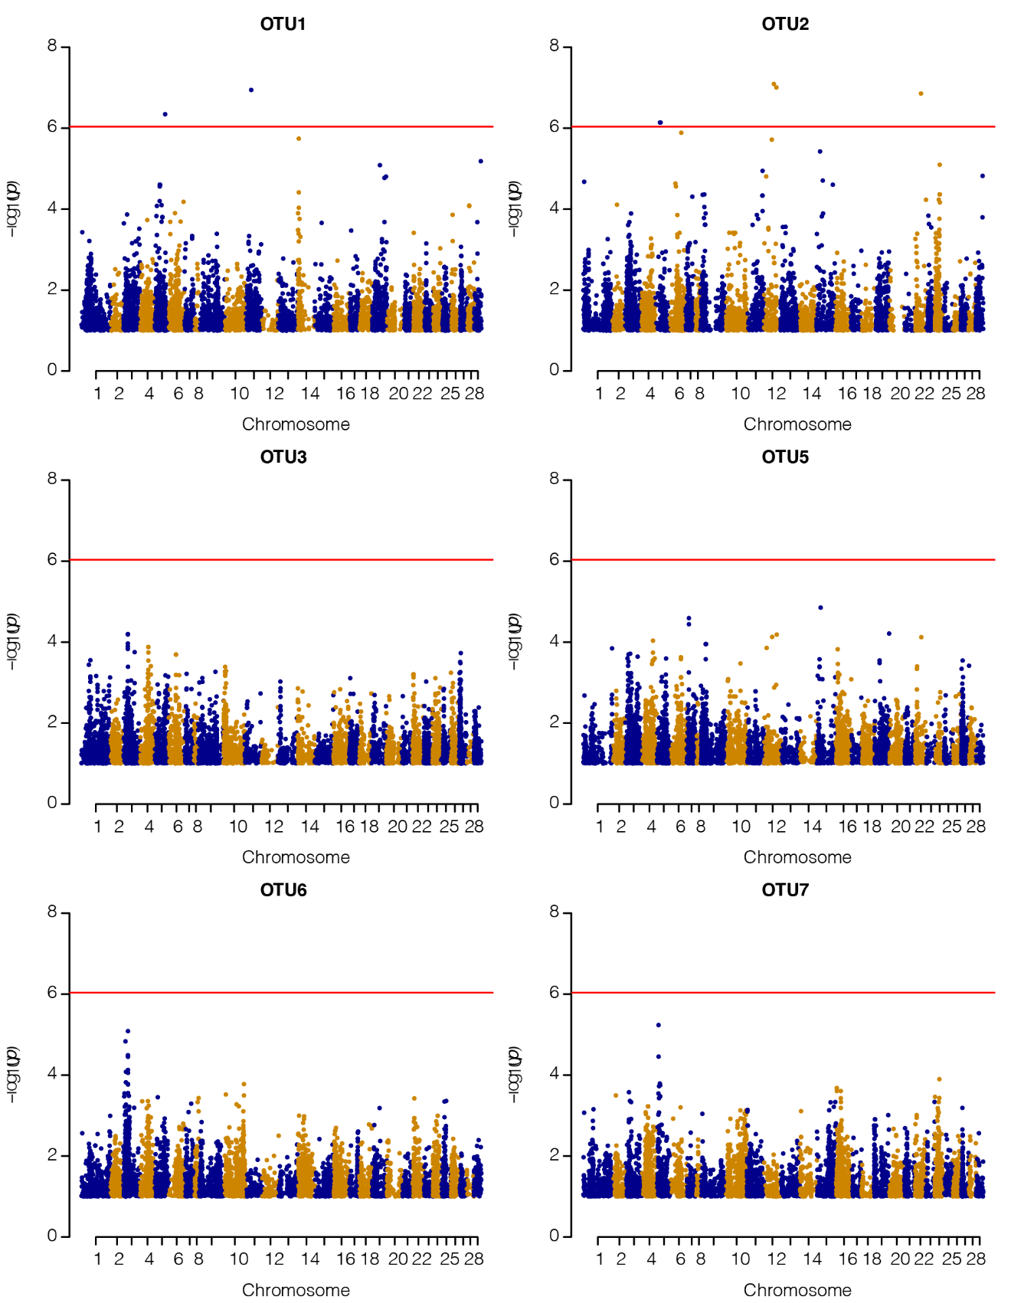
Suppl. Fig. 1. Genome-wide Manhattan plot for the different OTUs. The horizontal line represents the genome-wide Bonferroni -log₁₀ (p) = 6.03 threshold.
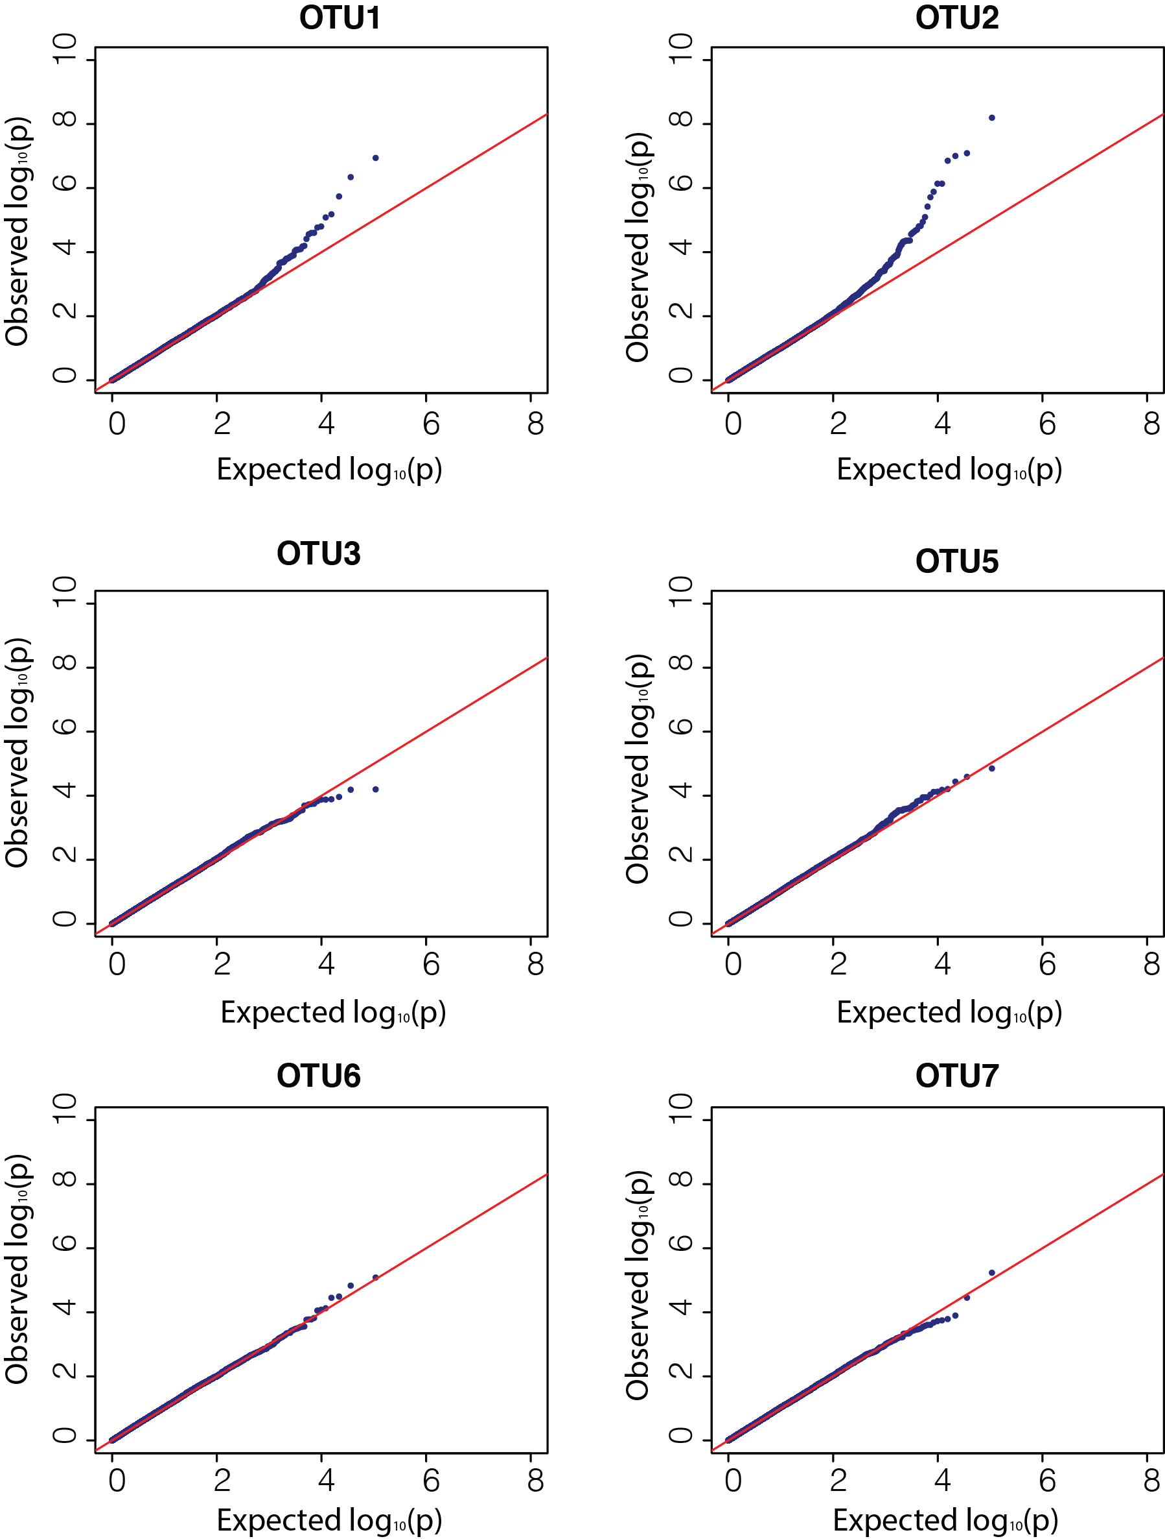
Suppl. Fig. 2. Q-Q plots from genome-wide association analyses of the different OTUs.

