Supporting Information
Article title: The bacterial communities of Alaskan mosses and their contributions to N₂-fixation
Authors: Hannah Holland-Moritz, Julia E. M. Stuart, Lily R. Lewis, Samantha N. Miller, Michelle C. Mack, Jose Miguel Ponciano, Stuart F. McDaniel, Noah Fierer
Article acceptance date: NA

List of supplementary tables and figures and their locations
Table S1 A list of all of the moss species sampled and the number of samples collected for each.
Table S2 A list of all of the moss species sampled and where and how many samples were collected for each. The species sampled include 26 moss species. (Submitted separately)
Table S3 List of sites and site characteristics. 10 sites around Fairbanks, AK, USA, and four sites around Toolik Lake, AK, USA were sampled in 2016 and an additional 10 sites from around Anchorage, AK, USA, were added in 2017. Sites were chosen to capture a breadth of common habitat types in boreal and tundra ecosystems
Table S4 Summary of the evidence for N₂-fixation for each of the 22 phylotypes positively correlated with N₂-fixation rate. (Submitted separately)
Table S5 Relative abundances of microbial families in each host species. (Submitted separately)
Table S6 Table summarizing the results of a Mantel test between moss microbial communities and moss phylogenetic relatedness. Microbial communities are significantly correlated with phylogenetic structure. An analysis of Sphagnum shows that these results are primarily driven by phylogenetic structuring within the Sphagnum branch of the phylogeny.
Table S7 Results of PERMANOVAs run on eight individual sites showing the effect of species in explaining microbial community differences.
Fig. S1 The best environmental predictors shaping microbial communities for each of the seven most abundant host species.
Table S8 Results of PERMANOVAs run on seven individual species showing the effect of site in explaining microbial community differences.
Table S9 Table summarizing the correlations between N₂-fixation rate and the 22 putative N₂-fixing phylotypes. (Submitted separately)
Table S10 Table summarizing the findings from nine studies about prevalence and strength of host phylogenetic structuring of plant-microbial communities. (Submitted separately)

Table S1 A list of all of the moss species sampled and the number of samples collected for each. The species sampled include 26 moss species and one liverwort (used as a phylogenetic outgroup).

Moss Species | Number of Samples
Hyocomium splendens (Hedw.) Schimp. | 87
Pleurozium schreberi (Brid.) Mitt | 80
Aulacomnium palustre (Hedw.) Schwägr. | 47
Ptilium crista-castrensis (Hedw.) De Not. | 36
Polytrichum commune Hedw. | 27
Polytrichum strictum Brid. | 22
Sphagnum russowii Warnst. | 19
Dicranum polysetum Sw. | 19
Aulacomnium turgidum (Wahlenb.) Schwägr. | 16
Dicranum acutifolium (Lindb. & Arnell) C.E.O. Jensen ex Weinm. | 12
Sphagnum girgensohnii Russow | 10
Sphagnum angustifolium (C.E.O. Jensen ex Russow) C.E.O. Jensen | 10
Rhytidium rugosum (Hedw.) Kindb. | 9
Sphagnum magellanicum Brid. | 9
Tomentypnum nitens (Hedw.) Loeske | 8
Dicranum scoparium Hedw. | 8
Dicranum undulatum Brid. | 7
Dicranum elongatum Schleich. ex Schwägr. | 7
Sphagnum fuscum (Schimp.) Klinggr. | 6
Dicranum fuscescens Turner | 5
Dicranum fragilifolium Lindb. | 5
Racomitrium lanuginosum (Hedw.) Brid. | 4
Sphagnum squarrosum Crome | 4
Niphotrichum canescens (Hedw.) Bednarek-Ochyra & Ochyra | 3
Sphagnum fimbriatum Wilson | 1
Hypnum lindbergii Mitt. | 1
Liverwort (used as outgroup)
Ptilidium ciliare (L.) Hampe | 9

Table S2 A list of all of the moss species sampled and where and how many samples were collected for each. The species sampled include 26 moss species. (Table provided in a separate file)

Table S3 List of sites and site characteristics. 10 sites around Fairbanks, AK, USA, and four sites around Toolik Lake, AK, USA were sampled in 2016 and an additional 10 sites from around Anchorage, AK, USA, were added in 2017. Sites were chosen to capture a breadth of common habitat types in boreal and tundra ecosystems.

Site ID | Latitude | Longitude | Focal Transect Location | Site Description
1 | 64.77 | -148.3 | Fairbanks | Bonanza Creek, Picea mariana (Black Spruce) dominant
2 | 64.77 | -148.27 | Fairbanks | Bonanza Creek, Picea mariana dominant
3 | 64.77 | -148.3 | Fairbanks | Bonanza Creek, Picea mariana dominant
4 | 64.71 | -148.31 | Fairbanks | Bonanza Creek Picea glauca/Alder/Birch dominant
5 | 64.7 | -148.3 | Fairbanks | Bonanza Creek bog-like, Picea mariana dominant
6 | 64.7 | -148.29 | Fairbanks | Bonanza Creek, fen-like, open canopy
7 | 64.87 | -147.86 | Fairbanks | UAF, tussock
8 | 64.96 | -148.37 | Fairbanks | Murphy Dome, Montane tundra
9 | 64.88 | -148.39 | Fairbanks | Murphy Dome, Aspen dominated
10 | 64.88 | -148.4 | Fairbanks | Murphy Dome, Picea mariana dominant
11 | 68.64 | -149.59 | Toolik Lake | Toolik, heath, many rocks no canopy
12 | 68.64 | -149.57 | Toolik Lake | Toolik, shrub tundra, no canopy
13 | 68.64 | -149.57 | Toolik Lake | Toolik, moist acidic tundra, no canopy
14 | 68.63 | -149.64 | Toolik Lake | Toolik, basic tundra, no canopy
15 | 61.2 | -149.81 | Anchorage | UAA Arboretum, Picea mariana dominant, bog-ish
16 | 61.2 | -149.81 | Anchorage | UAA Arboretum, Picea glauca (White Spruce) upland
17 | 61.16 | -149.8 | Anchorage | Campbell Creek, hummocky mixed dominance forest
18 | 61 | -149.09 | Anchorage | Winner's Creek, Girdwood, Tsuga heterophylla (western hemlock) forest
19 | 60.97 | -149.11 | Anchorage | Moose Meadows, Girdwood, Tsuga heterophylla/ Picea dominant
20 | 60.97 | -149.11 | Anchorage | Moose Meadows, Girdwood, open fen-like
21 | 61.14 | -149.77 | Anchorage | Anchorage High School (AC), Picea mariana dominant
22 | 61.17 | -149.78 | Anchorage | Campbell Creek (AB), Picea mariana dominant
23 | 61.2 | -149.81 | Anchorage | UAA Arboretum (AA), Picea mariana dominant
24 | 61.22 | -149.43 | Anchorage | Harp Mountain, Alpine tundra, Betula nana

Table S4 Evidence for N₂-fixation for each of the 22 phylotypes positively correlated with N₂-fixation rate. For each phylotype a we specify whether or not there is evidence for N₂-fixation, and if there is evidence, we specify the type of evidence (literature, isolate genome capable of growth on N-free media, or metagenome). For each phylotype, we also list the closest isolated relative (measured using RDP’s SeqMatch tool) and provide the similarity score for that isolate. For phylotypes with matches among the publicly-accessible MAGs from similar environments, the IMG metagenome bin ID is listed and the 16S SSU distances (as measured by the USEARCH global command) to the phylotype with >0.90 similarity scores are provided. In addition to SSU similarity information, we provide the percent completeness, percent contamination, 16S SSU IMG gene ID, and nifH IMG gene ID for MAGs that provide evidence for N₂-fixation. In cases where literature was used to support a claim of N₂-fixation or growth on N-free media, the relevant citation is provided. (Table provided in a separate file)

Table S5 Relative abundances of microbial families across host species. Only families that were present at greater an average relative abundance of 0.05 were included in the analysis. Host species are arranged in alphabetical order. Due to the large number of host species, the table has been split into three parts for readability. Significance values represent the results of Bonferroni-corrected p-values from a Kruskall-Wallace test of significance differences in the bacterial family’s relative abundance between host species. All families were found to significantly differ between hosts. (Table provided in a separate file)

Table S6 Table summarizing the results of a Mantel test between moss microbial communities and moss phylogenetic relatedness. Microbial communities are significantly correlated with phylogenetic structure. An analysis of Sphagnum shows that these results are primarily driven by phylogenetic structuring within the Sphagnum branch of the phylogeny.
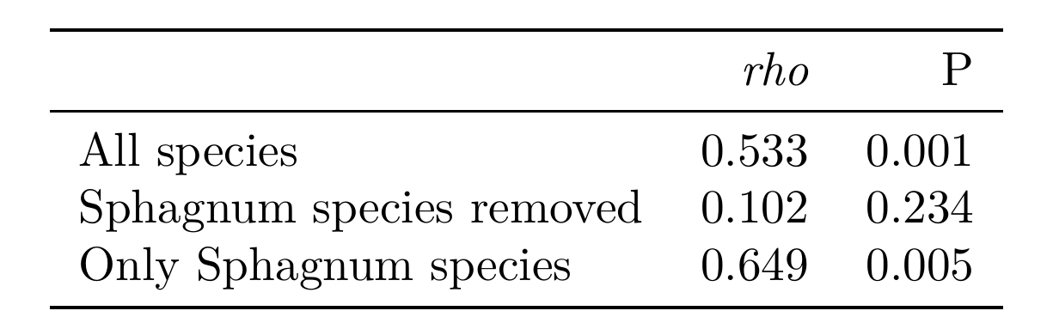

Table S7 PERMANOVA run on eight individual sites showing the effect of species in explaining microbial community differences.
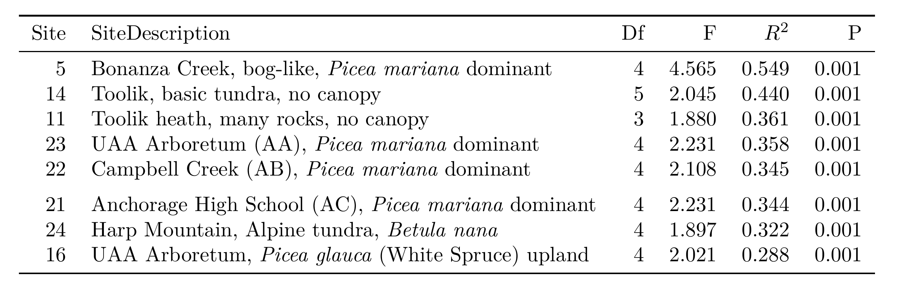

Fig. S1 Best environmental predictors shaping microbial communities on seven most abundant host species. Green boxes indicate the best predictors as chosen by BIO-ENV for each host species. Rho values for the BIO-ENV tests are displayed beneath the species names. Text inside the boxes indicate the results of a multiple regression of distance matrices (MRM), the top number indicates the regression coefficient, the bottom represents the p-value for that predictor. Darker green boxes indicate a coefficient that was confirmed significant in the MRM. Lighter green boxes were not significant. All correlations for these tests were measured with spearman rank correlations.
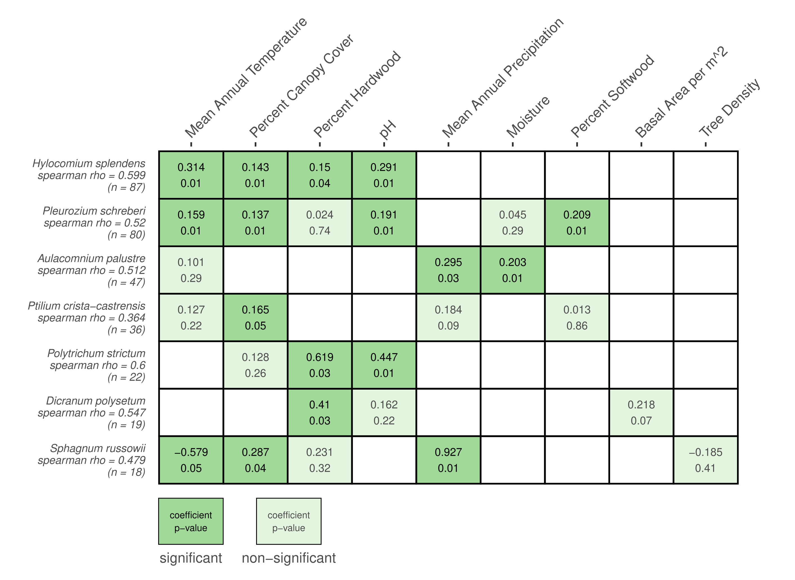

Table S8 PERMANOVA run on seven individual species showing the effect of site in explaining microbial community differences.
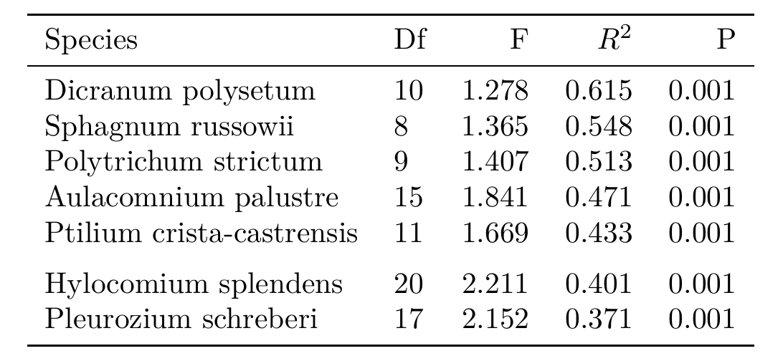

Table S9 Table summarizing the correlations between N₂-fixation rate and the 22 putative N₂-fixing phylotypes. We note that some phylotypes are listed more than once as they had significant positive correlations in multiple host species. (Table provided in separate file)

Table S10 Table summarizing the findings from nine studies about prevalence and strength of host phylogenetic structuring of plant-microbial communities. The strength quality column is based on theoretical expectations from simulated communities ref [44]. (Table provided in separate file)

