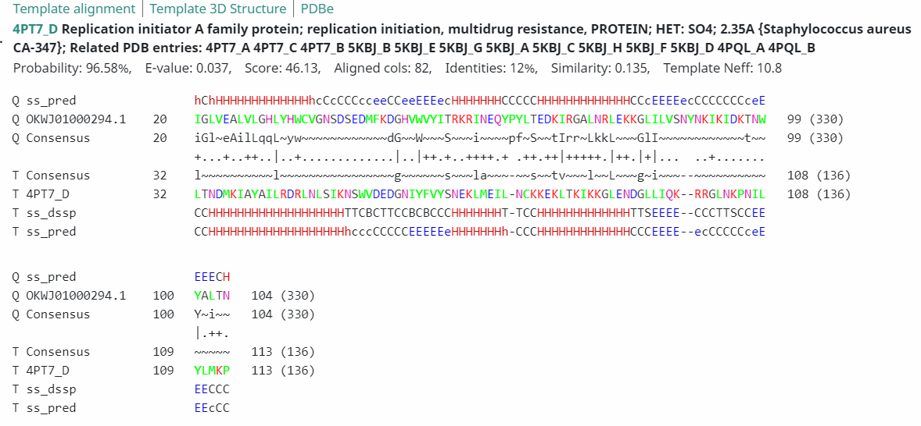
HHPred alignment of a Quimbyviridae protein (OKWJ01000294.1_36) with the N-terminal domain of RepA (PDB 4PT7_D)

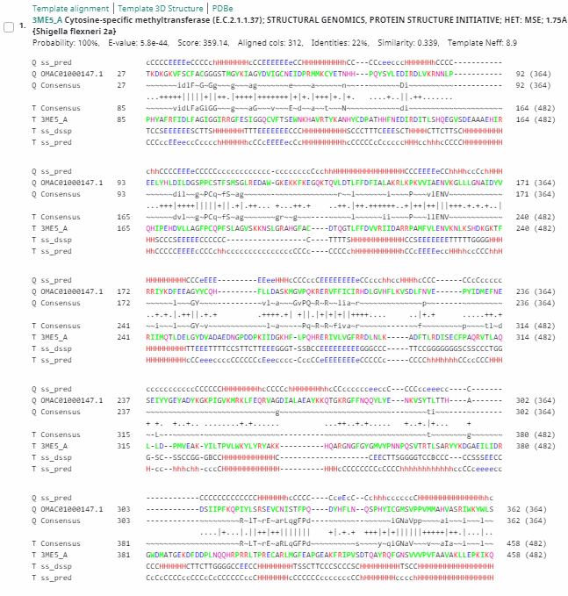
HHPred alignment of a Quimbyviridae protein (OMAC01000147.1_43) with a cytosine-specific methyltransferase (PDB 3ME5_A)

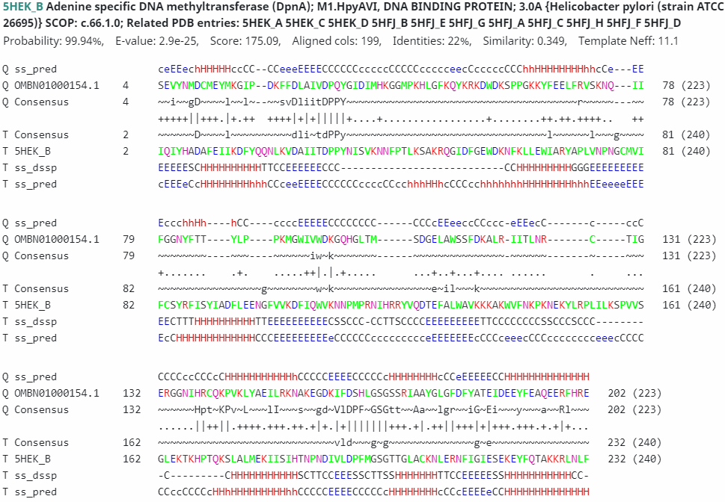
HHPred alignment of a Quimbyviridae protein (OMBN01000154.1_53) with an adenine-specific methyltransferase (PDB 3ME5_A)
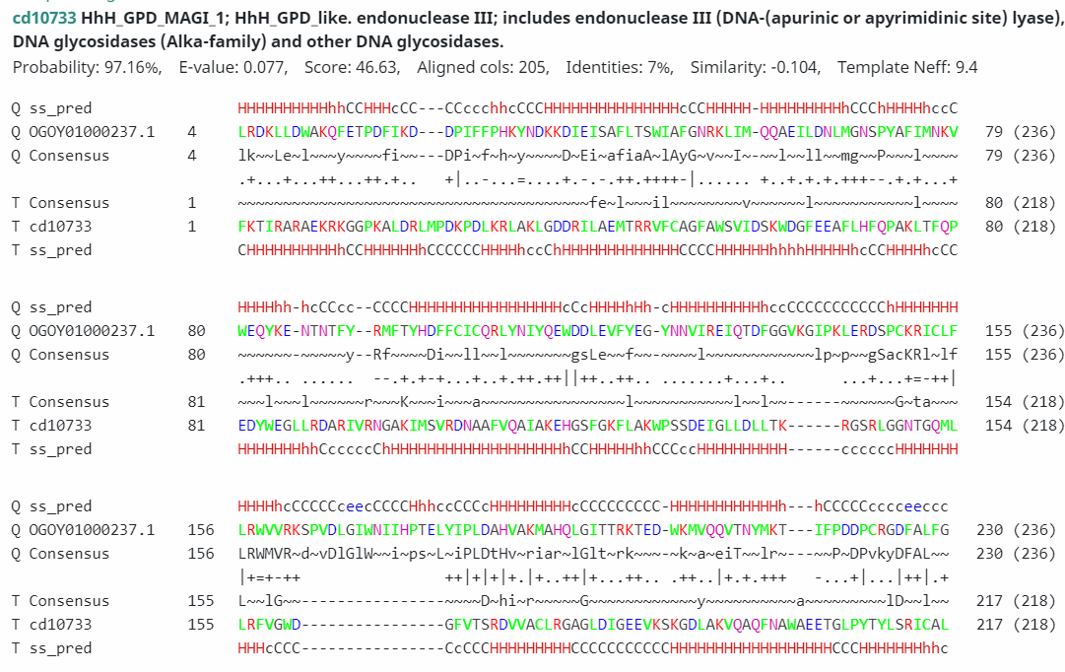
HHPred alignment of a Quimbyviridae protein (OGOY01000237.1_47) with a MutY-like nuclease (PDB cd10733)

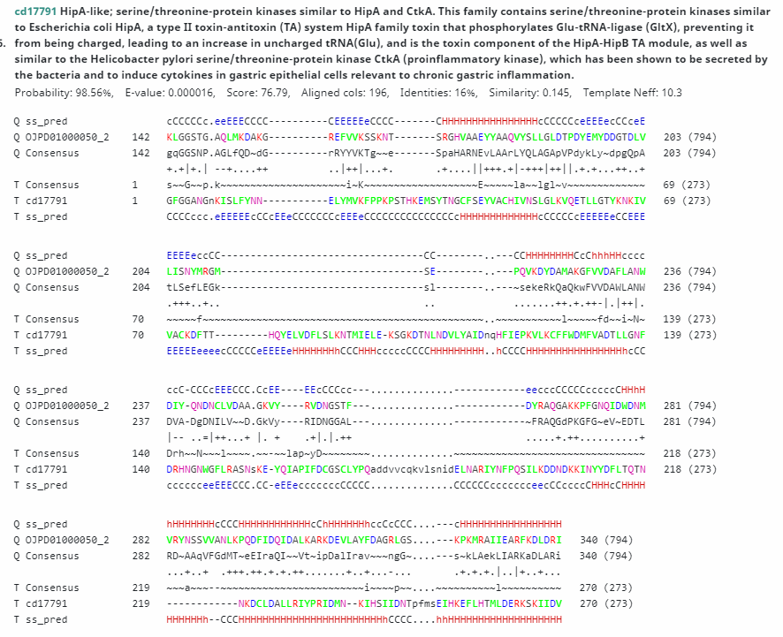
HHPred alignment of a Gratiaviridae protein (OJPW01000080.1_28) with a HipA-like kinase (CDD17791).

