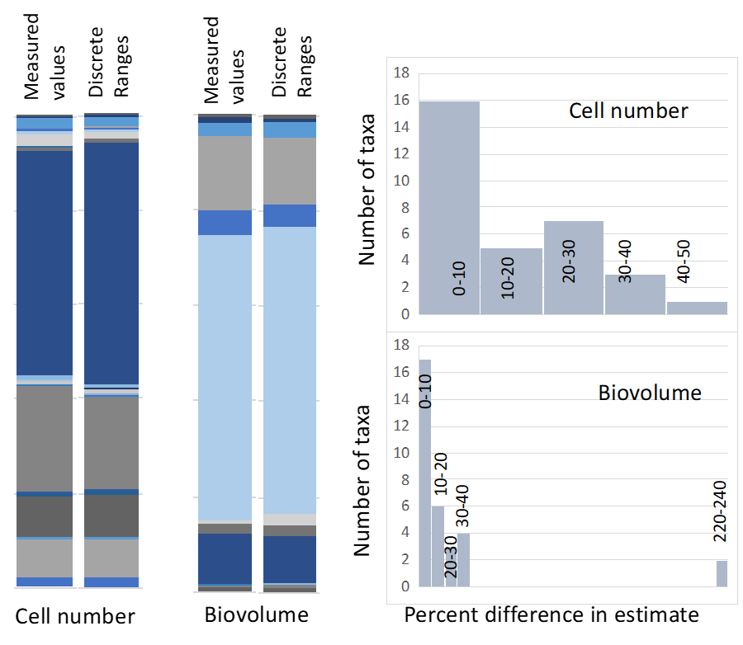
Fig. S1. Differences in allometric estimation of microbial community structure as cell number or biovolume from 16S rRNA gene counts in the dataset of Fig. 2 by either assigning measured cell volume values to taxa or by assigning taxa to a set of discrete size ranges. Left: stack bar graphs for relative proportions of taxa. Right: frequency histograms for taxa-specific percentual differences between the two approaches.

