Supplementary Figure S1. Taxonomic composition of bacterial genomes at different taxonomic levels.

Supplementary Figure S2. Examples of the selected PULs predicted in MAGs belonged to Bacteroidetes. A: the most common PULs, a susC/susD pair. B, C, D and E: PULs with similar configurations involved in xylan degradation. F and G: PULs involved in pectin degradation.

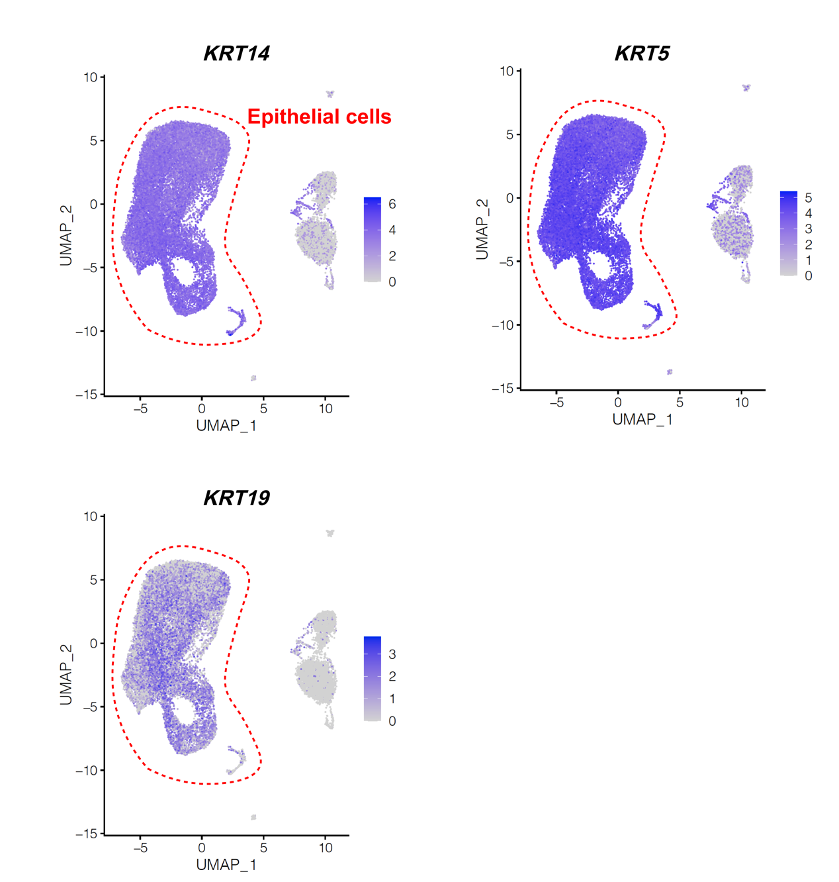
Supplementary Figure S3. The epithelial cell clusters were selected to repeat cluster analysis (second-level analysis) based on the markers KRT14, KRT5, and KRT19 in the rumen single-cell landscape.

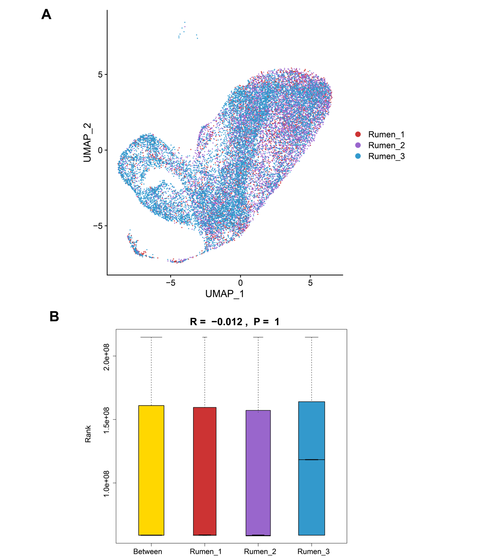

Supplementary Figure S4. The similarity between the single-cell data of the 3 cows’ rumen epithelial cells. (A) The multi-donor analysis showed cells from the 3 cows were well overlapped. (B) The analysis of similarities (ANOSIM) on the single-cell data after batch effect removal of the 3 cows through a distance measure using the vegan R package (v2.5-7) showed the ANOSIM statistic R was -0.012 and the P value was 1 indicating cells from the 3 cows overlapped well.

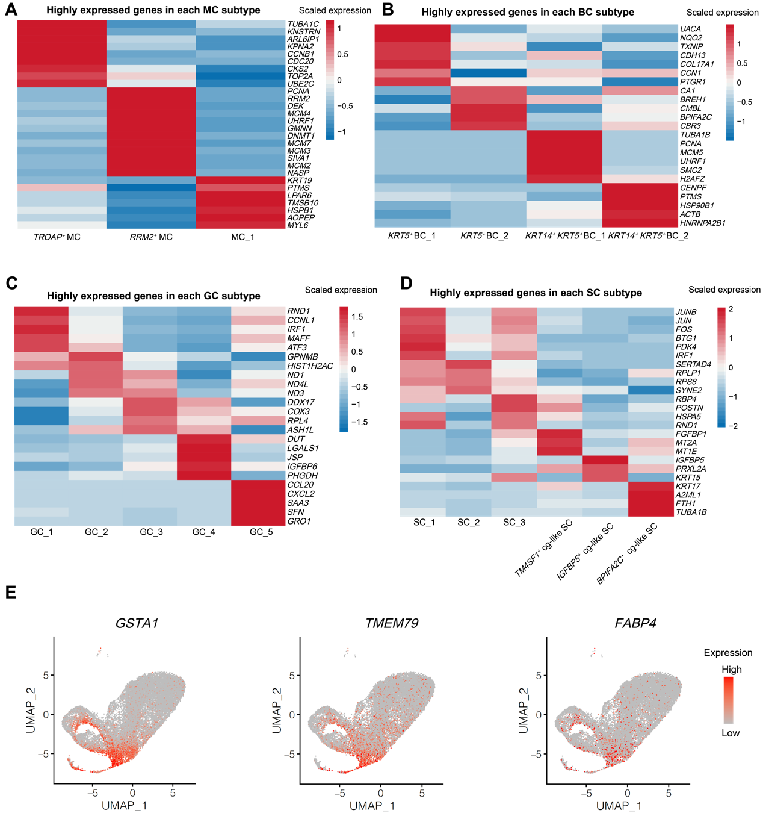
Supplementary Figure S5. The highly expressed genes in each cell subtype of rumen epithelial cells. (A-D) Heatmap showing the representative highly expressed genes of cell subtypes of MC (A), BC (B), GC (C), and SC (D). (E) The UMAP maps of rumen epithelial single-cell data with cells colored by expression of genes GSTA1, TMEM79, and FABP4 for channel-gap like spinous cells (cg-like SCs). Gene expression levels are indicated in shades of red. MC: Mitotic cell; BC: Basal cell; GC: Granular cell; SC: Spinous cell.

