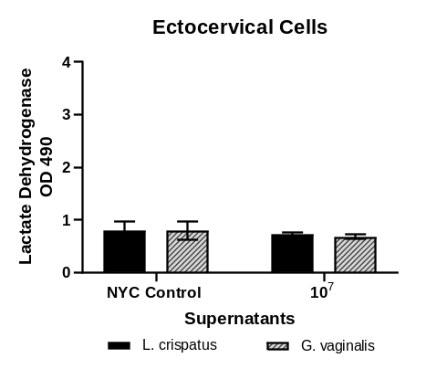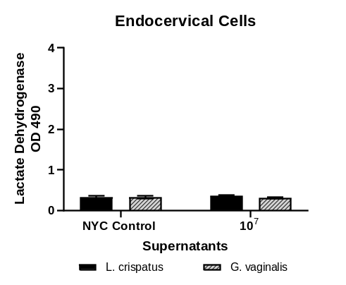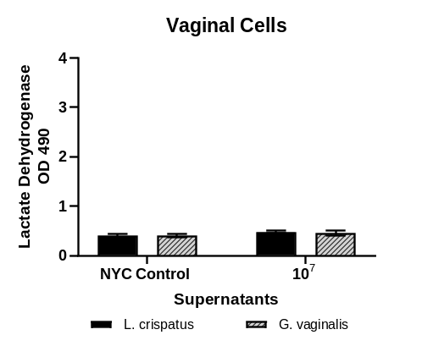
Supplemental Figure 1: Lactate Dehydrogenase levels after cervicovaginal epithelial cell exposure to 10% (v/v) bacteria-free supernatants from Lactobacillus crispatus or Gardnerella vaginalis (1x10⁵-1x10⁷ CFU/mL culture density) for 24 hours. Values are mean ± SEM.

Live Bacteria Bacterial Supernatant
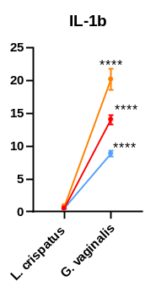
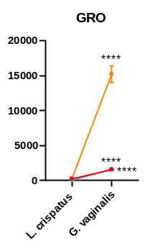
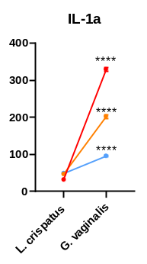
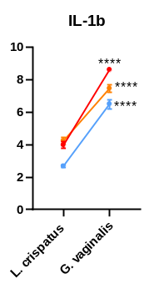
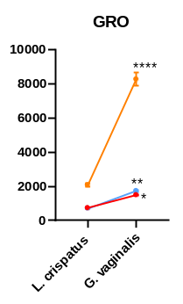
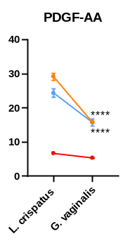
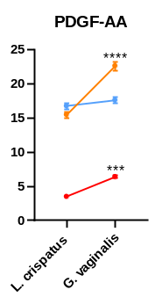
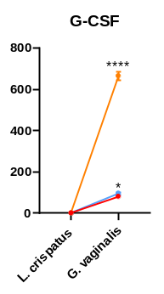
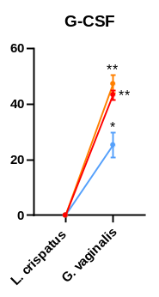
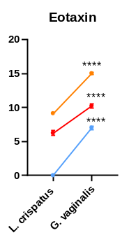
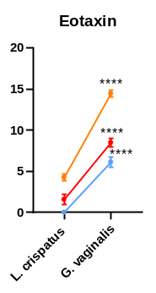
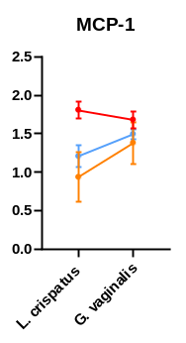
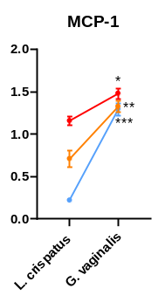
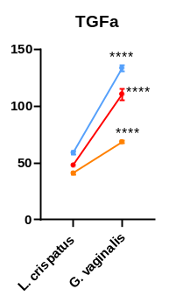
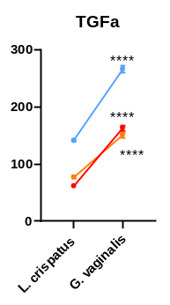
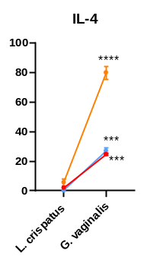
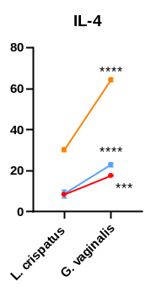
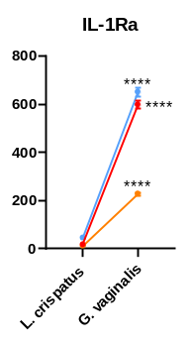
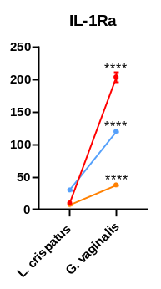
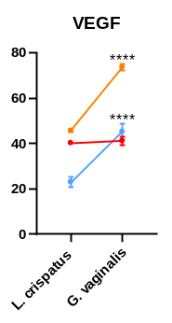
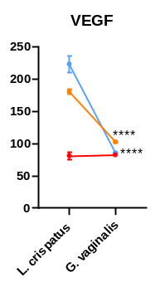
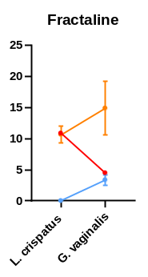
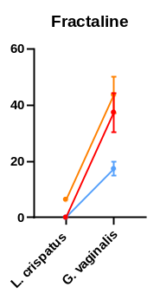
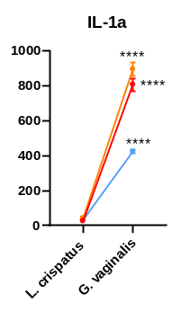

Live Bacteria Bacterial Supernatant
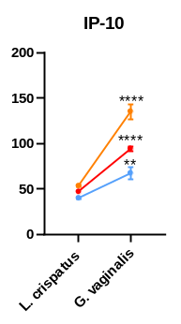
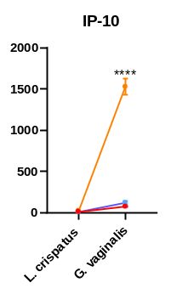
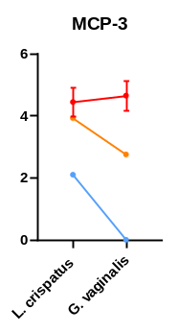
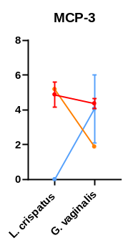
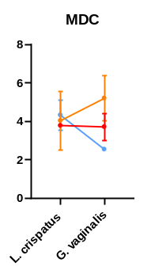
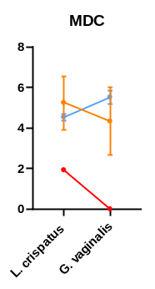
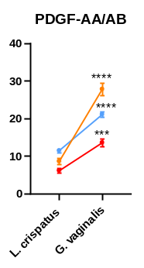
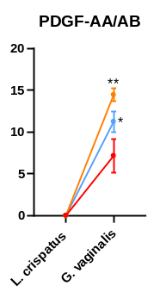
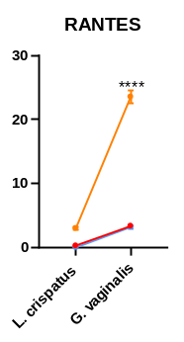
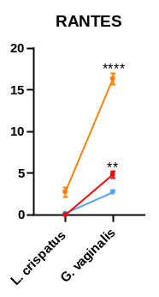
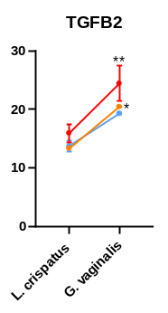
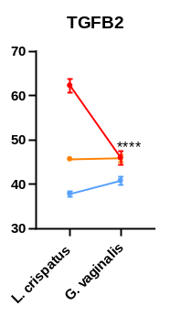
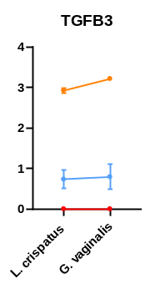
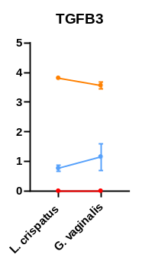
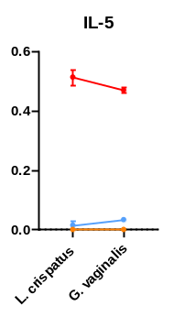
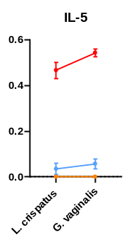
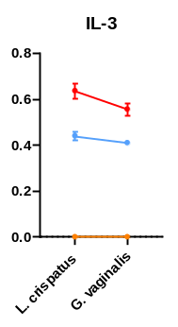
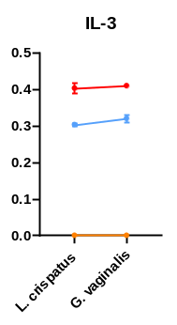
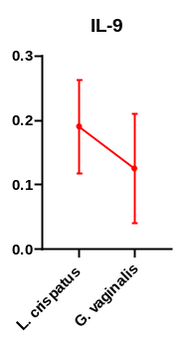

Supplemental Figure 2: Cytokine levels (pg/ml) after 24hr exposure to live bacteria or bacteria-free supernatants in ectocervical (red), endocervical (yellow) or vaginal (blue) epithelial cells showing epithelial cell specific responses. Statistical analysis compares L. crispatus vs G. vaginalis. Values are mean ± SEM. *p<0.05, **p<0.01, ***p<0.001, ****p<0.0001.
Supplemental Table 1A: Cytokine values (pg/ml) in cervicovaginal cells co-cultured with live L. crispatus (LC), G. vaginalis (GV) or non-treated control (NTC)
 | Ectocervical Cells |  |  |  | Endocervical Cells |  |  |  | Vaginal Cells
 | NTC | LC | NTC | GV | NTC | LC | NTC | GV | NTC | LC | NTC | GV
EGF | ND | ND | ND | ND | ND | ND | ND | ND | ND | ND | ND | ND
Eotaxin | 3.1  (0.80) | 1.6  (1.12) | 4.6  (0.99) | 8.5  (0.90) | ND | 4.2  (0.72) | 6.5  (0.49) | 14.4  (0.74) | ND | ND | ND | 6.1  (1.01)
FGF-2 | ND | ND | ND | ND | ND | ND | ND | ND | ND | ND | ND | ND
FLT-3L | ND | ND | ND | ND | ND | ND | ND | ND | ND | ND | ND | ND
Fractaline | ND | ND | ND | 37.4  (12.10) | ND | 6.4  (3.68) | 2.8  (1.64) | 43.7  (10.97) | ND | ND | ND | 17.3  (3.60)
G-CSF | ND | ND | 29.34  (9.99) | 80.72  (10.00) | ND | ND | ND | 664.9  (34.24) | ND | ND | ND | 95.7  (9.87)
GM-CSF | 19.7  (0.13) | 20.3  (0.15) | 71.7  (2.44) | 494.1  (20.62) | 11.5  (0.88) | 18.4  (0.23) | 24.7  (1.27) | 330.5  (16.04) | 14.6  (0.58) | 20.4  (0.16) | 15.6  (0.56) | 353.8  (32.05)
GRO | 298.5  (4.89) | 224.7  (3.18) | 774.2  (55.90) | 1555  (134.0) | 358.7  (78.2) | 312.3  (28.85) | 1126  (176.7) | 15197  (2048) | 87.4  (8.59) | 53.5  (12.04) | 135.6  (2.51) | 1645  (204.6)
IFNa2 | ND | ND | ND | ND | ND | ND | ND | ND | ND | ND | ND | ND
IFNgamma | ND | ND | ND | ND | ND | ND | ND | ND | ND | ND | ND | ND
IL-10 | ND | ND | ND | ND | ND | ND | ND | ND | ND | ND | ND | ND
IL-12p40 | ND | ND | ND | ND | ND | ND | ND | ND | ND | ND | ND | ND
IL-12p70 | ND | ND | ND | ND | ND | ND | ND | ND | ND | ND | ND | ND
IL-13 | ND | ND | ND | ND | ND | ND | ND | ND | ND | ND | ND | ND
IL-15 | ND | ND | ND | ND | ND | ND | ND | ND | ND | ND | ND | ND
IL-17 | ND | ND | ND | ND | ND | ND | ND | ND | ND | ND | ND | ND
IL-1Ra | 15.6  (0.46) | 16.8  (0.37) | 122.7  (8.21) | 598.0  (29.75) | 10.9  (1.58) | 12.0  (0.95) | 30.5  (1.43) | 227.3  (11.73) | 49.3  (5.20) | 45.3  (5.52) | 98.4  (4.66) | 650.8  (31.70)
IL-1a | 24.7  (2.03) | 26.7  (0.81) | 333.7  (35.92) | 807.6  (61.98) | 42.1  (5.39) | 43.1  (3.14) | 232.8  (20.49) | 895.4  (69.14) | 40.2  (3.23) | 34.2  (1.92) | 93.7  (3.36) | 423.9  (20.85)
IL-1b | 0.30  (0.10) | 0.50  (0.14) | 3.0  (0.34) | 14.1  (1.21) | 0.87  (0) | 0.88  (0.01) | 1.8  (0.11) | 20.2  (2.77) | 0.19  (0.08) | 0.50  (0.22) | 0.84  (0.03) | 8.9  (0.73)
IL-2 | ND | ND | ND | ND | ND | ND | ND | ND | ND | ND | ND | ND
IL-3 | 0.57  (0.03) | 0.64  (0.06) | 0.50  (0.03) | 0.56  (0.05) | ND | ND | ND | ND | ND | 0.48  (0.02) | 0.30  (0.03) | 0.44  (0.03)
IL-4 | 3.2  (1.91) | 1.9  (0.93) | 15.1  (5.89) | 24.6  (1.60) | 5.6  (1.14) | 5.5  (4.22) | 23.9  (5.20) | 79.9  (7.59) | 3.4  (0.87) | ND | 0.13  (0.10) | 26.9  (3.38)
IL-5 | 0.47  (0.02) | 0.51  (0.05) | 0.45  (0.06) | 0.47  (0.02) | ND | ND | ND | ND | ND | 0.02  (0.02) | ND | 0.03  (0.01)
IL-6 | 45.7  (0.86) | 68.5  (2.11) | 94.9  (8.28) | 227.1  (12.68) | 12.1  (1.10) | 17.4  (0.42) | 38.3  (8.44) | 260.1  (4.76) | ND | 0.20  (0.03) | 0.79  (0.19) | 23.0  (1.45)
IL-7 | ND | ND | ND | ND | ND | ND | ND | ND | ND | ND | ND | ND
IL-8 | 196.7  (6.38) | 169.5  (0.59) | 422.0  (62.68) | 876.2  (81.20) | 138.5  (3.27) | 155.2  (3.57) | 401.9  (38.23) | 2408  (203.0) | 37.5  (2.33) | 35.4  (1.72) | 71.0  (1.72) | 875.7  (63.20)
IL-9 | 0.20  (0.16) | 0.19  (0.12) | 0.06  (0.06) | 0.13  (0.12) | ND | ND | ND | ND | ND | ND | ND | ND
IP-10 | 17.7  (0.91) | 14.4  (1.39) | 53.5  (6.51) | 75.2  (5.40) | 18.9  (2.12) | 24.0  (2.28) | 462.9  (131.7) | 1527  (163.7) | 9.3  (3.03) | 6.9  (1.85) | 45.2  (7.48) | 121.0  (33.68)
MCP-1 | 1.1  (0.05) | 1.2  (0.09) | 1.3  (0.16) | 1.5  (0.21) | 1.2  (0.20) | 0.71  (0.14) | ND | 1.7  (0.72) | ND | ND | ND | 1.3  (0.12)
MCP-3 | 3.6  (1.14) | 4.4  (0.81) | 3.0  (0.64) | 4.6  (0.04) | ND | ND | ND | ND | ND | ND | ND | ND
MIP-1a | 1.4  (0.21) | 1.2  (0.14) | 1.6  (0.06) | 2.6  (0.32) | 0.40  (0.38) | 0.66  (0.25) | 0.74  (0.13) | 2.8  (0.12) | ND | 1.2  (0.30) | 0.87  (1.04) | 4.2  (0.27)
MDC | ND | ND | ND | 3.7  (0.98) | ND | 4.0  (2.17) | ND | 5.2  (1.68) | 2.2  (1.63) | 4.3  (1.09) | 2.8  (0.39) | ND
MIP-1b | ND | ND | ND | ND | ND | ND | ND | ND | ND | ND | ND | ND
PDGF-AA | 7.4  (0.43) | 6.7  (0.04) | 7.6  (0.53) | 5.4  (0.24) | 29.5  (4.18) | 29.2  (1.72) | 23.1  (0.76) | 15.8  (0.49) | 32.2  (2.38) | 24.4  (2.22) | 26.3  (0.47) | 15.7  (1.75)
PDGF-AB/BB | ND | ND | ND | 7.2  (3.46) | ND | ND | 1.2  (1.51) | 14.4  (1.34) | ND | ND | ND | 11.2  (2.15)
RANTES | ND | ND | 2.7  (0.71) | 3.4  (0.21) | 3.1  (1.22) | 3.0  (0.44) | 21.7  (3.47) | 23.5  (1.77) | ND | ND | 1.1  (0.45) | 3.3  (0.34)
TGFa | 48.9  (0.98) | 47.9  (0.37) | 86.6  (3.29) | 110.6  (8.66) | 40.7  (1.80) | 40.9  (2.32) | 41.7  (1.26) | 68.5  (2.05) | 65.6  (2.23) | 59.0  (2.95) | 72.0  (4.03) | 133.5  (4.73)
TNFa | 0.59  (0.10) | 0.71  (0.20) | 1.4  (0.17) | 26.6  (3.53) | 0.39  (0.09) | ND | ND | 1.1  (0.11) | ND | ND | ND | 16.1  (1.18)
TNFb | ND | ND | ND | ND | ND | ND | ND | ND | ND | ND | ND | ND
VEGF | 41.3  (0.96) | 40.3  (1.09) | 55.9  (5.11) | 41.8  (3.30) | 45.5  (2.29) | 45.7  (1.18) | 48.1  (3.05) | 73.6  (2.32) | 33.5  (1.48) | 23.1  (3.03) | 29.0  (1.35) | 45.3  (5.89)
sCD40L | ND | ND | ND | ND | ND | ND | ND | ND | ND | ND | ND | ND
TGF-B1 | 9.5  (1.20) | 8.5  (2.61) | 23.1  (1.62) | 25.2  (0.29) | 16.0  (5.15) | 20.1  (1.40) | 42.1  (1.14) | 40.0  (1.13) | 27.5  (1.25) | 21.8  (3.30) | 28.9  (0.66) | 31.5  (1.31)
TGF-B2 | 21.7  (5.06) | 15.9  (2.74) | 19.1  (1.17) | 24.4  (5.24) | 14.1  (3.37) | 13.3  (0.31) | 21.5  (1.50) | 20.4  (0.23) | 16.7  (0.32) | 13.7  (1.61) | 17.1  (8.17) | 19.3  (0.31)
TGF-B3 | ND | ND | ND | ND | ND | 2.9  (0.11) | 3.6  (0.19) | 3.2  (0.06) | 3.2  (0.20) | 0.79  (0.54) | 0.54  (0.24) | 0.79  (0.54)
*Standard deviation in italics parenthesis below pg/ml

Supplemental Table 1B: Cytokine values (pg/ml) in cervicovaginal cells exposed to L. crispatus (LC), G. vaginalis (GV) bacteria-free supernatant or NYC media alone (NYC)
 | Ectocervical Cells |  |  | Endocervical Cells |  |  | Vaginal Cells
 | NYC | LC | GV | NYC | LC | GV | NYC | LC | GV
EGF | ND | ND | ND | ND | ND | ND | ND | ND | ND
Eotaxin | 8.6  (0.70) | 6.2  (0.61) | 10.2  (0.55) | 13.1  (0.94) | 9.1  (0.09) | 15.0  (0.21) | 3.6  (0.24) | ND | 7.0  (0.47)
FGF-2 | ND | ND | ND | ND | ND | ND | ND | ND | ND
FLT-3L | ND | ND | ND | ND | ND | ND | ND | ND | ND
Fractaline | ND | ND | ND | 20.1  (14.46) | 10.7  (1.88) | 14.9  (7.42) | ND | ND | ND
G-CSF | ND | ND | 43.3  (2.99) | ND | ND | 47.3  (5.63) | 60.0  (1.95) | ND | 25.3  (7.89)
GM-CSF | 66.9  (3.58) | 84.8  (6.20) | 153.6  (6.43) | 71.2  (0.71) | 33.1  (0.98) | 138.6  (4.39) | 47.4  (1.67) | 106.8  (4.23) | 76.1  (3.25)
GRO | 1304  (29.08) | 729.2  (14.09) | 1494  (48.98) | 4036  (181.9) | 2079  (147.3) | 8265  (669.6) | 1788  (114.6) | 715.7  (55.17) | 1730  (75.46)
IFNa2 | ND | ND | ND | ND | ND | ND | ND | ND | ND
IFNgamma | ND | ND | ND | ND | ND | ND | ND | ND | ND
IL-10 | ND | ND | ND | ND | ND | ND | ND | ND | ND
IL-12p40 | ND | ND | ND | ND | ND | ND | ND | ND | ND
IL-12p70 | ND | ND | ND | ND | ND | ND | ND | ND | ND
IL-13 | ND | ND | ND | ND | ND | ND | ND | ND | ND
IL-15 | ND | ND | ND | ND | ND | ND | ND | ND | ND
IL-17 | ND | ND | ND | ND | ND | ND | ND | ND | ND
IL-1Ra | 13.8  (0.67) | 9.2  (1.21) | 203.8  (13.38) | 12.4  (1.23) | 7.3  (0.49) | 37.5  (1.88) | 44.3  (1.69) | 29.7  (1.58) | 119.9  (0.56)
IL-1a | 30.5  (1.95) | 31.7  (2.72) | 328.9  (9.45) | 65.2  (1.85) | 46.3  (1.84) | 202.0  (8.53) | 46.7  (4.24) | 48.8  (3.67) | 95.4  (4.12)
IL-1b | 5.8  (0.26) | 4.0  (0.34) | 8.6  (0.09) | 6.2  (0.15) | 4.2  (0.39) | 7.5  (0.44) | 4.1  (0.22) | 2.7  (0.11) | 6.5  (0.49)
IL-2 | ND | ND | ND | ND | ND | ND | ND | ND | ND
IL-3 | 0.40  (0.02) | 0.40  (0.02) | 0.41  (0.01) | ND | ND | ND | 0.26  (0.01) | 0.30  (0.01) | 0.32  (0.02)
IL-4 | 17.0  (0.56) | 8.3  (1.41) | 17.5  (0.37) | 41.2  (1.73) | 30.2  (1.58) | 64.3  (1.55) | 25.7  (2.91) | 8.7  (3.45) | 23.0  (1.39)
IL-5 | 0.49  (0.05) | 0.47  (0.06) | 0.54  (0.03) | ND | ND | ND | 0.10  (0) | 0.04  (0.04) | 0.04  (0.01)
IL-6 | 979.3  (29.32) | 501.1  (23.09) | 624.3  (19.34) | 574.9  (1.74) | 251.3  (8.87) | 699.5  (18.42) | 272.1  (12.45) | 61.6  (10.94) | 403.9  (38.16)
IL-7 | ND | ND | ND | ND | ND | ND | ND | ND | ND
IL-8 | 1354  (34.77) | 809.4  (31.56) | 2075  (45.77) | 2677  (149.6) | 1045  (40.89) | 4145  (69.80) | 1092  (38.46) | 545.2  (24.14) | 2877  (261.5)
IL-9 | ND | ND | ND | ND | ND | ND | ND | ND | ND
IP-10 | 45.2  (0.88) | 4701  (4.45) | 94.3  (4.32) | 63.9  (1.86) | 53.4  (1.11) | 135.2  (14.38) | 46.28  (0.24) | 40.10  (2.46) | 67.41  (11.29)
MCP-1 | 1.9  (0.40) | 1.8  (0.19) | 1.7  (0.19) | 1.5  (0.46) | 0.94  (0.46) | 1.4  (0.47) | 1.3  (0.18) | 1.2  (0.24) | 1.5  (0.11)
MCP-3 | 4.5  (0.99) | 4.9  (1.28) | 4.4  (0.50) | ND | ND | ND | 1.8  (0.53) | ND | 4.1  (2.77)
MIP-1a | 1.4  (0.31) | 1.2  (0.13) | 3.6  (0.22) | 1.8  (0.08) | 1.2  (0.26) | 2.2  (0.15) | 4.7  (1.25) | 4.0  (1.01) | 5.6  (0.36)
MDC | ND | ND | ND | 5.3  (3.72) | 5.2  (2.29) | 4.3  (2.88) | ND | 4.5  (0.25) | 5.5  (0.60)
MIP-1b | ND | ND | ND | ND | ND | ND | ND | ND | ND
PDGF-AA | 5.2  (0.26) | 3.5  (0.12) | 6.4  (0.33) | 18.4  (0.39) | 15.5  (0.77) | 22.6  (1.09) | 18.5  (0.86) | 16.7  (0.70) | 17.6  (0.71)
PDGF-AB/BB | 5.4  (1.20) | 6.2  (1.10) | 13.6  (1.82) | 10.8  (1.51) | 8.7  (1.46) | 27.9  (2.86) | 10.0  (2.29) | 11.5  (1.03) | 21.1  (1.33)
RANTES | ND | ND | 4.9  (0.67) | 7.5  (1.02) | 2.8  (0.95) | 16.4  (1.14) | ND | ND | 2.7  (0.50)
TGFa | 99.0  (1.92) | 61.5  (3.86) | 163.3  (7.79) | 132.0  (5.08) | 77.2  (3.84) | 151.1  (7.95) | 228.1  (17.63) | 141.2  (2.84) | 266.3  (10.57)
TNFa | 1.0  (0.09) | 1.8  (0.29) | 4.1  (0.16) | 0.23  (0.08) | ND | 0.18  (0.17) | 1.0  (0.16) | 0.44  (0.13) | 3.3  (0.69)
TNFb | ND | ND | ND | ND | ND | ND | ND | ND | ND
VEGF | 81.6  (2.01) | 81.0  (9.17) | 82.2  (3.95) | 84.2  (5.04) | 180.3  (6.86) | 102.5  (2.65) | 67.3  (2.29) | 223.0  (22.14) | 85.3  (1.93)
sCD40L | ND | ND | ND | ND | ND | ND | ND | ND | ND
TGF-B1 | 60.1  (0.79) | 65.7  (3.03) | 75.5  (4.98) | 81.3  (2.36) | 34.0  (1.17) | 94.1  (2.10) | 82.0  (5.08) | 85.6  (5.27) | 75.0  (0.87)
TGF-B2 | 59.7  (0.48) | 62.3  (2.67) | 46.0  (2.68) | 48.7  (0.45) | 45.7  (0.48) | 45.9  (1.29) | 41.7  (1.48) | 37.9  (1.08) | 40.8  (1.70)
TGF-B3 | ND | ND | ND | 4.1  (0.21) | 3.8  (0.10) | 3.6  (0.19) | 1.3  (0.29) | 0.77  (0.17) | 1.2  (0.78)
*Standard deviation in italics parenthesis below pg/ml

Supplemental Table 2A: Number of altered cytokines after exposure to live bacteria
Live Bacteria | Ectocervical | Endocervical | Vaginal
L. crispatus
Total # altered | 2 | 3 | 4
Analytes ↑ | 1 | 1 | 2
Analytes ↓ | 1 | 2 | 2
G. vaginalis
Total # altered | 16 | 19 | 22
Analytes ↑ | 15 | 18 | 20
Analytes ↓ | 1 | 1 | 2

Supplemental Table 2B: Number of altered cytokines after exposure to bacteria-free supernatants
Bacteria-free Supernatants | Ectocervical | Endocervical | Vaginal
L. crispatus
Total # altered | 10 | 16 | 11
Analytes ↑ | 2 | 4 | 4
Analytes ↓ | 8 | 12 | 7
G. vaginalis
Total # altered | 18 | 18 | 13
Analytes ↑ | 17 | 18 | 12
Analytes ↓ | 1 | 0 | 1

Supplemental Table 3: Number of cytokines altered after blocking TLR2
Live Bacteria | Ectocervical | Endocervical | Vaginal
LC vs LC + anti-TLR2 AB
Total # altered | 9 | 0 | 1
Analytes ↑ | 6 | 0 | 1
Analytes ↓ | 3 | 0 | 0
GV vs GV + anti-TLR2 AB
Total # altered | 8 | 11 | 4
Analytes ↑ | 0 | 2 | 2
Analytes ↓ | 8 | 9 | 2

