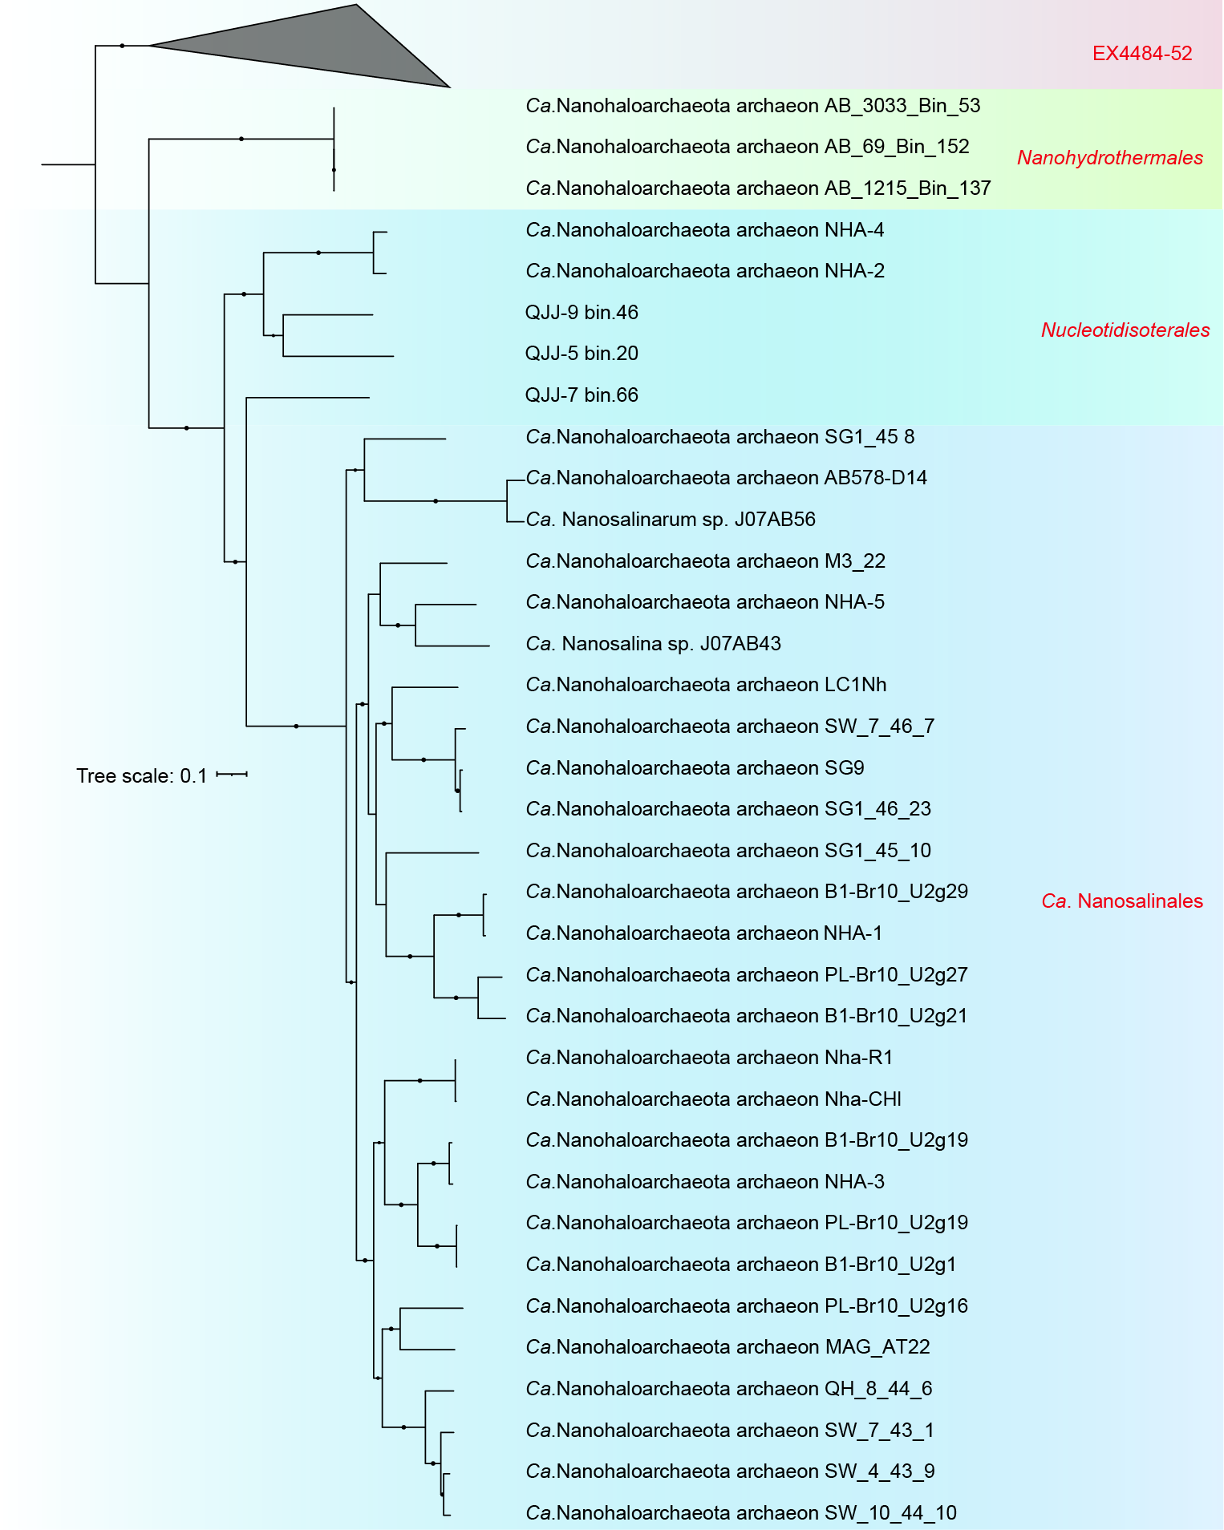
Supplementary Fig. S1 | Phylogenetic placement of MAGs based on 122 concatenated archaeal protein markers. The phylogeny was constructed using IQ-TREE with the best model of LG+F+R4. Bootstrap values were calculated based on 1000 replicates and nodes with percentages > 70% are indicated as black circles.
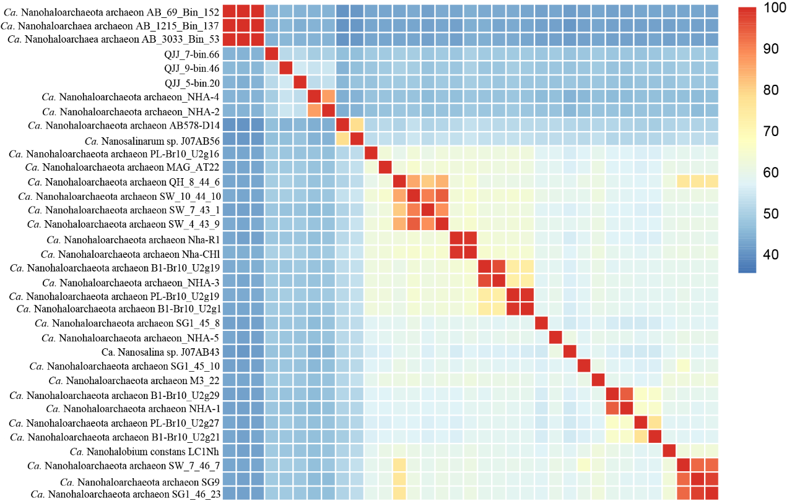Supplementary Fig. S2 | Pairwise comparisons of average amino acid identities among all Ca. Nanohaloarchaeota genomes.

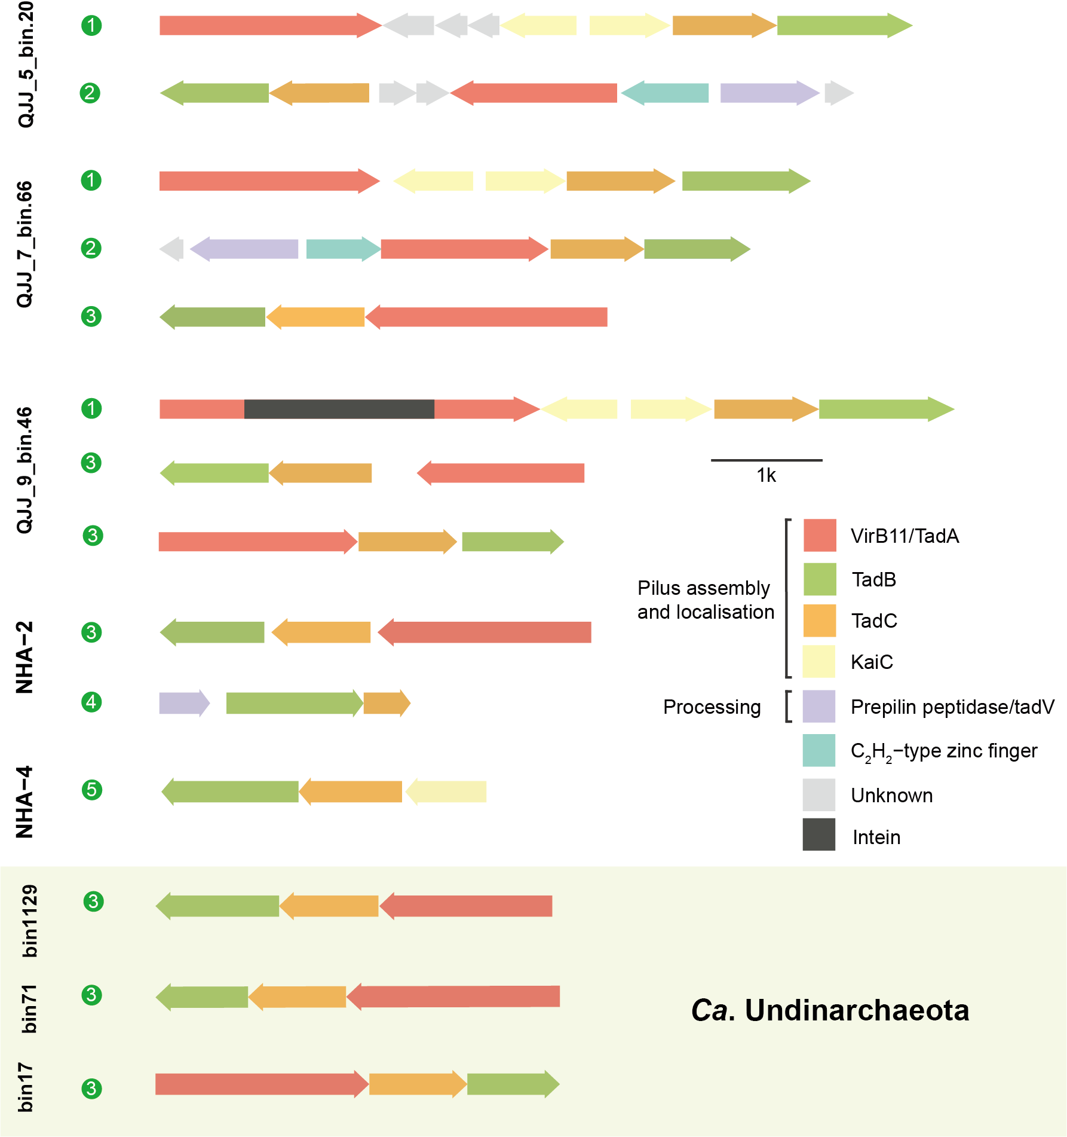
Supplementary Fig. S3 | The gene clusters related to the pili biosynthesis.
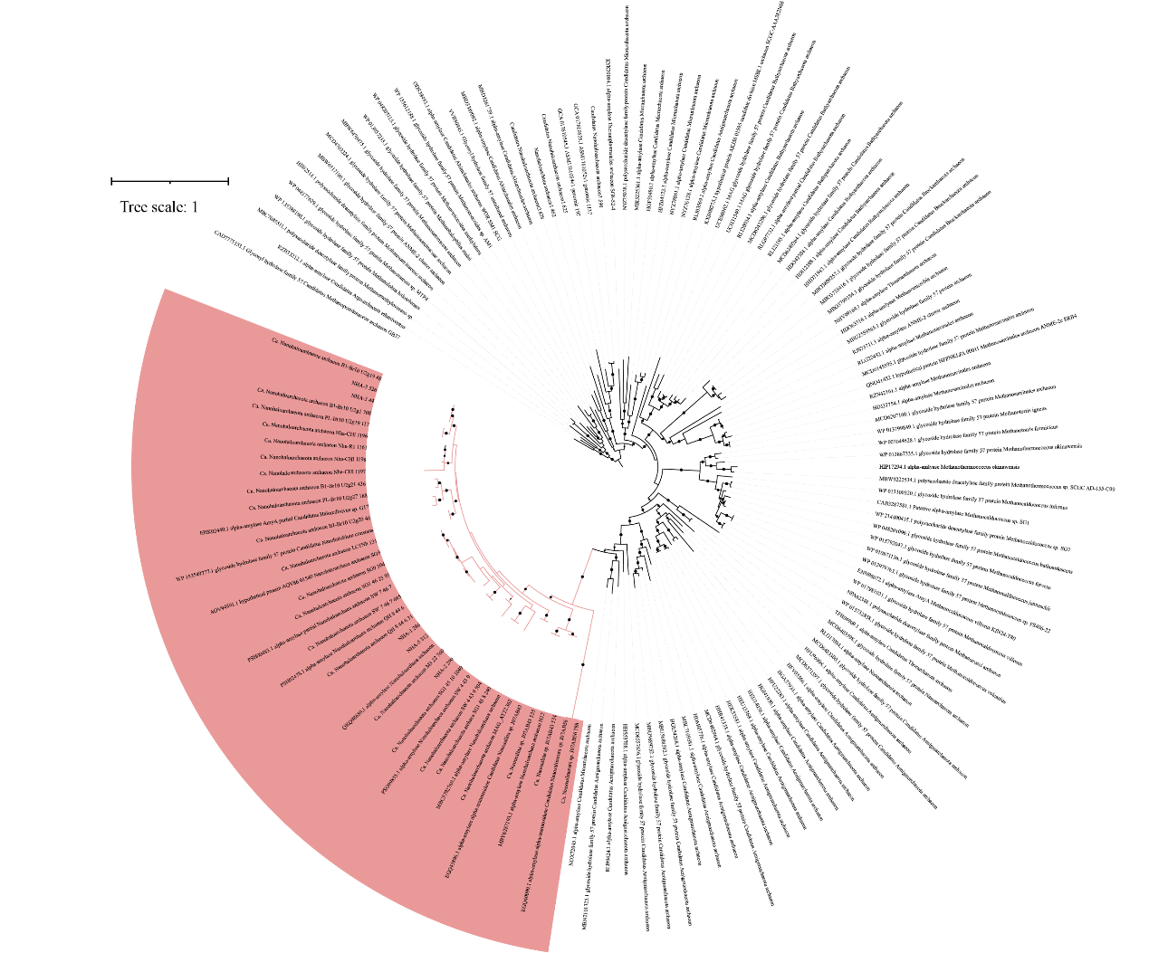
Supplementary Fig. S4 | Maximum likelihood-based phylogenetic tree of alpha amylase encoded by amy using IQ-TREE with the best model of LG+R5. Bootstrap values were calculated based on 1000 replicates and nodes with percentages > 70% are indicated as black circles. Items in red represent amy genes identified from Ca. Nanohaloarchaeota.
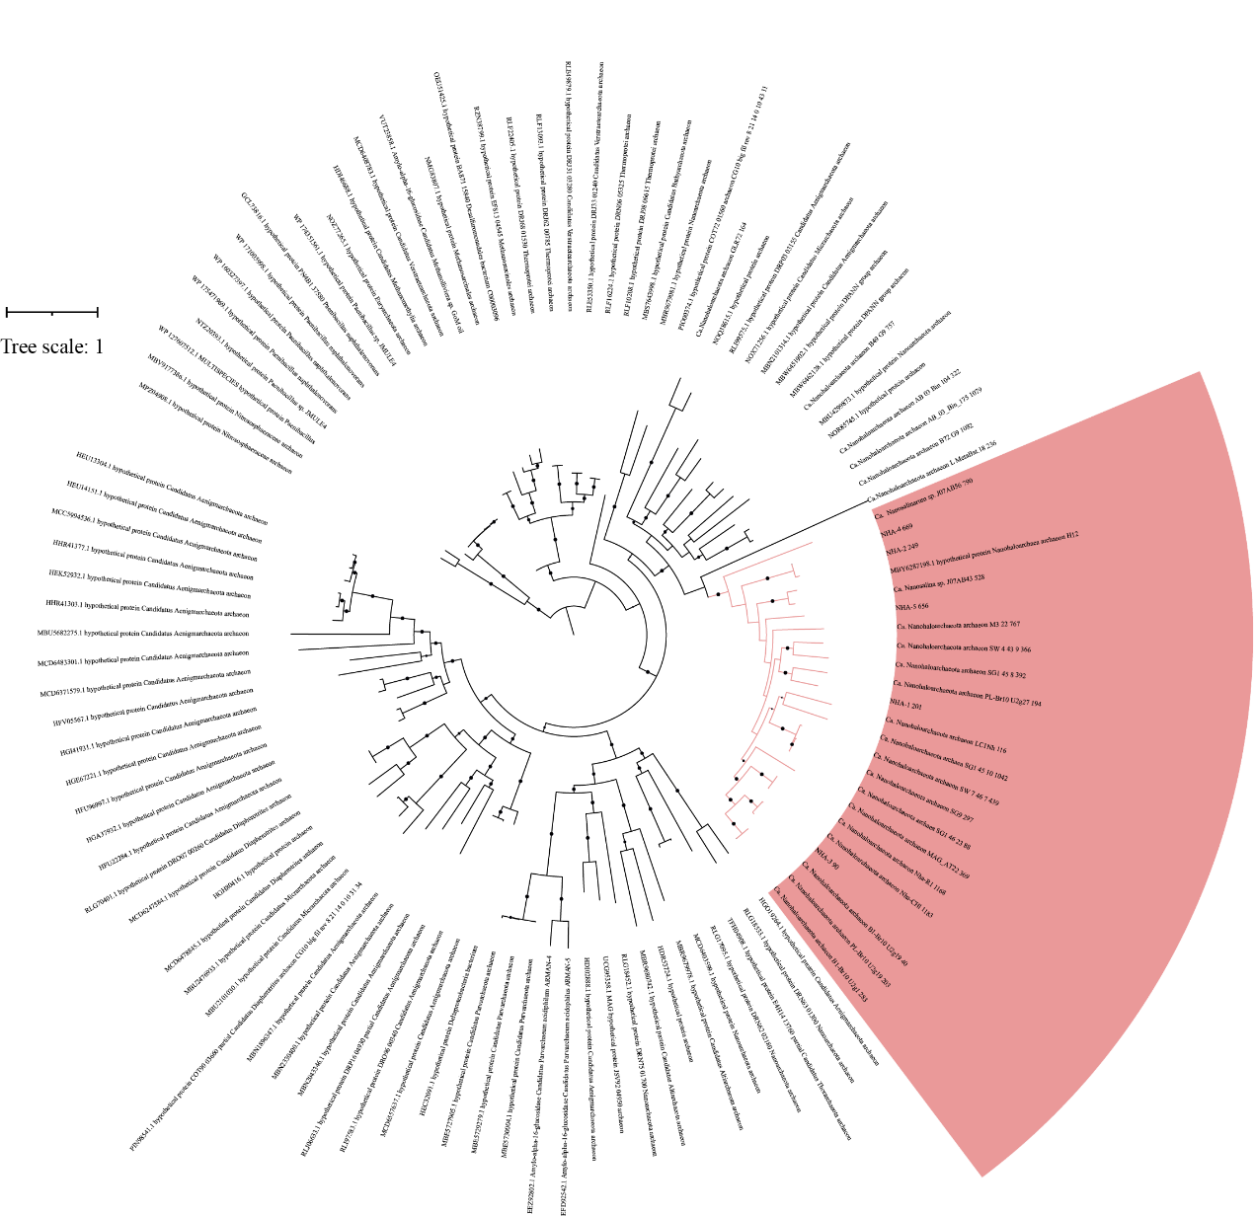
Supplementary Fig. S5 | Maximum likelihood-based phylogenetic tree of glycogen debranching enzyme encoded by AGL using IQ-TREE with the best model of LG+F+R6. Bootstrap values were calculated based on 1000 replicates and nodes with percentages > 70% are indicated as black circles. Items in red represent AGL genes identified from Ca. Nanohaloarchaeota.

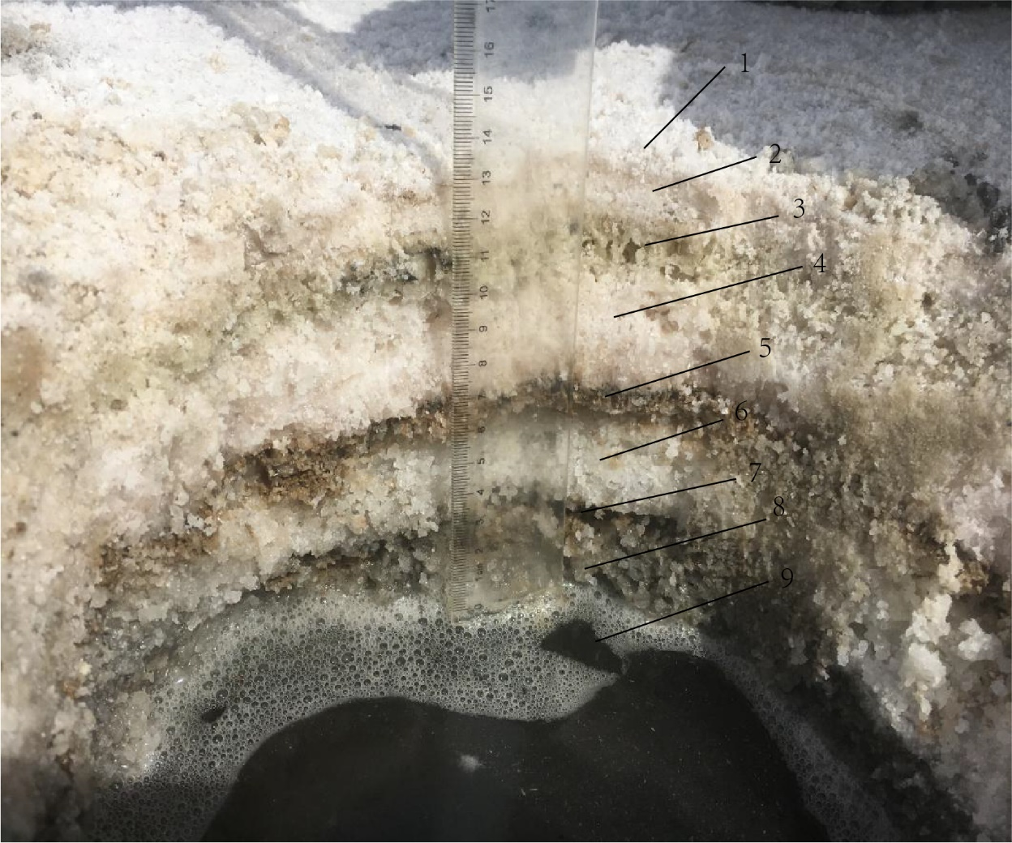
Supplementary Fig. S6 | The salt layer samples collected from Qi Jiao Jing Lake located at Xinjiang province, China.

