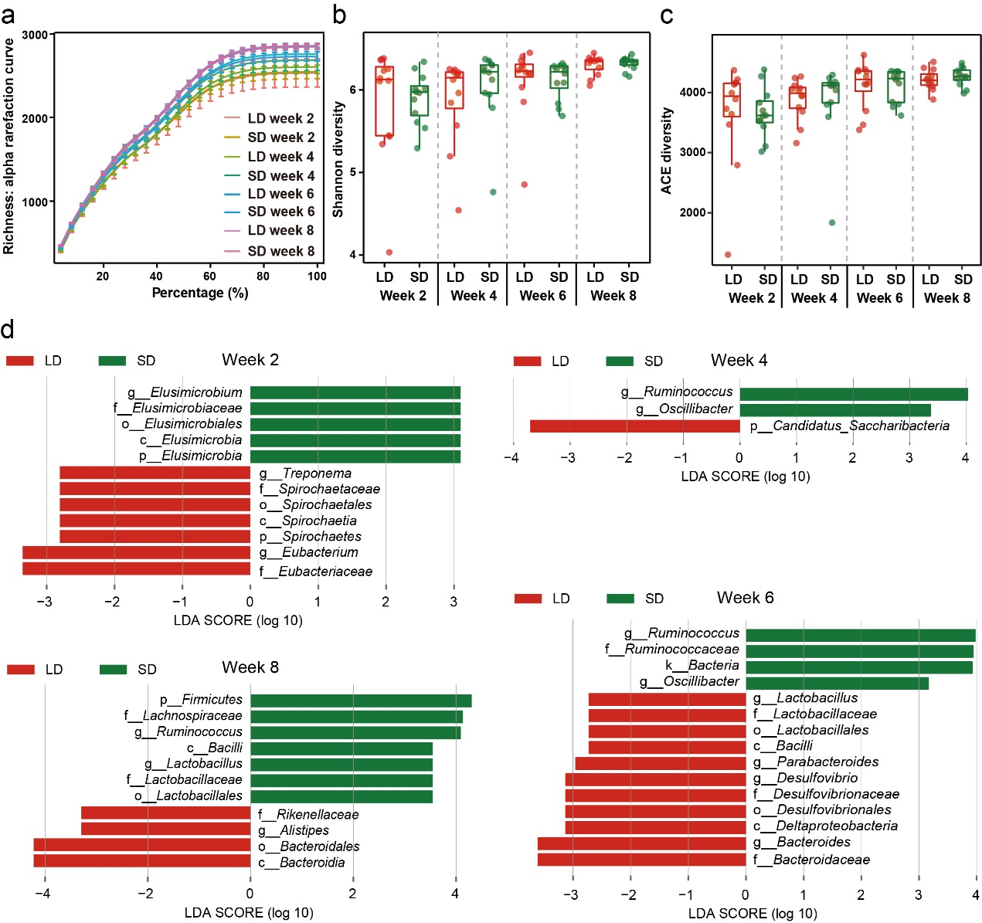
Figure S1 Diversity and composition of gut microbiota in the LD and SD groups of Brandt’s voles. a Rarefaction curves of Richness diversity. b, c Alpha diversity (Shannon and ACE diversity) of bacterial communities across the LD and SD groups (LMM). d The differentially abundant taxa enriched in microbial communities from the LD and SD groups at week 2, 4, 6, and 8 by LEfSe (LDA >2, a < 0.05). LD: long-day photoperiod (16L: 8D); SD: short-day photoperiod (8L: 16D).

