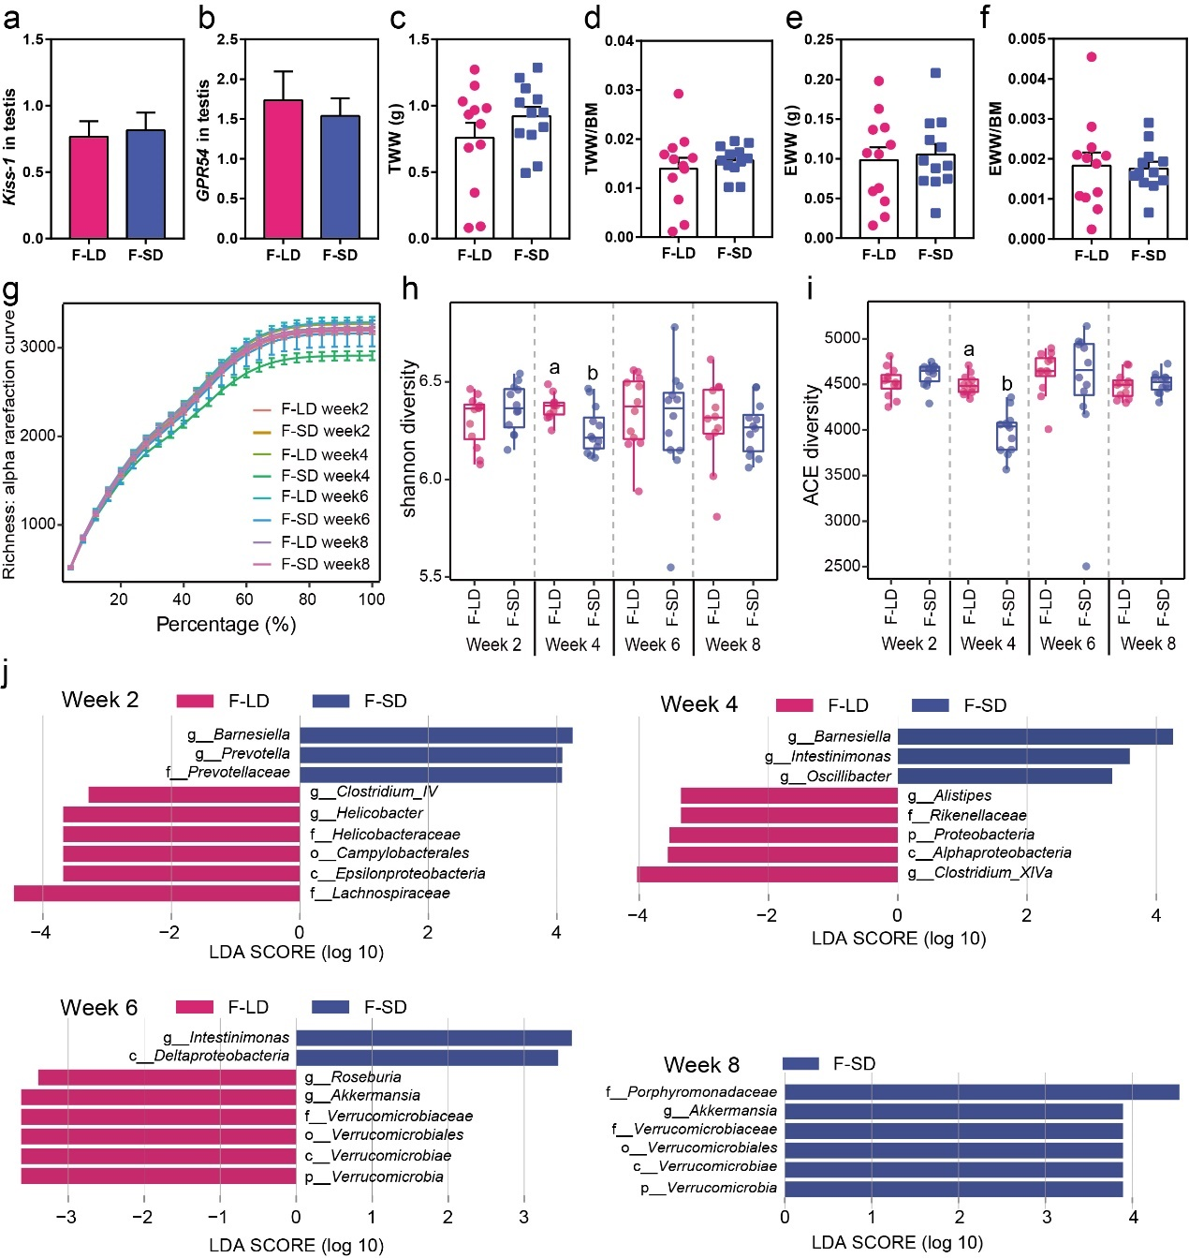
Figure S2 FMT alters reproductive genes, genital organs, and bacterial diversity and composition of Brandt’s voles. a, b The expression of Kiss-1 and GPR54 in testis. c-f TWW: testicular wet weight; TWW/BM: the ratio of testicular wet weight to body mass; EWW: epididymis wet weight; EWW/BM: the ratio of epididymis weight to body mass. g Rarefaction curves of Richness diversity. h, i Comparison of Shannon diversity and ACE diversity of bacterial communities in the F-LD and F-SD groups (means ± SEM). j The differentially abundant taxa enriched in microbial communities from the F-LD and F-SD groups at week 2, 4, 6, and 8 by LEfSe (LDA >2, a < 0.05). F-LD: recipients with LD-exposed microbiota; F-SD: recipients with SD-exposed microbiota.

