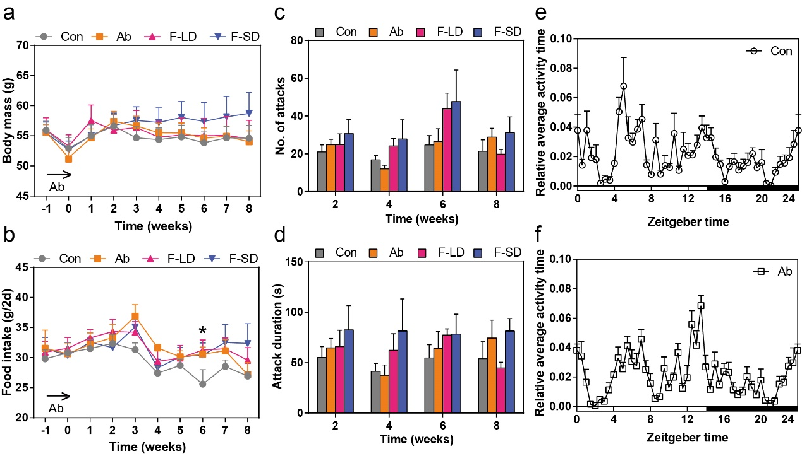
Figure S3 Differences in body mass, food intake, and behavior patterns between the control groups and the fecal microbiota transplantation (FMT) groups. a, b Changes in body mass and food intake during the period of all groups. c, d Number of attacks and attack duration at week 2, week 4, week 6, and week 8. e, f Relative average activity time of voles in 24 hours at the end of saline or antibiotic treatment. Data are means ± SEM

