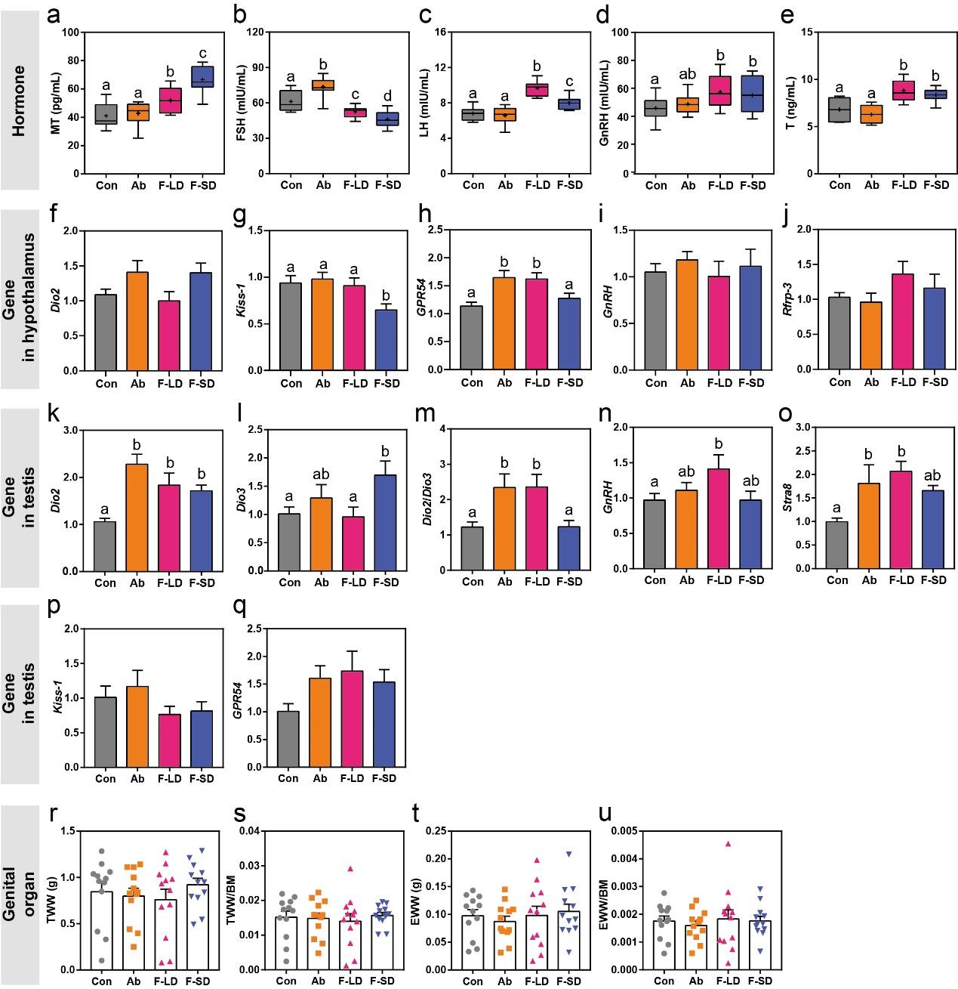
Figure S4 Differences in hormone, hypothalamic and testicular gene, and genital organ between the control groups and the FMT groups. a-e MT, FSH, LH, GnRH, and T levels in serum. f-j The expression of Dio2, Kiss-1, GPR54, GnRH, and Rfrp-3 in the hypothalamus. k-q The expression of Dio2, Dio3, Dio2/Dio3 (the ratio of Dio2 to Dio3 expression), GnRH, Stra8, Kiss-1, and GPR54 in the testis. r TWW: testicular wet weight. s TWW/BM: the ratio of testicular wet weight to body mass. t EWW: epididymis wet weight. u EWW/BM: the ratio of epididymis weight to body mass. Data are presented as mean ± SEM

