Additional file 4.
Relative abundance of bacterial families of the Bacteroidetes and Firmicutes

A
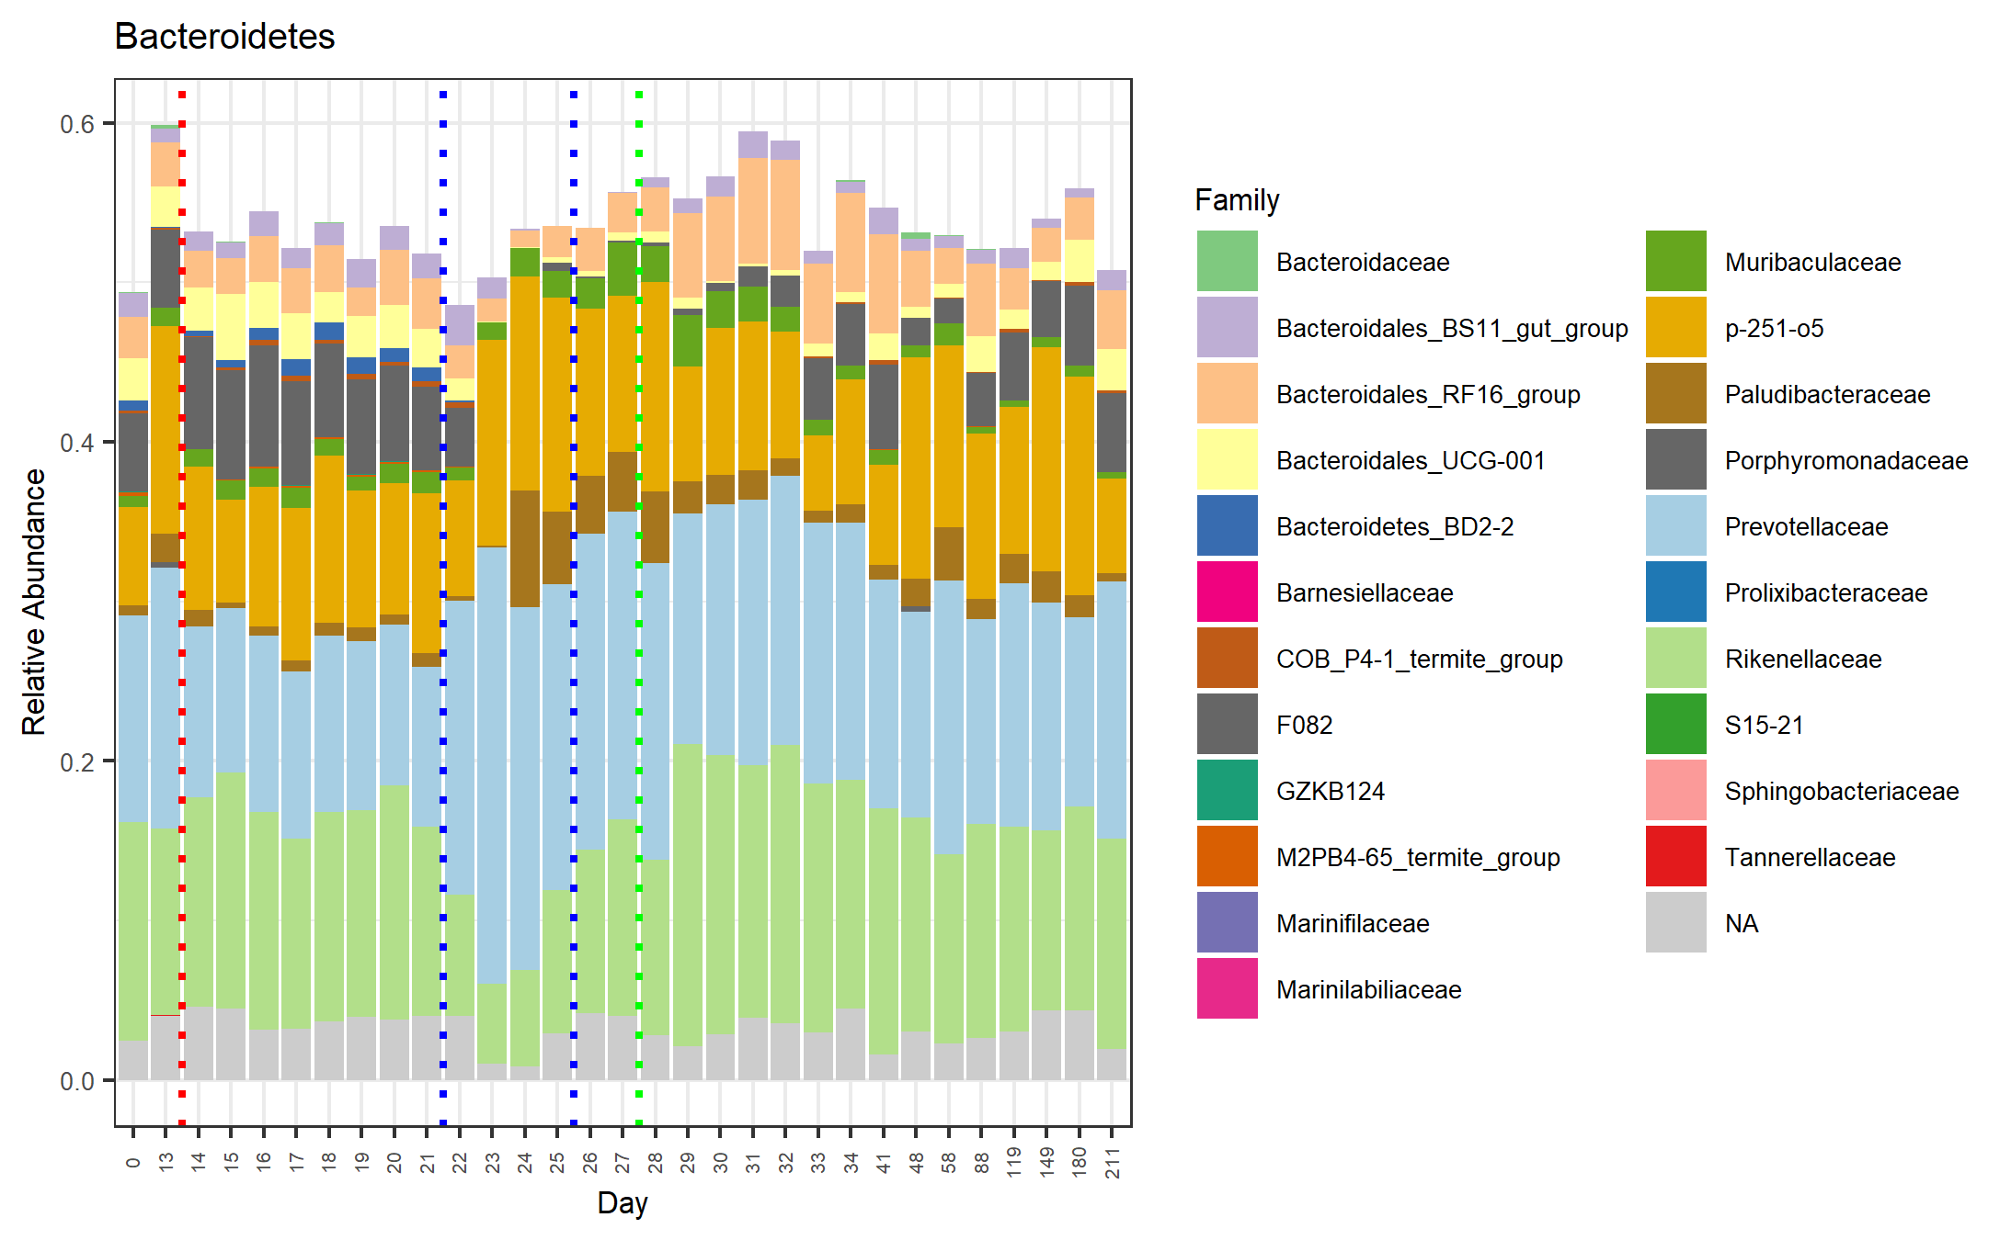
B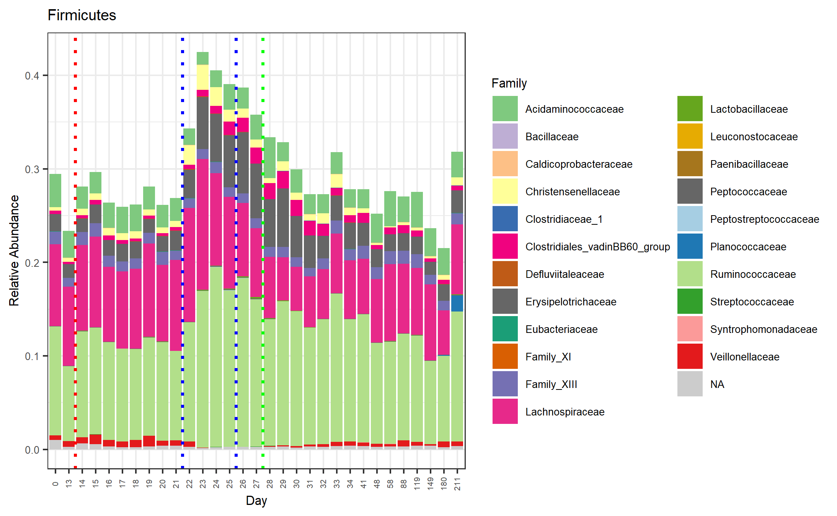
Additional file 4. Relative abundance of bacterial families of the Bacteroidetes (A) and Firmicutes (B) in faecal samples collected from healthy Welsh ponies at the farm (D0-D13), during hospitalization without treatment (D14-D21), during hospitalization and treatment with trimethoprim-sulfadiazine (TMS) (D22-D26) and after discharge from the hospital up until 6 months after hospitalization and antimicrobial treatment (D27-D211). NA = not applicable, indicating no family level name is yet available.

