Supplementary Information Figures

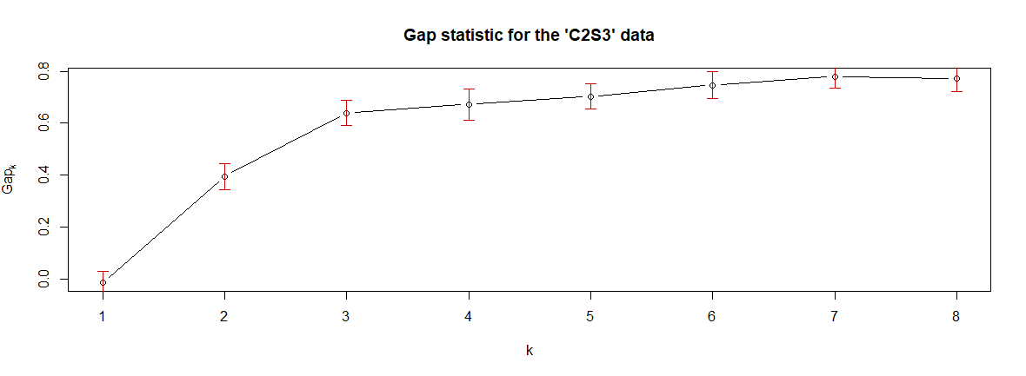
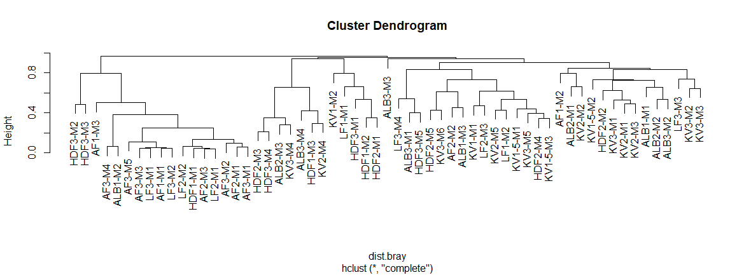

SI Figure 1: Gap statistic analysis (top) and Cluster dendogram (bottom) of subsetted samples. Gap statistic analysis was used to derive the appropriate number of sample groups and the cluster dendogram was used to validate the samples in each group.
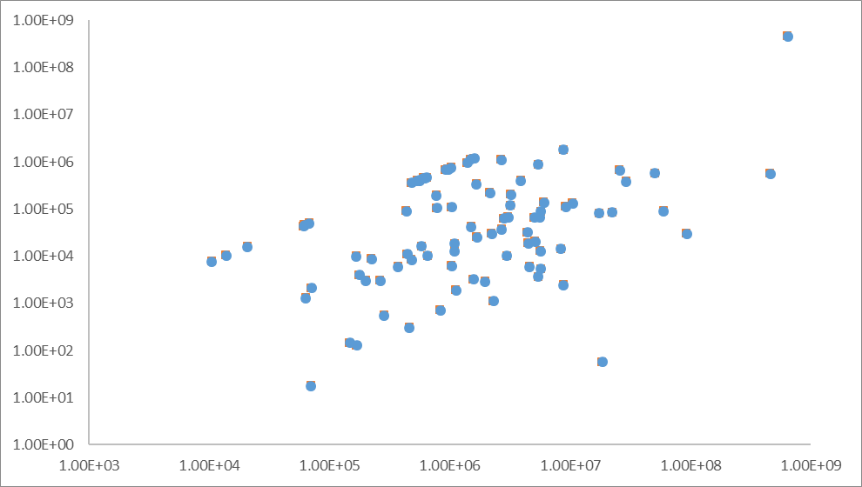

Estimated Pseudomonas abundance

Total Estimated bacterial abundance

SI Figure 2: Relationship between estimated abundance of Pseudomonas and estimated total cell abundance. No significant correlation was observed, r²=0.10. Values are in 16S rRNA copies.m2 (corrected for snow mass loading per sample).

SI Figure 3: Scatterplot matrix showing histograms, kernel density overlays, absolute correlations and significance asterisks (p<0.05*, p<0.01**, p<0.001***), for the relationships between immigration, abundance and diversity and selected parameters including pIN (ice nucleation), Cl⁻, NO₃-, POC, formic and acetic acid).
