SUPPORTING INFORMATION

- Supplementary tables
Table S1 Summary of sequence information of different samples in each step of metagenome sequencing analysis
Table S2 Multiple response permutation procedure (MRPP) analysis of functional profiles related to methane, nitrogen and sulphur cycling among different depths
Table S3 Analysis of similarity (ANOSIM) based on functional profiles related to methane, nitrogen and sulphur cycling among different depths
Table S4 The vertical distribution of physicochemical characteristics of all mangrove sediment samples in this study
Table S5 Summary statistics for Mantel tests of correlations between metabolic pathways and environmental factors
Table S6 Summary of correlations between functional groups and keystones
Table S7 Summary of correlations between functional groups in the deep sediment
- Supplementary figures
Fig. S1 The location of the sampling site at the Qi’ao Mangrove Reserve, Zhuhai, Guangdong province, China
Fig. S2 The depth-dependent profile of community structure in mangrove sediments (a) and linear regression analysis of correlations between the relative abundance of Proteobacteria and Euryarchaeota (b)
Fig. S3 Principal coordinate analysis (PCoA) plot of all microbial functions (a), methane cycling (b), nitrogen cycling (c), and sulphur cycling (d)
Fig. S4 Principal coordinate analysis (PCoA) plot of all microbial communities (a), and CH₄-cycling (b), N-cycling (c) and S-cycling (d) microbial communities
Fig. S5 A heatmap plot of functional pathways for predicted open reading frames (ORFs) from metagenome sequence reads for sediment samples at different depths
Fig. S6 The vertical distribution of relative abundances of key gene families involved in methane cycling
Fig. S7 The vertical distribution of relative abundances of key gene families involved in nitrogen cycling
Fig. S8 The vertical distribution of the relative abundance of key microbial taxa (top 5) responsible for genes involved in S oxidation and denitrification
Fig. S9 The vertical distribution of relative abundances of key gene families involved in sulphur cycling
Fig. S10 Correlations between the relative abundance of key gene families
Fig. S11 Methane, nitrogen and sulphur cycling co-occurrence networks of three sediment layers at the species level with OTUs colored by phylum/class
Fig. S12 The vertical distribution of relative abundances of retrieved methanogen/ANME/SRB MAGs
Fig. S13 Metabolic profiles of retrieved MAGs (A) and relative abundances of selected MAGs (B)
Fig. S14 Carbon, nitrogen, sulphur and metal metabolisms involved in different selected lineages
- Supplementary tables
Table S1 Summary of sequence information of different samples in each major step of metagenome sequencing analysis.

Sample | Raw Reads | Raw Base(G) | Q20 (%) | Q30 (%) | GC Content (%) | Qualified Reads | Merged Reads
ZH-Q0-5-1 | 39093129 | 11.73 | 96.88 | 91.98 | 59.99 | 34606417 | 17872173
ZH-Q0-5-2 | 35789446 | 10.74 | 96.96 | 92.16 | 58.28 | 31838513 | 15375518
ZH-Q0-5-3 | 40938057 | 12.28 | 96.75 | 91.47 | 59.79 | 36148697 | 7186994
ZH-Q0-5-4 | 37674841 | 11.3 | 96.56 | 91.25 | 60.07 | 32883395 | 9544945
ZH-Q0-5-5 | 34072469 | 10.22 | 97.01 | 92.03 | 57.66 | 30448662 | 9061589
ZH-Q5-10-1 | 39632706 | 11.89 | 96.69 | 91.48 | 57.26 | 34846093 | 12363889
ZH-Q5-10-2 | 37351666 | 11.21 | 96.72 | 91.56 | 57.49 | 32881517 | 11999254
ZH-Q5-10-3 | 38292544 | 11.49 | 96.69 | 91.25 | 58.44 | 33765221 | 10517851
ZH-Q5-10-4 | 45955254 | 13.79 | 96.67 | 91.49 | 62.6 | 40291210 | 14064158
ZH-Q5-10-5 | 38986911 | 11.7 | 96.61 | 91.35 | 59.39 | 34126182 | 10019152
ZH-Q10-15-1 | 47170312 | 14.15 | 97.01 | 92.15 | 61.63 | 42085161 | 16413492
ZH-Q10-15-2 | 66546667 | 19.96 | 97.54 | 93.49 | 60.29 | 60544329 | 58865523
ZH-Q10-15-3 | 40865433 | 12.26 | 96.89 | 91.88 | 59.18 | 36238772 | 12879577
ZH-Q10-15-4 | 46556802 | 13.97 | 96.77 | 91.63 | 57.23 | 41088683 | 13946952
ZH-Q10-15-5 | 39287230 | 11.79 | 96.7 | 91.58 | 59.3 | 34513120 | 13669507
ZH-Q15-20-1 | 42921407 | 12.88 | 96.73 | 91.68 | 62.02 | 37717955 | 16731248
ZH-Q15-20-2 | 44028520 | 13.21 | 96.89 | 91.91 | 57.65 | 39142844 | 10887026
ZH-Q15-20-3 | 49419311 | 14.83 | 96.73 | 91.63 | 58.52 | 43563653 | 13621803
ZH-Q15-20-4 | 40626725 | 12.19 | 96.49 | 91.16 | 59.73 | 35319288 | 11915506
ZH-Q15-20-5 | 33504696 | 10.05 | 96.99 | 92.07 | 55.34 | 29899853 | 11914085
ZH-Q20-30-1 | 35044724 | 10.51 | 96.69 | 91.47 | 59.42 | 30862340 | 6687057
ZH-Q20-30-2 | 46247908 | 13.87 | 96.74 | 91.62 | 57.09 | 40749313 | 15278919
ZH-Q20-30-3 | 67951834 | 20.39 | 96.7 | 91.53 | 59.15 | 59788364 | 18781442
ZH-Q20-30-4 | 39541019 | 11.86 | 97.94 | 94.16 | 56.26 | 36818944 | 24346382
ZH-Q20-30-5 | 61093695 | 18.33 | 97.06 | 92.27 | 55.49 | 54654711 | 26248204
ZH-Q30-40-1 | 34439422 | 10.33 | 98.05 | 94.55 | 57.54 | 32300193 | 20031930
ZH-Q30-40-2 | 50044485 | 15.01 | 96.88 | 91.92 | 56.17 | 44439237 | 17050996
ZH-Q30-40-3 | 47191054 | 14.16 | 96.57 | 91.24 | 57.02 | 41279353 | 10609715
ZH-Q30-40-4 | 36291095 | 10.89 | 97.91 | 94.1 | 54.05 | 33786874 | 19712266
ZH-Q30-40-5 | 34707079 | 10.41 | 97.56 | 93.27 | 57.05 | 31941327 | 10628724
ZH-Q40-50-1 | 39180448 | 11.75 | 97.92 | 94.15 | 54.82 | 36453033 | 22927945
ZH-Q40-50-2 | 38261891 | 11.48 | 97.51 | 93.14 | 57.48 | 35182999 | 10282353
ZH-Q40-50-3 | 36257235 | 10.88 | 97.46 | 92.9 | 54.13 | 33223736 | 11163701
ZH-Q40-50-4 | 36519819 | 10.96 | 97.63 | 93.35 | 55.16 | 33685336 | 17517547
ZH-Q40-50-5 | 34507721 | 10.35 | 96.96 | 91.81 | 54.81 | 30964271 | 13893635
ZH-Q50-60-1 | 37674354 | 11.3 | 97.72 | 93.66 | 54.19 | 34762109 | 23723682
ZH-Q50-60-2 | 44974552 | 13.49 | 97.88 | 94.12 | 56.5 | 41897125 | 21206649
ZH-Q50-60-3 | 35312547 | 10.59 | 97.27 | 92.66 | 56.42 | 32088130 | 8410023
ZH-Q50-60-4 | 37577731 | 11.27 | 97.43 | 92.95 | 54.19 | 34436972 | 11470757
ZH-Q50-60-5 | 36890109 | 11.07 | 97.59 | 93.41 | 54.48 | 34037053 | 10034897
ZH-Q60-80-1 | 37855160 | 11.36 | 97.42 | 93.16 | 53.98 | 34589347 | 12641880
ZH-Q60-80-2 | 36482704 | 10.94 | 97.55 | 93.38 | 54.32 | 33581269 | 11988175
ZH-Q60-80-3 | 34799733 | 10.44 | 97.6 | 93.49 | 56.38 | 32065315 | 12895421
ZH-Q60-80-4 | 34404399 | 10.32 | 97.58 | 93.53 | 53.98 | 31668849 | 9574563
ZH-Q60-80-5 | 37371641 | 11.21 | 97.21 | 92.65 | 54.65 | 33835609 | 12333269
ZH-Q80-100-1 | 35313245 | 10.59 | 97.59 | 93.45 | 56.97 | 32568181 | 8940087
ZH-Q80-100-2 | 35929383 | 10.78 | 97.64 | 93.52 | 53.34 | 33208473 | 10346104
ZH-Q80-100-3 | 34936488 | 10.48 | 97.32 | 92.81 | 55.95 | 31773323 | 9216940
ZH-Q80-100-4 | 37285450 | 11.19 | 97.54 | 93.34 | 55.22 | 34256599 | 10738277
ZH-Q80-100-5 | 40907879 | 12.27 | 97.33 | 92.81 | 55.64 | 37304899 | 7392991

Table S2 Multiple response permutation procedure (MRPP) analysis of functional profiles related to methane, nitrogen and sulphur cycling among different depths. Values for significant levels are denoted with *(0.01 < P < 0.05), **(0.001 < P < 0.01) and ***(P < 0.001).

Depth | 0-5 | 5-10 | 10-15 | 15-20 | 20-30 | 30-40 | 40-50 | 50-60 | 60-80 | 80-100
0-5 |  | 0.232 | 0.2 | 0.097 | * | ** | * | ** | ** | **
5-10 |  |  | 0.908 | 0.777 | 0.241 | ** | ** | ** | ** | *
10-15 |  |  |  | 0.805 | 0.232 | * | ** | ** | * | *
15-20 |  |  |  |  | 0.595 | * | * | * | * | *
20-30 |  |  |  |  |  | 0.357 | 0.059 | 0.06 | * | *
30-40 |  |  |  |  |  |  | 0.295 | 0.381 | 0.272 | 0.103
40-50 |  |  |  |  |  |  |  | 0.89 | 0.899 | 0.15
50-60 |  |  |  |  |  |  |  |  | 0.924 | 0.239
60-80 |  |  |  |  |  |  |  |  |  | 0.246
80-100

Table S3 Analysis of similarity (ANOSIM) based on functional profiles related to methane, nitrogen and sulphur cycling among different depths. Values for significant levels are denoted with *(0.01 < P < 0.05), **(0.001 < P < 0.01) and ***(P < 0.001).

Depth | 0-5 | 5-10 | 10-15 | 15-20 | 20-30 | 30-40 | 40-50 | 50-60 | 60-80 | 80-100
0-5 |  | 0.173 | 0.153 | 0.059 | * | * | ** | ** | * | *
5-10 |  |  | 0.787 | 0.92 | 0.26 | ** | ** | ** | ** | *
10-15 |  |  |  | 0.976 | 0.325 | ** | ** | ** | ** | **
15-20 |  |  |  |  | 0.706 | 0.118 | * | * | * | *
20-30 |  |  |  |  |  | 0.855 | 0.077 | 0.147 | 0.051 | *
30-40 |  |  |  |  |  |  | 0.327 | 0.391 | 0.271 | 0.056
40-50 |  |  |  |  |  |  |  | 0.893 | 0.902 | 0.07
50-60 |  |  |  |  |  |  |  |  | 0.926 | 0.172
60-80 |  |  |  |  |  |  |  |  |  | 0.075
80-100
Table S4 The vertical distribution of physicochemical characteristics of mangrove sediment samples (mean ± SD).

 | Depth (cm) | PH | Temperature  (℃) | Salinity  （%） | SO₄²⁻  (mg/l) | AVS  (mmol/l dry weight) | S₀  (mg/kg) | NO₃⁻  (μg N/L) | NO₂⁻  (μg N/L) | NH₄⁺  (mg N/L) | TC  （%） | TN  （%） | TS  （%）
KO1 | 0-5 | 6.39±0.12^{c} | 19.52±0.19^{ab} | 1.26±0.05ª | 596.17±75.03ª | 19.47±2.80ª | 448.01±183.12ª | 133.98±21.29^{ab} | 91.78±11.45ª | 3.30±0.39^{b} | 3.23±0.43ª | 0.28±0.03^{ab} | 0.94±0.12ª
KO2 | 5-10 | 6.52±0.13^{bc} | 19.22±0.11^{b} | 0.97±0.08^{ab} | 260.83±16.38^{ab} | 14.93±1.08^{b} | 717.05±257.82ª | 139.63±7.31^{ab} | 58.91±7.38^{b} | 4.74±0.87ª | 3.62±0.52ª | 0.31±0.04ª | 0.82±0.10ª
KO3 | 10-15 | 6.45±0.10^{bc} | 19.20±0.17^{b} | 1.01±0.16^{ab} | 155.33±9.95^{ab} | 16.99±3.00^{ab} | 1508.76±661.03ª | 88.29±21.34^{b} | 86.24±16.29^{ab} | 3.01±0.32^{bc} | 3.63±0.70ª | 0.31±0.05ª | 0.73±0.08ª
KO4 | 15-20 | 6.55±0.05^{bc} | 19.28±0.17^{b} | 0.98±0.14^{ab} | 88.17±4.29^{b} | 13.40±0.61^{b} | 2014.12±1088.38ª | 101.13±11.97^{b} | 47.12±16.30^{b} | 2.05±0.13^{c} | 3.41±0.64ª | 0.29±0.05^{ab} | 0.77±0.11ª
KO5 | 20-30 | 6.75±0.09^{b} | 19.48±0.19^{b} | 0.92±0.10^{ab} | 115.00±13.21^{b} | 16.06±1.30^{ab} | 1881.02±746.27ª | 229.97±34.37ª | 81.00±5.61^{ab} | 2.10±0.25^{c} | 3.05±0.55^{ab} | 0.26±0.04^{ab} | 0.84±0.15ª
KO6 | 30-40 | 6.88±0.15^{ab} | 19.72±0.15^{ab} | 0.91±0.12^{ab} | 95.50±9.90^{b} | 16.12±0.99^{ab} | 1168.65±642.71ª | 148.35±15.34^{ab} | 85.09±10.15^{ab} | 1.86±0.10^{c} | 2.69±0.48^{ab} | 0.23±0.04^{ab} | 0.91±0.18ª
KO7 | 40-50 | 7.07±0.07^{ab} | 19.76±0.17^{ab} | 0.87±0.09^{b} | 133.51±38.20^{b} | 0.80±0.14^{c} | 937.59±470.98ª | 213.14±12.11ª | 95.48±11.49ª | 1.84±0.57^{c} | 2.40±0.35^{ab} | 0.20±0.02^{b} | 1.02±0.25ª
KO8 | 50-60 | 7.11±0.11ª | 20.12±0.19ª | 0.84±0.13^{b} | 55.52±6.67^{b} | 0.84±0.17^{c} | 432.77±172.73ª | 227.92±5.27ª | 89.71±4.66ª | 2.38±0.39^{bc} | 2.45±0.35^{ab} | 0.20±0.03^{b} | 1.06±0.26ª
KO9 | 60-80 | 7.17±0.12ª | 20.12±0.31ª | 0.87±0.13^{b} | 64.00±1.92^{b} | 0.70±0.04^{c} | 270.91±66.21ª | 267.96±14.99ª | 86.86±5.44^{ab} | 2.56±0.30^{bc} | 2.39±0.25^{ab} | 0.19±0.03^{b} | 1.11±0.18ª
KO10 | 80-100 | 7.17±0.13ª | 20.12±0.39ª | 0.88±0.18^{b} | 30.48±1.91^{b} | 0.80±0.07^{c} | 312.73±38.42ª | 294.91±30.16ª | 103.95±6.25ª | 2.12±0.17^{c} | 1.75±0.12^{b} | 0.14±0.01^{b} | 1.03±0.16ª
Note: Small letters mean a statistical significance (P < 0.05) among different depths. AVS: acid volatile sulfide; TC: total carbon; TN: total nitrogen; TS: total sulphur.

Gene category | PH | Temperature  (℃) | Salinity  （%） | SO₄²⁻  (mg/l) | AVS  (mmol/l) | S₀  (mg/kg) | NO₃⁻  (μg N/L) | NO₂⁻  (μg N/L) | NH₄⁺  (mg N/L) | TC  （%） | TN  （%） | TS  （%）
Denitrification | 0.3564  (0.001) | 0.0112  (0.437) | 0.0009  (0.499) | 0.1057  (0.105) | 0.2698  (0.001) | 0.0500  (0.754) | 0.2393  (0.001) | 0.1610  (0.016) | 0.0301  (0.608) | 0.1028  (0.055) | 0.1060  (0.025) | 0.0507  (0.186)
Anammox | 0.2350  (0.004) | 0.0309  (0.314) | 0.1151  (0.029) | 0.0312  (0.295) | 0.1005  (0.027) | 0.0297  (0.313) | 0.0877  (0.098) | 0.0959  (0.14) | 0.0813  (0.849) | 0.0938  (0.094) | 0.1078  (0.057) | 0.0251  (0.613)
DNRA | 0.3835  (0.001) | 0.0068  (0.408) | 0.0324  (0.299) | 0.3290  (0.009) | 0.1877  (0.002) | 0.0829  (0.831) | 0.1668  (0.034) | 0.2045  (0.016) | 0.0260  (0.498) | 0.0592  (0.204) | 0.0588  (0.166) | 0.0248  (0.336)
N₂ fixation | 0.1060  (0.038) | 0.0409  (0.259) | 0.0585  (0.126) | 0.2918  (0.001) | 0.2862  (0.001) | 0.0350  (0.639) | 0.1141  (0.037) | 0.0911  (0.079) | 0.0877  (0.113) | 0.1670  (0.005) | 0.1852  (0.002) | 0.0315  (0.692)
Dissimilatory sulphur reduction and oxidation | 0.1608  (0.032) | 0.0533  (0.681) | 0.0372  (0.697) | 0.1286  (0.111) | 0.0308  (0.216) | 0.0470  (0.269) | 0.0805  (0.164) | 0.2077  (0.02) | 0.0701  (0.781) | 0.1616  (0.055) | 0.1213  (0.049) | 0.0456  (0.253)
Sulphur reduction | 0.3861  (0.001) | 0.0162  (0.508) | 0.0160  (0.369) | 0.3008  (0.015) | 0.1906  (0.002) | 0.0986  (0.904) | 0.1575  (0.033) | 0.1613  (0.036) | 0.0050  (0.406) | 0.0107  (0.355) | 0.0151  (0.516) | 0.0742  (0.16)
Sox system | 0.3524  (0.001) | 0.1270  (0.048) | 0.0463  (0.185) | 0.1668  (0.035) | 0.3979  (0.001) | 0.1199  (0.986) | 0.3335  (0.001) | 0.1689(  0.013) | 0.0398  (0.685) | 0.0914  (0.063) | 0.1409  (0.012) | 0.0408  (0.216)
sulphur oxidation | 0.2962  (0.001) | 0.1276  (0.014) | 0.1129  (0.01) | 0.2296  (0.001) | 0.4458  (0.001) | 0.0574  (0.841) | 0.3024  (0.001) | 0.1276  (0.011) | 0.0071  (0.505) | 0.1992  (0.001) | 0.2815  (0.001) | 0.0430  (0.802)
Aerobic oxidation of methane | 0.4084  (0.001) | 0.0610  (0.196) | 0.0634  (0.132) | 0.3327  (0.005) | 0.3067  (0.001) | 0.1096  (0.954) | 0.2437  (0.003) | 0.1849  (0.023) | 0.0061  (0.434) | 0.0636  (0.163) | 0.0832  (0.097) | 0.0282  (0.31)
Methanogenesis | 0.4289  (0.001) | 0.0214  (0.337) | 0.0314  (0.264) | 0.2868  (0.003) | 0.2918  (0.001) | 0.0966  (0.918) | 0.2194  (0.005) | 0.1672  (0.019) | 0.0066  (0.46) | 0.0762  (0.133) | 0.0837  (0.092) | 0.0489  (0.197)
Table S5 Summary statistics for Mantel tests of correlations between metabolic pathways and environmental factors.
Note: Values are correlation coefficients with P values in brackets (P < 0.05 in bold).
Table S6 Summary of correlations between functional groups and keystones.

Keystone | Interaction groups | Betweeness | Direction
Sulfuricaulis limicola (surface layer) | Bradyrhizobiaceae bacterium SG-6C | 61.17460317 | 1
Sulfuricaulis limicola (surface layer) | Bradyrhizobium taxid(374) | 187.6666667 | 1
Sulfuricaulis limicola (surface layer) | Bradyrhizobium oligotrophicum S58 | 64.12380952 | 1
Sulfuricaulis limicola (surface layer) | Bradyrhizobium sp. ORS | 76.91349206 | 1
Sulfuricaulis limicola (surface layer) | Methyloceanibacter caenitepidi | 74.43730159 | 1
Sulfuricaulis limicola (surface layer) | Pseudolabrys taiwanensis | 43.64285714 | 1
Sulfuricaulis limicola (surface layer) | Rhizobiales taxid (356) | 373.1190476 | 1
Sulfuricaulis limicola (surface layer) | Rhodoplanes sp. Z2-YC6860 | 120.3333333 | 1
Sulfuricaulis limicola (surface layer) | Stella humosa | 105.8007937 | 1
Sulfuricaulis limicola (surface layer) | unclassified Bradyrhizobium | 56.60396825 | 1
Betaproteobacteria taxid(28216) (middle layer) | Acidiferrobacter sp. SPIII 3 | 422.7364137 | 1
Betaproteobacteria taxid(28216) (middle layer) | Alphaproteobacteria taxid(28211) | 200.8745329 | 1
Betaproteobacteria taxid(28216) (middle layer) | Anaeromyxobacter dehalogenans 2CP-C | 139.1634994 | 1
Betaproteobacteria taxid(28216) (middle layer) | Anaeromyxobacter sp. Fw109-5 | 297.998284 | 1
Betaproteobacteria taxid(28216) (middle layer) | Ancylobacter sp. TS-1 | 285.9247463 | 1
Betaproteobacteria taxid(28216) (middle layer) | Aquabacterium olei | 418.7064161 | 1
Betaproteobacteria taxid(28216) (middle layer) | Azospirillum taxid 191 | 214.3621066 | 1
Betaproteobacteria taxid(28216) (middle layer) | Betaproteobacteria bacterium GR16-43 | 39.56250684 | 1
Betaproteobacteria taxid(28216) (middle layer) | Bradyrhizobium taxid(374) | 163.8546449 | 1
Betaproteobacteria taxid(28216) (middle layer) | Bradyrhizobium erythrophlei | 81.62162263 | 1
Betaproteobacteria taxid(28216) (middle layer) | Bradyrhizobium sp. 58S1 | 97.81294809 | 1
Betaproteobacteria taxid(28216) (middle layer) | Bradyrhizobium sp. BTAi1 | 193.7818279 | 1
Betaproteobacteria taxid(28216) (middle layer) | Bradyrhizobium zhanjiangense | 145.6329102 | 1
Betaproteobacteria taxid(28216) (middle layer) | Burkholderia taxid(32008) | 195.9464094 | 1
Betaproteobacteria taxid(28216) (middle layer) | Burkholderia cepacia complex | 124.1616815 | 1
Betaproteobacteria taxid(28216) (middle layer) | Burkholderia sp. DHOD12 | 175.5199592 | 1
Betaproteobacteria taxid(28216) (middle layer) | Burkholderia stagnalis | 160.3713164 | 1
Betaproteobacteria taxid(28216) (middle layer) | Burkholderiaceae taxid(119060) | 165.4540364 | 1
Betaproteobacteria taxid(28216) (middle layer) | Burkholderiales bacterium GJ-E10 | 1230.069034 | 1
Betaproteobacteria taxid(28216) (middle layer) | Burkholderiales bacterium JOSHI 001 | 102.1123937 | 1
Betaproteobacteria taxid(28216) (middle layer) | Candidatus Filomicrobium marinum | 59.72677178 | 1
Betaproteobacteria taxid(28216) (middle layer) | Candidatus Promineofilum breve | 165.3807778 | 1
Betaproteobacteria taxid(28216) (middle layer) | Candidatus Symbiobacter mobilis | 255.0044661 | 1
Betaproteobacteria taxid(28216) (middle layer) | Celeribacter indicus | 1567.64887 | 1
Betaproteobacteria taxid(28216) (middle layer) | Cupriavidus gilardii CR3 | 90.34454298 | 1
Betaproteobacteria taxid(28216) (middle layer) | Cupriavidus metallidurans | 266.4934203 | 1
Betaproteobacteria taxid(28216) (middle layer) | Cupriavidus taiwanensis | 127.8620869 | 1
Betaproteobacteria taxid(28216) (middle layer) | Desulfitobacterium hafniense | 448.7392246 | 1
Betaproteobacteria taxid(28216) (middle layer) | Desulfocurvibacter africanus subsp. | 510.1115552 | -1
Betaproteobacteria taxid(28216) (middle layer) | Gammaproteobacteria taxid(1236) | 556.9880575 | 1
Betaproteobacteria taxid(28216) (middle layer) | Halorhodospira halochloris | 120.2375618 | 1
Betaproteobacteria taxid(28216) (middle layer) | Hyphomicrobium nitrativorans NL23 | 235.7760125 | 1
Betaproteobacteria taxid(28216) (middle layer) | Methyloceanibacter sp. wino2 | 220.3156467 | 1
Betaproteobacteria taxid(28216) (middle layer) | Methylocystis bryophila | 494.9515661 | 1
Betaproteobacteria taxid(28216) (middle layer) | Microvirgula aerodenitrificans | 543.7331234 | 1
Betaproteobacteria taxid(28216) (middle layer) | Nitrospira japonica | 43.87087914 | 1
Betaproteobacteria taxid(28216) (middle layer) | Nitrospira moscoviensis | 78.15803573 | 1
Betaproteobacteria taxid(28216) (middle layer) | Pandoraea thiooxydans | 87.47978955 | 1
Betaproteobacteria taxid(28216) (middle layer) | Paraburkholderia rhizoxinica HKI | 58.72743396 | 1
Betaproteobacteria taxid(28216) (middle layer) | Phreatobacter sp. NMCR1094 | 122.7915884 | 1
Betaproteobacteria taxid(28216) (middle layer) | Pseudolabrys sp. FHR47 | 99.32104844 | 1
Betaproteobacteria taxid(28216) (middle layer) | Pseudolabrys taiwanensis | 129.2683113 | 1
Betaproteobacteria taxid(28216) (middle layer) | Pseudomonas protegens | 43.87087914 | 1
Betaproteobacteria taxid(28216) (middle layer) | Pseudorhodoplanes sinuspersici | 133.1747092 | 1
Betaproteobacteria taxid(28216) (middle layer) | Ralstonia insidiosa | 313.2213185 | 1
Betaproteobacteria taxid(28216) (middle layer) | Ralstonia solanacearum | 195.4115077 | 1
Betaproteobacteria taxid(28216) (middle layer) | Rhizobiales taxid(356) | 124.3549573 | 1
Betaproteobacteria taxid(28216) (middle layer) | Rhodopseudomonas palustris BisA53 | 829.8027115 | 1
Betaproteobacteria taxid(28216) (middle layer) | Rhodospirillaceae bacterium R5913 | 148.209782 | 1
Betaproteobacteria taxid(28216) (middle layer) | Sorangium cellulosum | 80.84117071 | 1
Betaproteobacteria taxid(28216) (middle layer) | Sphaerotilus natans subsp. | 238.703802 | 1
Betaproteobacteria taxid(28216) (middle layer) | Sphingomonas taxid(13687) | 306.1454149 | 1
Betaproteobacteria taxid(28216) (middle layer) | Sporosarcina sp. P37 | 120.2375618 | 1
Betaproteobacteria taxid(28216) (middle layer) | Sterolibacteriaceae bacterium M52 | 330.9111567 | 1
Betaproteobacteria taxid(28216) (middle layer) | Sulfuricella denitrificans skB26 | 281.3504831 | 1
Betaproteobacteria taxid(28216) (middle layer) | Sulfuritalea hydrogenivorans sk43H | 114.2097713 | 1
Betaproteobacteria taxid(28216) (middle layer) | Thauera aromatica K172 | 523.6797143 | 1
Betaproteobacteria taxid(28216) (middle layer) | Thauera chlorobenzoica | 192.9595801 | 1
Betaproteobacteria taxid(28216) (middle layer) | Thauera sp. MZ1T | 160.5445065 | 1
Betaproteobacteria taxid(28216) (middle layer) | Thermaerobacter sp. FW80 | 223.0478106 | 1
Betaproteobacteria taxid(28216) (middle layer) | unclassified Bradyrhizobium | 158.2715567 | 1
Betaproteobacteria taxid(28216) (middle layer) | unclassified Streptomyces | 73.45873278 | 1
Desulfomicrobium orale DSM (middle layer) | Achromobacter spanius | 435.5796406 | -1
Desulfomicrobium orale DSM (middle layer) | Arenimonas daejeonensis | 480.8639736 | -1
Desulfomicrobium orale DSM (middle layer) | Bordetella taxid(517) | 744.3177047 | -1
Desulfomicrobium orale DSM (middle layer) | Burkholderia cenocepacia | 275.8269673 | -1
Desulfomicrobium orale DSM (middle layer) | Chromatiaceae taxid(1046) | 325.1680208 | -1
Desulfomicrobium orale DSM (middle layer) | Hydrogenophaga taxid(47420) | 108.776537 | -1
Desulfomicrobium orale DSM (middle layer) | Melaminivora sp. SC2-9 | 1164.875136 | -1
Desulfomicrobium orale DSM (middle layer) | Methyloceanibacter sp. wino2 | 1427.928704 | -1
Desulfomicrobium orale DSM (middle layer) | Nocardioides sp. JS614 | 251.7813425 | -1
Desulfomicrobium orale DSM (middle layer) | Polaromonas sp. JS666 | 256.9074574 | -1
Desulfomicrobium orale DSM (middle layer) | Sphingomonadaceae taxid(41297) | 328.2065308 | -1
Desulfomicrobium orale DSM (middle layer) | Sulfuriflexus mobilis | 434.1440792 | -1
Desulfomicrobium orale DSM (middle layer) | Sulfuritortus calidifontis | 231.2605795 | -1
Desulfomicrobium orale DSM (middle layer) | Thiolapillus brandeum | 916.3502986 | -1
Desulfovibrio desulfuricans ND132 (middle layer) | Allochromatium vinosum DSM | 229.0540638 | 1
Desulfovibrio desulfuricans ND132 (middle layer) | Burkholderia ubonensis | 334.7756344 | 1
Desulfovibrio desulfuricans ND132 (middle layer) | Deltaproteobacteria taxid(28221) | 245.965672 | 1
Desulfovibrio desulfuricans ND132 (middle layer) | Desulfatibacillum aliphaticivorans | 140.6824562 | 1
Desulfovibrio desulfuricans ND132 (middle layer) | Desulfobacterium autotrophicum HRM2 | 111.3937388 | 1
Desulfovibrio desulfuricans ND132 (middle layer) | Desulfobacula toluolica Tol2 | 202.0304908 | 1
Desulfovibrio desulfuricans ND132 (middle layer) | Desulfococcus oleovorans Hxd3 | 93.85074602 | 1
Desulfovibrio desulfuricans ND132 (middle layer) | Desulfohalobium retbaense DSM | 585.3293245 | -1
Desulfovibrio desulfuricans ND132 (middle layer) | Desulfovibrio fairfieldensis | 80.97489537 | 1
Desulfovibrio desulfuricans ND132 (middle layer) | Desulfovibrio sp. IOR2 | 567.3667987 | 1
Desulfovibrio desulfuricans ND132 (middle layer) | Methanoculleus taxid(45989) | 352.1132944 | 1
Desulfovibrio desulfuricans ND132 (middle layer) | Methanoculleus marisnigri JR1 | 142.9190526 | 1
Desulfovibrio desulfuricans ND132 (middle layer) | Methanofollis liminatans DSM | 334.962723 | 1
Desulfovibrio desulfuricans ND132 (middle layer) | Methanolinea tarda NOBI-1 | 370.6460147 | 1
Desulfovibrio desulfuricans ND132 (middle layer) | Pseudomonas xinjiangensis | 130.2486172 | -1
Desulfovibrio desulfuricans ND132 (middle layer) | Syntrophus aciditrophicus SB | 674.9471227 | 1
Desulfovibrio desulfuricans ND132 (middle layer) | Thioploca ingrica | 214.0930059 | 1
Methanoregula boonei 6A8 (middle layer) | Achromobacter taxid(222) | 264.2457692 | -1
Methanoregula boonei 6A8 (middle layer) | Acidihalobacter prosperus | 449.3580996 | 1
Methanoregula boonei 6A8 (middle layer) | Azoarcus sp. SY39 | 490.7722312 | -1
Methanoregula boonei 6A8 (middle layer) | Betaproteobacteria bacterium GR16-43 | 330.3772344 | -1
Methanoregula boonei 6A8 (middle layer) | Bradyrhizobium sp. 58S1 | 224.8347062 | -1
Methanoregula boonei 6A8 (middle layer) | Burkholderia sp. KK1 | 498.6190081 | -1
Methanoregula boonei 6A8 (middle layer) | Celeribacter indicus | 200.7583864 | -1
Methanoregula boonei 6A8 (middle layer) | Chromatiaceae bacterium 2141T.STBD.0c.01a | 741.3601046 | 1
Methanoregula boonei 6A8 (middle layer) | Desulfovibrio gigas DSM | 285.7345448 | 1
Methanoregula boonei 6A8 (middle layer) | Halorhodospira halochloris | 560.1029575 | -1
Methanoregula boonei 6A8 (middle layer) | Methanoregula formicica SMSP | 153.4622732 | 1
Methanoregula boonei 6A8 (middle layer) | Methanosphaerula palustris E1-9c | 111.209705 | 1
Methanoregula boonei 6A8 (middle layer) | Methylovirgula ligni | 496.6118271 | -1
Methanoregula boonei 6A8 (middle layer) | Microbacteriaceae taxid(85023) | 567.7311042 | -1
Methanoregula boonei 6A8 (middle layer) | Microvirga sp. 17 | 760.2364939 | -1
Methanoregula boonei 6A8 (middle layer) | Microvirgula aerodenitrificans | 188.1968501 | -1
Methanoregula boonei 6A8 (middle layer) | Nitrospira japonica | 429.4262046 | -1
Methanoregula boonei 6A8 (middle layer) | Pseudomonas protegens | 429.4262046 | -1
Methanoregula boonei 6A8 (middle layer) | Sporosarcina sp. P37 | 560.1029575 | -1
Methanoregula boonei 6A8 (middle layer) | Sulfuricella denitrificans skB26 | 144.0290406 | -1
Methanoregula boonei 6A8 (middle layer) | Sulfurivermis fontis | 506.0466858 | 1
Methanoregula boonei 6A8 (middle layer) | Thauera aromatica K172 | 263.2210609 | -1
Methanoregula boonei 6A8 (middle layer) | unclassified Bradyrhizobium | 208.3066835 | -1
Methylobacterium sp. 17SD2-17 (middle layer) | Acidihalobacter ferrooxidans | 334.3136944 | -1
Methylobacterium sp. 17SD2-17 (middle layer) | Alcaligenes faecalis | 1014.863685 | -1
Methylobacterium sp. 17SD2-17 (middle layer) | Azoarcus sp. BH72 | 778.1072766 | -1
Methylobacterium sp. 17SD2-17 (middle layer) | Immundisolibacter cernigliae | 1040.701032 | -1
Methylobacterium sp. 17SD2-17 (middle layer) | Pandoraea apista | 708.9745848 | -1
Methylobacterium sp. 17SD2-17 (middle layer) | Paraburkholderia phymatum STM815 | 644.9852334 | -1
Methylobacterium sp. 17SD2-17 (middle layer) | Sedimenticola thiotaurini | 879.602917 | -1
Methylobacterium sp. 17SD2-17 (middle layer) | gamma proteobacterium SS-5 | 1464 | -1
Proteobacteria taxid(1224) (middle layer) | Achromobacter xylosoxidans | 107.7868361 | 1
Proteobacteria taxid(1224) (middle layer) | Azoarcus sp. DN11 | 117.7365656 | 1
Proteobacteria taxid(1224) (middle layer) | Azospirillum brasilense | 87.14514066 | 1
Proteobacteria taxid(1224) (middle layer) | Bacteria taxid(2) | 53.35484408 | 1
Proteobacteria taxid(1224) (middle layer) | Bradyrhizobium diazoefficiens | 329.6318569 | 1
Proteobacteria taxid(1224) (middle layer) | Bradyrhizobium guangxiense | 59.58760211 | 1
Proteobacteria taxid(1224) (middle layer) | Bradyrhizobium lablabi | 239.7922301 | 1
Proteobacteria taxid(1224) (middle layer) | Bradyrhizobium sp. BTAi1 | 147.0725035 | 1
Proteobacteria taxid(1224) (middle layer) | Bradyrhizobium sp. CCGE-LA001 | 139.4099036 | 1
Proteobacteria taxid(1224) (middle layer) | Bradyrhizobium zhanjiangense | 112.0538977 | 1
Proteobacteria taxid(1224) (middle layer) | Burkholderia lata | 115.0772825 | 1
Proteobacteria taxid(1224) (middle layer) | Candidatus Promineofilum breve | 107.95466 | 1
Proteobacteria taxid(1224) (middle layer) | Candidatus Solibacter usitatus | 635.8007959 | 1
Proteobacteria taxid(1224) (middle layer) | Cupriavidus metallidurans | 82.27991306 | 1
Proteobacteria taxid(1224) (middle layer) | Desulfitobacterium hafniense | 59.27978981 | 1
Proteobacteria taxid(1224) (middle layer) | Gammaproteobacteria taxid(1236) | 197.352874 | 1
Proteobacteria taxid(1224) (middle layer) | Gemmatirosa kalamazoonesis | 134.1842292 | 1
Proteobacteria taxid(1224) (middle layer) | Methylobacterium sp. 17Sr1-43 | 99.1621325 | 1
Proteobacteria taxid(1224) (middle layer) | Oscillibacter valericigenes Sjm18-20 | 724.0780643 | 1
Proteobacteria taxid(1224) (middle layer) | Pandoraea thiooxydans | 190.8007277 | 1
Proteobacteria taxid(1224) (middle layer) | Pseudolabrys sp. FHR47 | 218.2662621 | 1
Proteobacteria taxid(1224) (middle layer) | Pseudolabrys taiwanensis | 195.970922 | 1
Proteobacteria taxid(1224) (middle layer) | Rhodococcus taxid 1827 | 359.0632686 | 1
Proteobacteria taxid(1224) (middle layer) | Rhodoferax ferrireducens T118 | 143.8225628 | 1
Proteobacteria taxid(1224) (middle layer) | Rhodoferax sp. CHu59-6-5 | 569.0168732 | 1
Proteobacteria taxid(1224) (middle layer) | Rhodospirillum centenum SW | 264.4136509 | 1
Proteobacteria taxid(1224) (middle layer) | Sphingomonas taxid 13687 | 187.0969556 | 1
Proteobacteria taxid(1224) (middle layer) | Stella humosa | 87.36480888 | 1
Proteobacteria taxid(1224) (middle layer) | Sterolibacteriaceae bacterium M52 | 93.97549197 | 1
Proteobacteria taxid(1224) (middle layer) | Streptomyces taxid 1883 | 80.93861957 | 1
Proteobacteria taxid(1224) (middle layer) | Sulfuricaulis limicola | 192.0082358 | 1
Proteobacteria taxid(1224) (middle layer) | Terrabacteria group | 276.7242989 | 1
Proteobacteria taxid(1224) (middle layer) | Thioalkalivibrio sulfidiphilus HL-EbGr7 | 57.32435895 | 1
Proteobacteria taxid(1224) (middle layer) | unclassified Planctomycetes | 263.6746522 | 1
Rhizobiales taxid(356) (middle layer) | Achromobacter spanius | 138.4753869 | 1
Rhizobiales taxid(356) (middle layer) | Alphaproteobacteria taxid(28211) | 100.5589031 | 1
Rhizobiales taxid(356) (middle layer) | Ancylobacter sp. TS-1 | 180.6918024 | 1
Rhizobiales taxid(356) (middle layer) | Azoarcus sp. KH32C | 247.9727431 | 1
Rhizobiales taxid(356) (middle layer) | Betaproteobacteria taxid(28216) | 124.3549573 | 1
Rhizobiales taxid(356) (middle layer) | Betaproteobacteria bacterium GR16-43 | 68.34931897 | 1
Rhizobiales taxid(356) (middle layer) | Bradyrhizobiaceae taxid(41294) | 64.02636642 | 1
Rhizobiales taxid(356) (middle layer) | Bradyrhizobium taxid(374) | 50.15488364 | 1
Rhizobiales taxid(356) (middle layer) | Bradyrhizobium erythrophlei | 17.98795312 | 1
Rhizobiales taxid(356) (middle layer) | Bradyrhizobium sp. 2 | 223.3069609 | 1
Rhizobiales taxid(356) (middle layer) | Bradyrhizobium sp. BTAi1 | 131.4002052 | 1
Rhizobiales taxid(356) (middle layer) | Bradyrhizobium sp. SK17 | 88.75319468 | 1
Rhizobiales taxid(356) (middle layer) | Bradyrhizobium zhanjiangense | 91.93443599 | 1
Rhizobiales taxid(356) (middle layer) | Burkholderia taxid(32008) | 28.57996313 | 1
Rhizobiales taxid(356) (middle layer) | Burkholderia cenocepacia | 258.8616641 | 1
Rhizobiales taxid(356) (middle layer) | Burkholderia cepacia | 571.2059916 | 1
Rhizobiales taxid(356) (middle layer) | Burkholderia cepacia complex | 11.26339631 | 1
Rhizobiales taxid(356) (middle layer) | Burkholderia lata | 148.2279069 | 1
Rhizobiales taxid(356) (middle layer) | Burkholderia stagnalis | 32.94294599 | 1
Rhizobiales taxid(356) (middle layer) | Burkholderia territorii | 158.4427747 | 1
Rhizobiales taxid(356) (middle layer) | Burkholderiaceae taxid(119060) | 46.96688135 | 1
Rhizobiales taxid(356) (middle layer) | Burkholderiales taxid(80840) | 115.8569676 | 1
Rhizobiales taxid(356) (middle layer) | Burkholderiales bacterium JOSHI 001 | 7.7981012 | 1
Rhizobiales taxid(356) (middle layer) | Candidatus Filomicrobium marinum | 23.03209181 | 1
Rhizobiales taxid(356) (middle layer) | Candidatus Promineofilum breve | 110.9345429 | 1
Rhizobiales taxid(356) (middle layer) | Candidatus Thiodictyon syntrophicum | 115.0068192 | 1
Rhizobiales taxid(356) (middle layer) | Cupriavidus gilardii CR3 | 49.96095846 | 1
Rhizobiales taxid(356) (middle layer) | Cupriavidus metallidurans | 170.1763579 | 1
Rhizobiales taxid(356) (middle layer) | Cupriavidus necator N-1 | 66.80044928 | 1
Rhizobiales taxid(356) (middle layer) | Cupriavidus taiwanensis | 40.84020134 | 1
Rhizobiales taxid(356) (middle layer) | Gammaproteobacteria taxid(1236) | 291.2233161 | 1
Rhizobiales taxid(356) (middle layer) | Halorhodospira halochloris | 99.01597799 | 1
Rhizobiales taxid(356) (middle layer) | Hyphomicrobium nitrativorans NL23 | 81.74656554 | 1
Rhizobiales taxid(356) (middle layer) | Methylibium petroleiphilum PM1 | 38.65589775 | 1
Rhizobiales taxid(356) (middle layer) | Methyloceanibacter sp. wino2 | 41.19261012 | 1
Rhizobiales taxid(356) (middle layer) | Nitrospira japonica | 60.26403139 | 1
Rhizobiales taxid(356) (middle layer) | Nitrospira moscoviensis | 42.93533952 | 1
Rhizobiales taxid(356) (middle layer) | Pandoraea thiooxydans | 43.94889428 | 1
Rhizobiales taxid(356) (middle layer) | Paraburkholderia rhizoxinica HKI | 55.98414753 | 1
Rhizobiales taxid(356) (middle layer) | Polaromonas sp. JS666 | 526.2986318 | 1
Rhizobiales taxid(356) (middle layer) | Pseudolabrys sp. FHR47 | 56.74934369 | 1
Rhizobiales taxid(356) (middle layer) | Pseudolabrys taiwanensis | 63.90111 | 1
Rhizobiales taxid(356) (middle layer) | Pseudomonas taxid(286) | 65.24250553 | 1
Rhizobiales taxid(356) (middle layer) | Pseudomonas protegens | 60.26403139 | 1
Rhizobiales taxid(356) (middle layer) | Pseudorhodoplanes sinuspersici | 118.8796335 | 1
Rhizobiales taxid(356) (middle layer) | Ralstonia taxid(48736) | 121.1157412 | 1
Rhizobiales taxid(356) (middle layer) | Ralstonia insidiosa | 259.7629751 | 1
Rhizobiales taxid(356) (middle layer) | Ralstonia solanacearum | 188.3433703 | 1
Rhizobiales taxid(356) (middle layer) | Rhizobium leguminosarum | 67.58219154 | 1
Rhizobiales taxid(356) (middle layer) | Rhodopseudomonas palustris | 81.92452299 | 1
Rhizobiales taxid(356) (middle layer) | Rhodopseudomonas palustris BisA53 | 451.3698287 | 1
Rhizobiales taxid(356) (middle layer) | Rhodospirillaceae bacterium R5913 | 186.6679785 | 1
Rhizobiales taxid(356) (middle layer) | Sorangium cellulosum | 56.33385863 | 1
Rhizobiales taxid(356) (middle layer) | Sphingomonadaceae taxid(41297) | 184.3961154 | 1
Rhizobiales taxid(356) (middle layer) | Sporosarcina sp. P37 | 99.01597799 | 1
Rhizobiales taxid(356) (middle layer) | Sulfurifustis variabilis | 156.4236983 | 1
Rhizobiales taxid(356) (middle layer) | Sulfuritalea hydrogenivorans sk43H | 44.37880794 | 1
Rhizobiales taxid(356) (middle layer) | Thauera chlorobenzoica | 101.4133141 | 1
Rhizobiales taxid(356) (middle layer) | Thermaerobacter sp. FW80 | 124.3459618 | 1
Rhizobiales taxid(356) (middle layer) | Variovorax paradoxus B4 | 112.1406862 | 1
Rhizobiales taxid(356) (middle layer) | Variovorax sp. HW608 | 176.6657306 | 1
Rhizobiales taxid(356) (middle layer) | unclassified Streptomyces | 47.94736992 | 1
Thioalkalivibrio sulfidiphilus HL-EbGr7 (middle layer) | Achromobacter xylosoxidans | 71.12759472 | 1
Thioalkalivibrio sulfidiphilus HL-EbGr7 (middle layer) | Azoarcus sp. DN11 | 71.12124861 | 1
Thioalkalivibrio sulfidiphilus HL-EbGr7 (middle layer) | Bacteria taxid 2 | 103.8636304 | 1
Thioalkalivibrio sulfidiphilus HL-EbGr7 (middle layer) | Bradyrhizobium diazoefficiens | 150.7307191 | 1
Thioalkalivibrio sulfidiphilus HL-EbGr7 (middle layer) | Bradyrhizobium sp. CCGE-LA001 | 108.3644383 | 1
Thioalkalivibrio sulfidiphilus HL-EbGr7 (middle layer) | Candidatus Promineofilum breve | 96.2043364 | 1
Thioalkalivibrio sulfidiphilus HL-EbGr7 (middle layer) | Candidatus Solibacter usitatus | 241.2652293 | 1
Thioalkalivibrio sulfidiphilus HL-EbGr7 (middle layer) | Desulfitobacterium hafniense | 48.037375 | 1
Thioalkalivibrio sulfidiphilus HL-EbGr7 (middle layer) | Gammaproteobacteria taxid(1236) | 206.5086517 | 1
Thioalkalivibrio sulfidiphilus HL-EbGr7 (middle layer) | Gemmatirosa kalamazoonesis | 65.72274164 | 1
Thioalkalivibrio sulfidiphilus HL-EbGr7 (middle layer) | Geobacter taxid(28231) | 327.2855212 | 1
Thioalkalivibrio sulfidiphilus HL-EbGr7 (middle layer) | Methylovirgula ligni | 245.687625 | 1
Thioalkalivibrio sulfidiphilus HL-EbGr7 (middle layer) | Proteobacteria taxid(1224) | 57.32435895 | 1
Thioalkalivibrio sulfidiphilus HL-EbGr7 (middle layer) | Rhodospirillum centenum SW | 114.1651471 | 1
Thioalkalivibrio sulfidiphilus HL-EbGr7 (middle layer) | Sterolibacteriaceae bacterium M52 | 131.8853352 | 1
Thioalkalivibrio sulfidiphilus HL-EbGr7 (middle layer) | Terrabacteria group | 85.35203506 | 1
Note: 1 refers to positive correlation and -1 refers to negative correlation.

Table S7 Summary of correlations between functional groups in the deep sediment.

Source | Target | Betweenness | Direction
Bacillus clausii | Bradyrhizobium taxid 374 | 2 | -1
Burkholderia sp. CCGE1003 | Pelobacter propionicus DSM | 2 | -1
Caldilinea aerophila DSM | unclassified Pseudomonas | 4 | -1
Chryseobacterium bernardetii | Marichromatium purpuratum 984 | 8 | -1
Chryseobacterium bernardetii | Methyloceanibacter caenitepidi | 6 | -1
Cupriavidus pauculus | Ruegeria pomeroyi DSS-3 | 2 | -1
Fictibacillus phosphorivorans | unclassified Pseudomonas | 4 | -1
Gammaproteobacteria taxid 1236 | Thioflavicoccus mobilis 8321 | 6 | 1
Hydrogenophaga sp. PBC | Sulfuritalea hydrogenivorans sk43H | 2 | 1
Lautropia mirabilis | Methanoculleus taxid 45989 | 14 | -1
Lautropia mirabilis | Methanoregula boonei 6A8 | 24 | -1
Litoricola lipolytica | Methyloceanibacter sp. wino2 | 2 | -1
Marichromatium purpuratum 984 | Microvirga sp. 17 | 6 | -1
Methanoculleus marisnigri JR1 | Methanofollis liminatans DSM | 6 | 1
Methanoculleus marisnigri JR1 | Methanolinea tarda NOBI-1 | 8 | 1
Methanofollis liminatans DSM | Methanolinea tarda NOBI-1 | 3 | 1
Methanofollis liminatans DSM | Methanoregula boonei 6A8 | 13 | 1
Methanolinea tarda NOBI-1 | Methanoregula boonei 6A8 | 12 | 1
Methanolinea tarda NOBI-1 | Methanosarcina mazei | 5 | -1
Methanoregula boonei 6A8 | Methanoregula formicica SMSP | 14 | 1
Methanoregula boonei 6A8 | Methanosarcina mazei | 9 | -1
Methanothrix soehngenii GP6 | Planctomycetes bacterium ETA A1 | 2 | -1
Prosthecochloris sp. CIB | Thioflavicoccus mobilis 8321 | 6 | -1
Rhizobiales taxid 356 | Thioflavicoccus mobilis 8321 | 6 | 1

- Supplementary Figures

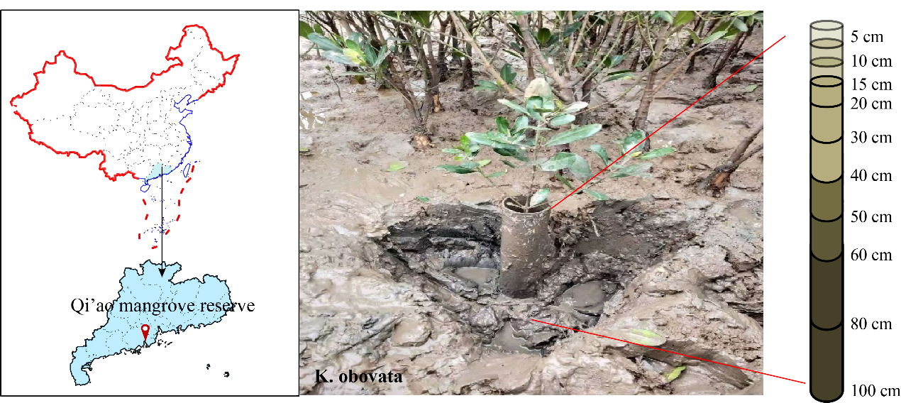

Fig. S1 Sampling location at the Qi’ao Mangrove Reserve, Zhuhai, China, which is dominated by Kandelia obovata. In this study site, five sediment cores were collected using a custom-made sampler with a 100-cm depth and a 11-cm diameter. The sediment core was divided into 10-depths: 0-5, 5-10, 10-15, 15-20, 20-30, 30-40, 40-50, 50-60, 60-80, and 80-100 cm.

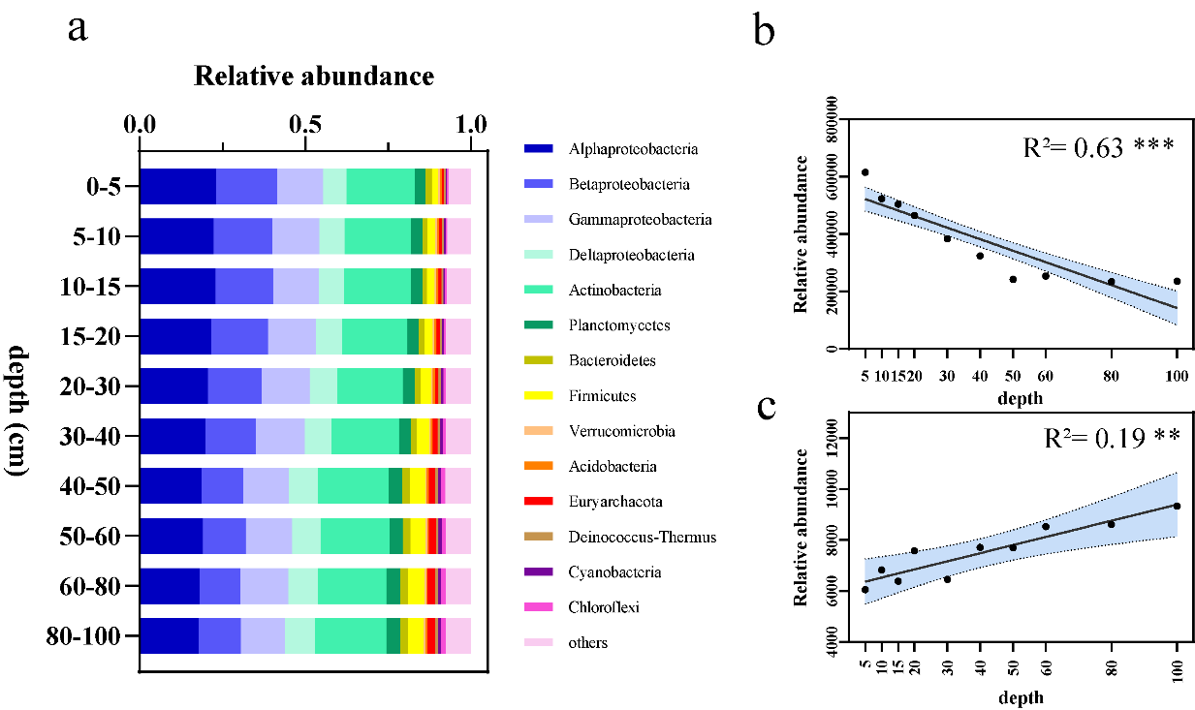

Fig. S2 The depth-dependent profile of community structure in mangrove sediments. a. Stacked plot showing the depth-dependent composition of community using the phylogenetic annotation of metagenome sequencing reads. b. Relationships between the relative abundance of Proteobacteria and depth of mangrove sediments. c. Relationships between the relative abundance of Euryarchaeota and depth of mangrove sediments. Black lines and blue shaded areas represent linear regressions and 95% confidence intervals, respectively. R² was obtained by linear regression analysis and significance levels are denoted with **(0.001 < P < 0.01) and ***(P < 0.001).

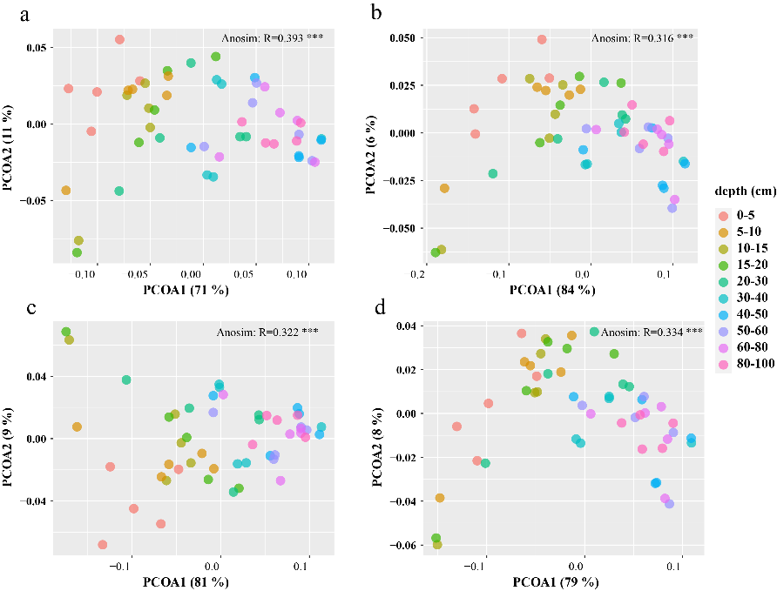

Fig. S3 Principal coordinate analysis (PCoA) plot of all microbial functions (a), methane cycling (b), nitrogen cycling (c), and sulphur cycling (d). Underlying data are based on the abundance-weighted Bray–Curtis distance matrix derived from gene families and KO terms. The 50 samples shown in the 2D plane of each plot are spanned by their first two principal components. The similarity value and significance among the samples from different depths were examined via ANOSIM tests, which are shown in each plot.

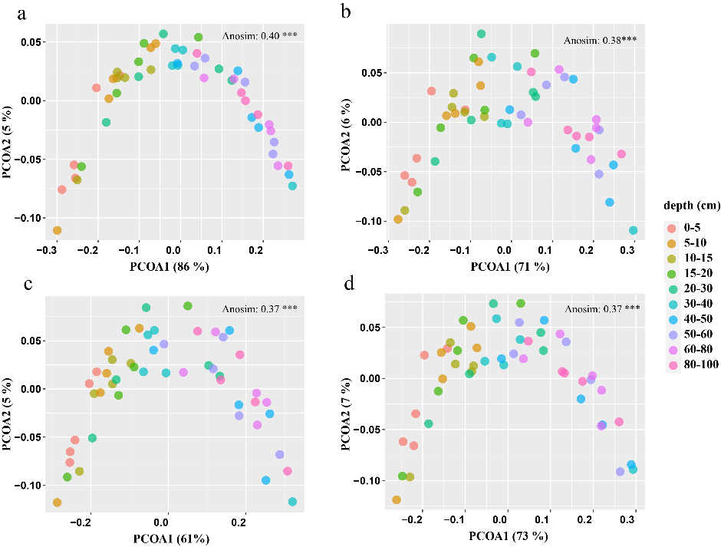
Fig. S4 Principal coordinate analysis (PCoA) plot of all microbial communities (a), microbial communities of methane cycling (b), microbial communities of nitrogen cycling (c), and microbial communities of sulphur cycling (d). Underlying data are based on the abundance-weighted Bray–Curtis distance matrix derived from taxonomical profiles. The 50 samples shown in the 2D plane of each plot are spanned by their first two principal components. The similarity value and significance among the samples from different depth were examined via ANOSIM tests, which are shown in each plot.
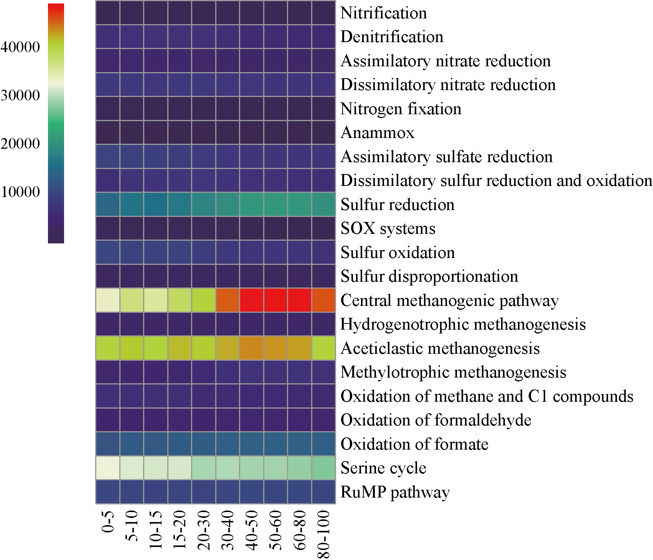

Fig. S5 A heatmap plot of functional pathways for predicted open reading frames (ORFs) from metagenome sequencing reads for different depths of sediment samples.
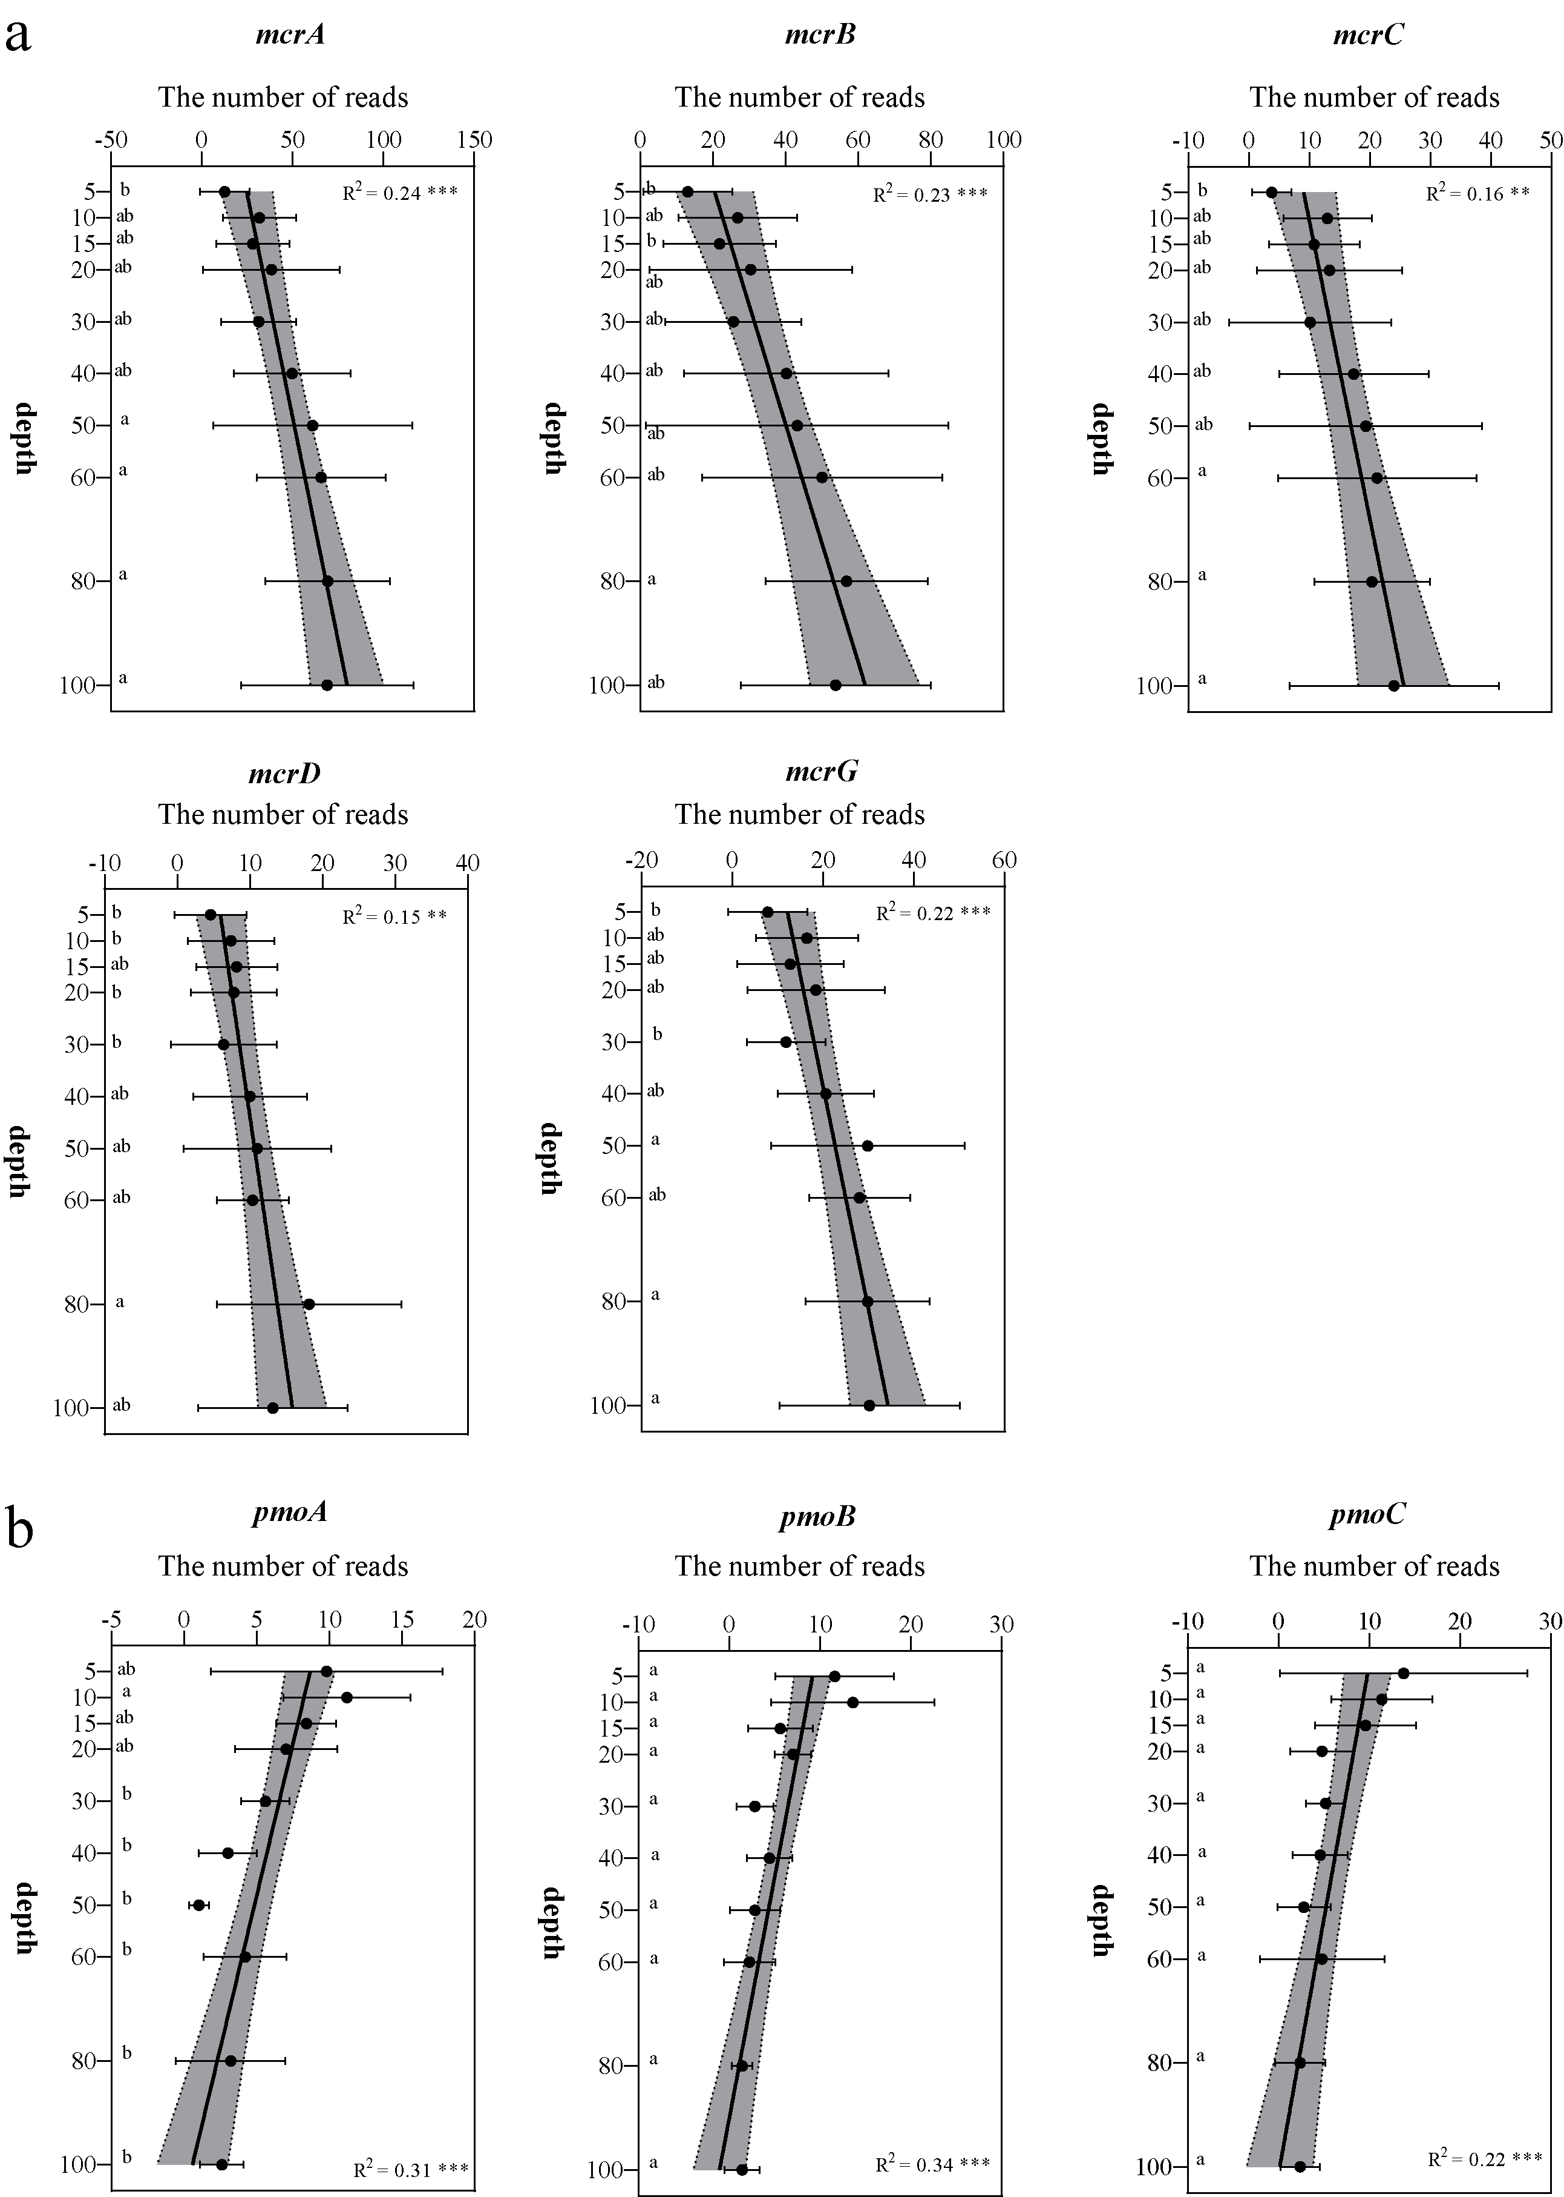

Fig. S6 The vertical distribution of relative abundances of key gene families involved in methane cycling. Black lines and gray shaded areas represent linear regressions and 95% confidence intervals, respectively. R² was obtained by linear regression analysis and significance levels are denoted with *(0.01 < P < 0.05), **(0.001 < P < 0.01) and ***(P < 0.001). Small letters mean a statistical significance (P < 0.05) among different depths.

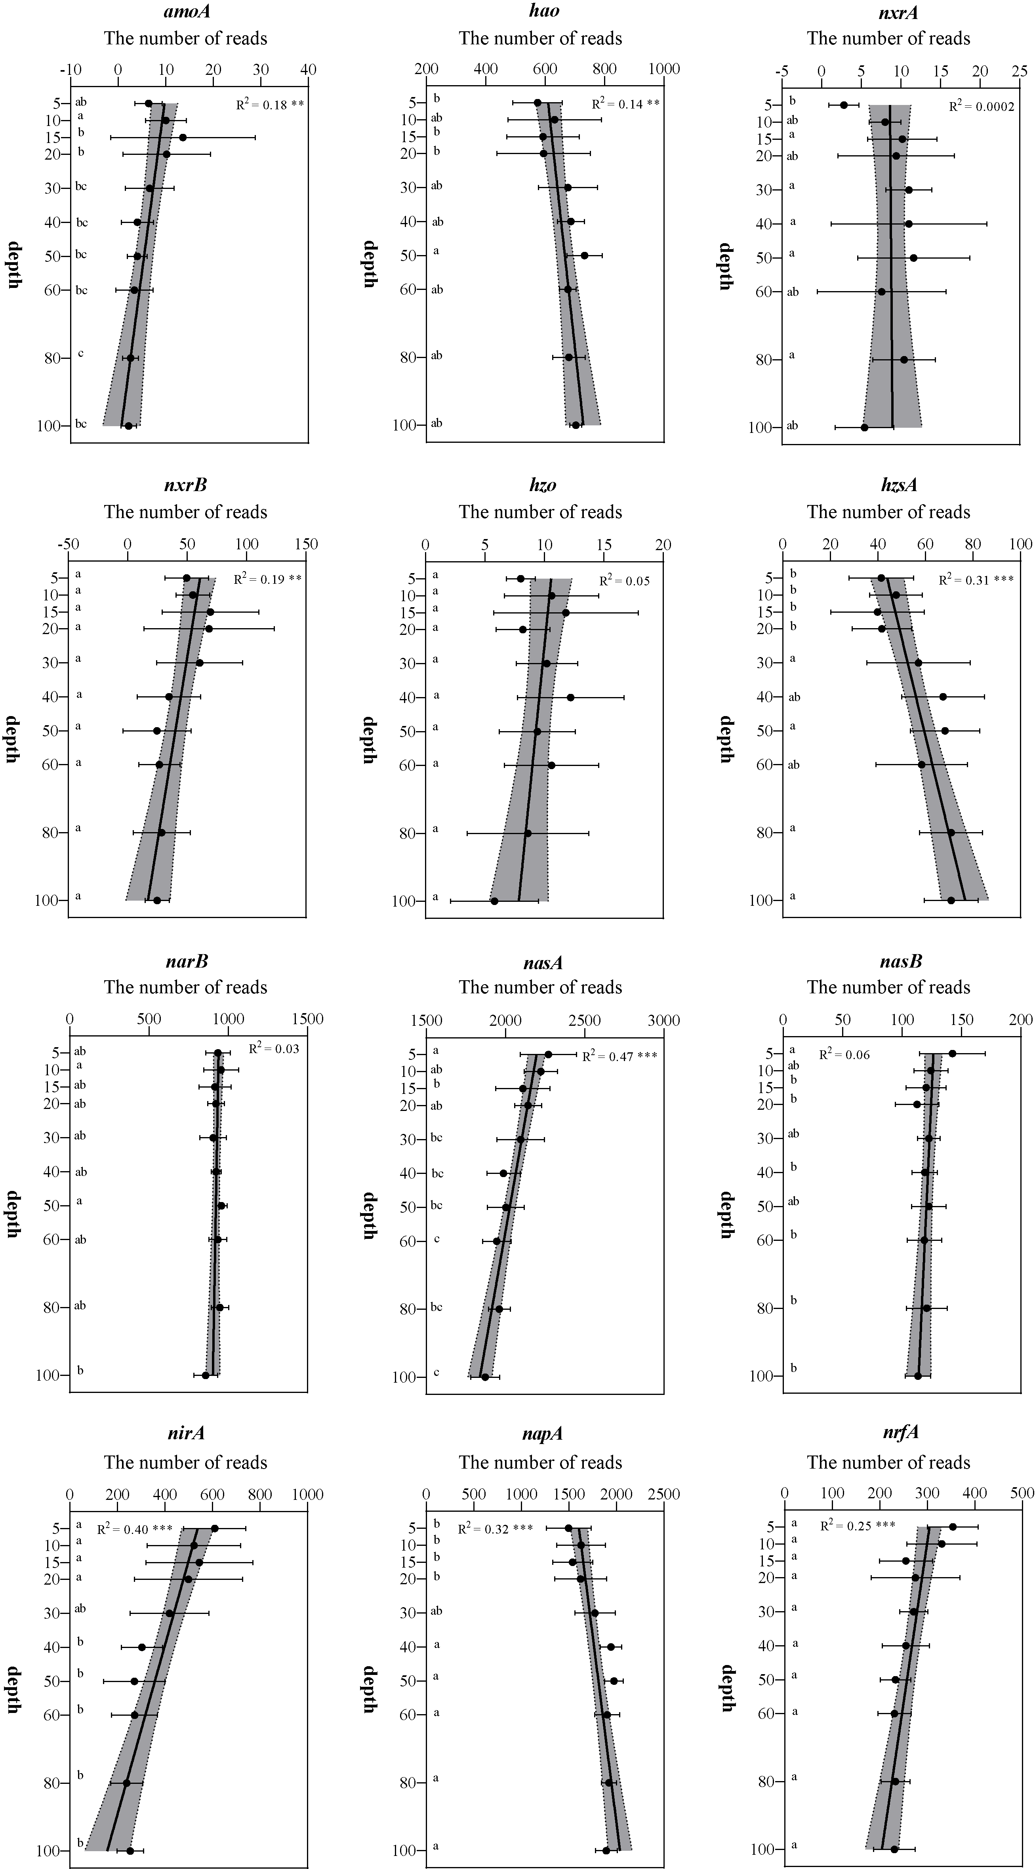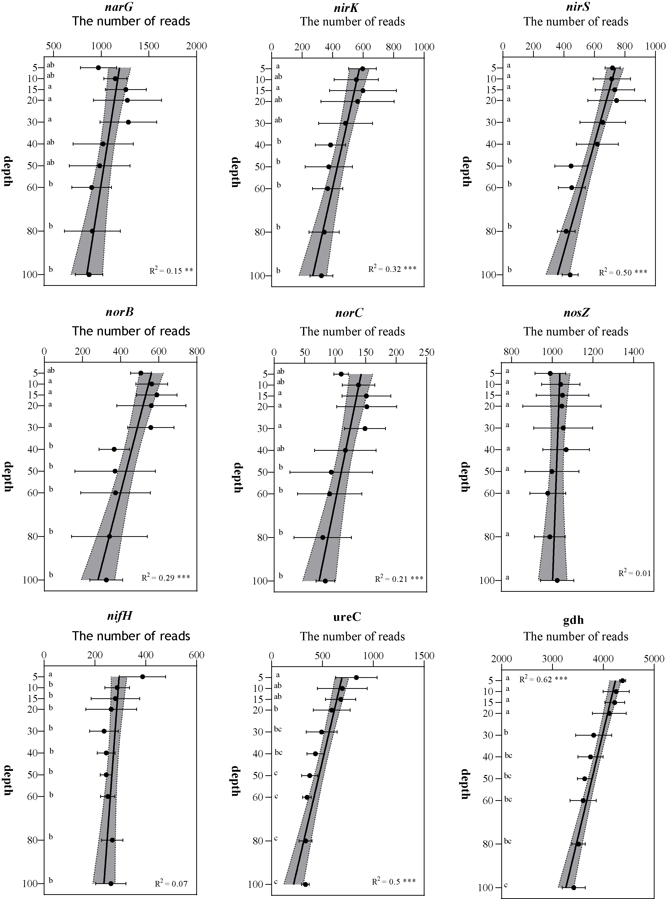

Fig. S7 The vertical distribution of relative abundances of key gene families involved in nitrogen cycling. Black lines and gray shaded areas represent linear regressions and 95% confidence intervals, respectively. R² was obtained by linear regression analysis and significance levels are denoted with *(0.01 < P < 0.05), **(0.001 < P < 0.01) and ***(P < 0.001). Small letters mean a statistical significance (P < 0.05) among different depths.

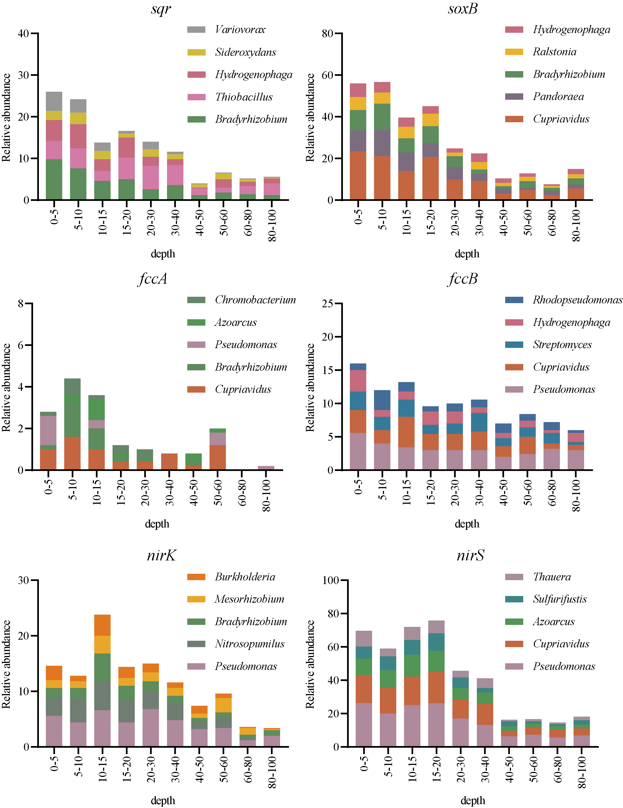

Fig. S8 The vertical distribution of the relative abundance of key microbial taxa (top 5) responsible for genes involved in S oxidation and denitrification.
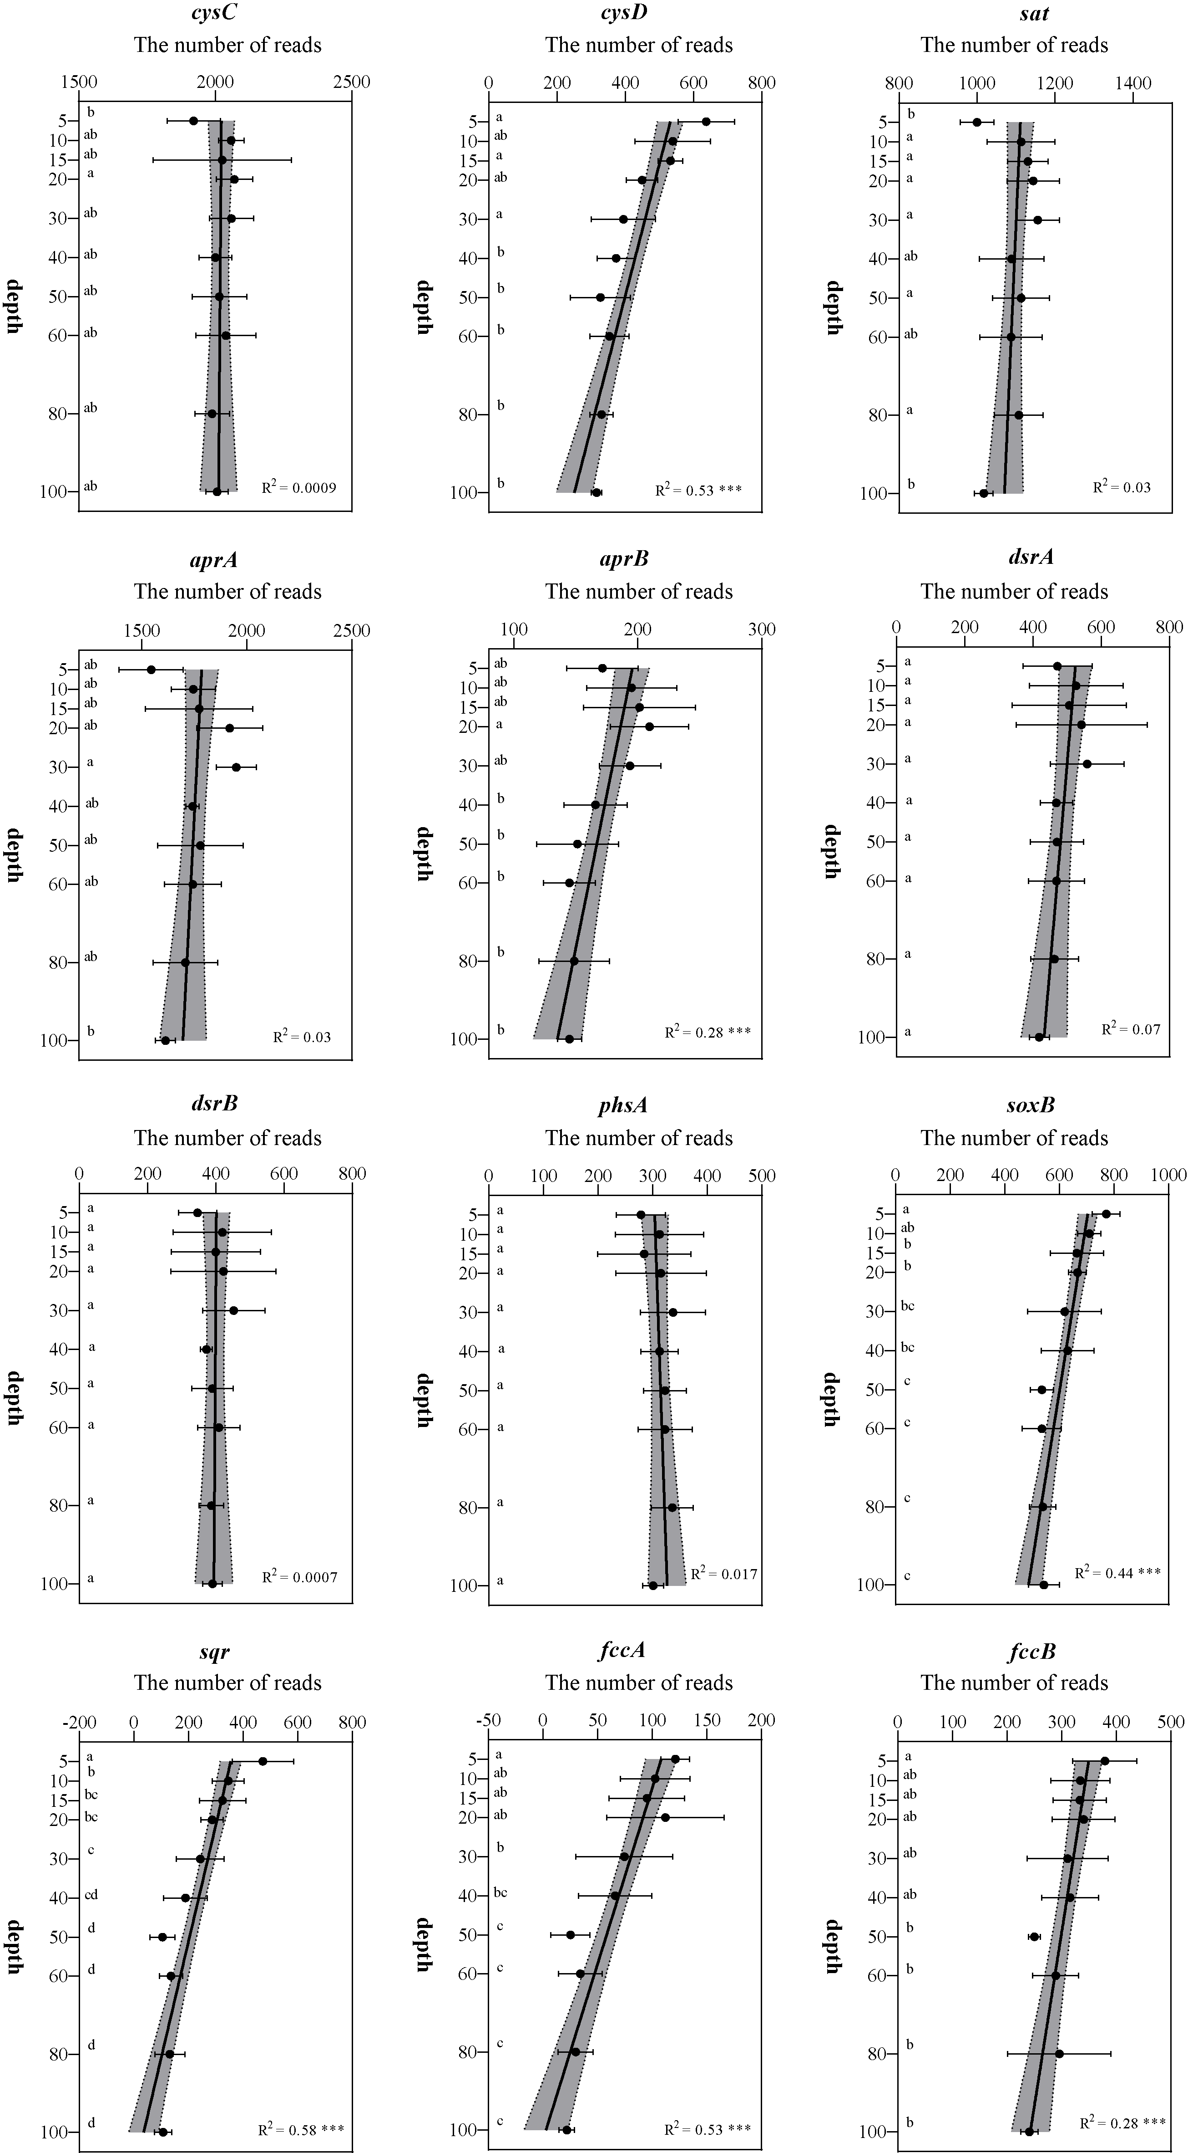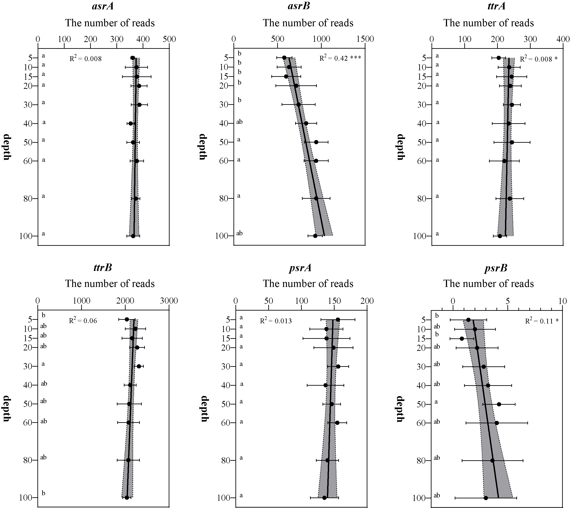

Fig. S9 The vertical distribution of relative abundances of key gene families involved in sulphur cycling. Black lines and gray shaded areas represent linear regressions and 95% confidence intervals, respectively. R² was obtained by linear regression analysis and significance levels are denoted with *(0.01 < P < 0.05), **(0.001 < P < 0.01) and ***(P < 0.001). Small letters mean a statistical significance (P < 0.05) among different depths.

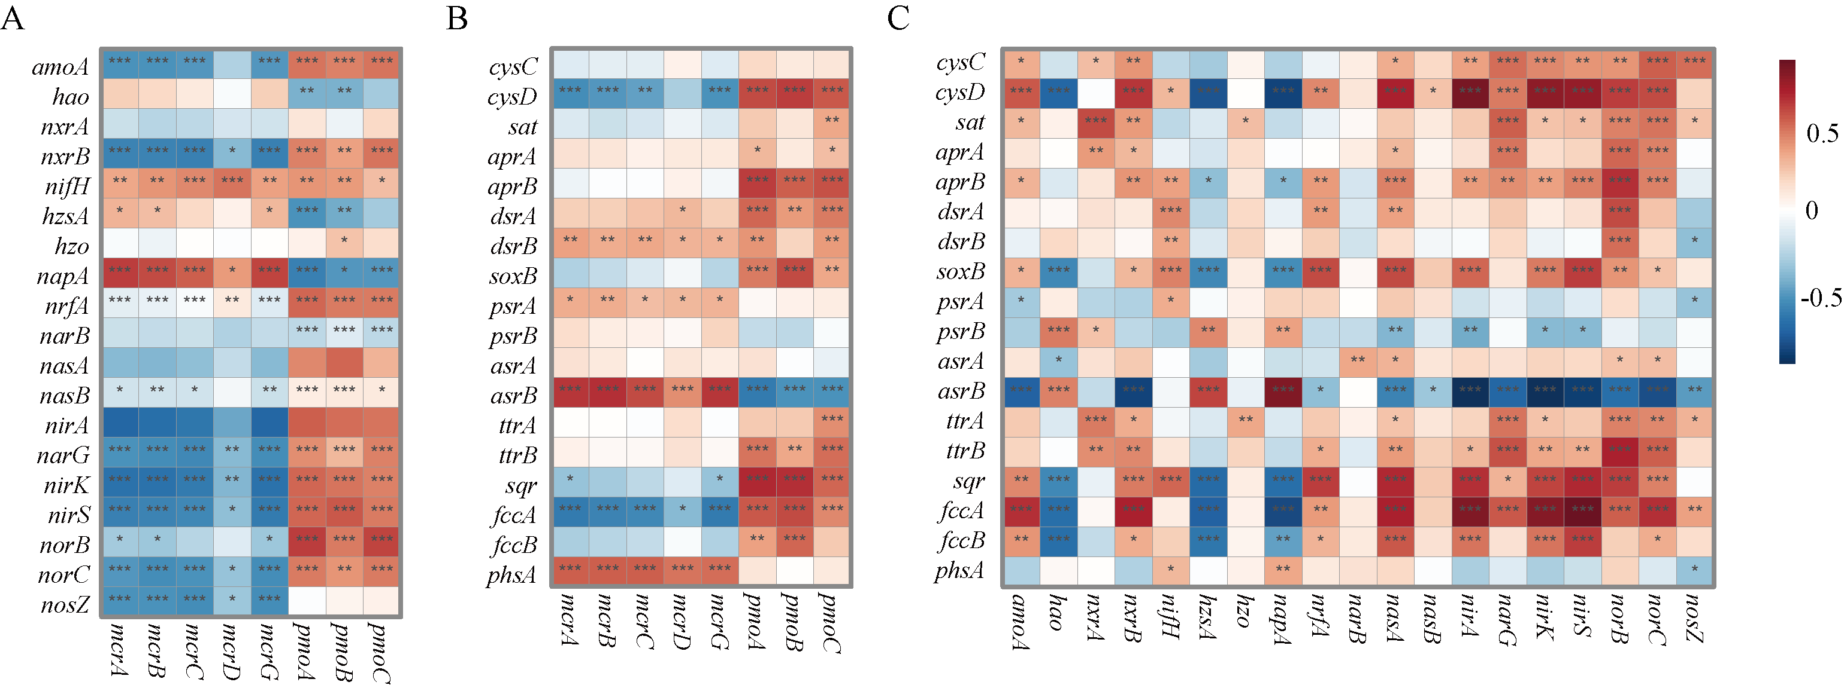

Fig. S10 Correlations between the relative abundance of key gene families. Spearman analysis revealed the correlations between key gene families involved in N/S/CH₄ cycling. a. N and CH₄ cycling; b. S and CH₄ cycling; and c. N and S cycling. ***: P < 0.001; **: 0.001 < P < 0.01; *: 0.01< P < 0.05.

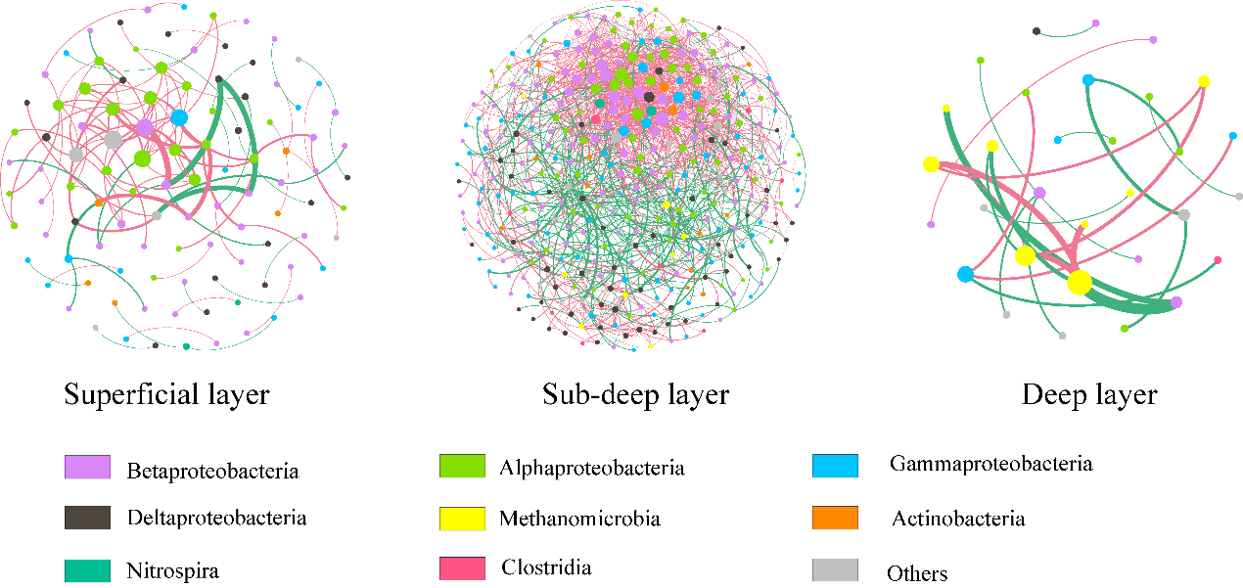

Fig. S11 Methane, nitrogen and sulphur cycling co-occurrence networks of three sediment layers at the species level with OTUs colored by phylum/class. The size of each node is proportional to the number of connections (i.e., degree), and the thickness of each connection between two nodes (i.e., edge) is proportional to the value of correlation coefficients. Red edges indicate positive relationships between two individual nodes, while green edges indicate negative relationships.

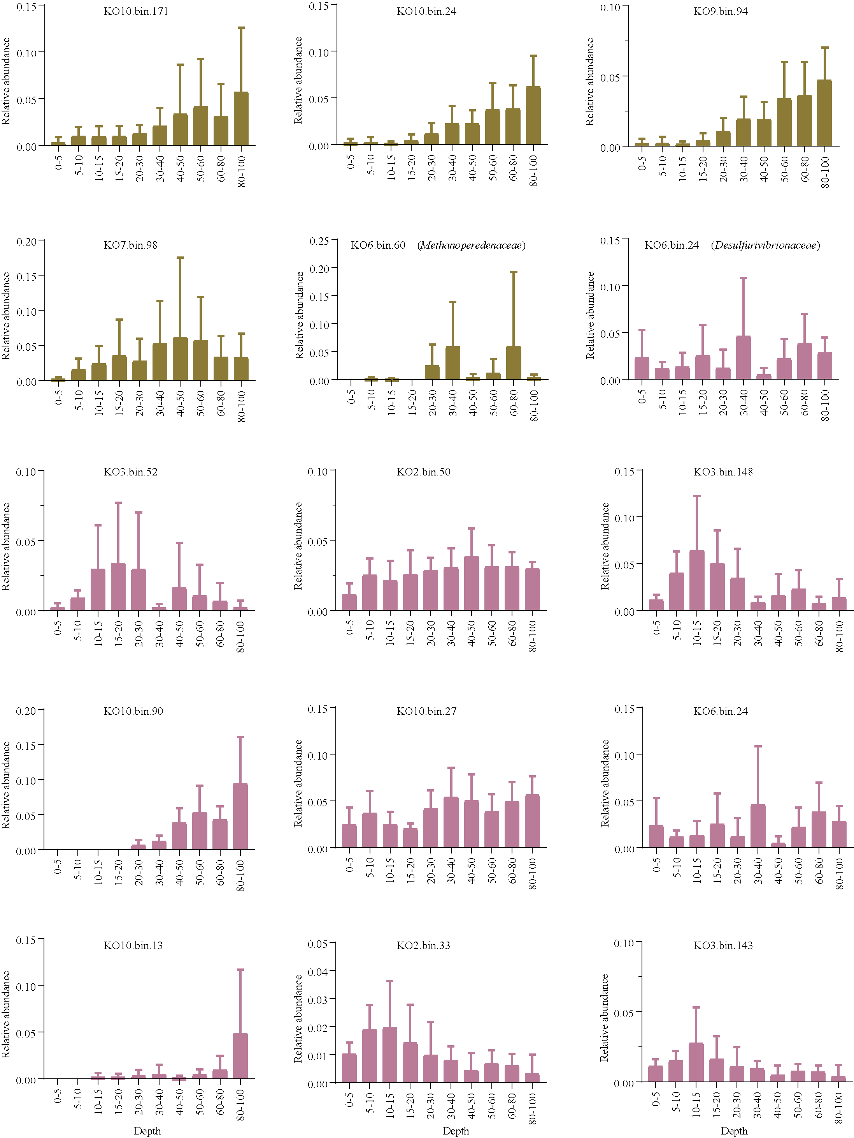
Fig. S12 The vertical distribution of relative abundances of retrieved methanogen/ANME/SRB MAGs. The yellow columns refer to the relative abundance of methanogen/ANME and the purple columns refer to the relative abundance of sulphate-reducing bacteria.
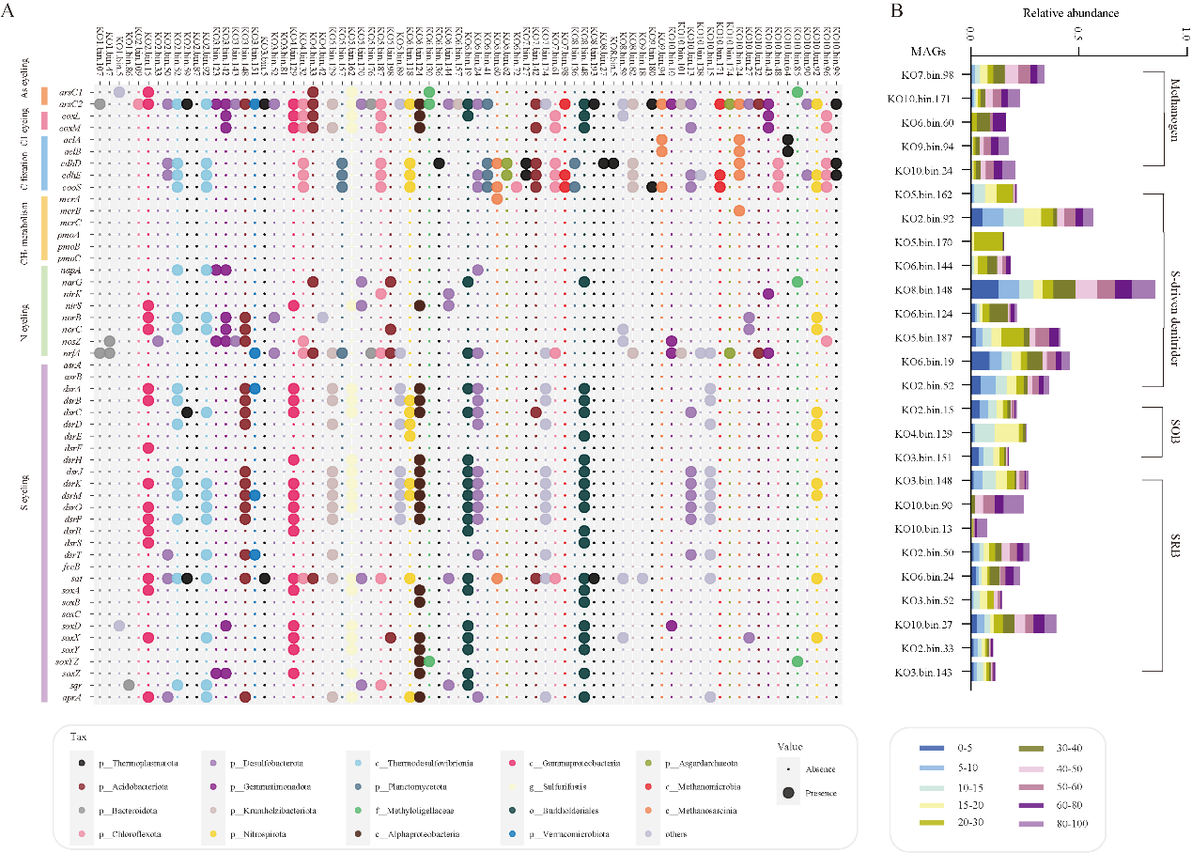

Fig. S13 Metabolic profile of retrieved MAGs (A) and relative abundances of selected MAGs (B). Please refer to Additional file 2: Dataset S2 for more details.

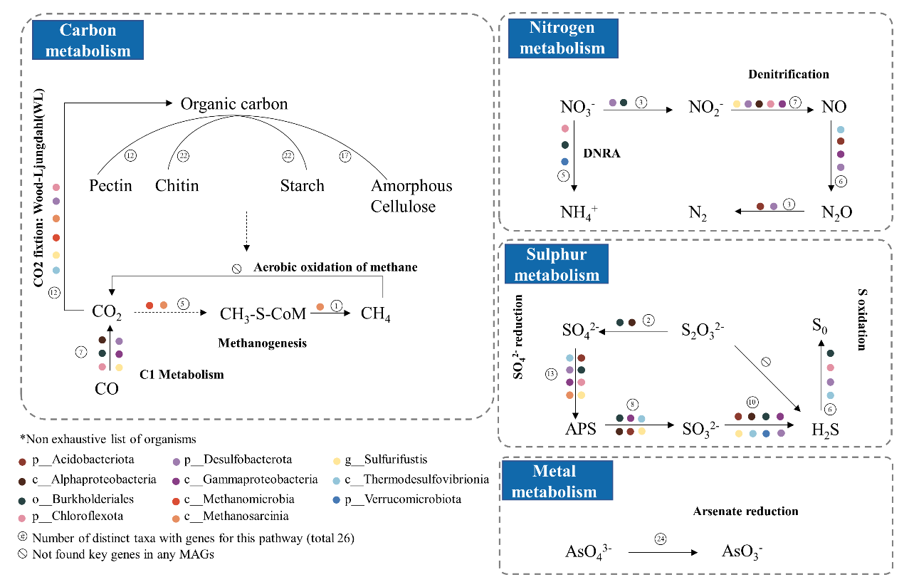

Fig. S14 Carbon, nitrogen, sulphur and metal metabolisms involved in different selected lineages based on retrieved MAGs containing gene families involved in S oxidation, denitrification, dissimilatory nitrate reduction, sulphate reduction, methanogenesis and anaerobic oxidation of methane.

