Supplementary Material

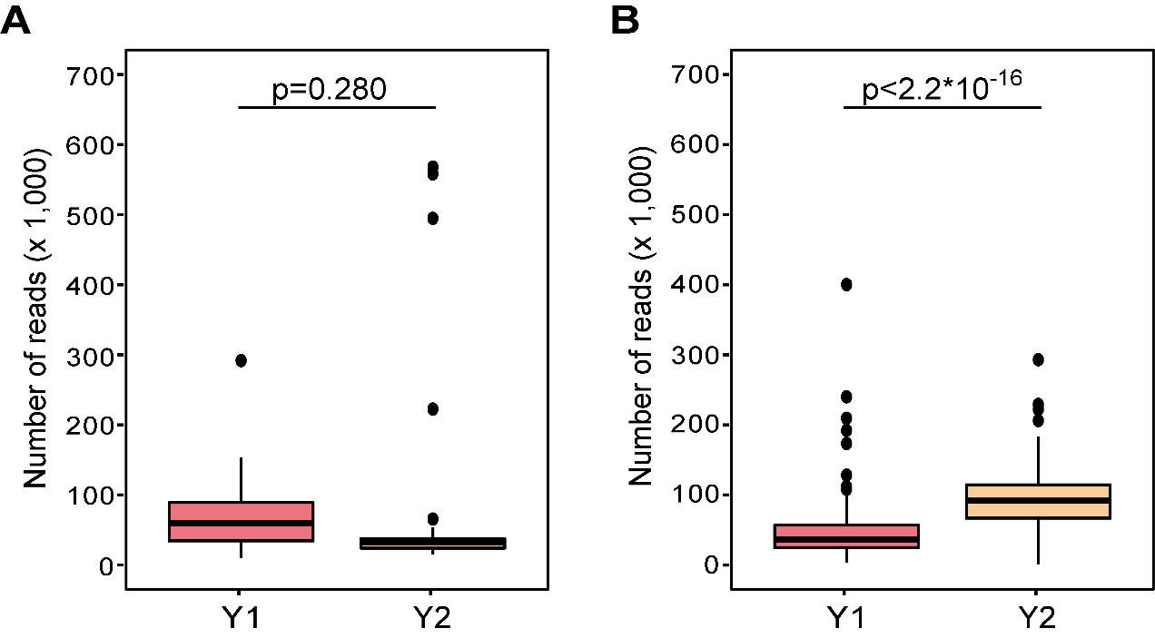
Fig. S1: Number of 16S rRNA and ITS sequencing reads obtained in two sampling years. Summary of the number of reads obtained from amplicon sequencing of the 16S rRNA V4 (A) and the ITS2 (B) in two sampling seasons (Y1 and Y2). The p values were obtained using a t-test by comparing means of reads between two sampling seasons.

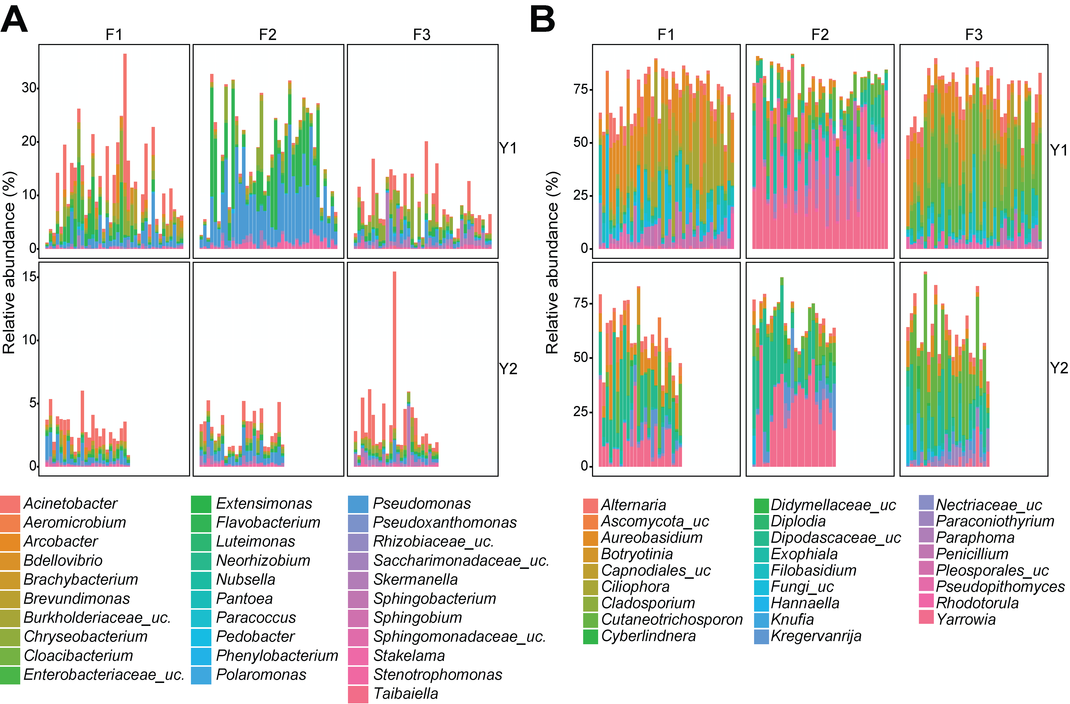
Fig. S2: Bacterial and fungal microbiota composition in each facility and year. Mean bacterial (A) and fungal (B) microbiota composition in each facility in year 1 (Y1) and year 2 (Y2) for all Amplicon Sequence Variants (ASVs) that had a relative abundance above 0.5% for bacteria or 10% for fungi in at least one sample. Each bar represents one sample, and they are presented in a chronological order of collection date on the x-axis. Bars are color-coded by taxonomic genus assigned to an ASV.
Table S1: Metadata for samples collected in year 2.

Bacterial microbiota sample nameª | Bacteria microbiota BioSample accession number | Fungal microbiota sample | Fungal microbiota BioSample accession number | Facility | Section | Collection date | Collection week | Collection month | L. monocytogenes enrichment result | Metagenome  BioSample accession number
1s-011119 | SAMN15951136 | 1t-011119 | SAMN15951243 | F1 | washing | 11-Jan-2019 | W05 | January | +
1s-012519 | SAMN15951137 | 1t-012519 | SAMN15951244 | F1 | washing | 25-Jan-2019 | W06 | January | +
1s-020719 | SAMN15951138 | 1t-020719 | SAMN15951245 | F1 | washing | 7-Feb-2019 | W07 | February | +
1s-022119 (M1) | SAMN15951139 | 1t-022119 | SAMN15951246 | F1 | washing | 21-Feb-2019 | W08 | February | + | SAMN23587631
1s-110318 | SAMN15951144 | 1t-110318 | SAMN15951251 | F1 | washing | 3-Nov-2018 | W01 | November | +
1s-112618 | SAMN15951145 | 1t-112618 | SAMN15951252 | F1 | washing | 26-Nov-2018 | W02 | November | -
1s-120718 | SAMN15951146 | 1t-120718 | SAMN15951253 | F1 | washing | 7-Dec-2018 | W03 | December | +
1s-121418 | SAMN15951147 | 1t-121418 | SAMN15951254 | F1 | washing | 14-Dec-2018 | W04 | December | -
2s-011119 | SAMN15951148 | 2t-011119 | SAMN15951255 | F1 | drying | 11-Jan-2019 | W05 | January | -
2s-012519 | SAMN15951149 | 2t-012519 | SAMN15951256 | F1 | drying | 25-Jan-2019 | W06 | January | +
2s-020719 | SAMN15951150 | 2t-020719 | SAMN15951257 | F1 | drying | 7-Feb-2019 | W07 | February | +
2s-022119 | SAMN15951151 | 2t-022119 | SAMN15951258 | F1 | drying | 21-Feb-2019 | W08 | February | -
2s-110318 | SAMN15951156 | 2t-110318 | SAMN15951263 | F1 | drying | 3-Nov-2018 | W01 | November | -
2s-112618 | SAMN15951157 | 2t-112618 | SAMN15951264 | F1 | drying | 26-Nov-2018 | W02 | November | -
2s-120718 | SAMN15951158 | 2t-120718 | SAMN15951265 | F1 | drying | 7-Dec-2018 | W03 | December | -
2s-121418 | SAMN15951159 | 2t-121418 | SAMN15951266 | F1 | drying | 14-Dec-2018 | W04 | December | -
3s011119 | SAMN15951160 | 3t011119 | SAMN15951267 | F1 | waxing | 11-Jan-2019 | W05 | January | +
3s012519 | SAMN15951161 | 3t012519 | SAMN15951268 | F1 | waxing | 25-Jan-2019 | W06 | January | -
3s020719 | SAMN15951162 | 3t020719 | SAMN15951269 | F1 | waxing | 7-Feb-2019 | W07 | February | -
3s022119 | SAMN15951163 | 3t022119 | SAMN15951270 | F1 | waxing | 21-Feb-2019 | W08 | February | +
3s110318 | SAMN15951168 | 3t110318 | SAMN15951275 | F1 | waxing | 3-Nov-2018 | W01 | November | -
3s112618 | SAMN15951169 | 3t112618 | SAMN15951276 | F1 | waxing | 26-Nov-2018 | W02 | November | +
3s120718 | SAMN15951170 | 3t120718 | SAMN15951277 | F1 | waxing | 7-Dec-2018 | W03 | December | -
3s121418 | SAMN15951171 | 3t121418 | SAMN15951278 | F1 | waxing | 14-Dec-2018 | W04 | December | -
4s-011119 | SAMN15951172 | 4t-011119 | SAMN15951279 | F2 | washing | 11-Jan-2019 | W05 | January | +
4s-012519 | SAMN15951173 | 4t-012519 | SAMN15951280 | F2 | washing | 25-Jan-2019 | W06 | January | +
4s-020719 | SAMN15951174 | 4t-020719 | SAMN15951281 | F2 | washing | 7-Feb-2019 | W07 | February | +
4s-022119 (M4) | SAMN15951175 | 4t-022119 | SAMN15951282 | F2 | washing | 21-Feb-2019 | W08 | February | + | SAMN23587632
4s-110318 | SAMN15951180 | 4t-110318 | SAMN15951287 | F2 | washing | 3-Nov-2018 | W01 | November | +
4s-112618 | SAMN15951181 | 4t-112618 | SAMN15951288 | F2 | washing | 26-Nov-2018 | W02 | November | +
4s-120718 | SAMN15951182 | 4t-120718 | SAMN15951289 | F2 | washing | 7-Dec-2018 | W03 | December | +
4s-121418 | SAMN15951183 | 4t-121418 | SAMN15951290 | F2 | washing | 14-Dec-2018 | W04 | December | +
5s-011119 | SAMN15951184 | 5t-011119 | SAMN15951291 | F2 | drying | 11-Jan-2019 | W05 | January | +
5s-012519 | SAMN15951185 | 5t-012519 | SAMN15951292 | F2 | drying | 25-Jan-2019 | W06 | January | +
5s-110318 | SAMN15951186 | 5t-110318 | SAMN15951293 | F2 | drying | 3-Nov-2018 | W01 | November | +
5s-112618 | SAMN15951187 | 5t-112618 | SAMN15951294 | F2 | drying | 26-Nov-2018 | W02 | November | +
5s-120718 | SAMN15951191 | 5t-120718 | SAMN15951298 | F2 | drying | 7-Dec-2018 | W03 | December | +
5s-121418 | SAMN15951192 | 5t-121418 | SAMN15951299 | F2 | drying | 14-Dec-2018 | W04 | December | +
6s-011119 | SAMN15951193 | 6t-011119 | SAMN15951300 | F2 | waxing | 11-Jan-2019 | W05 | January | +
6s-012519 | SAMN15951194 | 6t-012519 | SAMN15951301 | F2 | waxing | 25-Jan-2019 | W06 | January | +
6s-020719 | SAMN15951195 | 6t-020719 | SAMN15951302 | F2 | waxing | 7-Feb-2019 | W07 | February | +
6s-022119 | SAMN15951196 | 6t-022119 | SAMN15951303 | F2 | waxing | 21-Feb-2019 | W08 | February | +
6s-110318 | SAMN15951197 | 6t-110318 | SAMN15951304 | F2 | waxing | 3-Nov-2018 | W01 | November | +
6s-112618 | SAMN15951198 | 6t-112618 | SAMN15951305 | F2 | waxing | 26-Nov-2018 | W02 | November | +
6s-120718 | SAMN15951203 | 6t-120718 | SAMN15951310 | F2 | waxing | 7-Dec-2018 | W03 | December | +
6s-121418 | SAMN15951204 | 6t-121418 | SAMN15951311 | F2 | waxing | 14-Dec-2018 | W04 | December | +
7s-011119 | SAMN15951205 | 7t-011119 | SAMN15951312 | F3 | washing | 11-Jan-2019 | W05 | January | +
7s-012519 | SAMN15951206 | 7t-012519 | SAMN15951313 | F3 | washing | 25-Jan-2019 | W06 | January | +
7s-020719 | SAMN15951207 | 7t-020719 | SAMN15951314 | F3 | washing | 7-Feb-2019 | W07 | February | +
7s-022119 (M7) | SAMN15951208 | 7t-022119 | SAMN15951315 | F3 | washing | 21-Feb-2019 | W08 | February | + | SAMN23587633
7s-110318 | SAMN15951209 | 7t-110318 | SAMN15951316 | F3 | washing | 3-Nov-2018 | W01 | November | -
7s-112618 | SAMN15951210 | 7t-112618 | SAMN15951317 | F3 | washing | 26-Nov-2018 | W02 | November | +
7s-120718 | SAMN15951215 | 7t-120718 | SAMN15951322 | F3 | washing | 7-Dec-2018 | W03 | December | +
7s-121418 | SAMN15951216 | 7t-121418 | SAMN15951323 | F3 | washing | 14-Dec-2018 | W04 | December | +
8s-011119 | SAMN15951217 | 8t-011119 | SAMN15951324 | F3 | drying | 11-Jan-2019 | W05 | January | +
8s-012519 | SAMN15951218 | 8t-012519 | SAMN15951325 | F3 | drying | 25-Jan-2019 | W06 | January | +
8s-020719 | SAMN15951219 | 8t-020719 | SAMN15951326 | F3 | drying | 7-Feb-2019 | W07 | February | +
8s-022119 | SAMN15951220 | 8t-022119 | SAMN15951327 | F3 | drying | 21-Feb-2019 | W08 | February | +
8s-110318 | SAMN15951221 | 8t-110318 | SAMN15951328 | F3 | drying | 3-Nov-2018 | W01 | November | +
8s-112618 | SAMN15951222 | 8t-112618 | SAMN15951329 | F3 | drying | 26-Nov-2018 | W02 | November | +
8s-120718 | SAMN15951227 | 8t-120718 | SAMN15951334 | F3 | drying | 7-Dec-2018 | W03 | December | +
8s-121418 | SAMN15951228 | 8t-121418 | SAMN15951335 | F3 | drying | 14-Dec-2018 | W04 | December | +
9s-011119 | SAMN15951229 | 9t-011119 | SAMN15951336 | F3 | waxing | 11-Jan-2019 | W05 | January | +
9s-012519 | SAMN15951230 | 9t-012519 | SAMN15951337 | F3 | waxing | 25-Jan-2019 | W06 | January | +
9s-020719 | SAMN15951231 | 9t-020719 | SAMN15951338 | F3 | waxing | 7-Feb-2019 | W07 | February | +
9s-022119 | SAMN15951232 | 9t-022119 | SAMN15951339 | F3 | waxing | 21-Feb-2019 | W08 | February | +
9s-110318 | SAMN15951233 | 9t-110318 | SAMN15951340 | F3 | waxing | 3-Nov-2018 | W01 | November | -
9s-112618 | SAMN15951234 | 9t-112618 | SAMN15951341 | F3 | waxing | 26-Nov-2018 | W02 | November | +
9s-120718 | SAMN15951239 | 9t-120718 | SAMN15951346 | F3 | waxing | 7-Dec-2018 | W03 | December | +
9s-121418 | SAMN15951240 | 9t-121418 | SAMN15951347 | F3 | waxing | 14-Dec-2018 | W04 | December | +
ªSample names in parentheses correspond to the ID used for Nanopore sequencing.

Table S2: Differences in the occurrence of L. monocytogenes among samples collected from different facilities in year 2.

L. monocytogenes detection | Facility
 | F1 | F2 | F3
Absent | 13 | 0 | 2
Present | 11 | 24 | 22
 | Chi-square | DFª | P-value^{b}
Pearson | 26.82 | 2 | 1.50*10⁻⁶
Likelihood | 24.76 | 2 | 4.21*10⁻⁶
ªDF, degrees of freedom.
^{b}Chi-square test was carried out, followed by pairwise comparisons using Fisher’s Exact test with Bonferroni correction for multiple comparisons.

Table S3: Differences in the occurrence of L. monocytogenes among facilities and sections between year 1 and 2.

Variable | Level | χ² | DFª | p-value
Facility^{b} | F1 | 1.330 | 1 | 0.25
Facility^{b} | F3 | 13.873 | 1 | 1.96*10⁻⁴
Section | Washing | 1.819 | 1 | 0.18
Section | Drying | 1.996 | 1 | 0.16
Section | Waxing | 3.939 | 1 | 0.047
ªDF, degrees of freedom.
^{b}F2 was not included in this analysis as all the samples collected in this facility were positive for L. monocytogenes in both seasons.

Table S4: Common and temporal core fungal ASVs that were present in all facilities throughout the two sampling seasons.

ASVª | Kingdom | Phylum | Class |  | Order |  | Family |  | Genus |  |  | Species
2 | Fungi | Ascomycota |  | Dothideomycetes |  | Dothideales |  | Aureobasidiaceae |  | Aureobasidium | Pullulans
6 | Fungi |  |  |  |  | Pleosporales |  | Pleosporaceae |  | Alternaria | Betar-kenyensis
21 |  |  |  |  |  |  |  | Cucurbitariaceae |  | Neocucurbitaria | Neocucurbitaria_unclassified
9 | Fungi |  |  | Eurotiomycetes |  | Chaetothyriales |  | Herpotrichiellaceae |  | Exophiala | Exophiala_unclassified
10 |  |  |  |  |  |  |  |  |  |  | Cancerae
13 | Fungi |  |  |  |  | Eurotiales |  | Aspergillaceae |  | Penicillum | Aurantiogriseum
17 | Fungi | Basidiomycota |  | Tremellomycetes |  | Filobasidiales |  | Filobasidiaceae |  | Filobasidium | Floriforme
18 | Fungi |  |  | Cystobasidiomycetes |  | Cystobacidiales |  | Cystobasidiaceae |  | Cystobasidium | Slooffiae
ªASV, exact sequence variant.

Table S5: Network hubs for bacterial and fungal microbiota, identified as ASVs with the highest betweenness centrality.

ASVª | Kingdom | Phylum | Class | Order | Family | Genus^{b} | Species^{b}
1016 | Bacteria | Actinobacteria | Actinobacteria | Corynebacteriales | Nocardiaceae | Rhodococcus | Rhodococcus_uc.
570 |  |  |  |  |  | Williamsia | Williamsia_uc.
529 | Bacteria | Actinobacteria | Actinobacteria | Micrococcales | Microbacteriaceae | Microbacterium | Microbacterium_uc.
1920
1870 |  |  |  |  |  | Pseudoclavibacter | Pseudoclavibacter_uc.
163 |  |  |  |  | Micrococcaceae | Kocuria | Kocuria_uc.
767 | Bacteria | Bacteroidetes | Bacteroidia | Flavobacteriales | Flavobacteriaceae | Flavobacterium | Flavobacterium_uc.
1065
1568
2513
1126 |  |  |  |  | Weeksellaceae | Chryseobacterium | Chryseobacterium_uc.
1259
1531
1939
1049 |  |  |  |  |  | Cloacibacterium | Cloacibacterium_uc.
558 | Bacteria | Bacteroidetes | Bacteroidia | Sphingobacteriales | Sphingobacteriaceae | Pedobacter | Pedobacter_uc.
980
1109
1644 | Bacteria | Patescibacteria | Saccharimonadia | Saccharimonadales | Saccharimonadales_uc. | Saccharimonadales_uc. | Saccharimonadales_uc.
2089
2179
385 | Bacteria | Proteobacteria | Alphaproteobacteria | Caulobacterales | Caulobacteraceae | Brevundimonas | Brevundimonas_uc.
514
544
1118
1270
1335
1434
586 | Bacteria | Proteobacteria | Alphaproteobacteria | Rhizobiales | Beijerinckiaceae | Bosea | Bosea_uc.
329 |  |  |  |  | Rhizobiaceae | Allorhizobium-Neorhizobium-Pararhizobium-Rhizobium | Allorhizobium-Neorhizobium-Pararhizobium-Rhizobium_uc.
592
712
721
1523
2510
1748 |  |  |  |  | Rhizobiaceae | Rhizobiaceae_uc. | Rhizobiaceae_uc.
1616 | Bacteria | Proteobacteria | Alphaproteobacteria | Rhodobacterales | Rhodobacteraceae | Haematobacter | Haematobacter_uc.
3150
367 |  |  |  |  |  | Paracoccus | Paracoccus_uc.
1298
571 |  |  |  |  |  | Rhodobacteraceae_uc. | Rhodobacteraceae_uc.
121 | Bacteria | Proteobacteria | Alphaproteobacteria | Sphingomonadales | Sphingomonadaceae | Sphingobium | Sphingobium_uc.
387
472
476
1096
1167
1277
1294
1063 |  |  |  |  |  | Sphingomonadaceae_uc. | Sphingomonadaceae_uc.
313 |  |  |  |  |  | Sphingomonas | Sphingomonas_uc.
728
886
1628
2376 |  |  |  |  |  | Sphingopyxis | Sphingopyxis_uc.
9158
2319 |  |  |  |  |  | Stakelama | Stakelama_uc.
1105 | Bacteria | Proteobacteria | Deltaproteobacteria | Bdellovibrionales | Bdellovibrionaceae | Bdellovibrio | Bdellovibrio_uc.
1206 | Bacteria | Proteobacteria | Deltaproteobacteria | Bdellovibrionales | Bdellovibrionaceae | Bdellovibrio | Bdellovibrio_uc.
1330
2694
1050 | Bacteria | Proteobacteria | Gammaproteobacteria | Betaproteobacteriales | Burkholderiaceae | Acidovorax | Acidovorax_uc.
419 |  |  |  |  |  | Burkholderiaceae_uc. | Burkholderiaceae_uc.
450
531
819
1193
1876
2575
1702 |  |  |  |  |  | Delftia | Delftia_uc.
1451 |  |  |  |  |  | Variovorax | Variovorax_uc.
1609 |  |  |  |  |  | Xenophilus | Xenophilus_uc.
466 | Bacteria | Proteobacteria | Gammaproteobacteria | Enterobacteriales | Enterobacteriaceae | Enterobacteriaceae_uc. | Enterobacteriaceae_uc.
812
263 | Bacteria | Proteobacteria | Gammaproteobacteria | Pseudomonadales | Pseudomonadaceae | Pseudomonas | Pseudomonas_uc.
810
1810
1837
1881
2377
3728
9459
590 | Bacteria | Proteobacteria | Gammaproteobacteria | Xanthomonadales | Xanthomonadaceae | Pseudoxanthomonas | Pseudoxanthomonas_uc.
180 |  |  |  |  |  | Stenotrophomonas | Stenotrophomonas_uc.
495
1627
1809
4635
3659 | Bacteria | Proteobacteria | Gammaproteobacteria | Xanthomonadales | Xanthomonadaceae | Thermomonas | Thermomonas_uc.
8 | Fungi | Ascomycota | Dothideomycetes | Pleosporales | Cucurbitariaceae | Neocucurbitaria | keratinophila
11 |  |  |  |  | Didymosphaeriaceae | Paraconiothyrium | Paraconiothyrium_uc.
12 |  |  |  |  | Phaeosphaeriaceae | Muriphaeosphaeria | viburni
22 |  |  |  |  |  | Neosetophoma | samararum
23 | Fungi | Ascomycota | Eurotiomycetes | Chaetothyriales | Cyphellophoraceae | Cyphellophora | pluriseptata
24 | Fungi | Ascomycota | Leotiomycetes | Helotiales | Vibrisseaceae | Phialocephala | Phialocephala_uc.
28 | Fungi | Ascomycota | Saccharomycetes | Saccharomycetales | Pichiaceae | Kregervanrija | fluxuum
36 | Fungi | Ascomycota | Saccharomycetes | Saccharomycetales | Saccharomycetales_fam_Incertae_sedis | Candida | incommunis
41 | Fungi | Basidiomycota | Cystobasidiomycetes | Cystobasidiales | Cystobasidiaceae | Cystobasidium | pinicola
45 | Fungi | Basidiomycota | Tremellomycetes | Tremellales | Bulleraceae | Genolevuria | Genolevuria_uc.
54 |  |  |  |  | Bulleribasidiaceae | Vishniacozyma | carnescens
65 |  |  |  |  |  |  | foliicola
83 |  |  |  |  |  |  | heimaeyensis
94 |  |  |  |  |  |  | Vishniacozyma_uc.
116 | Fungi | Basidiomycota | Tremellomycetes | Trichosporonales | Trichosporonaceae | Cutaneotrichosporon | jirovecii
139 |  |  |  |  |  |  | moniliiforme
169 |  |  |  |  |  | Trichosporonaceae_uc. | Trichosporonaceae_uc.
250 | Fungi | Fungi_uc. | Fungi_uc. | Fungi_uc. | Fungi_uc. | Fungi_uc. | Fungi_uc.
ªASV, exact sequence variant.
^{b}Uc.: unclassified

