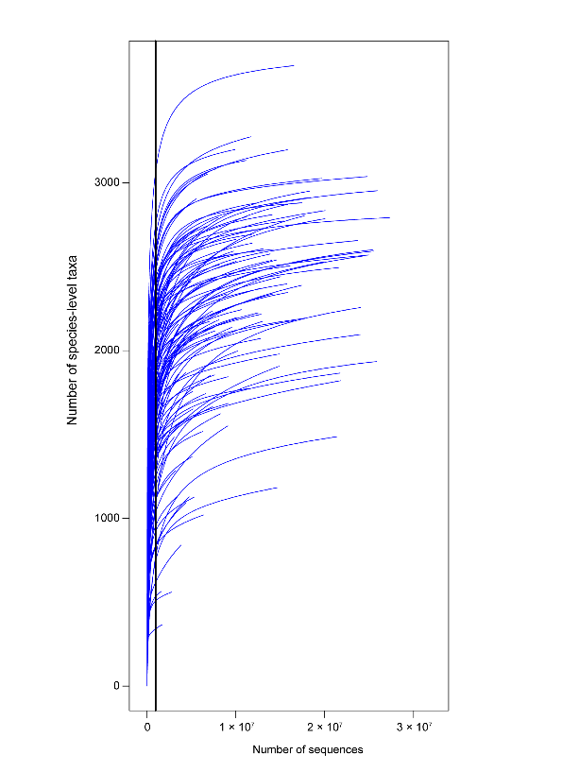
Supplementary Fig. 3. Rarefaction curves of sequencing reads after quality control. The plot shows the number of species identified in each sample as a function of sequencing depth. Samples were rarefied to an even sampling depth of 313,504 reads per sample (indicated by the vertical line) for α-diversity analysis.

