Supplementary material – murine HMO/ABX manuscript

Table S1. Strains used in this study.
Strain | Associated plasmid | Selective pressure
Bifidobacterium breve NRBB01 | pSKEM (35) | Erythromycin 50 µg/mL
Bifidobacterium breve NRBB57 | pPKCM (35) | Chloramphenicol 25 µg/mL
Bifidobacterium bifidum CNCM I-4319 | pDM1 (34) | Spectinomycin 400 µg/mL

Table S2. Diet formulation manufactured by SSNIFF (www.ssniff.com).
 |  | AIN93-G | AIN93-G | AIN93-G
g/ 1 kg feed |  | Control | 2.4% scGOS/lcFOS/HMOS (9:1:2) | 4% scGOS/lcFOS/HMOS (9:2:9)
Functional |  | g/kg feed | g/kg feed | g/kg feed
Carbs | Raw Material names
Cornstarch | C gel 03401 | 397.49 | 376.43 | 366.96
Moisture |  | 47.70 | 45.17 | 44.04
Carbohydrates |  | 349.39 | 330.88 | 322.56
Dextrinized cornstarch | Maltodextrin MD1925 WS | 132.0 | 125.0 | 121.9
Moisture |  | 6.6 | 6.3 | 6.1
Carbohydrates |  | 125.4 | 118.8 | 115.8
Sucrose | Sugar Melis | 100.0 | 94.7 | 92.3
Moisture |  | 0.1 | 0.1 | 0.1
Carbohydrates |  | 99.9 | 94.6 | 92.2
Fibre
Fibre source (cellulose) | Arbocel B800 | 50.00 | 47.35 | 46.16
Moisture |  | 0.25 | 0.24 | 0.23
Fibre |  | 49.75 | 47.11 | 45.93
GOS Vivinal syrup (45% GOS) | Galacto oligosaccharide syrup | 0.00 | 40.00 | 40.00
Moisture |  | 0.00 | 10.00 | 10.00
Fibre |  |  | 18.00 | 18.00
Lactose |  | 0.00 | 6.00 | 6.00
Other carbohydrates |  | 0.00 | 6.00 | 6.00
Inulin HP (lcFOS) (97% FOS fibre) | Inulin Fibre | 0.00 | 2.06 | 4.12
Moisture |  | 0.00 | 0.06 | 0.12
Fibre |  |  | 2.00 | 4.00
2-FucosylLactose (93.4% OS) |  | 0.00 | 4.16 | 19.27
Fibre |  |  | 4.16 | 18.00
Lactose |  | 0.00 | 0.04 | 0.00
Moisture |  | 0.00 | 0.08 | 1.21
Protein
Casein | Acid casein | 200.0 | 200.0 | 200.0
Moisture |  | 19.0 | 19.0 | 19.0
Fat |  | 1.6 | 1.6 | 1.6
Protein |  | 175.6 | 175.6 | 175.6
Lactose |  | 0.2 | 0.2 | 0.2
L-cystine | L-Cystine | 3.0 | 3.0 | 3.0
Fat
Soybean oil | Soy oil non-GMO | 70.0 | 70.0 | 70.0
Fat |  | 70.0 | 70.0 | 70.0
Others
Mineral mix | Mineral mix AIN 93G | 35.0 | 35.0 | 35.0
Moisture |  | 0.4 | 0.4 | 0.4
Carbohydrates |  | 7.7 | 7.7 | 7.7
Vitamin mix | Vitamin mix AIN 93VX | 10.0 | 10.0 | 10.0
Moisture |  | 0.0 | 0.0 | 0.0
Carbohydrates |  | 9.8 | 9.8 | 9.8
Choline bitartrate | Choline bitartrate | 2.50 | 2.50 | 2.50
Moisture |  | 0.01 | 0.01 | 0.01
TBHQ | Tert-butylhydroquinone | 0.014 | 0.014 | 0.014
Nutritional Value
 | Total weight | 1000.0 | 1010.2 | 1011.2
 | Dry mass | 922.0 | 925.1 | 926.0
 | Protein | 175.6 | 175.6 | 175.6
 | Total Carbohydrates | 642.1 | 645.2 | 646.2
 | Lactose | 0.2 | 6.2 | 6.2
 | Fat | 71.6 | 71.6 | 71.6
 | Dietary Fibre insoluble | 49.8 | 47.1 | 45.9
 | Dietary Fibre soluble | 0.0 | 24.2 | 40.0
 | Kcal | 3810.7 | 3805.3 | 3809.0

Table S3. Primers used in this study.
Target gene | Gene target |  | Primer sequence (5’-3’) | Reference
NRBB01 | NRBB01_0563 | F | GTGCGCCATGTTGCTCTCG | This study
NRBB01 | NRBB01_0563 | R | GTGCCGTTGTCCATGTCGTC | This study
NRBB57 | NRBB57_1070 | F | CCGACGGCTCATGAACAGGA | This study
NRBB57 | NRBB57_1070 | R | CCATCGAACGCTGCGGAATC | This study
CNCM | CNCMI4319_0149 | F | ATTGTCGTTCCCGTTCCTCC | This study
CNCM | CNCMI4319_0149 | R | TACTCGTACTGCTTGCGACG | This study
BifITS | 23S | F | CGTGTGAAAGTCCATCGCT | (1)
BifITS | 23S | R | GTCTGCCAAGGCATCCACCA | (1)
β-actin | Host housekeeper protein- qPCR control | F | CTAAGGCCAACCGTGAAAAG | (2)
β-actin | Host housekeeper protein- qPCR control | R | ACCAGAGGCATACAGGGACA | (2)
IL-1β | Interleukin 1 beta  Pro-inflammatory cytokine | F | AGTTGACGGACCCCAAAAG | (2)
IL-1β | Interleukin 1 beta  Pro-inflammatory cytokine | R | AGCTGGATGCTCTCATCAGG | (2)
IL6 | Interleukin 6  Pro-inflammatory cytokine and an anti-inflammatory myokine | F | GCTACCAAACTGGATATAATCAGGA | (2)
IL6 |  | R | CCAGGTAGCTATGGTACTCCAGAA | (2)
IL10 | Interleukin 10  Anti-inflammatory cytokine | F | CAGAGCCACATGCTCCTAGA | (3)
IL10 | Interleukin 10  Anti-inflammatory cytokine | R | TGTCCAGCTGGTCCTTTGTT | (3)
TNF-α | Tumour necrosis factor alpha  Pro-inflammatory cytokine | F | CTGTAGCCCACGTCGTAGC | (3)
TNF-α | Tumour necrosis factor alpha  Pro-inflammatory cytokine | R | TTGAGATCCATGCCGTTG | (3)
IFN-γ | Interferon gamma  Pro-inflammatory cytokine | F | TCTTCAGCAACAGCAAGGCG | (4)
IFN-γ | Interferon gamma  Pro-inflammatory cytokine | R | GCGACTCCTTTTCCGCTTCC | (4)
Muc2 | Mucin 2  Protein coding gene for mucus formation | F | GCTGACGAGTGGTTGGTGAATG | (5)
Muc2 | Mucin 2  Protein coding gene for mucus formation | R | GATGAGGTGGCAGACAGGAGAC | (5)
CLDN-1 | Tight junction protein claudin-1 | F | ACTCCTTGCTGAATCTGAACAGT | (6)
CLDN-1 | Tight junction protein claudin-1 | R | GGACACAAAGATTGCGATCAG | (6)
CLDN-2 | Tight junction protein claudin-2 | F | TGAACACGGACCACTGAAAG | (7)
CLDN-2 | Tight junction protein claudin-2 | R | TTAGCAGGAAGCTGGGTCAG | (7)
DEFA5 | Defensin Alpha 5  Antimicrobial and cytotoxic peptides | F | GGCCTCCAAAGGAGATAGACA | This study
DEFA5 | Defensin Alpha 5  Antimicrobial and cytotoxic peptides | R | CAGGCTGATCCTATCCACAAA | This study

Table S4. PERMANOVA statistics between microbiota sequence timepoints of beta diversity matrices for each treatment group. N=5/group.
NRBB01
 | Day -7 | Day 5 | Day 13 | Day 25 | Day 35
Day -7
Day 5 | 0.043
Day 13 | 0.021 | 0.223
Day 25 | 0.092 | 0.362 | 0.594
Day 35 | 0.098 | 0.018 | 0.028 | 0.036
Mix
 | Day -7 | Day 5 | Day 13 | Day 25 | Day 35
Day -7
Day 5 | 0.024
Day 13 | 0.02 | 0.927
Day 25 | 0.015 | 0.665 | 0.412
Day 35 | 0.046 | 0.041 | 0.072 | 0.063
PBS
 | Day -7 | Day 5 | Day 13 | Day 25 | Day 35
Day -7
Day 5 | 0.24
Day 13 | 0.3 | 0.601
Day 25 | 0.313 | 0.139 | 0.161
Day 35 | 0.402 | 0.192 | 0.436 | 0.436
NRBB01 + ABX
 | Day -7 | Day 5 | Day 13 | Day 25 | Day 35
Day -7
Day 5 | 0.052
Day 13 | 0.014 | 0.009
Day 25 | 0.01 | 0.003 | 0.008
Day 35 | 0.01 | 0.012 | 0.013 | 0.01
Mix + ABX
 | Day -7 | Day 5 | Day 13 | Day 25 | Day 35
Day -7
Day 5 | 0.098
Day 13 | 0.105 | 0.009
Day 25 | 0.009 | 0.007 | 0.01
Day 35 | 0.016 | 0.011 | 0.013 | 0.007
PBS + ABX
 | Day -7 | Day 5 | Day 13 | Day 25 | Day 35
Day -7
Day 5 | 0.009
Day 13 | 0.003 | 0.009
Day 25 | 0.007 | 0.01 | 0.01
Day 35 | 0.009 | 0.014 | 0.009 | 0.013

Supplementary figures
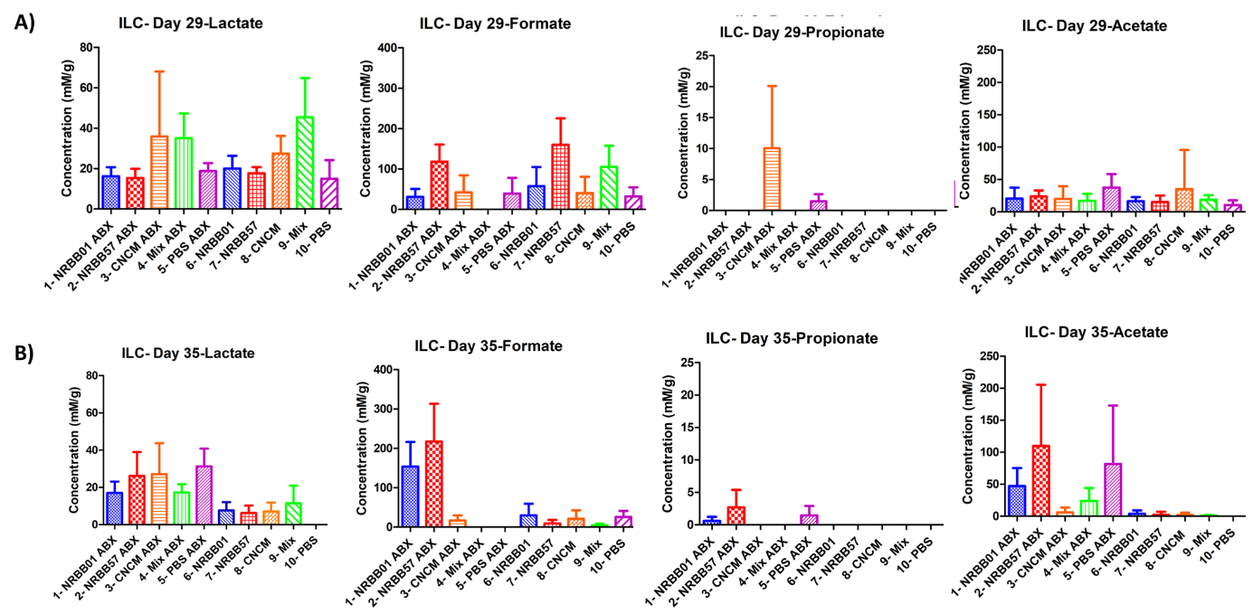
Figure S1. Ileum content HPLC VFA results for A) groups culled on Day 29, and B) Replicate groups culled on Day 35.
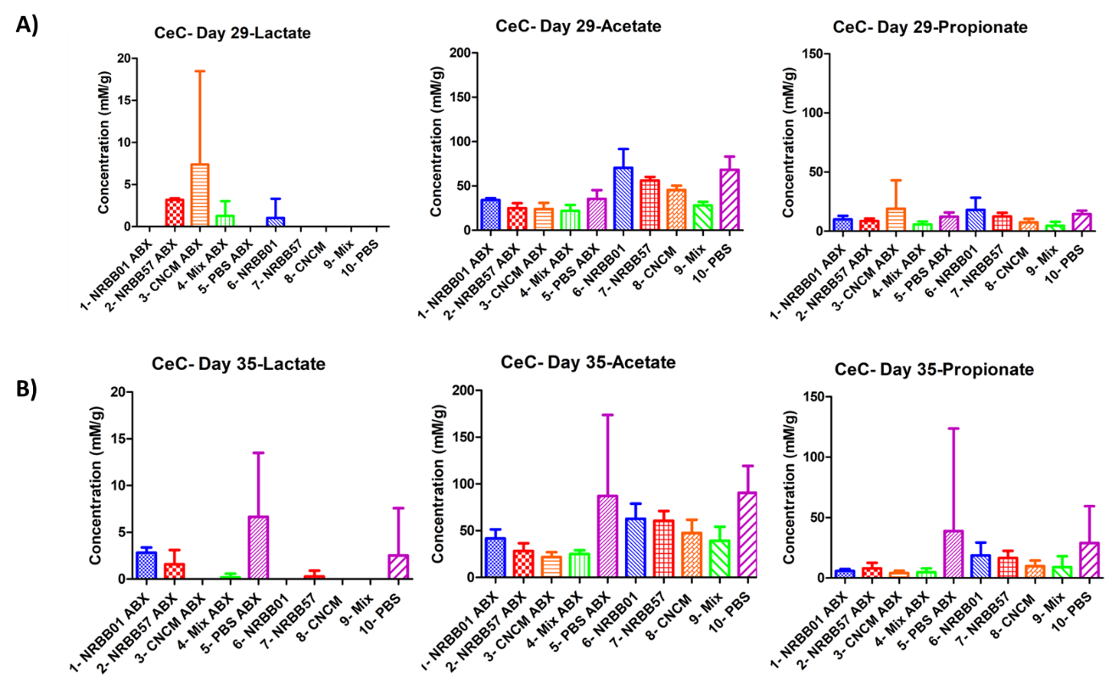Figure S2. Cecum content HPLC VFA results for A) groups culled on Day 29, and B) replicate groups culled on Day 35.

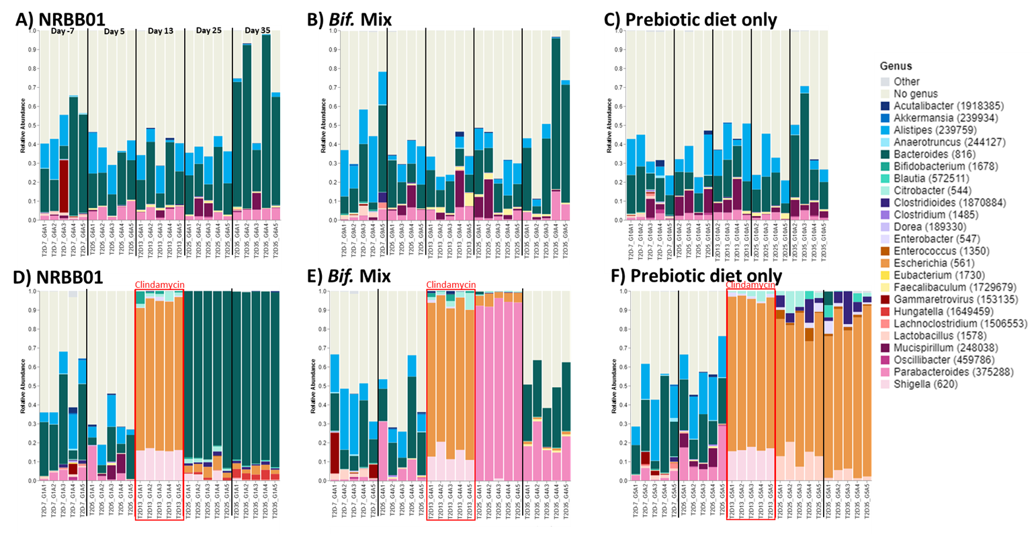
Figure S3. Relative abundance of the top 25 genera at Day -7, 5, 13, 25 and 35 across the 3 intervention groups supplemented with A) scGOS/lcFOS/2’-FL and B. breve NRBB01 B) scGOS/lcFOS/2’-FL and the Bifidobacterium strain Mix and C) scGOS/lcFOS/2’-FL diet only, without clindamycin treatment. Groups treated with clindamycin between Day 7-14 include groups supplemented with D) scGOS/lcFOS/2’-FL and B. breve NRBB01 E) scGOS/lcFOS/2’-FL and the Bifidobacterium strain Mix and F) scGOS/lcFOS/2’-FL diet only. N=5/group.
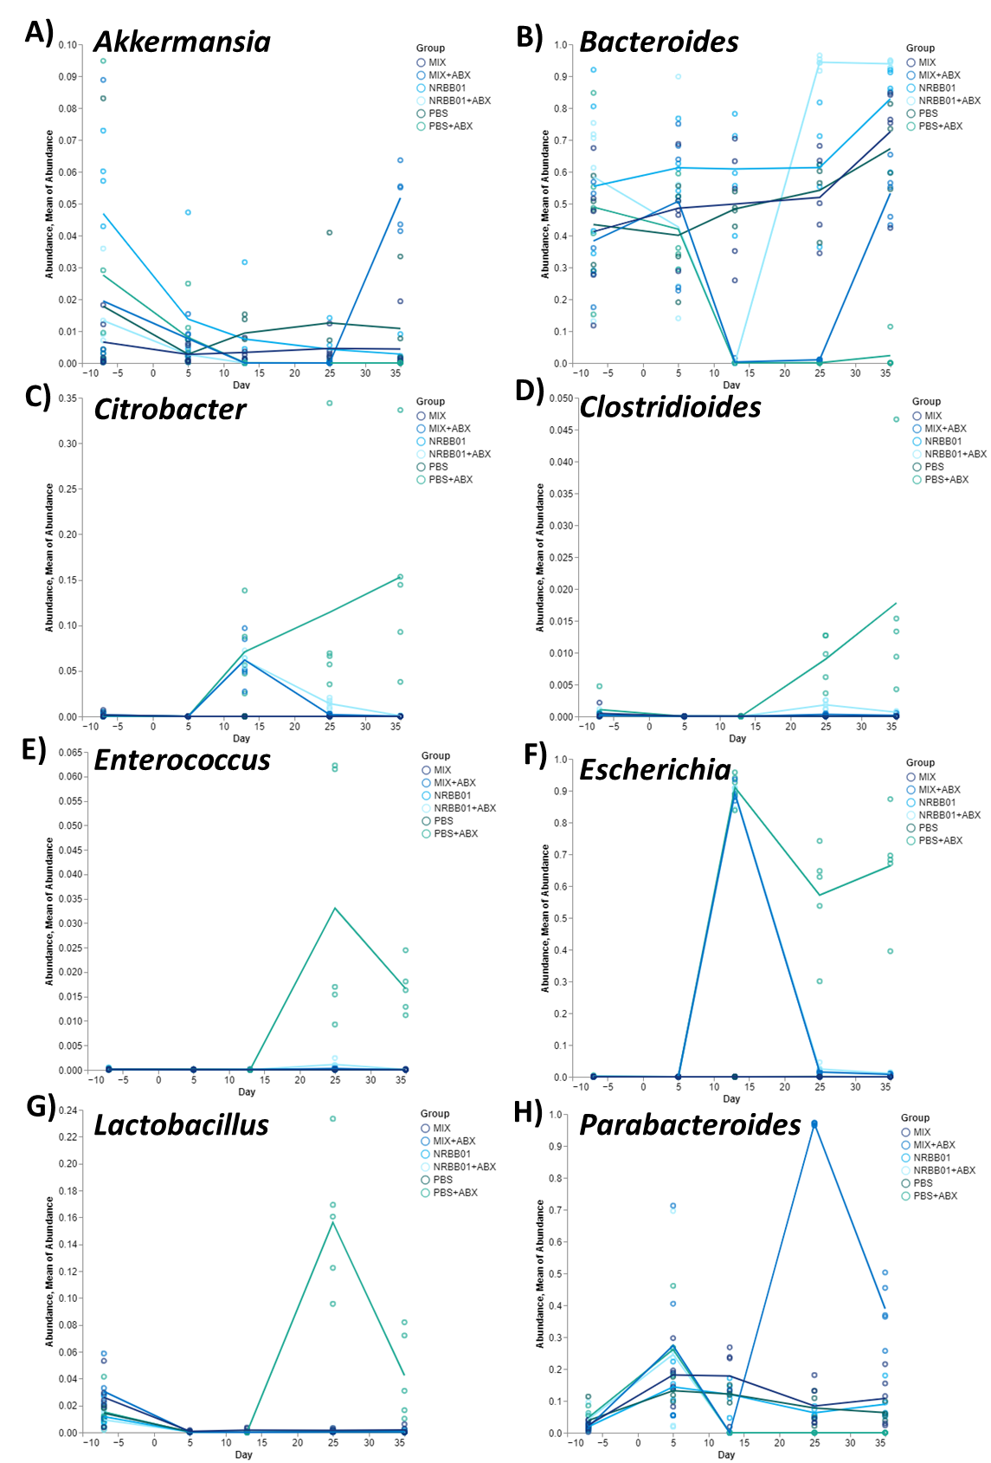
Figure S4. Line plot of the relative abundance of key genera A) Akkermansia, B) Bacteroides, C) Citrobacter, D) Clostridioides, E) Enterococcus, F) Escherichia, G) Lactobacillus, H) Parabacteroides at Days -7, 5, 13, 25 and 35. Each line represents a treatment group with and without antibiotic treatment (clindamycin) between Day 7-14 (B. breve NRBB01, Bifidobacterium strain Mix and scGOS/lcFOS/2’-FL diet only), without clindamycin treatment. Clindamycin treatment occurred between Day 7-14; n=5/group.

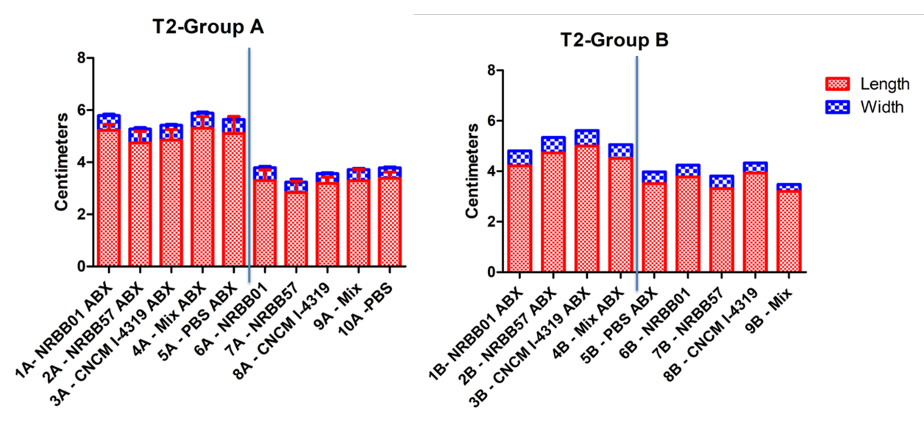
Figure S5. Cecum dimensions for replicate groups A (29 Day) and B (35 Day) demonstrate a difference between groups treated with and without antibiotics. Cecums of animals receiving clindamycin treatment are larger in length, which is more noticeable for Group A (cull Day 29) which was culled 2 weeks post antibiotic treatment (n = 5). Group B (cull Day 35) had an n=1 and PBS+ABX control was not imaged. Therefore, these results are only observational and not appropriate for statistical analysis.

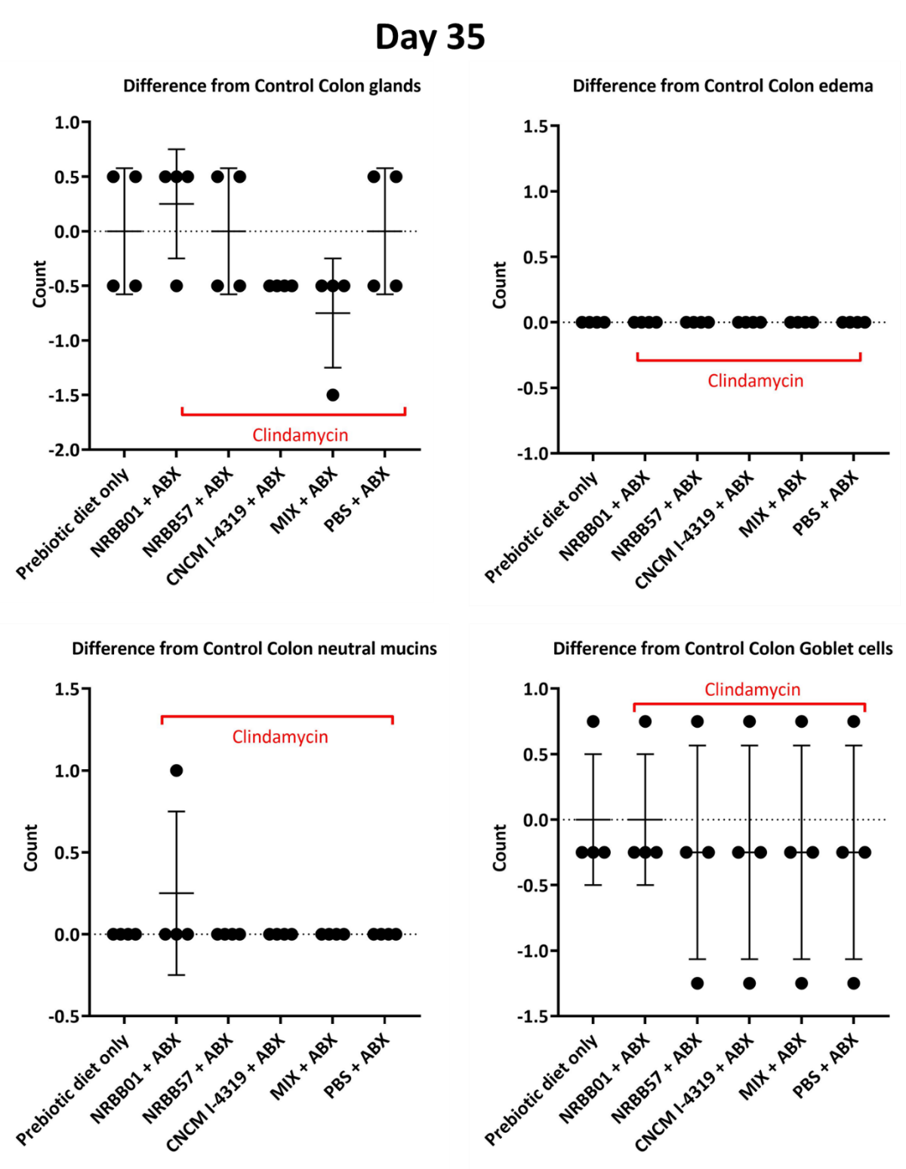
Figure S6. Histological scoring found no significant differences, at Day 35 (3 weeks post antibiotic), of the colonic folds number (glands), edema, neutral mucin staining, and goblets cells (I-L) were measured with at least 5 per mouse. Data are expressed as means ± SD. n= 4 per group. Mean values were significantly different between the groups: *P<0.05, **P<0.01, *** P<0.001.

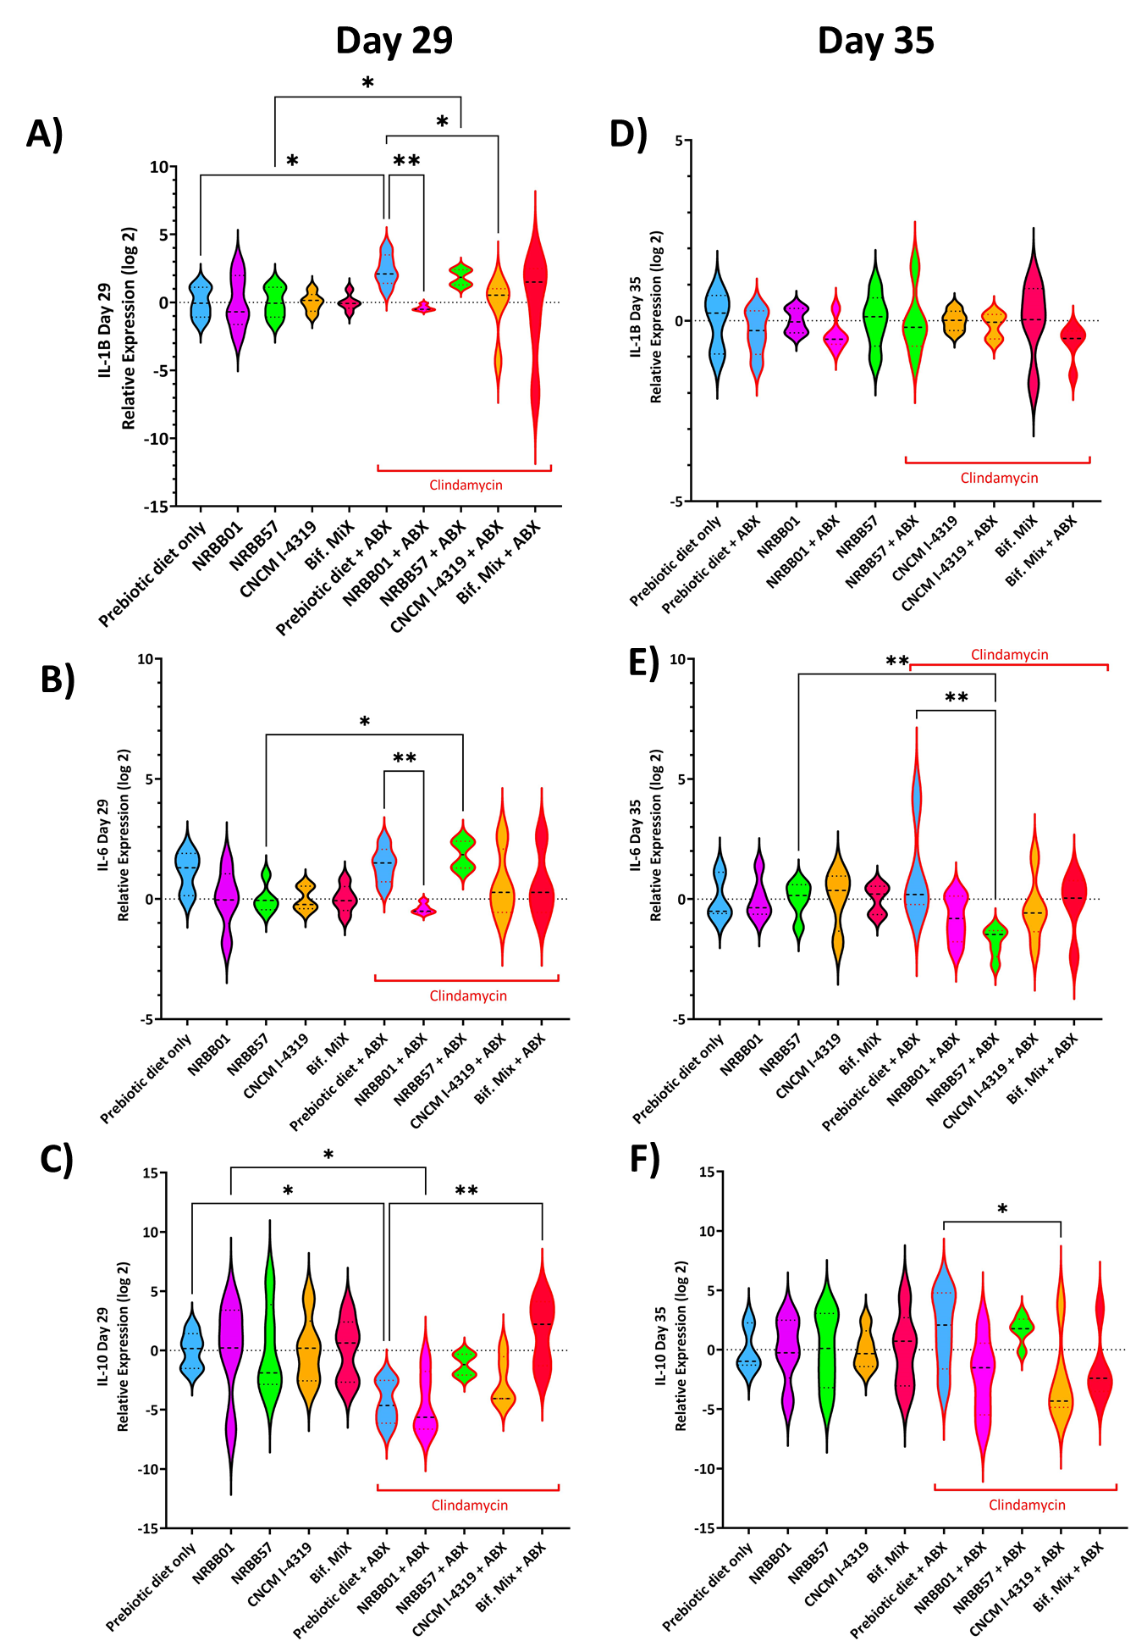
Figure S7. Immune markers A) IL-1β, B) lL-6, and C) IL-10 qPCR relative expressions at Day 29 and D) IL-1β, E) lL-6, and F) IL-10 at Day 35. Data are expressed as Log 2 transformed ± SD; n= 5 per group. Mean values were significantly different between the groups: *P<0.05, **P<0.01, *** P<0.001.

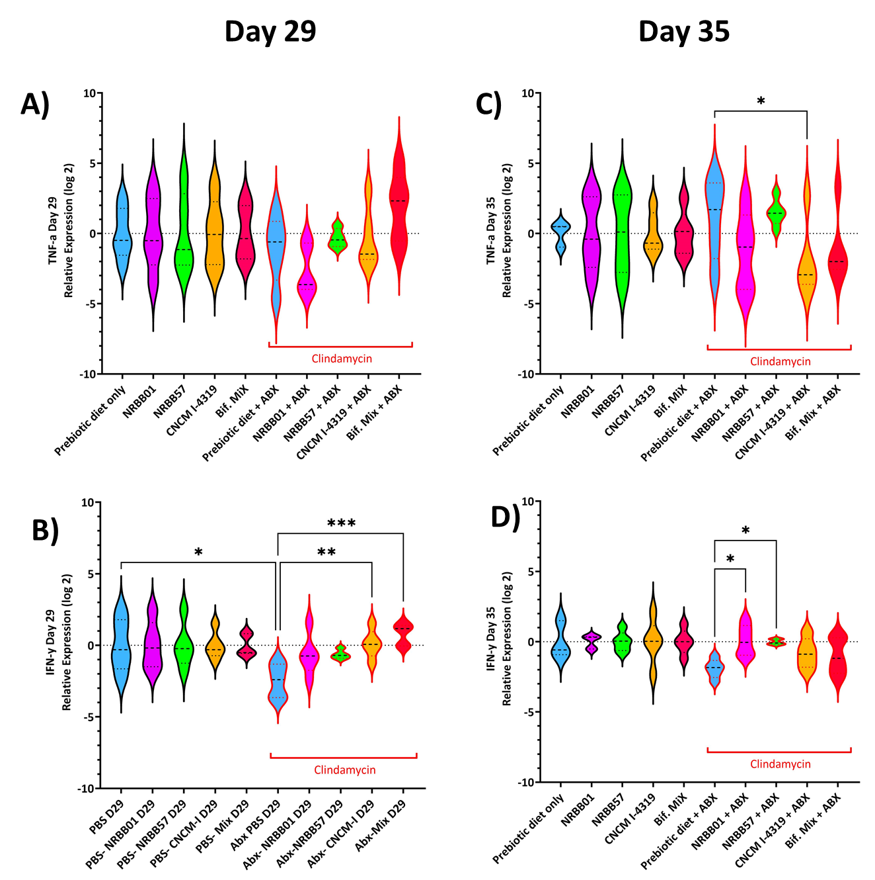
Figure S8. Immune markers A) TNF-α and B) IFN-γ qPCR relative expressions at Day 29 and C) TNF-α D) IFN-γ at Day 35. Data are Log 2 transformed ± SD; n= 5 per group. Mean values were significantly different between the groups: *P<0.05, **P<0.01, *** P<0.001.
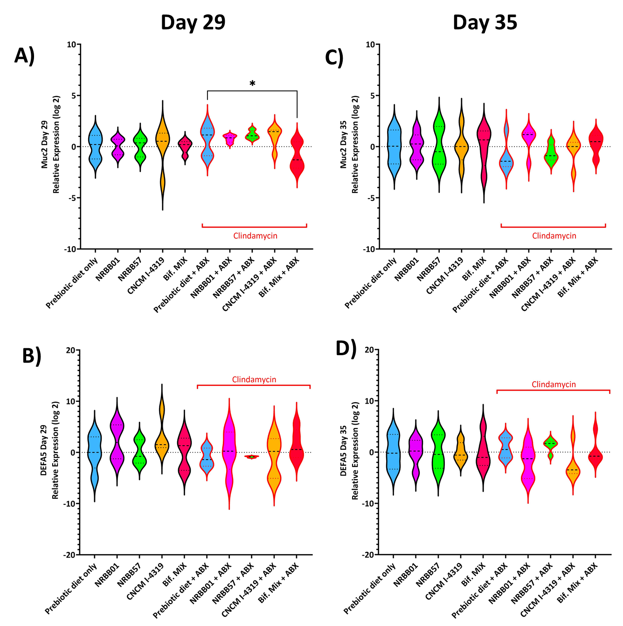
Figure S9. Epithelial barrier markers A) Muc2, and B) DEFA5 at Day 29 qPCR relative expressions and C) Muc2, D) DEFA5 at Day 35. Data is Log 2 transformed ± SD; n= 5 per group. Mean values were significantly different between the groups: *P<0.05, **P<0.01, *** P<0.001.

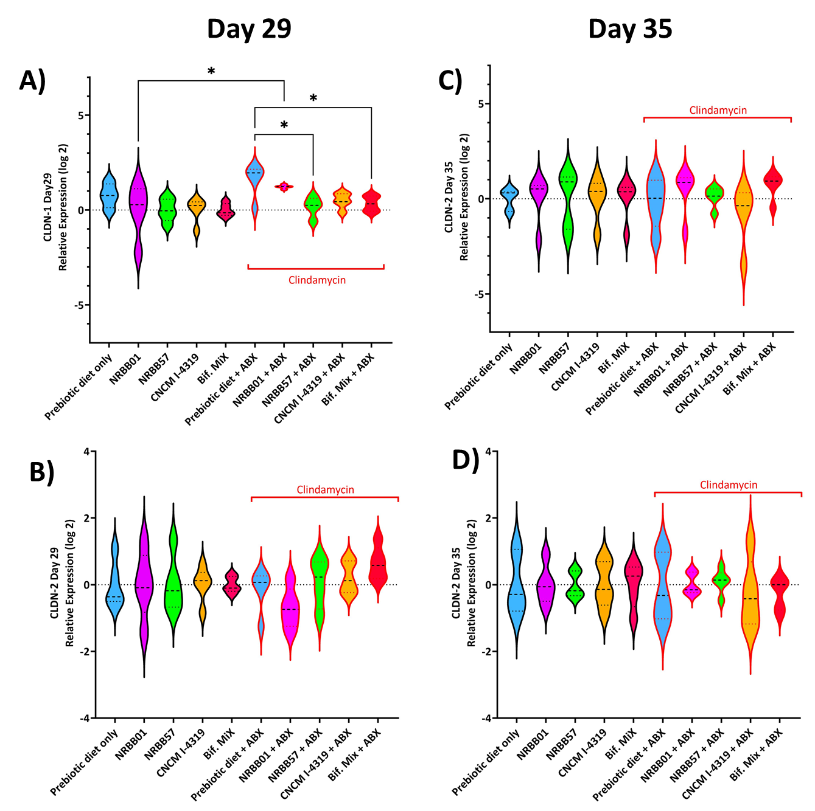
Figure S10. Epithelial barrier markers A) CLDN-1 and A) CLDN-2 qPCR relative expressions at Day 29 and C) CLDN-1, D) CLDN-2 at Day 35. Log 2 transformed data as ± SD; n= 5 per group. Mean values were significantly different between the groups: *P<0.05, **P<0.01, *** P<0.001.

References
1. F. Turroni et al., Exploring the diversity of the bifidobacterial population in the human intestinal tract. Appl Environ Microbiol 75, 1534-1545 (2009).
2. M. D. Thompson et al., Enhanced Steatosis and Fibrosis in Liver of Adult Offspring Exposed to Maternal High-Fat Diet. Gene Expr 17, 47-59 (2016).
3. N. Lubos et al., Inflammation shapes pathogenesis of murine arrhythmogenic cardiomyopathy. Basic Res Cardiol 115, 42-42 (2020).
4. I. Rostovsky, C. Davis, Induction of an Embryonic Mouse Innate Immune Response following Inoculation In Utero with Minute Virus of Mice. Journal of Virology 89, 2182 (2015).
5. A.-L. Cattin et al., Hepatocyte nuclear factor 4alpha, a key factor for homeostasis, cell architecture, and barrier function of the adult intestinal epithelium. Mol Cell Biol 29, 6294-6308 (2009).
6. J. Falero-Perez, C. M. Sorenson, N. Sheibani, Retinal astrocytes transcriptome reveals Cyp1b1 regulates the expression of genes involved in cell adhesion and migration. PLOS ONE 15, e0231752 (2020).
7. R. C. De Lisle, Disrupted tight junctions in the small intestine of cystic fibrosis mice. Cell Tissue Res 355, 131-142 (2014).

