Supplementary materials
Table S1. The 85 core genes with both presence and single-copy ratios > 95%. The presence and single-copy ratios were calculated based on the 5506 representative genomes.
HMM | Presence ratio | Single-copy ratio | Product
TIGR01050.1 | 99.6% | 99.6% | 30S ribosomal protein S19
PF00380.22 | 99.5% | 99.4% | Ribosomal protein S9/S16
TIGR01067.1 | 99.5% | 99.5% | 50S ribosomal protein L14
TIGR00981.1 | 99.4% | 99.4% | 30S ribosomal protein S12
PF00281.22 | 99.4% | 99.4% | Ribosomal protein L5
PF00410.22 | 99.4% | 99.4% | Ribosomal protein S8
TIGR01049.1 | 99.4% | 99.3% | 30S ribosomal protein S10
TIGR01164.1 | 99.4% | 99.4% | 50S ribosomal protein L16
PF00276.23 | 99.3% | 99.3% | Ribosomal protein L23
TIGR01029.1 | 99.3% | 99.2% | 30S ribosomal protein S7
TIGR00952.1 | 99.3% | 99.2% | 30S ribosomal protein S15
TIGR00029.2 | 99.3% | 99.2% | 30S ribosomal protein S20
TIGR03631.1 | 99.2% | 99.2% | 30S ribosomal protein S13
TIGR00060.1 | 99.1% | 99.0% | 50S ribosomal protein L18
TIGR01066.1 | 99.1% | 99.0% | 50S ribosomal protein L13
TIGR00855.1 | 99.1% | 98.8% | 50S ribosomal protein L7/L12
TIGR03654.1 | 99.1% | 99.1% | 50S ribosomal protein L6
PF00466.23 | 99.0% | 98.9% | Ribosomal protein L10
TIGR01171.1 | 99.0% | 99.0% | 50S ribosomal protein L2
TIGR01021.1 | 98.9% | 98.9% | 30S ribosomal protein S5
TIGR01032.1 | 98.9% | 98.8% | 50S ribosomal protein L20
TIGR00001.1 | 98.9% | 98.9% | 50S ribosomal protein L35
TIGR02027.1 | 98.9% | 98.1% | DNA-directed RNA polymerase subunit alpha
TIGR01071.1 | 98.9% | 98.9% | 50S ribosomal protein L15
TIGR03953.1 | 98.8% | 98.7% | 50S ribosomal protein L4
TIGR03632.1 | 98.8% | 98.7% | 30S ribosomal protein S11
TIGR00062.1 | 98.7% | 98.7% | 50S ribosomal protein L27
TIGR00116.1 | 98.7% | 98.5% | translation elongation factor Ts
TIGR00166.1 | 98.6% | 98.5% | 30S ribosomal protein S6
TIGR01169.1 | 98.6% | 98.6% | 50S ribosomal protein L1
TIGR01017.1 | 98.6% | 95.7% | 30S ribosomal protein S4
TIGR00086.1 | 98.5% | 97.9% | SsrA-binding protein
TIGR00158.1 | 98.5% | 98.4% | 50S ribosomal protein L9
TIGR03625.1 | 98.4% | 98.4% | 50S ribosomal protein L3
TIGR01079.1 | 98.3% | 98.3% | 50S ribosomal protein L24
TIGR00967.1 | 98.3% | 97.7% | preprotein translocase subunit SecY
TIGR00043.2 | 98.3% | 98.2% | rRNA maturation RNase YbeY
TIGR00061.1 | 98.3% | 98.2% | 50S ribosomal protein L21
TIGR01632.1 | 98.3% | 98.1% | 50S ribosomal protein L11
TIGR00414.1 | 98.2% | 95.6% | serine--tRNA ligase
TIGR01024.1 | 98.2% | 98.2% | 50S ribosomal protein L19
TIGR01030.1 | 98.1% | 98.1% | 50S ribosomal protein L34
TIGR00006.1 | 98.1% | 96.4% | 16S rRNA (cytosine(1402)-N(4))-methyltransferase RsmH
TIGR00168.2 | 98.1% | 95.3% | translation initiation factor IF-3
TIGR00755.1 | 98.0% | 98.0% | 16S rRNA (adenine(1518)-N(6)/adenine(1519)-N(6))-dimethyltransferase RsmA
TIGR03635.1 | 98.0% | 98.0% | 30S ribosomal protein S17
TIGR00468.1 | 98.0% | 97.9% | phenylalanine--tRNA ligase subunit alpha
TIGR01011.1 | 98.0% | 97.9% | 30S ribosomal protein S2
TIGR01044.1 | 97.8% | 97.8% | 50S ribosomal protein L22
TIGR00396.1 | 97.8% | 97.4% | leucine--tRNA ligase
TIGR03594.1 | 97.7% | 97.6% | ribosome biogenesis GTPase Der
TIGR00496.1 | 97.7% | 97.6% | ribosome recycling factor
TIGR00392.1 | 97.6% | 95.8% | isoleucine--tRNA ligase
TIGR00442.1 | 97.6% | 95.2% | histidine--tRNA ligase
TIGR03723.1 | 97.5% | 96.6% | tRNA (adenosine(37)-N6)-threonylcarbamoyltransferase complex transferase subunit TsaD
TIGR00964.1 | 97.5% | 97.4% | preprotein translocase subunit SecE
PF00162.22 | 97.5% | 95.8% | Phosphoglycerate kinase
TIGR02013.1 | 97.4% | 97.1% | DNA-directed RNA polymerase subunit beta
TIGR02729.1 | 97.3% | 97.3% | Obg family GTPase CgtA
TIGR00019.1 | 97.3% | 97.3% | peptide chain release factor 1
TIGR00810.1 | 97.2% | 97.0% | preprotein translocase subunit SecG
TIGR00092.1 | 97.2% | 97.1% | redox-regulated ATPase YchF
TIGR00012.1 | 97.2% | 97.2% | 50S ribosomal protein L29
TIGR01393.1 | 97.2% | 96.3% | translation elongation factor 4
TIGR01009.1 | 97.1% | 97.1% | 30S ribosomal protein S3
TIGR00344.1 | 97.1% | 96.4% | alanine--tRNA ligase
TIGR00059.1 | 97.0% | 96.9% | 50S ribosomal protein L17
TIGR02432.1 | 97.0% | 96.9% | tRNA lysidine(34) synthetase TilS
TIGR01391.1 | 96.9% | 95.7% | DNA primase
TIGR01953.1 | 96.8% | 96.8% | transcription termination factor NusA
TIGR02075.1 | 96.7% | 96.1% | UMP kinase
TIGR00002.1 | 96.7% | 96.6% | 30S ribosomal protein S16
TIGR00088.1 | 96.6% | 96.6% | tRNA (guanosine(37)-N1)-methyltransferase TrmD
TIGR00487.1 | 96.5% | 96.4% | translation initiation factor IF-2
TIGR00959.1 | 96.4% | 96.4% | signal recognition particle protein
TIGR00431.1 | 96.2% | 96.1% | tRNA pseudouridine(55) synthase TruB
TIGR03263.1 | 96.1% | 96.0% | guanylate kinase
TIGR00922.1 | 96.1% | 96.1% | transcription termination/antitermination protein NusG
TIGR00020.2 | 95.9% | 95.8% | peptide chain release factor 2
TIGR00064.1 | 95.7% | 95.7% | signal recognition particle-docking protein FtsY
TIGR00472.1 | 95.7% | 95.6% | phenylalanine--tRNA ligase subunit beta
TIGR00460.1 | 95.5% | 95.3% | methionyl-tRNA formyltransferase
TIGR00152.1 | 95.4% | 95.1% | dephospho-CoA kinase
TIGR00250.1 | 95.3% | 95.2% | Holliday junction resolvase RuvX
TIGR00635.1 | 95.2% | 95.1% | Holliday junction branch migration DNA helicase RuvB

Table S2. The 20 validated bacterial core genes upon the screens based on presence ratio, single copy ratio, and phylogenetic fidelity. The HMM ID of the genes, Robinson-Foulds (RF) distances from the corresponding 16S rRNA gene trees and the products of the genes were listed.
Rank | Core genes | RF Mean | RF STD | Products
1 | TIGR02013.1 | 115.9 | 14.8 | DNA-directed RNA polymerase subunit beta
2 | TIGR03594.1 | 120.1 | 13.4 | ribosome biogenesis GTPase Der
3 | TIGR01171.1 | 120.3 | 9.9 | 50S ribosomal protein L2
4 | PF00281.22 | 120.3 | 11.2 | Ribosomal protein L5
5 | TIGR02027.1 | 121.8 | 11.4 | DNA-directed RNA polymerase subunit alpha
6 | TIGR01011.1 | 122.0 | 12.0 | 30S ribosomal protein S2
7 | TIGR01009.1 | 122.3 | 10.3 | 30S ribosomal protein S3
8 | TIGR00959.1 | 123.2 | 11.9 | signal recognition particle protein
9 | TIGR00967.1 | 123.9 | 11.6 | preprotein translocase subunit SecY
10 | TIGR01393.1 | 124.1 | 13.8 | translation elongation factor 4
11 | TIGR00487.1 | 124.1 | 12.3 | translation initiation factor IF-2
12 | TIGR01029.1 | 125.3 | 10.9 | 30S ribosomal protein S7
13 | TIGR01021.1 | 125.8 | 11.4 | 30S ribosomal protein S5
14 | TIGR00468.1 | 126.5 | 11.7 | phenylalanine--tRNA ligase subunit alpha
15 | TIGR00019.1 | 126.6 | 10.8 | peptide chain release factor 1
16 | TIGR01169.1 | 126.7 | 14.0 | 50S ribosomal protein L1
17 | TIGR01953.1 | 127.6 | 12.3 | transcription termination factor NusA
18 | TIGR03625.1 | 127.8 | 12.4 | 50S ribosomal protein L3
19 | TIGR02729.1 | 128.7 | 11.7 | Obg family GTPase CgtA
20 | TIGR00092.1 | 128.8 | 12.1 | redox-regulated ATPase YchF

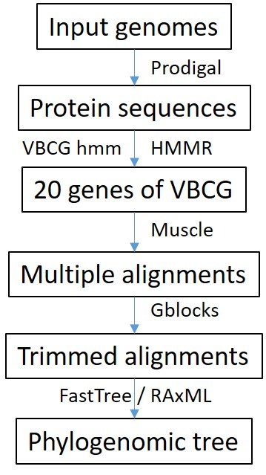
Figure S1. The workflow of the pipeline VBCG. The pipeline begins by predicting gene and protein sequences of the input genomes using Prodigal. Next, the protein sequences are used to identify the 20 VBCG genes with HMMER. The resulting VBCG genes of all the genomes are retrieved and put into separate files for each gene. The genes are aligned using Muscle, and any terminal gaps are removed from the multiple alignments. To select conserved blocks, Gblocks is applied. The processed alignments of the core genes are then concatenated, removing any taxa with more than one gene missing. Finally, the concatenated alignments are converted into Phylip files and fed to FastTree or RAxML for phylogenetic tree reconstruction.

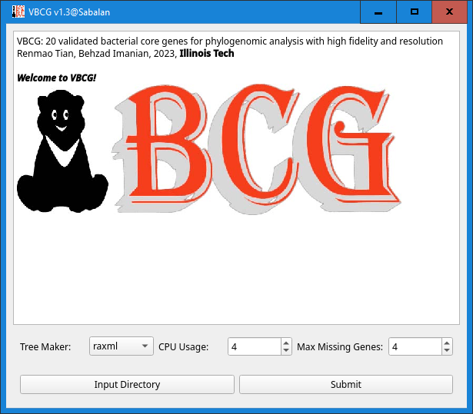
Figure S2. The interface of the VBCG desktop app (Windows version). Users only need to input genomic sequences and set the parameters, and it will identify the 20 VBCG genes with HMMER, and use the concatenated sequence for phylogenomic tree construction.

