Additional File 2

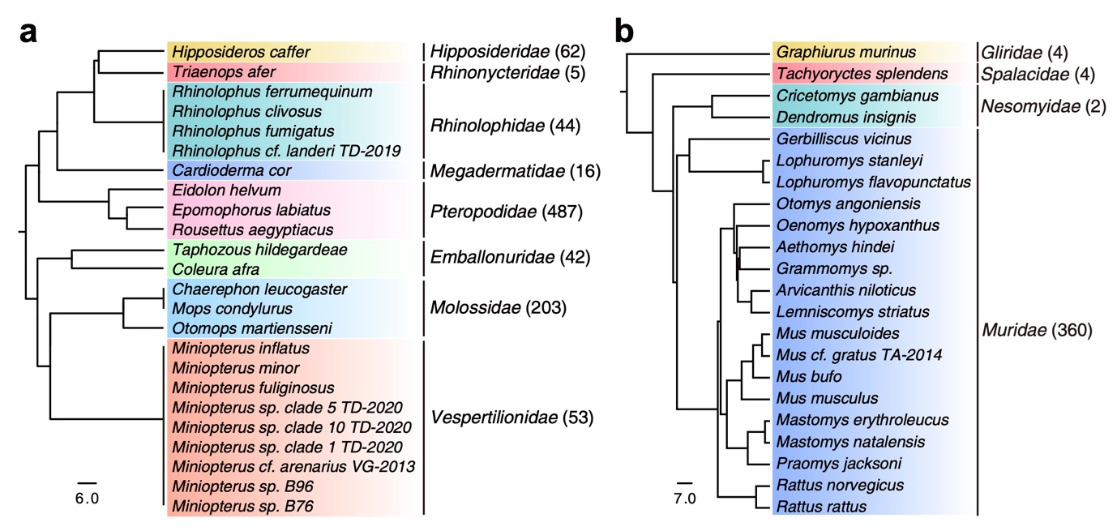Fig. S1. Taxonomy of surveyed host species
a Phylogeny of the bat species surveyed in this study. b Phylogeny of the rodent species surveyed in this study. Host phylogenies of host species were derived from public subsets of the mammalian phylogeny (http://vertlife.org/phylosubsets).

Fig. S2. Workflow for virus sequence identification
The reads were filtered to remove ribosomal RNA (rRNA), adapter, low-quality, duplicate and low complexity sequences. The filtered reads were de novo assembled and compared against viral proteins from the nonredundant (NR) protein database and the RefSeq and IMG-VR databases. The matched contigs were annotated using the Contig Annotation Tool (CAT) and compared against the nucleotide (NT) database and reference genomes of Chiroptera and Rodentia to remove host sequences. The proteins translated from each viral contig were compared against representative replication-associated proteins derived from the NR database. For RNA viruses, only the viruses matching the RdRp conserved domains from the conserved domain database (CDD) were considered further. To annotate vertebrate-associated viruses, all viral sequences were compared against proteins in the Virus‒Host Database (VHDB). Only the viral sequences that were most similar to a vertebrate-associated virus were selected for further analyses. The completeness of each viral sequence was assessed, after which the sequences were clustered at 80% nucleotide identity (vANI80) and 95% (vANI95). Within each clustering level, the viral sequence with the longest length was selected to represent the viral species/strain.

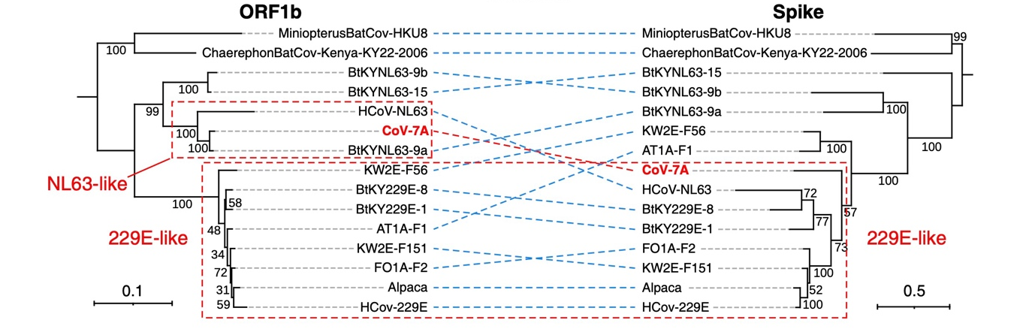

Fig. S3. Evolution of CoV-7A
Maximum likelihood phylogenetic trees of open reading frame (ORF)1b (left) and the spike region (right) of CoV-7A-related viruses. The trees are midpoint rooted, with the scale bar representing the count of amino substitutions per site.
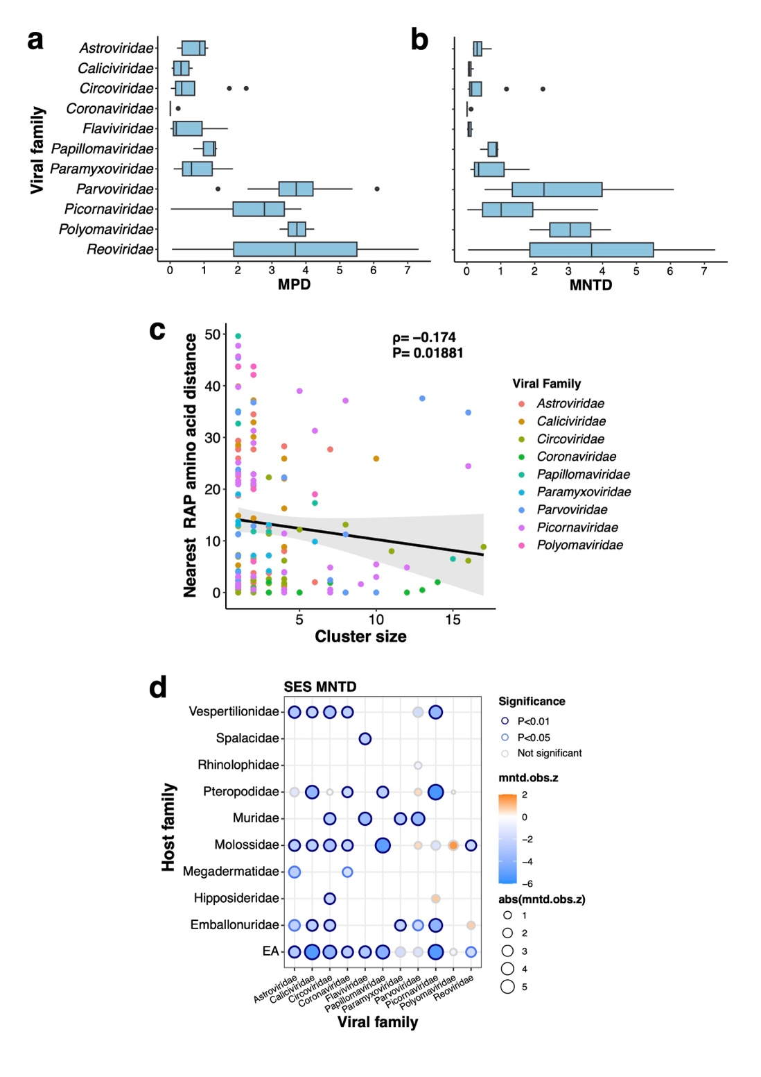

Fig. S4. Phylogenetic diversity of viruses among host groups
a Mean pairwise distance (MPD) among vANI95s within each viral family. b Mean nearest-pairwise distance (MNTD) among vANI95s within each viral family. c Spearman correlation between the nearest RAP amino acid distance to each vANI95 and the cluster size. d Phylogenetic diversity of the host families with at least three viral records as estimated by the standardised effect size of mean nearest taxon distance (SES-MNTD).
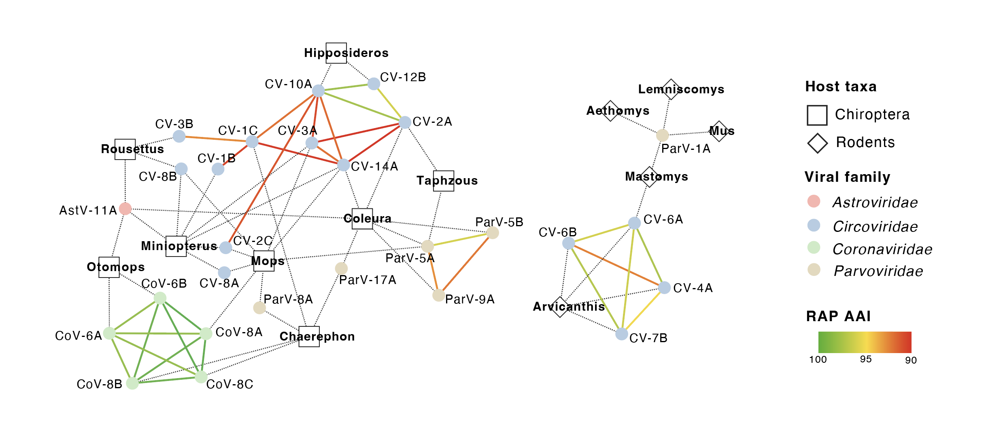

Fig. S5. Network of closely related vANI95 clusters associated with different host genera
Edges represent the RAP similarity. The nodes represent the host and virus.

Fig. S6. Phylogenies of capsid and replication-associated proteins in Cyclovirus
Phylogenetic tree of capsid protein (left) and replication-associated protein (right) with bootstrap support values labelled on each branch node, using chicken-associated cyclovirus 2 as the outgroup. The viruses identified here are shown in red.

Fig. S7. Recombination analysis of CoV-6 and CoV-8
a Sliding window analysis of the genomic similarity between CoV-6A and CoV-8A and their closely related coronaviruses. The putative recombination breakpoints are indicated by dashed lines. The similarities against different reference sequences are indicated by different colours. b Maximum likelihood phylogenetic trees of the ORF1b (left) and S1 regions (right) of the coronaviruses identified in the bat genera Chaerephon, Otomops and Mops and their close relatives, with BtYN63-9a serving as the outgroup. The trees are midpoint rooted, with the scale bar representing the count of amino substitutions per site.
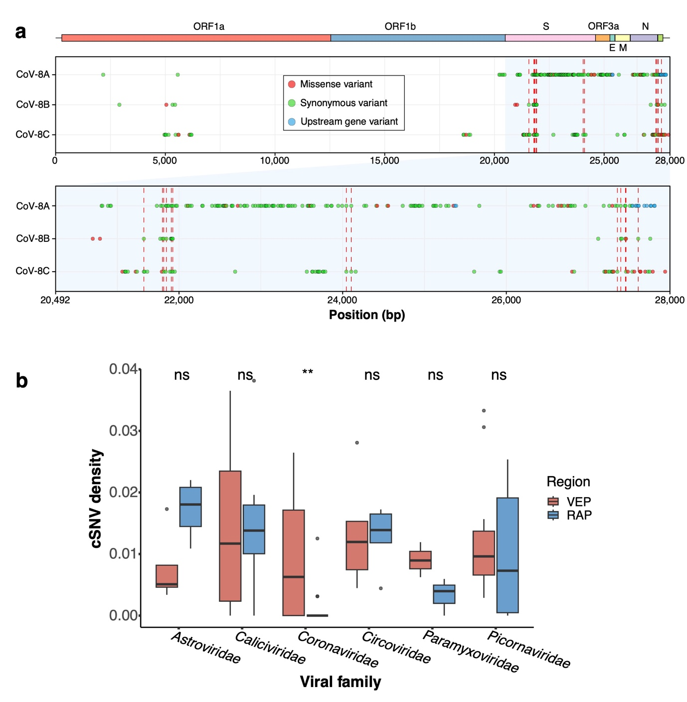

Fig. S8. Polymorphic sites in the genomes of Coronaviridae
a Variable sites across CoV-8 genomes. Polymorphic sites are indicated in circles along the CoV-8 genome. The colours represent the biological effects of the mutations. Recurrent mutations among at least two of the three vANI95 clusters are indicated by red dashed lines. b The cSNV density of the vANI95 cluster with at least 10 cSNV sites within the VEP and RAP regions.
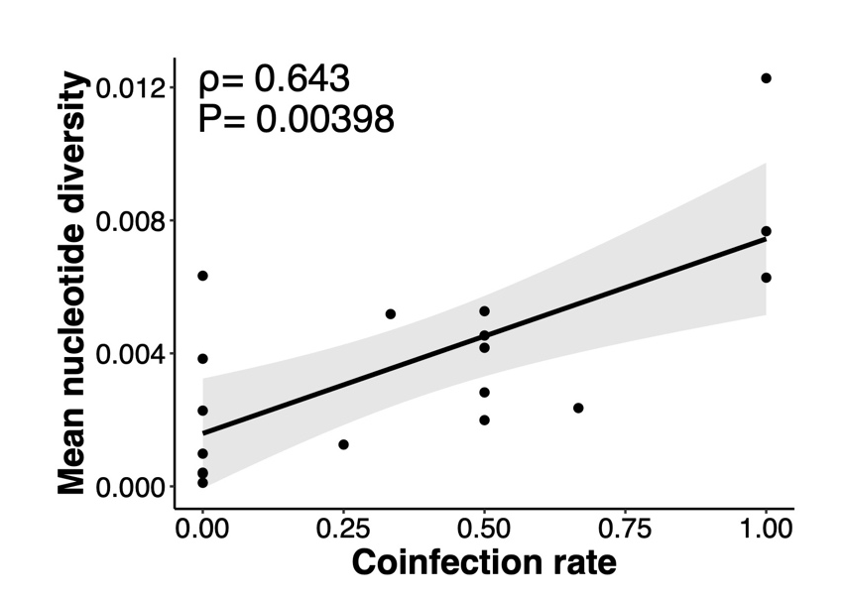

Fig. S9. The correlation between nucleotide diversity and the coinfection rate in major vANI95 clusters.

