Supplementary Tables

Table S1. Screen the existence of L. reuteri DSM 17938 among nine human stools and test the specificities of the designed primers for L. reuteri PB-W1 and DSM 20016^{T} based on the fecal background DNA
Sample ID | Existence of  DSM 17938ª | Primers for PB-W1  (Log₁₀ cells/g)^{b} | Primers for DSM 20016^{T}  (Log₁₀ cells/g)^{b}
Stool_1 | No | - | 4.15
Stool_2 | No | - | 3.90
Stool_3 | No | - | -
Stool_4 | No | - | -
Stool_5 | No | - | -
Stool_6 | No | - | 5.53
Stool_7 | No | - | -
Stool_8 | No | - | -
Stool_9 | No | - | -
Note: ªThe existence of L. reuteri DSM 17938 among these nine fecal samples was screened through qPCR using the strain-specific primers developed previously [1]; ^{b}Dash, no amplification.

Table S2. Quantities and qualities of DNA extracted using different DNA isolation methods
 | DNA concentration (ng/μl)ª | A_{260/280 nm}ª | A_{260/230 nm}ª

Phenol-chloroform (PC)
Overall | 1525 ± 290 | 2.00 ± 0.03 | 1.74 ± 0.16
R1 (n = 9) | 1391 ± 50 | 2.04 ± 0.01 | 1.92 ± 0.03
R2 (n = 9) | 1269 ± 30 | 1.97 ± 0.01 | 1.55 ± 0.03
R3 (n = 9) | 1915 ± 74 | 1.98 ± 0.01 | 1.76 ± 0.02

QIAamp Fast DNA Stool Mini Kit (QK)
Overall | 259 ± 41 | 1.97 ± 0.02 | 1.99 ± 0.15
R1 (n = 9) | 257 ± 14 | 1.96 ± 0.01 | 1.90 ± 0.06
R2 (n = 9) | 219 ± 19 | 1.96 ± 0.01 | 2.16 ± 0.14
R3 (n = 9) | 303 ± 30 | 2.00 ± 0.01 | 1.91 ± 0.05

Protocol Q (PQ)
Overall | 694 ± 76 | 2.08 ± 0.03 | 2.10 ± 0.15
R1 (n = 9) | 738 ± 59 | 2.05 ± 0.02 | 2.00 ± 0.03
R2 (n = 9) | 615 ± 54 | 2.09 ± 0.02 | 2.31 ± 0.04
R3 (n = 9) | 730 ± 42 | 2.09 ± 0.01 | 2.00 ± 0.03
Note: R1, R2, and R3 represent three fecal samples collected from three healthy human participants;
ªData are shown as mean ± SD.

Table S3. L. reuteri genomes available in Joint Genome Institute (JGI) genome portal selected for the present study
Strain | Origin | Lineageª | Subspecies^{b} | IMG Genome ID
PB-W1 | Human | Novel | Novel | JGI: 2880791114
DSM 20016 | Human | II | L. reuteri ssp. reuteri | JGI: 2758568725
I49 | Mouse | I | L. reuteri ssp. murium | JGI: 2718217763
lpuph | Mouse | I | L. reuteri ssp. murium | JGI: 2506381017
LTH5448 | Sourdough | I | L. reuteri ssp. murium | JGI: 2571042361
TD1 | Rat | I | L. reuteri ssp. murium | JGI: 2554235439
ATG-F4 | Human | II | L. reuteri ssp. reuteri | JGI: 2877523357
IRT | Human | II | L. reuteri ssp. reuteri | JGI: 2636415954
JCM 1112 | Human | II | L. reuteri ssp. reuteri | JGI: 642555135
MM2-3 | Human | II | L. reuteri ssp. reuteri | JGI: 2502171171
MM4-1a | Human | II | L. reuteri ssp. reuteri | JGI: 2502171170
100-23 | Rat | III | L. reuteri ssp. rodentium | JGI: 2500069000
LTH2584 | Sourdough | III | L. reuteri ssp. rodentium | JGI: 2534682349
R2lc | Rat | III | L. reuteri ssp. rodentium | JGI: 2716884882
TMW1.112 | Sourdough | III | L. reuteri ssp. rodentium | JGI: 2534682347
TMW1.656 | Sourdough | III | L. reuteri ssp. rodentium | JGI: 2534682350
ATCC 53608 | Pig | IV | L. reuteri ssp. suis | JGI: 2843020057
CGMCC 11154 | Pig | IV | L. reuteri ssp. suis | JGI: 2836652783
pg-3b | Pig | IV | L. reuteri ssp. suis | JGI: 2599185334
ZLR003 | Pig | IV | L. reuteri ssp. suis | JGI: 2687453552
20-2 | Pig | V | L. reuteri ssp. porcinae | JGI: 2599185332
3c6 | Pig | V | L. reuteri ssp. porcinae | JGI: 2599185333
CF48-3A | Human | VI | L. reuteri ssp. kinnarii | JGI: 2502171173
M27U15 | Human | VI | L. reuteri ssp. kinnarii | JGI: 2687453659
MM34-4A | Human | VI | L. reuteri ssp. kinnarii | JGI: 2660238834
PB-W2^{c} | Human | VI | L. reuteri ssp. kinnarii | JGI: 2758568723
SD2112 | Human | VI | L. reuteri ssp. kinnarii | JGI: 650716048
1366 | Chicken | VI | L. reuteri ssp. kinnarii | JGI: 2684623010
AP3 | Pheasant | VI | L. reuteri ssp. kinnarii | JGI: 2861118004
CSF8 | Chicken | VI | L. reuteri ssp. kinnarii | JGI: 2684623009
JCM 1081 | Chicken | VI | L. reuteri ssp. kinnarii | JGI: 2684623011
Note: ªLineage information was obtained from our previous studies [2-6]; ^{b}Subspecies information was obtained from [6]; ^{c}PB-W2 has the name PNG008B in Joint Genome Institute (JGI) genome portal.
Supplementary Figures

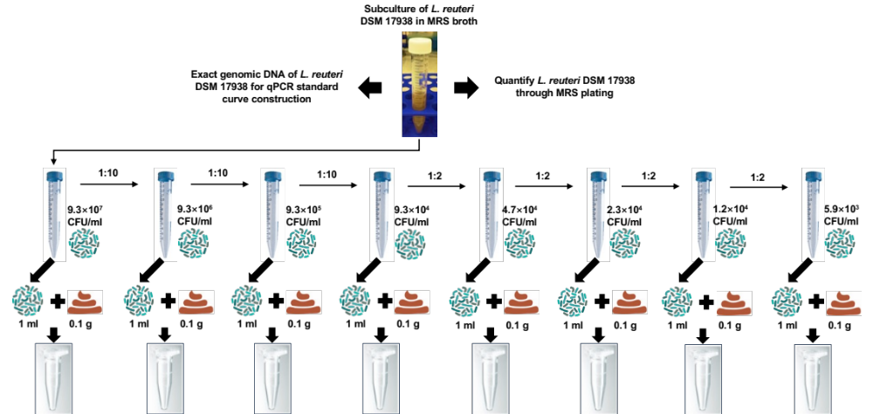

Figure S1. Preparation of fecal samples spiked with known numbers of bacteria. L. reuteri DSM 17938 was grown on MRS agar for 48 hours in an anaerobic chamber at 37 °C. After that, single colonies were picked and transferred to MRS broth, and sub-cultured twice (24 hours for the first sub-culture, and 8 hours for the second sub-culture to ensure bacterial cells stay at the late exponential phase or early stationary phase). Cell numbers in cultures were determined by plating a ten-fold serial dilution on MRS agar. Then serial dilutions of bacteria with exact cell numbers were prepared by dilution, and mixed with 0.1 g stool aliquots.
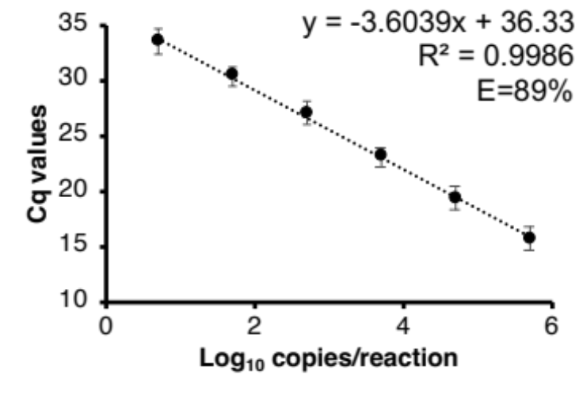
Figure S2. qPCR standards were established by a 10-fold serial dilution of genomic DNA of L. reuteri DSM 17938, and each dot represent the average Cq of six replicates from three independent runs.

Figure S3. Melt curves for stool samples spiked with L. reuteri DSM 17938 in qPCR. (A-C), results obtained from spiked samples of three individuals and there was one specific peak at around 87.5℃, which indicated the amplification of target sequence for all reactions.
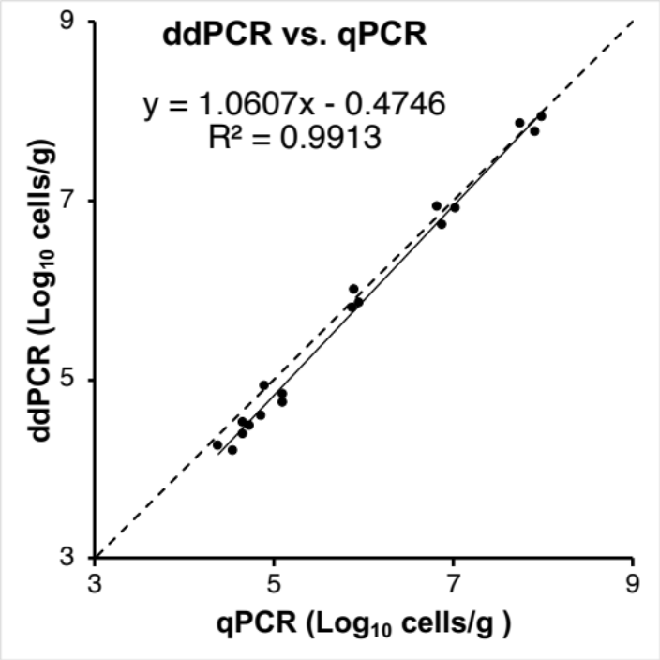

Figure S4. Correlation between qPCR and ddPCR for fecal samples spiked with L. reuteri DSM 17938 when the method PQ was used. Solid line, regression line; dash line, y = x. All dots are results obtained in qPCR and ddPCR.
Supplementary References

1. Egervärn M, Lindmark H, Olsson J, Roos S. Transferability of a tetracycline resistance gene from probiotic Lactobacillus reuteri to bacteria in the gastrointestinal tract of humans. Antonie Van Leeuwenhoek. 2010;97:189-200.
2. Oh PL, Benson AK, Peterson DA, Patil PB, Moriyama EN, Roos S, et al. Diversification of the gut symbiont Lactobacillus reuteri as a result of host-driven evolution. Isme j. 2010;4:377-387.
3. Walter J, Britton RA, Roos S. Host-microbial symbiosis in the vertebrate gastrointestinal tract and the Lactobacillus reuteri paradigm. Proc Natl Acad Sci U S A. 2011;108 Suppl 1:4645-4652.
4. Frese SA, Benson AK, Tannock GW, Loach DM, Kim J, Zhang M, et al. The evolution of host specialization in the vertebrate gut symbiont Lactobacillus reuteri. PLoS Genet. 2011;7:e1001314.
5. Duar RM, Frese SA, Lin XB, Fernando SC, Burkey TE, Tasseva G, et al. Experimental evaluation of host adaptation of Lactobacillus reuteri to different vertebrate species. Appl Environ Microbiol. 2017;83.
6. Li F, Cheng CC, Zheng J, Liu J, Quevedo RM, Li J, et al. Limosilactobacillus balticus sp. nov., Limosilactobacillus agrestis sp. nov., Limosilactobacillus albertensis sp. nov., Limosilactobacillus rudii sp. nov. and Limosilactobacillus fastidiosus sp. nov., five novel Limosilactobacillus species isolated from the vertebrate gastrointestinal tract, and proposal of six subspecies of Limosilactobacillus reuteri adapted to the gastrointestinal tract of specific vertebrate hosts. Int J Syst Evol Microbiol. 2021;71.

