Additional Material for “Cover Crop Root Exudates Impact Soil Microbiome Functional Trajectories in Agricultural Soils”

Authors: Valerie A. Seitz^{1,2}, Bridget B. McGivern³, Mikayla A. Borton³, Jacqueline M. Chaparro¹, Meagan E. Schipanski³, Jessica E. Prenni*^{1,2}, Kelly C. Wrighton* ^{2, 3}

*Co-Corresponding Authors:
Kelly C. Wrighton, kelly.wrighton@colostate.edu
Jessica E. Prenni, Jessica.prenni@colostate.edu

Affiliations: 1. Department of Horticulture and Landscape Architecture, Colorado State University, Fort Collins, CO 80523. 2. Program in Cell and Molecular Biology, Colorado State University, Fort Collins, CO 80523. 3. Department of Soil and Crop Science, Colorado State University, Fort Collins, CO 80523.

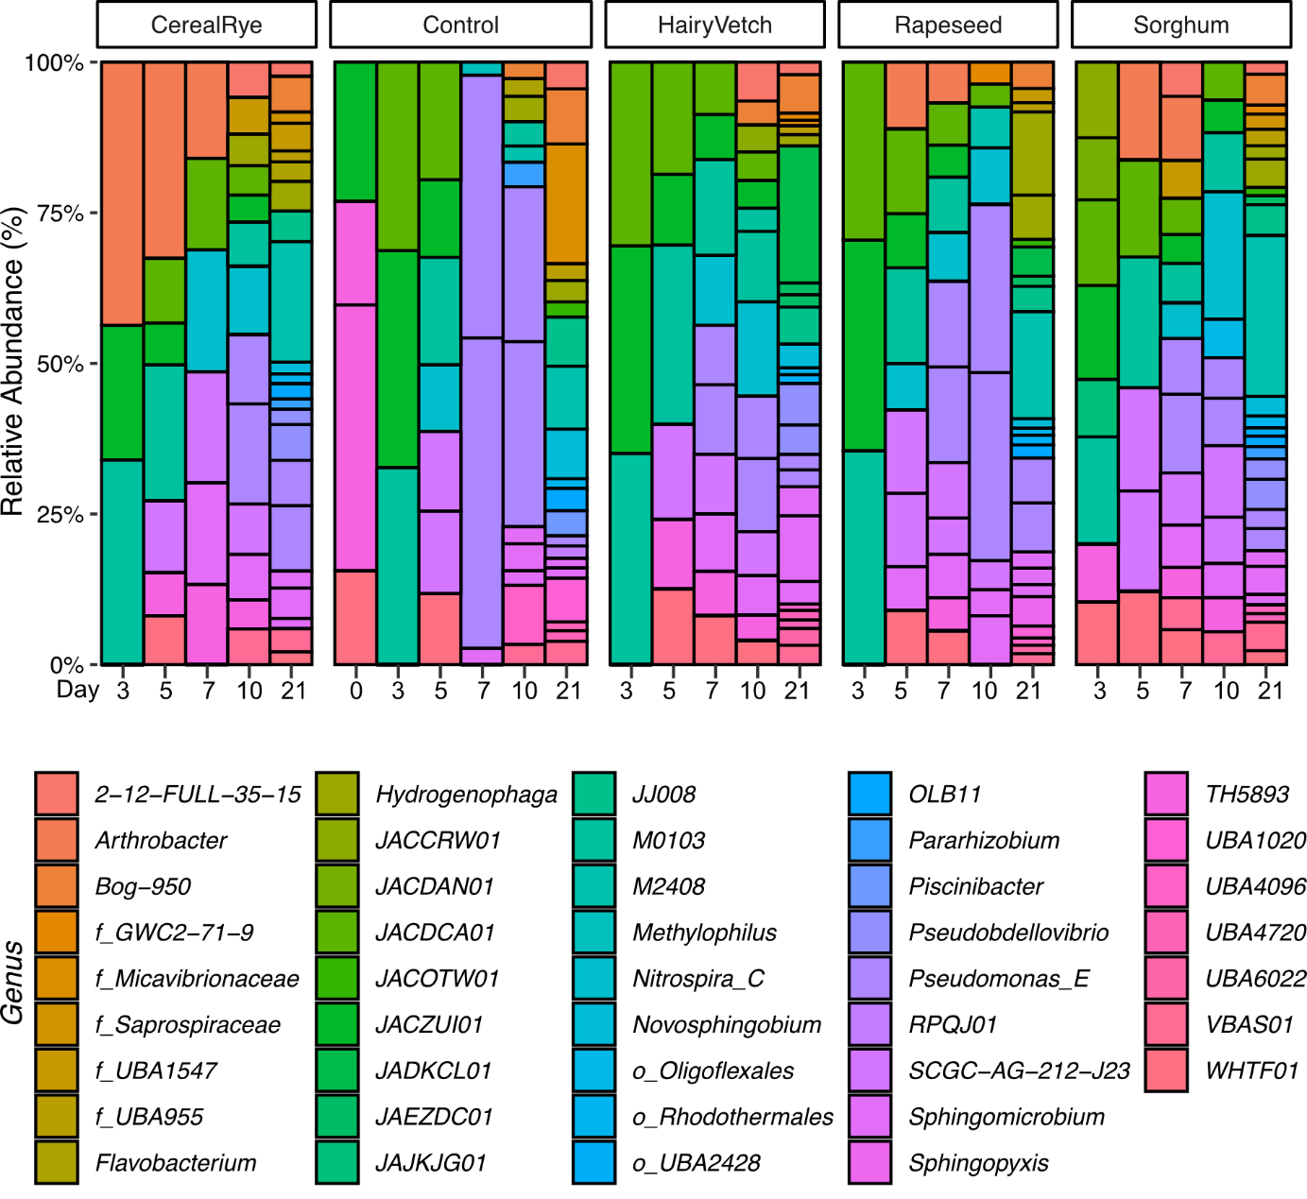

Additional Figure 1. Metagenomics taxonomic distribution by genus.
Taxa bar plots are separated by treatments showing relative abundance of MAGs colored by genus, or lowest taxonomic assignment within treatments at each timepoint (e.g. ‘g__’ represents genus while ‘f__’ represents a family annotation).

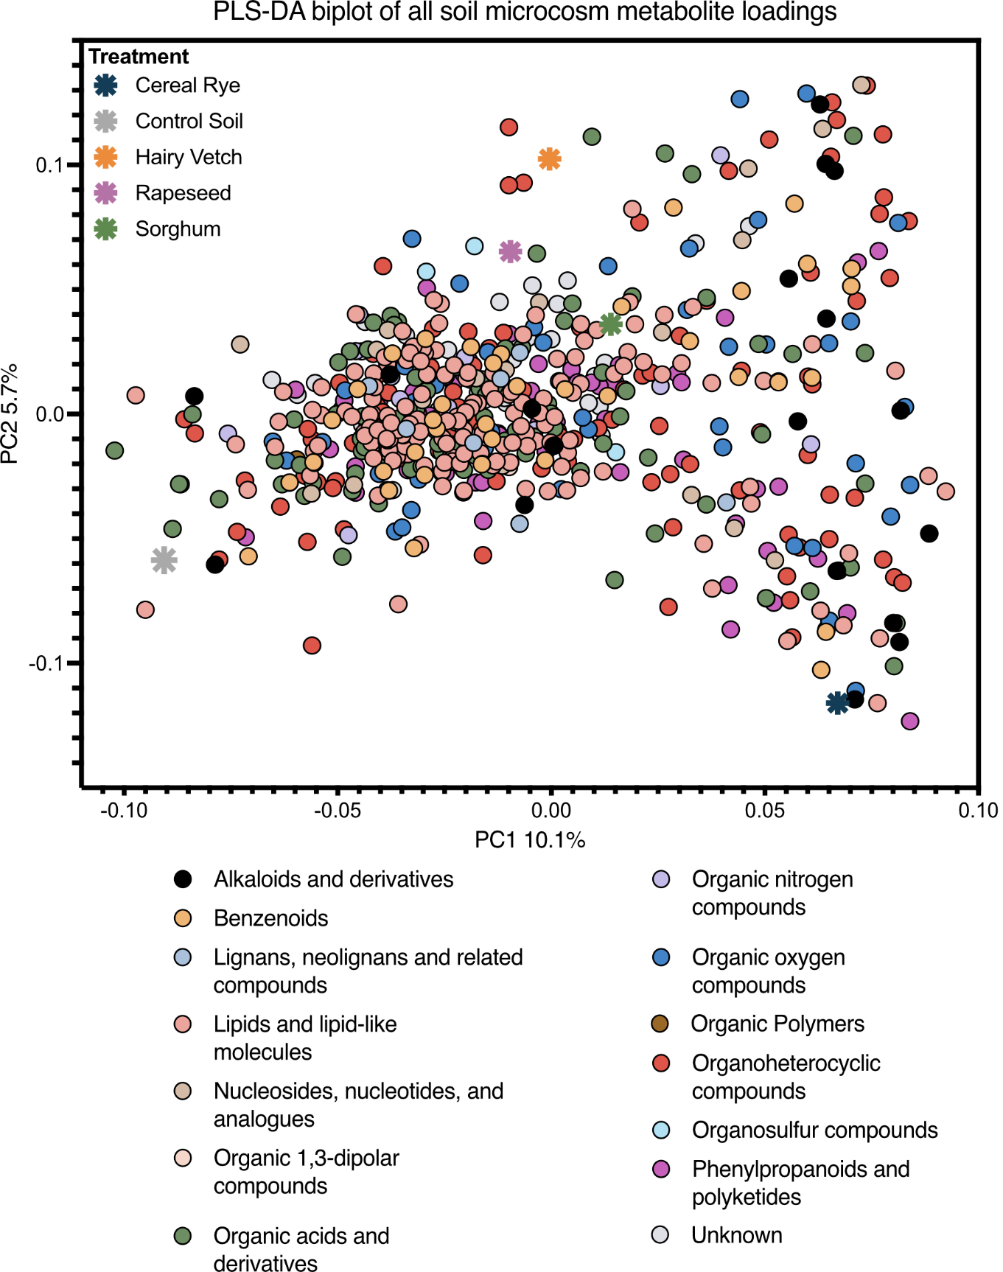

Additional Figure 2. Soil microcosms biplot of PLS-DA loadings highlighting distribution of all 641 metabolites colored by superclass.
Two-dimensional biplot of partial least squares discriminate analysis (PLS-DA) (R₂X = 0.101, R₂Y = 0.0597, Q₂ = 0.784) between all treatment metabolomes. Circles represent individual metabolites, colored by superclass. Stars represent treatment

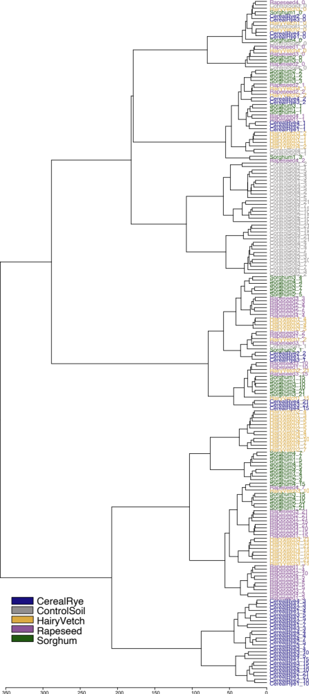

Additional Figure 3. Hierarchical clustering dendrogram of microcosm metabolomes.
Hierarchical clustering was completed in MetaboAnalyst using a Euclidean distance measure with Ward’s clustering algorithm to determine differences in metabolomes between treatments and within treatments at experimental timepoints. Colors correspond to treatment and labels indicate “treatmentRep_Day”.

Additional Table 1. PERMANOVA of metabolites by treatment and time.

Permutation test for adonis under reduced model
Terms added sequentially (first to last)
Permutation: free
Number of permutations: 999

adonis2(formula = metabolite_data ~ Treatment + Day + Treatment * Day, data = treatment, permutations = 999, method = "bray")

 | DF | SumofSqs | R2 | F | P Value
Treatment | 4 | 2.9384 | 0.21001 | 16.5891 | 0.001 ***
Day | 1 | 2.1019 | 0.15022 | 47.4663 | 0.001 ***
Treatment:Day | 4 | 0.5824 | 0.04162 | 3.2879 | 0.001 ***
Residual | 189 | 8.3694 | 0.59815
Total | 198 | 13.9922 | 1.00000

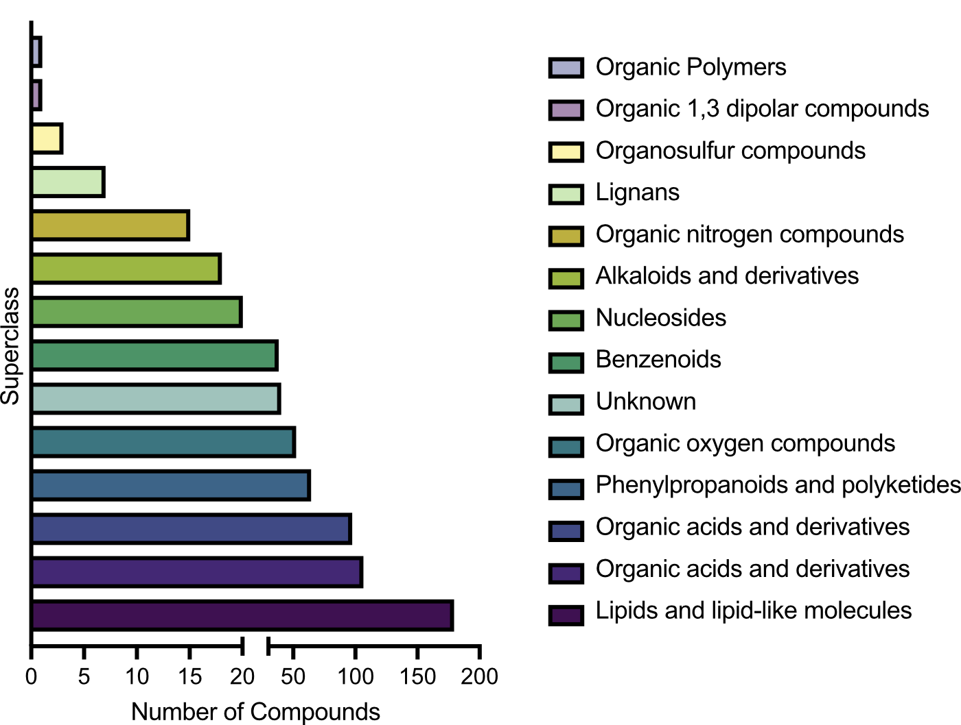

Additional Figure 4. Metabolite superclasses.
Characterization of all 641 molecular features identified with targeted and non-targeted LC-MS/MS data. Metabolites were classified using ClassyFire and colored by superclass.

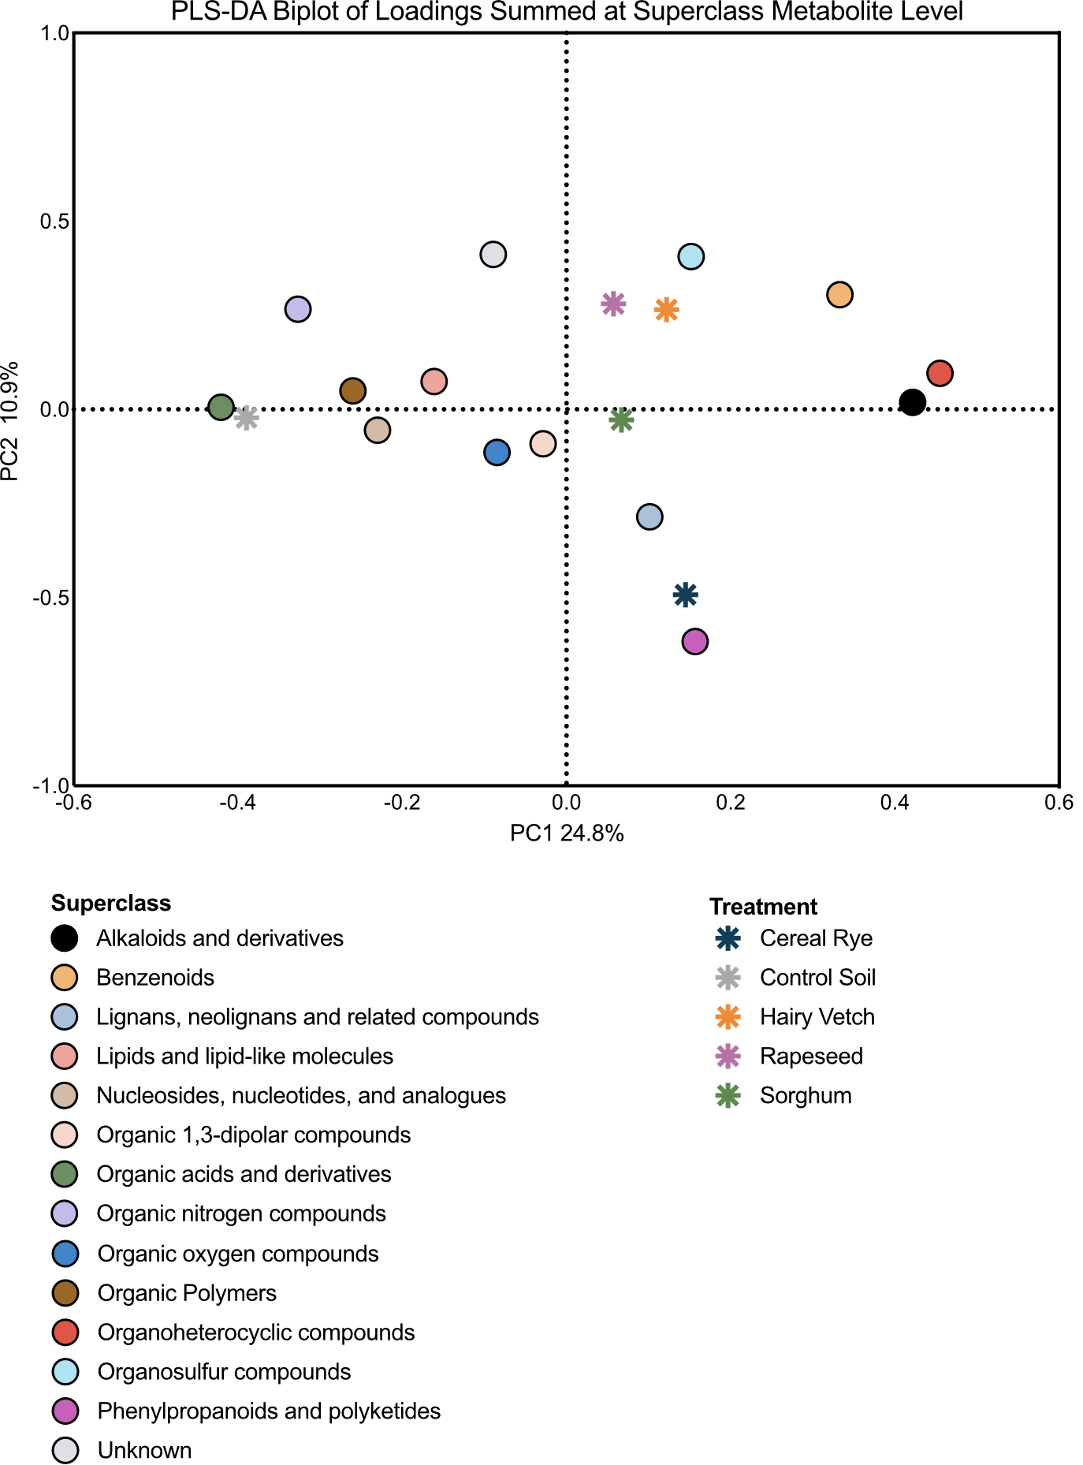

Additional Figure 5. PLS-DA biplot of summed superclasses by treatment.
Two-dimensional loadings biplot of partial least squares discriminate analysis (PLS-DA) (R₂X = 0.109, R₂Y = 0.248) between all treatment metabolomes summed at the superclass metabolite level. Circles represent a metabolite class, colored by superclass. Stars represent treatment.

Additional Table 2. PERMANOVA of superclass-level metabolites by treatment and time.

Permutation test for adonis under reduced model
Terms added sequentially (first to last)
Permutation: free
Number of permutations: 999

adonis2(formula = metabolite_data ~ species * Day, data = treatment, permutations = 999, method = "bray")

 | DF | SumofSqs | R2 | F | P Value
Species | 4 | 0.8091 | 0.20627 | 16.7207 | 0.001 ***
Day | 1 | 0.6547 | 0.16693 | 54.1251 | 0.001 ***
Species:Day | 4 | 0.1722 | 0.04390 | 3.5587 | 0.001 ***
Residual | 189 | 2.2863 | 0.58290
Total | 198 | 3.9223 | 1.00000

Additional Table 3. 2-way ANOVA comparing superclasses between treatments

Cereal Rye v Control
Number of families | 1
Number of comparisons per family | 14
Alpha | 0.05
Šídák's multiple comparisons test | Mean Diff. | 95.00% CI of diff. | Below threshold? | Summary | Adjusted P Value
Alkaloids and derivatives | 0.2607 | 0.1470 to 0.3743 | Yes | **** | <0.0001
Benzenoids | 0.2887 | 0.1751 to 0.4023 | Yes | **** | <0.0001
Lignans, neolignans and related compounds | 0.07905 | -0.03457 to 0.1927 | No | ns | 0.4592
Lipids and lipid-like molecules | -0.1734 | -0.2871 to -0.05983 | Yes | *** | 0.0001
Nucleosides, nucleotides, and analogues | -0.07922 | -0.1928 to 0.03440 | No | ns | 0.4558
Organic 1,3-dipolar compounds | 0.02576 | -0.08786 to 0.1394 | No | ns | >0.9999
Organic acids and derivatives | -0.1253 | -0.2389 to -0.01169 | Yes | * | 0.0188
Organic nitrogen compounds | -0.1726 | -0.2862 to -0.05899 | Yes | *** | 0.0001
Organic oxygen compounds | 0.02215 | -0.09147 to 0.1358 | No | ns | >0.9999
Organic Polymers | -0.06547 | -0.1791 to 0.04815 | No | ns | 0.7472
Organoheterocyclic compounds | 0.2540 | 0.1404 to 0.3676 | Yes | **** | <0.0001
Organosulfur compounds | -0.0001175 | -0.1137 to 0.1135 | No | ns | >0.9999
Phenylpropanoids and polyketides | 0.1916 | 0.07798 to 0.3052 | Yes | **** | <0.0001
unknown | -0.03634 | -0.1500 to 0.07727 | No | ns | 0.9977

Šídák's multiple comparisons test | Mean Diff. | 95.00% CI of diff. | Below threshold? | Summary | Adjusted P Value
Alkaloids and derivatives | -0.2612 | -0.3732 to -0.1492 | Yes | **** | <0.0001
Benzenoids | -0.3245 | -0.4364 to -0.2125 | Yes | **** | <0.0001
Lignans, neolignans and related compounds | -0.003305 | -0.1153 to 0.1087 | No | ns | >0.9999
Lipids and lipid-like molecules | 0.1244 | 0.01241 to 0.2363 | Yes | * | 0.0174
Nucleosides, nucleotides, and analogues | 0.08859 | -0.02338 to 0.2006 | No | ns | 0.2611
Organic 1,3-dipolar compounds | 0.01628 | -0.09569 to 0.1282 | No | ns | >0.9999
Organic acids and derivatives | 0.1121 | 0.0001193 to 0.2241 | Yes | * | 0.0495
Organic nitrogen compounds | 0.07063 | -0.04133 to 0.1826 | No | ns | 0.6180
Organic oxygen compounds | 0.03675 | -0.07522 to 0.1487 | No | ns | 0.9970
Organic Polymers | 0.04119 | -0.07078 to 0.1532 | No | ns | 0.9907
Organoheterocyclic compounds | -0.2891 | -0.4011 to -0.1771 | Yes | **** | <0.0001
Organosulfur compounds | -0.1402 | -0.2522 to -0.02825 | Yes | ** | 0.0039
Phenylpropanoids and polyketides | -0.002694 | -0.1147 to 0.1093 | No | ns | >0.9999
unknown | -0.0008917 | -0.1129 to 0.1111 | No | ns | >0.9999

Control v Hairy Vetch

Control v Rapeseed
Šídák's multiple comparisons test | Mean Diff. | 95.00% CI of diff. | Below threshold? | Summary | Adjusted P Value
Alkaloids and derivatives | -0.2166 | -0.3265 to -0.1067 | Yes | **** | <0.0001
Benzenoids | -0.4665 | -0.5764 to -0.3565 | Yes | **** | <0.0001
Lignans, neolignans and related compounds | 0.02799 | -0.08194 to 0.1379 | No | ns | 0.9998
Lipids and lipid-like molecules | 0.1200 | 0.01010 to 0.2300 | Yes | * | 0.0210
Nucleosides, nucleotides, and analogues | 0.08437 | -0.02556 to 0.1943 | No | ns | 0.3044
Organic 1,3-dipolar compounds | 0.02656 | -0.08336 to 0.1365 | No | ns | 0.9999
Organic acids and derivatives | 0.1034 | -0.006543 to 0.2133 | No | ns | 0.0841
Organic nitrogen compounds | 0.08391 | -0.02602 to 0.1938 | No | ns | 0.3125
Organic oxygen compounds | 0.06329 | -0.04663 to 0.1732 | No | ns | 0.7483
Organic Polymers | 0.06445 | -0.04548 to 0.1744 | No | ns | 0.7247
Organoheterocyclic compounds | -0.1909 | -0.3009 to -0.08101 | Yes | **** | <0.0001
Organosulfur compounds | -0.08142 | -0.1913 to 0.02851 | No | ns | 0.3584
Phenylpropanoids and polyketides | 0.007719 | -0.1022 to 0.1176 | No | ns | >0.9999
unknown | -0.01073 | -0.1207 to 0.09919 | No | ns | >0.9999

Control v Sorghum
Šídák's multiple comparisons test | Predicted (LS) mean diff. | 95.00% CI of diff. | Below threshold? | Summary | Adjusted P Value
Alkaloids and derivatives | -0.3192 | -0.4348 to -0.2036 | Yes | **** | <0.0001
Benzenoids | -0.3144 | -0.4300 to -0.1988 | Yes | **** | <0.0001
Lignans, neolignans and related compounds | -0.1184 | -0.2340 to -0.002844 | Yes | * | 0.0399
Lipids and lipid-like molecules | 0.1200 | 0.01010 to 0.2300 | Yes | * | 0.0220
Nucleosides, nucleotides, and analogues | 0.07224 | -0.04336 to 0.1878 | No | ns | 0.6326
Organic 1,3-dipolar compounds | 0.06967 | -0.04593 to 0.1853 | No | ns | 0.6863
Organic acids and derivatives | 0.1118 | -0.003797 to 0.2274 | No | ns | 0.0669
Organic nitrogen compounds | 0.08805 | -0.02755 to 0.2036 | No | ns | 0.3156
Organic oxygen compounds | 0.08824 | -0.02736 to 0.2038 | No | ns | 0.3124
Organic Polymers | 0.05213 | -0.06347 to 0.1677 | No | ns | 0.9470
Organoheterocyclic compounds | -0.1669 | -0.2825 to -0.05125 | Yes | *** | 0.0004
Organosulfur compounds | -0.05581 | -0.1714 to 0.05979 | No | ns | 0.9129
Phenylpropanoids and polyketides | -0.06951 | -0.1851 to 0.04608 | No | ns | 0.6895
unknown | 0.002009 | -0.1136 to 0.1176 | No | ns | >0.9999

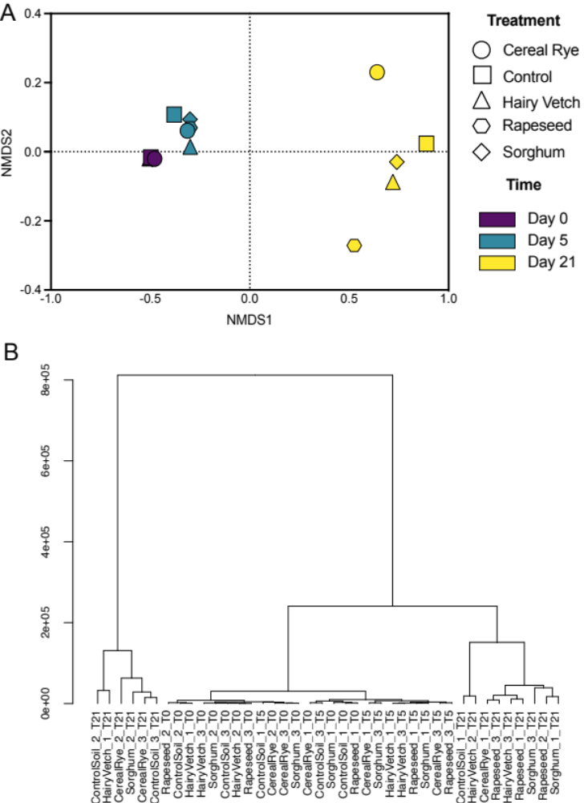

Additional Figure 6. NMDS and HCA of metatranscriptomes at the MAG level. A) Nonmetric multidimensional scaling (NMDS) of Bray-Curtis distances of each averaged treatment (represented as shapes) metatranscriptome showing significant changes in microbial community responses over time, with colors representing time and shape of circles representing treatment (stress = 0.05; mrpp = 0.001). B) Hierarchical clustering of metatranscriptomes. Clustering was achieved using Ward’s Method in R (v4.3.1) using the hclust() with method = "ward.D" and as.dendrogram() functions from the stat package.

Additional Table 4. Multi response permutation procedure of metatranscriptomes by time. Significance of compositional differences across time was quantified using a multi-response permutation procedure (mrpp) and the betadisper commands from the vegan package (v2.6-4) with an ANOVA model in R.

Class means and counts:

 | 0 | 5 | 21
delta | 0.07531 | 0.1064 | 0.3552
n | 15 | 10 | 15

mrpp(dat = bray_dist, grouping = factors$Day)

Dissimilarity index: bray
Weights for groups: n
Chance corrected within-group agreement A: 0.5308
Based on observed delta 0.1866 and expected delta 0.4007

Significance of delta: 0.001
Permutation: free
Number of permutations: 999

Additional Table 5. Multi Response Permutation Procedure (mrpp) of metatranscriptomes by treatment. Significance of compositional differences across treatment was quantified using a multi-response permutation procedure (mrpp) and the betadisper commands from the vegan package (v2.6-4) with an ANOVA model in R.

Class means and counts:

 | Cereal Rye | Control | Hairy Vetch | Rapeseed | Sorghum
delta | 0.4055 | 0.46 | 0.433 | 0.3784 | 0.4408
n | 8 | 8 | 8 | 8 | 8

mrpp(dat = bray_dist, grouping = factors$treatment)

Dissimilarity index: bray
Weights for groups: n

Chance corrected within-group agreement A: - -0.05699
Based on observed delta 0.4306 and expected delta 0.4007
Significance of delta: 0.999
Permutation: free
Number of permutations: 999

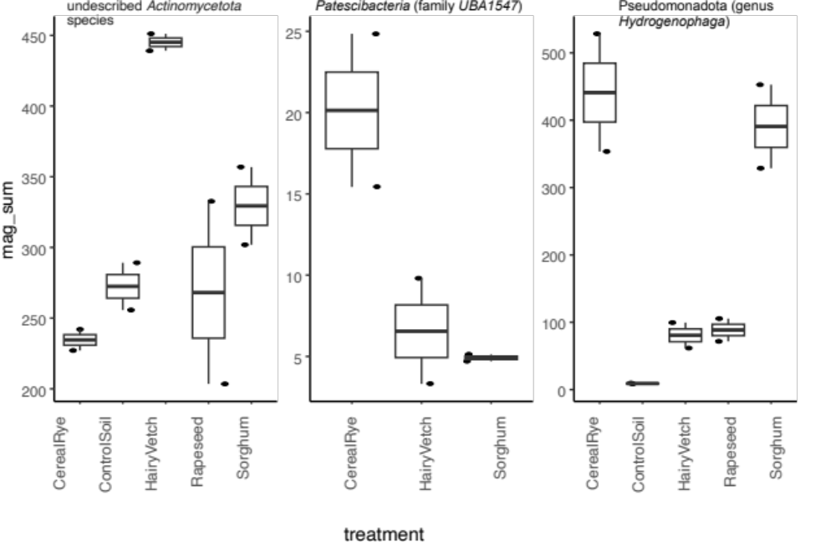

Additional Figure 7. Plots showing metatranscriptome abundance of A) one hairy vetch-discriminant MAG (a MAG of an undescribed species of the Actinomycetota phyla); B) a single MAG from a novel genus in the Patescibacteria (family UBA1547) was enriched in response to cereal rye exudates; and C) a single MAG from an undescribed species in the Pseudomonadota (genus Hydrogenophaga) increased in response to cereal rye and sorghum exudates. Boxplots show median expression and lines show one standard deviation.

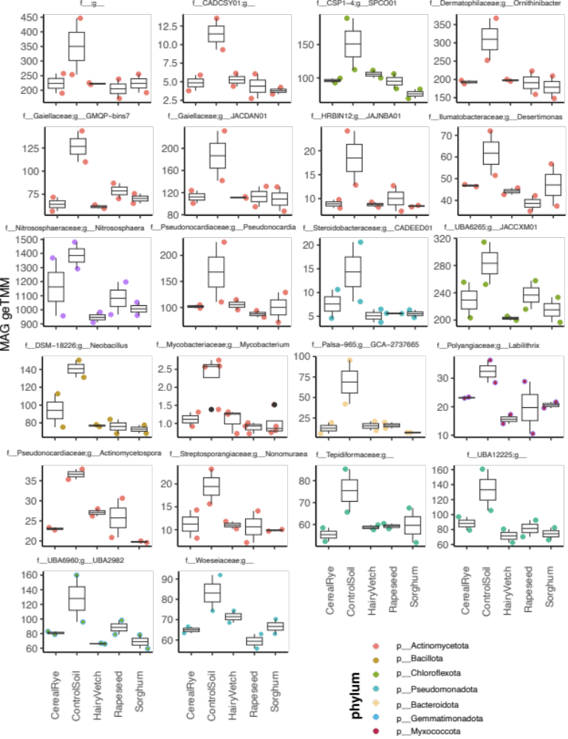

Additional Figure 8. Plots showing metatranscriptome abundance of control-discriminant MAGs. Twenty-three MAGs were discriminant to control metatranscriptomes at day 5 (MaAsLin2, q<0.25). Each point represents MAG expression for single transcriptome and is the sum of the geTMM for the genes expressed by the MAGs. Point colors indicate the taxonomy of the MAG with MAG family and genus annotation as the boxplot header, color corresponds to phylum. Boxplots show median expression and lines show one standard deviation.

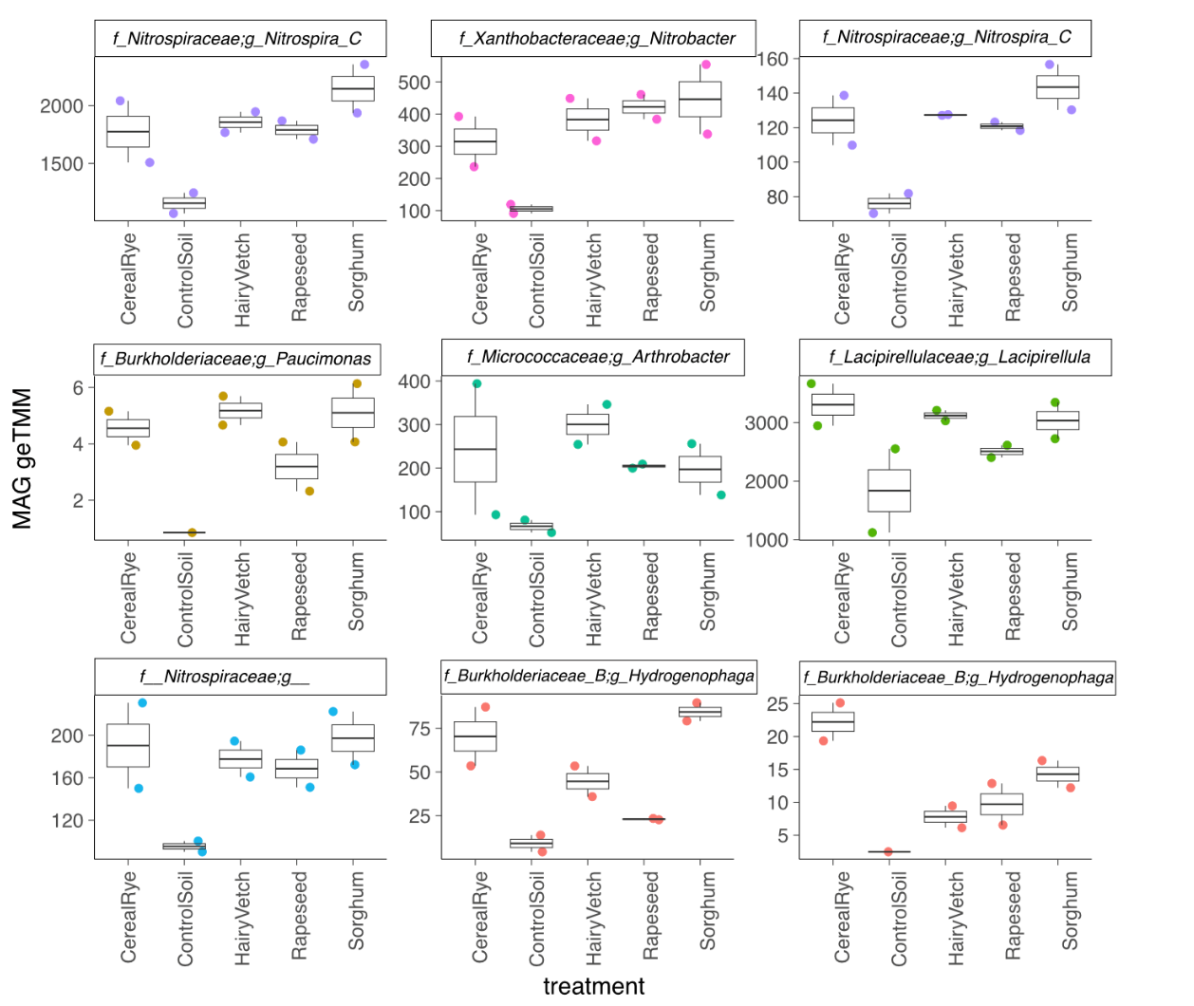

Additional Figure 9. Plots showing metatranscriptome abundance of exudate-discriminant MAGs. Nine MAGs were discriminant to exudate metatranscriptomes at day 5 (MaAsLin2, q<0.25). Each point represents MAG expression for single transcriptome and is the sum of the geTMM for the genes expressed by the MAGs. Point colors indicate the taxonomy of the MAG with MAG family and genus annotation as the boxplot header. Boxplots show median expression and lines show one standard deviation.

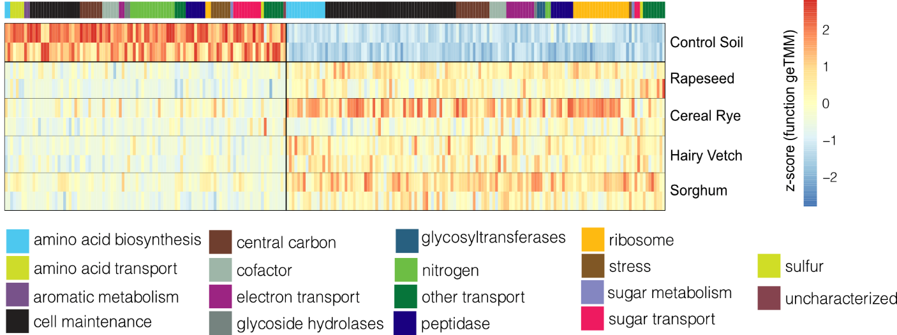

Additional Figure 10. Heatmap of MaAsLin2 identified functions that were significant to control or exudate metatranscriptomes at day 5. Each column represents a function that was significant to either control or exudate metatranscriptomes (MaAsLin2 q<0.25), colored by the z-score transformed metatranscriptome expression. The MaAsLin2 FDR-corrected q value (q<0.25) represents a statistically significant function to either the control or exudate microcosms. The z-score scaling of 2 (colored red) represents high gene expression, while a z-score of -2 (colored blue) indicates low gene expression. The top coloring corresponds to the metabolic category for the function. For data underlying this heatmap, see Table S3 in additional file 8.

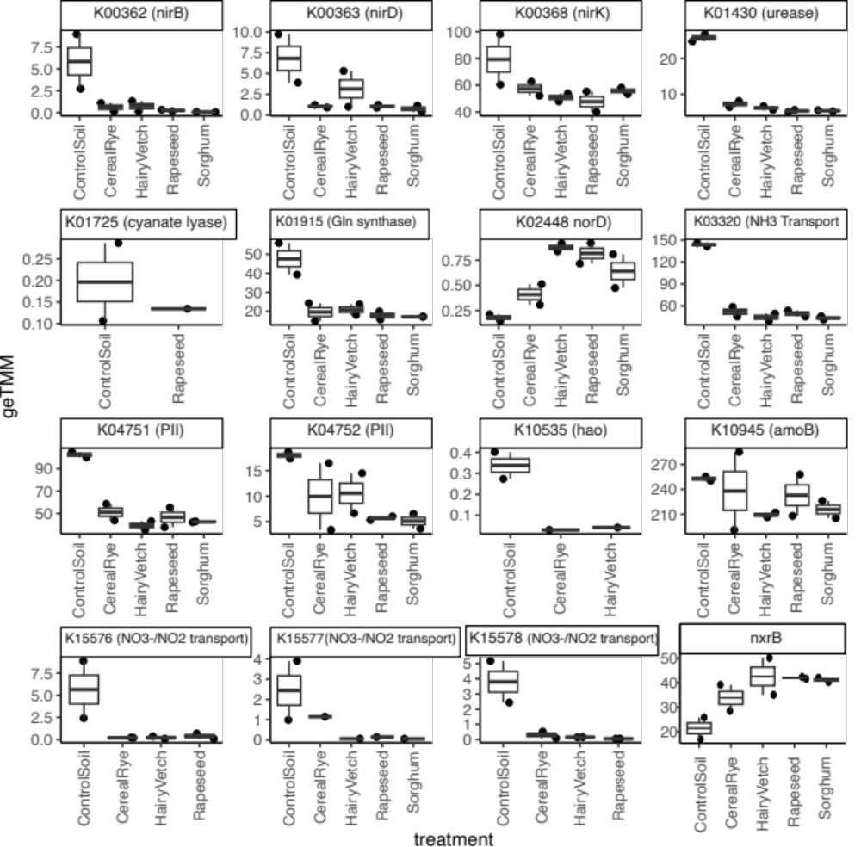

Additional Figure 11. Plots showing metatranscriptome abundance of discriminate nitrogen function. Sixteen nitrogen cycling functions were discriminant to exudate or control metatranscriptomes at day 5 (MaAsLin2, q<0.25). If a treatment metatranscriptome is not shown on plot, then its geTMM value was zero and excluded from the plot.

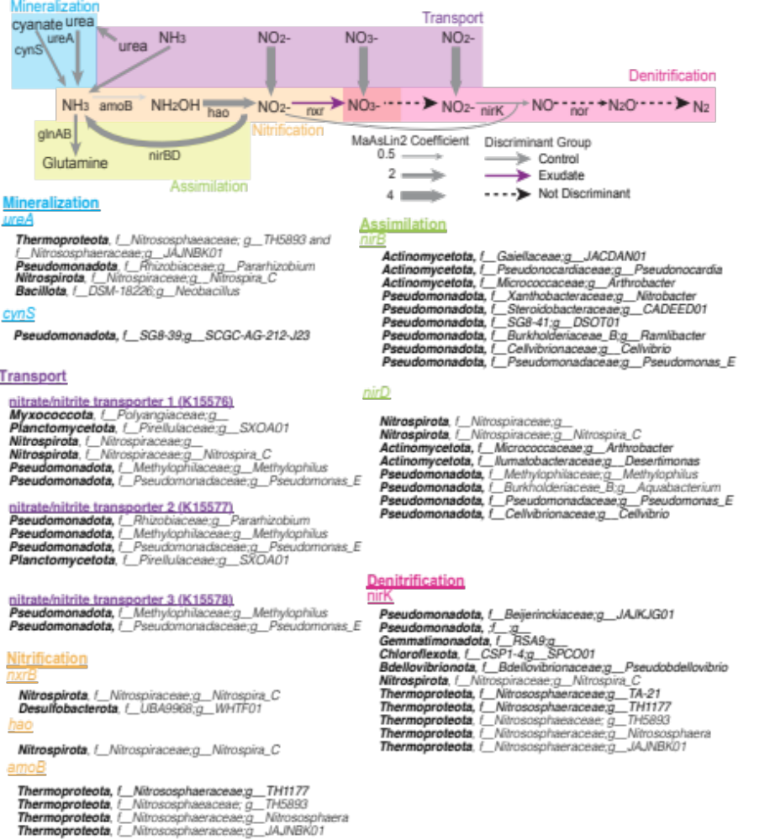

Additional Figure 12: Organisms discriminate to N cycling. An extension of figure 4B, all organisms referenced to be discriminate to a either control or exudate microcosms at day 5 are listed according to N cycling step and gene.

Additional Table 6. 2-way ANOVA and multiple comparisons of IBA

Table Analyzed | IBA
Two-way RM ANOVA | Matching: Stacked
Assume sphericity? | No
Alpha | 0.05
Source of Variation | % of total variation | P value | P value summary | Significant? | Geisser-Greenhouse's epsilon
Day x Treatment | 37.60 | <0.0001 | **** | Yes
Day | 37.60 | <0.0001 | **** | Yes | 0.2816
Treatment | 16.12 | <0.0001 | **** | Yes
Subject | 1.115 | 0.2619 | ns | No
ANOVA table | SS | DF | MS | F (DFn, DFd) | P value
Day x Treatment | 0.03047 | 9 | 0.003385 | F (9, 54) = 29.80 | P<0.0001
Day | 0.03047 | 9 | 0.003385 | F (2.534, 15.20) = 29.80 | P<0.0001
Treatment | 0.01306 | 1 | 0.01306 | F (1, 6) = 86.78 | P<0.0001
Subject | 0.0009032 | 6 | 0.0001505 | F (6, 54) = 1.325 | P=0.2619
Residual | 0.006133 | 54 | 0.0001136

Uncorrected Fisher's LSD | Mean Diff. | 95.00% CI of diff. | Below threshold? | Summary | Individual P Value
Cereal Rye - Control Soil
T0 | 0.000
T1 | 0.000
T2 | 0.000
T3 | 0.000
T4 | 0.000
T5 | 0.000
T7 | 0.01413 | -0.03083 to 0.05908 | No | ns | 0.3910
T10 | 0.04320 | -0.003935 to 0.09034 | No | ns | 0.0617
T15 | 0.09425 | 0.06416 to 0.1243 | Yes | ** | 0.0021
T21 | 0.1040 | 0.07588 to 0.1321 | Yes | ** | 0.0013

Additional Table 7. 2-way ANOVA of GA₄

Two-way RM ANOVA | Matching: Stacked
Assume sphericity? | No
Alpha | 0.05
Source of Variation | % of total variation | P value | P value summary | Significant? | Geisser-Greenhouse's epsilon
Day x trt | 18.18 | <0.0001 | **** | Yes
Day | 18.29 | 0.0010 | ** | Yes | 0.1893
trt | 55.76 | <0.0001 | **** | Yes
Subject | 0.7632 | 0.4479 | ns | No
ANOVA table | SS | DF | MS | F (DFn, DFd) | P value
Day x trt | 22.00 | 9 | 2.444 | F (9, 54) = 15.56 | P<0.0001
Day | 22.13 | 9 | 2.459 | F (1.703, 10.22) = 15.66 | P=0.0010
trt | 67.47 | 1 | 67.47 | F (1, 6) = 438.4 | P<0.0001
Subject | 0.9234 | 6 | 0.1539 | F (6, 54) = 0.9800 | P=0.4479
Residual | 8.481 | 54 | 0.1571

Šídák's multiple comparisons test | Mean Diff. | 95.00% CI of diff. | Below threshold? | Summary | Adjusted P Value
Cereal Rye - Control Soil
Row 1 | 0.000
Row 2 | 0.3920 | 0.1342 to 0.6498 | Yes | * | 0.0150
Row 3 | 1.995 | -3.043 to 7.033 | No | ns | 0.4678
Row 4 | 3.410 | 0.9059 to 5.913 | Yes | * | 0.0207
Row 5 | 0.9405 | 0.2963 to 1.585 | Yes | * | 0.0169
Row 6 | 2.680 | 0.8082 to 4.551 | Yes | * | 0.0179
Row 7 | 1.530 | 0.5081 to 2.551 | Yes | * | 0.0157
Row 8 | 2.137 | 1.114 to 3.160 | Yes | ** | 0.0059
Row 9 | 2.495 | 1.297 to 3.693 | Yes | ** | 0.0054
Row 10 | 2.790 | 0.9085 to 4.670 | Yes | * | 0.0161

Additional Table 8. 2-way ANOVA and multiple comparisons of Benzoic Acid

Mixed-effects model (REML) | Matching: Stacked
Assume sphericity? | No
Alpha | 0.05
Fixed effects (type III) | P value | P value summary | Statistically significant (P < 0.05)? | F (DFn, DFd) | Geisser-Greenhouse's epsilon
Day | 0.0105 | * | Yes | F (4.488, 74.30) = 3.386 | 0.4987
Treatment | <0.0001 | **** | Yes | F (4, 149) = 31.95
Day x Treatment | 0.0001 | *** | Yes | F (36, 149) = 2.425
Random effects | SD | Variance
Subject | 0.000 | 0.000
Residual | 28.11 | 790.1

Dunnett's multiple comparisons test | Mean Diff. | 95.00% CI of diff. | Below threshold? | Summary | Adjusted P Value
0
CS vs. CR | -0.02500 | -69.16 to 69.11 | No | ns | >0.9999
CS vs. HV | 6.000 | -63.10 to 75.10 | No | ns | 0.9907
CS vs. RS | 3.700 | -67.09 to 74.49 | No | ns | 0.9991
CS vs. S | 4.025 | -70.24 to 78.29 | No | ns | 0.9991
1
CS vs. CR | 17.68 | -50.42 to 85.77 | No | ns | 0.7595
CS vs. HV | 27.80 | -40.50 to 96.10 | No | ns | 0.4994
CS vs. RS | 25.30 | -57.55 to 108.2 | No | ns | 0.7225
CS vs. S | 28.13 | -41.25 to 97.50 | No | ns | 0.5165
2
CS vs. CR | -23.19 | -77.92 to 31.55 | No | ns | 0.4973
CS vs. HV | -13.91 | -69.24 to 41.41 | No | ns | 0.8244
CS vs. RS | 3.738 | -49.56 to 57.03 | No | ns | 0.9974
CS vs. S | 3.063 | -48.20 to 54.33 | No | ns | 0.9981
3
CS vs. CR | 15.29 | -50.46 to 81.03 | No | ns | 0.8573
CS vs. HV | 26.78 | -29.40 to 82.95 | No | ns | 0.3424
CS vs. RS | 8.650 | -53.27 to 70.57 | No | ns | 0.9701
CS vs. S | 20.18 | -36.42 to 76.77 | No | ns | 0.5272
4
CS vs. CR | 65.03 | -11.98 to 142.0 | No | ns | 0.0866
CS vs. HV | 67.33 | -14.60 to 149.2 | No | ns | 0.0858
CS vs. RS | 65.25 | -14.64 to 145.1 | No | ns | 0.1032
CS vs. S | 85.06 | 8.211 to 161.9 | Yes | * | 0.0346
5
CS vs. CR | 43.50 | -27.10 to 114.1 | No | ns | 0.1808
CS vs. HV | 69.65 | -2.558 to 141.9 | No | ns | 0.0553
CS vs. RS | 55.78 | -15.14 to 126.7 | No | ns | 0.0977
CS vs. S | 57.93 | -9.463 to 125.3 | No | ns | 0.0824
7
CS vs. CR | 59.45 | -26.28 to 145.2 | No | ns | 0.1263
CS vs. HV | 67.27 | -12.43 to 147.0 | No | ns | 0.0837
CS vs. RS | 83.08 | -0.9039 to 167.1 | No | ns | 0.0515
CS vs. S | 62.48 | -15.55 to 140.5 | No | ns | 0.1015
10
CS vs. CR | 114.3 | 32.41 to 196.2 | Yes | * | 0.0154
CS vs. HV | 79.90 | -5.805 to 165.6 | No | ns | 0.0652
CS vs. RS | 99.05 | 16.29 to 181.8 | Yes | * | 0.0277
CS vs. S | 101.2 | 18.50 to 183.9 | Yes | * | 0.0256
15
CS vs. CR | 131.6 | 14.67 to 248.6 | Yes | * | 0.0354
CS vs. HV | 105.6 | -5.571 to 216.8 | No | ns | 0.0590
CS vs. RS | 117.3 | 6.883 to 227.7 | Yes | * | 0.0400
CS vs. S | 130.1 | 20.02 to 240.2 | Yes | * | 0.0272
21
CS vs. CR | 112.8 | -90.89 to 316.5 | No | ns | 0.2140
CS vs. HV | 105.1 | -92.68 to 302.8 | No | ns | 0.2478
CS vs. RS | 107.6 | -85.97 to 301.2 | No | ns | 0.2371
CS vs. S | 99.90 | -100.7 to 300.5 | No | ns | 0.2736

Additional Table 9. 2-way ANOVA and multiple comparisons of ACC

ANOVA summary
F | 19.62
P value | <0.0001
P value summary | ****
Significant diff. among means (P < 0.05)? | Yes
R squared | 0.2880
Brown-Forsythe test
F (DFn, DFd) | 24.56 (4, 194)
P value | <0.0001
P value summary | ****
Are SDs significantly different (P < 0.05)? | Yes
Bartlett's test
Bartlett's statistic (corrected) | 171.2
P value | <0.0001
P value summary | ****
Are SDs significantly different (P < 0.05)? | Yes

ANOVA table | SS | DF | MS | F (DFn, DFd) | P value
Treatment (between columns) | 2464872 | 4 | 616218 | F (4, 194) = 19.62 | P<0.0001
Residual (within columns) | 6093513 | 194 | 31410
Total | 8558385 | 198

Dunnett's multiple comparisons test | Mean Diff. | 95.00% CI of diff. | Below threshold? | Summary | Adjusted P Value
Control vs. Cereal | -271.8 | -369.4 to -174.2 | Yes | **** | <0.0001
Control vs. Hairy Vetch | -189.1 | -287.3 to -90.88 | Yes | **** | <0.0001
Control vs. Rapeseed | -297.8 | -395.4 to -200.2 | Yes | **** | <0.0001
Control vs. Sorghum | -284.7 | -382.2 to -187.1 | Yes | **** | <0.0001

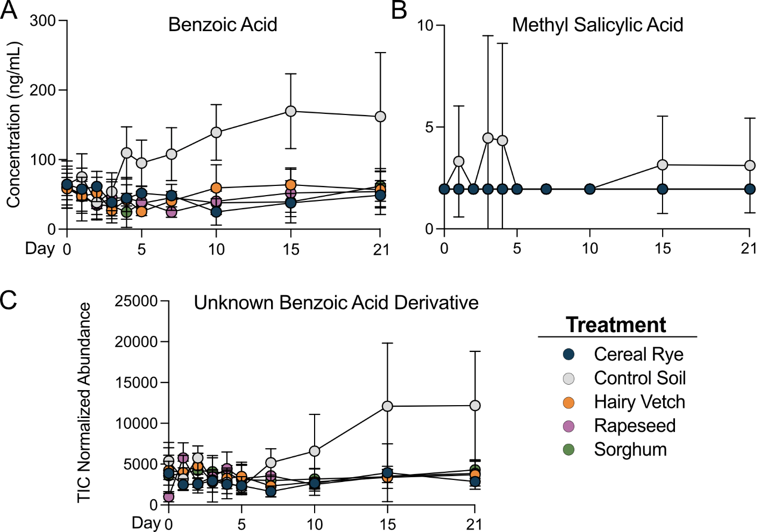

Additional Figure 13. Control microcosms increased production of two phenolic compounds.
A-B) Line graphs show concentration of benzoic acid (BA) and methyl-Salicylic Acid (mSA) in all treatments highlighting phenolic acid production in control microcosms. C) Line plot represents TIC normalized abundances of an unknown BA derivative. Coloring corresponds to treatment, circles represent the mean, error bars represent standard deviation.

Additional Table 10. 2-way ANOVA of IAA

Two-way RM ANOVA | Matching: Stacked
Assume sphericity? | No
Alpha | 0.05
Source of Variation | % of total variation | P value | P value summary | Significant? | Geisser-Greenhouse's epsilon
Day | 4.004 | 0.5113 | ns | No | 0.5889
Treatment | 1.302 | 0.6017 | ns | No
Subject | 6.939 | 0.5637 | ns | No
ANOVA table | SS | DF | MS | F (DFn, DFd) | P value
Day | 0.3087 | 9 | 0.03430 | F (5.300, 100.7) = 0.8669 | P=0.5113
Treatment | 0.1004 | 4 | 0.02509 | F (4, 15) = 0.7034 | P=0.6017
Subject | 0.5350 | 15 | 0.03567 | F (15, 171) = 0.9014 | P=0.5637
Residual | 6.766 | 171 | 0.03957

Additional Table 11. Annotation of unknown indoles, gibberellins, and a benzoic acid.
5 unknown, but related phytohormones identified at level 3 annotation using ClassyFire (see Methods). Indole-3-acetic acid (IAA), gibberellic acid 4 (GA) and benzoic acid (BA). Abbreviations: phytohormone (PH).

PH | Cluster |  | InChikey | Kingdom |  |  | Superclass | Class | Subclass | Parent Class 1 | Parent Class 2
IAA | C013 |  | DRLFMBDRBRZALE-UHFFFAOYSA-N | Organic compounds |  |  | Organoheterocyclic compounds | Indoles and derivatives | Indoles | 3-alkylindole | N/A
IAA | C01053 |  | SEOVTRFCIGRIMH-UHFFFAOYSA-N | Organic compounds |  |  | Organoheterocyclic compounds | Indoles and derivatives | Indolyl carboxylic acids and derivatives | Indole-3-acetic acid derivative | N/A
GA | C068 |  | UKMHZZVLPQAOX-UHFFFAOYNA-N | Organic compounds |  |  | Lipids and lipid-like molecules | Prenol lipids | Diterpenoids | gibberellins | c20-gibberellins
GA | C043 |  | RSQSQJNRHICNNH-FVAGACCNNA-N | Organic compounds |  |  | Lipids and lipid-like molecules | Prenol lipids | Diterpenoids | gibberellins | c19-gibberellins
BA | C273 |  | SYLLWWIXOMLOPY-UHFFFAOYSA-N | Organic compounds |  |  | Benzenoids | Benzene and substituted derivatives | Benzoic acids and derivatives | Benzoic acids and derivatives | N/A

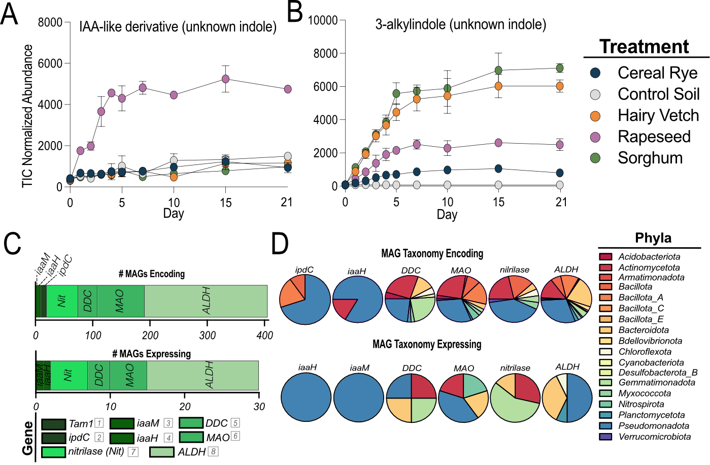

Additional Figure 14. Production of IAA-like compounds in soil microcosms and the distribution of indole biosynthetic capacity from diverse lineages.
A-B) Line plots represent TIC normalized abundances of two unknown IAA-like compounds, an unknown IAA-like derivative and an unknown indole, respectively, annotated at a level 3 annotation. Color corresponds to treatment, circles represent the mean, error bar represent standard deviation. C) Summed abundance of all MAGs across all treatments either encoding an IAA-production gene (top) or expressing the gene (bottom). Colors correspond to IAA pathway and number corresponds to enzyme ID from the main text figure 7. D) Pie charts show the distribution of each IAA-production gene summed at the phylum level for MAGs encoding (top) or expressing (bottom) the gene. Color corresponds to phyla assignment.

Additional Table 12. 2-way ANOVA and multiple comparisons of Indole-3-acetic acid derivative (C01053)

Mixed-effects model (REML) | Matching: Stacked
Assume sphericity? | No
Alpha | 0.05
Fixed effects (type III) | P value | P value summary | Statistically significant (P < 0.05)? | F (DFn, DFd) | Geisser-Greenhouse's epsilon
Day | <0.0001 | **** | Yes | F (5.067, 75.44) = 938.0 | 0.5630
Treatment | <0.0001 | **** | Yes | F (4, 15) = 2009
Day x Treatment | <0.0001 | **** | Yes | F (36, 134) = 73.66
Random effects | SD | Variance
Subject | 0.02176 | 0.0004734
Residual | 0.05896 | 0.003476

Tukey's multiple comparisons test | Mean Diff. | 95.00% CI of diff. | Below threshold? | Summary | Adjusted P Value
Row 1
Cereal Rye vs. Control Soil | 0.006625 | -0.3202 to 0.3335 | No | ns | >0.9999
Cereal Rye vs. Hairy Vetch | 0.1033 | -0.3703 to 0.5770 | No | ns | 0.8432
Cereal Rye vs. Rapeseed | 0.1140 | -0.06170 to 0.2897 | No | ns | 0.2235
Cereal Rye vs. Sorghum | 0.02369 | -0.2683 to 0.3156 | No | ns | 0.9964
Control Soil vs. Hairy Vetch | 0.09671 | -0.3664 to 0.5598 | No | ns | 0.9169
Control Soil vs. Rapeseed | 0.1074 | -0.2227 to 0.4374 | No | ns | 0.6479
Control Soil vs. Sorghum | 0.01707 | -0.3323 to 0.3665 | No | ns | 0.9997
Hairy Vetch vs. Rapeseed | 0.01064 | -0.4692 to 0.4904 | No | ns | >0.9999
Hairy Vetch vs. Sorghum | -0.07965 | -0.5379 to 0.3786 | No | ns | 0.9500
Rapeseed vs. Sorghum | -0.09029 | -0.3838 to 0.2033 | No | ns | 0.7028
Row 2
Cereal Rye vs. Control Soil | 0.1094 | -0.1831 to 0.4018 | No | ns | 0.5536
Cereal Rye vs. Hairy Vetch | 0.1013 | -0.2536 to 0.4562 | No | ns | 0.7123
Cereal Rye vs. Rapeseed | -0.4197 | -0.5635 to -0.2759 | Yes | *** | 0.0002
Cereal Rye vs. Sorghum | 0.1413 | 0.005627 to 0.2770 | Yes | * | 0.0426
Control Soil vs. Hairy Vetch | -0.008040 | -0.3703 to 0.3542 | No | ns | >0.9999
Control Soil vs. Rapeseed | -0.5290 | -0.8244 to -0.2337 | Yes | ** | 0.0063
Control Soil vs. Sorghum | 0.03196 | -0.2704 to 0.3343 | No | ns | 0.9833
Hairy Vetch vs. Rapeseed | -0.5210 | -0.8798 to -0.1621 | Yes | * | 0.0147
Hairy Vetch vs. Sorghum | 0.04000 | -0.3269 to 0.4069 | No | ns | 0.9789
Rapeseed vs. Sorghum | 0.5610 | 0.4366 to 0.6854 | Yes | **** | <0.0001
Row 3
Cereal Rye vs. Control Soil | 0.1634 | -0.3269 to 0.6537 | No | ns | 0.6421
Cereal Rye vs. Hairy Vetch | 0.08323 | -0.4422 to 0.6087 | No | ns | 0.9202
Cereal Rye vs. Rapeseed | -0.5119 | -1.009 to -0.01520 | Yes | * | 0.0453
Cereal Rye vs. Sorghum | 0.08917 | -0.3971 to 0.5754 | No | ns | 0.9336
Control Soil vs. Hairy Vetch | -0.08021 | -0.3145 to 0.1541 | No | ns | 0.6214
Control Soil vs. Rapeseed | -0.6754 | -0.9213 to -0.4294 | Yes | *** | 0.0003
Control Soil vs. Sorghum | -0.07426 | -0.3630 to 0.2144 | No | ns | 0.8578
Hairy Vetch vs. Rapeseed | -0.5951 | -0.7960 to -0.3943 | Yes | *** | 0.0005
Hairy Vetch vs. Sorghum | 0.005942 | -0.2753 to 0.2871 | No | ns | >0.9999
Rapeseed vs. Sorghum | 0.6011 | 0.3221 to 0.8801 | Yes | ** | 0.0015
Row 4
Cereal Rye vs. Control Soil | -0.001057 | -0.2641 to 0.2620 | No | ns | >0.9999
Cereal Rye vs. Hairy Vetch | 0.02556 | -0.4330 to 0.4841 | No | ns | 0.9991
Cereal Rye vs. Rapeseed | -0.7544 | -1.132 to -0.3771 | Yes | ** | 0.0024
Cereal Rye vs. Sorghum | 0.01688 | -0.3138 to 0.3476 | No | ns | 0.9996
Control Soil vs. Hairy Vetch | 0.02662 | -0.4801 to 0.5333 | No | ns | 0.9981
Control Soil vs. Rapeseed | -0.7534 | -1.166 to -0.3406 | Yes | ** | 0.0085
Control Soil vs. Sorghum | 0.01793 | -0.3337 to 0.3696 | No | ns | 0.9985
Hairy Vetch vs. Rapeseed | -0.7800 | -1.258 to -0.3024 | Yes | ** | 0.0053
Hairy Vetch vs. Sorghum | -0.008687 | -0.4718 to 0.4544 | No | ns | >0.9999
Rapeseed vs. Sorghum | 0.7713 | 0.3739 to 1.169 | Yes | ** | 0.0021
Row 5
Cereal Rye vs. Control Soil | 0.1406 | -0.8272 to 1.108 | No | ns | 0.9450
Cereal Rye vs. Hairy Vetch | 0.09772 | -0.2553 to 0.4508 | No | ns | 0.8159
Cereal Rye vs. Rapeseed | -0.7990 | -1.080 to -0.5185 | Yes | ** | 0.0021
Cereal Rye vs. Sorghum | 0.1071 | -0.1983 to 0.4126 | No | ns | 0.6910
Control Soil vs. Hairy Vetch | -0.04288 | -0.9819 to 0.8961 | No | ns | 0.9994
Control Soil vs. Rapeseed | -0.9396 | -1.964 to 0.08424 | No | ns | 0.0628
Control Soil vs. Sorghum | -0.03348 | -0.9917 to 0.9248 | No | ns | 0.9997
Hairy Vetch vs. Rapeseed | -0.8968 | -1.281 to -0.5122 | Yes | ** | 0.0042
Hairy Vetch vs. Sorghum | 0.009407 | -0.3520 to 0.3708 | No | ns | >0.9999
Rapeseed vs. Sorghum | 0.9062 | 0.5931 to 1.219 | Yes | ** | 0.0021
Row 6
Cereal Rye vs. Control Soil | -0.008991 | -1.024 to 1.006 | No | ns | >0.9999
Cereal Rye vs. Hairy Vetch | 0.05377 | -0.5087 to 0.6163 | No | ns | 0.9942
Cereal Rye vs. Rapeseed | -0.7786 | -1.157 to -0.4001 | Yes | ** | 0.0017
Cereal Rye vs. Sorghum | -0.03660 | -0.4647 to 0.3915 | No | ns | 0.9970
Control Soil vs. Hairy Vetch | 0.06276 | -0.9202 to 1.046 | No | ns | 0.9986
Control Soil vs. Rapeseed | -0.7696 | -1.808 to 0.2683 | No | ns | 0.1173
Control Soil vs. Sorghum | -0.02760 | -1.035 to 0.9797 | No | ns | >0.9999
Hairy Vetch vs. Rapeseed | -0.8324 | -1.394 to -0.2704 | Yes | * | 0.0113
Hairy Vetch vs. Sorghum | -0.09037 | -0.6570 to 0.4762 | No | ns | 0.9654
Rapeseed vs. Sorghum | 0.7420 | 0.3408 to 1.143 | Yes | ** | 0.0031
Row 7
Cereal Rye vs. Control Soil | 0.1029 | -0.3675 to 0.5734 | No | ns | 0.7754
Cereal Rye vs. Hairy Vetch | 0.01280 | -0.5473 to 0.5729 | No | ns | 0.9996
Cereal Rye vs. Rapeseed | -0.7957 | -0.9374 to -0.6540 | Yes | *** | 0.0003
Cereal Rye vs. Sorghum | 0.1965 | -0.04911 to 0.4421 | No | ns | 0.0897
Control Soil vs. Hairy Vetch | -0.09012 | -0.5514 to 0.3712 | No | ns | 0.9250
Control Soil vs. Rapeseed | -0.8986 | -1.339 to -0.4578 | Yes | ** | 0.0049
Control Soil vs. Sorghum | 0.09356 | -0.3259 to 0.5131 | No | ns | 0.8722
Hairy Vetch vs. Rapeseed | -0.8085 | -1.278 to -0.3392 | Yes | * | 0.0133
Hairy Vetch vs. Sorghum | 0.1837 | -0.2271 to 0.5945 | No | ns | 0.3714
Rapeseed vs. Sorghum | 0.9922 | 0.7731 to 1.211 | Yes | **** | <0.0001
Row 8
Cereal Rye vs. Control Soil | -0.07291 | -0.7447 to 0.5989 | No | ns | 0.9749
Cereal Rye vs. Hairy Vetch | 0.3077 | 0.1303 to 0.4851 | Yes | ** | 0.0049
Cereal Rye vs. Rapeseed | -0.6664 | -0.7814 to -0.5513 | Yes | **** | <0.0001
Cereal Rye vs. Sorghum | 0.1792 | -0.07331 to 0.4317 | No | ns | 0.1444
Control Soil vs. Hairy Vetch | 0.3806 | -0.2696 to 1.031 | No | ns | 0.2102
Control Soil vs. Rapeseed | -0.5934 | -1.273 to 0.08578 | No | ns | 0.0721
Control Soil vs. Sorghum | 0.2521 | -0.3762 to 0.8803 | No | ns | 0.4807
Hairy Vetch vs. Rapeseed | -0.9741 | -1.152 to -0.7958 | Yes | **** | <0.0001
Hairy Vetch vs. Sorghum | -0.1285 | -0.3809 to 0.1238 | No | ns | 0.3805
Rapeseed vs. Sorghum | 0.8455 | 0.5863 to 1.105 | Yes | *** | 0.0008
Row 9
Cereal Rye vs. Control Soil | -0.03243 | -0.5073 to 0.4425 | No | ns | 0.9987
Cereal Rye vs. Hairy Vetch | 0.05020 | -0.4780 to 0.5784 | No | ns | 0.9951
Cereal Rye vs. Rapeseed | -0.6440 | -1.037 to -0.2514 | Yes | ** | 0.0060
Cereal Rye vs. Sorghum | 0.1759 | -0.2188 to 0.5706 | No | ns | 0.4222
Control Soil vs. Hairy Vetch | 0.08263 | -0.4644 to 0.6297 | No | ns | 0.9748
Control Soil vs. Rapeseed | -0.6116 | -1.058 to -0.1653 | Yes | * | 0.0145
Control Soil vs. Sorghum | 0.2083 | -0.2486 to 0.6652 | No | ns | 0.3875
Hairy Vetch vs. Rapeseed | -0.6942 | -1.213 to -0.1757 | Yes | * | 0.0170
Hairy Vetch vs. Sorghum | 0.1257 | -0.4107 to 0.6621 | No | ns | 0.8084
Rapeseed vs. Sorghum | 0.8199 | 0.5565 to 1.083 | Yes | *** | 0.0002
Row 10
Cereal Rye vs. Control Soil | -0.2556 | -0.9422 to 0.4310 | No | ns | 0.5011
Cereal Rye vs. Hairy Vetch | -0.1309 | -0.7841 to 0.5222 | No | ns | 0.9176
Cereal Rye vs. Rapeseed | -0.7643 | -1.497 to -0.03177 | Yes | * | 0.0446
Cereal Rye vs. Sorghum | -0.06947 | -0.7398 to 0.6008 | No | ns | 0.9867
Control Soil vs. Hairy Vetch | 0.1246 | -0.2740 to 0.5233 | No | ns | 0.6965
Control Soil vs. Rapeseed | -0.5087 | -0.7297 to -0.2876 | Yes | ** | 0.0040
Control Soil vs. Sorghum | 0.1861 | -0.07877 to 0.4510 | No | ns | 0.1742
Hairy Vetch vs. Rapeseed | -0.6333 | -1.076 to -0.1903 | Yes | * | 0.0183
Hairy Vetch vs. Sorghum | 0.06148 | -0.3368 to 0.4598 | No | ns | 0.9669
Rapeseed vs. Sorghum | 0.6948 | 0.4120 to 0.9776 | Yes | ** | 0.0035

Additional Table 13. 2-way ANOVA and multiple comparisons of 3-alkylindole (C013)

Mixed-effects model (REML) | Matching: Stacked
Assume sphericity? | No
Alpha | 0.05
Fixed effects (type III) | P value | P value summary | Statistically significant (P < 0.05)? | F (DFn, DFd)
Day | <0.0001 | **** | Yes | F (5.067, 75.44) = 938.0
Treatment | <0.0001 | **** | Yes | F (4, 15) = 2009
Day x Treatment | <0.0001 | **** | Yes | F (36, 134) = 73.66
Random effects | SD | Variance
Subject | 0.02176 | 0.0004734
Residual | 0.05896 | 0.003476

Tukey's multiple comparisons test | Mean Diff. | 95.00% CI of diff. | Below threshold? | Summary | Adjusted P Value
Row 1
Cereal Rye vs. Control Soil | 0.01870 | -0.1638 to 0.2012 | No | ns | 0.9807
Cereal Rye vs. Hairy Vetch | -0.02432 | -0.1023 to 0.05361 | No | ns | 0.6846
Cereal Rye vs. Rapeseed | -0.01011 | -0.1257 to 0.1055 | No | ns | 0.9916
Cereal Rye vs. Sorghum | -0.04053 | -0.1280 to 0.04698 | No | ns | 0.3822
Control Soil vs. Hairy Vetch | -0.04302 | -0.2134 to 0.1274 | No | ns | 0.8037
Control Soil vs. Rapeseed | -0.02881 | -0.1979 to 0.1403 | No | ns | 0.9544
Control Soil vs. Sorghum | -0.05922 | -0.2283 to 0.1099 | No | ns | 0.6182
Hairy Vetch vs. Rapeseed | 0.01421 | -0.09747 to 0.1259 | No | ns | 0.9844
Hairy Vetch vs. Sorghum | -0.01620 | -0.1085 to 0.07607 | No | ns | 0.9580
Rapeseed vs. Sorghum | -0.03042 | -0.1442 to 0.08332 | No | ns | 0.8362
Row 2
Cereal Rye vs. Control Soil | 0.3392 | 0.1932 to 0.4853 | Yes | *** | 0.0008
Cereal Rye vs. Hairy Vetch | -0.6756 | -0.8337 to -0.5174 | Yes | **** | <0.0001
Cereal Rye vs. Rapeseed | -0.3516 | -0.6426 to -0.06052 | Yes | * | 0.0258
Cereal Rye vs. Sorghum | -0.7787 | -0.9695 to -0.5879 | Yes | **** | <0.0001
Control Soil vs. Hairy Vetch | -1.015 | -1.171 to -0.8591 | Yes | **** | <0.0001
Control Soil vs. Rapeseed | -0.6908 | -0.9830 to -0.3986 | Yes | ** | 0.0020
Control Soil vs. Sorghum | -1.118 | -1.308 to -0.9281 | Yes | **** | <0.0001
Hairy Vetch vs. Rapeseed | 0.3240 | 0.03512 to 0.6129 | Yes | * | 0.0331
Hairy Vetch vs. Sorghum | -0.1031 | -0.2975 to 0.09117 | No | ns | 0.3579
Rapeseed vs. Sorghum | -0.4271 | -0.7161 to -0.1382 | Yes | ** | 0.0098
Row 3
Cereal Rye vs. Control Soil | 0.5685 | 0.3578 to 0.7791 | Yes | *** | 0.0009
Cereal Rye vs. Hairy Vetch | -0.7836 | -0.9948 to -0.5724 | Yes | *** | 0.0001
Cereal Rye vs. Rapeseed | -0.4305 | -0.6405 to -0.2205 | Yes | ** | 0.0027
Cereal Rye vs. Sorghum | -0.8157 | -1.026 to -0.6051 | Yes | *** | 0.0002
Control Soil vs. Hairy Vetch | -1.352 | -1.497 to -1.208 | Yes | **** | <0.0001
Control Soil vs. Rapeseed | -0.9990 | -1.127 to -0.8713 | Yes | **** | <0.0001
Control Soil vs. Sorghum | -1.384 | -1.506 to -1.262 | Yes | **** | <0.0001
Hairy Vetch vs. Rapeseed | 0.3531 | 0.2055 to 0.5007 | Yes | *** | 0.0007
Hairy Vetch vs. Sorghum | -0.03208 | -0.1767 to 0.1126 | No | ns | 0.9049
Rapeseed vs. Sorghum | -0.3852 | -0.5132 to -0.2572 | Yes | *** | 0.0002
Row 4
Cereal Rye vs. Control Soil | 0.8605 | 0.6640 to 1.057 | Yes | **** | <0.0001
Cereal Rye vs. Hairy Vetch | -0.7728 | -0.9142 to -0.6314 | Yes | **** | <0.0001
Cereal Rye vs. Rapeseed | -0.4172 | -0.7552 to -0.07921 | Yes | * | 0.0250
Cereal Rye vs. Sorghum | -0.7859 | -0.9111 to -0.6607 | Yes | **** | <0.0001
Control Soil vs. Hairy Vetch | -1.633 | -1.830 to -1.437 | Yes | **** | <0.0001
Control Soil vs. Rapeseed | -1.278 | -1.606 to -0.9496 | Yes | *** | 0.0001
Control Soil vs. Sorghum | -1.646 | -1.847 to -1.446 | Yes | **** | <0.0001
Hairy Vetch vs. Rapeseed | 0.3556 | 0.01800 to 0.6931 | Yes | * | 0.0423
Hairy Vetch vs. Sorghum | -0.01312 | -0.1398 to 0.1136 | No | ns | 0.9921
Rapeseed vs. Sorghum | -0.3687 | -0.7209 to -0.01648 | Yes | * | 0.0437
Row 5
Cereal Rye vs. Control Soil | 0.9461 | 0.8050 to 1.087 | Yes | **** | <0.0001
Cereal Rye vs. Hairy Vetch | -0.7430 | -0.9138 to -0.5721 | Yes | **** | <0.0001
Cereal Rye vs. Rapeseed | -0.4548 | -0.6596 to -0.2501 | Yes | ** | 0.0018
Cereal Rye vs. Sorghum | -0.7670 | -0.8842 to -0.6497 | Yes | **** | <0.0001
Control Soil vs. Hairy Vetch | -1.689 | -1.863 to -1.515 | Yes | **** | <0.0001
Control Soil vs. Rapeseed | -1.401 | -1.606 to -1.196 | Yes | **** | <0.0001
Control Soil vs. Sorghum | -1.713 | -1.845 to -1.581 | Yes | **** | <0.0001
Hairy Vetch vs. Rapeseed | 0.2881 | 0.07410 to 0.5021 | Yes | * | 0.0135
Hairy Vetch vs. Sorghum | -0.02399 | -0.1969 to 0.1489 | No | ns | 0.9645
Rapeseed vs. Sorghum | -0.3121 | -0.5255 to -0.09877 | Yes | * | 0.0145
Row 6
Cereal Rye vs. Control Soil | 0.9892 | 0.8141 to 1.164 | Yes | **** | <0.0001
Cereal Rye vs. Hairy Vetch | -0.8022 | -0.9430 to -0.6614 | Yes | **** | <0.0001
Cereal Rye vs. Rapeseed | -0.4886 | -0.6216 to -0.3556 | Yes | *** | 0.0002
Cereal Rye vs. Sorghum | -0.8999 | -1.041 to -0.7591 | Yes | **** | <0.0001
Control Soil vs. Hairy Vetch | -1.791 | -1.962 to -1.620 | Yes | **** | <0.0001
Control Soil vs. Rapeseed | -1.478 | -1.651 to -1.305 | Yes | **** | <0.0001
Control Soil vs. Sorghum | -1.889 | -2.060 to -1.718 | Yes | **** | <0.0001
Hairy Vetch vs. Rapeseed | 0.3136 | 0.1986 to 0.4286 | Yes | *** | 0.0006
Hairy Vetch vs. Sorghum | -0.09768 | -0.2269 to 0.03152 | No | ns | 0.1415
Rapeseed vs. Sorghum | -0.4113 | -0.5263 to -0.2962 | Yes | *** | 0.0001
Row 7
Cereal Rye vs. Control Soil | 1.079 | 0.8907 to 1.268 | Yes | **** | <0.0001
Cereal Rye vs. Hairy Vetch | -0.7881 | -1.001 to -0.5755 | Yes | *** | 0.0001
Cereal Rye vs. Rapeseed | -0.4693 | -0.6552 to -0.2835 | Yes | *** | 0.0008
Cereal Rye vs. Sorghum | -0.8286 | -1.021 to -0.6360 | Yes | *** | 0.0003
Control Soil vs. Hairy Vetch | -1.867 | -2.078 to -1.657 | Yes | **** | <0.0001
Control Soil vs. Rapeseed | -1.549 | -1.668 to -1.429 | Yes | **** | <0.0001
Control Soil vs. Sorghum | -1.908 | -1.991 to -1.824 | Yes | **** | <0.0001
Hairy Vetch vs. Rapeseed | 0.3188 | 0.1233 to 0.5144 | Yes | ** | 0.0093
Hairy Vetch vs. Sorghum | -0.04045 | -0.2636 to 0.1827 | No | ns | 0.8143
Rapeseed vs. Sorghum | -0.3593 | -0.4779 to -0.2407 | Yes | *** | 0.0005
Row 8
Cereal Rye vs. Control Soil | 1.140 | 0.9545 to 1.325 | Yes | **** | <0.0001
Cereal Rye vs. Hairy Vetch | -0.7432 | -0.9437 to -0.5428 | Yes | *** | 0.0002
Cereal Rye vs. Rapeseed | -0.3662 | -0.5656 to -0.1668 | Yes | ** | 0.0048
Cereal Rye vs. Sorghum | -0.7785 | -0.9629 to -0.5942 | Yes | *** | 0.0001
Control Soil vs. Hairy Vetch | -1.883 | -2.100 to -1.666 | Yes | **** | <0.0001
Control Soil vs. Rapeseed | -1.506 | -1.723 to -1.290 | Yes | **** | <0.0001
Control Soil vs. Sorghum | -1.918 | -2.126 to -1.711 | Yes | **** | <0.0001
Hairy Vetch vs. Rapeseed | 0.3771 | 0.1530 to 0.6011 | Yes | ** | 0.0043
Hairy Vetch vs. Sorghum | -0.03530 | -0.2519 to 0.1813 | No | ns | 0.9677
Rapeseed vs. Sorghum | -0.4124 | -0.6283 to -0.1964 | Yes | ** | 0.0022
Row 9
Cereal Rye vs. Control Soil | 1.175 | 0.9457 to 1.403 | Yes | *** | 0.0003
Cereal Rye vs. Hairy Vetch | -0.7624 | -0.9756 to -0.5491 | Yes | *** | 0.0002
Cereal Rye vs. Rapeseed | -0.4020 | -0.6372 to -0.1667 | Yes | * | 0.0106
Cereal Rye vs. Sorghum | -0.8244 | -1.041 to -0.6081 | Yes | **** | <0.0001
Control Soil vs. Hairy Vetch | -1.937 | -2.059 to -1.815 | Yes | **** | <0.0001
Control Soil vs. Rapeseed | -1.577 | -1.629 to -1.524 | Yes | **** | <0.0001
Control Soil vs. Sorghum | -1.999 | -2.159 to -1.839 | Yes | **** | <0.0001
Hairy Vetch vs. Rapeseed | 0.3604 | 0.2323 to 0.4884 | Yes | ** | 0.0018
Hairy Vetch vs. Sorghum | -0.06204 | -0.2202 to 0.09614 | No | ns | 0.5987
Rapeseed vs. Sorghum | -0.4224 | -0.5889 to -0.2559 | Yes | ** | 0.0029
Row 10
Cereal Rye vs. Control Soil | 1.039 | 0.8192 to 1.260 | Yes | *** | 0.0004
Cereal Rye vs. Hairy Vetch | -0.8789 | -0.9460 to -0.8118 | Yes | **** | <0.0001
Cereal Rye vs. Rapeseed | -0.4927 | -0.6396 to -0.3458 | Yes | *** | 0.0006
Cereal Rye vs. Sorghum | -0.9507 | -1.006 to -0.8951 | Yes | **** | <0.0001
Control Soil vs. Hairy Vetch | -1.918 | -2.136 to -1.701 | Yes | **** | <0.0001
Control Soil vs. Rapeseed | -1.532 | -1.741 to -1.324 | Yes | **** | <0.0001
Control Soil vs. Sorghum | -1.990 | -2.216 to -1.764 | Yes | **** | <0.0001
Hairy Vetch vs. Rapeseed | 0.3862 | 0.2413 to 0.5311 | Yes | ** | 0.0013
Hairy Vetch vs. Sorghum | -0.07183 | -0.1349 to -0.008727 | Yes | * | 0.0304
Rapeseed vs. Sorghum | -0.4580 | -0.6102 to -0.3059 | Yes | ** | 0.0014

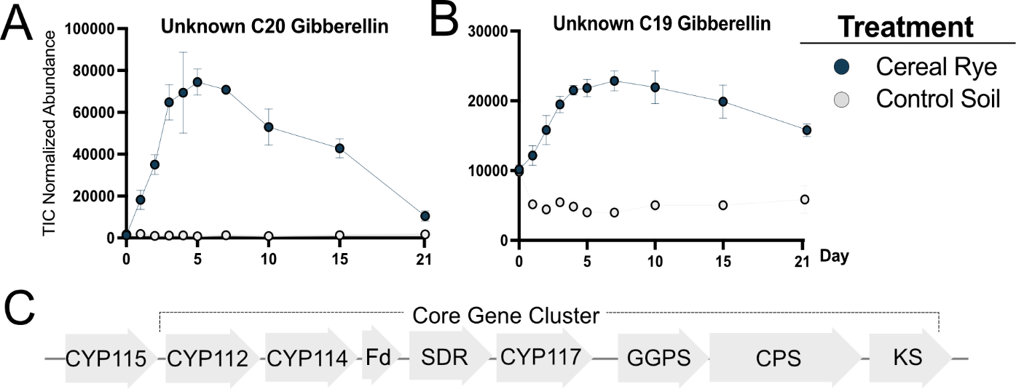

Additional Figure 15. Gibberellic acid (GA) biosynthesis in cereal rye microcosms.
A-B) Line plots represent TIC normalized abundances of two unknown GA-like compounds, a C20-GA and an unknown C19-GA, respectively, annotated at a level 3 annotation. Color corresponds to treatment, circles represent the mean, error bar represent standard deviation. C) GA biosynthetic operon. In bacteria, GAs are derived from isoprenoid diphosphates which are converted to the 20-carbon isoprenyl precursor (E,E,E)-geranylgeranyl diphosphate (GGDP), by the geranylgeranyl diphosphate synthase (GGPS or idsA) gene. GGDP is transformed into ent-copalyl diphosphate (CDP) by ent-CDP synthase followed by cyclization to form ent-kaurene by ent-kaurene synthase (KS), creating a key intermediate in the GA biosynthesis pathway. ent-kaurene is then oxidized to ent-kaurenoic acid by cytochrome P450 (CYP) monooxygenase 117 (CYP117) before a final oxidation to GA₁₂-aldehyde by CYP114. GA₁₂-aldehyde is modified to form GA₁₂ by a short chain dehydrogenase, converted to GA₉ by CYP112, and finally converted to GA₄ by a GA-3-oxidase known as CYP115. The core operon CYP KS is primarily conserved across bacteria, while CYP115 and KS have only been found in certain bacterial strains.

Additional Table 14. 2-way ANOVA of unknown GA C068

Table Analyzed | C068 log10
Two-way RM ANOVA | Matching: Stacked
Assume sphericity? | No
Alpha | 0.05
Source of Variation | % of total variation | P value | P value summary | Significant?
Day x Treatment | 14.47 | <0.0001 | **** | Yes
Day | 7.252 | 0.0001 | *** | Yes
Treatment | 74.90 | <0.0001 | **** | Yes
Subject | 0.1126 | 0.9286 | ns | No
ANOVA table | SS | DF | MS | F (DFn, DFd)
Day x Treatment | 7.827 | 9 | 0.8696 | F (9, 54) = 26.64
Day | 3.922 | 9 | 0.4357 | F (2.793, 16.76) = 13.35
Treatment | 40.50 | 1 | 40.50 | F (1, 6) = 3991
Subject | 0.06089 | 6 | 0.01015 | F (6, 54) = 0.3109
Residual | 1.763 | 54 | 0.03264

Tukey's multiple comparisons test | Mean Diff. | 95.00% CI of diff. | Below threshold? | Summary | Adjusted P Value
Row 1
CR vs. C | -0.08054 | -0.3769 to 0.2158 | No | ns | 0.4766
Row 2
CR vs. C | 0.9867 | 0.7984 to 1.175 | Yes | **** | <0.0001
Row 3
CR vs. C | 1.606 | 1.333 to 1.878 | Yes | *** | 0.0001
Row 4
CR vs. C | 1.811 | 1.437 to 2.186 | Yes | *** | 0.0004
Row 5
CR vs. C | 1.848 | 1.346 to 2.350 | Yes | *** | 0.0007
Row 6
CR vs. C | 2.082 | 1.610 to 2.553 | Yes | *** | 0.0007
Row 7
CR vs. C | 1.780 | 1.420 to 2.139 | Yes | *** | 0.0005
Row 8
CR vs. C | 1.807 | 1.507 to 2.106 | Yes | *** | 0.0001
Row 9
CR vs. C | 1.575 | 1.129 to 2.020 | Yes | ** | 0.0013
Row 10
CR vs. C | 0.8175 | 0.4999 to 1.135 | Yes | ** | 0.0016

Additional Table 15. 2-way ANOVA and multiple comparisons of unknown GA C043.

Two-way RM ANOVA | Matching: Stacked
Assume sphericity? | No
Alpha | 0.05
Source of Variation | % of total variation | P value | P value summary | Significant?
Day x Treatment | 12.41 | <0.0001 | **** | Yes
Day | 1.692 | 0.0695 | ns | No
Treatment | 82.65 | <0.0001 | **** | Yes
Subject | 0.1076 | 0.9301 | ns | No
ANOVA table | SS | DF | MS | F (DFn, DFd)
Day x Treatment | 0.8570 | 9 | 0.09523 | F (9, 54) = 23.67
Day | 0.1169 | 9 | 0.01299 | F (2.174, 13.05) = 3.228
Treatment | 5.710 | 1 | 5.710 | F (1, 6) = 4608
Subject | 0.007436 | 6 | 0.001239 | F (6, 54) = 0.3080
Residual | 0.2173 | 54 | 0.004023

Tukey's multiple comparisons test | Mean Diff. | 95.00% CI of diff. | Below threshold? | Summary | Adjusted P Value
Row 1
CR vs. C | 0.01378 | -0.03587 to 0.06344 | No | ns | 0.5217
Row 2
CR vs. C | 0.3725 | 0.2877 to 0.4574 | Yes | **** | <0.0001
Row 3
CR vs. C | 0.5557 | 0.4334 to 0.6779 | Yes | **** | <0.0001
Row 4
CR vs. C | 0.5524 | 0.4933 to 0.6115 | Yes | **** | <0.0001
Row 5
CR vs. C | 0.6538 | 0.5257 to 0.7820 | Yes | *** | 0.0004
Row 6
CR vs. C | 0.7364 | 0.6532 to 0.8195 | Yes | **** | <0.0001
Row 7
CR vs. C | 0.7646 | 0.6284 to 0.9009 | Yes | *** | 0.0002
Row 8
CR vs. C | 0.6430 | 0.5254 to 0.7606 | Yes | **** | <0.0001
Row 9
CR vs. C | 0.5979 | 0.4930 to 0.7028 | Yes | **** | <0.0001
Row 10
CR vs. C | 0.4531 | 0.2237 to 0.6825 | Yes | ** | 0.0075

Additional Table 16. Pearson r correlation of CYP115 expression from Thermomicrobiales MAG (geTMM) with GA₄ phytohormone abundance.

Pearson r
r | 0.7278
95% confidence interval | 0.04754 to 0.9469
R squared | 0.5297
P value
P (two-tailed) | 0.0407
P value summary | *
Significant? (alpha = 0.05) | Yes
Number of XY Pairs | 8

