Tumor-colonized Streptococcus mutans metabolically reprograms tumor microenvironment and promotes oral squamous cell carcinoma
Jiaying Zhou^{1,2†}, Zixuan Hu^{3,4,5†}, Lei Wang^{6,7,8†}, Qinchao Hu^{1,2†}, Zixu Chen^{9†}, Tao Lin⁹, Rui Zhou^{1,2}, Yongjie Cai⁹, Zhiying Wu⁹, Zhiyi Zhang⁹, Yi Yang⁹, Cuijuan Zhang¹⁰, Guibo Li^{6,7,8}, Lingchan Zeng¹, Kai Su^{1,2}, Huan Li¹¹, Qiao Su¹², Gucheng Zeng^{9*}, Bin Cheng^{1,2*}, Tong Wu^{1,2*}

This file includes:
Materials and Methods
Figures S1 to S8
Table S1 to S3
References

Materials and Methods
Metabolomics and data analysis
Sample collection: Saliva samples for widely targeted metabolomic (hydrophilic and hydrophobic compounds) detection were obtained during the morning period, at least 2 hours after dental brushing. Participants were asked to rest for 15 min, and then whole saliva was collected into a sterile plastic collector to a volume of 1 mL. Samples were immediately kept on ice, and then centrifuged at 2600g for 15 min at 4 °C to remove insoluble materials, and supernatants were frozen at -80 °C for further analysis. Additionally, fresh adjacent non-tumor and tumor tissues from OSCC patients for widely targeted metabolomic (hydrophilic compounds) detection were collected and weighed. Tongue tissues of rats for targeted metabolomic (tryptophan and its metabolites) detection were also collected. Samples were snap frozen in liquid nitrogen and then stored at -80 ℃ until use by Ultra Performance Liquid Chromatography Tandem Mass Spectrometry (UPLC-MS/MS).

Preparation and extraction of hydrophilic compounds: The saliva samples were thawed on ice, vortexed for 10 s and mixed well. 300 uL pure methanol was added to 50 uL saliva, and then the mixture was whirled for 5 min and centrifuged for 10 min at 12,000 rpm at 4 ℃. 200 uL supernatant was placed at -20 ℃ for 30 min, and then centrifuged at 12000 rpm at 4 ℃ for 3 min. Finally, 150 uL aliquots of supernatant were transferred to the corresponding injection bottle for further analysis.
The tissue samples were thawed on ice, weighed (20 mg), homogenized (30 HZ) for 20 s with a steel ball and centrifuged (3000 rpm, 4 °C) for 30 s. Then 400 μL 70% methanol containing internal standard was added. After shaking (1500 rpm) for 5 min and incubating on ice for 15 min, the samples were centrifuged (12000 rpm, 4 °C) for 10 min. Next, 300 μL supernatant was collected and placed at -20 °C for 30 min before centrifugation (12000 rpm, 4 °C) for 3 min. Finally, 200 μL aliquots of supernatant were transferred for further analysis.
Preparation and extraction of hydrophobic compounds: The saliva sample was thawed on ice, whirled around 10 s, and then centrifuged with 3000 rpm at 4 ℃ for 5 min. 1 mL mixture (MTBE : methanol=3:1, v/v) containing internal standard mixture was added to 50 uL saliva, and then the mixture was whirled for 15 min. 200 uL ultrapure water was added to the mixture and whirled for 3 min before centrifugation (12000 rpm, 4 °C, 5 min). 200 μL upper organic layer was collected and evaporated using a vacuum concentrator. The dry extract was reconstituted using 200 μL complex solution (ACE: IPA =1:1, v/v) prior to LC-MS/MS analysis.
The above sample extracts were analyzed using an LC-electrospray ionization (ESI)-MS/MS system (UPLC, ExionLC AD, https://sciex.com.cn/; MS, QTRAP® System, https://sciex.com/).

UPLC conditions of hydrophilic compounds: The analytical conditions were as follows, UPLC: column, Waters ACQUITY UPLC HSS T3 C18 (1.8 µm, 2.1 mm*100 mm); solvent system: A-water (0.1% formic acid), B-acetonitrile (0.1% formic acid); gradient program: A:B=95:5 V/V at 0 min, 10:90 V/V at 11.0 min, 10:90 V/V at 12.0 min, 95:5 V/V at 12.1 min, 95:5 V/V at 14.0 min; column temperature, 40 ℃; flow rate, 0.4 mL/min; injection volume, 2 μL.
UPLC conditions of hydrophobic compounds: The analytical conditions were as follows, UPLC: column, Thermo Accucore™ C30 (2.6 μm, 2.1 mm*100 mm i.d.); solvent system: A-acetonitrile/water (60:40, V/V, 0.1% formic acid, 10 mmol/L ammonium formate), B-acetonitrile/isopropanol (10:90 V/V, 0.1% formic acid, 10 mmol/L ammonium formate); gradient program: A:B=80:20, V/V= at 0 min, 70:30 V/V at 2.0 min, 40:60 V/V at 4 min, 15:85 V/V at 9 min, 10:90 V/V at 14 min, 5:95 V/V at 15.5 min, 5:95 V/V at 17.3 min, 80:20 V/V at 17.3 min, 80:20 V/V at 20 min; flow rate, 0.35 mL/min; temperature, 45 ℃; injection volume: 2 μl.
The effluent was alternatively connected to an ESI-triple quadrupole-linear ion trap (QTRAP)-MS.

ESI-Q TRAP-MS/MS of hydrophilic compounds: Linear ion trap (LIT) and triple quadrupole (QQQ) scans were acquired on a triple quadrupole-linear ion trap mass spectrometer (QTRAP® LC-MS/MS System), equipped with an ESI Turbo Ion-Spray interface, operated in positive and negative ion mode and controlled by Analyst 1.6.3 software (Sciex). The ESI source operation parameters were as follows: source temperature 500 ℃; ion spray voltage (IS) 5500 V (positive), -4500 V (negative); ion source gas I (GSI), gas II (GSII) and curtain gas (CUR) were set at 55, 60, and 25 psi, respectively; the collision gas (CAD) was high.
ESI-Q TRAP-MS/MS of hydrophobic compounds: The ESI source operation parameters were as follows: ion source, turbo spray; source temperature 500 ℃; ion spray voltage (IS) 5500 V (Positive), -4500 V (Negative); ion source gas I (GSI), gas II (GSII) and curtain gas (CUR) were set at 45, 55, and 35 psi, respectively; the collision gas (CAD) was medium. Instrument tuning and mass calibration were performed with 10 and 100 μmol/L polypropylene glycol solutions in QQQ and LIT modes, respectively. QQQ scans were acquired as MRM experiments with collision gas (nitrogen) set to 5 psi. Declustering potential (DP) and collision energy (CE) for individual MRM transitions were done with further DP and CE optimization. A specific set of MRM transitions were monitored for each period according to the metabolites eluted within this period.

Quality control (QC): Quality control (QC) samples were prepared for detecting the intra-batch variability, which were obtained by mixing all the sample extracts of the same batch. In this study, QC samples were inserted into the queue to monitor the stability and repeatability every 10-15 test samples, which was examined by the total ion current (TIC) overlapping diagrams of different QC samples.

Data processing and statistical analysis: The UPLC-MS/MS raw data collected by metabolomic analysis were imported into Analyst 1.6.3 software. Unsupervised principal component analysis (PCA) was performed by statistics function prcomp within R (www.r-project.org). W∗_{d}-test was applied to assess the significance¹. The data was unit variance scaled before unsupervised PCA. For hierarchical cluster analysis (HCA), Z-score normalized signal intensities of metabolites (unit variance scaling) were visualized as color spectrum, which were presented as heatmaps with dendrograms by R package ComplexHeatmap. For variables with small correlations, orthogonal partial least squares discriminant analysis (OPLS-DA) was used to combine orthogonal signal correction and partial least squares-discriminant analysis in order to decompose the X matrix information into two types of information that were related and unrelated to Y, and filter the different variables by removing unrelated differences. OPLS-DA included score plots and permutation plots.
Based on the OPLS-DA results, the variable importance in projection (VIP) value was obtained using R package MetaboAnalystR. The metabolites with VIP ≥ 1 and absolute Log2FC ≥ 1 were selected as the differential metabolites between groups. In order to avoid overfitting, a permutation test (200 permutations) was performed. Identified metabolites were annotated using Kyoto Encyclopedia of Genes and Genomes (KEGG) Compound database (http://www.kegg.jp/kegg/compound/), and annotated metabolites were then mapped to KEGG pathway database (http://www.kegg.jp/kegg/pathway.html). Significantly enriched pathways were identified with a hypergeometric test’s p-value and adjusted p-value of Benjamini-Hochberg FDR correction for a given list of metabolites. The diagrams were plotted by ggplot2 packages (Version 3.3.0) in R software (Version 3.5.1).

Single-cell RNA sequencing (scRNA-seq) and data analysis
4NQO-induced Sprague-Dawley (SD) rat oral carcinogenesis model: Male Sprague-Dawley (SD) rats (4 weeks) were fed daily with 0.002% 4NQO (Sigma-Aldrich, Saint Louis, MO, USA) solution in their drinking water. At week 16 and week 20, the experimental rats were sacrificed, as visible lesions of OLK and OSCC had developed, respectively. The tongues were dissected, and a longitudinal mid-lingual incision was made. Half of the specimens were fixed in 10% buffered formalin, embedded in paraffin and cut into 5-μm sections for hematoxylin and eosin (H&E) staining to confirm the pathological diagnosis. The other halves of the specimens were collected for the experiment describe below.
scRNA-seq panel 1 (Figure 5A): Tissue dissociation: OLK and OSCC tissue samples were harvested from rats and mechanically dissociated. Tissues were placed in Dulbecco’s modified Eagle’s medium/F-12 (Corning, MT10090CV) complete medium containing penicillin streptomycin (50 μg/mL; HyClone, SV30010), collagenase type I (0.5 mg/mL; Sigma-Aldrich, SCR103) and collagenase type IV (1 mg/mL; Sigma-Aldrich, C5138) and digested at 37°C on a shaker for 45 min. Samples were centrifuged at 500g for 5 min at room temperature (RT), and the cells were resuspended in HBSS and centrifuged at 500g for 5 min at RT. 2 ml of 0.05% trypsin (Corning, 25-052-CI) was added to the cells with incubation at 37°C for 10 min. Samples were centrifuged at 500g for 5 min, and then resuspended in 5 ml of HBSS with 2% FBS. The cell suspension was filtered through a 70-um cell strainer and incubated for 5 min at RT in 3 ml of RBC lysis buffer. Cells were quenched with 10 mL of HBSS with 2% FBS and centrifuged at 500g for 5 min at RT. Cells were then resuspended in RPMI with 10% FBS, and total remaining live cells were counted by Countess II.

scRNA-seq panel 2 (Figure 6A): Peripheral blood collection, OSCC tissue dissociation and neutrophil isolation: Peripheral blood at the different stage was collected from the angular vein of rats, and neutrophils were isolated from blood using Polymorphprep™ (AS1114683, Axis-Shield, Norway) density gradient centrifugation. Collected neutrophils were centrifuged at 500g at 4°C for 5 min, and resuspended in 5 mL of RBC lysis buffer for incubating at RT for 5 min. Cells were quenched in 5 mL of RPMI with 3% FBS and centrifuged at 500g at 4°C for 5 min. Cells were then resuspended in 3 mL of FACS buffer (1× PBS and 3% FBS). OSCC tissue dissociation followed the above steps. Total remaining live cells were counted by Countess II and processed for fluorescence activated cell sorting (FACS).

Fluorescence activated cell sorting (FACS): The cell suspension of panel 2 was stained with CD11b/c-APC and His48-FITC antibodies at the same time, incubated on ice and protected from light for 30 min. After washing once with PBS, we resuspend cells in PBS containing 0.04% BSA and sorted CD11b/c+ and His48+ double positive cells into 1.5mL tubes.

Single cell library preparation: After adjusting the cell concentration to 700-1200 cells/μL, a Chromium Controller instrument (10X Genomics) and a Chromium ™ Single Cell 3 'Library & Gel Bead Kit v2 (10X Genomics, PN-120237 / PN-120267) kit were processed. Then, these cells were subjected to single-cell droplet generation, expansion, and library construction. After converting the library into a circular library, sequencing on the BGISEQ-500 sequencing platform was performed. Raw sequencing data were processed using 10x CellRanger 3.0.0, and each sample was aligned to an indexed Rnor_6.0 genome using Cell Ranger Count.

Processing of scRNA-seq data: We applied SoupX for background correction (see below), and analyzed each donor sample separately. In parallel, we used scrublet (see below) to infer the number of the doublets in the dataset before applying the filters and excluded any remaining cells predicted to be doublets that were still present in the dataset. Data were combined in R (version 3.4.1), and converted to a Seurat object using the Seurat R package (version 3.0.2). From this, all cells were removed that had either fewer than 200 expressed genes, or over 20% UMIs derived from mitochondrial genome. Downstream analyses including, normalization, scaling, clustering of cells, and identifying cluster marker genes were performed using the R software package Seurat (https://github.com/satijalab/seurat). To normalize the library size effect in each cell, we scaled UMI counts using scale.factor = 10,000. The expression matrix was then log-normalized using the ‘NormalizeData’ function. Other factors, including “percent.mt”, “nCount_RNA” and “nFeature_RNA”, were corrected for variation regression using the ScaleData function in Seurat (v3.0.2).

Dimensionality reduction, clustering and cell annotation: We performed principal component analysis (PCA) dimensionality reduction with the 2000 highly variable genes as input, and used ‘RunHarmony’ function to integrate samples for batch correction. UMAP analysis was performed using the ‘RunUMAP’ function with default parameters. We used the function ‘FindClusters’ from Seurat. In brief, this method used a shared nearest neighbor (SNN) modularity optimization-based clustering algorithm to identify clusters of cells based on their HARMONYs. To annotate the cell type and cluster-specific genes, FindAllMarkers function was run in the Seurat package to the normalized gene expression data. Genes that met the criteria of adjusted p-value<0.05 in Seurat method and absolute log₂(FC) ≥ 0.25, were considered as significant differential expression genes (DEGs). We used Metascape (http://metascape.org)² to perform biological process enrichment analysis with the Gene Ontology (GO). The markers used to define cell types included: Cd3e, Cd3d, Cd3g, Cd2 and Klrd1 for T and NK cells; C1qb, C1qc, Cd14, Cd68, and C1qa for Macrophages; Acta2, Myl9, Mylk, and Actg2 for Smooth muscle cells; Plvap, Cdh5, Mmrn2, and Fabp4 for Endothelial cells; Mbp, S100b, Cnp, Sfrp5 and Mal for Neurons; Hba-a2.1, Hba-a2, Hbb, Hba-a3, and alas2 for Erythrocytes; Cpa1, Myf5, Cdh15, and Nppc for Acinar cells; Dcn, Col1A1, Col3A1, and Col12A1 for Fibroblasts; Epcam1, Krt5, Perp, and Krt17 for Epithelial cells; Krt18, Krt8, Prb3 and Fcgbp for salivary gland Epithelial cells; S100a8, G0s2, S100a9, and Cxcl2 for Neutrophils; IRF7, LILRA4, PLD4, and PLAC8 for pDCs; Clec10a, Cd83, and Cd207 for DCs; Tpsb2, Cpa3, Tpsab1, and Cma1 for Mast cells.

Ambient RNA correction (SoupX): Different batches can be affected by different levels of ambient RNA. To take this into account, we used the recently developed SoupX method. Briefly, ambient RNA expression was estimated from the empty droplet pool (10 UMI or less). Expression of these genes in each cell was then calculated and compared with their proportion in the ambient RNA profile. Transcripts with a bimodal profile (characterizing specific groups of cells but were also highly abundant in empty droplets) were then grouped based on their function. The contamination fraction derived from the expression of these genes was then used to calculate the fraction of each droplet’s expression corresponding to the actual cell. Finally, this fraction and the ambient profiles were subtracted from the real expression values.

Doublet removal: We used Scrublet for unbiased computational doublet inference. Doublets were identified in each 10x sample individually using Scrublet, setting the expected doublet rate to 0.046 and keeping all other parameters at their default values. Cells were excluded when they had a score higher than 0.2 for all samples. In addition to the general quality control described above, we combined literature knowledge about cell lineages with computational clustering to identify clusters enriched in potential doublets. The strategy for each dataset was described below.
(1) Epithelial cells. We removed cells with expression level higher than 1 for any of the following markers: Ptprc (immune), Dcn (fibroblast), Cdh5 (endothelial), and Hba-a2.1 (erythrocyte).
(2) Non-epithelial cells. We removed cells with expression level higher than 1 for any of the following markers: Krt17, Krt5, Amy1a, Prpmp5, and markers for other non-epithelial lineages.
(3) Neutrophils. Doublets were identified through annotations of clusters using curated gene sets for the major cell types, and clusters which high expressed markers of T cell, B cell or Epithelial were removed.

Cell-cell communication analysis: To analyze cell-cell interactions between T/NK cells and S100a8^{high}S100a9^{high} neutrophils in OSCC tissues, we firstly sub-clustered T/NK cells derived from OSCC tissues and identified 5 cell subtypes, including NK cells, CD8 T cells, CD4 T cells and 3 types of Treg cells. And then we used CellPhoneDB to identify significant ligand-receptor pairs³. We constructed a rat orthologous gene ligand and receptor database using the human cell interaction database from CellPhoneDB. The CellPhoneDB analysis was performed using the CellPhoneDB Python package (1.1.0). Only receptors and ligands expressed in more than 10% of the cells in the specific cell subsets were considered. By calculating the proportion of the means that were higher than the actual mean, a p-value for the likelihood of the cell type specificity of the corresponding receptor-ligand complex was obtained.

Statistical analysis: Single cell RNA data were analyzed statistically using R (version 3.4.1) and Python (version 3.7.0). Student’s t or ANOVA test was used to evaluate the statistical significance for normally distributed data, and Mann-Whitney U or Kruskal–Wallis test was used for non-normally distributed data.

Supplementary Figure S1
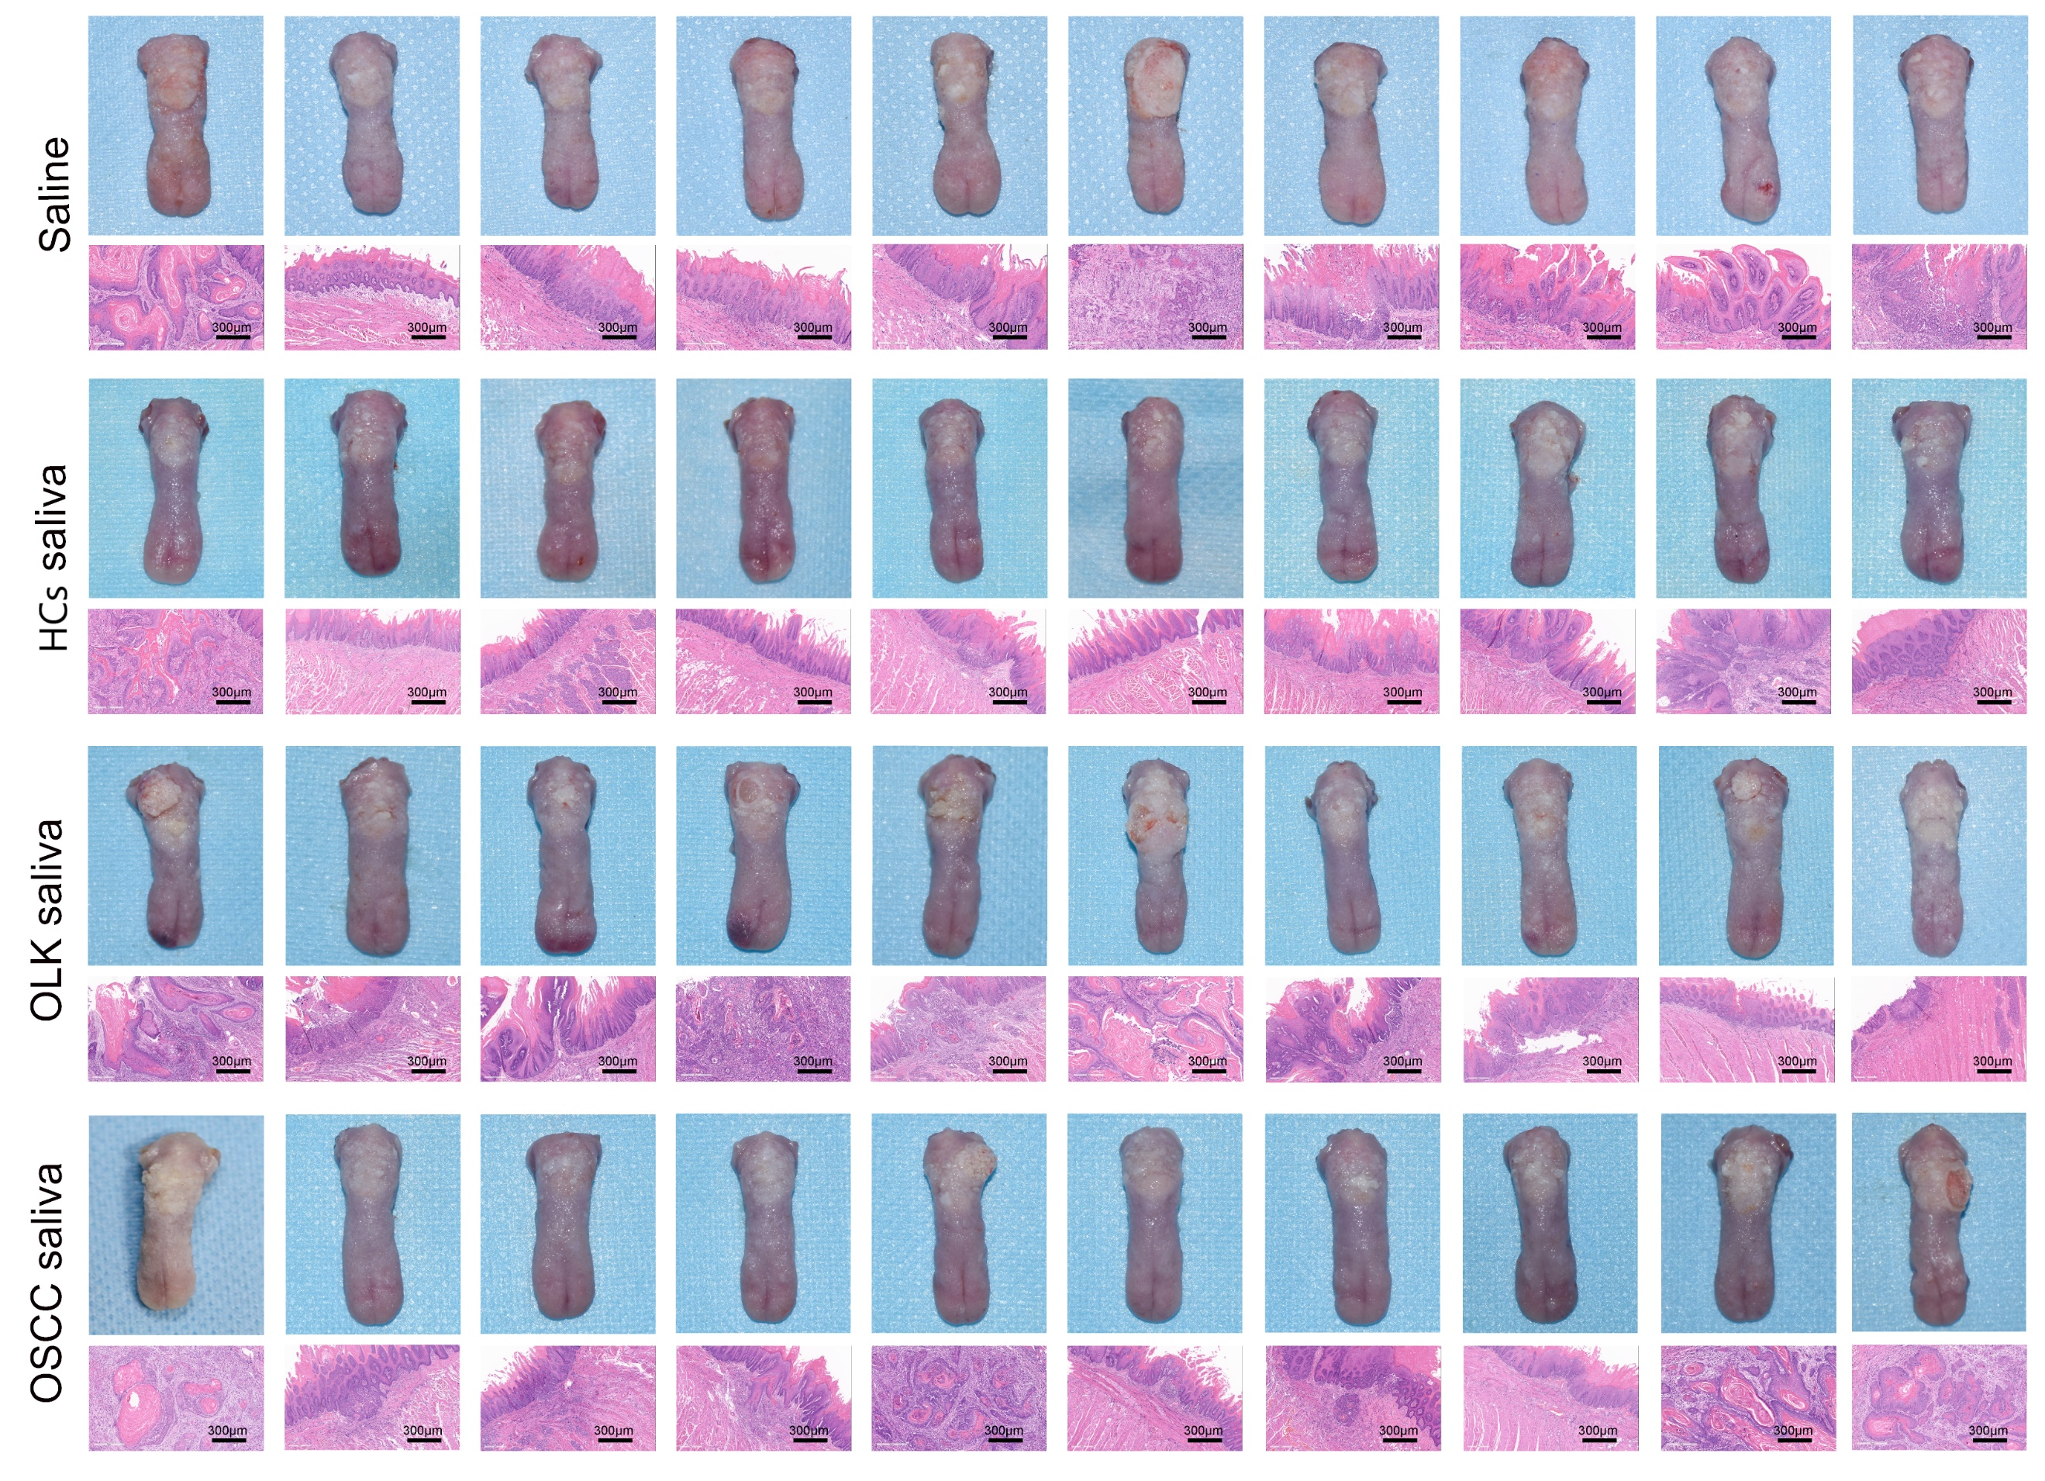
Supplementary Figure S1. Gross observation and H&E images of tongues derived from rats treated with saline, saliva from HCs, OLK and OSCC patients at endpoint. Scale bars: 300 µm. HCs, healthy controls; OLK, oral leukoplakia; OSCC, oral squamous cell carcinoma.

Supplementary Figure S2.
Supplementary Figure S2. Widely targeted metabolomics sequencing analyses of saliva and tissues.
- The presentative overlapping TIC diagrams of quality control (QC) samples of saliva monitored by widely targeted metabolomics (hydrophilic and hydrophobic compounds) in positive and negative ion mode detection.
- PCA of HCs, OLK, OSCC and mix groups in whole saliva. W∗_{d}-test was applied to assess the significance. Mix group referred to the quality control samples. PCA, principal component analysis.
- OPLS-DA (left) of HCs, OLK, OSCC and mix (QC samples) groups in whole saliva. Permutation test (right) for OPLS-DA model verification. OPLS-DA, orthogonal partial least squares discriminant analysis. Mix group referred to the quality control samples.
- Benjamini-Hochberg FDR multiple correction in KEGG metabolomic pathway analyses.
- The relative concentration of kynurenine in whole saliva by UPLC-MS/MS in HCs (n = 6), OLK (n = 15) and OSCC (n = 12) groups.
- The presentative overlapping TIC diagrams of QC samples of tissues monitored by widely targeted metabolomics (hydrophilic compounds) in positive and negative ion mode detection.
- PCA of adjacent non-tumor, tumor tissues and mix groups from OSCC patients. W∗_{d}-test was applied to assess the significance. Mix group referred to the quality control samples. PCA, principal component analysis.
- OPLS-DA (left) of adjacent non-tumor, tumor tissues and mix (QC samples) groups. Permutation test (right) for OPLS-DA model verification. Mix group referred to the quality control samples.
- The relative concentration of kynurenine by UPLC-MS/MS in paired adjacent non-tumor and tumor tissues from OSCC patients (n=10).
In Figures S2B and S2G: W∗_{d}-test; Figures S2C and S2H: permutation test; Figures S2D: Benjamini-Hochberg FDR correction; Figures S2E: Kruskal-Wallis test; Figures S2I: Wilcoxon matched-pairs signed rank test.

Supplementary Figure S3.
Supplementary Figure S3. Confirmation of qPCR products for S. mutans.
(A) The qPCR product determination by 2.0% agarose gel electrophoresis. Lane 1: 100 bp DNA ladder. Lane 2-6: Amplicon products of S. mutans obtained by qPCR from human oral samples.
(B) Alignment of the qPCR product sequences compared to S. mutans complete genome (Accession number: AE014133.2).

Supplementary Figure S4.
Supplementary Figure S4. KYNA regulates tumor microenvironment and promotes oral carcinogenesis
- Expression of AHR in adjacent non-tumor and tumor tissues in TCGA dataset. RPKM, Reads Per Kilobase Million.
- The relative expression of IL-1β in SCC1 after KYNA treatment detected by RT-qPCR.
- Gross observation and H&E images of the rat tongues in three groups at endpoint. Scale bars: 300 µm.
In Figures S4A: unpaired Student’s t test; Figures S4B, Kruskal-Wallis test.

Supplementary Figure S5.
Supplementary Figure S5. S. mutans promotes the expansions of neutrophils.
- Expression of known cell type markers for clustering the cell types of OLK and OSCC tissues in scRNA-seq.
(B-C) Representative flow cytometry dot plots and statistical analysis of CD11b+CD16+ neutrophils from the peripheral blood of OSCC patients treated with the supernatant (B) and lysate (C) of S. mutans. One-way ANOVA for the comparison.

Supplementary Figure S6.
Supplementary Figure S6. Single-cell transcriptomic landscape reveals spatiotemporal dynamic changes of CD11b/c+His48+ cells during oral carcinogenesis.
- UMAP plots showing S100a8 and S100a9 gene expression in CD11b/c+His48+ cells. The color scale representing log-normalized expression. Gray to red: low to high expression.
- Heat map of gene profiling of S100a8^{low}S100a9^{low} neutrophils in peripheral blood and OSCC tissues. Color representing the scaled normalized expression level of the marker genes across all cells. Yellow: high expression; purple: low expression.
- The most enriched pathways for the S100a8^{high}S100a9^{high} neutrophils of TME during carcinogenesis by Gene Ontology analysis. q-values were acquired by multiple comparison correction.
- Representative flow cytometry dot plots and statistical analysis of IL-1β+ neutrophils from the peripheral blood of OSCC patients after treatments of KYNA in indicated concentration in vitro.
- UMAP plots of T and NK cell clusters of OSCC tissues in scRNA-seq (panel 1).
- Dot plot of the enriched interactions between S100a8^{high}S100a9^{high} neutrophils and different T/NK cells in OSCC tissues. H.N, S100a8^{high}S100a9^{high} neutrophils in OSCC tissues. For a given ligand (left) and receptor pair (right), for example, “NK_H.N” refers that the ligand was derived from NK cells and the receptor was derived from H.N cells. “H.N_NK” refers that the ligand was derived from H.N cells and the receptor was derived from NK cells.
- Quantitative analyses of CD274 expression on S100a8^{high}S100a9^{high} neutrophils in normal blood, OLK blood, OSCC blood, and OSCC tissues during the carcinogenesis process.
In Figure S6D: One-way ANOVA test; Figures S6G, Kruskal-Wallis test.

Supplementary Figure S7.
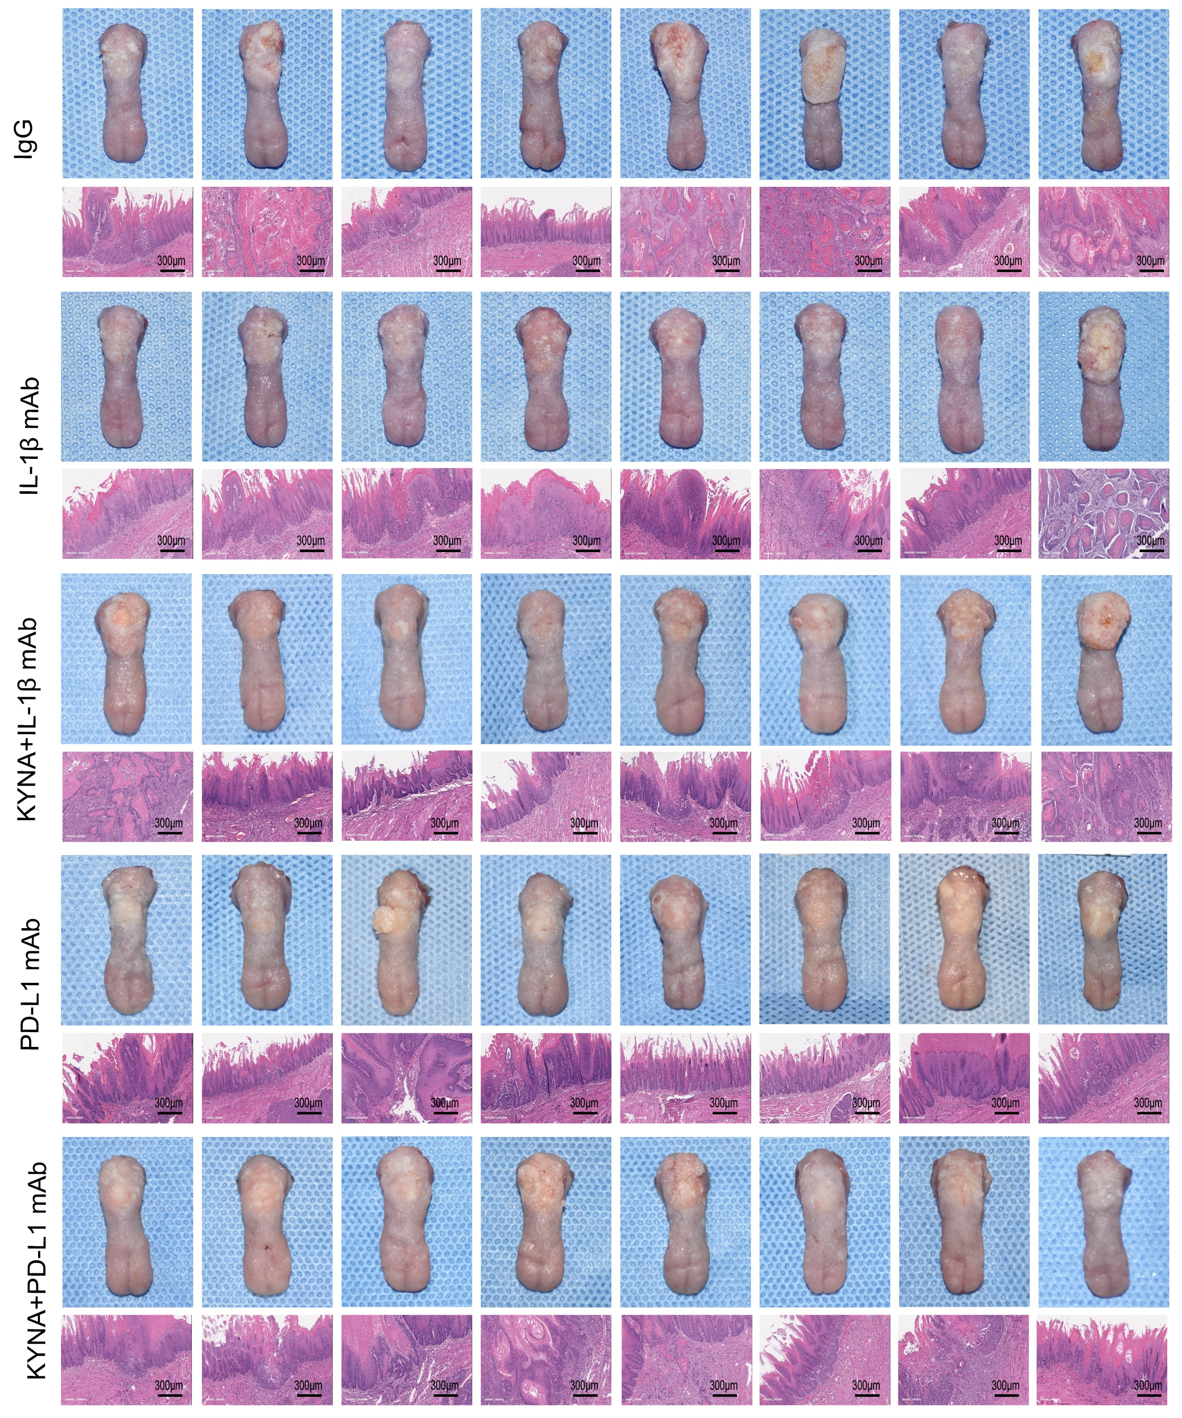
Figure S7. Gross observation and H&E images of the tongues in rats with indicated treatments. Tongues derived from rats treated with IgG, IL-1β monoclonal antibody (IL-1β mAb), KYNA+IL-1β mAb, PD-L1 monoclonal antibody (PD-L1 mAb), and KYNA+ PD-L1 mAb at endpoint. Scale bars: 300 µm.

Supplementary Figure S8.
Supplementary Figure S8. The correlation between tryptophan-catabolic enzymes expression and prognosis in OSCC patients
- Correlation analysis between CD274 and AHR in TCGA dataset.
- Kaplan–Meier survival curve of overall survival based on OSCC patients with high- and low-expression of FCGR3B (CD16) in TCGA dataset.
- Kaplan-Meier survival curves of overall survival based on OSCC patients with high- and low-expression of IL1β, CD274, AHR and FCGR3B in GSE41613 and GSE65858 datasets.
- Kaplan–Meier survival curves of overall survival based on OSCC patients with high- and low-expression of KYAT1 in TCGA datasets.
In Figures S8A: Spearman Correlation analysis; Figures S8B, S8C and S8D: Log-rank test.

Table S1. Characteristics of the participants for the metabolomics analysis of saliva in the exploratory cohort.
Characteristics | HCs | OLK | OSCC | p-value
Total number | 6 | 15 | 12
Gender |  |  |  | 0.9820
Male | 3 | 8 | 6
Female | 3 | 7 | 6
Age |  |  |  | 0.2683
Range | 24-61 | 20-71 | 29-72
Mean ± SEM | 45.33±5.613 | 43.80±3.935 | 52.67±3.724
Smoking history |  |  |  | 0.6410
Yes | 2 | 5 | 6
No | 4 | 10 | 6
HCs: healthy controls; OLK: oral leukoplakia; OSCC: oral squamous cell carcinoma; SEM: Std. Error of Mean. One-way ANOVA was employed to compare the age data, and Fisher’s exact test was applied for comparing gender and smoking history variables.

Table S2. Characteristics of the participants for KYNA analysis of saliva in the validation cohort.
Characteristics | HCs | OSCC | p-value
Total number | 32 | 45
Gender |  |  | 0.9560
Male | 19 | 27
Female | 13 | 18
Age |  |  | 0.1469
Range | 32-80 | 27-84
Mean ± SEM | 52.69±2.163 | 56.93±1.897
Smoking history |  |  | 0.9800
Yes | 12 | 17
No | 20 | 28
HCs: healthy controls; OSCC: oral squamous cell carcinoma; SEM: Std. Error of Mean. Unpaired Student’s t test was employed to compare the age data, and Chi-square test was applied for comparing gender and smoking history variables.

Table S3. List of primers used for qPCR and RT-qPCR.
Target species/mRNA | Forward primer sequence 5’- 3’ | Reverse primer sequence 5’- 3’ | Amplicon size | References
Eubacteria 16S | GGTGAATACGTTCCCGG | TACGGCTACCTTGTTACGACTT | 144 | [4]
Streptococcus mutans | GCCTACAGCTCAGAGATGCTATTCT | GCCATACACCACTCATGAATTGA | 114 | [5]
Streptococcus gordonii | CAGGAAGGGATGTTGGTGTT | GACTCTCTTGGCGACGAATC | 136 | [6]
Streptococcus mitis | AAGGAGGAGCTTGCTTCTCT | ACCTTTCAAACAGTTATCATGC | 141 | [7]
Streptococcus salivarius | TGAACAAGCRGTWGTCGGTAAC | ACTCCGTGTCCAACCAAATC | 108 | [8]
Streptococcus parasanguis | TAACCTGCCTCTTAGCGGG | AGGTCCATCTCTTAGTGATGCA | 115 | [7]
Streptococcus sanguis | GGAGCTTGCTCTTCTTGGA | TGATGCAATTGCATCTTTCAAT | 149 | [7]
GAPDH | GGACCTGACCTGCCGTCTAG | GTAGCCCAGGATGCCCTTGA | 100 | [9]
CYP1B1 | GCCACTATCACTGACATCTTCGG | CACGACCTGATCCAATTCTGCC | 129 | [10]
SLC7A5 | CCGTGAACTGCTACAGCGT | CTTCCCGATCTGGACGAAGC | 113 | [11]
SLC7A8 | TTGCCAATGTCGCTTATGTCA | AGAGACCCATTAACTCCTCCAAA | 157 | [11]
IL-1β | TGAGCTCGCCAGTGAAATGA | AGATTCGTAGCTGGATGCCG | 143 | Self-designed in NCBI

Reference:
1. Hamidi B, Wallace K, Vasu C, Alekseyenko AV. W∗_{d} -test: robust distance-based multivariate analysis of variance. Microbiome. 7, 51 (2019).
2. Tripathi S, et al. Meta- and orthogonal integration of influenza “omics” data defines a role for UBR4 in virus budding. Cell Host Microbe 18, 723-735 (2015).
3. Vento-Tormo R, et al. Single-cell reconstruction of the early maternal-fetal interface in humans. Nature 563, 347-353 (2018).
4. Wang X, et al. Porphyromonas gingivalis Promotes Colorectal Carcinoma by Activating the Hematopoietic NLRP3 Inflammasome. Cancer Res 81, 2745-2759 (2021).
5. Childers NK, et al. Real-time quantitative polymerase chain reaction for enumeration of Streptococcus mutans from oral samples. Eur J Oral Sci 119, 447-454 (2011).
6. Neves BG, et al. Quantitative analysis of biofilm bacteria according to different stages of early childhood caries. Archives of oral biology 96, 155-161 (2018).
7. Wolff D, et al. Bacterial biofilm composition in caries and caries-free subjects. Caries research 47, 69-77 (2013).
8. Wei JM, et al. Salivary microbiota may predict the presence of esophageal squamous cell carcinoma. Genes & diseases 9, 1143-1151 (2021).
9. Wang B, et al. Tubular-specific CDK12 knockout causes a defect in urine concentration due to premature cleavage of the slc12a1 gene. Mol Ther 30, 3300-3312 (2022).
10. Ternes D, et al. The gut microbial metabolite formate exacerbates colorectal cancer progression. Nat Metab 4, 458-475 (2022).
11. Liu Y, et al. Tumor-Repopulating Cells Induce PD-1 Expression in CD8+ T Cells by Transferring Kynurenine and AhR Activation. Cancer Cell 33, 480-494 (2018).

