Supplementary Information for
Volatile-mediated interspecific plant interaction promotes root colonization by beneficial bacteria via induced shifts in root exudation

Supplementary Methods
Quantitative PCR analysis of Bacillus and Pseudomonas spp.
Quantitative PCR assays were performed in a 25 μl reaction mixture containing 12.5 μl of 2×Real SYBR Mixture (Tiangen Biotech, Beijing, China), 0.2 μM of each of the forward and reverse primers, and 5 ng of DNA. Sterile deionized water was used to bring the final volume to 25 μl. The primer sets used are shown in Table S1. The PCR was performed with an EasyCycler PCR System (Analytik Jena, Jena, Germany) using a cycling program of 95°C for 5 min; followed by 35 cycles of 95°C for 30 s, 60°C for 30 s for Bacillus sp. (63°C for 30 s for Pseudomonas sp.), 72°C for 45 s; and a final extension at 72°C for 10 min. Sterile deionized water was used as a negative control, and each amplification was performed in triplicate. Standard curves were created with a 10-fold dilution series of plasmids containing the target gene of previously isolated Bacillus sp. B56 [1] or Pseudomonas sp. P13 [2]. The threshold cycle values obtained for each sample were compared with the standard curve to calculate the copy numbers of the target gene.

Evaluation of plant growth-promoting traits in bacterial isolates
The phosphate solubilization activity was determined using the National Botanical Research Institute Phosphate (NBRIP) broth [10 g L⁻¹ glucose, 5 g L⁻¹ Ca₃(PO₄)₂, 5 g L⁻¹ MgCl₂·6H₂O, 0.25 g L⁻¹ MgSO₄·7H₂O, 0.2 g L⁻¹ KCl, and 0.1 g L⁻¹ (NH₄)₂SO₄] [3]. The phytate mineralization activity was determined using the phytate screening broth [10 g L⁻¹ glucose, 4 g L⁻¹ Na-phytate, 2 g L⁻¹ CaCl₂, 5 g L⁻¹ NH₄NO₃, 0.5 g L⁻¹ KCl, 0.5 g L⁻¹ MgSO₄·7H₂O, 0.01 g L⁻¹ FeSO₄·7H₂O, 0.01 g l⁻¹ MnSO₄·H₂O] [4]. In brief, each isolate was cultivated in Luria-Bertani broth at 28°C with shaking at 120 rpm for 24 h, and the culture was diluted to an optical density of 600 nm (OD₆₀₀) to 1.0 with fresh Luria-Bertani broth. Then, 500 μl of the diluted culture was transferred into 50 ml of NBRIP broth or phytate screening broth. After incubation at 28°C with shaking at 120 rpm for 48 h, bacterial cells were removed from the culture medium via membrane filtering (0.22 μm). The culture filtrates of the NBRIP broth were analyzed for soluble phosphate content, pH, and organic acid content. The culture filtrates of the phytate screening broth were analyzed for soluble phosphate content and phytase activities.
Soluble phosphate in the culture filtrate was determined using the molybdenum blue method [5]. The phosphate quantities were calculated from a standard curve of soluble phosphate (KH₂PO₄). The pH of the culture filtrate was measured using a glass electrode. Organic acid content was determined using high-performance liquid chromatography (HPLC) analysis with a Waters HPLC system (Waters, Milford, USA). The column was XDB-C18 (4.6×250 mm, Agilent, Santa Clara, USA) and the mobile phase consisted of 5 mM H₂SO₄ (A) and methanol (B) with a gradient elution. The gradient profile was: 0-10 min, 95 % A plus 5 % B; 10-22 min, 90 % A plus 10 % B; 22-25 min, 90 % A plus 5 % B. The flow rate was kept constant at 1 ml min⁻¹. The injection volume was 10 μl and the column temperature was maintained at 25°C. The detection was performed by measuring the ultraviolet absorbance at 210 nm. The identification and quantification of organic acid compounds were confirmed by comparing retention times and areas with pure standards.
The phytase activity was determined as described by Patel et al. [6]. Briefly, 0.7 ml assay buffer consisting of 0.1 M of Tris-Cl (pH 8.0) containing 0.7 mM of Na-phytate, and the assay system was made up to 1.0 ml with bacteria culture filtrate. Then, the mixture was incubated at 37°C for 30 min. The release of soluble phosphate from Na-phytate was determined by the molybdenum blue method [5]. One unit of phytase activity was defined as the amount of enzyme required to release 1 μmol inorganic phosphate min⁻¹ from sodium phytate under the assay condition.

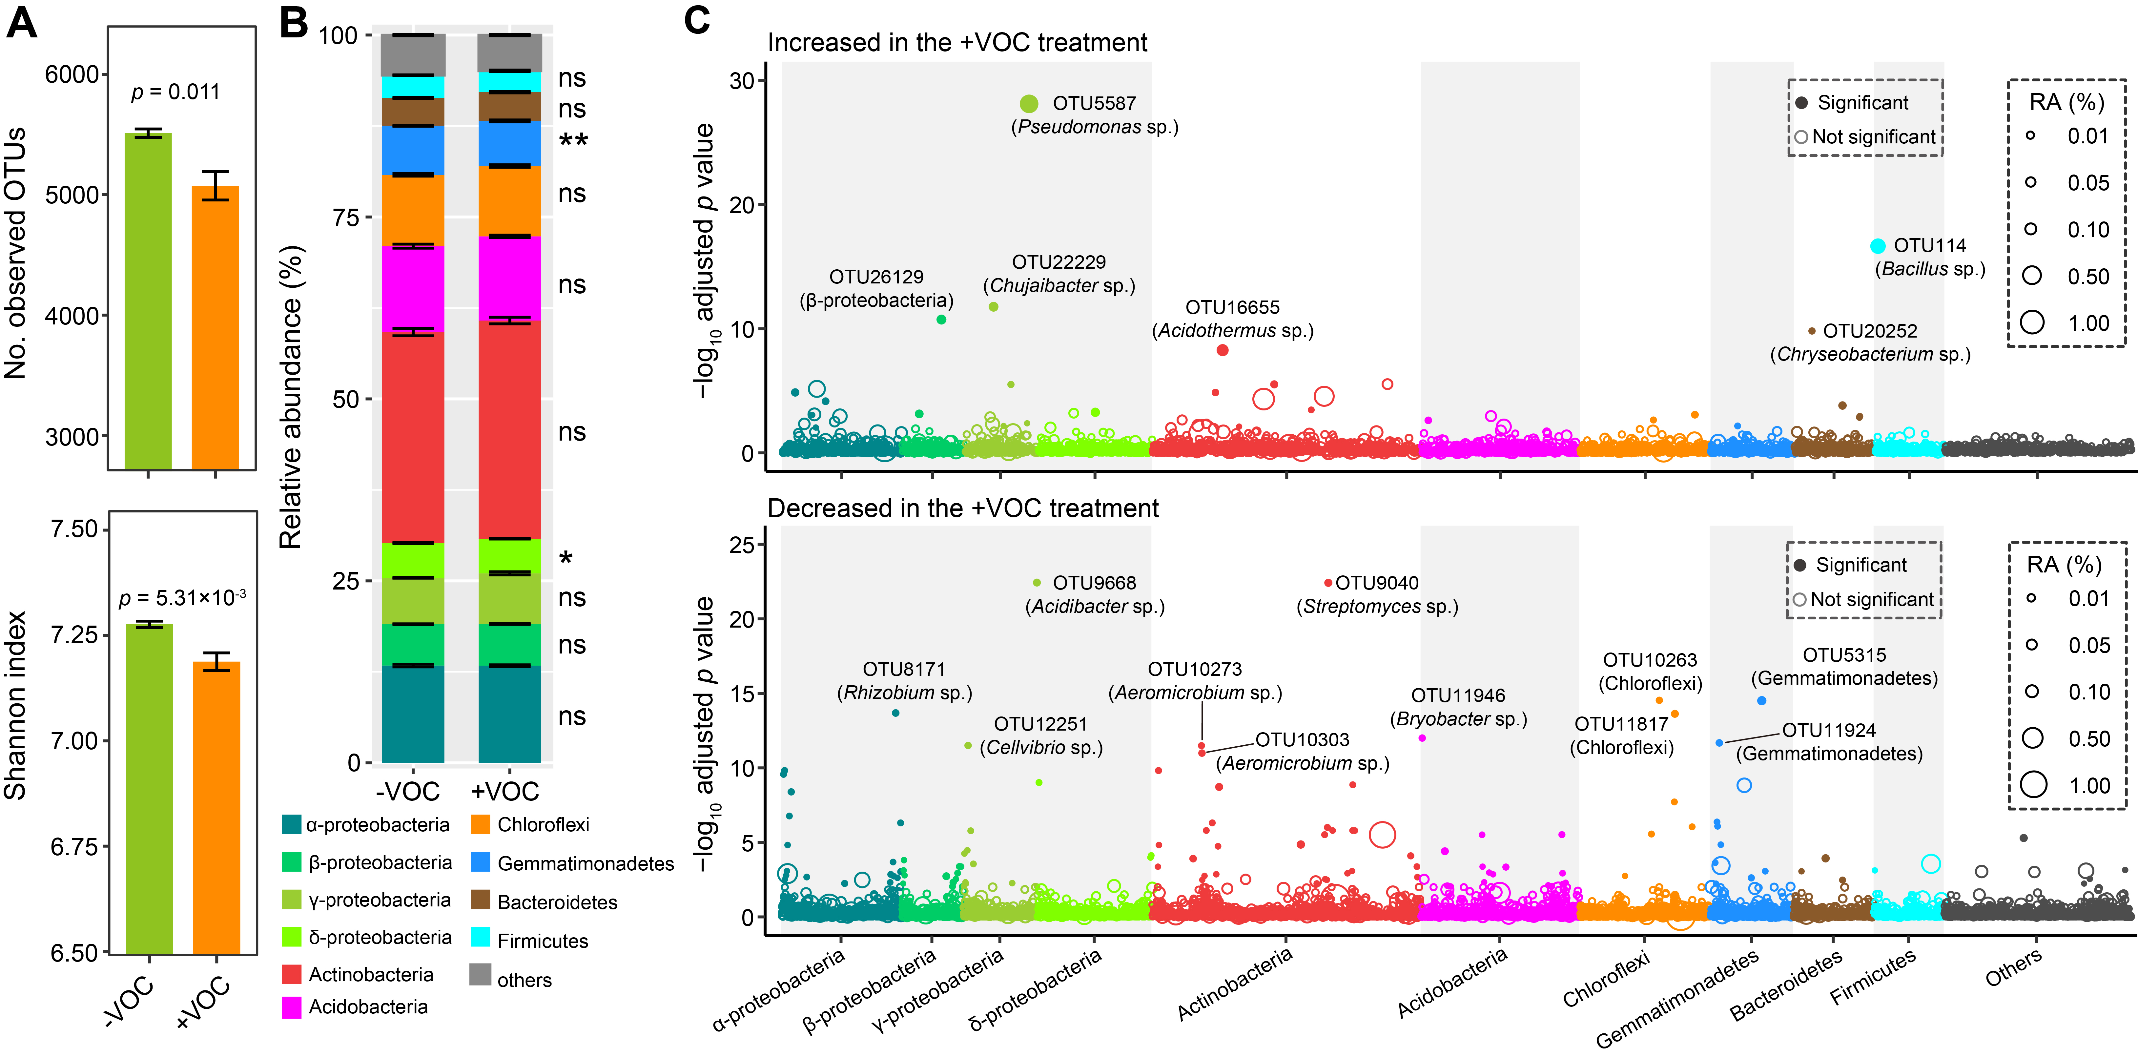
Figure S1. Effects of potato-onion VOCs on the α-diversity and taxonomic composition of the tomato rhizosphere bacterial community. A Bacterial community α-diversity from the tomato rhizosphere. The number (No.) of observed OTUs and the Shannon index are shown. B Relative abundance (RA) of the main bacterial phyla/Proteobacteria classes (mean relative abundances > 1%) in each treatment. Tomato plants were exposed to potato-onion VOCs (+VOC) or not (-VOC). Each bar represents the mean value of six replicates. C Manhattan plot displaying the taxonomic assignments of OTUs that increased or decreased (in terms of relative abundance) after exposure to potato-onion VOCs (false discovery rate-adjusted p < 0.01, log₂ fold change > 1). * and ** indicate significant difference at p < 0.05 and p < 0.01, respectively (Welch’s t-test).

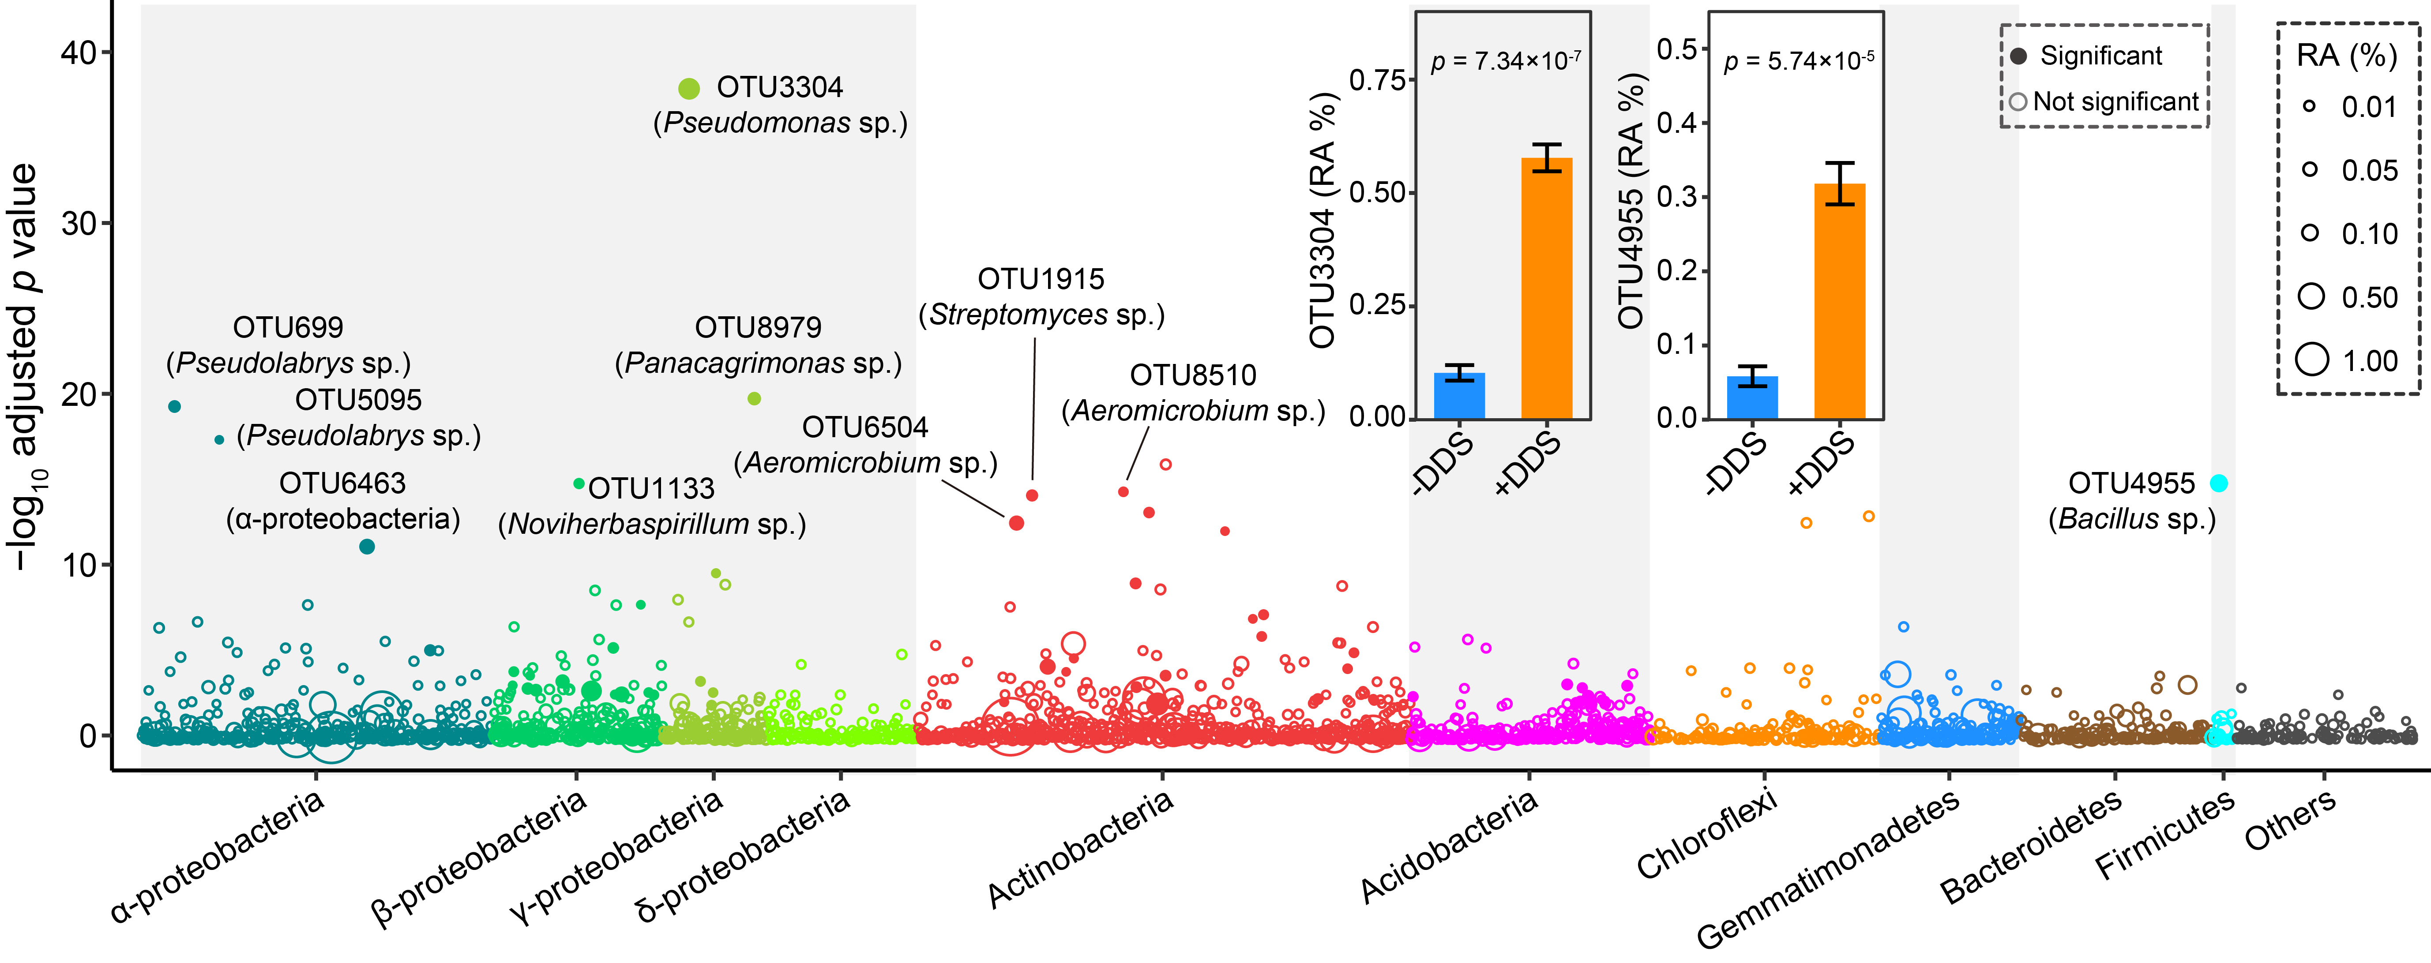
Figure S2. Effect of dipropyl disulfide on bacterial OTUs in the tomato rhizosphere. The Manhattan plot displays the taxonomic assignments of OTUs that increased in relative abundance after exposure to dipropyl disulfide (false discovery rate-adjusted p < 0.01, log₂ fold change > 1). The bar plot within the panel shows the relative abundances (RA) of OTU3304 and OTU4955. Tomato plants were treated with dipropyl disulfide (+DDS) or not (-DDS). Data are shown as mean ± SEM (n = 6). P-values were determined using Welch’s t-tests.

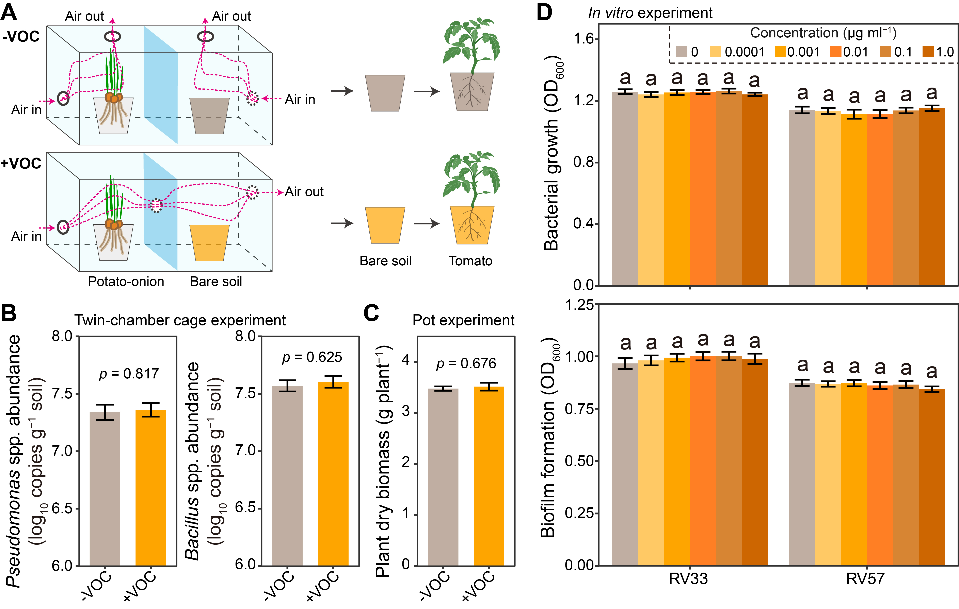
Figure S3. Effects of potato-onion VOCs on Pseudomonas and Bacillus spp. growth and biofilm formation. A The experimental set-up of the twin-chamber system was used to test the effect of potato-onion VOCs on the abundance of Pseudomonas and Bacillus spp. in bare soil. In this system, the bare soil was exposed to potato-onion VOCs (+VOC) or not (-VOC). In the following pot experiment, tomato plants were grown in bare soil from the twin-chamber system. B Pseudomonas and Bacillus spp. abundances in bare soil from the twin-chamber system. C Tomato plant dry biomass in the following pot experiment. D Effects of dipropyl disulfide on the in vitro growth and biofilm formation of RV33 and RV57. Data are shown as mean ± SEM (n = 6). P-values were determined using Welch’s t-tests. Different letters indicate significant differences between treatments (Tukey’s HSD test, p < 0.05).
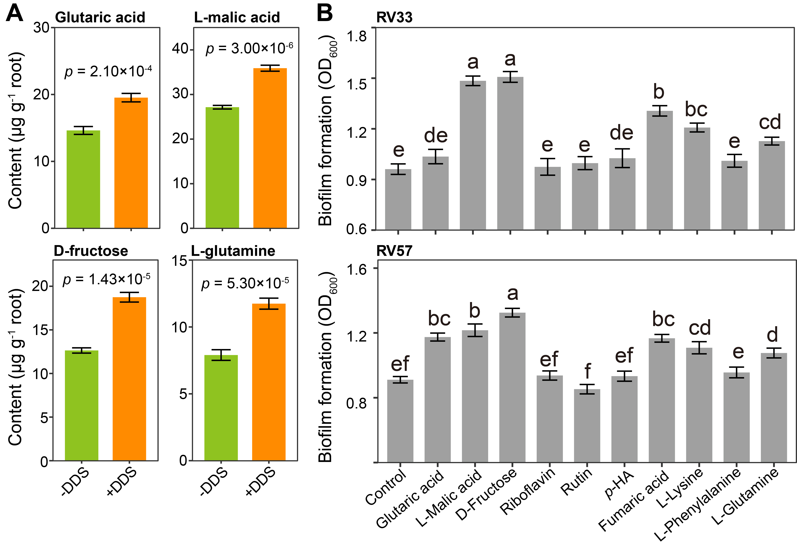
Figure S4. Effect of dipropyl disulfide on tomato root exudates and the effects of selected metabolites on the biofilm formation of bacterial isolates. A Concentration of selected metabolites in the tomato root exudate that were stimulated by exposure to dipropyl disulfide. B Effects of selected root exudate compounds (glutaric acid, L-malic acid, D-fructose, riboflavin, rutin, p-HA, fumaric acid, L-lysine, L-phenylalanine, L-glutamine) on the biofilm formation of the bacterial isolates RV33 and RV57. p-HA: p-Hydroxyacetophenone. Data are shown as mean ± SEM (n = 6). Different letters indicate significant differences between treatments (Tukey’s HSD test, p < 0.05). P-values were determined using Welch’s t-tests.
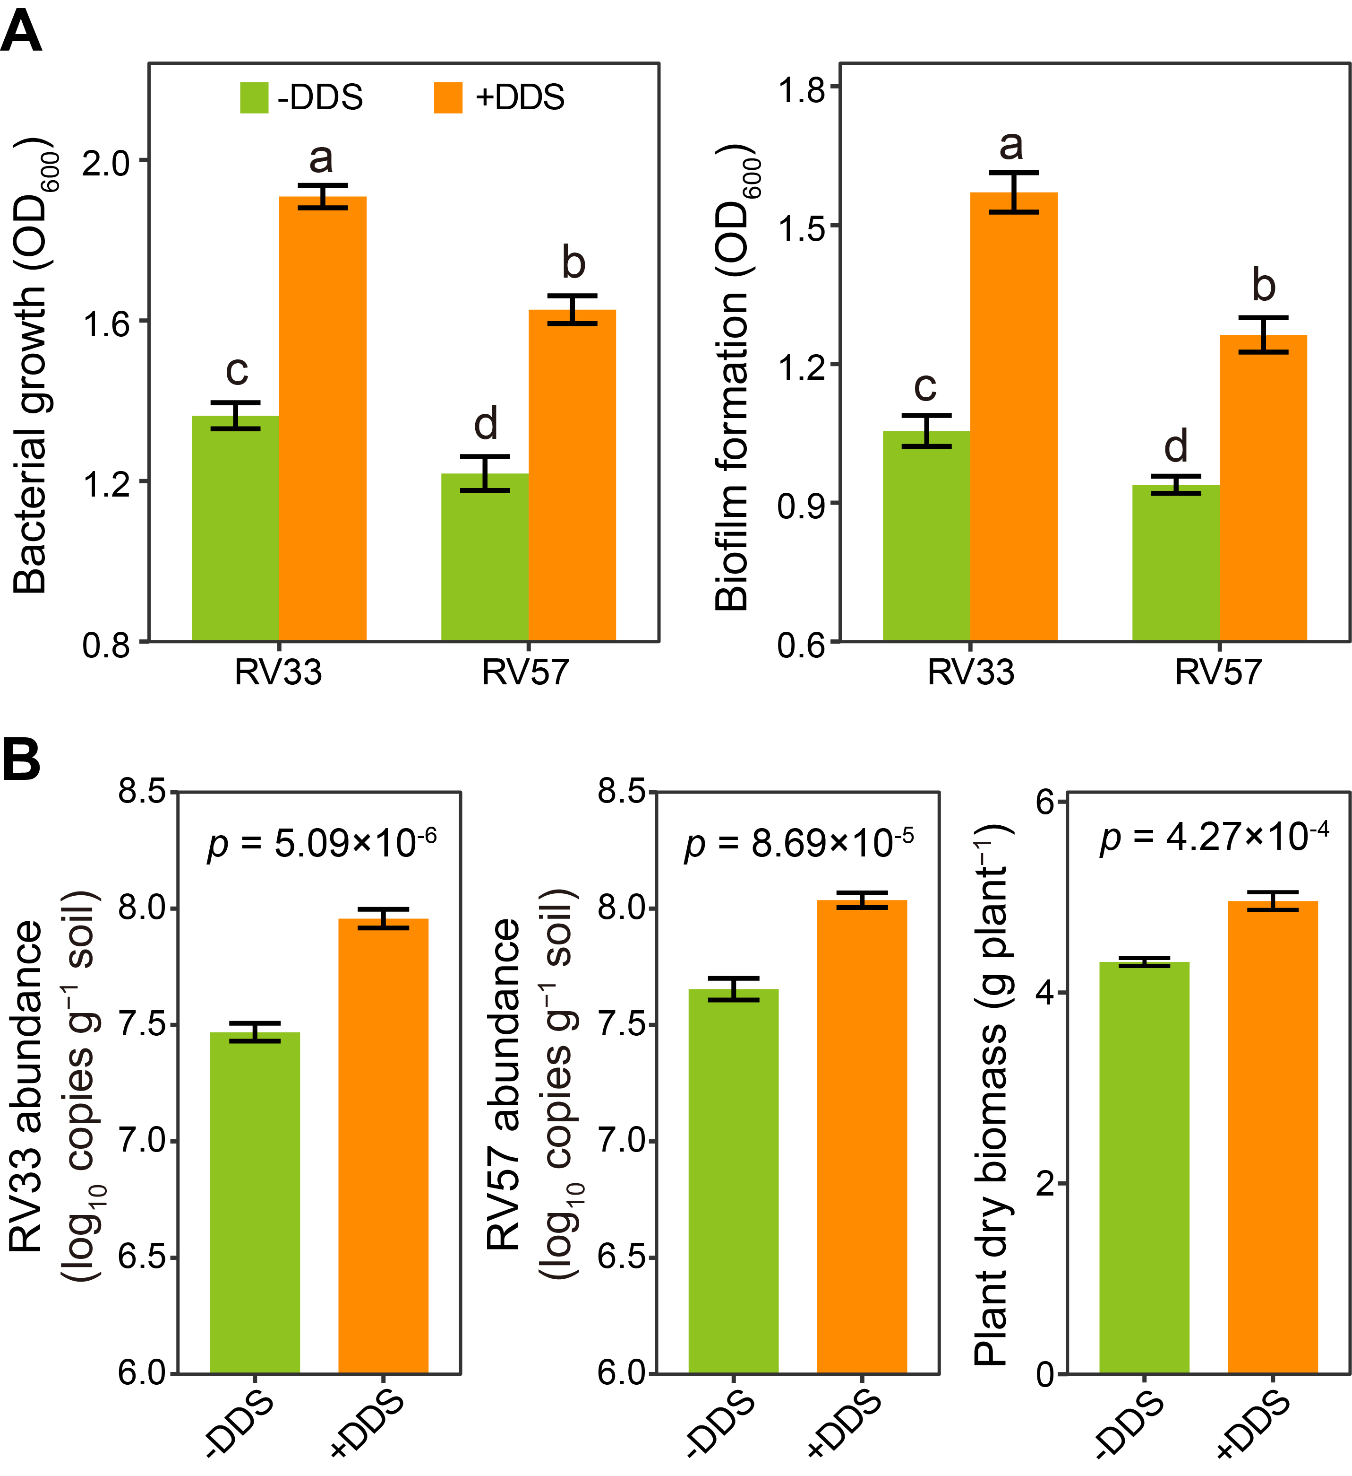
Figure S5. Root exudates of tomato plants treated with dipropyl disulfide stimulate root colonization by specific bacteria that positively affect plant growth. A Effects of root exudates of tomato plants treated with dipropyl disulfide (+DDS) or not (-DDS) on the growth and biofilm formation of the bacterial isolates RV33 and RV57. B Abundances of RV33 and RV57 in the rhizosphere and dry biomass of tomato plants grown in soil amended with root exudate of tomato plants treated with dipropyl disulfide (+DDS) or not (-DDS). Data are shown as mean ± SEM (n = 6). P-values were determined using Welch’s t-tests.
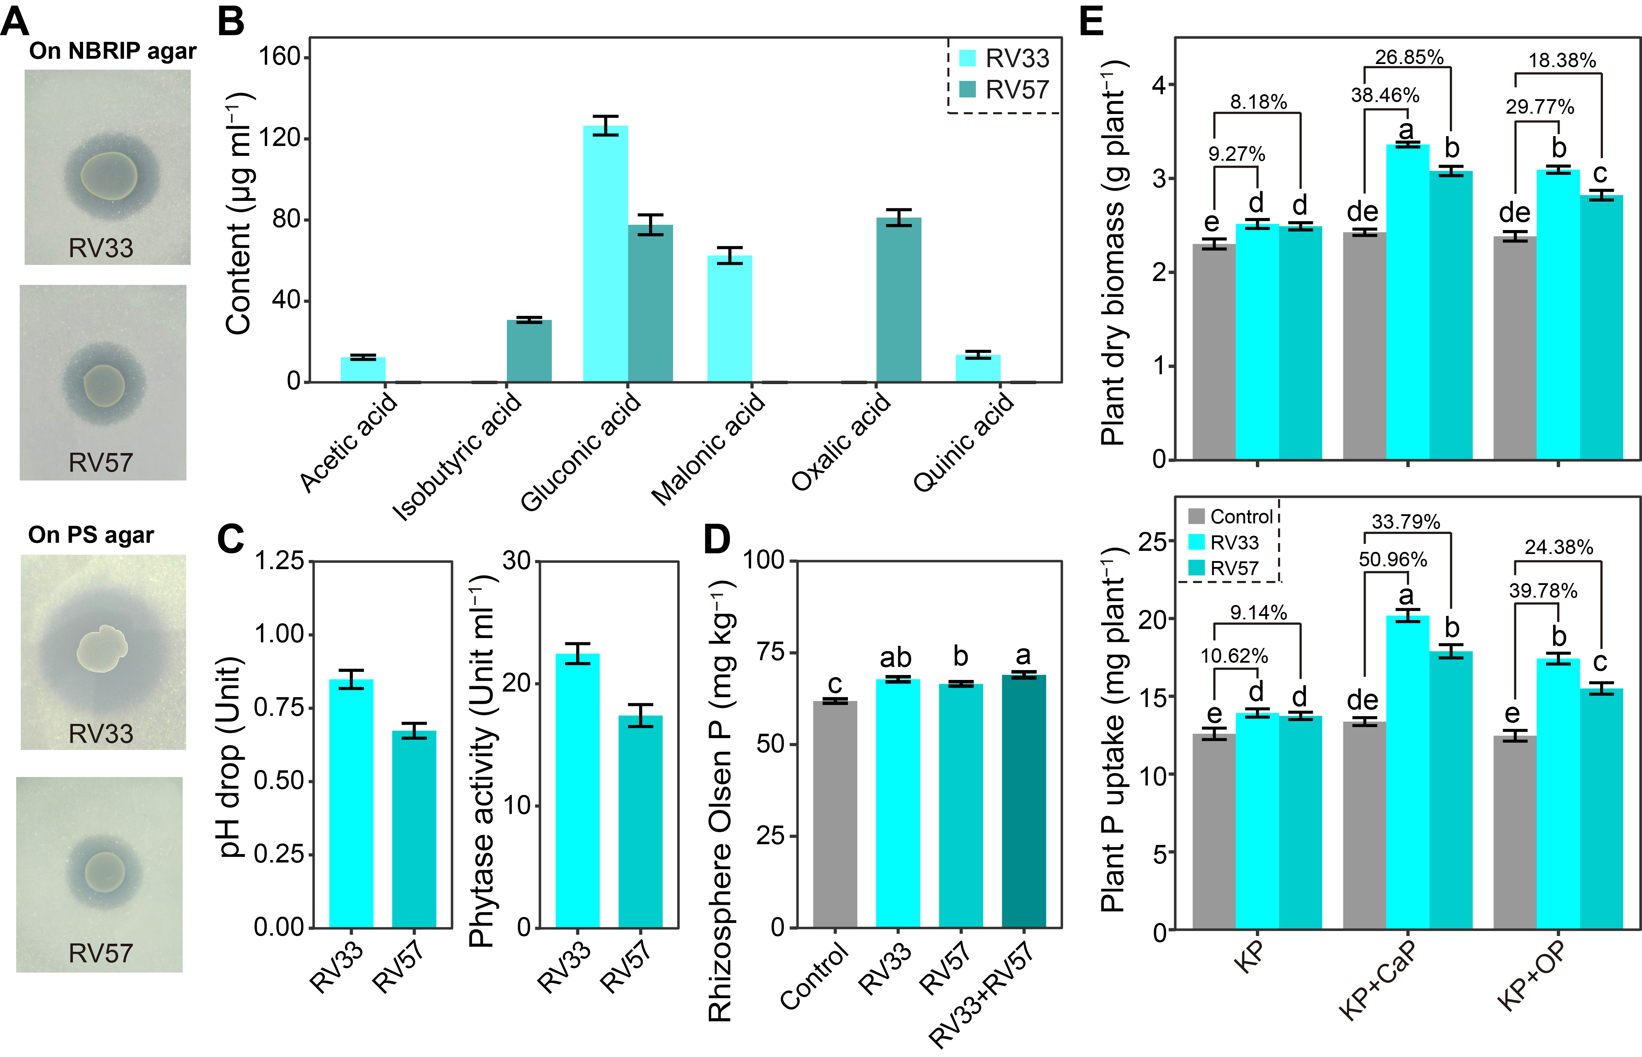
Figure S6. Phosphorous mobilization activity of the bacterial isolates RV33 and RV57. A Photographs showing the abilities of RV33 and RV57 to mobilize P on National Botanical Research Institute Phosphate (NBRIP) agar and phytase screening (PS) agar. B Organic acids produced by RV33 and RV57 in NBRIP broth determined by high-performance liquid chromatography analysis. C Changes in the pH of the culture medium caused by bacteria grown in NBRIP broth, and the bacterial phytase activity in PS broth. D Effects of the bacterial isolates RV33 and RV57 on the rhizosphere Olsen P content in the pot experiment. E Effects of RV33 and RV57 on the dry biomass and P uptake of tomato plants grown in soilless medium supplemented with different forms of phosphates. KP, soluble phosphate potassium dihydrogen phosphate (KH₂PO₄); CaP, poorly soluble inorganic phosphate tricalcium phosphate [Ca₃(PO₄)₂]; OP, organic phosphate Na-phytate. The values above bars are the increased percentages in each bacteria treatment vs. control. Data are shown as mean ± SEM (n = 6). Different letters indicate significant differences between treatments (Tukey’s HSD test, p < 0.05).

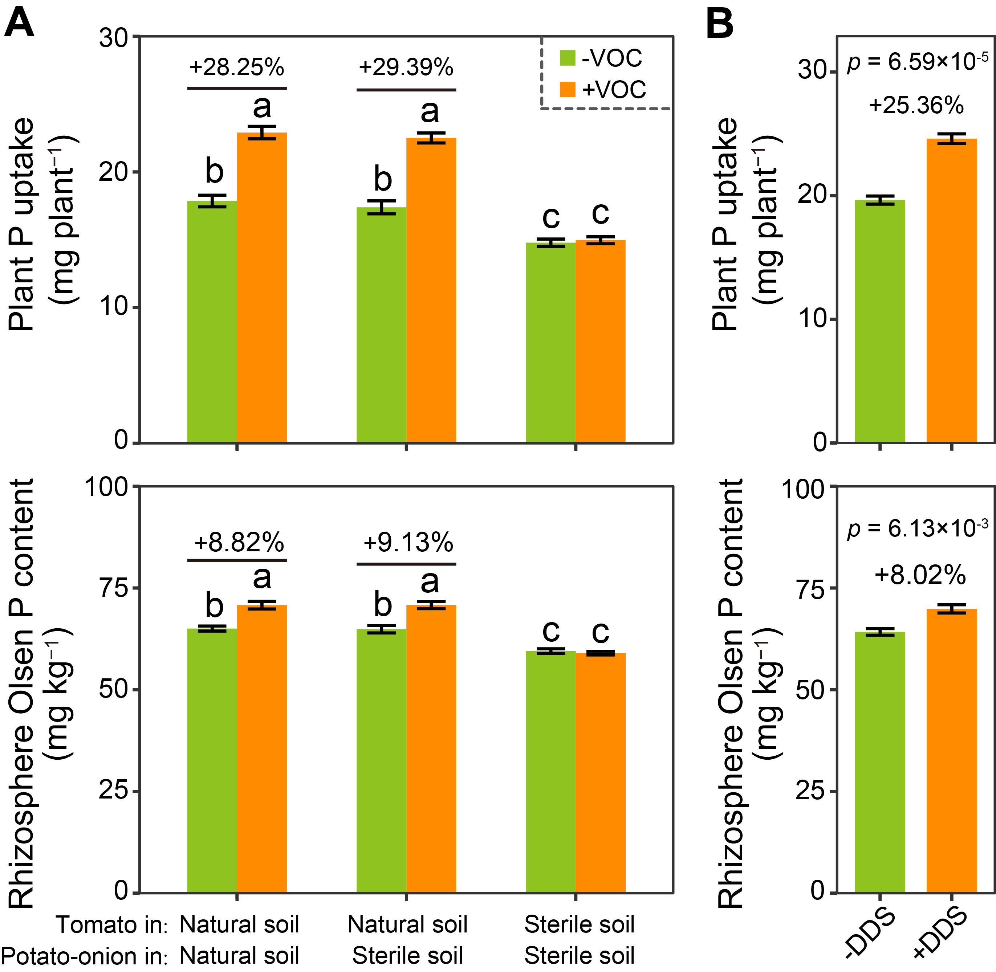
Figure S7. Potato-onion VOCs and dipropyl disulfide enhance tomato P uptake. A Tomato P uptake and rhizosphere Olsen P content data from the twin-chamber system used to test the effects of potato-onion VOCs on tomato growth. B Tomato plant P uptake and rhizosphere Olsen P content in the experiment used to test the effects of dipropyl disulfide on tomato growth in natural soil. Values above bars are the increased percentages in the +VOC treatment vs. the -VOC treatment (or in the +DDS treatment vs. the -DDS treatment). Data are shown as mean ± SEM (n = 6). P-values were determined using Welch’s t-tests. Different letters indicate significant differences between treatments (Tukey’s HSD test, p < 0.05).
Table S1. PCR primers used in this study
Target group/use | Primer name and sequence (5´-3´) | Reference
Bacteria  (Illumina sequencing) | F515, GTGCCAGCMGCCGCGG | Caporaso et al. [7]
Bacteria  (Illumina sequencing) | R907, CCGTCAATTCMTTTRAGTTT | Caporaso et al. [7]
Bacteria  (taxonomic affiliation) | 27F, AGAGTTTGATC(A/C)TGGCTCAG | Heuer et al. [8]
Bacteria  (taxonomic affiliation) | 1492R, TACGG(C/T)TACCTTGTTACGACTT | Heuer et al. [8]
Pseudomonas spp.  (quantitative PCR) | Pse435F, ACTTTAAGTTGGGAGGAAGGG | Bergmark et al. [9]
Pseudomonas spp.  (quantitative PCR) | Pse686R, ACACAGGAAATTCCACCACCC | Bergmark et al. [9]
Bacillus spp.  (quantitative PCR) | BacF, GGGAAACCGGGGCTAATACCGGAT | Garbeva et al. [10]
Bacillus spp.  (quantitative PCR) | BacR, GTCACCTTAGAGTGCCC | Garbeva et al. [10]

Supplementary references
1. Zhou X, Zhang J, Rahman MKU, Gao D, Wei Z, Wu F, et al. Interspecific plant interaction via root exudates structures the disease suppressiveness of rhizosphere microbiomes. Mol Plant. 2023;16:849-864.
2. Jin X, Rahman MKU, Ma C, Zheng X, Wu F, Zhou X. Silicon modification improves biochar’s ability to mitigate cadmium toxicity in tomato by enhancing root colonization of plant-beneficial bacteria. Ecotox Environ Safe. 2023;249:114407.
3. Mehta S, Nautiyal CS. An efficient method for qualitative screening of phosphate-solubilizing bacteria. Curr Microbiol. 2001;43:51-56.
4. Jorquera MA, Hernández MT, Rengel Z, Marschner P, de la Luz Mora M. Isolation of culturable phosphobacteria with both phytate-mineralization and phosphate-solubilization activity from the rhizosphere of plants grown in a volcanic soil. Biol Fertil Soils. 2008;44:1025-1034.
5. Murphy J, Riley JP. A modified single solution method for the determination of phosphate in natural waters. Anal Chim Acta. 1962;26:31-36.
6. Patel KJ, Singh AK, Nareshkumar G, Archana G. Organic-acid-producing, phytate-mineralizing rhizobacteria and their effect on growth of pigeon pea (Cajanus cajan). Appl Soil Ecol. 2010;44:252-261.
7. Caporaso JG, Lauber CL, Walters WA, Berg-Lyons D, Huntley J, Fierer N, et al. Ultra-high-throughput microbial community analysis on the Illumina HiSeq and MiSeq platforms. ISME J. 2012;6:1621-1624.
8. Heuer H, Krsek M, Baker P, Smalla K, Wellington EM. Analysis of actinomycete communities by specific amplification of genes encoding 16S rRNA and gel-electrophoretic separation in denaturing gradients. Appl Environ Microbiol. 1997;63:3233-3241.
9. Bergmark L, Poulsen PHB, Abu Al-Soud W, Norman A, Hansen LH, Sørensen SJ. Assessment of the specificity of Burkholderia and Pseudomonas qPCR assays for detection of these genera in soil using 454 pyrosequencing. FEMS Microbiol Lett. 2012;333:77-84.
10. Garbeva P, van Veen JA, van Elsas JD. Predominant Bacillus spp. in agricultural soil under different management regimes detected via PCR-DGGE. Microb Ecol. 2003;45:302-316.

