Figure S1. Data characteristics of phenotype and their relationships.
A-J. The data characteristics of lactation performance and rumen SCFA. MY: milk yield, MF: milk fat, MP: milk protein, ML: milk lactose, ECM: energy-corrected milk, A:P: acetate/propionate, TA: total acid. K. The relationships between rumen SCFA and lactation performance.

Figure S2. The differences of rumen microbial diversity and compositions at species level among low, medium and high group of ECM.
A. The differences of rumen microbial α-diversity among low, medium and high group of ECM. B. The differences of rumen microbial β-diversity among low, medium and high group of ECM. The differences of rumen microbial compositions at species level among low, medium and high group of ECM by LEfSe analysis. The threshold set as 3.

Category | Count
Variants processed | 57
Variants filtered out | 0
Novel / existing variants | 40 (70.2) / 17 (29.8)
Overlapped genes | 16
Overlapped transcripts | 36
Overlapped regulatory features | -

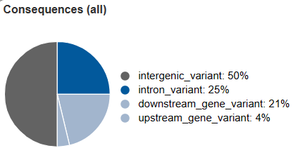
D

Figure S3. Individual genetic information of 304 dairy cows.
A. Genome-wide genetic variation distribution and functional annotation. B. The kinship matrix of 304 dairy cows. C. The population structure of 304 dairy cows. D. The variant effect predictor results of lactation performance and rumen SCFA by Ensembl Variant Effect Predictor

Category | Count
Variants processed | 104
Variants filtered out | 0
Novel / existing variants | 72 (69.2) / 32 (30.8)
Overlapped genes | 32
Overlapped transcripts | 58
Overlapped regulatory features | -
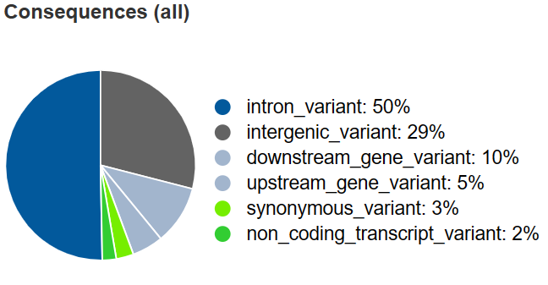
A

Figure S4. The heritability and genetic information of rumen microbiota
A. The variant effect predictor results of rumen highly heritable subsets from top 100 microorganisms at species level by Ensembl Variant Effect Predictor.

Category | Count
Variants processed | 103
Variants filtered out | 0
Novel / existing variants | 63 (61.2) / 40 (38.8)
Overlapped genes | 9
Overlapped transcripts | 19
Overlapped regulatory features | -
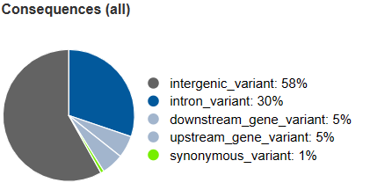
B
C
Figure S5. The variants information of highly heritable CAZy modules at family level by GWAS.
A. The Manhattan plot of highly heritable subsets from top 100 CAZy modules at family level. B. The variant effect predictor results of highly heritable subsets from top 100 CAZy modules at family level by Ensembl Variant Effect Predictor. C. The relative contribution (%) of top abundant species for GH95, GH115, GH10, GH13, GH43_10, GH13_38, and GH87
Category | Count
Variants processed | 141
Variants filtered out | 0
Novel / existing variants | 131 (92.9) / 10 (7.1)
Overlapped genes | 15
Overlapped transcripts | 19
Overlapped regulatory features | -
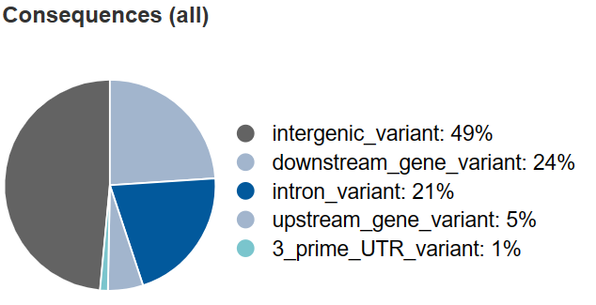
F

Figure S6. The characteristic and variant information of rumen highly heritable metabolites.
A. The PLS-DA plot of low, medium, and high group of ECM. B. the relationship between lowly, highly heritable metabolites and phenotype. C. The HMDB classification of rumen highly heritable metabolites at superclass level. D. The KEGG enrichment pathways of rumen highly heritable metabolites. E. The Manhattan plot of rumen highly heritable subsets from top 50 metabolites. F. The variant effect predictor results of rumen highly heritable subsets from top 50 metabolites by Ensembl Variant Effect Predictor.

Figure S7. Validation of key microbes affecting phenotype by random forest
Random forest analysis was conducted on 247 rumen microbes identified through MWAS that simultaneously affect ECM and rumen A:P ratio. The top 20 microbes with mean decrease accuracy index were identified as key biomarkers for ECM (A) and rumen A:P ratio (C). 10 fold cross validation was used to validate the results of ECM (B) and rumen A:P ratio (D). At the same time, heritability statistics were conducted on the top 20 microbes with mean decrease accuracy (E).

Figure S8. The relationships among ECM, GH24, Pseudobutryrivibrio, and 9,10,13-TriHOME
A-D. The differences of ECM (A), GH24 (B), Pseudobutryrivibrio (C), and 9,10,13-TriHOME (D) between AG and GG genotype.
E. The Spearman correlation between GH24 and highly or lowly heritable microbes. Blue circle represents lowly heritable microbes. Green circle represents lowly heritable microbes. Black arrows represent correlation coefficient is greater than or equal to 0.6. Grey arrows represent correlation coefficient is lower than 0.6.
F. The relationships among ECM, GH24, Pseudobutryrivibrio, and 9,10,13-TriHOME in SEM. Red arrows represent positive paths, and green arrows represent negative paths.

