Supporting Information for

Lineage-dependent partitioning of activities in chemoclines defines Woesearchaeota ecotypes in an extreme aquatic ecosystem

Lilian A. Cloarec ¹, Thomas Bacchetta ¹, Maxime Bruto ², Christophe Leboulanger ³, Vincent Grossi ^{4#}, Céline Brochier-Armanet ^{5,6}, Jean-Pierre Flandrois ⁵, Adrian Zurmely ⁵, Cécile Bernard ⁷, Marc Troussellier ³, Hélène Agogué ⁸, Magali Ader ⁹, Christine Oger-Desfeux ¹⁰, Philippe M. Oger ¹, Adrien Vigneron ¹, Mylène Hugoni ^{1,6,*}

*Corresponding author: Mylène Hugoni, Université Claude Bernard Lyon 1, INSA Lyon, CNRS, UMR5240 Microbiologie Adaptation et Pathogénie, F-69621 Villeurbanne, France - mylene.hugoni@univ-lyon1.fr
ORCID: 0000-0002-2430-1057​

This PDF file includes:

Supplementary Methods
Supplementary References
Figures S1, S2, S3, S4 and S5
Tables S1 to S3
Source data 1, 2, 3, 4 and 5 are available here: https://doi.org/10.6084/m9.figshare.26212661

Source data 1: Presence/absence of genes involved in metabolic pathways of Woesearchaeota, with their respective KO number and gene name according to KEGG and PGAP. Activity for each predicted ORF was calculated for each sampling depth and normalized by reads per kilo base per million mapped reads (TPM).

Source data 2: Transcriptomic activity for each predicted ORF in quality MAGs (n=9). Calculation was conducted for the different sampling depths and normalized by reads per kilo base per million mapped reads (TPM).

Source data 3: Summary of metabolic annotations of MAGs of Woesearchaeota from Lake Dziani Dzaha using PGAP, KOFAMscan, CAZy, METABOLIC and HydDB.

Source data 4: [FeFe]-hydrogenases sequences used in Supplementary Figure 2.

Source data 5: Custom Python 3.10 script for inferring the ratio of amino acids in the Woesearchaeota MAGs from Lake Dziani Dzaha.

Supplementary Methods

RNA extraction
RNA was extracted from 0.2µm filters (i.e. three pooled replicates per sample to obtain enough RNA) using the Quick-RNATM MiniPrep kit (Zymo Research), optimized for the hypersaline samples. Briefly, filters were cut into pieces using sterile material and then placed in the 2mL ZR BashingBead Lysis tubes filled with 500 µL of phenol/chloroform/isoamyl alcohol (25:24:1) and 600 µL of lysis buffer. Samples were then homogenized using a FastPrep-24TM 5G (MP BiomedicalsTM) at 6 min.sec⁻¹ during 30 seconds, placed on ice for 5 minutes, and homogenized again (6 min.sec⁻¹, 30 seconds). Centrifugation was performed for 5 minutes at speed 13,000g, 4°C. The aqueous phase was then transferred to step 2 of the Quick-RNATM MiniPrep kit, following manufacturer’s instructions. Elution was performed using two 50 µL volumes of DNase/RNase-free water, which were later combined. Additional DNAse treatment was performed using the TURBO DNA-freeTM kit (InvitrogenTM), and a generalist 16S rRNA gene PCR was performed out using 515F/909R primers [1,2] to assess the absence of any residual DNA contamination. RNA extracts from triplicates were then pooled and quantified using the Qubit RNA BR Assay Kit (Invitrogen, Carlsbad, USA) and quality assessed using a Bioanalyzer Pico chip (Agilent). RNA extracts were stored at -80°C until library preparation. The library was prepared after rRNA depletion by RiboZero Gold + Bacterial kit, using the TruSeq stranded mRNA kit (Illumina, CA, USA) and sequenced on HiSeq 4000 2*150bp by the Fasteris company (Plan-les-Ouates, Switzerland).

Hydrogenases phylogeny
The amino acid sequences of 1,397 [FeFe] hydrogenases were retrieved from the hydrogenase database (HydDB) [3], from the archaeal genomes analyzed in the Greening et al. (2024) study [4], and from the [FeFe] hydrogenases retrieved from both MAGs of Woesearchaeota retrieved from Lake Dziani Dzaha. CD-hit [5] v4.8.1 was used to reduce the dataset at 100% amino acid sequence identity level. Altogether, the set of genes used for genes-level phylogenetic contained 1,384 genes: 26 [FeFe] hydrogenase from woesearchaeal MAGs from this study with non-assigned subgroups and 1,358 from previously analyzed [FeFe] hydrogenases. Alignment of the sequences was performed as previously described in Greening et al. (2024) [4] with MAFFT [6] v7.520 (options: --localpair --maxiterate 1000 --reorder). Trimming was performed with TrimAl [7] v1.4 (options: -gt 0.1). ML phylogenetic trees were inferred with IQ-tree [8] v2.2.5 (options: -m LG+C20+R+F -nt AUTO -bb 1000 -alrt 1000).

Supplementary References

1. Luis P, Saint-Genis G, Vallon L, Bourgeois C, Bruto M, Marchand C, et al. Contrasted ecological niches shape fungal and prokaryotic community structure in mangroves sediments. Environ Microbiol. 2019;21:1407–24.
2. Parada AE, Needham DM, Fuhrman JA. Every base matters: assessing small subunit rRNA primers for marine microbiomes with mock communities, time series and global field samples. Environ Microbiol. 2016;18:1403–14.
3. Søndergaard D, Pedersen CNS, Greening C. HydDB: A web tool for hydrogenase classification and analysis. Sci Rep. 2016;6:34212.
4. Greening C, Cabotaje PR, Valentin Alvarado LE, Leung PM, Land H, Rodrigues-Oliveira T, et al. Minimal and hybrid hydrogenases are active from archaea. Cell. 2024;187:3357-3372.e19.
5. Fu L, Niu B, Zhu Z, Wu S, Li W. CD-HIT: accelerated for clustering the next-generation sequencing data. Bioinforma Oxf Engl. 2012;28:3150–2.
6. Katoh K, Rozewicki J, Yamada KD. MAFFT online service: multiple sequence alignment, interactive sequence choice and visualization. Brief Bioinform. 2019;20:1160–6.
7. Capella-Gutiérrez S, Silla-Martínez JM, Gabaldón T. trimAl: a tool for automated alignment trimming in large-scale phylogenetic analyses. Bioinforma Oxf Engl. 2009;25:1972–3.
8. Minh BQ, Schmidt HA, Chernomor O, Schrempf D, Woodhams MD, von Haeseler A, et al. IQ-TREE 2: New Models and Efficient Methods for Phylogenetic Inference in the Genomic Era. Mol Biol Evol. 2020;37:1530–4.
9. Hugoni M, Escalas A, Bernard C, Nicolas S, Jézéquel D, Vazzoler F, et al. Spatiotemporal variations in microbial diversity across the three domains of life in a tropical thalassohaline lake (Dziani Dzaha, Mayotte Island). Mol Ecol. 2018;27:4775–86.

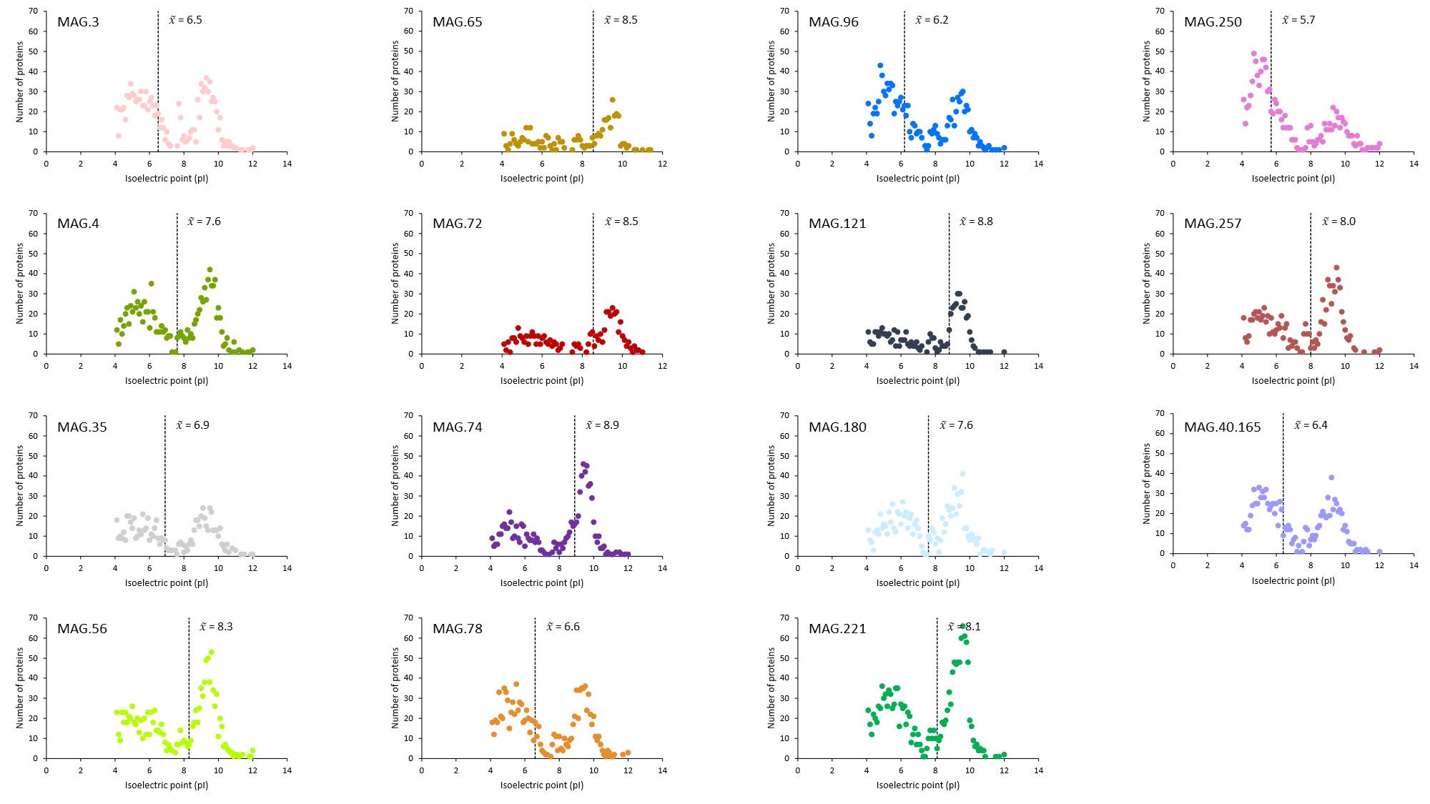

Supplementary Figure 1. Distribution of the Isoelectric point (pI) of the predicted proteins in Woesearchaeota MAGs from Lake Dziani Dzaha. To calculate pI distribution, pI values were rounded to one digit.

Supplementary Figure 2. Proportion of total ORFs assigned as hypothetical or annotated proteins for each of the nine MAGs of Woesearchaeota from Lake Dziani Dzaha (contamination <5%, completion >70%). Percentage of ORFs annotated as “annotated proteins” is labeled for each MAGs.

Supplementary Figure 3. Maximum likelihood phylogeny of the [FeFe] hydrogenase genes. The tree was inferred using 1384 [FeFe] hydrogenases sequences. The tree was computed with IQ-TREE, model LG+C20+R+F. The tree was rooted using [FeFe] hydrogenases affiliated to subgroups B and C. Branch robustness was evaluated using ultrafast bootstrap and aLRT supports computed with IQ-TREE. Only branches with both supports >0.95 are highlighted (black circles). The scale bar corresponds to evolutionary distance (i.e., the average number of substitutions inferred per site). Subgroups from A to G are colored within the corresponding branches in the tree. Uncolored branches identify sequences that were not previously analyzed. Phylum levels of identified Archaea sequences are colored at the corresponding labels in the tree. Source data are available in Source data 4.

Supplementary Figure 4. Transcriptomic activity of the nine woesearchaeal MAGs from Lake Dziani Dzaha for A. 0.25m, B. 1m, C. 2.5m, D. 5m, E. 11m, F. 14m and G. 16m. Each circle represents a transcript, whose size depends on the level of activity (based on the output of the jgi_summarize_bam_contig_depths from MetaBAT 2). The ten most active transcripts for each depth were numbered and the PGAP annotation filled in. (n = total number of active transcripts for the nine MAGs)

1: Hypothetical protein (MAG.221_000310) ; 2: Hypothetical protein (MAG.221_001533) ; 3: S-layer protein (MAG. 96_000161) ; 4: S-layer protein (MAG. 4_000130) ; 5: Hypothetical protein (MAG.257_000750) ; 6: Hypothetical protein (MAG.221_000975) ; 7: CRISPR-associated protein Cas7/Csp1 ; 8: YceI family protein ; 9: Hypothetical protein (MAG. 96_001127) ; 10: Archaellin/type IV pilin (flaB) ; 11: Cell division protein FtsZ ; 12: Translation elongation factor EF-1 ; 13: Hypothetical protein (MAG.96_000259) ; 14: Stress response translation initiation inhibitor YciH ; 15: Hypothetical protein (MAG.221_000887) ; 16: TRAM domain-containing protein 17: ATP synthase F0 subunit C ; 18: Hypothetical protein (MAG.3_000810) ; 19: S-layer protein (MAG. 78_001144) ; 20: Peptidylprolyl isomerase ; 21: Hypothetical protein (MAG.221_001021) ; 22: Archaellin/type IV pilin (flaB) ; 23: Histone family protein ; 24: Cold shock domain-containing protein 25: Hypothetical protein (MAG.221_000178) ; 26: 50S ribosomal protein P1 ; 27: Hypothetical protein (MAG.221_000862) ; 28: Archaellin/type IV pilin (flaB) ; 29: Archaellin/type IV pilin (flaB).

Supplementary Figure 5. Woesearchaeota distribution in historically stratified periods in 2014 and 2015. Depth profiles of Woesearchaeota populations were estimated based on the percentage of mapped reads from metagenomes produced from 2014 and 2015 samples. Scale is logarithmic. According to Hugoni et al. (2018)[9], the seasonal chemoclines are represented in blue, and the deep chemoclines in pink.

Supplementary Table 1. Average Amino Acid Identity (AAI) between the 15 Woesearchaeota MAGs from Lake Dziani Dzaha.

Supplementary Table 2. Genomic characteristics of the 636 Woesearchaeota MAGs retrieved from NCBI database. Woesearchaeota MAGs that reach our threshold (contamination <5%, completion >70%, numbers of contigs ≤150, sequencing depth >10X) were specified. In 136 cases the sequencing depth was not available, N.A. was then filled in. The last column indicated subgroups of MAGs used in Huang et al. (2021).

Supplementary Table 3. Genomic characteristics of the 38 DPANN MAGs retrieved from NCBI database (contamination <5%, completion >70%, numbers of contigs ≤150, sequencing depth >10X). In 3 cases the sequencing depth was not available, N.A. was then filled in.

