Supplementary figures

Figure S1 Map of the geographic locations of the field-collected samples. The latitudes and longitudes of the seven collection sites are as follows: MengLun: 21.892319 N, 101.280868 E; KaiYuan: 23.66561 N, 103.280817 E; ShiLin: 24.41086 N, 98.495312 E; MangShi: 24.41086 N, 98.495312 E; QingYuan: 24.633446 N, 112.331656 E; NanNing: 22.64309 N, 108.234571 E; and SanYa: 18.386363 N, 109.143506 E.

Figure S2 Fluorescence micrographs of maize roots (A-C) and leaves (D-E) taken under visible light (C-D) and UV light (A, B, E). The exposure conditions are the same as those shown in Figure 2.

Figure S3 Bright field of Malpighian tubules from FAW larvae.

Figure S4 Bxs detected in maize crude extract and frass of FAW after metabolism by gut microbiome and P. dispersa. (A-E) The 5th instar of normal (Nor, with entire FAW larval microbiome), aseptic (Ase), and P. dispersa-inoculated FAW were starved for 4 h. Gut contents from each FAW were collected and inoculated with 200 µl maize crude extract for 3 h, and (F) frass was collected after FAW feeding on surface-sterilized maize leaves for 24 h. In frass, the levels of HDMBOA-Glc were below limits of detection. Different letters denote significant differences between groups based on one-way ANOVA followed by Duncan’s multiple comparison test at P < 0.05 (n = 5).

Figure S5 Nitrogen fixation by P. dispersa. Nitrogen fixation activity measured by acetylene reduction. The data are means ± SEs. Asterisks indicate significant differences between the control (Con, P. dispersa cultured in media supplemented with NH₄Cl) and treatment (P. dispersa cultured in media not supplemented with NH₄Cl) groups (Student’s t test, n = 6, ***, P < 0.001).
ssssss

Figure S6 Fluorescence micrographs of FAW testes (A-B), eggs (C-D), and Malpighian tubules taken under visible light (A, C, E) and UV light (B, D, F, G). The exposure conditions are the same as those shown in Figure 2. Fluorescence in eggs is marked by the red arrows.
Figure S7 P. dispersa has no effect on the larval growth of M. separata. Aseptic M. separata without (Con) or with P. dispersa inoculation were fed on wild-type (WT) maize leaves for a period of 10 days. The data are presented as the means ± SEs; n = 30.

Figure S8 Genome and transcriptome sequencing revealed candidate genes involved in Bxs metabolism. (A) Gene map of the P. dispersa chromosome and (B-C) gene map of two plasmids. (D) Top upregulated genes related to Bxs metabolism with a log2-fold change > 4 between the control (Con1-3) and Bx treatment (BX1-3).

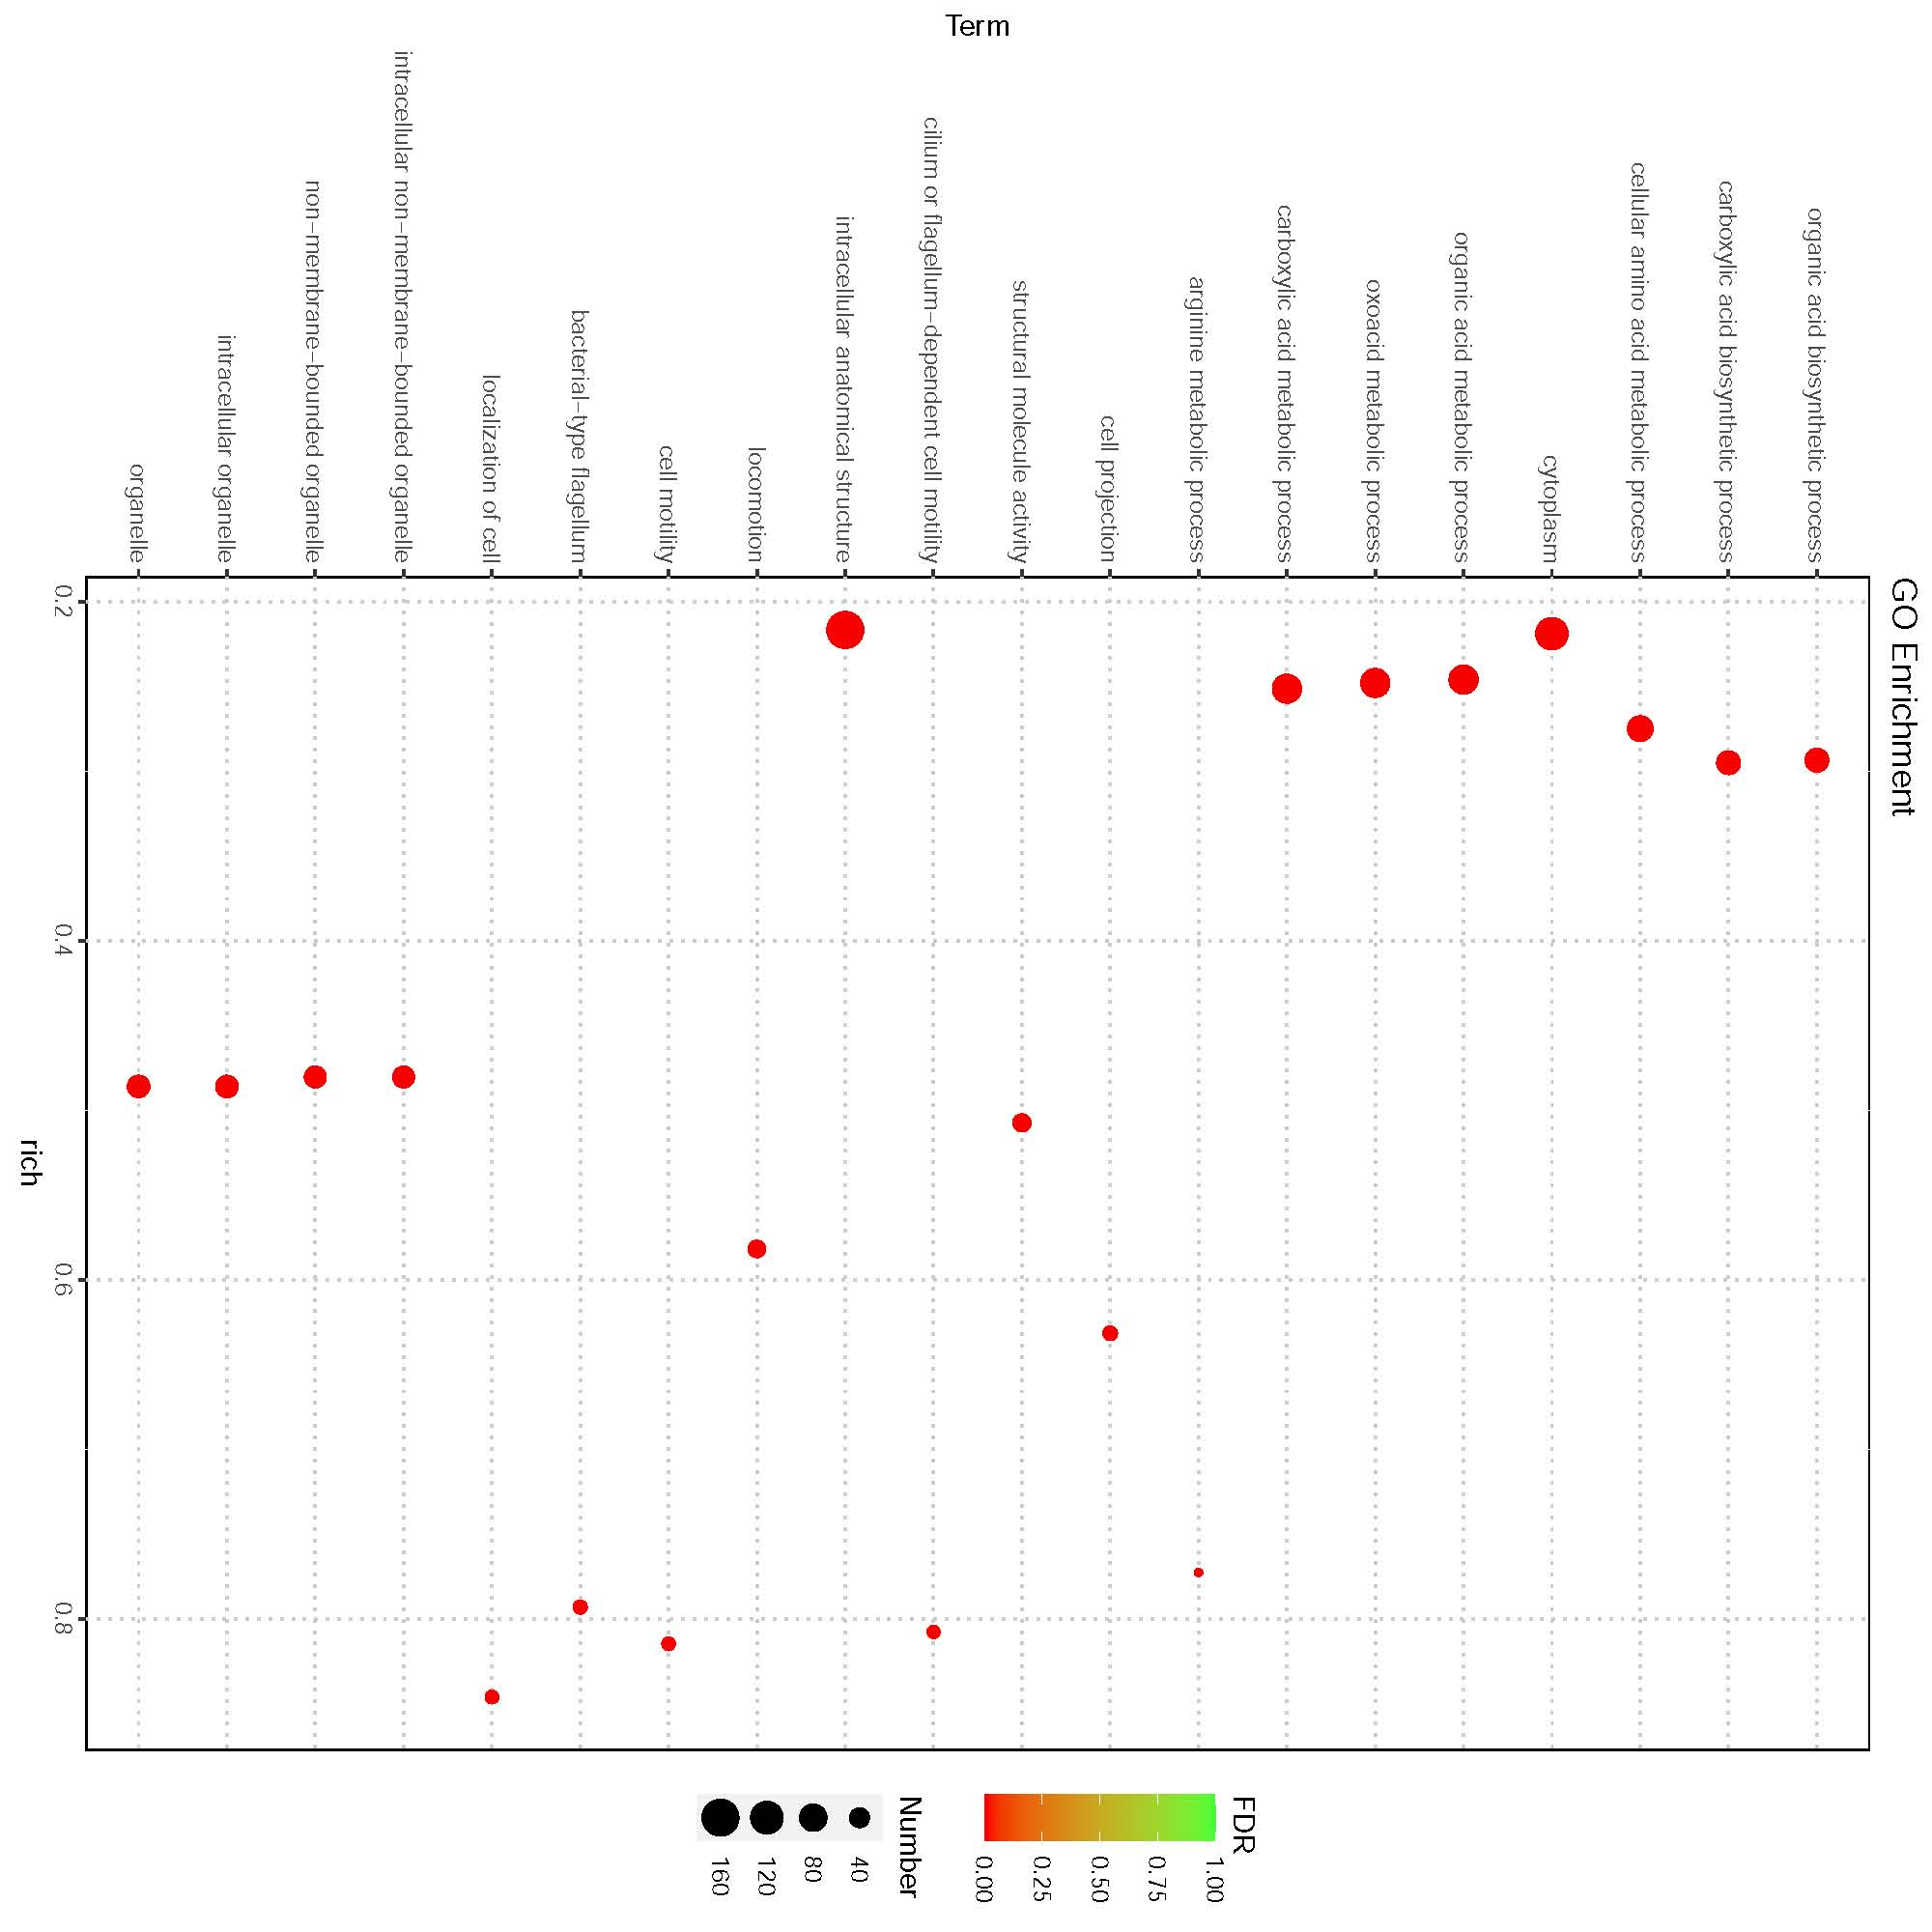
Figure S9 GO enrichment analysis of P. dispersa genes whose expression was altered in response to Bxs serving as the sole carbon and nitrogen source.

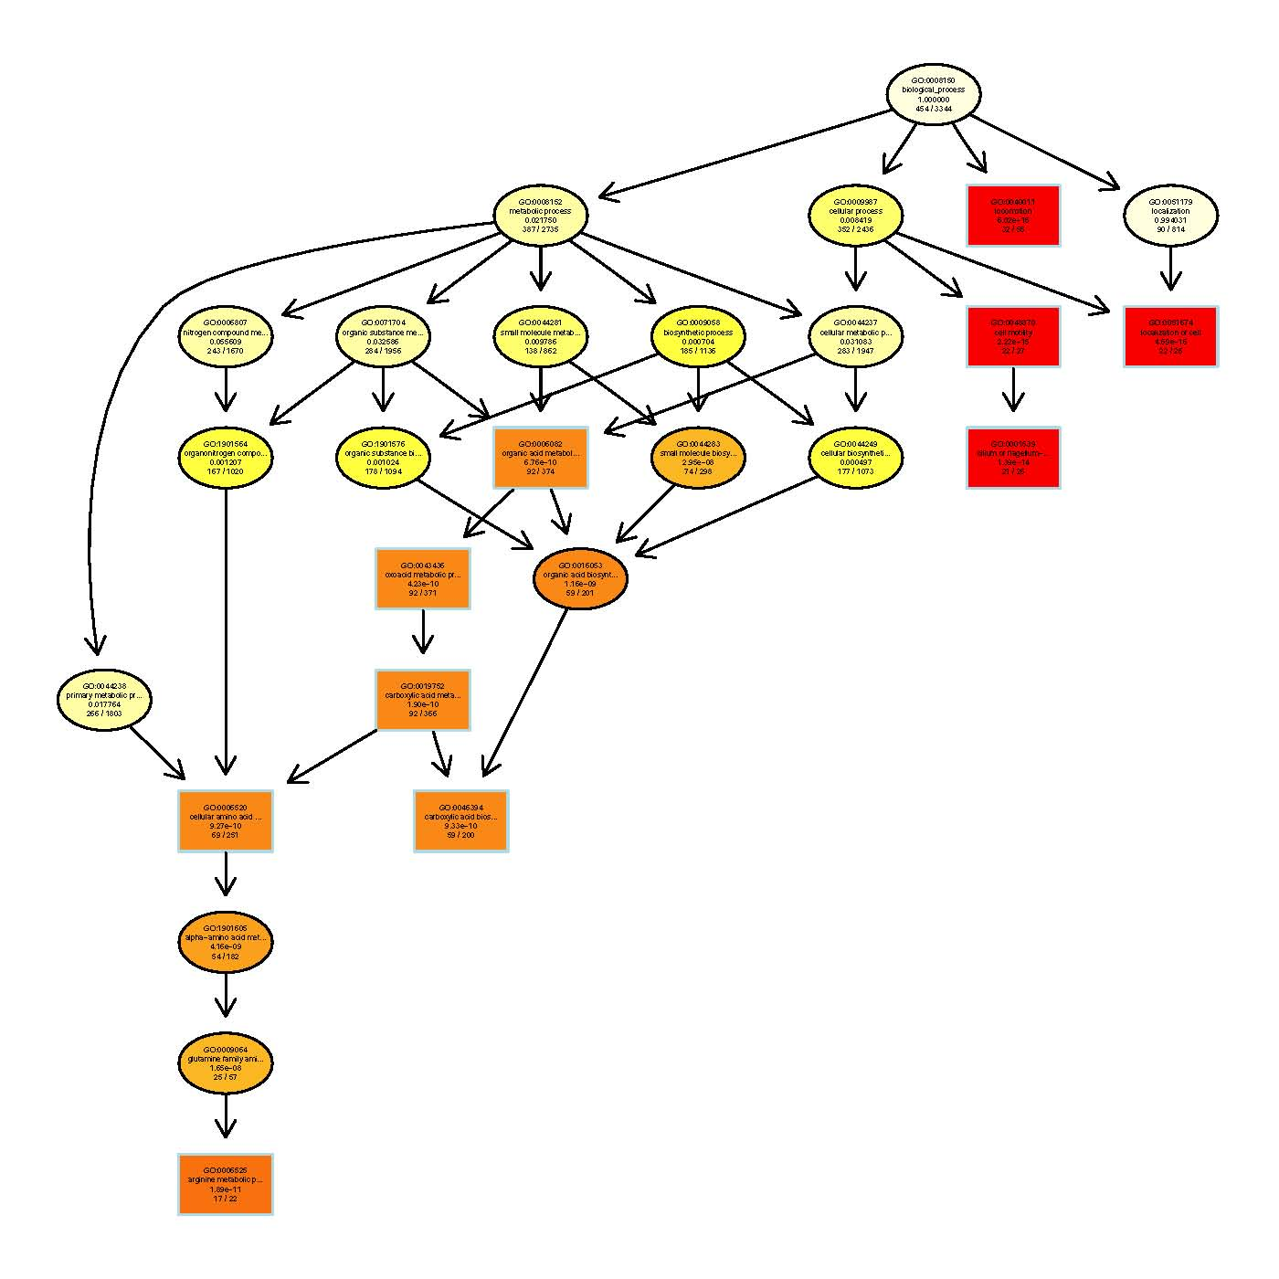
Figure S10 GO metabolic processes of P. dispersa genes when Bxs served as the sole carbon and nitrogen source.

Figure S11 Identification of purified proteins translated from candidate genes involved in Bxs metabolism. Quantitative determination of Bx levels following metabolism by the purified proteins translated from candidate genes, with protein from empty vector as a control (Con). Determination of Bxs was performed 3 h after inoculation at 28°C in Hepes buffer (pH 7.0). The data are means ± SEs. Different letters denote significant differences between groups based on one-way ANOVA followed by Duncan’s multiple comparison test at P < 0.05 (n = 5).
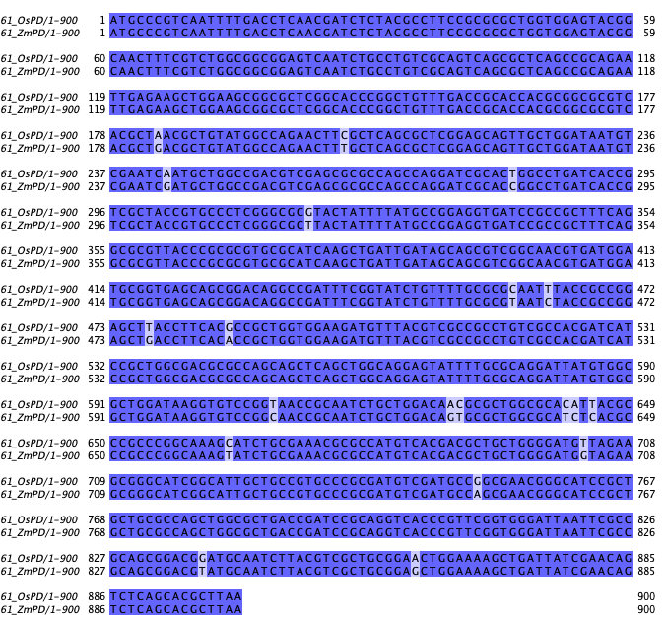

Figure S12 Nucleotide sequence alignment of the target genes in two P. dispersa strains (OsPD and ZmPD). Number 61 indicates the target gene No. #8.
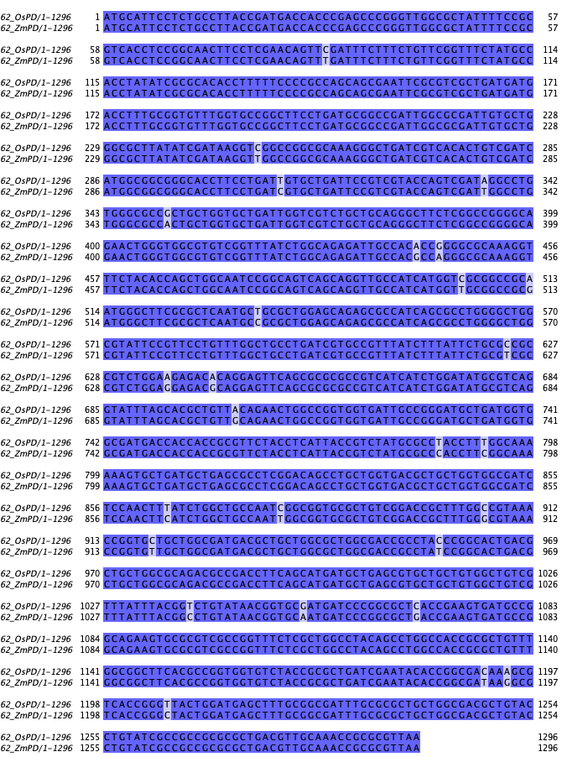
Figure S13 Nucleotide sequence alignment of the target genes in two P. dispersa strains (OsPD and ZmPD). Number 62 indicates the target gene No. #9.

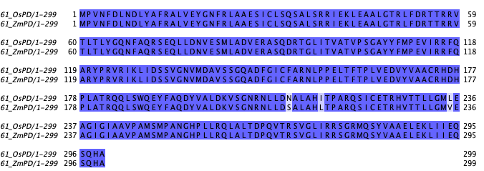
Figure S14 Amino acid sequence alignment of the target genes in two P. dispersa strains (OsPD and ZmPD). Number 61 indicates the target gene No. #8.

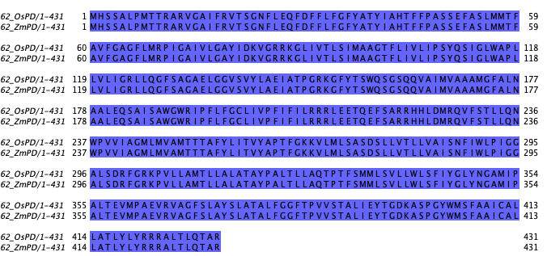

Figure S15 Amino acid sequence alignment of the target genes in two P. dispersa strains (OsPD and ZmPD). Number 62 indicates the target gene No. #9.

Figure S16 Metabolism of Bxs by P. dispersa under different pH conditions. The levels of Bxs metabolized by P. dispersa at 28°C after a 3-hour incubation at pH 5-10 (as the numbers indicated in the abscissa axis). Data are means ± SEs. Asterisks indicate significant differences between control (Con) and each treatment (e.g., 5+PD indicates P. dispersa incubated under a pH of 5) (Student’s t test, n = 6-8; *, P < 0.05; **, P < 0.01; **, P < 0.001).

Table S1 The target gene IDs and primers used in this study.
Table S2 All differentially expressed genes in response to Bxs serving as the sole carbon and nitrogen source.
Table S3 All differentially expressed genes involved in flagellin biosynthesis or movement in response to Bxs serving as the sole carbon and nitrogen source.

